Written evidence submitted by the Recruitment and Employment Confederation

Introduction
The Recruitment & Employment Confederation (REC) is the professional body for the recruitment industry, we represent over 3,200 recruitment businesses – 80% of the UK’s £38.9 billion industry by turnover, and 11,500 individual recruiters. The UK recruitment sector places over a million people into permanent jobs each year and ensures that a further million are working flexibly through temporary assignments on any given day. Through our code of practice and complaints procedures we promote industry standards and compliance.

REC members supply workers to all sectors of the UK economy including health, education, executive search, interim management, logistics, industrial, retail and hospitality. As well as running specific sector groups for these specialisms we also conduct our own research surveys. We therefore have access to some of the most up-to-date, robust data and insight about what is happening in the jobs and employment market across the country

We welcome the opportunity to provide written evidence to the Treasury Committee.

Job Protection Scheme and Self-Employment Income Support Scheme
Where has Government support been too generous and where has it not been generous enough?
What gaps in coverage remain and are changes required to increase their effectiveness?

Temporary workers

The Coronavirus Job Retention Scheme (CJRS) has been a much needed and generous scheme. We were pleased to see temporary workers included in the scheme and a good proportion of our members have had access to financial support through the CJRS. Whilst members have used the scheme to furlough their direct employees, which has been helpful, it is the furloughing of agency workers which has been most complex. Furloughing temporary workers comes with a direct cost - administrative, apprenticeship levy contribution and cost of operating payroll all at a time with reduced income. The recruitment industry recognised Its role to play in helping during the crisis - however, there are concerns following the HMRC clauses on enforcement included in the Finance Bill.

We appreciate that for government it is both unusual and difficult to put in place enforcement mechanisms after businesses and employers have already participated in the scheme. We recognise that the legislation must be broad in its approach, to cover the various schemes and scenarios. However, given the gaps in clarity for the CJRS regarding temporary workers throughout this period we would like assurances from the government that efforts to recoup money from employment agencies, will be proportionate and keep in mind the difficulties faced when furloughing temporary workers. These included multiple updates to the scheme, lack of legal clarity on issues which meant they remained unanswered and open to interpretation.

Self-employed

Although the Chancellor’s package of support for the self-employed was incredibly generous, meeting the needs of 95% of self-employed workers, there are still 5% of self-employed workers who lack support. Company directors of limited companies are ineligible for the Self-Employed Income Support Scheme (SEISS) offered by the Chancellor, and therefore at risk.

When the government first published guidance on the CJRS in March, there was a lack of clarity as to wherever self-employed limited company directors were eligible to the CJRS. Directors were only mentioned in the SEISS as not being covered by the SEISS but by the CJRS for their salary. However, company directors who were able to receive support under the CJRS found that their dividends were not considered, leaving them with a sustainable fall in income. Moreover, directors are prevented from working while on the scheme, this may work for other types of workers but as company directors, they still need to carry on with some activities to keep their business afloat.

Company directors of executive search limited companies were particularly affected, as the sharp fall in vacancies left them with no incoming revenue and continuous outgoing costs such as rent on office space, etc.

The REC advises government to extend their offer of wage protections to self-employed workers on the same basis as other workers; perhaps via a temporary Income Protection Fund to provide all self-employed with a monthly income.

Support to businesses and financial services

How effective is the Coronavirus Corporate Finance Facility, Coronavirus Business Interruption Loan Scheme, and the Coronavirus Larger Business Interruption Loan Scheme? Are these measures succeeding in preventing viable businesses from potentially going under during the Coronavirus lockdown?

The coronavirus pandemic placed an unprecedented halt on the labour market. As business confidence dropped, temporary billings in March fell at their fastest rate since 2009. This has had a profound effect on cash flow in the recruitment sector. From the outset the REC received thousands of enquiries from recruiters with cash-flow concerns. Recruitment businesses struggled to paying their overheads whilst receiving little income revenue.

A common concern for REC members has been the slow and often inaccessible nature of the government backed loan schemes. Although generous, the government's Coronavirus Business Interruption Loan Scheme (CBILS) does not offer any kind of solution to firms’ cashflow needs, due to the slow pace of its delivery by the banks, and some of the unwarranted requests firms are facing to access the finance – including requests to switch other financial products to the lender as part of the deal. Although CBILS is improving, it remains the case that only a small proportion of applicants have received funding so far. Given the uncertainty of the crisis there was also an understandable reluctance to apply for long-term loans, the problem was more accessing quick cash flow to pay workers ahead of the CJRS funds coming into the bank account.

The REC would have liked to have seen government set up emergency grant support for cash strapped agencies who were struggling to pay their temp wages. The money could then be retrieved from furlough payments, this solution would have come at no net cost to government but would have been hugely beneficial for agencies.

Economy, public finances and monetary policy

What economic challenges may arise as the public health and social distancing policies are lifted and the economy begins to recover? What preparations can be made to manage these challenges? For example, could there be difficulty in restarting sectors of the economy quickly, a risk of a spike in inflation, or pressure on the UK balance of payments?

The Coronavirus pandemic has had a huge impact on business and economic activity across the UK. As experts on the world of work, our members have put forward several suggestions to help restart the economy.

- Cuts to National Insurance, VAT and active tax
- An investment in skills funding
- A rebate of SSP for all businesses
- A partnership with recruiters to help get people back into work

Stimulus package for business

A stimulus package which includes cuts on active taxes such as VAT, employer’s NI, Business Rates etc. will help drive up business spending and reduce the cost of employing people. Tax cuts on business have typically come in the form of cuts in corporation tax, however it is time for a shift. The benefit of cutting corporation tax is limited. Corporation tax is a tax on output and therefore not every business pays it. Cutting taxes on activity such as VAT, which is payable to all businesses will allow businesses to invest more.

Statutory Sick Pay Rebate Scheme

The Chancellor’s Statutory Sick Pay (SSP) rebate scheme for SMEs was a generous proposal and one which was welcomed by the REC; however, it did not go far enough. As the definition of an SME applied by the government was revealed, it became apparent that it would not protect the hundreds of thousands of cash strapped SMEs in the recruitment sector.

Employment agencies supply temporary workers to third parties and those workers are usually engaged on contracts for services rather than contracts of employment. These temporary workers will fall within the ‘employee’ definition in the Equality Act 2006 as they will be included on the employment business’ payroll. This meant that employment business with a large temporary workforce but fewer than 250 permanent staff were excluded from the rebate scheme. Even though they, like many other smaller employers, were desperately in need of additional support to help them meet their legal obligations, due to limited resources and the challenges of running a small business. These employment agencies represent more than 90 per cent of REC's membership, with 72 per cent directly employing fewer than 50 people.

Now that we are moving into the recovery stage of this crisis, with the government's Test Track and Trace system, there is growing concern amongst our membership that they will not be able to pay their potential SSP costs.

Anecdotal evidence from our members suggests that the inclusion of test and trace system is already making agencies cautious to take on new temporary staff for fear of high SSP costs. If government were to extend SSP protection to all employers, this would ensure many more people have access to temporary work and would reduce the call on benefits over time. In the current environment, temporary work is a huge part of available new jobs.

The REC advises government to cover SSP costs for 2 weeks for all workers, this would ensure many more people can be placed, and would reduce the call on benefits over time, saving the government money.

Skills Investment

Government investment is key to economic recovery. This does not just means spending on infrastructure projects – both physical and digital, but also on skills. An investment in skills and education is crucial in restarting the economy once lockdown measures are lifted. Government must replace the current approach to the apprenticeship levy, which has had a net negative effect on employer training spend, with a levy approach designed to boost it. Broadening the current levy into a training and skills levy that can be used to fund Ofsted regulated training courses would boost UK productivity at a time when we need it most. It would help workers transition from the worst affected sectors to those least affected by the crisis.

This is something the REC has long been calling for to increase skills provision for temporary workers. Recruitment businesses with many agency workers on payroll are paying the levy but cannot use the funds to train those workers. Over 670 REC members have £104 million of unspent apprenticeship levy funds between them because it cannot be used to support the temporary workers on their payrolls. This is temporary workers have assignments that normally always last less than a year, while an apprenticeship has to be at least a year long.

Supporting people back into work

The labour market deteriorated sharply as the Covid-19 pandemic, and lockdown, pushed the economy into recession. According to REC's Report on Jobs data (June 2020) the number of vacancies in April halved, while unemployment claimant surged to over 2 million. As the furlough scheme comes to an end in October there is a worry than many more people will find themselves unemployed.

Government should seek the expertise of the recruitment industry to get people back into work. As experts in the labour market, recruiters can identify opportunities and skill shortages in the labour market. A recovery strategy, involving the recruitment industry would help workers move from declining into expanding and viable sectors. Such a partnership was successful in 2008, following the financial crash. REC members can help to deliver employability services at this critical time - with support on how to job search in the modern market, CV construction, skills pathways and interview skills. Committing resource to supporting the unemployed via private employment businesses has two clear benefits: immediate help for the unemployed, and a more robust recruitment sector as the recovery heats up – better able to drive unemployment down.

This is one of the recommendations in the Institute of Employment Studies latest report, Help Wanted Short Term Unemployment, (May 2020). Committing resources to employability services being delivered by private sector recruitment agencies is an investment that will pay off for workers and the government alike.

Is the economy’s recovery likely to be shallow or sharp?

The Coronavirus pandemic has had an unprecedented impact on business and economic activity across the UK. The speed of the crisis has been fast - in late March, as the lockdown was announced, permanent hiring and hiring in temporary markets fell dramatically. But the impact is still unknown to a large extent. This is not a normal recession - the economy in March was effectively paused, with jobs protected by the state, and clear sectoral differences as some industries were better placed to work from home, or were vital to essential services such as food or health, whilst others such as tourism and hospitality were effectively shut. However, given the widespread protections placed on jobs by the government, we hope that as we see the easing of the lockdown restrictions, the economy will be in a good place to recover quickly in most sectors. This optimism is reflected in our survey data in recent reports. However, there are a lot of unknowns as the CJRS support reduces over the next few months, with businesses having to make difficult decisions.

The REC’s Jobs Outlook is a monthly survey which reports on employers’ confidence in economic conditions and their expectations for short-term and medium-term staffing requirements. As Figure 1 illustrates, business confidence in the UK economy’s prospects plummeted at the start of the COVID-19 outbreak. This was mainly driven by a dive in sentiment among small businesses (0-49 employees), who have been hardest hit by the pandemic. Economic confidence in this group fell dramatically from net: 0 in February to net: -32 in March (Jobs Outlook April 2020).

Overall business confidence levels plummeted from net: -23 in March to a record low of net: -62 in April. Similarly, employers’ confidence in making hiring and investment decisions fell between March and April from net: -5 to net: -21.

While employers’ confidence in the UK economy remains at a joint record low, there are signs that things are improving, and employers are starting to feel a little more confident about their ability to hire new staff and invest in their own businesses.

The latest Jobs Outlook report, which surveyed employers between 4 and 14 May, found that business confidence in making hiring and investment decisions improved by 11 percentage points compared to early April. However, confidence levels remained negative overall at net: -10.

Figure 1: Employers' confidence in the prospects for the UK economy and in making hiring and investment decisions, Jobs Outlook, May 2020

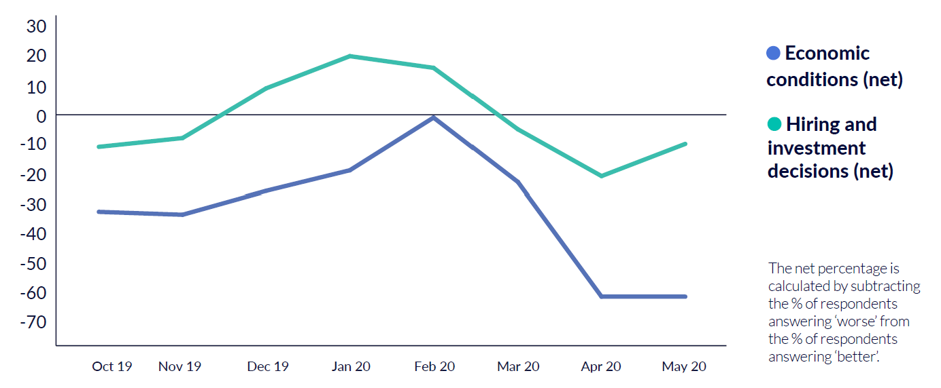

In a separate survey of 84 signatories of the REC’s Good Recruitment Collective conducted between 1 April and 16 April 2020, a third of respondents said they are very confident that the economy and their business will bounce back. Six in ten said they are a little confident but that it will take time. Similarly, over a third of recruitment business leaders who have taken part in our COVID-19 webinars consistently said they are very confident that the economy and their business will bounce back post-COVID-19. This indicates a feeling that we have hit the bottom and conditions will improve moving forward.

This is being reflected in latest data from the REC's Jobs Recovery Tracker, which has revealed that the number of active job postings in the UK has risen slowly over the past four weeks. There were almost 963,000 job postings between 1-7 June, up from 950,000 in the week starting 11 May (REC's Jobs Recovery Tracker June 2020).

The number of new job adverts in the first week of June was 112,000, a significant 64% more than for the last week of May. This could indicate more companies starting to hire again since the lockdown measures have been eased, and that the recovery is starting to pick up speed.

Scotland and Wales are currently leading the recovery – active job postings there have risen by 3.6% and 2.3% respectively between the weeks of 25-31 May and 1-7 June. Individual hiring hotspots for the first week of June include Bridgend & Neath Port Talbot (+14.7%), Dumfries & Galloway (+13.1%), and East Lothian & Midlothian (+10.4%).

Sectors

While all sectors of the world's economy are affected by the coronavirus outbreak, the hotel, leisure, retail, and travel industries have been hit particularly hard. As illustrated by figure two, there were substantial falls in demand for permanent workers across almost all monitored job categories in April. The nine sectors posting falls all saw record rates of decline, led by Hotels & Catering.

Figure 2: Permanent Vacancies Index, REC's Report on Jobs (May 2020)
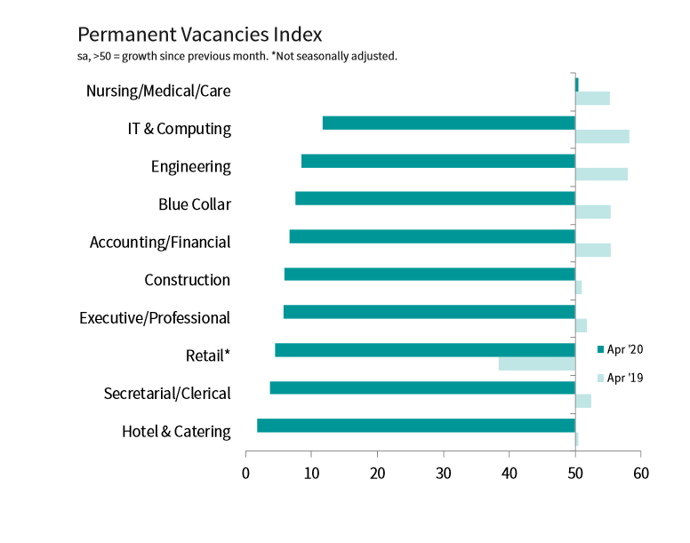

Nursing/Medical/Care was one of the few sectors to register an increase in demand for not only permanent but also temporary staff in April. In contrast, record falls were seen across all categories. Secretarial/Clerical and Hotel & Catering recorded the most severe declines.

Figure 3: Temporary Vacancies Index, REC's Report on Jobs (May 2020)
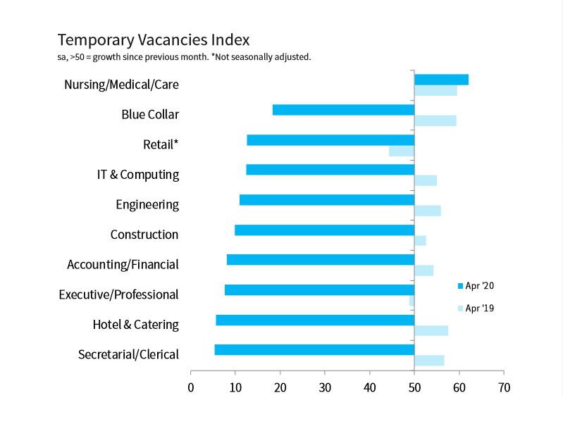

What will be the impact on inequalities within society and how should the Government address inequalities that may have been exacerbated by the crisis?

We know that women, people from minority ethnic groups, people with disabilities, and those aged under 25 and over 55 years suffer most from higher unemployment rates during recessions. The last recession saw youth unemployment surpass 1 million in the UK, with black and mixed raced young people experiencing higher rates than their white counter parts. There is also a concern that the large proportion of women who have been furloughed will be facing redundancies once the scheme ends. According to the IFS data, women are more likely to work in a low paid sector which have been forced to close (retail, hospitality, leisure, etc.).

The REC urges government to develop a cross departmental Good Recruitment Taskforce to develop a strategy to support marginalised groups enter and maintain their position in the labour market. Specific labour market policies will also need to be introduced to support those most marginalised in the labour market. Support should come in the form of schemes such as the Future Job Fund, which create jobs and training places in sectors important to recovery and progress, and tailored to local needs.

June 2020

