Written evidence submitted by the Anti Tribalism Movement (MAC0009)
This submission was re-published on 30 July 2020 in order to resolve an issue with the HTML and PDF conversion which had significantly altered the placement of text and data.
ATM and the Somali community hugely appreciate UK Parliament’s attempt to assess the state of play of race and policing. Towards this, we are pleased to share feedback from the community. Given how much ground the police have to cover to achieve equitable policing, this endeavour will remain ‘timely’ for the next may years.

1. Introduction
The COVID-19 pandemic is disproportionately affecting Black, Asian and Minority Ethnic (BAME) communities in Britain. BAME communities appear more susceptible to the disease in terms both of contracting it (486 black females per 100,000 are diagnosed with it as against 220 white females, and 649 black males per 100,000 as against 224 white males) and dying from it if they do contract it (for instance, Bangladeshis’ risk of death is double that among white British people¹).
As if this were not worrying enough, BAME people are facing a disproportionate ‘ethnic penalty’ in the criminal justice system too. UK Government has accepted that there is
‘current over-representation of people from racial and ethnic minorities in the Criminal Justice System’,² and COVID-19 policing confirms that pattern. Liberty Investigates³ reports that 22% of Fixed Penalty Notices went to BAME people in England, who make up 15.5% of the population. BAME people are 54% more likely to be fined than white people, and they may have received 90% more fines than would have been proportionate.
Anti-Tribalism Movement (ATM) has been hearing much anecdotal evidence about high COVID-related anxiety in the Somali community. The two trends described above are significant triggers, but there are other socio-economic factors too which are amplifying the difficulty of riding through the pandemic safely and in good mental health. These include overcrowded housing with no access to open spaces, a profile of insecure employment and huge job losses, the resultant disruption in remittances to dependents in Somalia, disproportionate poverty, educational disadvantage in an on-line teaching world due to a paucity of connectivity, computers and smartphones, and the temporary closure of mosques and community organizations. These are summarised in ATM’s April 2020 policy briefing for UK government.⁴
These hardships have been compounded by a perception of heavy-handed and insensitive policing. The relationship is being further tested, and a strong community perception exists that Somalis are targeted unfairly for police punishment. The community thinks Somalis are a) policed over-zealously, and b) receive poor service when they are victims of crime. We believe this compromises the key principle of policing by consent, which is at the heart of UK policing.
In order to present an evidence-based account to the Select Committee, ATM carried out original research with Somalis in the UK. The findings are summarised in this report, and we very much hope the Committee will find it useful when considering how to make policing fair and equitable in the UK.

2. Headline findings
Our respondents say:
- Somali community is disproportionately targeted for COVID-19 policing and general policing.
- Young Somali men suffer disproportionate rates of stop and search, and in most cases, reasons are not clearly explained to them.
- Somalis suffer high incidence of hate crime and other crime.
- They report a very small percentage of these to the police.
- Lack of trust in the police is high, as also the perception that the police do not trust or believe Somalis
- The community have high rates of dissatisfaction with investigations, action and victim support.
- The community rates the police low in representativeness, service, fairness and equality, and proportionality.
- Many respondents believe that police officers behave in a racist way towards Somalis.

3. Methodology
ATM conducted an online survey which was sent to its mailing list and shared across ATM’s social media platforms including Facebook, Twitter and Instagram which collectively reached tens of thousands of followers.
The questionnaire received 110 responses from UK Somalis. Of these, 47 were male and 63 female. Most respondents were aged between 18 and 49, although 9 were either under 18, or 50 and above. Over 90% of respondents were from London, but a small numbers of respondents were from Cardiff, Southampton, Manchester, Birmingham, and Leicester. Policing of COVID-19 regulations

4. Policing of COVID-19 regulations

‘The police need to build bridges with Somali community and organisations to address our concerns regarding the quarantine and policing in general.’

Headlines
- Somalis, particularly men aged 18-34, are being disproportionately targeted for Fixed Penalty Notices and arrests, for breaching COVID-19 legislation.
- Almost a third of respondents believe Somalis are targeted more than others for breaching COVID-19 laws.

A recent statement from the Met Police admits that ‘higher proportions of those in black and minority ethnic (BAME) groups were issued with FPNs or arrested across London as a whole.’⁵ They say the reasons are ‘complex and reflect a range of factors,’ which, as far as the Somali community is concerned, explains nothing and leaves racial profiling on the table as an explanation. Our survey reveals that 3% of our respondents have been arrested or charged for breaking COVID-19 lockdown rules, where Somalis make up only 0.001% of the UK population. This finding resonates with other research showing disproportionate targeting of black people – one recent study shows that 31% of London arrests for COVID-19 were of black people, though they make up only 12% of the population.⁶
A similar disproportionality emerges with Fixed Penalty Notices (FPNs) amongst our respondents. Our survey shows that 6.36% have been given Fixed Penalty Notices. Compare this with the 0.02% of England’s population who have received FPNs.⁷ The majority (71%) of respondents who received FPNs were young men.
All those arrested and charged were male, and all were aged 18-34. This fits with broader literature on over-heavy police action against young black men.⁸ For instance, 2019 figures show that black men in London were more likely to be stopped and searched than white men by a factor of 3⁹ or higher¹⁰.

5. Stop and search

‘…they assume somali people especially the young boys have weapons or drugs based off of appearance…’ (Respondent)

Headlines
- 28.2% of respondents had been stopped and searched in the past 12 months – this is higher than England and Wales rates.
- Over three-quarters of respondents who had been stopped and searched said the police officer had not clearly explained the reasons for the stop and search.
- Most stop and searches were against men, and the vast majority of targets were aged 18-34.
- 42.73% of respondents thought Somalis were targeted for stop and search because of their ethnicity.

Overall rates of stop and search in England and Wales have decreased since 2014, but disproportionality based on race has risen.¹¹ UK government figures show that there were 4 stop and searches for every 1,000 white people, compared with 38 for every 1,000 black people.¹² Further, stop and search rates for BAME groups were higher than the national rate every year.¹³
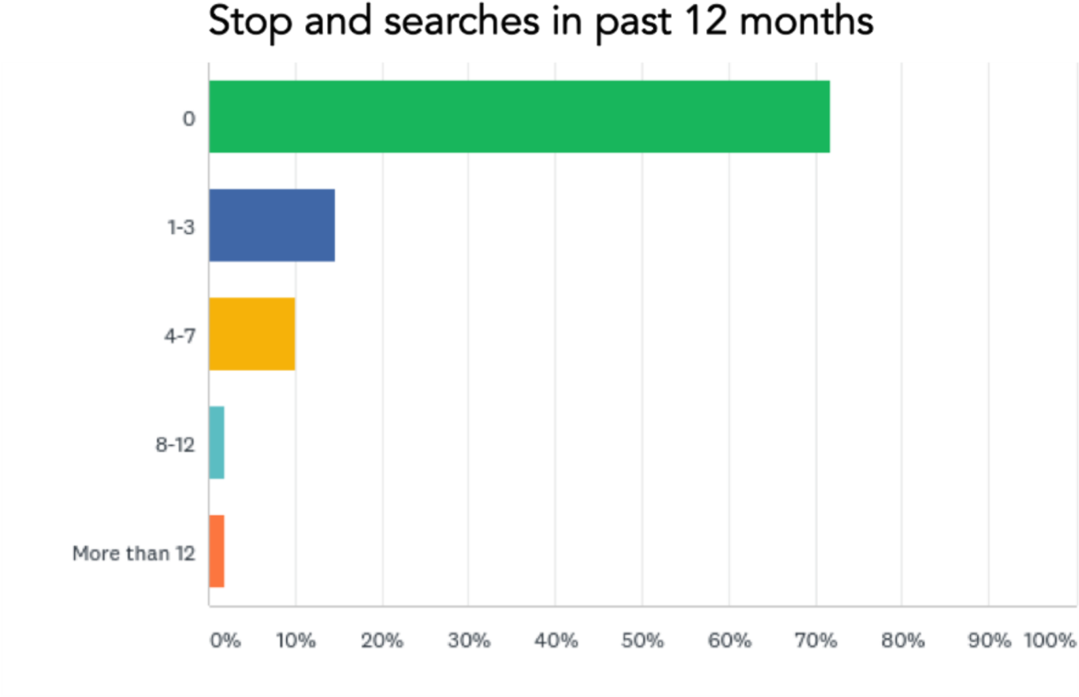
28.2% of respondents had been stopped and searched in the past 12 months. Compare this with the England and Wales stop and search rate of 0.7 per 100 population, and 0.4 per 100 white people.¹⁴ The number of times they were stopped and searched is in the table on the left. Note that almost 13% had been stopped over 8 times.
Of those who had been stopped and searched in the past 12 months, three quarters were young men aged 18-34. Only 6% of those who had been stopped and searched in the past 12
months have then been charged with an offence, which raises questions about the validity of the stop and search in the first place. Of those who have ever been stopped and searched,
42.73% thought they had been targeted because of their ethnicity.
Further, there is a strong community perception that Section 60 of the Criminal Justice and Public Order Act, which give officers the power to search people in a defined area during a specific time period when they believe serious violence will occur, is used disproportionately in areas with high-BAME (including Somali) populations.¹⁵ Whether this is a result of well-evidenced intelligence or racial profiling remains unclear.

6. Hate crimes

Headlines
- 62% of respondents or their families had suffered hate crime in the past year, where 23% had suffered other types of crime. Hate crime therefore appears a dominant crime category for the community.
- The Somali community suffers high rates of victimisation for hate crime (62% of respondents), and very low rates of reporting to police (20%).
- Most victims were ‘dissatisfied’ or ‘very dissatisfied’ with police investigation, action and victim support.

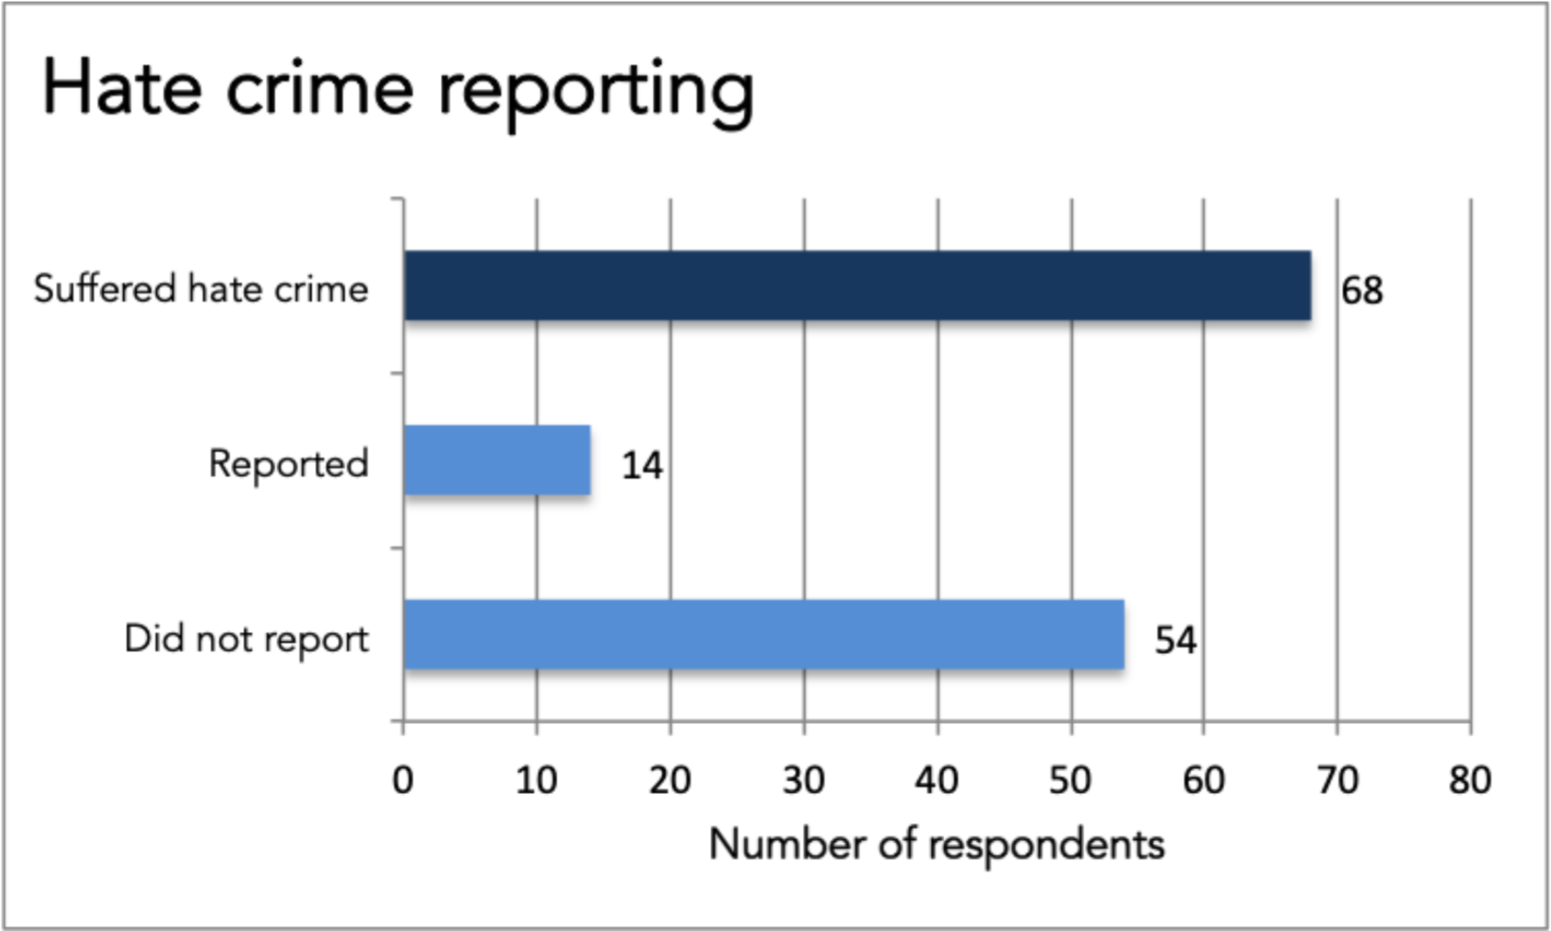
Almost 62% of respondents, or a member of their family, had suffered a hate crime in the past 12 months. Hate crime appears to be far more prevalent than other crime (only 23.6% who had suffered non-hate crime in the same period).
An overwhelming 80% of those who had suffered hate crime in the last year had not reported it to police. This is an exceptionally high figure, but does not surprise ATM as it chimes with what we found in a submission to a Parliamentary Inquiry on hate crime (see ‘Is racism the new normal?’).¹⁶ It is also roughly in line with 2016 research by the University of
Huddersfield which estimated that 77% of hate crimes goes unreported.¹⁷

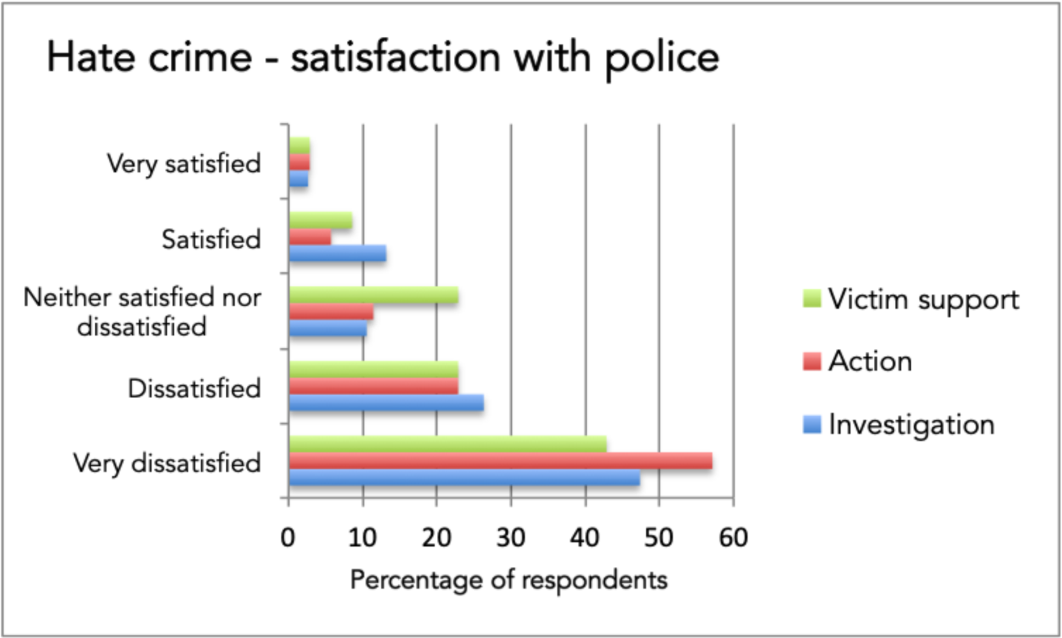
Satisfaction rates were very low amongst those who had reported hate crime in the past 12 months. Over 73% were either dissatisfied or very dissatisfied with the police investigation, 80% were dissatisfied or very dissatisfied with police action, and over 65% were dissatisfied or very dissatisfied with the victim support they received subsequent to reporting.
For ATM, these high rates of dissatisfaction are rooted in the same grievances that are driving the support for the ‘Justice for Shukri’ campaign. Shukri Yahye-Abdi was a 12-year old refugee who drowned in June 2019 while she was at a river with a group of children. She had been bullied in school before, and no action taken. Greater Manchester Police said it was a ‘tragic incident’ but without suspicious circumstances. However, her family and one million petitioners feel there is more to the story. They feel the police washed their hands off the case without an adequate investigation. They feel that this is typical of the hundreds of hate crimes that are reported to police each year, which get poor investigation, action, and victim support.

7. Crimes other than hate crimes

‘Due to previous issues with the police I will never ever trust them or ask for their help in other words I’d rather die then ask for their help, only thing I can thank them for is the ptsd They’ve given me.’ (Respondent)

Headlines
- Almost a quarter of respondents had suffered a non-hate crime in the past year.
- Of these, 70% had NOT reported it to the police.
- Levels of dissatisfaction with police investigation, action, and victim support were high, but not as high as the dissatisfaction on hate crime.

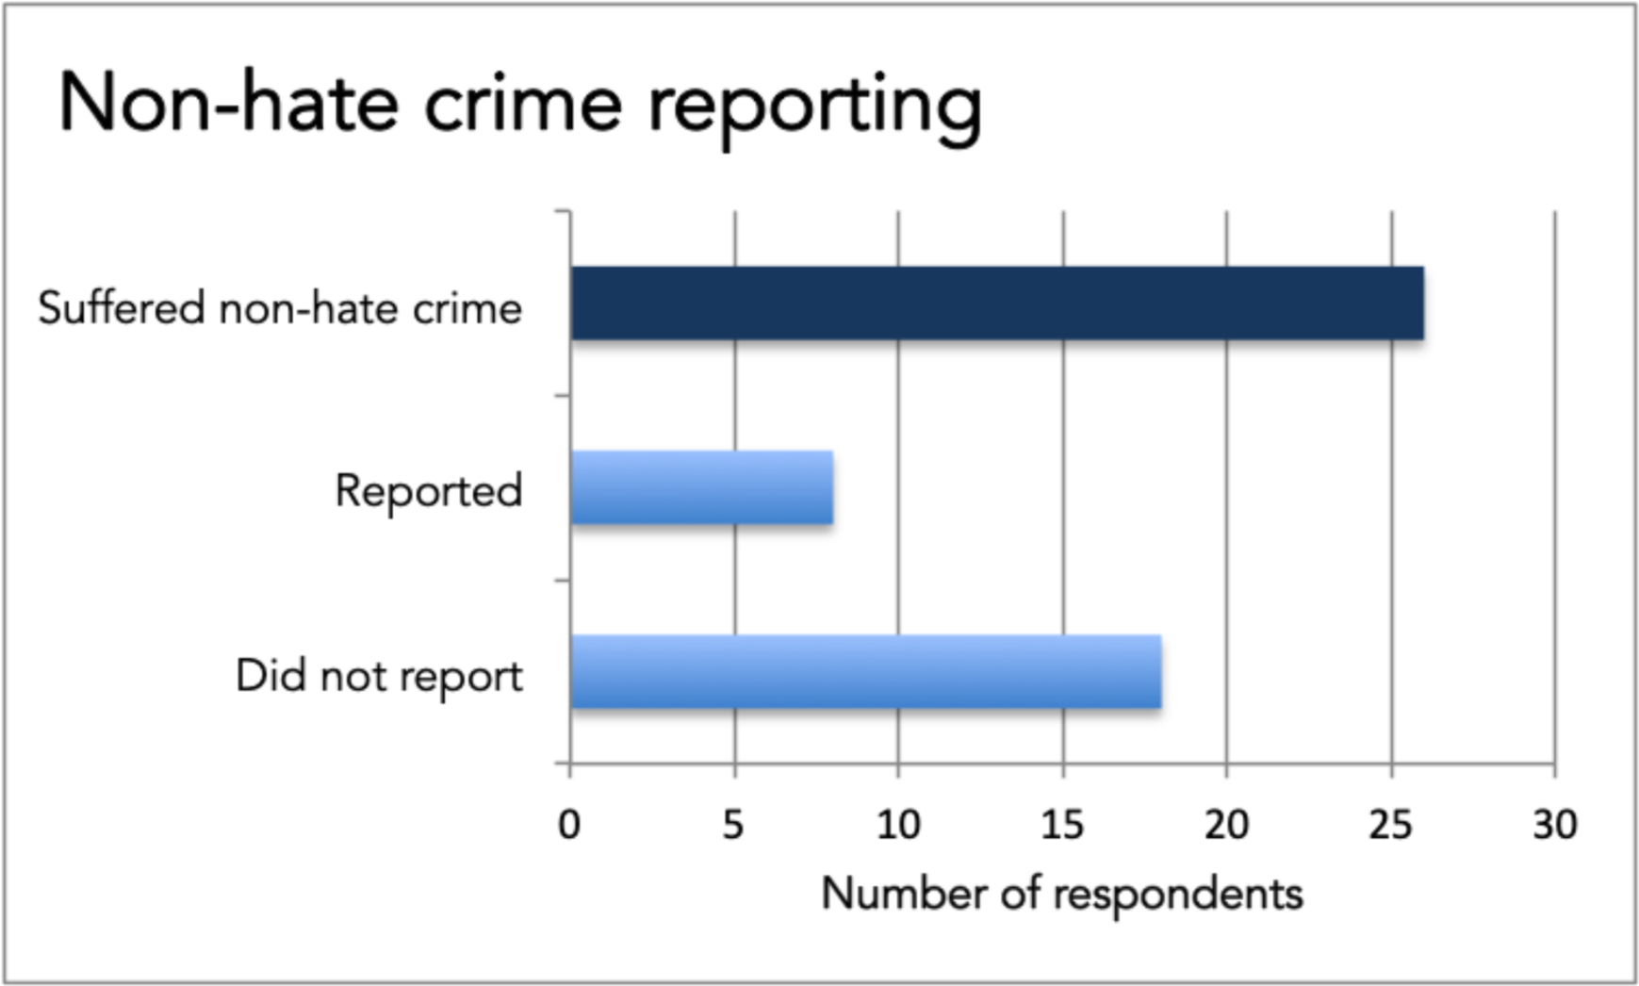
Of all respondents, 23.6% had suffered a crime other than a hate crime in the past 12 months. Levels of non-reporting are very high here too – just under 70% had not reported the crime to the police. This is higher than the overall under-reporting rates of all crime in England and Wales; as far as we estimate from the Crime in England and Wales datasets for year ending December 2019, 55% of all crimes were reported, whereas Somalis seem to be reporting only 30% as per our survey. This is worthy of further in-depth investigation by the police.
Where crimes had been reported, levels of satisfaction were very low. 56% of respondents were very dissatisfied with the police investigation and another quarter were dissatisfied. The pattern was similar in regards to police action (70% either dissatisfied or very dissatisfied), and victim support (over 65% dissatisfied or very dissatisfied). While our sample was small, the pattern is clear. The police would do well to dig deeper into the reasons for such overwhelmingly low satisfaction rates.

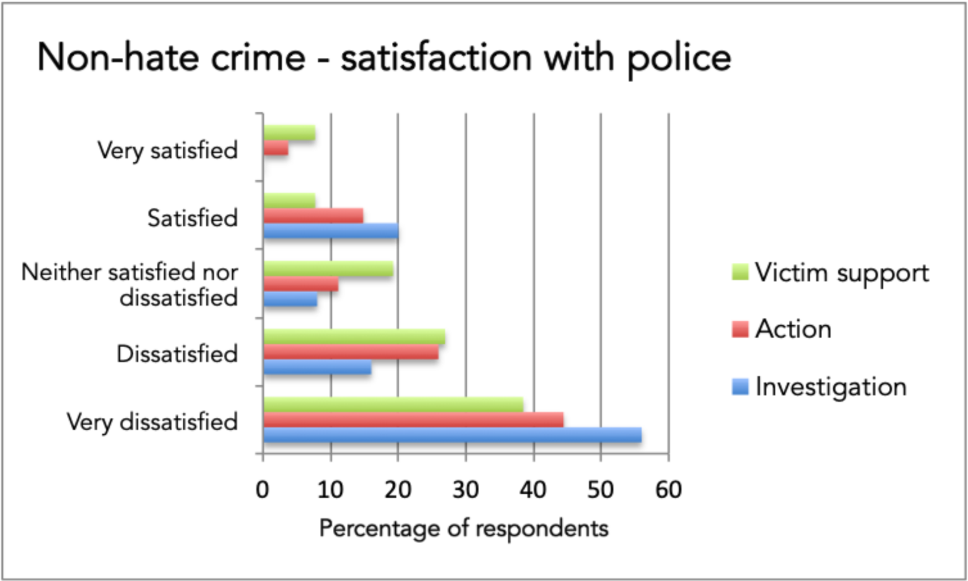

8. Community-police relations

‘Our young somali … boys are treated like criminals and if you keep on alienating someone they are bound to turn into what you already assume they are.’

Headlines
- There is severe lack of trust in police.
- The community feels the police do not represent their community, so not serve the community well, target them disproportionately, and behave in a racist manner.
Lack of trust was the single biggest reason for non-reporting. The community did not trust the police, and they perceived that the police did not trust or believe Somalis. These are difficult things to address and will take concerted and committed action. The other more procedural reasons are easier to address, if there is the will. They include the time taken to report, lack of knowledge about what and how to report crimes, and communication barriers.
We asked respondents about their perceptions of representation, service, racism, disproportionate targeting in general, and disproportionate targeting on COVID-19. The police did badly on all counts.

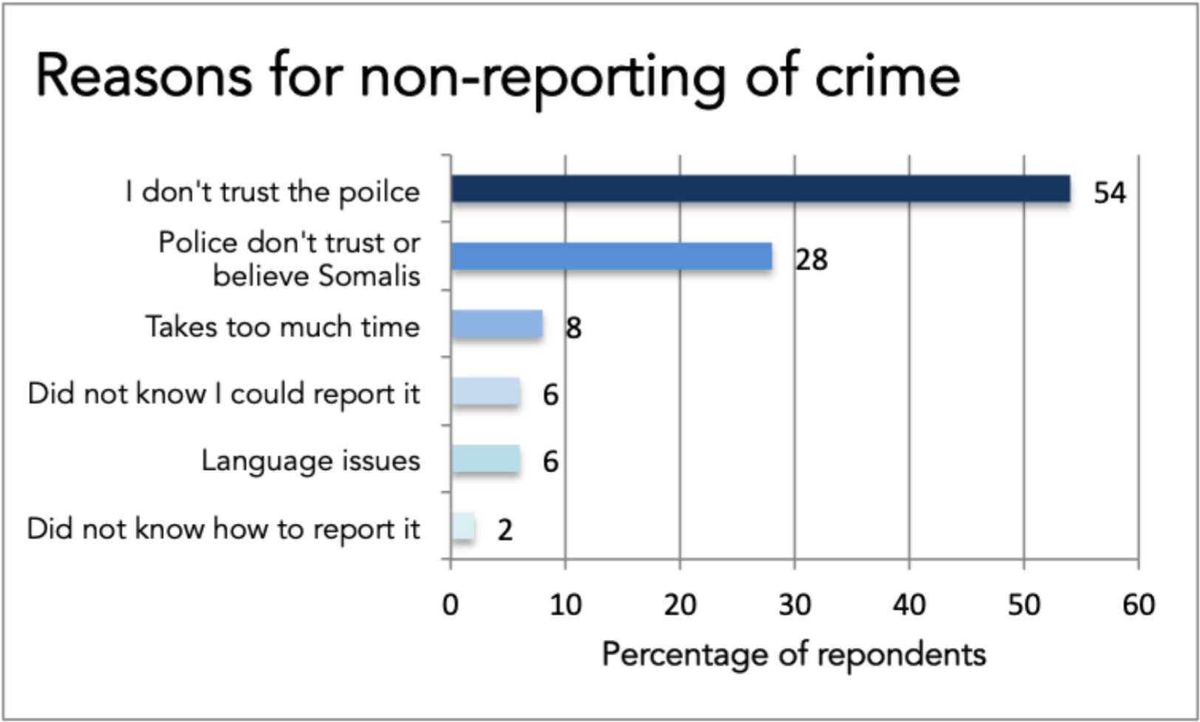
Not a single respondent sees the police as representative of the Somali community. This was because there are not enough Somalis working with the police.

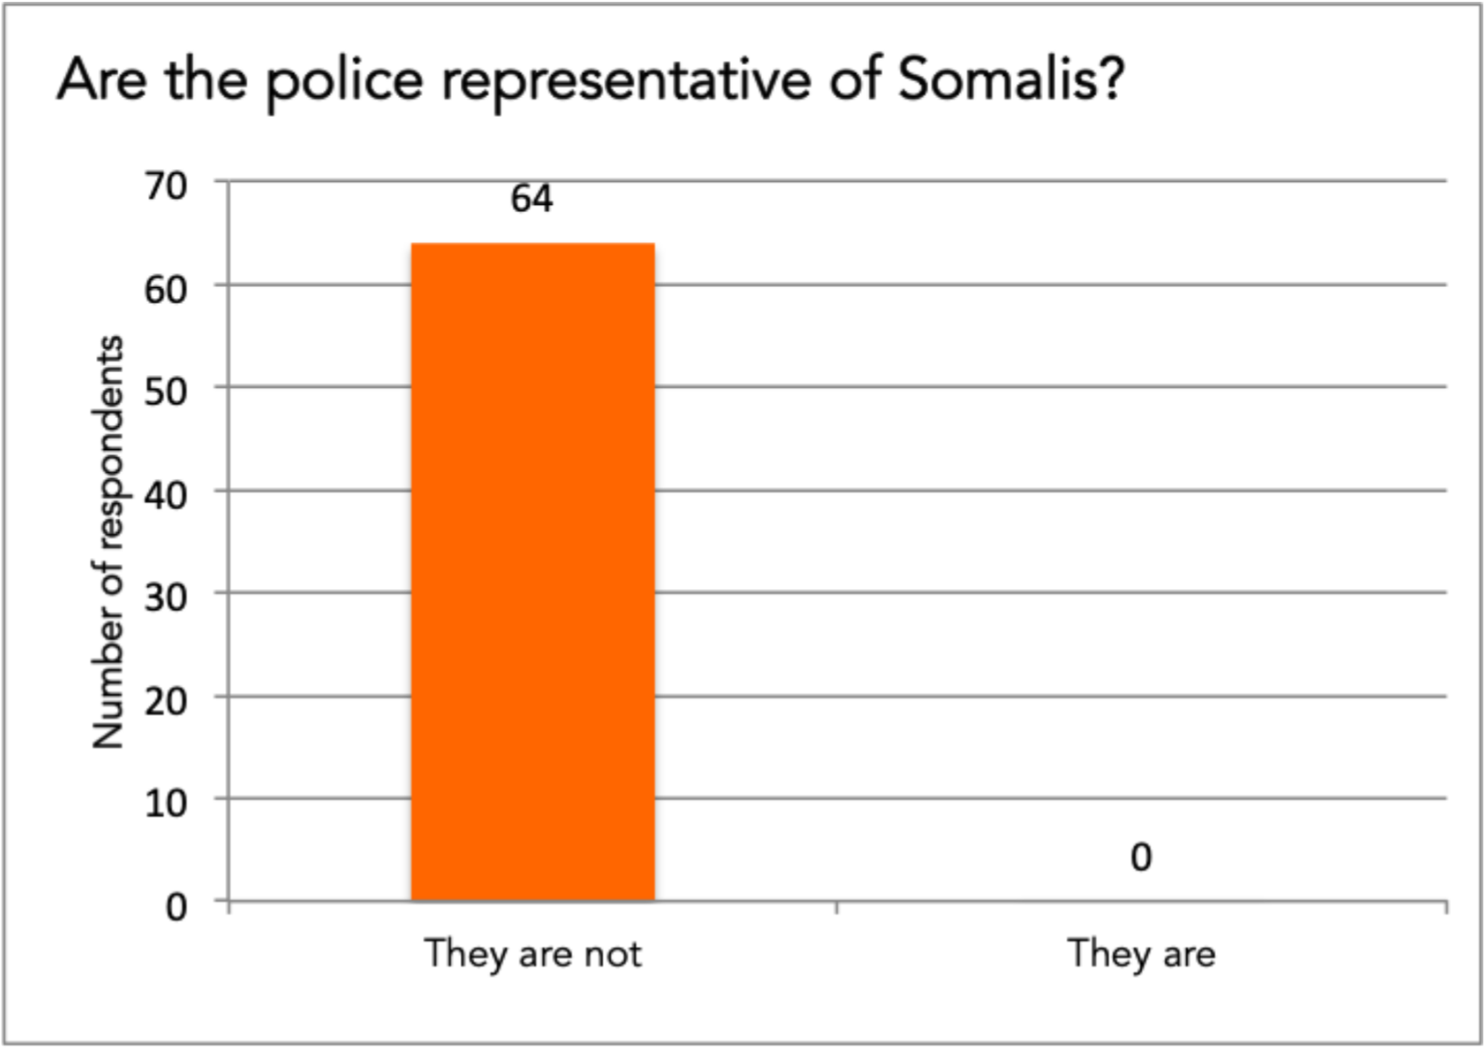
Connected to the lack of representation, was the perception that the police do not serve the Somali community well. This is of a piece with the other findings from the survey – where crime reporting is low, that will in some way arise from a feeling of not being served well, thus not trusting the police enough to report more.

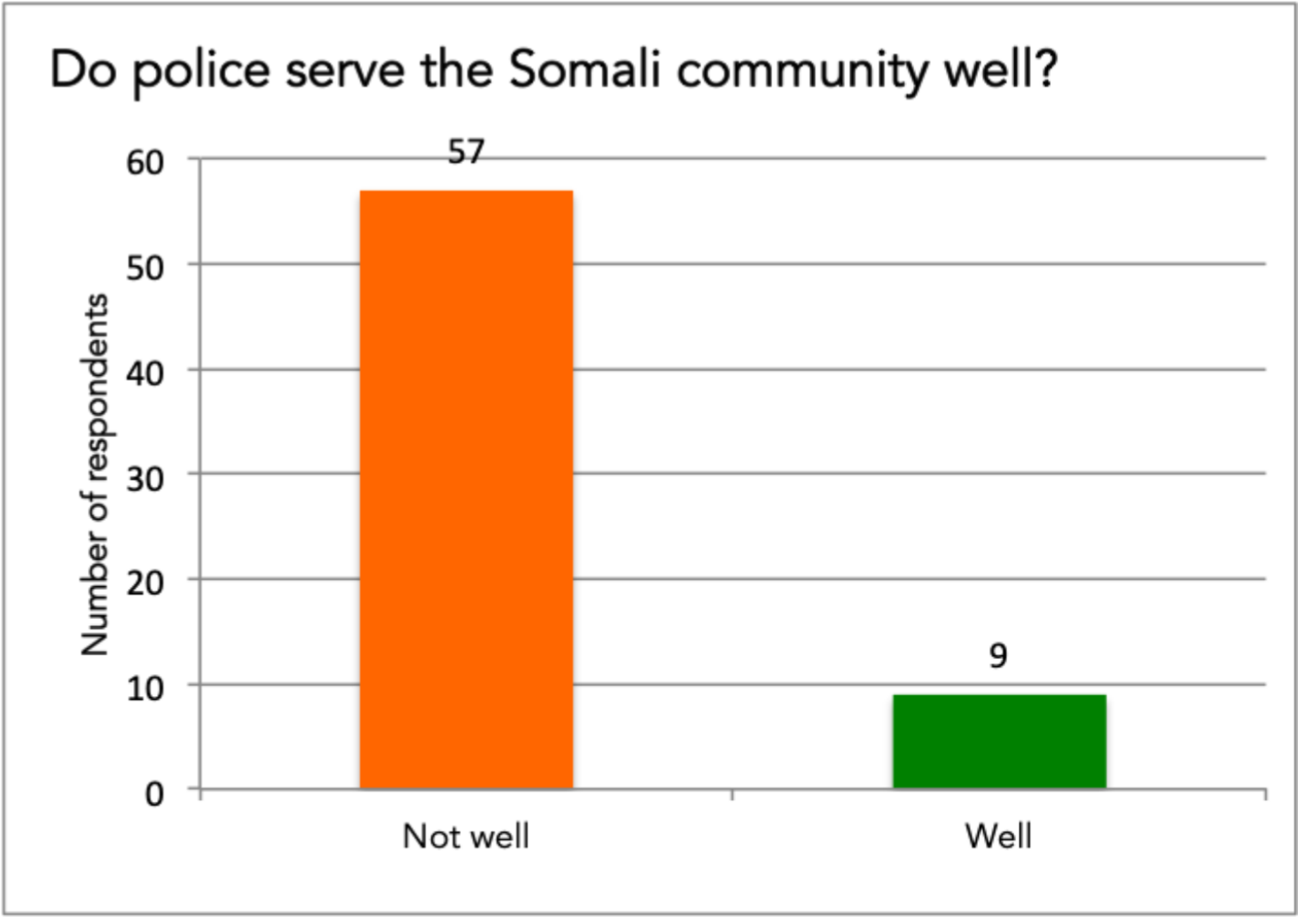
We asked about disproportionate policing for breaching COVID-19 regulations. Here we found not a huge gap between those who believed Somalis were targeted more than other communities (20 respondents), and those who felt there was no such targeting (13 respondents).

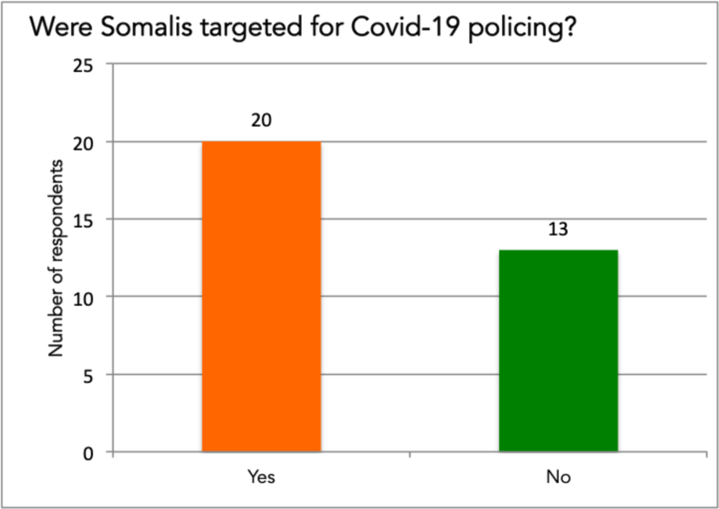
Does the community feel targeted more generally? A surprising 11 respondents (10% of the total sample) felt that the police target all communities equally and fairly. Far more felt that Somalis are targeted more than the white community (43%) and more than other minority communities (26%).

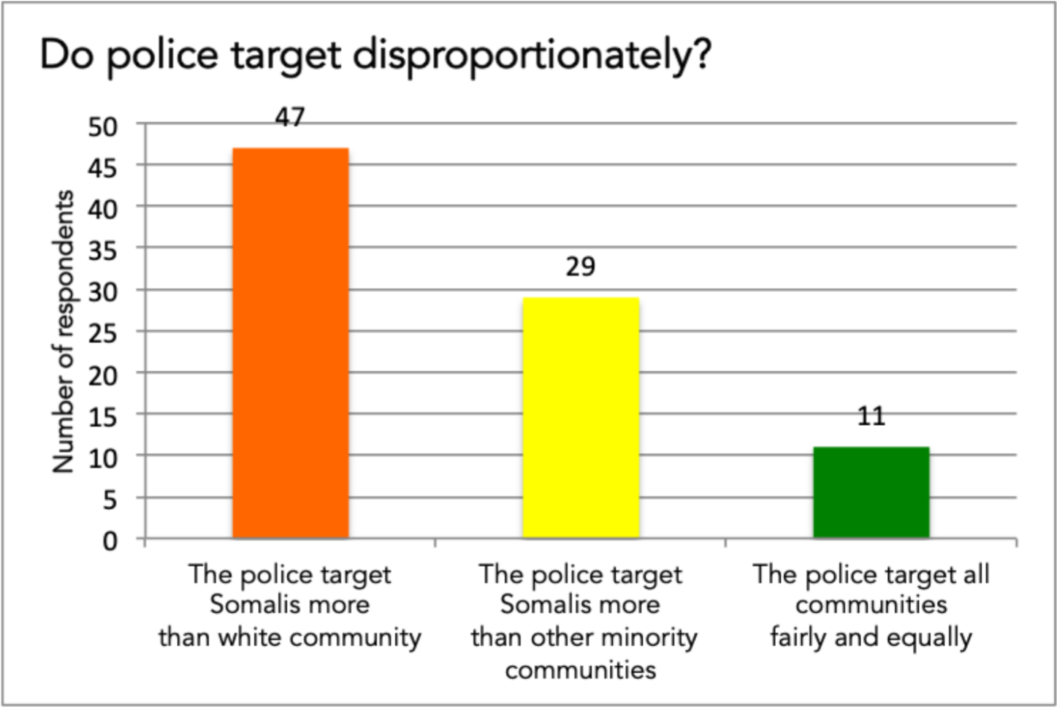
Rather than ask if the police were institutionally racist, we asked respondents whether police officers in their area behave in a racist way. This seemed a more accessible way of identifying it on an everyday basis. Far more respondents thought officers behaved in a racist manner to Somalis, than those who thought they did not. This is interesting in itself, and also helps explain low crime reporting rates.

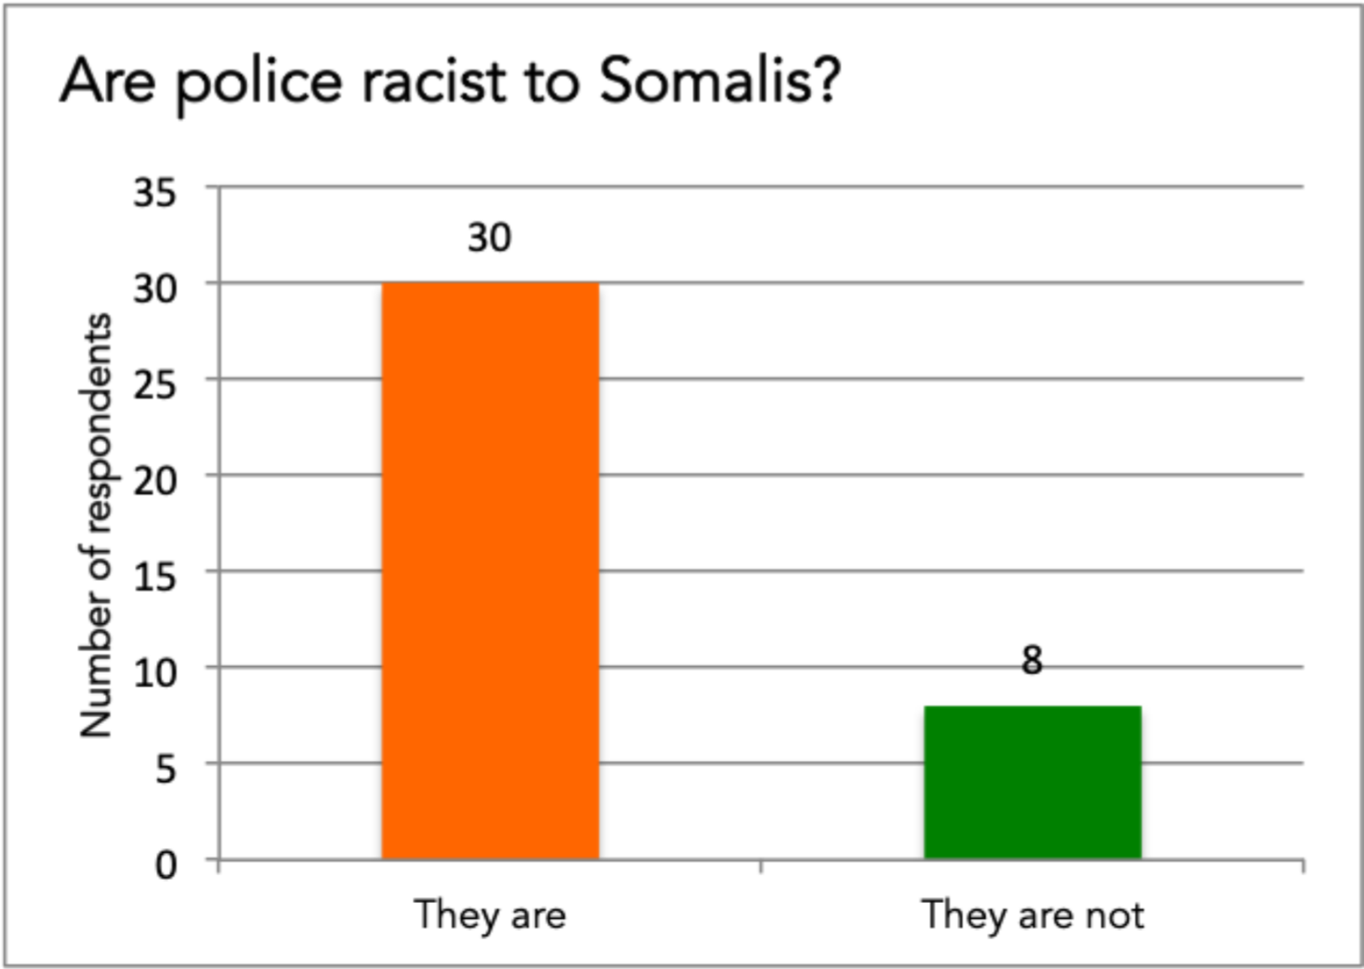
9.

In

their

own

words

9. In their own words

We would like to give voice directly to the community, in the hope that this gives the Inquiry an unmediated sense of the grassroots.

‘They give a benefit of doubt to white people but to blacks and specifically British Somalis, they assume they're the wrong doers. They arrest you without explanation and often with unreasonable excessive force.’
‘I was an innocent 11 year old the first time I was stopped and searched, I am not sure that there any many white people who can relate to this, which i believe is a consequence of systematic racism.’
‘As a woman, sexual harassment affects us disproportionately and I can say that (also within the Covid timeframe) the police have been dismissive to us Somali women when we have raised concerns.’
‘If you spoke to the boys rather than asking for a stop and search you would see how kind and respectful they are as that is how they have been raised.’
‘The police need to build bridges with Somali community and organisations to address our concerns regarding the quarantine and policing in general.’
‘I have never had a bad experience with the police and all my interaction with the police have always been positive. However over the last couple of year i have dealt with cases where the police conduct was appalling. Including police officers smacking a 15 year old boy to the ground on school uniform hand cuffed… The injustice and inequality exist in the police like all the other institutes.’

10. Recommendations

Based on our original research on the perceptions of the UK Somali community towards policing, we make the following recommendations.
To Her Majesty’s Inspectorate of Constabulary and Fire and Rescue Services (HMICFRS)
- In line with HMICFRS motto of ‘Promoting improvements in policing and fire & rescue services to make everyone safer,’ more emphasis should be placed on making BAME communities feel safer. They clearly do not right now.
- Scrutinise forces more robustly for race and diversity, perhaps under the PEEL framework which assesses forces for effectiveness, efficiency and legitimacy.

To Home Office
- Re-issue key recommendations from Macpherson to all forces – particularly ones around defining, reporting, and recording racist incidents, investigating and prosecuting, and effective victim and witness support.
- Reiterate to all forces Macpherson recommendation 16: ‘That all possible steps should be taken by Police Services at local level in consultation with local
Government and other agencies and local communities to encourage the reporting of racist incidents and crimes.’ This is still not happening evenly.
- Encourage forces to re-commit to protect and serve, as opposed to punish and isolate which seems to be the current ethos for BAME communities. That just creates disillusionment and promotes anger and frustration with institutions.
- Issue guidance to police forces around dealing with diverse communities, particularly keeping in mind recent research on racial and ethnic disadvantage.
- Direct and support forces to increase recruitment from BAME communities.
- Encourage forces to collect disaggregated ethnicity data in better detail than current census categories. Only then can disadvantages of specific communities can be understood and addressed.
- Scrutinise for signs of racial profiling or unconscious bias in policing. Working with HMICFRS, roll out imaginative training for forces who fail in this regard.
To all police forces in areas with high Somali populations
- Build relationships with credible, representative civil society groups who work directly with the community – they could help police reach into the community more effectively and sensitively, and can also help improve crime reporting.
- Undertake better community outreach to build relationships, understand barriers to reporting, and improve recruitment of Somalis into the forces.
- Improve meaningful training for officers:
  - On policing COVID-19. ATM’s policy briefing referenced earlier will help officers understand the constraints that most Somali families live in. This impacts on how well they handle lockdown. Some sensitivity in this would be welcomed by the community. Also, Somali families often send youngsters out to run errands outside the home and this is even more likely to be the case during lockdown.
  - On imaginative ways to increase trust and reporting.
  - On current data on disproportionate policing of BAME communities – make this a safe learning space, or defensive barriers will be put up.
  - On nuanced stop and search powers, including section 60 impositions, to ensure they are based on evidence and not racial profiling.
- Beware of stereotyping or criminalising BAME young people. These may lead to false ‘quick wins’, but in fact set up barriers which take years to dismantle.
June 2020
Endnotes

¹ https://www.theguardian.com/world/2020/jun/02/covid-19-death-rate-in-england-higher-among-bame-people
²https://assets.publishing.service.gov.uk/government/uploads/system/uploads/attachment_data/file/881317/tackling-racialdisparity-cjs-2020.pdf
- https://libertyinvestigates.org.uk/articles/bame-people-disproportionately-targeted-by-coronavirus-fines/
- https://theatm.org/wp-content/uploads/2020/04/COVID-19-Impact-on-the-Somali-Community-ATM-2020.pdf
- http://news.met.police.uk/news/metropolitan-police-release-detailed-analysis-of-covid-19-related-enforcement-403705
- https://www.theguardian.com/uk-news/2020/jun/03/met-police-twice-as-likely-to-fine-black-people-over-lockdown-

breaches-research
- Liberty Investigates figure of 13,445 FPNs, divided by 56 million England population.
- http://news.met.police.uk/news/metropolitan-police-release-detailed-analysis-of-covid-19-related-enforcement-403705
- https://public.tableau.com/profile/brian5366#!/vizhome/MPSStopandSearchMonthlyReport/SSR12Summary
- https://www.theguardian.com/law/2019/jan/26/met-police-disproportionately-use-stop-and-search-powers-on-blackpeople
- https://www.libertyhumanrights.org.uk/wp-content/uploads/2020/05/2020_05_28_Joint-Letter-Policing-Regulations.pdf
- https://www.ethnicity-facts-figures.service.gov.uk/crime-justice-and-the-law/policing/stop-and-search/latest#by-ethnicity
- https://www.ethnicity-facts-figures.service.gov.uk/crime-justice-and-the-law/policing/stop-and-search/latest#by-ethnicity
- https://www.ethnicity-facts-figures.service.gov.uk/crime-justice-and-the-law/policing/stop-and-search/latest#by-ethnicity
- https://www.theguardian.com/law/2019/oct/18/more-bame-people-likely-to-be-targeted-under-relaxed-stop-and-searchrules
- http://data.parliament.uk/writtenevidence/committeeevidence.svc/evidencedocument/home-affairs-committee/hate-crimeand-its-violent-consequences/written/36587.html
- https://www.sciencedaily.com/releases/2016/10/161020092232.htm

