Written evidence submitted by the Royal Institute of British Architects

Response to Digital, Culture, Media and Sport Select Committee call for evidence: impact of Covid-19 on DCMS sectors, June 2020

The Royal Institute of British Architects (RIBA) is a global professional membership body that serves its members and society in order to deliver better buildings and places, stronger communities and a sustainable environment. We provide the standards, training, support and recognition that put our members – in the UK and overseas – at the peak of their profession. With government and our partners, we work to improve the design quality of public buildings, new homes and new communities.

Introduction

Architecture directly contributes £4.8 billion to the UK economy each year, with a further £1 billion embedded in the exports of the other industries it supports.
The sector consists of predominantly small and medium-sized enterprises, with 69% of practices in England employing nine people or less and 94% of practices in England employing less than 50 people. Because of this, and the profession’s adjacency to the project-based nature of the construction industry, it is particularly susceptible to economic uncertainty and recession.
Question 1: What has been the immediate impact of Covid-19 on the sector?
The RIBA has conducted two surveys of the profession – in March and in May to understand the immediate and ongoing impact of the coronavirus pandemic on the personal and professional lives of architects.
- Working patterns
Like many sectors, a significant proportion of architects and practices have shifted from office to home-working as a result of the pandemic. In both our surveys, this applied to over 70% of respondents that stated they were working entirely from home. For some this created significant changes and challenges, stating concerns with the ability to undertake work due to the suitability of infrastructure available at home and changes to methods of communication. For others however, the change in working patterns has accelerated innovation, with 37% of respondents to our second survey reporting that they had found ‘new and better ways of working’ as a result of the pandemic.
- Income
The RIBA’s first survey demonstrated a significant proportion of the sector had begun to feel the economic impacts of coronavirus from early on. 45% of respondents stated that they had seen a reduction in their individual income as a result of the pandemic, and many were uncertain about the future. Although the majority of architects had not yet applied for any support packages from UK Government at this time, 16% had stated that they had applied for a mortgage holiday. Those reporting an impact to incomes rose to 56% by May.
- Job security
An immediate but small disruption to staffing across the architecture sector was clear from the beginning, 5% stated that they are currently looking for work and 1% reported that they have been made redundant. This is compared to findings from a study by Oxford Economics that suggests the UK architecture sector is projected to lose £1 billion in revenue (24%) and 2% of jobs (1,800 jobs) as a result of the pandemic. The RIBA Future Trends Survey for May 2020 also demonstrated that 70% of practices expect the level of permanent staff to remain constant over the coming three months, whilst 26% expect permanent staffing levels to decrease.
- Practice workloads
Project delays, cancellations and site closures as a result of the pandemic have all lead to practice workloads being impacted significantly. In April, widespread disruptions were reported with 79% of our survey respondents reporting project delays and 37% reporting project cancellations. Delays were being caused by a number of factors, such as site closures – with 61% reporting this outcome – new delays within the planning system, and disruption caused by instructions to work from home. Only 5% of respondents reported no impact on projects in March.

The RIBA has been calling on the UK Government to introduce greater flexibility around the operation and submission of evidence to planning committees to tackle this and allow the continued operation of the UK construction sector. Despite more flexible, virtual measures being introduced by the Planning Inspectorate, findings from our survey in May showed the ongoing economic impact of the pandemic with 58% reporting fewer new business enquiries and 53% a decreased workload. Widespread disruption continued to impact workloads, with 90% of respondents experiencing project delays and 60% being impacted by site closures. Project cancellations also continued in to May, with 48% of respondents stating this was due to the client, 12% due to main contractors and 10% due to sub-contractors.
- Government support
In March, the majority of respondents to our survey had not yet applied for any government support measures, but 33% stated that they are considering applying for the HMRC Time to Pay Service, and 25% were looking to apply variously to the Contributory Employment and Support Allowance, application for grants as businesses eligible for rate relief, or the Coronavirus Business Interruption Loan Scheme.
In May it became apparent that there had been a broad level of take-up to these support measures however a proportion of architects, particularly the self-employed, found themselves outside of the scope of these schemes. 14% of those surveyed said that they have been furloughed, which demonstrates a proportion of the sectors reliance on the Coronavirus Job Retention Scheme (CJRS) however, 20% said that the terms of other schemes such as Business Rates Relief Scheme (BRRS) and Self-Employed Income Support Scheme (SEISS) left them unable to claim. The RIBA continues to lobby the government to address gaps in support for the self-employed.
- Mental health
Finally, the impact that the pandemic is having on the stress and mental health of professionals within the sector is particularly concerning. Our most recent survey showed a significant decline in mental health with 39% stating that their mental health is being impacted by the lockdown and 20% stating they are feeling isolated. This is compared to our initial survey where 23% of respondents said they had experienced a negative impact on their mental health, citing isolation and uncertainty as frequent causes for this.

Question 2: How effectively has the support provided by DCMS, other Government departments and arms-length bodies addressed the sector’s needs?
Through the RIBA’s membership of the Creative Industries Council (CIC), we have been engaging with the Department for Digital, Culture, Media and Sport (DCMS) on a weekly basis since the lockdown period was called. These calls have been useful in relaying the key concerns of our members to government.

Question 3: What will the likely long-term impacts of Covid-19 be on the sector, and what support is needed to deal with those?
The RIBA carries out a Future Trends Survey each month to monitor the employment and business trends affecting the architectural profession. The surveys carried out for April and May both demonstrated a useful yet concerning insight into what the long-term impacts of Covid-19 may be on the sector.
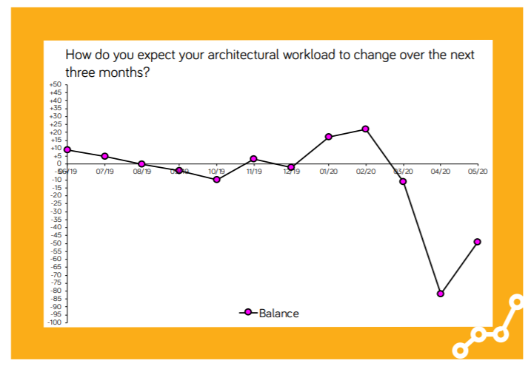The Workload Index within the RIBA Future Trends Survey looks at the architectural workload of practices, and whether this is expected to change over the next three months. Our survey from April 2020 demonstrated a historically low record balance figure of -82 for the Future Trends Workload, far lower than -31 recorded in March 2009 following the global Financial Crisis.
Graph 1: RIBA Future Trends Workload Index over time

Graph 1 demonstrates the latest figures for the RIBA Future Trends Workload Index for May 2020 rose to -49 this month. 62% of Architects stated they still expect their workload to decrease in the next three months whilst 13%
anticipate an increase, up from just 2% in April. The UK government’s plans for the construction sector to return to work, site visits recommencing and further digital hearings and inquiries being held by the Planning Inspectorate is likely to have been responsible for this increase.

The Staffing Index within RIBA Future Trends looks at the number of permanent architectural staff employed in an organisation and how this is expected to change over the next three months. For April 2020, the largest monthly drop on record from 0 to -30 was reported, with 31% of practices saying they expect to employ fewer full-time staff in the next three months.
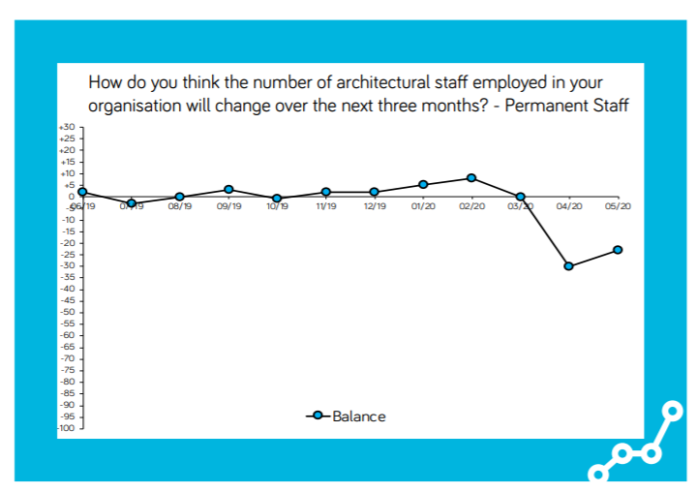
Graph 2: RIBA Future Trends Staffing Index over time

As demonstrated in Graph 2, this figure increased marginally in May which was again possibly a result of the government easing lockdown pressures for the construction sector to return to work, and more flexibility around the planning system. Though a slight improvement from the previous month, over a quarter (26%) of practices still expect the level of permanent staff to decrease over the next three months.
The RIBA Future Trends Survey for May has also carried out specific analysis with a focus on COVID-19. A few points to highlight include:
- The level of unemployment within UK architecture is expected to rise in the next 3 months as the RIBA Future Trends Staffing Index for May 2020 shows that 8% of practices consider they are unlikely to remain viable and only 3% expect to increase levels of permanent staff over the same period. This affects a significant proportion of the sector and is reflective of diminishing future workload predictions.
- Although sites are re-opening as lockdown measures are lifted, further cancellations or delays to construction projects are expected in the next 3 months as a result of new working methods. A considerable 79% of practices expect on-site productivity to decrease because of this.
- The effect that the pandemic will have on future tender prices is unclear; the majority of practices area uncertain however 32% expect prices to increase whilst 21% expect a decrease. This is significant as the government is a major client in the construction industry hence any decrease in tender prices is likely to impact the sector’s financial means considerably.

Finally, a study by Oxford Economics found that the UK Architecture sector alone is projected to face revenue losses of nearly a quarter (£1 billion) as a result of the pandemic. The same study found that around 1,800 job losses are expected within the profession. This is incredibly concerning for the sector hence the RIBA are calling on DCMS to help ensure:
- A review of the future viability of the Coronavirus Job Retention Scheme is carried out. This scheme has been a lifeline for eligible practices that have been hit hardest by the pandemic. On average, 22% of architectural staff surveyed in RIBA Future Trends have been furloughed, an increase of 8% on April’s figure of 14%. Employers are expected to contribute to salaries of furloughed workers from August, as flexible furloughing is introduced. It is unclear as to how quickly the construction sector will bounce back after the pandemic. A review of the future viability of the scheme is therefore necessary to keep architects employed, should this not be the case.

- Gaps in government support schemes support the self-employed are addressed
There are particular groups of workers who still remain ineligible for the government support schemes. Within our membership, the largest of these groups are those working in small practices who receive parts of their salary through dividends. While we recognise that there are practical challenges that need to be overcome, the lack of support for this group of small businesses must be addressed by Government as it threatens to do grave long-term damage to the sector.

Question 4: What lessons can be learnt from how DCMS, arms-length bodies and the sector have dealt with Covid-19?
- Continued and regular engagement with the sector and department is crucial, not only during a national emergency.
- At the beginning of the crisis, many architects reported confusion around the Government guidelines, in particular in relation to access to construction sites. Although the Government has improved some of its communications, detailed guidance is integral going forward.
- Not all parts of the economy will be affected in the same way – uptake of government support packages from the architects sector may be slowed because the economic impact may emerge further down the track than those businesses - such as music venues – that immediately had to close. The Government has to be flexible in its approach to the future of support schemes in order to ensure these continue to help those that need it most, and when they need it most.

Question 5: How might the sector evolve after Covid-19, and how can DCMS support such innovation to deal with future challenges?
- Increased number of architects working from home more regularly
With working from home likely to become more of a norm in the future, funding for practices to equip employees with the essential technology required to work efficiently and continue to deliver on projects that are still going ahead is essential. This would assist small practices to preserve cash flow whilst allowing them to continue to work effectively from home.
- Increased number of virtual planning meetings and hearings Greater flexibility around the operation and submission of evidence to planning committees that has been announced over this period has been encouraging. These changes are likely to positively impact projects that are currently delayed as a result of reduced planning services due to the pandemic however it is important that this continues.
- The role of architects in a ‘Green recovery’
Though the majority of the UK’s efforts are currently focused on dealing with the impact of coronavirus, the climate emergency remains a significant issue that will be key to the UK’s economic recovery post-pandemic. The RIBA recognise the scale and urgency of climate change and emphasise the valuable role that Architects play in a sustainable future.
It is essential that the government continue to invest in more environmentally sustainable housing and infrastructure, and that Architects are given the opportunities to demonstrate the skills and leadership required for the UK to achieve net zero carbon in all new and retrofitted buildings and infrastructure. We recognise that this is a significant challenge and that it is predominantly an area of responsibility of the Department for Business (BEIS) and the Ministry for Housing (MHCLG) however, it is essential that all government departments and industries come together to deliver a more sustainable future.

RIBA Covid-19 Survey, Executive Summary, April 2020 https://www.architecture.com/knowledge-and-resources/knowledge-landing-page/riba-covid-19-survey-executive-summary
RIBA Covid-19 Survey, Executive Summary, May 2020 https://www.architecture.com/knowledge-and-resources/knowledge-landing-page/second-riba-covid-19-survey-executive-summary
RIBA Covid-19 Survey, Executive Summary, May 2020 https://www.architecture.com/knowledge-and-resources/knowledge-landing-page/second-riba-covid-19-survey-executive-summary
RIBA Covid-19 Survey, Executive Summary, April 2020 https://www.architecture.com/knowledge-and-resources/knowledge-landing-page/riba-covid-19-survey-executive-summary
RIBA Covid-19 Survey, Executive Summary, May 2020 https://www.architecture.com/knowledge-and-resources/knowledge-landing-page/second-riba-covid-19-survey-executive-summary
RIBA Covid-19 Survey, Executive Summary, April 2020 https://www.architecture.com/knowledge-and-resources/knowledge-landing-page/riba-covid-19-survey-executive-summary
The Projected Economic Impact of Covid-19 on the UK Creative Industries report, Oxford Economics, June 2020 https://www.creativeindustriesfederation.com/publications/report-projected-economic-impact-covid-19-uk-creative-industries
RIBA Future Trends Survey: May 2020 https://www.architecture.com/knowledge-and-resources/resources-landing-page/future-trends-survey-2020
RIBA Covid-19 Survey, Executive Summary, April 2020 https://www.architecture.com/knowledge-and-resources/knowledge-landing-page/riba-covid-19-survey-executive-summary
RIBA Future Trends Survey: May 2020 https://www.architecture.com/knowledge-and-resources/resources-landing-page/future-trends-survey-2020
RIBA Covid-19 Survey, Executive Summary, April 2020 https://www.architecture.com/knowledge-and-resources/knowledge-landing-page/riba-covid-19-survey-executive-summary
RIBA Future Trends Survey: May 2020 https://www.architecture.com/knowledge-and-resources/resources-landing-page/future-trends-survey-2020
RIBA Future Trends Survey: May 2020 https://www.architecture.com/knowledge-and-resources/resources-landing-page/future-trends-survey-2020
RIBA Covid-19 Survey, Executive Summary, April 2020 https://www.architecture.com/knowledge-and-resources/knowledge-landing-page/riba-covid-19-survey-executive-summary
RIBA Future Trends Survey: April 2020 https://www.architecture.com/-/media/GatherContent/RIBA-Part-3-examination-information/Additional-Documents/FutureTrendsApril2020pdf.pdf
RIBA Future Trends Survey: May 2020 https://www.architecture.com/-/media/GatherContent/RIBA-Part-3-examination-information/Additional-Documents/FutureTrendsMay2020pdf.pdf
RIBA Future Trends Survey: April 2020 https://www.architecture.com/-/media/GatherContent/RIBA-Part-3-examination-information/Additional-Documents/FutureTrendsApril2020pdf.pdf
RIBA Future Trends Survey: May 2020 https://www.architecture.com/-/media/GatherContent/RIBA-Part-3-examination-information/Additional-Documents/FutureTrendsMay2020pdf.pdf
RIBA Future Trends Survey: May 2020 https://www.architecture.com/-/media/GatherContent/RIBA-Part-3-examination-information/Additional-Documents/FutureTrendsMay2020pdf.pdf
RIBA Future Trends Survey: May 2020 https://www.architecture.com/-/media/GatherContent/RIBA-Part-3-examination-information/Additional-Documents/FutureTrendsMay2020pdf.pdf
RIBA Future Trends Survey: May 2020 https://www.architecture.com/-/media/GatherContent/RIBA-Part-3-examination-information/Additional-Documents/FutureTrendsMay2020pdf.pdf
The Projected Economic Impact of Covid-19 on the UK Creative Industries report, Oxford Economics, June 2020 https://www.creativeindustriesfederation.com/publications/report-projected-economic-impact-covid-19-uk-creative-industries
RIBA Future Trends Survey: May 2020 https://www.architecture.com/-/media/GatherContent/RIBA-Part-3-examination-information/Additional-Documents/FutureTrendsMay2020pdf.pdf

