Written evidence submitted by Birmingham City Council [EXA 114]

Summary
Birmingham City Council is the largest local authority area in the UK & Europe. According to the 2011 census 1,073,000 people were living in Birmingham, which was an increase of 9.9% over a period of 10 years since 2001, with a rate of population growth exceeding the UK average.
Prior to the last 12 months, the growth of exempt accommodation in Birmingham has been increasing significantly and rose from around 11,740 units in 2018 to over 20,000 by the end of 2020. The roots of the growth in Birmingham can be traced back to national disinvestment and deregulation. This includes reduction in budgets for key vulnerable groups such as substance misuse, mental health, offenders and removal of the ring fence for the Supporting People programme. Alongside that there has been a reduction in regulatory powers, resources and agencies which has led to other parts of the housing sector being left to explore how best to meet the demand that was still there and has grown. The lack of national guidance on current regulations has made it easy to enter the market and meet the minimum requirements. The range and quality of this accommodation varies and at its worst, provides poor support to some of the most vulnerable people living in our city.

In November 2020, Birmingham began a pilot with £1.8m funding from Department for Levelling Up, Housing and Communities (previously MHCLG) to introduce and test new arrangements and oversight of the exempt sector including setting up new multi-disciplinary teams to improve oversight and roll out a new Birmingham Quality Standard and Charter of Rights to drive up property and support standards.

Since our intervention work, the increase in exempt accommodation units has plateaued and the total linked to Housing Benefit claims was 21826 in December 2021. It is clear that the funding for the pilot has enabled us to achieve this stabilisation but there is a need for consideration of future funding approach.
The majority of exempt accommodation tenants are living in Housing Association accommodation, much of which has materialised over the last few years, with registered providers (RPs) taking on managing agents which are private tenancies (PT). There has also been a small rise in PT over the last 6 months who are going it alone after some RPs have ceased to operate or are shedding some stock. These PT have not applied for registered status through Homes England but only exempt status for Housing Benefit purposes. This increases the subsidy lost on BCC.

The scale and nature of the accommodation is causing problems for neighbourhoods and communities as well as reducing the available accommodation for families. As supply outstrips local need, Landlords continue to market vacancies and seek referrals of vulnerable people from well beyond the City’s boundaries, bringing people with support needs to Birmingham where they are remote from their natural support networks and without the support infrastructure to cope.

The accommodation is trapping some of the most vulnerable people in some of the poorest accommodation with inadequate support, unable to take up employment or with any pathway to move on. There is also a concerning prevalence of housing providers linked to organised crime groups (OCGs) which in turn exacerbates the vulnerability of their tenants. Some longer-term tenants also may require a different solution if exempt accommodation is not meeting their needs.

In addition to the learning from the pilot, the council has undertaken its own public inquiry into Exempt Accommodation and has published an Overview & Scrutiny Committee report which outlines significant evidence towards this review and a number of key recommendations including some which require government action.

In summary, our proposals to government to address the issue include:

- A review of the current funding model for locally delivered supported housing – incorporating funding of support for vulnerable tenants. There needs to be greater transparency as part of the application process around charges and costs for support provision.
- Consideration of a government national accreditation requirement for providers, administered by the relevant Local Authority supported with additional funding and regulation to enforce this and a national database of providers performance against these standards
- Oversight of the provision and development of supported housing to be within the remit of Local Housing Authorities, based on delivery of key outcomes for the individual and a duty to assess the local need for supported housing and development of a supported housing strategy, which meets local need and includes those who cannot remain in their local areas, for example refuge provision. Funding to be linked with this to ensure capacity for greater oversight.
- If the proposal to introduce a locally commissioned approach is not agreed, local authorities still need to have greater tools, authority, and ability to control provision and growth based on their needs assessment. Currently Councils cannot stop or restrict growth based on market saturation or oversupply. There are 4 key aspects required:
  - Alignment of existing planning and HMO licencing powers to capture supported housing provision – currently exempt from licencing, Article 4 etc. to assist in managing supply.
  - Strengthened definitions within current regulations relating to the level of provision of care, support, and supervision.
  - Consideration of the scale of provision and ratios of support workers to vulnerable residents they are supporting
  - Review of Local Housing Allowance (LHA) rates and affordable social housing, the lack of which is driving the market up further
- Strengthen the role of the Regulator for Social Housing role and ability to effectively monitor compliance against consumer standards for registered providers in this sector. Including and especially, where providers operate a leased based model for the provision and supply of accommodation and support.
- Strengthen the role of non-registered provider regulators including within the Charity sector to ensure proper oversight of quality is in place.
- Protocols put in place for statutory referring agencies into Exempt Accommodation to create greater consistency and accountability including oversight of out of area placements.
- Greater enforcement powers to tackle providers who do not effectively manage anti-social behaviour, including additional Community Safety powers.

There is an opportunity for government to ensure that the current funding for this unacceptable housing provision is used in a constructive and progressive way, enabling some of the most vulnerable to secure good quality, progressive accommodation, and support, enabling them to transition to greater independence and employment.

Birmingham Supported Housing Needs Assessment
In 2021, a Birmingham Supported Housing Needs Assessment was undertaken, the full report is soon to be signed off in February 2022 and will be appended to this submission.
In summary, the local needs assessment estimates there is mismatch between locally needed supported housing and the existing provision which is situated in the city. Approximately only 42% of current provision is meeting local need. The remaining 58% is potentially being filled by other identified local needs, regional and national supported housing needs (coming from out of area), or simply filling affordable housing gaps.
Key points in the estimate of local needs are (annual requirements):
- With over 21,000 claims it is estimated that fewer than 9000 units of accommodation are required for the local groups of vulnerable people identified in the Government’s National Statement of Expectations cluster groups - Young People (including Care Leavers); Offenders: People with experience of the criminal justice system; Mental Health; Learning Disabilities; Homeless with support Needs; Physical Disabilities; Domestic Abuse and Substance Misuse (SM).

- Based on population growth, local needs for supported housing are expected to increase around 1.05% every five years with 21.1 per households per thousand requiring supported housing in the city. Given the volume of provision, the current footprint of is 50.8 per thousand households, this additional supply is potentially meeting needs from outside of the city or simply filling gaps in affordable housing provision given growth of 78% in three years.

- Of the 9000 people in Birmingham requiring supported housing the largest share 22% is represented by single homeless people with low levels of support needs (2031 units), closely followed by people with mental needs 19% (1787). Local demand for supported housing amongst these groups requires further investigation with other neighbouring and health partner commissioning agencies, as it appears particularly for these groups could be equally have their needs served with floating support services, if more affordable rented sector was available to them.

- The other groups locally estimated to be in need of supported housing, were young people (including care leavers) 1536 representing 16% of local needs; domestic abuse 1355 (14%); Offenders 807 (9%). NSE cluster groups representing a smaller share of local need included in estimated needs for supported housing were people with physical disabilities (6%) with learning disabilities and substance misuse each representing around 3% of local needs respectively.

- Groups not included in the NSE Good Practice guide requiring short-term accommodation identified in Birmingham supported housing needs estimates included refugees accommodating in transitional accommodation such as Afghan and Syrian households in vulnerable person resettlement schemes. These are estimated to account for around 8% of local need (755)

What is the quality of exempt housing provision?
Birmingham has been running a pilot since November 2020 to test new approaches to improve quality of provision. Multi-disciplinary inspection teams have been undertaking inspections of housing standards, reviews of support and benefit arrangements, and investigations into community safety including ASB and organised crime. Our findings below on the quality of provision, relate to 94% of provision which is non-commissioned.
Up to December 2021, a 770 properties have been inspected as part of the pilot, using a Housing Health & Safety Rating System checklist and these inspections have found 2545 Category 1 hazards (those where the most serious harm outcome is identified – risk to life, fire, damp and mould, asbestos) and 1465 Category 2 hazards (If a hazard is less serious or less urgent). Pilot teams are working with the relevant landlords and registered providers to ensure these hazards are resolved.
Supported Housing Inspection and Social Care teams are finding evidence of poor levels of support and training among providers. The registered provider is often not aware of the poor standard of support being provided through the managing agent. Support may be provided ‘more than minimally’ but it does not necessarily meet the needs of the citizen. We have come across a number of tenants with mental health, trauma, alcohol or drugs issues who as well as their professional support need a lot more than minimal support with practical and emotional issues, but because they are capable of personal, domestic and relationship needs they also do not meet eligibility criteria for adult social care.
The Social Care team has undertaken 271 support reviews and 69 safeguarding reviews to ensure citizens are safeguarded and supported to build their capability and autonomy, signposting to other services and working with providers to improve standards of support.
Poor provision is leading to further community safety issues, and there is a significant issue around ASB, with over 70% of complaints having an element of this. A dedicated Community Safety team has worked alongside the Supported Housing Inspection team and supported on joint visits where there have been reports of anti-social behaviour or serious organised crime. 453 investigations have been undertaken or are in progress, 70 of these relate to Organised Criminality only, 96 of these relate to both Organised Criminality and Anti-social behaviour (ASB), 287 of these relate to ASB only. The types of criminality that relate to the Organised Crime include Drug Dealing/Supply/Cultivation, Sexual Offences; Fraud (Ghost Tenants, Fraudulent Claims); Weapons (Firearms, Bladed Articles); Gang Affiliation (Members of Gangs residing together and breaches of conditions). As part of the investigations there have been 170 evictions/removal of tenants, 1 closure order, 16 Community Protection warning, 24 properties which are decommissioning, and 20 arrests by West Midlands Police. 336 properties have been offered advice to improve their ASB policy or to improve relationship building with residents, signposting tenants to further support.
For some areas of the city where there is a higher concentration of non-commissioned supported exempt accommodation, there is a detrimental effect on the local neighbourhood with higher levels of drug use, criminality and anti-social behaviour. For the Stockland Green ward as an example, this has 6% of the overall provision focused in a small number of roads. Local residents have set up an action group to address issues with exempt accommodation, and they are reporting large numbers of properties with tenants insufficiently supported and lack of oversight over placements and mixes within households. There have been higher levels of property inspections for the area (11%) and community safety investigations (18%) undertaken by the teams. It has also been a focus for the Safer Streets programme and the Stockland Green Impact team has been looking at exempt accommodation, HMOs and unlicenced properties to address issues of fly-tipping, and general crime and ASB.
There is no national quality standard for Exempt Accommodation but in Birmingham, working with the Birmingham Voluntary Sector Council (BVSC) we have developed a standard which is rolling out alongside a new Charter of Rights for tenants to support work with registered providers to improve quality. Take up is improving slowly, with 70 out of 148 providers signed up to the Charter of Rights, and 30 providers now actively going through the Quality Standards assessment process, but many are failing to engage and the local authority has a lack of power to enforce this. 9 providers are nearing the end of the assessment stage but have not yet been awarded the Quality Standard. Several of these have current regulatory judgments from the Regulator for Social Housing regarding their financial and governance arrangements.
We are aware through the pilot activity that some providers of supported housing are openly advertising on social media and through letting agents to fill supported housing accommodation, which leads it to it being more general needs provision rather than meeting need. This is leading to the continued growth which is being seen in the city.
Is the current model of exempt accommodation financially viable, and does it represent value for money?
The current model is currently not financially viable as in accordance with regulations, the Housing Benefit payments are only able to pay for the property costs and not the support – it is often left for the tenant to meet these costs out of their own pocket, and charges can range from around £10-£40 per week, a significant amount for many citizens whose only income may be universal credit. It is the only model of support in the welfare system where the cost to the citizen is not means tested.
There are significant amounts of housing benefit being paid to exempt accommodation landlords in Birmingham. As of November 2021, the average awarded for the previous months is £14.4m per month, and the average per claim for November was £640.52 (per month). Our reviews of Housing Benefit payments have uncovered many overpayments made to registered providers and landlords for tenants who are no longer living at an address (also known as ghost tenants), or where we have assessed the claim as not meeting the criteria due to insufficient care, support and supervision. A total of £3.9m overpayments have been recalled since April 2019 which has been widely reported.
The current funding model, as well as not providing for support provision, does not include funding for the local authority to put in place oversight needed. Without ongoing funding for the additional oversight of the sector, this is public money which will continue to be mis-used.

Are there significant geographical and regional differences in the provision and the problems of exempt accommodation?
Local concentrations in Birmingham
The Birmingham Overview & Scrutiny report shows properties were concentrated in some 20 wards; and that within those wards there are concentrations in certain areas and roads. The wards with the highest concentrations of properties were:
• Stockland Green (249 units, 6% of city’s provision);
• Aston (216 units, 5.2%);
• Soho & Jewellery Quarter (207 units, 4.9%);
• North Edgbaston (194 units, 4.6%);
• Sparkbrook and Balsall Health East (175 units, 4.2%).
Other Wards have lower overall concentrations, but very high concentrations in some roads where the majority of the Ward’s Exempt Accommodation is clustered. Ladywood (71 units, 1.7%, 21st in the city) and Handsworth Wood (105 units, 2.4%, 13th in the city) are examples of this. Other Wards with higher overall concentrations like Handsworth (159 units, 3.85%, 7th in the city) similarly have high concentrations at road level. The detrimental impact of this intensive clustering on individual roads, and its destabilising effect on the wider neighbourhood, can be significant.
In Birmingham there is a large private housing sector and the stock profile – large family-size houses in low property cost areas – lends itself to house conversions to HMOs. There is also limited access to social housing, and the Local Housing Allowance Shared Accommodation Rates are low, rendering much of the private sector inaccessible to many on low incomes. Housing options for low-income single person households are therefore extremely limited, ‘pushing’ people into supported accommodation as their only option. The threshold for demonstrating a support need within Housing Benefit regulations is low.
What we are seeing now is providers we have relied upon to provide housing closing down or suspending referrals into next year. This is very worrying as we will not be able to move residents on or meet the demand for good quality accommodation. If good and adequate providers cease trading, the ones who offered a lower standard, instead of upping their game will just move into the lucrative private rental sector leaving vulnerable people with no housing options at all.
Benchmarking housing benefit claims with other Local Authorities
There is a lack of national and regional data available on exempt accommodation but in 2021, Prospect Housing undertook an FOI to obtain data from local authorities. Birmingham has used this data to benchmark Housing Benefit claims and the number of Supported Housing units per 1000 adult population in other authorities to determine if the increase found in Birmingham is also being replicated around the country. Birmingham had the highest available substantiated number of claims of 21,317 in May 2021, and this represents an 83% increase over the last 3 years. The results of the benchmarking exercise show many gaps in data available, especially with the Core Cities, although there are indications that several other local authorities are now also seeing an increase in the proportion of supported housing units paid for through housing benefit since 2018 – for example Bedford, Blackburn, Doncaster, Southampton and Peterborough.
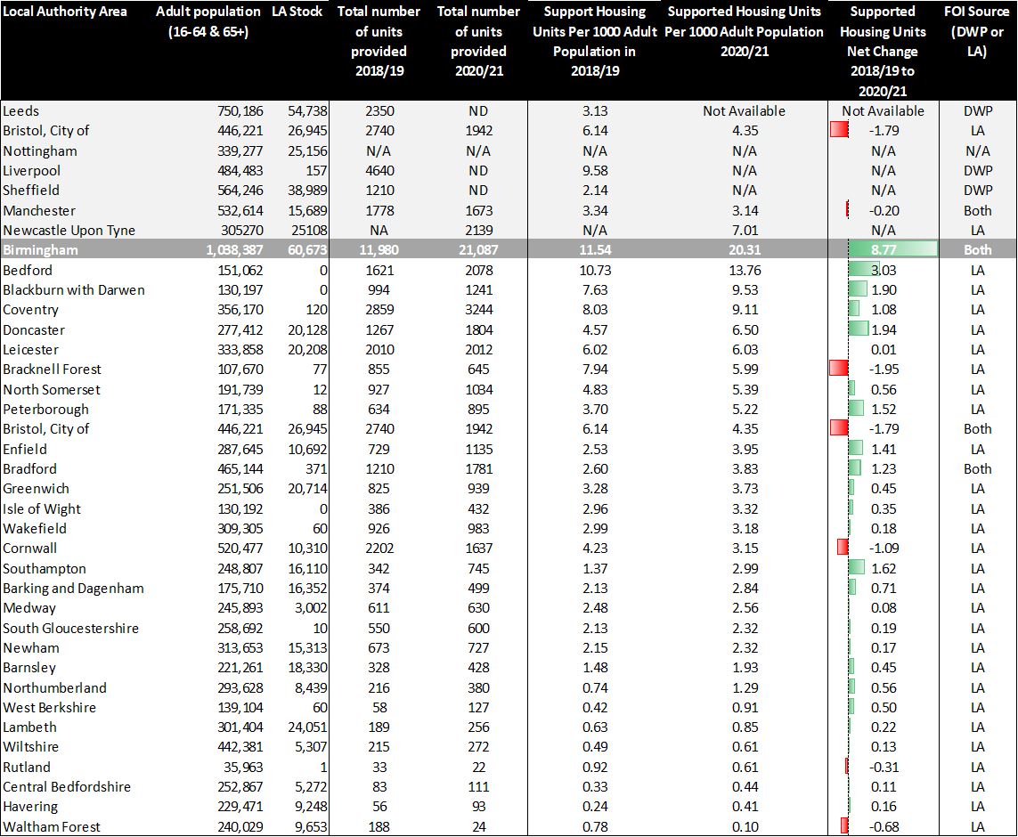
Despite the information gathered through FOI requests there remains a critical and substantial gap of routinely annually updated data which would improve benchmarking based on number claims relative to overall adult population or household numbers. Reliable annual data on the number of claims at local authority level published by the DWP and DHLUC would assist in the preparation and updating of needs assessment data for benchmarking purposes. This would enable rudimentary benchmarking to assess and compare levels of local and regional needs for different types of supported housing as proportion of the adult population.
Our needs assessment work undertaken as part of the oversight pilot has highlighted the current position and gaps in availability of reliable, annual statistics at local authority level. Current data is piecemeal and gathered on an ad hoc basis or through FOI requests in relation other cities and neighbouring areas, with some LA’s not able to substantiate the number of claims of units of provision in their localities. This is important to assist cross boundary work with other local authority boundaries and understand factors which influence the provision of accommodation.
A further enhancement on the provision of data that would be greatly welcomed is the disaggregation of Housing Benefit claims data for Exempt Accommodation in line with the National Statement of Expectations (NSE) good practice guide client group clusters. At the very basic level this should separate out key categories of supported housing such as domestic abuse refuge provision and accommodation for care experienced young people current being provided in any local area. Given the specialist nature of accommodation provision for Care Leavers and people affected by domestic abuse and violence, this would facilitate statutory duties around the provision of accommodation for these vulnerable communities who often have their supported housing needs met in regional supported housing hubs like Birmingham and not necessarily their original area of local connection. In light of recent legislative developments which include the Domestic Abuse Act and the recent Department of Education consultation to bring commissioning of this provision under the regulation of OSTED, this would improve the quality of information available to local authorities and independent Children’s Trusts helping them to strategically assess and plan for the provision of accommodation and support services required by these groups. A further NSE cluster group whose accommodation needs are met on pan regional level include former offenders requiring accommodation upon release from custodial sentence without a fixed abode who to return to the community whose immediate short-term accommodation needs appear to be served by parts of the sector that have grown the most within Birmingham.

What is the proportion of exempt accommodation that is provided by registered compared to non-registered providers, and is an appropriate balance being struck?
In Birmingham there are 148 providers, of which 81 are Registered Providers (covering 93% of properties) and the remainder are private landlords. This does not indicate an appropriate balance however as Registered Providers are simply the vehicle by which the welfare system is assessed. Property, tenancy and support services are, in the main, not delivered by the Registered Provider directly and these often fall to 3rd party entities called Managing Agents. Significant sums of money are transferred to these Managing Agents, some of which are profit making. A significant number of units have been designated as non-social housing. This means that not for profit registered providers are able to access enhanced Housing Benefit payments to fund private sector portfolios. Oversight and regulation of the private sector portfolio is limited and does not include rent, property, tenancy or value for money. There is significant risk around the lease-based model, and providers do not have clear oversight which indicates the current regulations surrounding registered provision is insufficient.

What is the proportion of exempt accommodation provided by commissioned compared to non-commissioned providers, and is an appropriate balance being struck?
Approximately 6% of provision is commissioned by the Local Authority. This provision has been formally commissioned and effectively managed. However, it is unknown if other statutory agencies are commissioning in the sector as no central register exists, without which the local authority cannot track or influence who commissions what and where. It is recommended that the introduction of a formal mechanism for commissioners to regularly meet to discuss commissioning plans and current provision is introduced. The balance between commissioned and non-commissioned is clearly problematic and unacceptable.

How does whether a provider is registered or non-registered, or commissioned or non-commissioned, impact the quality of provision?
Commissioned providers are expected to work towards contracted terms and conditions which include expectations around how services are delivered and monitored, and this in turn means the local authority has greater control and insight to the quality. There are a small number of commissioned providers who are subject to a regulatory judgment according to RSH, but the city council is still actively monitoring contracts to influence their standards and ensure it meets the commissioned expectations. Non-commissioned providers are subject to current Housing Benefit regulations which are widely known to be insufficient for the sector.
Registered providers are expected to adhere to the Regulator for Social Housing (RSH) framework, although in accordance with the current Housing Benefit regulations regarding ‘more than minimal’ support, there is no set expectation around how vulnerable people should be supported. Some registered providers have agreed to sign up to the Birmingham Quality standards, and an assessment process is underway but this is not yet an indicator of their quality.
Compliance with RSH framework standards is poor, and it is known that 85% of Birmingham’s non-commissioned provision is delivered by Registered Providers who are under review or have a non-compliant regulatory judgment relating to finance and governance standards from RSH – although some judgments are about provision in another area/city. Oversight and regulation of the private sector portfolio associated with the Registered Provider is limited and does not include rent, property, tenancy or value for money. Vulnerable citizens are separately charged and often self-fund support.
Previous research on the supported housing provision, has highlighted provision in the city serves as a destination for both national and regional needs, as well providing for Birmingham residents. The is also reflected in the diverse range of national and regional commissioners and organisations involved in utilising supported housing in Birmingham. There are multiple referral routes into exempt accommodation which are untracked, unmonitored, and disparate range of referral routes into the sub-sector. A four-month snapshot of evidenced referral routes uncovered 129 separate ‘points of entry’; 43 of which were external to Birmingham.

This encompassed a wide range of agencies and organisations, including local authority housing options departments; rough sleeper teams; hospitals; mental health trusts; internet sites and homelessness charities. There are varying assessment methods used by referring agencies and accommodation providers prior to placement and the varying levels of attention to safety and resident wellbeing. Clearly this increases potential for harm from ill-considered or ‘risky’ mixes of residents within small, shared units. Residents have a lack of choice and control over their accommodation placements, and report common experiences such as isolation, insecurity and lack of privacy for residents, and the corresponding negative effects on mental health and wellbeing. The study uncovered lack of transparency for what the sub-sector was offering to clients and the absence of communication and partnership working between agencies involved. The weak regulation and monitoring of the sector as a whole increases the potential for inexperienced, ill-equipped or unscrupulous practice.

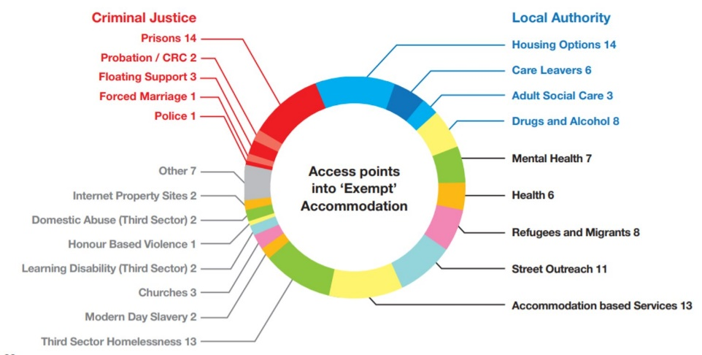

How should exempt accommodation be provided and what should the service cost?
For the Birmingham pilot, new multi-disciplinary teams and processes were introduced to oversee inspections of properties and undertake reviews of support as well as investigations into associated community safety issues (ie anti-social behaviour or organised crime). These teams include various council departments - Supported Housing, Community Safety, Social Care, Benefits, Planning Enforcement - and partners including the Police, Birmingham Voluntary Sector Council, St Basils, Sifa Fireside and Spring Housing. Inspections and reviews provide additional evidence towards achievement of the Birmingham Quality Standards and sign up to the Charter of Rights for tenants.
The cost of the operational teams and oversight of the quality standards is approximately £1.9m per year, although it should be noted that the 700 inspections over the last year account for less than 10% of Birmingham’s exempt accommodation property portfolio of 8000, and so the level of resource is still too low to maintain adequate oversight of the sector in Birmingham.
Our recent Supported Housing Needs Assessment has indicated that approximately only 42% of current provision is potentially meeting local need. The remaining 58% is filled as a result of other identified local needs, regional and national supported housing needs (coming from out of area), or simply filling affordable housing gaps. There needs to be a robust oversight and governance of the placements to avoid continued growth in the sector.
Housing Benefit regulations have not been updated since 1996, and the payments currently only cover rental costs and intensive housing management fee, but not support costs.
On the basis that we would recommend supported housing or exempt accommodation should be fully commissioned through the local authority we would set costs based on affordable rent fee, plus an intensive housing management sliding fee, dependent on the level of additional housing related needs ie additional help with maintaining tenancy.
Additional support needs of a social care nature ie mental health, disabilities, substance misuse should be commissioned through separate and additional funding.
ICT systems to track referrals and case management are inadequate will also need cost consideration.
How should the regulatory oversight of exempt accommodation be organised?
What should be the regulations governing exempt accommodation and how should those regulations be enforced?
A reform of the current system for how future regulation, oversight and funding of Supported Housing requires levelling up would include the following:
Regulation and Oversight
National Level - An Independent Regulator that enables organisations of different types to be held accountable to the same set of regulatory standards. Regulator responsibilities would cover Governance/organisational competence, Financial security and stability and Due diligence testing
Local Authorities - At a Local authority level, with resourcing in place for local oversight which would cover service delivery, property conditions and outcomes being delivered for people in supported housing. This would be based on testing and assessing against quality standards and charter of rights work piloted and tested in Birmingham.
Accreditation
The role of Local Accreditation would enable the Local Authorities’ role in managing volume and types of provision in their locality linked to four tests:
- Test 1 – Volume, type, location
- Test 2 – Planning permission in place
- Test 3 – Organisation Due Diligence (i.e. check that provider meets the Independent national regulator standards)
- Test 4 – Adequate funding of support for residents is in place
- Test 5 – Review provision in line with evidenced e.g. needs assessments
Planning
In order to control the growth of SEA this type of accommodation should come under the planning regime for HMOs; this would mean amendments to the definition of an HMO in Schedule 14 of the Housing Act 2004 so that Exempt Accommodation controlled or managed by a non-profit registered provider of social housing can be considered as a HMO. This may require a change to primary legislation, but the Government should consider whether this can be changed by statutory instrument, such as via the Town & Country Planning (Use Classes) Order 1987, which would be quicker.
Funding
There is a need to update current Housing Benefit regulations. We would propose retaining funding for accommodation related costs, such as core rent and service charges remaining with the Housing Benefit system. These should be limited to formula rent rates or Local Housing Allowance (LHA) with additional service charges at cost. There also needs to be a review of LHA rates and affordable social housing, the lack of which is driving this market up.
The reform of Housing Benefit regulations should include the removal of the enhancement for Intensive Housing Management and the removal of ‘care, support or supervision’.
This saving within the welfare system could be used by the local authority to commission housing management related support. Where additional support needs are evident that are of a social care focus, additional funding from central government to close current funding gaps will be required.
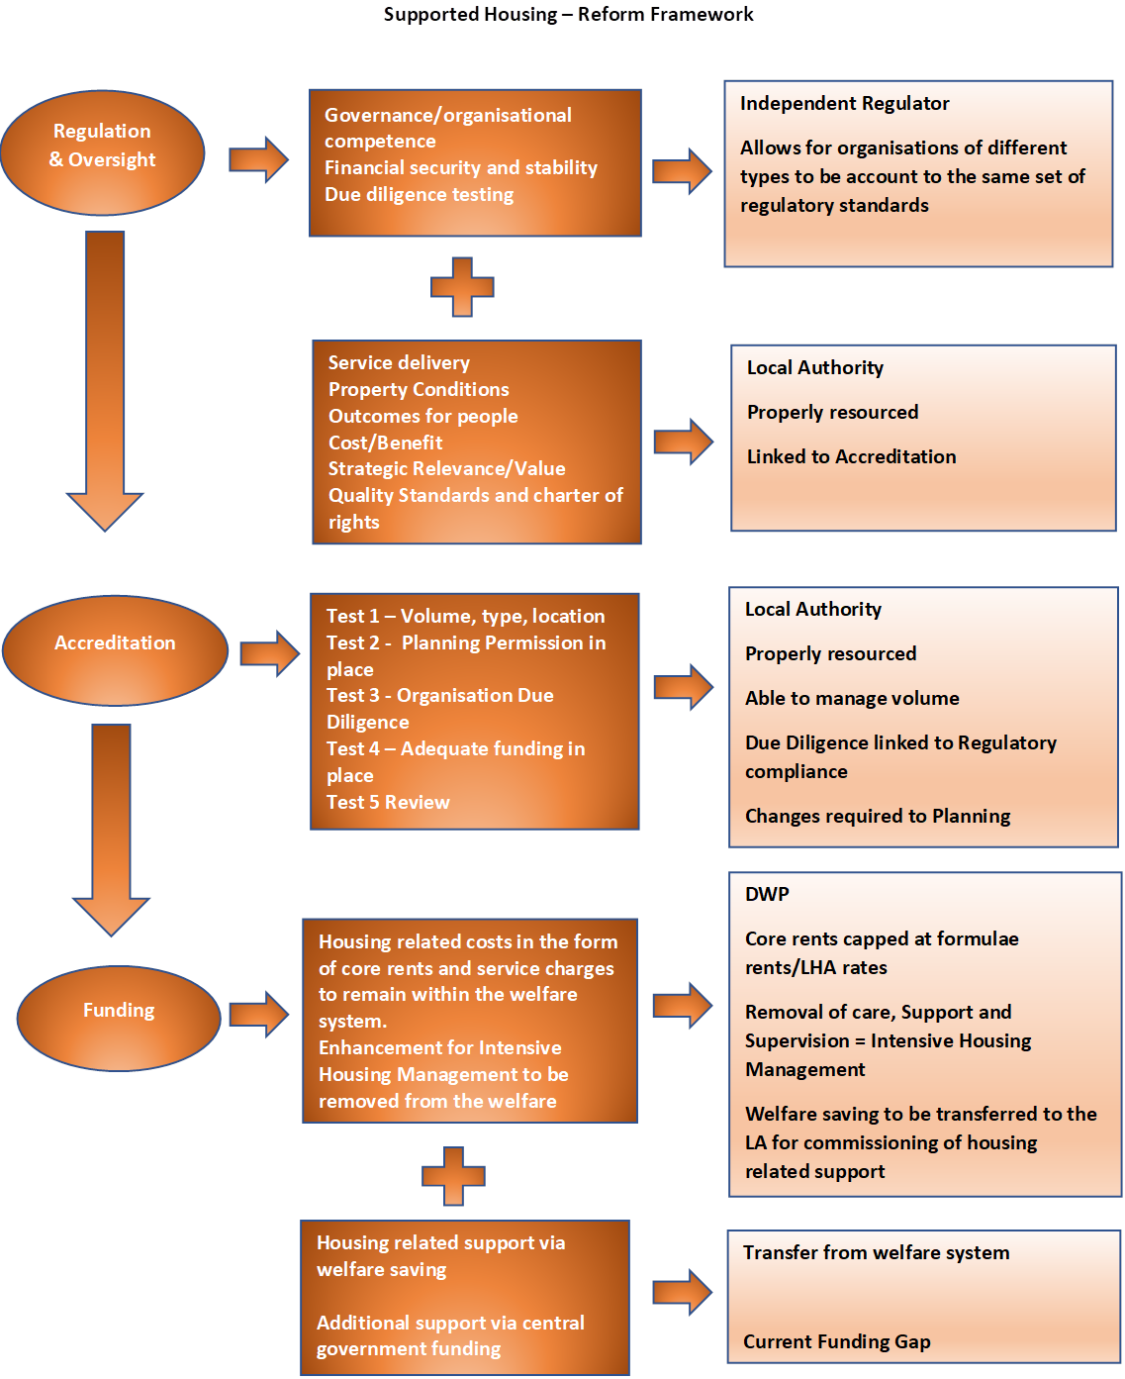

Is there sufficient publicly available information about exempt accommodation?
The National Statement of Expectations goes some way towards this, but it remains clear there is still a lack of understanding for the public of what supported housing or exempt accommodation is, and different tenants and providers see things through a different lens.
There is no single approved list of registered providers and 3rd party managing agents. Many providers do not have their own website setting out their offer, and tenants are not clear what to expect.
Extensive engagement work undertaken by Spring Housing as part of the development of Birmingham’s Charter of Rights highlighted a lack of choice, understanding and control many residents feel they have over their accommodation, placements and living environments. Common experiences of isolation, insecurity and lack of privacy, and the corresponding negative effects on mental health, wellbeing, and safety. A lack of awareness of rights, and a lack of opportunities for residents to have any input or involvement in their accommodation and their communities. Residents are not sufficiently enabled to transition to greater independence and employment.
The Charter was co-produced by Spring Housing working with Birmingham City Council and a group of 50 residents with lived experience of supported exempt accommodation and launched in March 2021. The rights are:
- A right to feel safe and protected
- A right to decent living conditions
- A right to clear information on your support entitlement
- A right to security of property
- A right to seek advice and assistance, and to challenge
Roll out of the Charter to over 70 providers in Birmingham has significantly improved the level of understanding and information available for tenants who are in this accommodation.
Birmingham City Council is continuing to engage local groups and improve the level of information on the local authority website for tenants and residents although there remains a lack of information nationally about good provision.

February 2022

New Charter of Rights and Quality Standards for exempt supported housing launched | Birmingham City Council
Bham Coordinating Overview & Scrutiny Committee report - Inquiry into Exempt Accommodation Dec 2021
Inside Housing - News - Council reclaims £3.6m in benefit overpayments from exempt accommodation landlords and tenants
Bham Coordinating Overview & Scrutiny Committee report - Inquiry into Exempt Accommodation Dec 2021
Exempt from Responsibility? Ending Social Injustice in Exempt Accommodation: Research and Feasibility Report for Commonweal Housing, Risk (2019), Safety and Wellbeing in Shared ‘Exempt’ Accommodation in Birmingham, England (2018), Housing and Communities Research Group, Spring Housing.
Charter-Of-Rights-Provider-Guidance.pdf (springhousing.org.uk)

