Dr Terence Huw Edwards and Dr Mustapha Douch – Written Evidence(TIG0001)
Our evidence is based upon our paper ‘The Bilateral Trade Effects of Announcement Shocks: Brexit as a Natural Field Experiment’, which is accepted and available on the pre-publication section of the Journal of Applied Econometrics.
To summarise the relevance of this article: we examine evidence that UK traders in goods changed in their trade engagement with other countries in anticipation of disruption from Brexit. We focus on aggregate goods exports to and imports from a number of Britain’s main trading partners (EU and non-EU) in the period up to March 2018. In common with a number of other studies, we find that anticipation effects are very important – there is strong evidence that expectations of a difficult Brexit have been damaging Britain’s trade, not just with the EU, but also with non-EU countries, and that this started earlier than other studies indicated: businesses began to reduce engagement with the EU, due to policy uncertainty, from about the time of the 2015 General Election (with its commitment to a referendum), and exports to non-EU countries also started falling short of expectations not long after that.
Our study is an application of the Synthetic Control Method for Natural Field Experiments, and as such is highly topical, since this week David Card won the Nobel Prize in Economics for his development of the Synthetic Control Method, SCM, which he shared with Joshua Angrist and Guido Imbens for their work on ‘natural field experiments’. The point is that we can best explain the effect of a policy change upon one country (or region, or set of firms, or people), by comparing with other, ‘untreated’ countries (/firms/regions/people). Although a few other people have applied SCM to Brexit, we have developed the analytical tool much further than the other studies, by investigating alternative ‘treatment dates’, and by carrying out Monte Carlo analysis of the statistical significance of our results.
The conclusions of our paper are:
- The treatment happened earlier than most other studies suggested. Firms seem to have been worried by Brexit sufficiently to change their behaviour from the date of the 2015 general election.
- When we take into account that Brexit worries have affected trade by firms across Europe, and also of this earlier starting date, it turns out that the anticipation shock of Brexit reduced Britain’s exports to EU countries by 25% by 2018 compared to the counterfactual. Much of this is hidden in official statistics on UK exports, since these are valued in Sterling, which crashed beginning early 2016 (fears of Brexit affected the exchange rate from before the referendum. The fact that Sterling fell about 10% within hours of the referendum confirms that this was the principal fear affecting markets. Exports measured in foreign currency are more relevant, since these determine Britain’s ability to pay for imports.
- Brexit worries affected UK exports, not just to the EU, but also to non-EU countries (reduced in dollar terms by an average of about 15%, against 25% for the EU). While we sadly do not have a detailed sectoral breakdown, our paper (which predates the current supply chains crisis) emphasises that the likely cause of this is that UK exporters to the rest of the World are mostly dependent upon EU supply chains, and that fears over the cost (and security) of these inputs would have negatively affected our exports, even to these countries. The evolution of this can be seen in Figure 1, which shows a negative effect on UK exporters to the EU starting around the time of the 2015 general election. Furthermore, the “gap” between actual UK compared to a counterfactual based upon trade flows which best matched UK exports prior to early 2015 can be seen in Figure 2. The shortfall in UK exports began well before the referendum, since even a low perceived probability of disruption of trade was enough to affect traders’ behaviour.
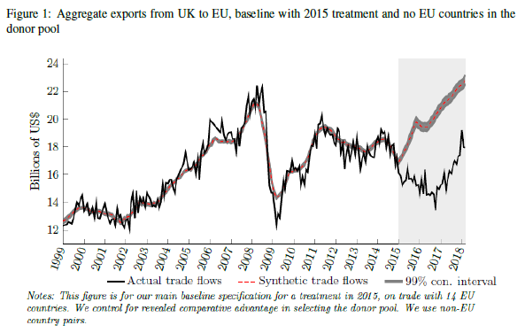Source: Douch & Edwards, (2021a).
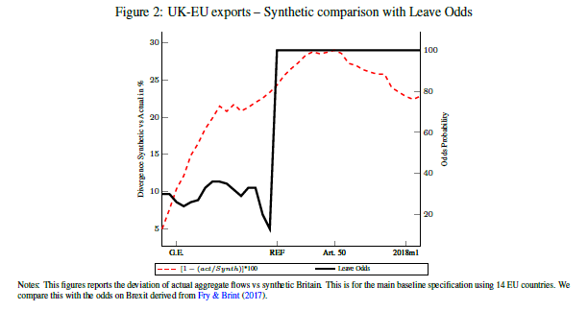
Source: Douch & Edwards, (2021a).

- There is some tentative evidence that UK importers began to switch particularly to Commonwealth countries, but no sign that the latter countries began switching to UK exporters.
- Evidence from the largest economy in Africa, South Africa, shows that the increased uncertainty in the UK has led to local firms to deviate their exports and imports to alternative markets. In fact, using a unique database on trade transaction data Douch (2020) shows that small firms from South Africa have reacted negatively to Brexit referendum. This highlight potential impact beyond the EU-UK relationship.
- Increased servitisation of manufacturing firms –i.e. large number of firms offering services trade alongside goods trade - means that we cannot really not look at the service sector, which turns to have been negatively affected by increased uncertainties caused by the Brexit shock.

Regarding your specific questions on detailed trade policy questions looking forwards, at first sight the fact that our study is up to 2018 q1 may make it seem old. However, we would argue that its relevance is very strong: firms do not wait for actual implementation of policy shocks to start changing their behaviour. This is because developing trading relationships takes time, and involves significant investments (in terms of marketing and developing ties and supply chains). Had the UK achieved a ‘softer’ Brexit agreement in late 2019, one might have expected a recovery of trade: in reality (we refer to a short draft paper, currently under consideration for publication by the Conversation, which we can supply upon request), recent trade patterns were badly hit by the lateness of the FTA with the EU, and the recovery from the (already greatly reduced) levels of last year looks likely to be only partial.
We are happy to discuss more recent developments, although we regard disentangling the COVID and Brexit trade shocks as something quite difficult to achieve (we are working on it!). However, our work on policy uncertainty and announcement shocks is potentially very important to the current situation. We should caution that any unilateral action by the UK on the Northern Ireland Protocol could seriously damage UK traders, if businesses were to perceive that it could lead to a suspension by the EU of the FTA, let alone to sanctions.
We also caution that UK exports to non-EU countries are highly dependent upon the UK’s recent competitive advantage, stemming from its ability to access EU supply chains.
Finally, we should caution about the (mis-) use of export figures in Sterling. The weakening of the Pound, which started before the 2016 referendum, is a significant factor in pushing up the cost of living and reducing real wages in the UK.
We would be very happy to answer any further questions on our work. Incidentally, we have also published, in parallel, a SCM study on UK services exports, which also showed a decline compared to the counterfactual (although less than for goods).
13 October 2021

Douch, M. & Edwards, T. H. (2021a). The bilateral trade effects of announcement shocks: Brexit as a natural field experiment. Journal of Applied Econometrics, 1– 25. https://doi.org/10.1002/jae.2878 Douch, M. & Edwards,T.H. (2021b). ‘The Brexit policy shock: Were UK services exports affected, and when?’, Journal of Economic Behavior & Organization, Volume 182, 2021, Pages 248-263. Edwards, T.Huw and M.Douch (2021). ‘The Brexit shock to trade started earlier and is bigger than widely believed, and is ongoing.’ Mimeo, Loughborough University (under consideration for the Conversation). Douch, M., 2020. The effect of policy uncertainty on South Africa, SADC, and beyond (No. 2020/59). WIDER Working Paper

