Written evidence submitted by the Department for Digital, Culture, Media and Sport

WRITTEN EVIDENCE TO THE DIGITAL, CULTURE, MEDIA AND SPORT COMMITTEE’S INQUIRY, “WHAT NEXT FOR THE NATIONAL LOTTERY?”

- The Department for Digital, Culture, Media and Sport (DCMS) is pleased to respond to the Committee’s inquiry into the future of the National Lottery.

The National Lottery
- Since its launch in 1994, the National Lottery has raised over £43 billion for good causes, with 635,000 grants issued supporting arts, heritage, sport, communities and (previously) the Millennium - the equivalent of more than 220 grants in every postcode district.

- In the 2019/20 financial year (the most recent set of fully-audited figures), the National Lottery saw sales of £7.905 billion and returns to good causes of £1.801 billion. Annex A sets out how that has changed over the life of the National Lottery.

- The Gambling Commission estimate that the average breakdown for every £1 of ticket sales in 2019/20 was:
  - 23p to good causes
  - 12p to the government in lottery duty
  - 55p to winners in prizes
  - 4p to National Lottery retailers on tickets sold (retailers receive 6% of scratchcard sales in their store, 5% on draw-based games, and a portion of some prize payouts; for online sales, retailer commission instead goes to good causes)
  - 6p retained by the operator to meet costs and returns to shareholders. The operator retained profits of approximately 1p in every pound of sales (1.2% of gross ticket sales pre-tax, 0.99% after tax).

- In the 2020/21 financial year, the National Lottery saw sales of £8.374 billion and good cause returns of £1.833 billion (NB these figures are in draft and subject to audit).

- National Lottery grant funding is awarded by the twelve National Lottery distributors and reaches right across the UK. Each distributor receives a portion of good cause returns as set out in the National Lottery etc. Act 1993 (summarised below). Six National Lottery distributors - those in bold - are arm’s-length bodies of DCMS.

Entitlement under Act | Distributor
40% Community | The National Lottery Community Fund
20% Arts | British Film Institute 13.52%
20% Arts | Arts Council England 69.78%

 | Arts Council Wales 5%
 | Arts Council Northern Ireland 2.8%
 | Creative Scotland 8.9%
20% Heritage | The National Lottery Heritage Fund
20% Sports | UK Sport 22.8%
20% Sports | Sport England 62%
20% Sports | Sport Scotland 8.1%
20% Sports | Sport Wales 4.5%
20% Sports | Sport Northern Ireland 2.6%

- The National Lottery was also used to fund the London 2012 Olympic Games. £2.175 billion of National Lottery funds was raised for the Olympics out of a total funding package of £9.3 billion.

National Lottery games
- National Lottery products consist of draw-based games and instant-win games (which can be further broken down into scratchcards, and online interactive instant win games). Draw-based games return a higher proportion to good causes than instant win games, as instant win games return a higher proportion in prizes to maintain player interest.

- In 2019/20, the operator sold £4.537 billion in draw-based games (57%), and £3.368 billion in instant-win games (43%). According to the operator’s 2020/21 financial results press release (all subject to audit), the operator sold £4.691 billion in draw- based games (56%), and £3.683 billion in instant-win games (44%).

- According to the operator’s 2020/21 financial results press release (all subject to audit), the Covid-19 pandemic led to a decrease in retail sales of £0.58 billion (10.7%, to £4.864 billion) from 2019/20 levels, and an increase in online sales of
£1.05 billion (42.8%, to £3.51 billion) from 2019/20 levels.

Roles and responsibilities
- The National Lottery etc. Act 1993 sets out three statutory duties towards the National Lottery, which DCMS and the Gambling Commission (an arm’s-length body of DCMS) share:
  - To ensure that the National Lottery is run with all due propriety
  - To ensure that the interests of National Lottery players are protected
  - Subject to a and b, to ensure that returns to good causes are maximised.

- DCMS holds responsibility for the National Lottery in Government. DCMS is responsible for:

  - Managing the legislative framework
  - Sponsorship of the Gambling Commission
  - Sponsorship of English and UK-wide National Lottery distributors, including setting directions to them about what to take into account when making grants
  - Managing the National Lottery Distribution Fund, which pays good cause funding to the National Lottery distributors

- The Gambling Commission is responsible for the day-to-day regulation of the National Lottery, ensuring that the operator runs the National Lottery appropriately and fulfils the terms of the licence. It is also responsible for awarding the licence to run the National Lottery.

- The National Lottery etc. Act 1993 gives the Secretary of State the power to issue regulations by negative resolution relating to the promotion of the National Lottery (e.g. the minimum age to purchase tickets or the places in which they can be sold). It also gives the power for the Secretary of State to issue directions to the Gambling Commission concerning the matters that they should take into account in deciding whether or not to grant National Lottery licences, and what conditions the licences should contain.

National Lottery policy
- The Government decided at the outset that there would be a single National Lottery. This enables it to sell enough tickets across the UK to offer large jackpots.

- From the very beginning, the National Lottery was designed to be different to commercial gambling - a low-risk product, played little and often by many people to raise money for good causes. The Government is keen to maintain this “clear blue water” between the National Lottery and the commercial gambling sector, and the legal framework supports this. This includes:
  - how and where tickets are sold (for example, National Lottery tickets cannot be sold in betting shops, racecourses and so on)
  - the profile of National Lottery games (National Lottery games are low-stake and only the National Lottery can offer lotteries with large prizes)
  - maintaining leading measures to protect players (the Combined Health Survey 2016 shows that National Lottery draws and scratchcards have far lower rates of problem gambling associated with them than commercial gambling products).

- Since its inception, the ambition has been for funding raised by the National Lottery to be used for time-limited projects for which Government funding is not available (known as the “additionality principle”).

- The National Lottery has seen relatively few legislative changes in recent years given its maturity. In 2016, the Government extended the prohibition of betting on the National Lottery to include EuroMillions, in order to avoid customer confusion. In December 2020, the Government announced its intention to increase the minimum age to play the National Lottery from 16 to 18, following a consultation where respondents highlighted emerging evidence, international comparisons and public opinion. The operator implemented this change in April 2021.

The fourth National Lottery licence
- The Gambling Commission is currently running a competition for the fourth licence to run the National Lottery. The current (third) licence runs until 31 January 2024, having recently been extended by six months to facilitate additional time for the competition.

- The Gambling Commission is responsible for running the competition and selecting the preferred bidder. DCMS has no influence over the outcome of the competition.

- Prior to the competition’s launch, the Gambling Commission actively engaged with and consulted DCMS on the development of the competition and the fourth licence, to ensure that it supports our statutory duties and the Government’s objectives.

- Under the National Lottery etc. Act 1993, the Secretary of State may (with the approval of the Treasury) use the National Lottery Distribution Fund to pay for the costs of the Gambling Commission discharging its functions. This includes the cost of running the competition. The Secretary of State signs off spending using the Government’s ‘Green Book’ business case approach.

- The Gambling Commission’s design for the fourth licence addresses concerns raised in 2018 by the Public Accounts Committee, including the fact that the operator’s profits and good cause returns had followed differing trends. The new approach to sharing money raised from ticket sales, known as the “incentive mechanism”, ensures that the operator’s profit incentive and the maximisation of good cause returns are much more closely aligned.

A single operator for a single National Lottery
- The National Lottery Act 2006 gives the Government the power to move towards a multiple operator structure by order. The explanatory notes state that the Secretary of State will only make this order if he “considers that the current licensing structure has failed in creating an effective competition for the licence… and so risks failing to maximise returns to good causes”.

- In line with advice from the Gambling Commission in 2019, the Government confirmed it did not see a case to change the current structure of a single operator being responsible for running the entire National Lottery for the fourth licence.

Society lotteries
- Society lotteries pre-date the National Lottery. They are fundraising tools run for the benefit of charities and other non-commercial organisations. Society lotteries and the National Lottery are subject to different legislation and rules, including:
- Prize and sales limits - society lotteries are subject to limits on sales and prizes.
- Taxation - the National Lottery is subject to lottery duty of 12%. Society lotteries are treated in the same way as charitable giving and are not subject to lottery duty. The Taking Part Survey and 2019 Gambling Commission research has shown that the primary motivation for playing society lotteries is donating to the specific charities or good causes they support, whereas for the National Lottery it is the large jackpots.

- Society lotteries must return a minimum of 20% of proceeds to good causes, and expenses must be ‘reasonable’.

- Between April 2019 and March 2020, society lottery sales were £831 million, with returns to good causes of £367 million (around 44% of sales). Society lottery sales and good cause returns have grown steadily for more than a decade, from £179 million in sales and £95 million in good cause returns in 2008/9 to their current record level (see Annex A).

- Following a consultation in 2019, the Government announced the following changes to the limits for large society lotteries:
  - Increase the individual per draw sales limit from £4 million to £5 million;
  - Increase the individual per draw prize limit from £400,000 to £500,000 (retaining the rule that the maximum prize is the greater of £25,000 or 10% of proceeds);
  - Increase the annual sales limit by introducing a split tier licence, initially increasing the limit from £10 million to a lower tier £50 million.

- These reforms came into force in July 2020. The reforms aim to continue to allow both society lotteries and the National Lottery to thrive. They balance enabling society lotteries to continue to grow with ensuring the unique position of the National Lottery is maintained.

- DCMS is currently reviewing the impact of these reforms, a year on from their implementation.

- The Taking Part Survey shows that a majority of Society Lottery players (68%) also participate in the National Lottery. For the financial year 2019/20, National Lottery good cause income rose by 11.5% from the previous year to £1,801m and the society lottery sector has also grown in this period with returns to good causes up 3.7% from the previous year.

Answers to the call for evidence questions
Q1. How effectively has the fourth National Lottery licence competition fulfilled the Gambling Commission’s objectives?
- We are limited in what we can say in response to this question while the competition is in train. However, paragraphs 15-17 set out the Government’s general vision and objectives for the National Lottery. We are satisfied that to date the competition is progressing in line with this framework.

- The Commission’s evidence provides more detail on the specific objectives for the competition. These objectives are submitted to DCMS as part of the business case process we set out in the evidence. We will consider the Commission’s final, full business case at the end of the competition, where we will be able to assess whether the competition has met the objectives agreed at the previous, outline business case stage.

Q2. What will the way in which returns for good causes are calculated under the fourth licence mean for the distributing bodies and the projects they support?
- In order to maximise the fantastic impact the distributors have on arts, sports, heritage and communities, the next licence aims to maximise returns to good causes (subject to ensuring that it operates in players’ interests and with all due propriety). Paragraph 23 notes that the calculation for returns to good causes - known as the “incentive mechanism” - implements recommendations from the Public Accounts Committee’s 2018 report into the National Lottery that there should be greater alignment between operator profits and good cause returns. The Commission engaged DCMS in developing the new mechanism, which is explained in more detail in their evidence.

Q3. What needs to happen to ensure a smooth transition between the third and fourth licence period?
- As the regulator, the Gambling Commission is responsible for ensuring a smooth transition between licences. As the sponsoring department, DCMS has a keen interest in ensuring that the transition is successful, ensuring no disruption to players and that returns to good causes are maintained. The Gambling Commission has set out more detail in its response. Given our respective responsibilities, we do not have anything additional to add to their evidence.

Q4. What will the outcome of the fourth National Lottery licence competition mean for the UK’s wider lottery market?
- The Government’s vision for the lottery sector is to have a single National Lottery offering large jackpots and raising money for the arts, sports, heritage and communities; and many smaller society lotteries which raise money for specific charities and are distinguished from the National Lottery with draw and prize limits. Paragraphs 26-32 set out our answer to this question. As we do not know the outcome of the competition yet, we are unable to say anything more at this stage, but it is our intention that the competition should not shift this balance.

Department for Digital, Culture, Media and Sport October 2021

Annex A: National Lottery sales and good cause returns over time Figure 1a: National Lottery good cause returns, since November 1994
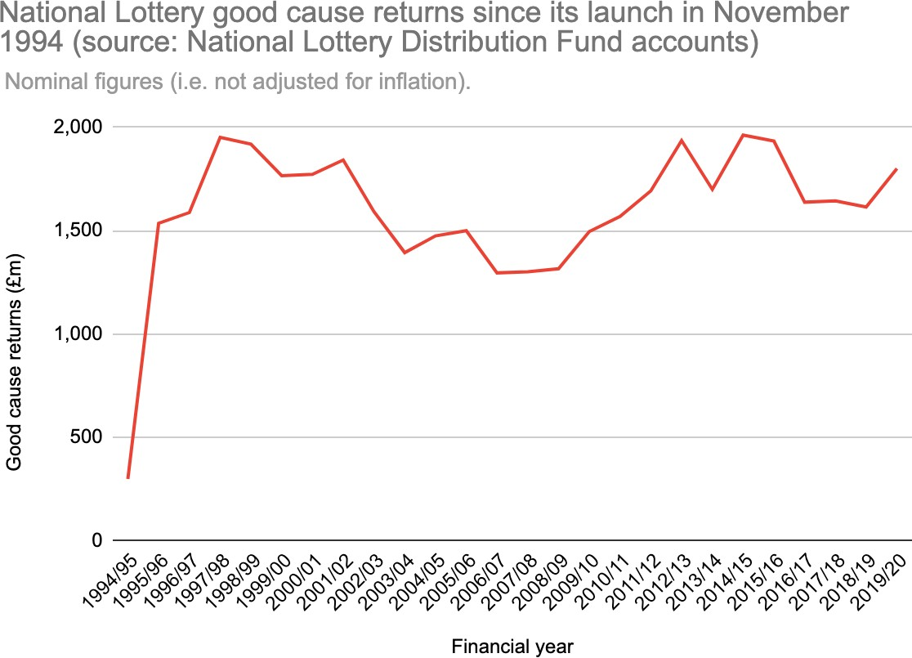

Figure 1b: National Lottery good cause returns, adjusted for inflation, since November 1994
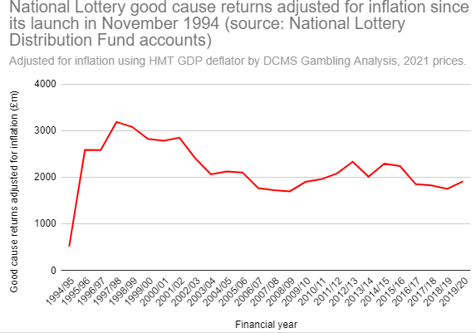
*As the Lottery began in November 1994, data from 1994/1995 is only for a partial year.

Figure 2a: Society lottery good cause returns, since April 2008

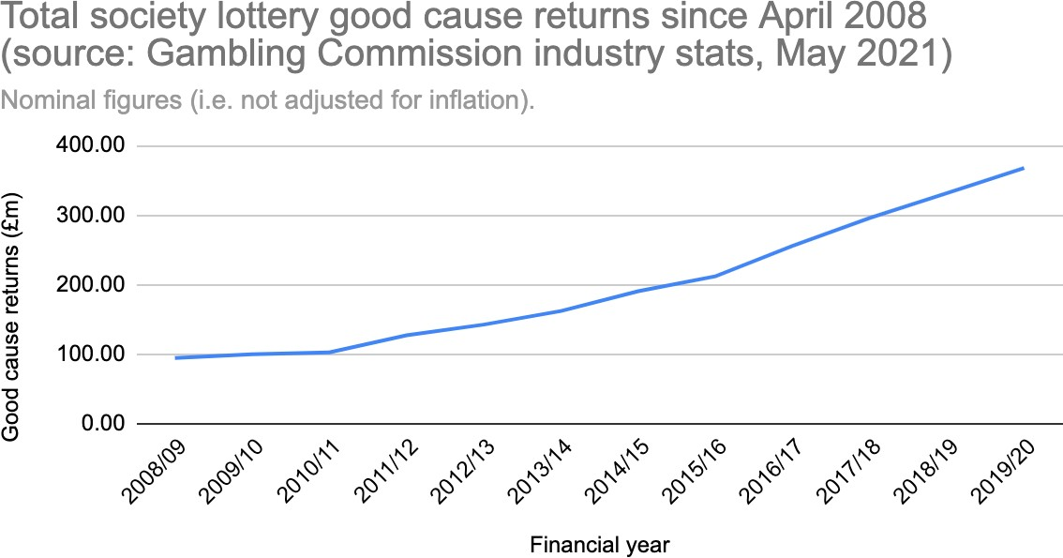

Figure 2b: Society lottery good cause returns, adjusted for inflation, since April 2008
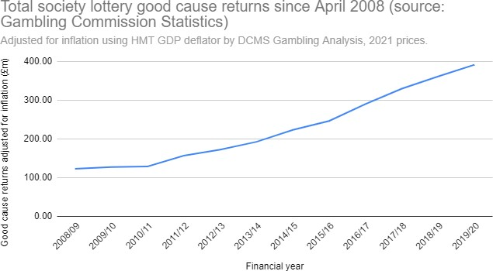

These figures are estimates as the precise breakdown of where the money goes depends on the actual level of sales, the types of game being sold and the period of the licence that has been reached.
https://www.camelotgroup.co.uk/news/camelot-uk-lotteries-limited-2020-21-financial-results/
The Taking Part Survey statistical releases (https://www.gov.uk/government/collections/sat--2)
Taking Part ad hoc statistical release (https://www.gov.uk/government/statistical-data-sets/ad-hoc- statistical-analysis-202021-quarter-3#october-2020---taking-part-lotteries-request)

