Submission to International Development Committee: UK aid to Pakistan

Introduction
This submission is from Stephen Jones, Senior Principal Consultant at Oxford Policy Management (OPM) and Team Leader of the Performance Evaluation of the Punjab Education Sector Programme Phase 2 (PESP2), on behalf of OPM and the e-Pact consortium.
PESP2 has been the UK’s largest bilateral programme to support education and has run over the period from January 2013 to July 2021. Under the programme, the UK has allocated £420.5 million to support the Government of Punjab (GoPb) to reform and transform the delivery of education in Punjab. PESP2 has provided a combination of sector budget support (SBS), targeted financial support, and technical assistance (TA). Specific programme components have focused on support to public–private partnerships (PPPs) through the Punjab Education Foundation (PEF) programmes with low-cost private schools; support for the rehabilitation of school infrastructure; scholarship programmes; support to special and inclusive education; and support for adolescent girls who are out of school.
The reason for submitting this evidence is that PESP2 is one of the most important recent UK aid programmes to Pakistan, and this evaluation (which has since August 2017 carried out a large number of studies on the education sector in Punjab and the results achieved by UK support to the sector) represents one of the most systematic and comprehensive evaluation assessments of recent UK aid to Pakistan. The evaluation is in the final stages of completion (with findings having been extensively reviewed and discussed with FCDO and other stakeholders) but the full Final Evaluation Report is not expected to be published by FCDO before May 2021. In order to allow members of the IDC access to this evidence source, a short summary of key findings has been prepared, identifying evidence relevant to answering selected questions from the Terms of Reference of the Enquiry. This document has been shared with the FCDO Pakistan education team for comment, but the views expressed are those of the consultants.

Summary of evidence against questions from the terms of reference

How effective is UK aid in Pakistan in supporting its progress towards achieving the SDGs?
Progress has been made in Punjab over the period of PESP2 (since 2013) in increasing participation in education, but not in improving net enrolment rates, though this progress has been checked by the impact of Covid-19. There is some evidence of improvements in learning outcomes but the available data is insufficient for firm conclusions about this to be drawn. Teachers are better qualified and have generally good attendance but there is evidence of significant weaknesses in their knowledge of the curriculum and effective classroom practice. Physical infrastructure in government schools has improved significantly.
The GoPb has shown strong commitment to education with an increasing shift in focus from a principal emphasis on increasing enrolment to paying greater explicit attention to learning outcomes and inclusion. Important policy initiatives have been taken in relation to Early Childhood Education and inclusive education, and in enshrining the right to education in law (though these remain to be fully implemented). Capacity has improved in some key sector organisations, such as the Quaid-e-Azam Academy for Educational Development (QAED) which is responsible for the professional development of teachers, though progress has been less in other organisations and public finance management for education has had weaknesses throughout the period, in part reflecting the lack of a comprehensive policy framework for education. Priorities for further progress include:
- Identifying and effectively reaching children who are out of school or whose learning has been most significantly disrupted, as well as those with special educational needs and disabilities.
- Ensuring teachers (in both the government and private sectors) have adequate subject knowledge, use appropriate teaching methods, and are effectively motivated and managed.
- Ensuring effective and sustainable public-private partnership arrangements for education, within the framework of a comprehensive policy towards private education including the appropriate regulatory and facilitating roles for government.
- Implementing a model of decentralised management of education that enables schools to control a greater share of resources while improving accountability especially to pupils, teachers and communities.
Up to 2018, UK support through PESP2 built on a long track record of engagement in Punjab to support the Chief Minister’s strong commitment to improving access to, and the quality of, education. The Roadmap and Stocktake process provided the main instrument for driving and monitoring improvements in the education system, and PESP2 played a central role in implementing this, including encouraging a stronger emphasis on learning outcomes. After the change of government following the July 2018 elections, which led to the abandonment of the Roadmap model, DFID/FCDO worked with the new to help support its development of policies and initiatives in a period of fiscal stress, followed by the impact of the Covid-19 pandemic.
The overall design approach of the programme was appropriate to achieve its key initial objectives of supporting the achievement of increased enrolment in education, and provided valuable flexibility especially in relation to Sector Budget Support and Technical Assistance. Spending through established and effective public-private partnership programmes operated by the Punjab Education Foundation (PEF) and scholarships from the Punjab Education Endowment Fund (PEEF) provided cost effective ways to boost access and learning.
The programme was less well-designed to focus on and achieve systemic improvements. PESP2’s contribution was also constrained by some design and implementation weaknesses for specific components, including school infrastructure, which suffered from major delays and cost escalation, and sector budget support which was insufficiently well-integrated with the budget process, while also not succeeding in ensuring that weaknesses in public financial management were addressed.
The record of support to achieving transformational impact consequently varied across organisations and policy areas. The district delivery system developed under the Roadmap required substantial modification in the light of the changed approach to decentralisation favoured by the new government after 2018. Engagement with QAED was generally successful in supporting organisational reform and in piloting new approaches to continuous professional development (CPD) for teachers, including potentially transformational changes towards a much more flexible and cost-efficient CPD model. The programme supported development of the Inclusive Education Strategy (IES) and Special Education Policy (SEP) during 2019, following earlier less successful initiatives on these issues. Less progress was made in strengthening the capacity of PEF, or improving the policy and financing arrangements under which it operated.

To what extent is UK aid in Pakistan focused on the poorest, most marginalised and most vulnerable people in that country?
The PESP2 programme was strongly focused on the poorest, most marginalised and most vulnerable people in Punjab (home to more than half of Pakistan’s population) through in particular:
- The overarching emphasis of the programme on supporting GoPb to improve education access, reduce the number of out of school children and improve education opportunities for girls.
- The focus of the programme on eleven priority districts which had particularly low levels of access to education.
- The funding of programmes of the Punjab Education Foundation for partnerships with low cost private schools.
- The provision of scholarships for girls for intermediate education (especially in the priority districts) through the Punjab Education Endowment Fund.
- A strong and sustained emphasis by DFID/FCDO on addressing special education needs and disabilities which contributed to the development of an Inclusive Education Strategy by GoPb.
- Support to the Siyani Sahelian initiative to develop and implement approaches for providing remedial education and related support to reach out of school adolescent girls in rural areas of South Punjab.

How effective are the partners (NGOs, private contractors and multilateral agencies) through which UK aid is delivered in Pakistan?
The initial performance of PESP2 was adversely affected by delays in the process of contracting international providers both of technical assistance and to manage the school infrastructure component. Weaknesses in the performance of the private contractors also had adverse effects on performance especially for the school infrastructure component. The effectiveness of private contractors improved over the lifetime of programme implementation reflecting both more effective management by DFID/FCDO, and the use of contractors (private companies and NGOs) with stronger knowledge of the local context. The programme also worked through highly effective government partners particularly the Punjab Education Foundation, Punjab Education Endowment Fund, and the Programme Monitoring and Implementation Unit, though in general the effectiveness of government partner organisations varied.

What are the key risks (and mitigations) to the value for money, effectiveness and impact of UK aid projects and programmes in Pakistan?
The effectiveness and impact of PESP2 have faced contextual risks from political change, instability in government staffing, and limited genuine decentralisation (including a lack of accountability directly to parents and communities). Some weaknesses in design and management of the programme have also militated against effectiveness. Effective mitigation strategies are likely to require a flexible and adaptive programme design based around clear strategic objectives focused on active monitoring and improvement of the delivery and performance of key education system functions, as well as greater involvement of government in some programme management decisions.

Are there adequate processes of independent evaluation and self-evaluation built into the country programme?
The evaluation of PESP2 has produced findings that have been extensively used by, in particular, DFID/FCDO and technical assistance providers. However, the adequacy of the evaluation process was constrained by the fact that evaluation only began at a relatively late stage of programme implementation, and effective GoPb ownership of the evaluation was not achieved. The effectiveness of programme implementation might have been improved by a full mid-term review, rather than reliance on self-assessment by DFID through Annual Reviews.

What evidence is there of lesson-learning and turning learning into action?
The First Interim Evaluation Report of the PESP2 evaluation in 2018 was published with a Management Response by DFID, and a review was undertaken by DFID in 2019 of progress in implementing recommendations from the First Interim Evaluation Report. Lessons significantly influenced in particular the second phase of TA support (beginning in 2018) and DFID/FCDO’s planning for future engagement in the education sector in Pakistan. There is less evidence of lesson learning from the evaluation so far impacting on GoPB decision-making.

How has UK aid responded to the challenges of covid-19 in Pakistan, and how effective has this response been?
School closures and disruption to livelihoods resulting from Covid-19 have had a significant negative impact on education in Punjab, probably reversing several years of the progress made in improving access to education and learning. While available data is limited, it appears that this negative impact has been greatest on the youngest children and on those from relatively disadvantaged backgrounds who have lacked access to learning resources outside school and whose families have suffered negative livelihood shocks. Technical assistance resources provided by PESP2 have been used flexibly and effectively to support GoPb response, through development of a costed school reopening strategy, support to the design of the Back to School campaign and, especially, support to the Accelerated Learning Platform (ALP).

Detailed evidence

How effective is UK aid in Pakistan in supporting its progress towards achieving the SDGs?
Progress has been made in Punjab over the period of PESP2 (since 2013) in increasing participation in education, but not in improving net enrolment rates, though this progress has been checked by the impact of Covid-19. There is some evidence of improvements in learning outcomes but the available data is insufficient for firm conclusions about this to be drawn. Teachers are better qualified and have generally good attendance but there is evidence of significant weaknesses in their knowledge of the curriculum and effective classroom practice. Physical infrastructure in government schools has improved significantly.
The GoPb has shown strong commitment to education with an increasing shift in focus from a principal emphasis on increasing enrolment to paying greater explicit attention to learning outcomes and inclusion. Important policy initiatives have been taken in relation to Early Childhood Education and inclusive education, and in enshrining the right to education in law (though these remain to be fully implemented). Capacity has improved in some key sector organisations, such as the Quaid-e-Azam Academy for Educational Development (QAED) which is responsible for the professional development of teachers, though progress has been less in other organisations and public finance management for education has had weaknesses throughout the period, in part reflecting the lack of a comprehensive policy framework for education. Priorities for further progress include:
- Identifying and effectively reaching children who are out of school or whose learning has been most significantly disrupted, as well as those with special educational needs and disabilities.
- Ensuring teachers (in both the government and private sectors) have adequate subject knowledge, use appropriate teaching methods, and are effectively motivated and managed.
- Ensuring effective and sustainable public-private partnership arrangements for education, within the framework of a comprehensive policy towards private education including the appropriate regulatory and facilitating roles for government.
- Implementing a model of decentralised management of education that enables schools to control a greater share of resources while improving accountability especially to pupils, teachers and communities.
Up to 2018, UK support through PESP2 built on a long track record of engagement in Punjab to support the Chief Minister’s strong commitment to improving access to, and the quality of, education. The Roadmap and Stocktake process provided the main instrument for driving and monitoring improvements in the education system, and PESP2 played a central role in implementing this, including encouraging a stronger emphasis on learning outcomes. After the change of government following the July 2018 elections, which led to the abandonment of the Roadmap model, DFID/FCDO worked with the new to help support its development of policies and initiatives in a period of fiscal stress, followed by the impact of the Covid-19 pandemic.
The overall design approach of the programme was appropriate to achieve its key initial objectives of supporting the achievement of increased enrolment in education, and provided valuable flexibility especially in relation to Sector Budget Support and Technical Assistance. Spending through established and effective public-private partnership programmes operated by the Punjab Education Foundation (PEF) and scholarships from the Punjab Education Endowment Fund (PEEF) provided cost effective ways to boost access and learning.
The programme was less well-designed to focus on and achieve systemic improvements. PESP2’s contribution was also constrained by some design and implementation weaknesses for specific components, including school infrastructure, which suffered from major delays and cost escalation, and sector budget support which was insufficiently well-integrated with the budget process, while also not succeeding in ensuring that weaknesses in public financial management were addressed.
The record of support to achieving transformational impact consequently varied across organisations and policy areas. The district delivery system developed under the Roadmap required substantial modification in the light of the changed approach to decentralisation favoured by the new government after 2018. Engagement with QAED was generally successful in supporting organisational reform and in piloting new approaches to continuous professional development (CPD) for teachers, including potentially transformational changes towards a much more flexible and cost-efficient CPD model. The programme supported development of the Inclusive Education Strategy (IES) and Special Education Policy (SEP) during 2019, following earlier less successful initiatives on these issues. Less progress was made in strengthening the capacity of PEF, or improving the policy and financing arrangements under which it operated.

Progress towards improving education in Punjab (SDGs 4, 5, 10) during the period of support through PESP2
Evidence on progress in access to education
A comprehensive review of data sources undertaken by the Evaluation suggests that:
- A larger percentage of children in Punjab are now in school but they are not always in the appropriate grades for their age, since participation rates have increased (Figure 1) but not net enrolment rates (Figure 2).
- Educational access differs by location, by gender, and by socioeconomic and disability status, with significant continuing inequalities (Figure 3).
- There has been some success in getting more of the poorest into schools, but not always in retaining them in school.
- While available data is incomplete, the impact of Covid-19 (as discussed in more detail below) has been to reduce participation especially for the youngest children and the socio-economically disadvantaged.

Figure 1: School participation rates for children aged 5-16 in Punjab
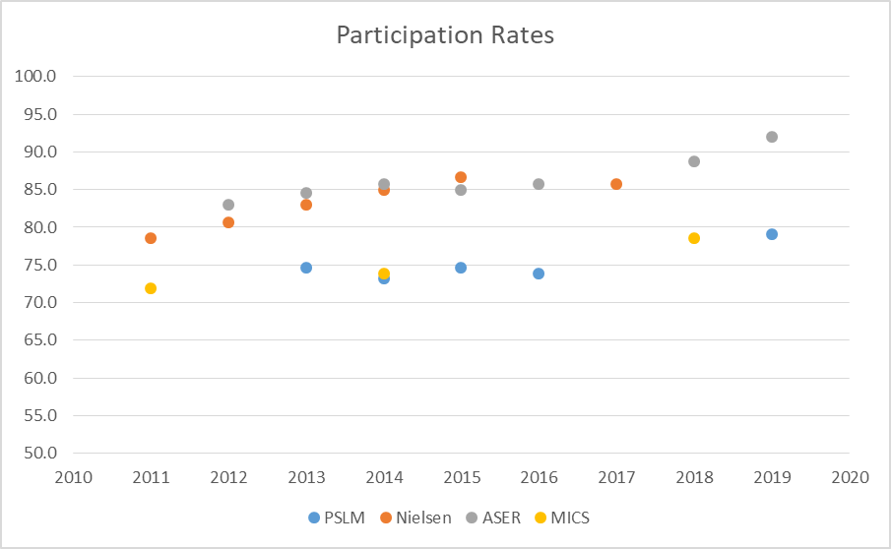

Figure 2: Primary Net Enrolment Ratio in Punjab, children aged 5-16
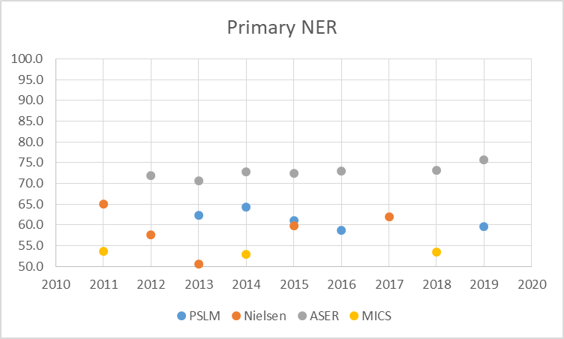

Figure 3: Participation and Net enrolment by wealth quintile (PSLM data)
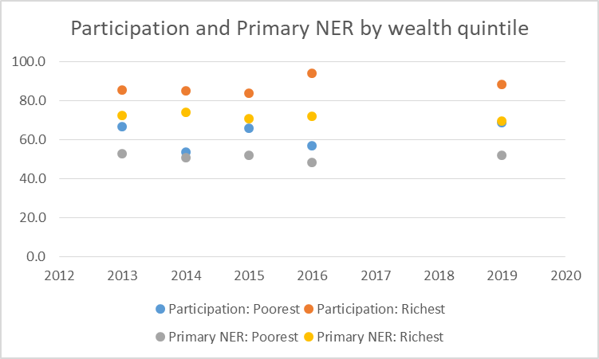
Evidence on learning outcomes
UK support including through PESP2 has improved the data available on learning outcomes but it remains insufficiently complete, representative, or disaggregated to allow firm conclusions about trends to be drawn. Available data suggests:
- Learning outcomes from school-based data showed some improvements in the period 2014–19 (see Figure 4), with differences by location, gender, and school type and persistent differences in learning achievement based on socio-economic status.
- Data on rural areas paint a less optimistic picture of learning in Punjab, with some recent improvements.
- Children do learn more in school than out of it.
- Children in (rural) Punjab have performed above the national average as compared to other provinces and regions in the country over the period of PESP2, though overall achievement levels remain persistently low.

Figure 4: Average school-level score (%), Learning and Numeracy Drive data by subject
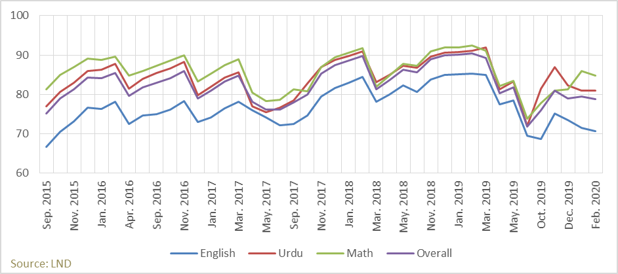
Are learners prepared for education?
- There was some increase in pre-primary enrolment in Punjab (though this may have been reversed in 2019 and 2020), but most children of three to four years are not participating in formal learning.
- Early childhood development lags in regard to literacy and numeracy in Punjab.
- There is limited support for learning in the household, with gaps by wealth and location.
- There are limited good data to measure learner preparedness in Punjab.
Has the effectiveness of teaching improved?
- Data from the main survey sources does not capture fundamental aspects of teacher effectiveness or allow assessment of changes over time.
- Teacher attendance in (rural) Punjab has consistently averaged more than 85% during 2012–19.
- Student–teacher ratios have fluctuated and are slightly higher in 2018 than in 2012.
- More qualified teachers have been hired in the province over the last few years.
- Some evidence suggests that teachers are not sufficiently prepared to teach challenging classrooms and that teachers are not fully competent in the curriculum, are unable to transfer their knowledge to students, and do not show good teaching practices.
Has the provision of learner-focused inputs in schools improved?
There have been improvements in the provision of physical infrastructure and facilities in Punjab’s schools – almost all schools have electricity, drinking water, toilets, and boundary walls. However, there are no comprehensive data on other learner-focused inputs, such as materials.
Has the management and governance of schools improved?
Insufficient information is available to draw any clear conclusions about the effectiveness of school management and governance, and how this has changed.

Education policies and reforms in Punjab since 2013
Over the period of PESP2, the GoPb has shown strong commitment to education with an increasing shift in focus from a principal emphasis on increasing enrolment to paying greater explicit attention to learning outcomes and inclusion. This commitment has been reflected in public spending which has generally continued to prioritise education, as well as an active process of development of policies, initiatives and organisational reform, and effective cooperation with the UK and the World Bank as the main external providers of financial support to the sector. It has led to increases in enrolment both in government schools and through PEF programmes with private schools, improved infrastructure and facilities in government schools, and increases in the number and qualifications of teachers. Important policy initiatives have been taken in relation to Early Childhood Education and inclusive education, and in enshrining the right to education in law (though these remain to be fully implemented).
However, the lack throughout the period of a comprehensive education policy has constrained the achievement of coherence and alignment on learning objectives. This has resulted in a lack of strategic guidance for spending decisions, and unresolved issues about priorities and focus including in relation to clarifying the role of the private sector in fulfilling sector policy objectives and establishing an appropriate regulatory and partnership policy.
Up to 2018, the Roadmap (which built on sustained UK support over many years including through the work of the DFID Special Representative on Education, Sir Michael Barber) provided a framework of targets, a focus for highlighting the political priority that the Chief Minister had placed on education, and a generally effective process of performance monitoring down to school level, with strong sanctions where progress was not achieved. The Roadmap and Stocktake process was effective in aligning the education system on the achievement of specific short- and medium-term targets but not in itself sufficient to guide comprehensive policy and organisational reform.
Continuing weaknesses in public financial management have also militated against ensuring resources have been allocated to address critical priorities. Only limited progress was made in implementing the model of decentralisation of education management through District Education Authorities that was developed by the previous government, and uncertainty remains about how the decentralisation approach embodied in the Punjab Local Government Act of 2019 will be implemented for education. The difficult fiscal context since 2018 and the impact of school closures in response to Covid-19 in 2020 (as well as the high rate of turnover in key sector leadership roles) have posed significant challenges for taking forward the implementation of reforms – though the response to Covid-19 has also stimulated awareness of alternative approaches to delivering education.
Sustaining and taking further progress in improving access to education and learning outcomes, especially in the wake of Covid-19, is likely to require a focus of action by GoPb and other stakeholders in the following areas:
- Identifying and effectively reaching (including through remedial support) children who are out of school or whose learning has been most significantly disrupted, as well as those with special educational needs and disabilities.
- Ensuring teachers (in both the government and private sectors) have adequate subject knowledge, use appropriate teaching methods, and are effectively motivated and managed.
- Ensuring effective and sustainable PPP arrangements for education, within the framework of a comprehensive policy towards private education including the appropriate regulatory and facilitating roles for government.
- Implementing a model of decentralised management of education that enables schools to control a greater share of resources while improving accountability especially to pupils, teachers and communities.

Effectiveness of UK aid to education in Punjab through PESP2
Over the period from the start of 2013 to the middle of 2018, DFID, through the PESP2 programme, built on a long track record of engagement in Punjab to support the Chief Minister’s strong commitment to improving access to, and the quality of, education. The Roadmap and Stocktake process provided the main instrument for driving and monitoring improvements in the education system, and PESP2 played a central role in implementing this, including encouraging a stronger emphasis on learning outcomes. PESP2 provided a combination of SBS, direct financial support, and TA to support the achievement of targets set out (from 2015) in the Chief Minister’s 2018 Education Goals. After the change of government following the July 2018 elections, which led to the abandonment of the Roadmap model, DFID/FCDO worked with the new government (particularly through TA provision under PESP2) to help support its development of policies and initiatives in a period of fiscal stress, followed by the impact of the Covid-19 pandemic.
The overall design approach of the programme was appropriate to achieve its key initial objectives of supporting the achievement of increased enrolment in education, and provided valuable flexibility especially in relation to SBS and TA (which successfully supported many policy and organisational reform initiatives). Spending through established and effective programmes from PEF and PEEF provided cost effective ways to boost access and learning.
The programme was less well-designed to focus on and achieve systemic improvements. While the original logframe structure correctly emphasised the importance of tracking the performance of key elements of the education system (such as the effectiveness of teaching, and the quality of school governance), during implementation more emphasis was placed on tracking the implementation of specific reforms and high level results. Without the monitoring of results achieved in improving the delivery of key elements of learning, and in the absence of a fully articulated theory of change, it is difficult to trace the causal impact of support through PESP2. Better tracking of system performance and management against a fully articulated Theory of Change might have provided clearer guidance for strategic decisions for the programme – especially through a formal mid-term review.
PESP2’s contribution was also constrained by some design and implementation weaknesses for specific components, including school infrastructure, which suffered from major delays and cost escalation, and SBS which was insufficiently well-integrated with the budget process, while also not succeeding in ensuring that weaknesses in PFM were addressed.
The record of support to achieving transformational impact (e.g. organisational strengthening and improved policies and systems) varied across organisations and policy areas. The district delivery system developed under the Roadmap required substantial modification in the light of the changed approach to decentralisation favoured by the new government after 2018. Engagement with QAED was generally successful in supporting organisational reform and in piloting new approaches to CPD, including potentially transformational changes towards a much more flexible and cost-efficient CPD model. The programme supported development of the Inclusive Education Strategy and Special Education Policy during 2019, following earlier less successful initiatives on these issues. Less progress was made in strengthening the capacity of PEF, or improving the policy and financing arrangements under which it operated.
Effectiveness of PESP2 components
Sector Budget Support is likely to have contributed to encouraging a focus on learning objectives and strengthening DFID’s role in policy dialogue with GoPb, and may have contributed to higher education spending than would otherwise have occurred. However, continued weaknesses in public finance management, and a lack of alignment of SBS provision with the provincial budget process, means it is difficult to trace a causal link to specific results.
Both programme design flaws and weaknesses in contractor performance and DFID’s response to this contributed to long delays and failure to reach intended targets for the school infrastructure component, though performance improved substantially following restructuring in 2018 and with part of the resources redirected to be managed by PMIU and TCF. However, the component has not succeeded in its original objective of successfully piloting and replicating new approaches and building technologies.
PESP2 funding played a critical role in enabling the Punjab Education Foundation (PEF) to increase enrolment in its well-run and effective programmes, and DFID’s support for PEF has been important in enabling it to maintain political support. However, only limited progress has been made in building PEF’s capacity (in functions such as research) and its future role and funding arrangements remain uncertain.
The Technical Assistance (TA) provided has generally been highly effective in producing agreed short-term outputs and responsive and flexible, but its record in contributing to sustainable organisational transformation, and addressing key governance issues for the sector, has been mixed. Effectiveness has in general improved over time and has reflected a greater attention in the selection of consultants to understanding of the local context. While TA provision has been responsive to GoPb priorities, GoPb ownership has been limited by lack of involvement in the selection of TA providers or management of TA arrangements.
PESP2 funding was effectively used by well-designed and managed scholarship programmes operated by PEEF and the Lahore University of Management Sciences National Outreach Programme (LUMS/NOP). Support was provided to building the management capacity of the LUMS/NOP but the long-term sustainability of its funding remains uncertain. PEEF scholarships were directly targeted on priority beneficiaries (including in disadvantaged districts). The targeting of support under LUMS/NOP was less clearly in line with programme priorities and its design was not focused on its originally intended role as a pilot to inform approaches for higher education scholarships.
Siyani Sahelian appears to have been highly successful in developing and implementing approaches for providing remedial education and related support to reach out of school adolescent girls in rural areas of South Punjab. While it has secured some funding to allow its activities to continue after the end of PESP2, it is not clear to what extent GoPb will adopt lessons from the programme and support scaling it up.
DFID’s continued engagement, commitment, and advocacy and funding of support to special and inclusive education has been important in ultimately enabling progress to be made towards the adoption of the IES and SEP. PESP2 contributed (through the Punjab Inclusive Education Programme - PIEP) to the successful development and adoption of the Inclusive Voucher Scheme (IVS) by PEF, but the School Education Department (SED) component of PIEP was not successful. PESP2 support to the Special Education Department achieved limited results in strengthening its capacity and was not directly relevant to the objective of improving the extent to which the requirements of most children with special educational needs and disabilities were addressed in the education system.

To what extent is UK aid in Pakistan focused on the poorest, most marginalised and most vulnerable people in that country?
The PESP2 programme was strongly focused on the poorest, most marginalised and most vulnerable people in Punjab (home to more than half of Pakistan’s population) through in particular:
- The overarching emphasis of the programme on supporting GoPb to improve education access, reduce the number of out of school children and improve education opportunities for girls.
- The focus of the programme on eleven priority districts which had particularly low levels of access to education.
- The funding of programmes of the Punjab Education Foundation for partnerships with low cost private schools.
- The provision of scholarships for girls for intermediate education (especially in the priority districts) through the Punjab Education Endowment Fund.
- A strong and sustained emphasis by DFID/FCDO on addressing special education needs and disabilities which contributed to the development of an Inclusive Education Strategy by GoPb.
- Support to the Siyani Sahelian initiative to develop and implement approaches for providing remedial education and related support to reach out of school adolescent girls in rural areas of South Punjab.

How effective are the partners (NGOs, private contractors and multilateral agencies) through which UK aid is delivered in Pakistan?
The initial performance of PESP2 was adversely affected by delays in the process of contracting international providers both of technical assistance and to manage the school infrastructure component. Weaknesses in the performance of the private contractors also had adverse effects on performance especially for the school infrastructure component. The effectiveness of private contractors improved over the lifetime of programme implementation reflecting both more effective management by DFID/FCDO, and the use of contractors (private companies and NGOs) with stronger knowledge of the local context. The programme also worked through highly effective government partners particularly the Punjab Education Foundation, Punjab Education Endowment Fund, and the Programme Monitoring and Implementation Unit, though in general the effectiveness of government partner organisations varied.

What are the key risks (and mitigations) to the value for money, effectiveness and impact of UK aid projects and programmes in Pakistan?
The effectiveness and impact of PESP2 have faced contextual risks from political change, instability in government staffing, and limited genuine decentralisation (including a lack of accountability directly to parents and communities). Some weaknesses in design and management of the programme have also militated against effectiveness. Effective mitigation strategies are likely to require a flexible and adaptive programme design based around clear strategic objectives focused on active monitoring and improvement of the delivery and performance of key education system functions, as well as greater involvement of government in some programme management decisions.
The following factors influenced the effectiveness and impact of PESP2 and may be seen as key risks for aid programmes in Pakistan:
- Political change and ownership: the original design and approach of the programme was strongly aligned on the then (up to 2018) Chief Minister of Punjab’s objectives and approach to education sector management. This contributed to effectiveness but posed challenges for the programme after the change of government in Punjab in 2018. While the new government shared the overall objectives of the programme, it had some significant differences in priorities and approach, especially in relation to decentralisation and the abandonment of the Roadmap model for sector management.
- Instability in government staffing: the effectiveness of the programme benefited stability in staffing of key posts in the education bureaucracy before 2018, especially the Secretary of the School Education Department. A high rate of turnover in this post (and that of the Managing Director of PEF) since 2018 has militated against effective engagement for the programme with GoPb, though the TA providers have sought to mitigate this especially through effective working relationships with other government staff.
- Limited genuine decentralisation of decision-making and control over resources or of effective influence for civil society: the management of sector reform under the Roadmap model was based on top-down setting of targets and accountability of school leadership and the education system against these targets (rather than to parents and the local community). While education reforms have envisaged decentralisation of decision-making to schools and strengthening of accountability through school management councils, only limited progress has been made in implementing this model. Civil society organisations have been involved in policy dialogue and service provision but have exerted generally limited influence on sector policy.
- Programme design and management: the effectiveness of PESP2 was constrained by some design weaknesses particularly in the school infrastructure component and the approach to some pilot initiatives. The lack of articulation of a complete Theory of Change, and a structure of objectives that paid insufficient attention to the performance of key functions of the education system, may also have constrained the effectiveness of the programme.
Effective mitigation strategies are likely to require a flexible and adaptive programme design based around clear strategic objectives focused on active monitoring and improvement of the delivery and performance of key education system functions (such as effective teaching) with regular reviews of progress and active programme management against a well-articulated Theory of Change. This could facilitate adjustment to important contextual changes, such as at the political level. Greater involvement of government in key programme decisions (such as the recruitment of consultants) would increase effective local ownership.

Are there adequate processes of independent evaluation and self-evaluation built into the country programme?
The evaluation of PESP2 has produced findings that have been extensively used by, in particular, DFID/FCDO and technical assistance providers. However, the adequacy of the evaluation process was constrained by the fact that evaluation only began at a relatively late stage of programme implementation, and effective GoPb ownership of the evaluation was not achieved. The effectiveness of programme implementation might have been improved by a full mid-term review, rather than reliance on self-assessment by DFID through Annual Reviews.
There has been a significant commitment of resources to the independent evaluation of PESP2. A First Interim Evaluation Report was published in 2018, and findings from a large number of evaluation studies have been presented to, and discussed with, DFID/FCDO and a wide range of stakeholders in Punjab. Use has been made of the findings by, in particular, DFID/FCDO and the Technical Assistance providers for PESP2. While this appears to have been valuable, there have been two aspects in which evaluation and self-evaluation might have been strengthened.
First, independent evaluation of the programme only began four and a half years into implementation. This meant that it was not possible to undertake a baseline study or to ensure that the programme was designed and implemented in a way that facilitated its evaluation. It also meant that no evaluation findings were available that could have provided lessons to improve performance until a relatively late stage in the programme’s implementation. The evaluation of PESP2 concluded that performance of the programme might have been improved by undertaking a full strategic/mid-term review that would have involved a more systematic and independent assessment than was provided by the DFID Annual Review processes, in particular to involve a complete articulation and re-assessment of the programme’s Theory of Change.
Second, the governance arrangements for the evaluation of PESP2 did not succeed in establishing a structured process of engagement by GoPb in the evaluation which limited local ownership, especially in the context since 2018 of an extremely high turnover of the senior management of the education sector.

What evidence is there of lesson-learning and turning learning into action?
The First Interim Evaluation Report of the PESP2 evaluation in 2018 was published with a Management Response by DFID, and a review was undertaken by DFID in 2019 of progress in implementing recommendations from the First Interim Evaluation Report. Lessons significantly influenced in particular the second phase of TA support (beginning in 2018) and DFID/FCDO’s planning for future engagement in the education sector in Pakistan. There is less evidence of lesson learning from the evaluation so far impacting on GoPB decision-making.

How has UK aid responded to the challenges of covid-19 in Pakistan, and how effective has this response been?
School closures and disruption to livelihoods resulting from Covid-19 have had a significant negative impact on education in Punjab, probably reversing several years of the progress made in improving access to education and learning. While available data is limited, it appears that this negative impact has been greatest on the youngest children and on those from relatively disadvantaged backgrounds who have lacked access to learning resources outside school and whose families have suffered negative livelihood shocks. Technical assistance resources provided by PESP2 have been used flexibly and effectively to support GoPb response, through development of a costed school reopening strategy, support to the design of the Back to School campaign and, especially, support to the Accelerated Learning Platform (ALP).

Impact of Covid-19 on school enrolment and learning in Punjab
Schools in Punjab closed in March 2020 and re-opened from 23rd September to 25th November. Schools re-opened from 1st February 2021 with the academic year being extended to May 2021. Spilt attendance mechanisms are being followed to allow for social distancing.
The only comprehensive empirical data available on the impact of school closures comes from the 2020 Annual School Census/Education Management Information System (EMIS) whose provisional results suggested that there had been a reduction in total enrolment from 11.7 to 11.2 million children compared to 2019, based on EMIS raw data as shown in Table 1.

Table 1: Comparison of School Enrolment in Government Schools (ASC/EMIS Data)
 | 2019/20 | 2020/21 (P)
Primary (Katchi-Class 5) | 7,647,498 | 7,002,824
Middle (Class 6-8) | 2,513,867 | 2,572,791
High (Class 9-12) | 1,565,310 | 1,624,185
Total | 11,726,675 | 11,199,800

2020 EMIS data suggests a fall in the Primary Gross Enrolment Rate in Government Schools from 46.7 to 42.0 from 2019 to 2020 (i.e. removing gains made in the Gross Enrolment Ratio made since 2016). However, there are issues of data comparability since the 2020 EMIS data omits government schools managed by the private sector (which were included in previous years), and the 2020 EMIS also collected information on student registration numbers which are now required for enrolment to reduce possible duplicate enrolment. Data on enrolment in private schools is not available but key informants considered that the impact of Covid-19 restrictions on (low cost) private schools was likely to be greater than on government schools because government teachers continued to be paid while private schools lost revenue.
A study (see Box 1) carried out by the Institute of Social and Political Sciences following school re-opening in September suggested that household income stress as a result of Covid-19 restrictions was an important factor in explaining school drop-outs, implying that drop-out rates are likely to be substantially higher for children from disadvantaged socio-economic households.
No comprehensive data of the impact on learning outcomes is available since the LND survey has not been conducted since February 2020. A simulation study covering the whole of Pakistan estimated that income losses would lead to around 900,000 children dropping out of school (increasing the total number of children out of school by around 4.2%), and an average loss of between 0.3 and 0.8 years of learning for each child enrolled in school. The share of children defined as “learning poor” (defined as being unable to read and understand a simple by the age of 10) was estimated as likely to increase nationally from an already very high 75% to 79%.
A further study based on interviewing parents and teachers found that nationally in Pakistan only 53% of parents and 58% of teachers were aware of the distance learning platforms established to provide access to education during school closure, and that of those aware only 30% of parents and 70% of teachers (with the rate for private school teachers twice that for government school teachers) were making use of the platforms with access to them largely restricted to those in urban areas with adequate internet penetration.
The PESP2 supported initiative on girl’s education (focused on priority districts) estimated that only 62% of households from which pupils came had television while 64% had a simple phone, and that Covid-19 was associated with a reduction in enrolment in the programmes supported by the initiative of 2-3% which was particularly associated with migration (families returning to home villages following employment loss).
While the evidence available so far is very limited, it suggests that Covid-19, both through the direct effects of school closure in disrupting teaching, and the indirect effects of negative income shocks, are likely to lead to a setback amounting to several years of the progress that has been made in improving enrolment and learning outcomes, with the impact heavily concentrated on children from the poorest and most vulnerable households who were already most disadvantaged in terms of access and educational achievement.

Box 1: Findings from I-SAPS Study of Student Drop Out

The study was conducted following the re-opening of schools in September 2020 and involved a school-based survey in 382 sample schools in Punjab focused on changes in student enrolment and attendance, and a household survey with 765 parents of children who had not re-joined schools after school reopening.
Key findings of the survey:
- Around 5% of the students had dropped out of school after school reopened in September 2020. More boys (7% of total) dropped out in comparison with girls (3%). The majority of these dropped-out students were enrolled in Katchi, Grade 5, Grade 8, and Grade 9 in the pre-COVID period (i.e., January 2020).
- The attendance of students dropped by 10 percentage points after school reopening compared with pre-COVID times.
- The survey finds that the major reason for drop-out was the income crisis of family due to COVID-19. 25% of the parents reported an income crisis of family as the reason for their children not being able to continue schooling. 58% of students who have dropped out because of family’s financial hardships were boys.
- Around 27% of the students (13% girls and 9% boys) who have left schools are supporting their parents with work and household chores. The parents of all these children are earning less than PKR 25,000 per month.
- More than 23% of the dropped-out children are doing nothing at home, with boys and girls have the same proportion. More than three-quarters of these children were enrolled at the primary level before dropping out of school. The parents of all these children have matric or lower level of education.
- Around 14% of the dropped-out children were reported to be studying at home. The majority of these children had preferred not to go to school after reopening because of COVID-19 related fears.
- The survey also finds that more than 11% of children who have left schools are working and earning livelihood for themselves and supporting their families. All these children are employed at local shops.
- 25% of the parents plan to send their children back to school. Around 32% of these parents were willing to send their children to schools if the COVID situation eases. In 23% of the cases, the parents were even willing to send their children if they had surety of adequate COVID-19 Standard Operating Procedures (SOPs) being observed by the schools.
- 28% of the parents highlighted their financial hardships and the extra costs of schooling. They mentioned sending their children back to schools if they were provided any scholarships or stipends to cover the income loss and the extra schooling costs.

Source: I-SAPS (Alam and Ali, 2020)

Government of Punjab response to the impact of Covid-19 on education
There have been three main elements to the Government of Punjab response to the impact of Covid-19 on education:
- Plans for school reopening based on observing Standard Operating Procedures (SOPs);
- Promoting online learning, in particular through the Taleem Ghar initiative;
- The Accelerated Learning Platform (ALP) which has involved producing learning resources and a revised academic calendar.
In relation to the overall response, key informants noted that no additional budget resources have been provided by GoPb for the education sector specifically to address the impact of Covid-19, with schools reliant on using the existing Non-Salary Budget (NSB) allocation to fund costs associated with following the SOPs, and School Education Department (SED) funding other support out of its existing budget. This has generated concerns from schools that other priorities for the use of NSB resources cannot be met. However, there has been an emphasis on ensuring NSB resources have been available for schools to use on a timely basis (which had not been the case in the previous year).
School reopening plans
Key informants noted that when reopening schools had been successful in observing SOPs to reduce Covid-19 transmission risk (for instance through the wearing of masks, hand washing, posters promoting hygiene practices, and alternative day attendance) – probably more so than other sectors of society. The process of school reopening in February 2021 has involved a media campaign based on the slogan "ao parhain, hum aa gay barhain" (“Let’s Study, Let’s Move Forward”) and the establishment of markaz level enrolment targets for children aged 5 to 16. These targets have been developed by SED’s Programme Monitoring and Implementation Unit (PMIU) using datasets mapping out of school children (with an estimated 5.5 children out of school). An innovation approach has been the inclusion of targets for high and higher secondary schools when the previous focus has been on primary schools only. The campaign has a target to bring at least 1 million children to government schools through School Management Committee engagement in the local community. To support this, there has been an upgrading of the application used by Assistant Education Officers (AEOs) to include markaz level enrolment targets, NSB spending, a checklist of topics for discussion with School Management Committees and for community meetings.
The central role of the NSB in the response is seen by SED as part of a broader process of devolving authority to schools. This is envisaged as involving wider links between NSB provision and the achievement of targets (beyond enrolment), strengthened monitoring of NSB utilization and a future increase of the NSB budget to PKR 4-5 billion.
Taleem Ghar and online learning implementation
Implementation of Taleem Ghar has continued with lessons being shown on television (since this has greater reach than online provision), with SED working with the Pakistan Electronic Media Regulatory Authority (PEMRA) to encourage channels to show this content. A PC-1 project document has been approved for a project to support remote learning initiatives at Federal and Provincial level, including for creating online content from the whole syllabus, with a view to this being available in parallel to face to face teaching. Taleem Ghar has so far been using existing content.
As noted in the previous section, however, there is a large digital divide in access to online resources by pupils. SED has had no resources to address this. In addition, while high and higher secondary schools have IT facilities most primary and middle schools do not. It is estimated that around 9,000 schools have IT facilities while around 40,000 do not.
Accelerated Learning Platform (ALP)
The Accelerated Learning Platform (ALP) was developed by the Punjab Curriculum and Textbook Board (PCTB) in collaboration with the PESP2 TA in order to help teachers deliver priority elements of the curriculum in the light of the disruption of teaching and loss of teaching time resulting from the alternative day SOPs. It involved the provision of a shortened curriculum (covering English, Maths and Science for Grades 1-8) and a comprehensive teaching plan around a revised academic calendar. Teachers were provided with standardized and structured daily lesson plans. The initiative also provided some innovations like the development of student worksheets. The toolkit of “COVID-19 Accelerated Response for Education” (CARE) material has been made available online (through the PMIU website) so that teachers (in both government and private schools) can print, copy and distribute worksheets and other material funded by NSB. This material has been distributed from PCTB to PMIU and then to CEOs at district level in order to reach teachers before school opening. PCTB estimated that around 50-55% of the syllabus has been retained without compromising/reducing the Student Learning Outcomes (SLOs).

PESP2 Technical Assistance support to response to Covid-19
With the I-SAPS TA contract beginning in July 2020, PESP2 TA has played an important role in supporting the process of school reopening. This has included development of a costed school reopening strategy, support to the design of the Back to School campaign and, in particular in terms of the resources involved, support to the ALP.
TA is also supporting the SED/PMIU in undertaking a perception survey of Taleem Ghar usage and effectiveness. It is ongoing. Just thought to provide this update. In addition, the TA is aligning Taleem Ghar lesson plans with the revised academic calendar for the upcoming year. TA is also facilitating the development of model lesson plans that will be used by the engaged firm (under PC-1) for dedicated video content development for Taleem Ghar.
Development of the ALP was in response to requirements from the Minister of Education and SED who tasked PCTB with implementation. The TA team provided technical leadership and management. The task was carried out by a large team that included PESP2 TA, SED subject specialists, and Quaid-e-Azam Academy for Educational Development Punjab (QAED) and PCTB personnel, with PCTB meeting the costs of SED personnel who were not based in Lahore but as educators involved in other jobs were called into Lahore to work on this as an additional assignment.
The process of ALP development began in early September 2020 and has taken four months to implement, including the development of around 2,600 documents that have gone through three levels of quality assurance. The process involved an extremely intensive work schedule for the whole team (in order to meet the timetable for school reopening set by the Minister), under the leadership of the TA Teaching and Learning Lead and based in PCTB. The TA team role included the coordination of the process to ensure appropriate subject matter specialists were provided by SED and QAED and negotiation to ensure their time was adequately resourced, as well as capacity development for subject specialists to enable them to undertake the required tasks.
In addition to its immediate use to support teachers during the remainder of this disrupted academic year, PCTB considers that the ALP provides material that can be used and developed further in the future to support teachers, including through potentially institutionalising the lesson plan regime. The capacity of the subject specialists who worked on the initiative has also been developed, providing PCTB and QAED with enhanced capacity for making and supporting future modifications to the curriculum.
Development of the ALP faced significant challenges relating both to the tight timeframe and the lack of experience and limited technical capacity of PCTB staff and subject specialists in carrying out such an assignment. It also affected PCTB capacity to perform other functions such as book reviews for the Single National Curriculum (SNC).
The extreme time pressure on the process has led to some limitations, such as the fact that it was not possible to design and implement a monitoring and evaluation system in parallel with ALP development. However, there has now been reach out to district delivery managers (in the capacity building training) to obtain feedback on the ALP material, and focus group discussions have also been carried out in Lahore and Multan to understand teacher experience in using the resources. Once schools reopen, it is planned that AEOs will check if schools have received, printed and used ALP tools.
Key informants considered that the TA team effectively led and managed the ALP initiative, working closely with (and being located in) PCTB to ensure effective communication and coordination and to manage production of the large number of outputs as well as quality control, effectively to focus the government staffing resources that were drawn on. The implementation process was constrained by the need to agree financial resources to support logistics expenses borne by PCTB, and key informants considered implementation might have benefited from initial orientation workshops for the staff involved had these been feasible. Key informants also provided a positive assessment of the Back to School Plan, especially its attention to psychosocial factors.

OPM is an international development consulting company that has been contracted by DFID/FCDO to undertake this evaluation, through the e-Pact consortium and under the Global Evaluation Framework Agreement (GEFA).
PSLM: Pakistan Social and Living Standards Measurement Survey; Nielsen: Survey commissioned by DFID; ASER: Annual Status of Education Report (partly funded by DFID); MICS: Multiple Indicator Cluster Survey.
A staggered school opening strategy was followed between 15th September to 30th September with first Grades 9-12, then Grades 6-8 and finally primary Grades.
Alam, A., and Ali, A. (2020), COVID-19 and Education: Survey to Analyse Student Drop-out after School Reopening in Punjab Province of Pakistan, PESP2, Institute of Social and Policy Sciences, Islamabad, December.
Geven, K., and A. Hasan (2020), Learning Losses in Pakistan Due To Covid-19 School Closures: A Technical Note on Simulation Results, The World Bank South Asia, October.
I-SAPS/Ipsos (2020), Gauging the Impact of Covid-19 on the Education Sphere in Pakistan: Findings from Interviews with Education Stakeholders and Surveys with Parents and Teachers, Institute of Social and Policy Sciences, Islamabad, September.
An earlier study for the evaluation had noted estimates that “the SED will require an additional PKR 9 billion for the purpose of ensuring that SOPs are adequately followed across all its schools which includes provisions of sanitizers, masks for teachers and washing facilities in schools across the province.” While the RISE Punjab strategy recognises the need for additional resources for strengthening online learning no resources were made available in the 2020/21 budget.
https://www.thenews.com.pk/print/783528-school-enrolment-drive-launched
http://pesrp.edu.pk/lesson-plan

