Written evidence submission from Surfers Against Sewage

Executive Summary
- Interaction with rivers and ocean have been proven to have positive health and wellbeing effects
- When people interact with water polluted by sewage and diffuse pollution they are at risk of contracting serious illness
- The widespread and routine use of Combined Sewage Overflows (CS0s) combined with the growing popularity of water sports risks deepening a public health crisis
- There is widespread public and political appetite for rapid action to End Sewage Pollution
- To keep people safe when using the water, water companies must provide real-time monitoring information for ALL CSO locations
- Water companies must urgently invest in updating their sewerage infrastructure, prioritising the use of nature-based solutions
- Regulators must be empowered and resourced to ensure polluters address sewage and diffuse pollution
- SAS volunteer to provide formal oral evidence to the committee

Surfers Against Sewage Overview
  - Overview:
Surfers Against Sewage (SAS) is a national marine conservation and campaigning charity that inspires, unites and empowers communities to act to protect oceans, beaches, waves and wildlife. Formed in the 1990s SAS has almost 500,000 digital supporters, over 8,000 members and mobilises over 100,000 volunteers annually.
  - Reason for Submitting Evidence:
SAS has been an authority on water quality issues and human health impacts since the 1990s. Representing all water users and bringing together many organisations that are affected by poor water quality, SAS has helped dramatically improve coastal water quality, and is now focused on the whole water system – rivers, lakes, and streams – as increasing numbers of people use these unique sites for recreation. Sewage and diffuse pollution still plague these aquatic amenities which SAS is committed to helping restore and protect.

The Human effects of sewage pollution

Health and Wellbeing Benefits of Interacting with Blue Spaces
Numerous studies have highlighted the health and wellbeing benefits of time spent in and around natural blue and green spaces. SAS’s Generation Sea Blueprint Survey, completed by 3,300 participants, found that respondents felt free, calm, alive and peaceful when close to blue spaces. It showed during the pandemic blue spaces were more important than ever with 80% of respondents having an increased appreciation of the environment.
This growing body of evidence has led Government to invest £5.77 million into Green Social Prescribing to support patients to engage with nature to improve mental health and wellbeing.
Rivers, beaches and lakes have become essential community amenities delivering health, prosperity and wellbeing in villages, towns and cities nationwide. It is therefore crucial that people are able to access and interact safely with these spaces.

Economic Benefits of Water Based Recreation
Water sports and water use in the UK have a positive impact on the UK economy. Surfing alone directly contributes up to £1.8billion per year, with indirect contributions of £3.96bn. With water sports such as Stand Up Paddle Boarding and open water swimming undergoing a boom in popularity these economic benefits will continue to increase.

Effects of Sewage Pollution on Human Health
Poor water quality is a public health issue, putting water users at risk of exposure to harmful viruses and antimicrobial resistant bacteria causing sickness, distress and in some cases, long-term health effects.
Over the course of the 2020 Bathing Season 153 water users submitted health reports to SAS after falling ill from using the water.
The most common illness was gastroenteritis or infectious diarrhoea (64%), Ear, nose and throat related infections also featuring highly. In the most severe cases, two water users needed antibiotics for their gastroenteritis issues and another required emergency care.
The European Centre for Environment and Human Health recently found that bathers in the UK remain just as likely to become ill from seawater as they were in the 1990s. Another ground-breaking study found bathers are being put at greater risk of exposure to antibiotic resistant bacteria, with 9% of surfers colonised by resistant bacteria, compared to just 3% of non-surfers.Antibiotic resistant bacteria cause increasing failures in routine medical treatments, and it’s been estimated by the UK Special Envoy for Antimicrobial Resistance that if no action is taken, by 2050, an estimated 10 million antimicrobial resistant bacteria related deaths will occur every year. This will be more than the number of cancer deaths occurring each year.
Given the real and present risks posed by sewage pollution we can no longer ignore this public health crisis. Water users need to see real-time monitoring information for all locations where CSOs discharge be that be coastal or inland waters, designated and undesignated spots to ensure they make informed decisions regarding the risk of entering the water.

Prevalence of Contaminated Water in the UK
21,462 CSOs and pumping stations exist in England and Wales discharging untreated wastewater directly into riverine and coastal waters.
The Urban Wastewater Treatment Directive states CSOs should only be used in “exceptional circumstances”. However SAS’s Water Quality Reports suggest, the scale and frequency at which water companies use CSOs suggests that’s discharging untreated effluent into the environment appears to be routine behaviour.

Coastal Discharges
SAS’s 2020 Water Quality Report, which reports on the data compiled though the Safer Seas Service (SSS), found 2,941 CSO notifications were issued over a twelve-month period for discharges into bathing waters. 1,195 CSO notifications were issued across England and Wales during the bathing season and 1,746 CSO were issued outside the season (See Figure 1).
However, three of the eight water companies did not provide CSO notifications outside the season. We therefore estimate the real number of discharges to be closer to 3,434 over twelve months. This means at least 6% of “swimming days” were lost during the official season and 10% out of season.
With such widespread and routine use of CSOs urgent investment is needed to reduce reliance on CSOs and ensure dangerous pollution does not enter our waters.

Figure 1: 2020 Coastal CSO Discharges
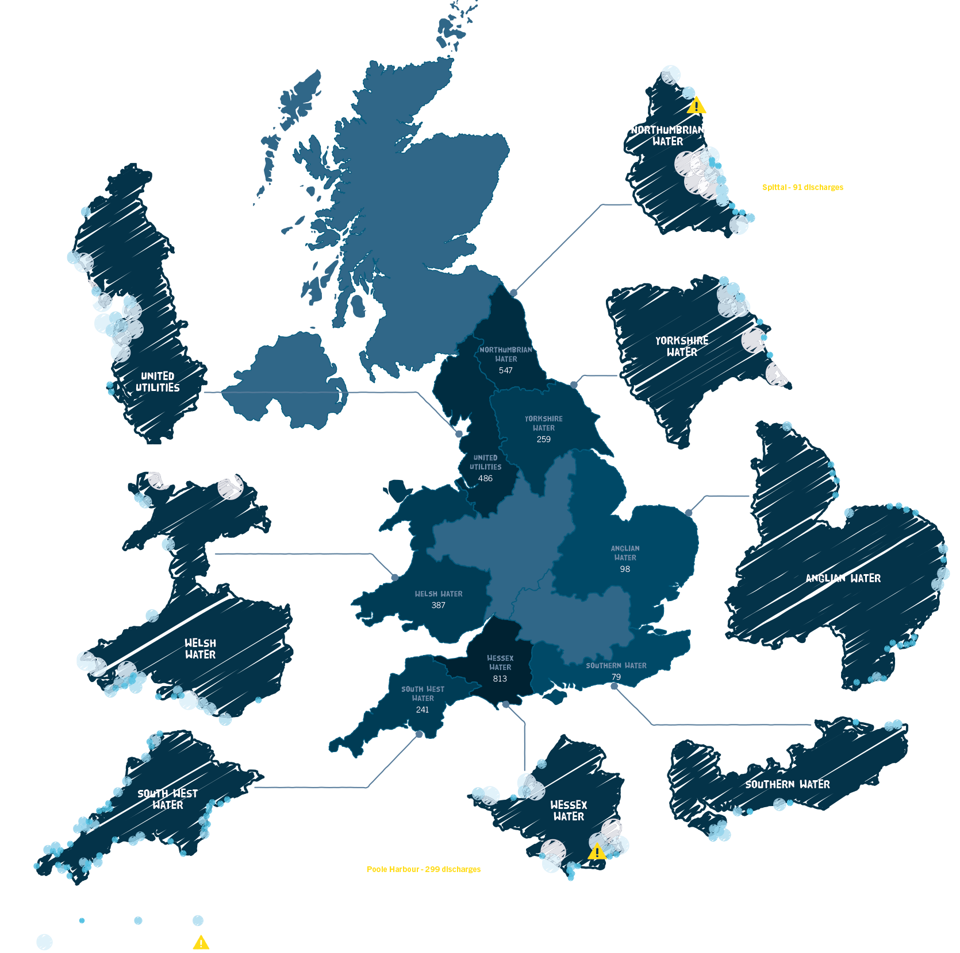

Discharges into Rivers
Around 90% of CSOs in England and Wales discharge directly into rivers. In 2019, sewage was discharged into English rivers over 200,000 times, totalling 1.5 million hours of discharges.
However, until the designation of Ilkley on the River Wharf in December 2020, there were no designated river bathing waters despite the invaluable recreational space they provide for a huge proportion of the population. SAS therefore did not have access to sewage discharge information for rivers during 2020 and could not provide information to river users through the SSS.
With inland water recreation only increasing, we must build on the example of Ilkley and ensure inland waters are officially designated to protect public health and to drive investment for improving inland water quality.

Diffuse Pollution and Pollution Risk Forecasts (PRF)
The Environment Agencies provide PRF during the bathing season to predict changes in water quality as a result of environmental factors, such as rainfall which affect the likelihood of sewage discharges and diffuse pollution from agricultural and urban runoff from entering the water.
During the 2020 bathing season over 2,600 PRF warnings were issued across the UK warning against bathing (see Figure 2).
This highlights the need to tackle diffuse pollution from agricultural and urban runoff in addition to sewage pollution.

Figure 2: 2020 PRF Notifications
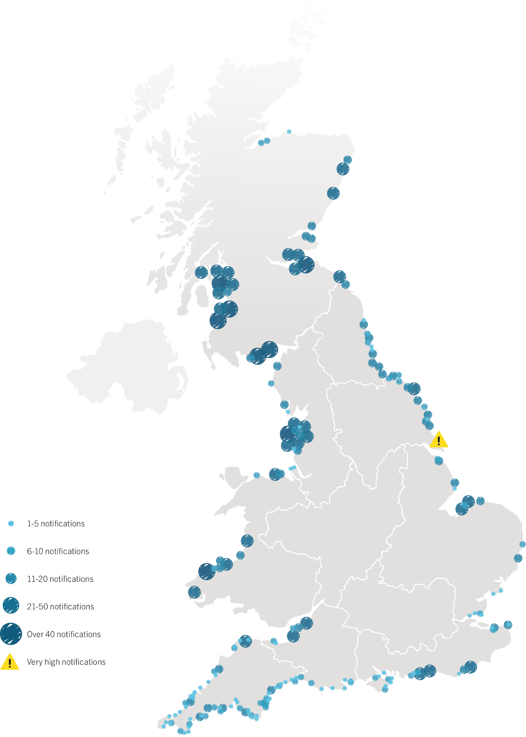

Public Desire for Action

#EndSewagePollution
The #EndSewagePollution Petition, which called for an end to sewage pollution and a guarantee of safe seas and rivers all year-round, was signed by 44,691 individuals and supported by a coalition of over 20 environmental NGO’s, local campaign groups, national governing bodies, and media. All of them desperate to see government deliver:
- An enhanced water-quality testing regime
- World-leading water quality legislation
- Nature-based solutions to sewage pollution
In addition, over 3,000 emails were sent to 93 MPs during the 2020 Bathing Season highlighting when water quality was reduced.

Sewage (Inland Waters) Bill
This Bill will help to tackle the root causes of sewage pollution.
As of 04/02/2021 MPs have been contacted just under 6,000 times by their constituents urging them to support the Bill, resulting in 136 MPs backing the Bill. The government and opposition have also committed to support the principles of the Bill.
With such strong public and political support, the government has a clear mandate to act on this issue in order to end sewage pollution.

Recommendations
In order to #EndSewagePollution, we need:
An enhanced water-quality testing regime –
- which tests for emerging threats
- accurate real-time water quality information available for all CSO locations year-round
World-leading water quality legislation –
- an Environment Bill that exceeds EU standards
- legally binding targets to end untreated discharge in all bathing waters by 2030
- legislation that upholds the same high standards for inland and coastal waters
Nature-based solutions to sewage pollution –
- increased investment and targets for the restoration of natural habitats to reduce pressure and prevent sewer overflows.

Questions

What are the best indicators for river water quality that could be used as targets being developed under the Environment Bill?

Virus and Bacteria
The bathing water quality testing regime classifies water quality based on the presence of bacteria and virus in order to inform whether the water is safe for people to use. This has helped drive improvements in coastal water quality by forcing investment from water companies, and has the potential to do the same for rivers.
However, SAS would caution simply adopting the existing bathing water testing regime as it has myriad flaws. At present the regime does not measure for emerging pollutants such as antimicrobial resistant bacteria or microplastics. The limited bathing water season and sampling days means just 20 out of 153 days in the season are monitored. Shockingly an optional provision within the Water Framework Directive (WFD) has allowed 1 in 7 samples to be discounted in 2019 meaning potentially 65 bathing waters in England achieved a higher quality rating then they should.
We would recommend adopting testing for virus and bacteria as a potential indicator of river water quality. However, to be effective a redeveloped bathing water quality regime is required that tests for emerging pollutants and embraces emerging technology that allows for continuous testing year-round.

Biodiversity
A crucial indicator of river water quality is the biodiversity which a river and the surrounding habitats which form riverine ecosystems and catchment areas holds.
Including targets to increase biodiversity would ensure the whole of the riverine ecosystem is improved.

CSO Discharges
CSO discharges have damaging effects on natural ecosystems as well as on humans. In rivers, ponds and lakes sewage can cause algae blooms which remove oxygen from the water killing biodiversity within the water and surrounding habitats. As a result, whole riverine ecosystems can be damaged by pollution. Rivers also carry pollution into the ocean where it degrades sensitive ecosystems such as kelp beds and sea grasses. By reducing biodiversity, this sewage pollution also destroys the natural ability of ecosystems to act as carbon sinks.
The number and duration of CSO discharges will provide a clear indication of a river’s health. SAS recommend the Environment Bill set legally binding long term and interim targets for the reduction of the use of CSOs.

EU Standards
Government are falling well short of their commitment under the EU WFD for all rivers to meet good ecological status by 2027.
Government must work to achieve these EU standards in the first instance.
The Environment Bill should ensure government can only increase standards, rather than reduce or water down legislation to achieve standards through manipulation.

How could drainage and sewage management plans, introduced by the Environment Bill, play a role in reduced sewer discharges?
CSO’ are the primary route for sewage to enter into the environment. Sewage Management Plans should therefore set targets to reduce water company’s reliance on these assets and ensure they are only used in emergencies.
Plans should prioritise investment in nature-based solutions to reduce surface water flooding, improve water quality, increase biodiversity, store carbon and help tackle climate change.
Sewage Management plans must not become a vehicle for water companies to dictate what they will do. Instead the direction given by the Minister must clearly outline actions companies must take.

How adequate are the monitoring and reporting requirements around water company discharges? How can technology improve and assist with transparency and enforcement?
Discharge information is provided on a voluntary basis by water companies through their own systems and collated through the SSS for designated bathing waters. This information is welcome but improvements are needed to ensure information is of maximum benefit to public health.

Consistency, Accuracy and Transparency
Information must be easy to understand, freely available and provided in real-time.
There is a lack of consistency in how water companies provide information. In some instances, multiple discharges notifications are issued in a short period of time compared to just one discharge notification in the same period at another location. There is also variation between when a notification is triggered, with some triggers relating to duration of discharge and some in relation to time.
Water companies must also be transparent in the location of CSO assets and how the impact of surrounding bathing waters has been assessed.
There needs to be an agreed and consistent method for how real-time CSO discharge notifications are provided so the public can access more insightful information to inform their understanding of risk. Best practice would be to make information on CSO locations, real-time discharge times, frequency and volume of discharge through an Application Programme Interface (API).

Year-Round Information
The rapid increase in water sports and advancement in wetsuit technology has resulted in significant use of coastal and inland waters year-round. SAS therefore welcome the recent commitment by water companies to provide year-round real-time data on discharges available at bathing sites.
However, water users need to see real-time monitoring information for all locations where CSOs discharge. This includes coastal and inland waters as well as designated and undesignated recreation spots to ensure all water users can use the water safely.
With winter months often being wetter, there is an increased risk of poor water quality from diffuse pollution. The public therefore must also have access to PRF information from the environment agencies year-round.

Real-time Water Quality Technology
Emerging technology that provides real-time information on water quality is currently being tested by local groups including Windrush Against Sewage Pollution on the River Windrush and Sewage Free Swimmers on the River Avon. Investigation into these technologies would be welcome to provide more accurate information of actual risk. This should however not substitute real-time information on when a discharge occurs.

What is the impact of plastic pollution and other materials on drainage and water quality in rivers and what should be done to mitigate it?

Microplastics:
Eunomia have estimated huge quantities of microplastic pollution enter UK waterways from a number of sources every year including car tyres and clothing. Bangor University’s recent report found these microplastics in some of the most iconic and remote rivers and lakes in the UK including the River Thames and Loch Lomond. Whilst little is currently known about microplastics effects on ecosystems and human health this research shows microplastics are an emerging contaminant.

The respective environment agencies should measure the concentration of microplastics as part of testing programmes to develop a clearer picture of microplastic distribution in the water environment. A greater understanding of the effects of microplastics and the distribution will help to educate people and encourage them to reduce their consumption of materials containing microplastics.

Plastic Pollution Reduction Targets
The root cause of plastic pollution is the systemic overproduction and overconsumption of polluting plastics. This is exacerbated by the failure of systems to deal with the plastic waste produced. To stop plastic pollution, we need to reduce consumption and production of plastic products.
The Government must legislate, through the Environment Bill, for targets to reduce plastic pollution, with a particular focus on non-essential single-use and polluting plastic and embrace ‘reduce and reuse’ principals.

How effective is Ofwat’s remit and regulation of water companies? Does it facilitate sufficient investment in improvements to water quality, including sustainable drainage systems and nature-based solutions such as constructed wetlands?

Price Review Process (PR)
The PR process does not adequately facilitate investment in nature-based solutions.
- Cost benefit assessment for investment should be based on Natural Capital rather than financial costs alone. Ofwat should require an industry wide approach to Natural Capital Accounting.
- Regulation that creates barriers to nature-based solutions should be removed.
- Ofwat should require water companies demonstrate growth in use of nature-based solutions.
- Options appraisals must give increased weighting to investment schemes that contribute to nature recovery.
In addition to overarching targets within the Environment Bill, a requirement for 20% biodiversity net gain should be included within the PR process.

Asset Management Plan (AMP) Cycle
The AMP cycle means reviews of infrastructure and performance are undertaken during a 5-year period but action to address problems is not undertaken until the following 5-year period. This system is unable to react to climate change or tackle problem assets before they cause irreversible damage.
We need a continual process of review and investment to tackle poor performing assets at the earliest opportunity.

Enforcement
Financial penalties do not reflect the true environmental damage caused by the systematic discharging of untreated sewage. For example, fines issued to Southern Water in 2019 of £126 million for serious failings equated to just 11 days of profit. Additionally, underfunded and under resourced environment agencies are unable to hold water companies to account or drive compliance. For example, all water companies in England are failing to fulfil their regulatory requirement to classify the quality of their CSO assets.
It is pivotal that the regulators have adequate resources to investigate and enforce regulations.

Is adequate investment being made in adapting water treatment systems to future climate change?
Numerous studies have linked climate change predictions to drastic increases in CSO events.
The Met Office forecast an extended period of extreme winter rainfall in the UK, is now seven times more likely and summer rainfall is expected to occur in heavier, more intense bursts. Simulations run in Norway predicted this pressure will increase CSO discharge frequency at 1.5–3 times the rate of increased precipitation.

Profit Over Improvement
Despite threats posed by climate change water companies have not committed the capital to respond. Instead privatised water companies have provided eye watering renumeration packages to CEOs (see Figure 3). Southern Water’s CEO alone received over £1 million in 2019/2020 and over £57 billion has been paid out to water company shareholders since 1991.
This is despite Southern Waters failure to provide CSO discharge notifications for the 2020 bathing season which meant water users were being exposed to harmful sewage discharges without them even knowing, as well as their notorious record for continuous poor performance, deceit and lack of transparency.
We would recommend investigating limiting the salaries and bonusses paid to CEO, executives or shareholders, and where bonusses are retained are linked to the environmental benefits water companies deliver.

Figure 3: Water Company CEO Renumeration 2019/20
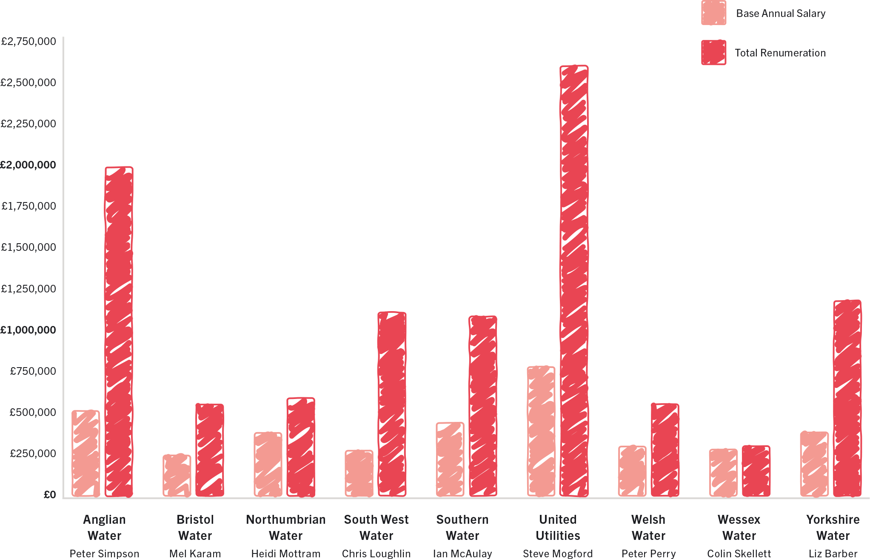

How could the designation of inland bathing waters by water companies affect the costs of achieving the associated water quality standards?
As highlighted in section 3.1.1 the legal obligation that is placed on water companies to improve water quality when a bathing water is officially designated has triggered huge improvements in coastal water quality. 98.5% of the 625 UK designated bathing waters are now classified as excellent, good, or sufficient compared to 1990, when just 27% met the same standards.
During the 2019 bathing season, 306 new bathing sites were identified throughout Europe and 60% of these are situated on rivers and lakes and shows our European neighbours are already committed and successful in restoring and protecting rivers. Whilst the designation of bathing waters is not the sole solution to sewage pollution and does not prevent water users become ill it does provide a starting point to improve water quality in rivers.
SAS would encourage requirements for at least two inland bathing waters to be designated in each water company operation area each year.

Additional information

SAS volunteer to provide formal oral evidence to the committee

SAS 2020 Water Quality Report - https://www.sas.org.uk/wp-content/uploads/SAS-Water-Quality-Report-Digital-v1.pdf

SAS 2019 Water Quality Report - https://www.sas.org.uk/wp-content/uploads/SAS_2019_Water_Quality_Report_Digital-1.pdf

February 2021

Kindermann., E.B., Caitriona Carlin and Gesche (2020) Connecting with Nature for Health and Wellbeing, 2020, http://www.epa.ie/pubs/reports/research/health/JS%20-%20NEAR%20Toolkit%20FINAL%20V1.6%201Oct20.pdf
Environment Agency (2020) The social benefits of Blue Space: a systematic review, October 2020, https://assets.publishing.service.gov.uk/government/uploads/system/uploads/attachment_data/file/928136/Social_benefits_of_blue_space_-_report.pdf
Public Health England (March2020) Improving Access to Greenspace 2020 review, March2020, https://assets.publishing.service.gov.uk/government/uploads/system/uploads/attachment_data/file/904439/Improving_access_to_greenspace_2020_review.pdf
Surfers Against Sewage (2020) Long Time No Sea: Beach Loving Brits Count Down the Days Until They’re Reunited with the Coast • Surfers Against Sewage
DEFRA (2020) New sites to test how connecting people with nature can improve mental health, accessed 27 January 2021, https://www.gov.uk/government/news/new-sites-to-test-how-connecting-people-with-nature-can-improve-mental-health
Cummins, A., and Mills, D.B. (2013) The economic impact of domestic surfing on the United Kingdom, October 2013
Slack, A., Tagholm, H., and Field, A. (2020) 2020 Water Quality Report, 2020, https://www.sas.org.uk/wp-content/uploads/SAS-Water-Quality-Report-Digital-v1.pdf
The English bathing season runs from 15 May to 30 September
Slack, A., Tagholm, H., and Field, A. (2020) 2020 Water Quality Report, 2020, https://www.sas.org.uk/wp-content/uploads/SAS-Water-Quality-Report-Digital-v1.pdf
Leonard, A.F.C., Garside, R., Ukoumunne, O.C., and Gaze, W.H. (2020) A cross-sectional study on the prevalence of illness in coastal bathers compared to non-bathers in England and Wales: Findings from the Beach User Health Survey, Water Research, Vol.176, p.115700
Leonard, A.F.C., Zhang, L., Balfour, A.J., et al. (2018) Exposure to and colonisation by antibiotic-resistant E. coli in UK coastal water users: Environmental surveillance, exposure assessment, and epidemiological study (Beach Bum Survey), Environment International, Vol.114, pp.326–333
BBC Radio 4 (2020) Costing the Earth, Swimming in Superbugs?, accessed 22 October 2020, https://www.bbc.co.uk/programmes/m000mr6r
Environment Agency (2020) Consented Discharges to Controlled Waters with Conditions, accessed 23 September 2020, https://data.gov.uk/dataset/55b8eaa8-60df-48a8-929a-060891b7a109/consented-discharges-to-controlled-waters-with-conditions
European Commission (2020) Urban Waste Water Treatment, 2020, https://ec.europa.eu/environment/water/water-urbanwaste/index_en.html
Slack, A., Tagholm, H., and Dennis, H. (2019) Water Quality Report 2019, October 2019, https://www.sas.org.uk/wp-content/uploads/SAS_2019_Water_Quality_Report_Digital-1.pdf
Slack, A., Tagholm, H., and Field, A. (2020) 2020 Water Quality Report, 2020, https://www.sas.org.uk/wp-content/uploads/SAS-Water-Quality-Report-Digital-v1.pdf
The award-winning Safer Seas Service is the only national real-time water quality service that protects all water users from pollution. The pioneering service alerts water users when sewer overflows discharge untreated human sewage into the sea and when water quality is temporarily reduced due to heavy rainfall and pollution incidents at over 370 beaches across England, Scotland and Wales. https://www.sas.org.uk/safer-seas-service/
Slack, A., Tagholm, H., and Field, A. (2020) 2020 Water Quality Report, 2020, https://www.sas.org.uk/wp-content/uploads/SAS-Water-Quality-Report-Digital-v1.pdf
We would expect an additional 940 CSO notifications, should those water companies have been issuing year-round alerts, bringing the total out of season notifications to 2,686, and total CSO discharge notifications issued over twelve months to 3,434. Slack, A., Tagholm, H., and Field, A. (2020) 2020 Water Quality Report, 2020, https://www.sas.org.uk/wp-content/uploads/SAS-Water-Quality-Report-Digital-v1.pdf
Slack, A., Tagholm, H., and Field, A. (2020) 2020 Water Quality Report, 2020, https://www.sas.org.uk/wp-content/uploads/SAS-Water-Quality-Report-Digital-v1.pdf
WWF (2017) Flushed Away: How Sewage Is Still Polluting The Rivers Of England And Wales, 2017, https://www.wwf.org.uk/sites/default/files/2017-12/Flushed%20Away__Nov2017.pdf
Laville, S., and McIntyre, N. (2020) Exclusive: water firms discharged raw sewage into England’s rivers 200,000 times in 2019, The Guardian
Slack, A., Tagholm, H., and Field, A. (2020) 2020 Water Quality Report, 2020, https://www.sas.org.uk/wp-content/uploads/SAS-Water-Quality-Report-Digital-v1.pdf
Slack, A. (2020) Piping up to #EndSewagePollution: Petition delivered to Government
The detail behind these calls will be explored in response to the specific posed questions.
Bathing Water quality is classified excellent through to poor
Gowen, P., and Eades, S. (2020) Sand, Sea and Sewage. Are English Sea Bathing Waters Safe?, January 2020, http://www.marinet.org.uk/campaign-article/sand-sea-and-sewage
Gowen, P., and Eades, S. (2020) Sand, Sea and Sewage. Are English Sea Bathing Waters Safe?, January 2020, http://www.marinet.org.uk/campaign-article/sand-sea-and-sewage
Jones, B., Cullen-Unsworth, L., R Unsworth. (2018) Tracking Nitrogen Source Using δ¹⁵N Reveals Human and Agricultural Drivers of Seagrass Degradation across the British Isles. Frontiers in Plant Science [online] Available at: https://www.frontiersin.org/articles/10.3389/fpls.2018.00133/full
Salvidge, R. All England’s rivers fail to meet legal water quality standards, accessed 10 October 2020, http://www.endsreport.com/article/1694741?utm_source=website&utm_medium=social
Laville, S. (2020) Environment Agency chief supports plan to weaken river pollution rules, accessed 9 September 2020, https://www.theguardian.com/environment/2020/aug/19/environment-agency-chief-backs-plan-to-water-down-river-cleanliness-rules-james-bevan
British Geological Survey Sustainable drainage systems (SuDS)
DEFRA (2021) Taskforce sets goal to end pollution from storm overflows, accessed 28 January 2021, https://www.gov.uk/government/news/taskforce-sets-goal-to-end-pollution-from-storm-overflows
The key sources of pollution include car tyres (7,000-19,000 tonnes), clothing (150-2,900 tonnes), plastic pellets used to make plastic items (200-5,900 tonnes) and paints on buildings and road markings (1,400-3,700 tonnes). Hann, S., Darrah, C., Sherrington, C., Blacklaws, K., Horton, I., and Thompson, A. (2018) Reducing Household Contributions to Marine Plastic Pollution, p.75 https://cdn.friendsoftheearth.uk/sites/default/files/downloads/reducing-household-plastics_0.pdf
Dunn, C., Owens, J., Fears, L., et al. (2020) An affordable methodology for quantifying waterborne microplastics - an emerging contaminant in inland-waters:, Journal of Limnology, Vol.79, No.1
Dasgupta, P. (2021) The Economics of Biodiversity: The Dasgupta Review, February 2021, https://assets.publishing.service.gov.uk/government/uploads/system/uploads/attachment_data/file/957291/Dasgupta_Review_-_Full_Report.pdf
Laville, S.E. (2020) MP calls for crackdown on raw sewage discharges in English rivers, The Guardian
Nilsen, V., Lier, J. A., Bjerkholt, J. T., & Lindholm, O. G. (2011). Analysing urban floods and combined sewer overflows in a changing climate. Journal of water and climate change, 2(4), 260-271.
Fortier, C., & Mailhot, A. (2014). Climate change impact on combined sewer overflows. Journal of Water Resources Planning and Management, 141(5), 04014073. 8
Tavakol-Davani, H., Goharian, E., Hansen, C. H., Tavakol-Davani, H., Apul, D., & Burian, S. J. (2016). How does climate change affect combined sewer overflow in a system benefiting from rainwater harvesting systems? Sustainable cities and society, 27, 430-438
Christidis et al. 2015. Extreme rainfall in the UK during winter 2013/14: The role of atmospheric circulation and climate change. Explaining Extreme Events of 2014 from a Climate Perspective.
MetOffice UKCP18
Kendon et al. 2014. Heavier summer downpours with climate change revealed by weather forecast resolution model. Nature Climate Change 4, 570–576
Nie, L., Lindholm, O., Lindholm, G., & Syversen, E. (2009). Impacts of climate change on urban drainage systems – a case study in Fredrikstad, Norway. Urban Water Journal, 6(4), 323–332. doi:10.1080/157306208026009
Southern Water (2020) Annual Report and Financial Statement, 2020, https://www.southernwater.co.uk/media/3632/southernwater_ar2020-150720.pdf
Laville, S. (2020) England’s privatised water firms paid £57bn in dividends since 1991, The Guardian
Slack, A., Tagholm, H., and Field, A. (2020) 2020 Water Quality Report, 2020, https://www.sas.org.uk/wp-content/uploads/SAS-Water-Quality-Report-Digital-v1.pdf
Southern water achieved a one-star rating for environmental performance in 2019, were fined £126 million for serious failings in its sewage treatment works and deliberately misreporting in 2019, in 2020 they pleaded guilty in court to deliberately dumping poisonous, noxious substances including untreated sewage into rivers and coastal recreational hot-spots over five years in. (Plimmer, G. (2020) Southern Water in court after pleading guilty to dumping sewage, accessed 28 October 2020, https://www.ft.com/content/3efb3e7b-3388-4f27-85ac-44b00aa1fd37)
https://www.sas.org.uk/water-quality/

