Written evidence submitted by Peter Lloyd
I am a retired scientist, and worked for the Environment Agency and predecessor Authorities for 40 years. My work during this time was involved with pollution prevention of rivers, and I covered a wide range of activities including monitoring, modelling, enforcement, and data analysis. My last years, before retiring, were as Project Scientist for the Thames Tideway Tunnel Project, which required me to produce the scientific evidence necessary to justify the expenditure on this multi-billion-pound project.
The reason for making this submission is that during my career, I experienced many examples of ineffective and costly environmental monitoring. I also developed an understanding of how improvements could be made.
Summary
This submission relates to the chemical monitoring of rivers and effluents, and provides examples of existing bad practice, and suggests ways forward.
- The existing system of surveillance monitoring of rivers and effluents consists, almost exclusively, of taking small numbers of random individual samples during the working day. This method of sampling is referred to as spot sampling.
- The samples that are taken only reflect the conditions that occur at the time of sampling, but rivers and effluents vary considerably in quality as a result of factors such as weather, time of day and river flow.
- Some monitoring has been carried out using technology which provides continuous data. This data shows, overwhelmingly, that the information obtained from spot sampling is not reliable and is extremely misleading.
- Examples are given which demonstrate the substantial problems which arise from the continued use of data derived from spot sampling.
- The Environment Agency has been aware of these problems for many years, and commenced a strategic monitoring review over 5 years ago. This review has been completed, but instead of introducing improvement measures, the Agency intends to continue with the use of spot sampling as an essential part of the new system.
- Details are provided of how an improved monitoring system could be introduced, which would be more cost-effective, and would take full account of known problems and constraints.

1.0 Background
Most of the topics listed in the Call for Evidence require some degree of monitoring in order to quantify the problems and to be able to formulate improvement plans and cost benefits. Monitoring will also be a key factor in assessing compliance with new standards imposed by future legislation. There are a number of different types of monitoring that can be applied to rivers, but this submission only deals with chemical monitoring.
The traditional method of chemical monitoring of rivers has been to take a fixed number of individual, instantaneous samples of river water from selected sites every year. This method (spot sampling) has remained largely unchanged, with samples being taken at monthly intervals on random days and at random times during working hours. Obviously, these samples can only be truly representative of the water quality at the time of sampling. When this monitoring was first introduced, over 40 years ago, there was much less information available on river water quality, so the flaws in the system were not apparent, but in recent years, the Environment Agency has acquired large amounts of continuous monitoring data, which has demonstrated that there is considerable variability in chemical water quality, which makes it impossible to assess the overall condition of the river by taking small numbers of random samples.

2.0 Constraints of Chemical Monitoring

The main factors which cause variability of water quality are summarised below. It is essential to take account of these factors when interpreting data and designing monitoring systems.
2.1 Time of Day
One of the most widely used indicators of river water quality is dissolved oxygen (DO). In many rivers, the DO content varies significantly throughout the day due to plant photosynthesis and respiration. DO levels are normally lowest around dawn and highest in the afternoon. False trends might be assumed if no account is taken of sampling time. Figure 1 shows the diurnal variation of DO that occurs in a river.
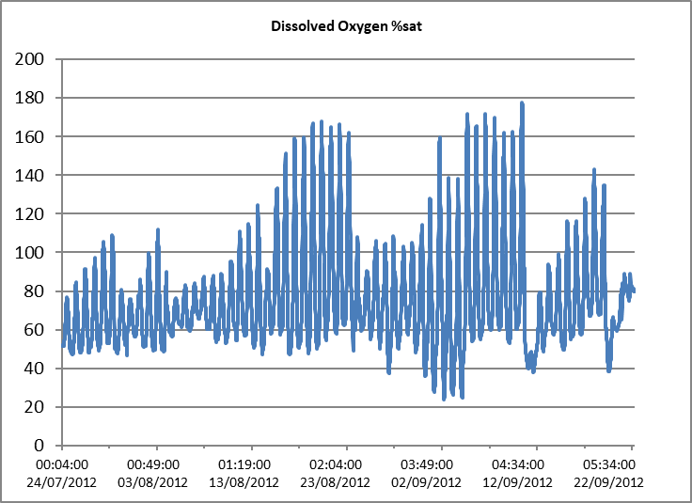
Figure 1. DO %Saturation of the Salmons Brook July – September
2.2 Rainfall and River Flow
Weather related events, particularly rainfall, can have a very significant effect on river and effluent quality. Wet weather discharges occur from sewage treatment works, combined sewer overflows, and run-off from agricultural and urban areas. The impact on the river might only be of short duration, but can have a harmful effect on the ecological status of the river. Because of the intermittent nature of these events, there is only a very small chance of random sampling coinciding with an event. Figure 2 shows, using data from a continuous monitoring site, how the river can be affected by untreated sewage effluent during heavy rainfall. On this occasion, the high ammonia concentration and low DO would have had a serious effect on river ecology, but wasn’t detected by random sampling.
Figure 2. Effect of Wet Weather Sewage Discharge on River
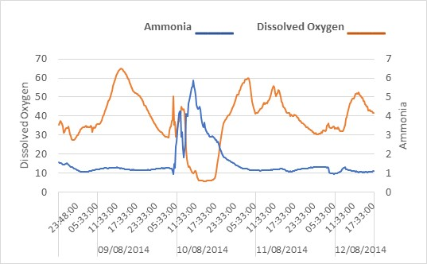
In addition to the high impact events that can be caused by rainfall, the concentration of all chemical substances in river water varies according to river flow. Some substances will be diluted by higher flows, whilst others will be increased due to contaminated run-off and discharges. High flows also resuspend sediment from the bed of the river, which will affect the quality of samples taken under different flow conditions.
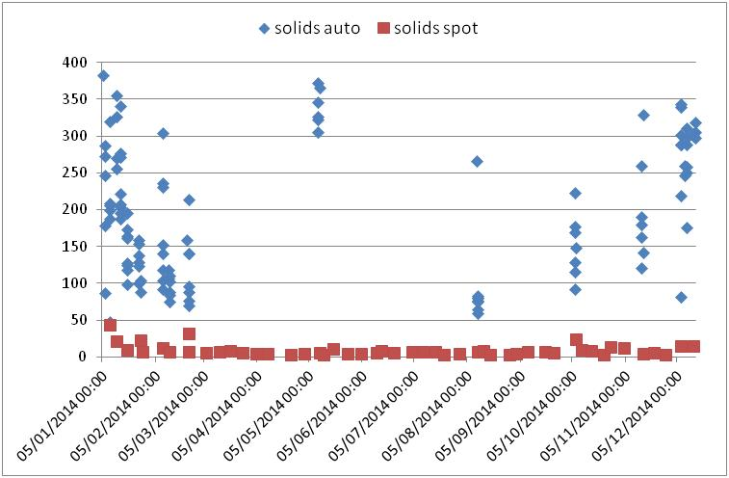
Fig 3. Variability of Water Quality During Wet Weather
Figure 3 shows how water quality at a river site is affected by wet weather and river flow. The chart shows data sets consisting of samples taken during dry weather (red markers) and during wet weather (blue markers). It can be seen that the dry weather samples contain low concentrations of solids, whilst the wet weather samples have higher concentrations of solids. This shows how the effect of wet weather has implications, not just for the monitoring of solids, but for monitoring any other substance, such as metals and pesticides, that are associated with solids or run-off, and demonstrates the difficulty of attempting to characterise river quality by taking random spot samples.
2.3 Discharges of Sewage Effluent
Chemical water quality in many rivers is dominated by sewage effluent discharges, so it is essential that any interpretation of river quality data takes full account of the quality of sewage effluent that is discharged upstream.

Fig. 4. Ammonia Concentration in Sewage Effluent for One Month
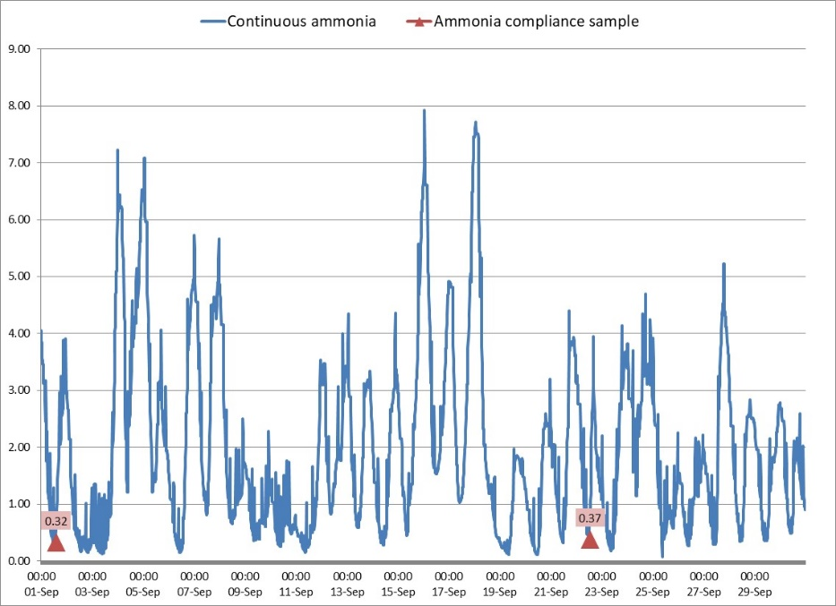
The blue trace in Figure 4 shows the continuously recorded ammonia concentration of the discharge for one month, with the two spot samples taken for compliance assessment shown as red markers. This chart shows a pronounced diurnal variation in quality, with worst quality being discharged outside working hours, which means that the samples taken for compliance assessment during working hours do not reflect the real picture of effluent quality.
2.4 Implications of Variability in Quality
The reliance on spot sample data generated by the monitoring programme means that the problems outlined above are not merely of academic interest, but have far reaching consequences:
- It is not possible to identify intermittent events which have a critical impact on the river.
- There is incomplete knowledge regarding the quality of sewage effluent discharges.
- Sources of pollution cannot be identified.
- Trends in quality cannot be detected.
- River water quality models that have been constructed using spot sample data will not produce reliable outputs.
3.0 Diffuse Pollution
A specific example of how random spot sample data gives rise to false conclusions, is in the case of diffuse pollution. The origin of the perceived importance of diffuse pollution can be traced back to the production of river quality models, which did not produce outputs that matched observed data in rivers. The assumption was then made that there must be another source of pollution that hadn’t been included in the model.
Although the concept of diffuse pollution is not unreasonable, the scale and source of this pollution input has never been convincingly demonstrated. This is because of the unreliable nature of the spot sample data that has been used in the formulation of the model and has been observed in the river data. Paragraph 2.3 above demonstrates that, in the case of sewage effluent discharges, it is highly likely that there will be a discrepancy between the actual effect on the river and the effect that is assumed from the effluent spot samples. If any further work is required to quantify diffuse pollution, it is essential to have access to improved river quality data
4.0 Environment Agency Monitoring Review

A Strategic Monitoring Review has been undertaken by the Environment Agency over the last 5 years, at a cost of well over £1M. It would be expected that there would be detailed documentation available on the strategic processes and the scientific knowledge that were used during the review, and that there would be information on any trials that have been undertaken, together with an evaluation of different options and cost benefits. This information has not been made available by the Environment Agency.

4.1 Proposed New Monitoring System

The Agency claims to be fully aware of the constraints of chemical monitoring, and is proposing to introduce a new monitoring scheme based on the GRTS (Generalised Random Tessellation Stratified) system, but this proposed system completely ignores the basic scientific facts that have been presented above.

4.2 Random Sampling Points

The new GRTS monitoring sites have been selected randomly, taking no account of any existing knowledge, and many will be at locations that do not provide worthwhile and relevant information. The proposed new system has, therefore, ignored all of the knowledge that has been acquired over the last 40 years on the factors that affect water quality. For example, areas that are known to be at risk from diffuse pollution might no longer have monitoring sites in key locations.

4.3 Emerging Pressures/Trends

One of the main stated Agency objectives is to identify trends and emerging pressures, but chemical monitoring should only form part of an overall strategy in partnership with other organisations, to assess the nature of any likely change that might reasonably be expected to occur, together with the potential environmental consequences of such an occurrence. If monitoring is considered to be advisable, it would need to be targeted to sites and conditions that have been identified as at risk. It is also essential to take account of the likely pathways by which any individual pressure might affect river water quality, and to design an effective monitoring strategy, which would vary according to the nature of the threat. For example, it can be seen from Figure 3 that, for some substances, wet weather conditions are likely to be critical, so under these circumstances, it would be anticipated that surveillance monitoring would be targeted to these conditions.

It is difficult to conceive of any likely situation where monitoring would be cost-effective by selecting random sites and random sampling, in the expectation of detecting an unknown trend that might appear at any location at any time, yet this is the approach that is being adopted by the Agency, and takes no account of priorities, strategic thinking, or science.

4.4 Priorities

It is always necessary to be aware of the fact that, whatever the political climate might be, there will always be limits on funding that will preclude the possibility of doing everything that is desirable. It is therefore essential to take account of the fact that resources are likely to be scarce, and that risk-based priorities need to be developed to ensure that the resources that are available are targeted effectively.

The proposed GRTS system takes an approach which is contrary to this, by concentrating resources to achieve some vaguely defined objectives at the expense of dealing with existing well-known problems. Instead of targeting the monitoring to known problems, and using well established scientific principles to establish monitoring priorities, the GRTS strategy involves monitoring random sites and taking random samples that will have no value whatsoever. A proper targeted risk-based approach should be developed in order to ensure that every sample counts.

4.5 Value of Outputs from GRTS

The GRTS system will combine the data from all of the sampling points on all of the rivers into one database, from which summary statistics will be produced. This pooling of data from all sites cannot be justified, because there are large fundamental differences between data obtained from different sampling points. The merging of data from all points on all rivers will produce composite data that will be impossible to interpret and of no value when attempting to quantify specific problems.

5.0 Ways Forward
The most cost-effective way forward is to discontinue the use of random spot sampling and increase the use of continuous monitoring. For those substances, such as complex organic chemicals, that require laboratory analysis, automatic sampling devices can be used which can be remotely activated at the optimum time for obtaining the required data. Continuous monitoring technology has been used successfully for many years for local investigatory work, but for unknown reasons, has not been considered for surveillance monitoring. A major advantage of the use of continuous monitoring is that the data obtained can provide a high level of certainty of the condition of a river and the causes of pollution, thus alleviating the need to apply complex statistical processes.

Continuous monitoring is very versatile and can fulfill many objectives. A small number of sites chosen to reflect different pressures and potential risks can be used for surveillance monitoring, and will provide long term comprehensive data, that will identify the status of the river and will detect change. Continuous monitoring can also be used in short-term bursts to establish the patterns of quality variations, which can then be used to target future sampling to the conditions that are of interest.
It is sometimes claimed that continuous monitoring is very expensive, but if a detailed cost benefit analysis is made between a conventional random spot sampling scheme and continuous monitoring, it is likely that the benefit attached to the random sampling will be close to zero. This is because, as mentioned above, random sampling is very unlikely to capture the most important and relevant events and can be very misleading. It is therefore preferable to have comprehensive data from a smaller number of high priority sites rather than unreliable data from a larger number of sites.

If objectives are defined with absolute clarity, continuous monitoring and targeted sampling can focus on obtaining the specific data required to meet an objective, and will obtain more useful data in a few weeks than can be achieved by many years of random sampling.

The need to follow clear priorities will inevitably mean that there will be no chemical monitoring at sites with a low priority ranking, but for these sites, there should be a plan to incorporate participation of local communities and the Rivers Trust to carry out local work, which would help to ensure that the lower priority sites, which are not included in the main programme, would receive some form of surveillance.

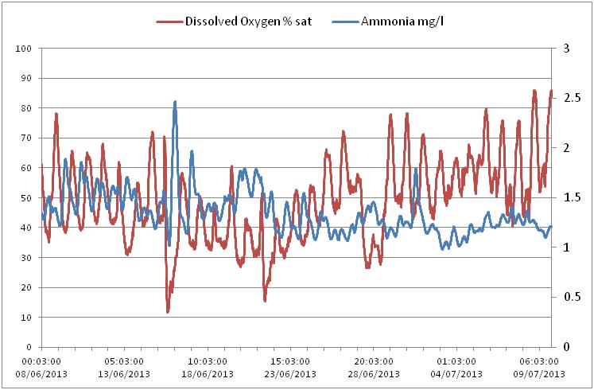
Fig, 5 Variation of Ammonia and DO at Springfield – River Lee

Figure 5 demonstrates the value of continuous monitoring, and shows for one river site, how the taking of just one random sample every month is of little value and has the potential to also be extremely misleading

6.0 Conclusions

- The factors that have been highlighted above, demonstrate that it cannot be justified to continue with the use of random spot sampling as part of any monitoring strategy, but people have grown accustomed to the strategy of random spot sampling, and there is a great reluctance to change to a more effective system. It is also a commonly held, but erroneous, belief that the use of statistical processes compensates for the inadequacies of random sampling. Unfortunately, very often the use of statistical processes conceals the problems rather than eliminating them.

- It is essential for any monitoring strategy to be based on clear objectives and focused on priorities. In defining objectives, consideration should be given to precisely what data is required, who will use it, for what purpose and what the benefit will be. This has not happened in the case of the Agency monitoring review.

- The constraints imposed by chemical monitoring due to the variability in quality of rivers and effluents are substantial, and cannot be ignored. When the objectives have been defined, the monitoring should target the situations, sites and times where monitoring is likely to be most effective at producing the information that is required. Random sampling at random locations will not be a cost-effective method, because there will always be doubt regarding the relevance of the data, particularly with regard to intermittent impacts and quality variations.

- Continuous monitoring will quickly highlight the conditions that need to be focused on, and can ensure that samples required for complex analysis are only taken at the optimum time to provide the most valuable information and reduce laboratory costs.

- Where statistical processing of data takes place, it is important that the final outputs are still understandable in the context of the objectives. It is often the case that a statistic might be justifiable in terms of the mathematical process, but will be of no help in understanding the dynamics of river quality, and in achieving the desired result.

- The points that have been highlighted in this paper do not relate to minor technicalities nor to complex science, but are based on well-established scientific knowledge that has been gained over many years, and is demonstrated by the charts which are presented in this paper. The Environment Agency holds a wealth of similar data that is freely available and easy to understand, and which confirms the points made in this paper. Regrettably, instead of translating this information into a credible and effective form of monitoring, the Agency has decided to continue with the discredited and unreliable method of random spot sampling.

February 2021

