Written evidence by Dr Dusana Dorjee (ECA0125)

Education Committee
Every Child Achieving and Thriving’ White Paper

Policies on children’s achieving and thriving need to be anchored in understanding of children’s wellbeing neurodevelopment

Dr Dusana Dorjee is a Senior Lecturer in Psychology in Education at the University of York where she leads the Well Minds Lab and the Psychology in Education Research Centre.
Dr Dorjee’s translational neuroscience research programme on mental health and wellbeing neurodevelopment combines her expertise in cognitive neuroscience and clinical psychology. She investigates psychological and neural processes underpinning mental health and wellbeing and works on ‘translating’ new understanding of these processes into interventions, school curricula and policy.

Summary
Rigorous research evidence shows that children’s mental health and wellbeing capacities are central to their life-long achieving and striving. A new framework of child and adolescent mental health and wellbeing neurodevelopment specifies these capacities, and associated brain networks, from a translational perspective - to inform educational policy and practice. This framework highlights two key capacities - the self-regulation capacity and the self-world capacity. These capacities determine children’s achievement and thriving in each area considered in the White Paper. For example, effective self-regulation is a key prerequisite for children’s learning. And children’s self-world capacity is strengthened in schools with a strong sense of belonging and better wellbeing of teachers. Effective fostering of these capacities can also help bridge achievement gaps and reduce numbers of young people not in education, employment or training, if embedded into education alongside policies addressing socio-economic and other inequalities. Therefore, anchoring policies aiming to improve children’s achievement and thriving in research-based understanding of mental health and wellbeing capacities can enhance policy focus, effectiveness and accountability, including greater value for money spent on initiatives.

Context

Research indicates that supporting children’s wellbeing is the key to both their achieving and thriving. Children who are better able to adaptively manage their thoughts, emotions and behaviours are better able to learn (e.g., Cárdenas et al., 2022). Similarly, children who have positive peer-relationships, greater sense of school belonging, as well as strong sense of agency and purpose, thrive in education and beyond (e.g., Korpershoek et al., 2020). The White Paper includes several recommendations that may improve wellbeing of children, but it can be strengthened further by more specific neuroscience-based considerations about key capacities that underpin children’s wellbeing and ways these can be effectively fostered in education. This written evidence outlines how new understanding of neurodevelopment underpinning wellbeing capacities can inform effective policies on children’s achieving and thriving.

Despite a range of initiatives introduced over the past decade, support of children’s wellbeing in schools has been limited by lack of understanding of processes in the mind and brain underpinning wellbeing. A new neuroscience-based framework of wellbeing development addresses this gap and allows for ready translation of the new understanding into school policies and practice to effectively foster children's life-long achieving and thriving. The framework - called Neurodevelopmental Theory of Mental Health and Wellbeing Capacities (NDeTeC) - specifies neurodevelopment of two key capacities underpinning children’s mental health and wellbeing - the self-regulation capacity and the self-world capacity. The NDeTeC has already been translated into a new wellbeing curriculum for primary school children developed by the PSHE Association in partnership with University of York (‘Foundations for Wellbeing’; PSHE Association, 2026). And, as this written evidence shows, alongside implementation of this curriculum, the NDeTeC can strengthen a wider policy on children’s achieving and thriving.

Why and how does self-regulation capacity support
children’s achieving and thriving?

The self-regulation capacity specifies processes in the mind and brain underpinning children’s ability to effectively and adaptively manage their thoughts, emotions and behaviours (Dorjee, 2026). Rigorous research shows that children’s self-regulation is a strong predictor of their academic achievement, their life-long mental health and wellbeing, and even their employment success and engagement in crime in adulthood (Moffitt et al., 2011; Robson et al., 2020). Therefore, the self-regulation capacity is a key target across educational initiatives for children to achieve and thrive in education and beyond (e.g., Pandey et al., 2018). Improvements in the self-regulation capacity will most likely raise children’s attainment, improve their school attendance, reduce numbers of young people not in education, employment or training, and reduce attainment gaps.

The NDeTec (Dorjee, 2025; 2026) specifies a progression of five facets of the self-regulation capacity that need to be gradually fostered in age-appropriate ways across the the school years: emotional awareness, managing of distractions, cultivation of healthy habitual thoughts and emotions, and managing of reactivity, rumination and worry. These facets are associated with development of large scale brain networks including the triad of salience, executive and default mode networks (enabling monitoring and managing of attention, emotions and behaviours), reward network (responding to rewarding experiences) and the HPA axis (underpinning the stress response) (see Figure 1).

Specification of these facets and associated brain networks together with their development enables refinement of mental health and wellbeing curricula which was previously not possible (see Dorjee, 2025 for examples). It also creates the basis for effective research-based teacher training on fostering mental health and wellbeing in children that is currently limited (Stubbs & Dorjee, 2026). And it can facilitate effective anchoring and evaluation of education policies that aim to improve children’s achievement and thriving.
- Without such anchoring, the policies may include gaps in age-appropriate systematic fostering of the different facets of the self-regulation capacity and thus be less effective in supporting healthy development of this capacity in children, limiting their achieving and thriving.
- In addition, improvements in children’s self-regulation capacity can serve as early indicators of improvements in their achievement and thriving that will manifest in actual grades and mental health/wellbeing of children over years. Such early assessment ensures that public funds are spent in more effective ways.

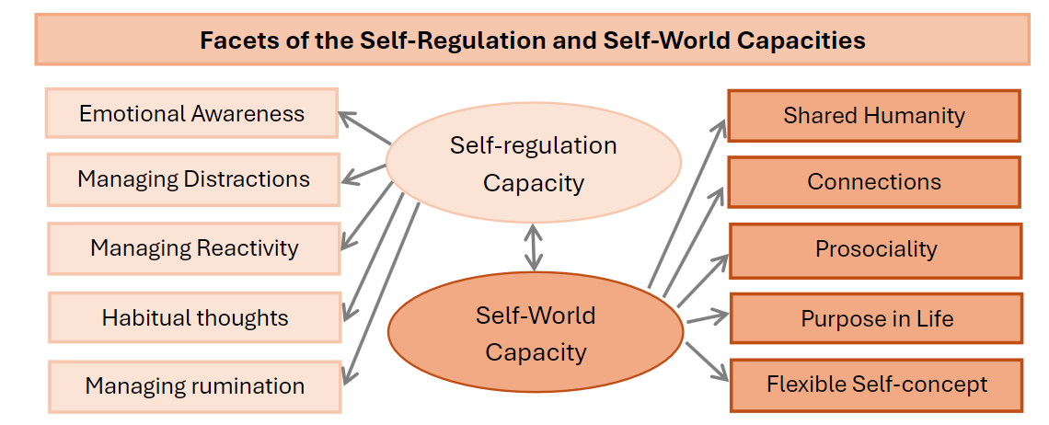

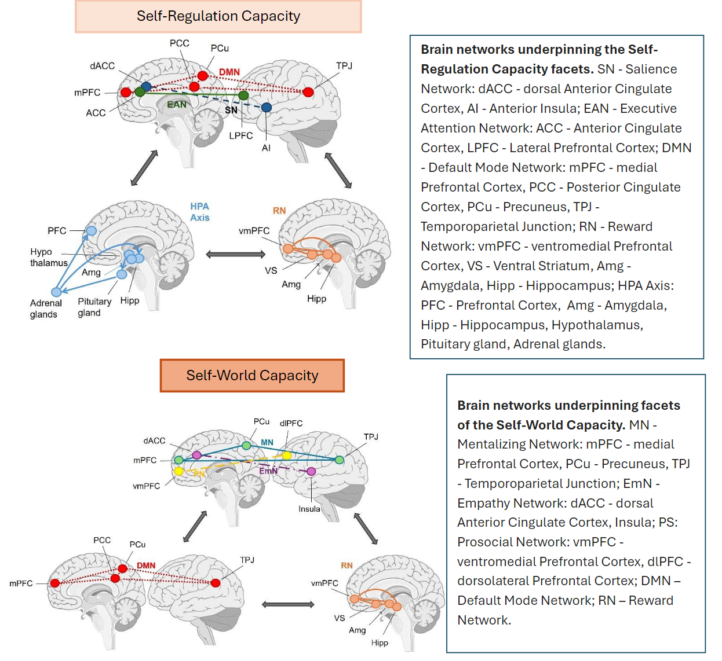

Figure 1. Key concepts of the Neurodevelopmental Theory of Mental Health and Wellbeing Capacities (NDeTeC). Figures adapted with permission from Dorjee (2026).

Why and how does self-world capacity support
children’s achieving and thriving?

Research indicates that effective fostering of the self-regulation capacity in children needs to be accompanied by cultivation of relational wellbeing to support their achievement and thriving (Dorjee, 2026). Positive relationships and social competencies are strong determinants of children’s wellbeing that are likely to improve their achievement, school attendance and engagement (e.g., Kiuru et al., 2020). Similarly, children’s sense of connectedness, sense of purpose and prosocial agency all support their achieving and thriving (e.g., Dorjee, 2025; Yeager et al., 2014; Shoshani & Russo-Netzer, 2017). The challenge is that both in research and in practice these different relational wellbeing qualities are typically considered in isolation. The NDeTeC framework offers a new integrated perspective on the processes in the mind and brain linked to relational wellbeing - the self-world capacity specifically underpins development of children’s connected, flexible, ethically grounded and purposeful sense of self in support of their long-term wellbeing (Dorjee, 2026).

Just like the self-regulation capacity, the self-world capacity is further specified in terms of five facets: shared humanity, connections, agency, purpose in life and flexible sense of self. Brain networks underpinning the self-world capacity include the mentalizing network (reasoning about one’s own and others' mental states), empathy network (affective relating to others), prosociality and reward networks (engaging in behaviours that benefit others) and default mode network (identity formation, moral reasoning and purpose in life). Adaptive functioning in the brain networks associated with the self-world capacity, and their healthy development, predicts better long-term mental health and wellbeing outcomes in children (Dorjee, 2026).

Importantly, the facets of the self-world capacity have been translated into learning objectives and activities that can foster the capacities as part of school curricula (Dorjee, 2025). Systematic understanding of the self-world capacity and its facets can also help anchor and evaluate relational wellbeing policies proposed in the White Paper on every child achieving and thriving.
- The NDeTeC enables identification of gaps in age-appropriate systematic fostering of the self-world capacity facets in the proposed policies and can inform their further refinement to ensure their maximum effectiveness in supporting children’s achieving and thriving.
- Alongside assessments of changes in the self-regulation capacity, improvements in children’s self-world capacity can provide further early indicators of improvements in their achievement and thriving. This can ensure early identification of policies that lead to expected positive changes in children’s achievement and thriving, and those that are less effective, to ensure cost effectiveness of public spending on the new policies and initiatives.

Key policy recommendations:
- Specify how each of the policies/initiatives proposed in the White Paper will contribute to systematic fostering of children’s self-regulation and self-world capacities.
- Systematically assess effectiveness of the proposed policies/initiatives in supporting children’s self-regulation and self-world capacities to ensure best value for money invested in the proposed changes.
- Expand the policy to include specific guidance on systematic age-appropriate fostering of the self-regulation and self-world capacities through school mental health and wellbeing curricula within PSHE and whole school approaches.
- Provide CPD training for all teachers on neurodevelopment of self-regulation and self-world capacities and its links to achievement and thriving of children.
- Make support of teachers’ self-regulation and self-world capacities part of the ‘Improve Workload and Wellbeing for School Staff’ initiative since teacher’s wellbeing capacities impact on children’s wellbeing capacities and vice versa.
- Make assessment of children’s improvements in self-regulation and self-world capacities part of Ofsted evaluations of schools on how they support children’s achievement and thriving.
- Create a task-force to assess and recommend wellbeing programmes and initiatives to schools based on whether and to what extent they foster the self-regulation and self-world capacities to ensure cost effective spend of public funding. The task force could be led by the current national body and subject association for PSHE which has already been providing quality assurance and guidance on how to identify high quality resources.

References:

Cárdenas, D., Lattimore, F., Steinberg, D., & Reynolds, K. J. (2022). Youth well-being predicts later academic success. Scientific Reports, 12(1), 2134.

Dorjee, D. (2025). Making Sense of Mental Health and Wellbeing in Primary Schools: A Practical Neuroscience-based Guide. Taylor & Francis.

Dorjee, D. (2026). Conceptualising child and adolescent mental health and wellbeing neurodevelopment: An integrative brain networks framework. New Directions in Child and Adolescent Development. https://doi.org/10.1155/cad/3489051

Kiuru, N., Wang, M. T., Salmela-Aro, K., Kannas, L., Ahonen, T., & Hirvonen, R. (2020). Associations between adolescents’ interpersonal relationships, school well-being, and academic achievement during educational transitions. Journal of youth and adolescence, 49(5), 1057-1072.

Korpershoek, H., Canrinus, E. T., Fokkens-Bruinsma, M., & De Boer, H. (2020). The relationships between school belonging and students’ motivational, social-emotional, behavioural, and academic outcomes in secondary education: A meta-analytic review. Research papers in education, 35(6), 641-680.

Moffitt, T. E., Arseneault, L., Belsky, D., Dickson, N., Hancox, R. J., Harrington, H., ... & Caspi, A. (2011). A gradient of childhood self-control predicts health, wealth, and public safety. Proceedings of the national Academy of Sciences, 108(7), 2693-2698.

Pandey, A., Hale, D., Das, S., Goddings, A. L., Blakemore, S. J., & Viner, R. M. (2018). Effectiveness of universal self-regulation–based interventions in children and adolescents: A systematic review and meta-analysis. JAMA pediatrics, 172(6), 566-575.

Robson, D. A., Allen, M. S., & Howard, S. J. (2020). Self-regulation in childhood as a predictor of future outcomes: A meta-analytic review. Psychological bulletin, 146(4), 324.

PSHE Association, Foundations for Wellbeing, 2026, https://pshe-association.org.uk/foundations-for-wellbeing-curriculum.

Shoshani, A., & Russo-Netzer, P. (2017). Exploring and assessing meaning in life in elementary school children: Development and validation of the meaning in life in children questionnaire (MIL-CQ). Personality and Individual Differences, 104, 460-465.

Stubbs, J. E., & Dorjee, D. (2026, March 16). What are primary school pupils taught about mental health and wellbeing in England? Findings from a brief nationwide mixed-methods survey. Retrieved from https://osf.io/preprints/edarxiv/9ch6x_v1

Yeager, D. S., Henderson, M. D., Paunesku, D., Walton, G. M., D'Mello, S., Spitzer, B. J., & Duckworth, A. L. (2014). Boring but important: a self-transcendent purpose for learning fosters academic self-regulation. Journal of personality and social psychology, 107(4), 559.

September 2026

