Dr Nigel Moor and Prof Doug Clelland – Written evidence (NTB0015)
- This document is a detailed submission critiquing and analysing the proposed development of new towns, particularly Tempsford, in relation to infrastructure, planning, and environmental considerations within the UK government’s housing and urban development programs.

Overview of the New Towns Programme and Tempsford Project
- The document critically examines the planning, delivery, and placemaking challenges of the UK’s new towns programme, with a focus on the proposed Tempsford development, highlighting issues of integration, governance, infrastructure, and environmental sustainability.
The Role and Operation of the Proposed New Towns Locations
- The seven proposed new towns aim to deliver approximately 191,000 homes over a decade, but face challenges due to a number of factors:
        - The private sector controls about 75% of house production, contrasting with post-war public-led models.
        - Housebuilding in the current parliamentary term is estimated to reach 706,000 homes, only 47% of the initial 1.5 million homes target.
        - Existing land banks and speculative schemes may hinder new town development.
        - The programme risks disrupting overall housing delivery if not carefully coordinated.
        - A successor to the New Towns Commission should oversee private sector engagement to prevent market inertia.

Delivery and Planning Strategies for New Towns
- The current approach lacks integration with the private sector and sub-regional markets, risking delays and ineﬃciencies; historical models used Development Corporations with special legal mechanisms for swift, large-scale development.
    - The post-war model involved central government-led Development Corporations with special planning powers.
    - Special Development Orders enabled deemed consent, speeding up development.
    - The current hybrid planning approach creates uncertainty and delays.
    - Establishing a dedicated New Towns Development Corpora3on is recommended for better governance.
    - The original model prioritized placemaking, masterplans, and fast-tracked approvals, which are lacking now.
    - The new approach risks losing the benefits of the post-war development model, potentially leading to failure.

Governance and Funding of New Towns
- The current government oﬀer lacks the robust support and ﬁnancial backing of the original post-war model, risking instability and ineﬀec3ve delivery. The original New Towns Act 1946 established Development Corporations with strong government backing. The new programme’s governance is fragmented, with no clear commitment to Treasury-backed Development Corporations. Past criticism highlighted insuﬃcient community consultation; this can be addressed with modern governance models. The oﬀer suggests a mix of initiatives but lacks the ﬁnancial stability that enabled rapid development historically. A clear statement on establishing Development Corporations with Treasury support is necessary for success.

Critical Infrastructure and Transport Challenges for Tempsford
- Decisions on infrastructure, especially the EWR route and A421 road, undermine placemaking principles, with high embankments and separated stations creating physical and social barriers.
- The EWR route alignment 1C passes north of the A421, creating a rural ‘wall’ and separation.
- The station interchange is split into northern and southern parts, separated by at least 200 metres, leading to poor pedestrian experience.
- The current station design is hostile, with bleak underpasses prone to graﬃti and antisocial behaviour.
- The A421 dual carriageway is built on an 8m high embankment, with limited north-south connections.
- The design increases noise and reduces accessibility, contradicting placemaking principles.
- The separation of platforms and stations hampers seamless transport integration.
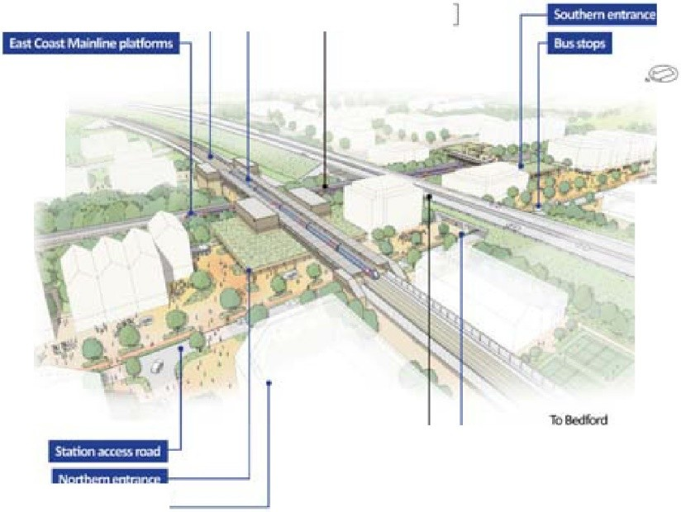
Fig 1 An indicative aerial illustration of Tempsford Station. Source East West Rail. Placemaking and Environmental Concerns for Tempsford
- The current infrastructure decisions and design proposals fail to meet placemaking principles, resulting in poor density, safety, and environmental standards.
  - The station and interchange design are fragmented, unattractive, and unsafe.
  - The transport infrastructure fosters rurality and car dependency, contradicting transit-oriented development goals.
  - Flood risk management should be innovative, turning ﬂood events into assets with landscape design.
  - The proposed design does not support active travel, green spaces, or community facilities, undermining health and safety objectives.

Challenges and Risks for the Tempsford Development
- Recent infrastructure decisions threaten the success of the Tempsford new town, risking failure due to siloed working and inadequate placemaking.
    - The decision to adopt alignment 1C reduces the potential for a central, integrated station.
    - The early construction of ECML platforms before EWR arrival creates a split, hostile station environment.
    - The separation and design of the interchange undermine the vision of a vibrant, accessible town square.
    - Infrastructure choices, such as the high embankments and limited connections, hinder walkability and community integration.
- The current proposals risk creating a ‘failure’ scenario, with rurality, poor design, and lack of seamless transport integration contradicting placemaking principles. A more integrated, compact, and well-designed infrastructure plan is essential for a successful, world-class new town.
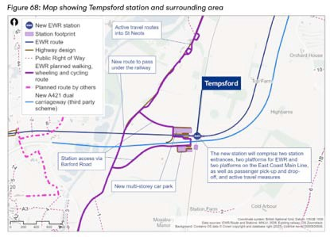
Fig 2 A separated rather than an integrated station interchange. Source East West Rail.

Long-term Stewardship and Community Engagement
- Eﬀective management of communal assets and active community involvement are essential for sustainable new towns.
- A long-term stewardship model should be established from the start, including governance and funding structures.
- Community engagement must be clear and eﬀective, empowering residents to shape vision, build social capital, and deﬁne cultural identity.
- Current consultation practices are siloed and isolated, needing improvement.
- The appearance and location of the Tempsford new town’s broad location are misaligned with key transport infrastructure, raising concerns.
- Reassessing the EWR alignment and reﬁning spatial strategies are necessary for better integration and eﬀectiveness

Improving Station Interchange Design and Town Structure
- A well-designed, integrated station and a vision-led town are crucial for successful placemaking and reducing car dependency.
- The current station plans are ﬂawed, resembling detached parking lots rather than vibrant town centres.
- The station should be moved closer to the A421, with tracks running parallel within 15-20 meters, to create a fully indoor, accessible interchange.
- A ground-level hall with an upper deck, spanning the ECML and EWR, would eliminate tunnels and outdoor walks, fostering a lively civic space.
- The station design should include shops, waiting areas, and possibly a shared public facility like an AI forum.
- The town should be vision-led, supporting high-density, mixed-use, walkable development aligned with Transit-Oriented Development principles.
- A strategic road from Black Cat Roundabout to the station, along with reﬁned EWR alignment, would create a compact, high-density urban core.
- The town’s design emphasizes high-quality, sustainable infrastructure, with a focus on placemaking, dense neighbourhoods, and environmental mitigation.

Spatial Strategy and Land Use Planning
- A refined spatial strategy aims to create a compact, high-density new town with well-planned neighbourhoods and satellite communities.
- The core town would have 25,000 dwellings on 690 hectares, with an average density of 50 dwellings per hectare.
- The total land area is 1200 hectares, with 920 hectares developable and 280 hectares for open space.
- The population is projected at 57,500 across the entire area, with a mix of high-density housing and micro-district neighbourhoods.
- Satellites, about 15 in total, would house 1,000 dwellings each, totalling 15,000 homes and 37,500 people.
- Satellites should have local centres with amenities and respect the legacy of RAF Tempsford, especially for car-dependent uses.
- The development aims to balance environmental constraints, the existing village character and the opportunities presented by this exceptional transport interchange.
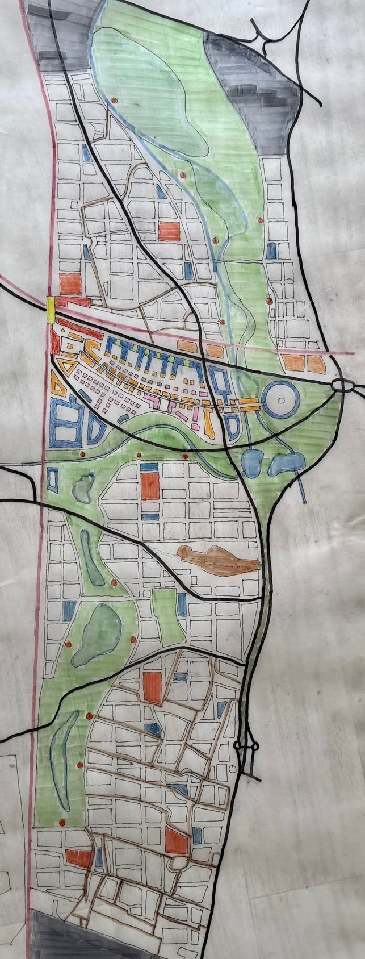

Fig 3 The Spatial Strategy for Tempsford

Environmental and Cumulative Effects Management
- The development will have significant long-term impacts on economy, society, and environment, requiring mitigation.
- Positive effects include job creation, affordable housing (40%), and health benefits.
- Negative impacts involve loss of greenfield land, landscape
- Infrastructure and transport pressures are higher in the South, risking overburdened road networks.
- Cumulative effects include landscape degradation, soil conversion, and environmental impacts, but can be mitigated.
- Long-term benefits depend on strategic infrastructure delivery, early transport investments, and sustainable design.
- Partnerships between government, Development Corporations, and private sector are vital for effective delivery and risk management.
Practical Methods for Monitoring and Mitigation
- Implementing advanced, data-driven urban management and active mitigation strategies is essential for sustainable development.
- Monitoring should use high-resolution ecosystem data, digital governance, and real-time compliance portals.
- Active mitigation includes climate resilience, flood protection, active travel infrastructure, and energy management.
- Technologies like digital twin utility mapping and performance-based monitoring are UK-ready.
- Practical challenges include developer viability, public opposition, GDPR hurdles, and the need for political will.
- Infrastructure-led phasing and long-term certainty are key to successful implementation.
- Maintaining densities of 50–80 dwellings per hectare supports the ‘10-minute city’ model and placemaking goals.
Conclusion and Recommendations
- The Tempsford project has the potential to demonstrate a sustainable, high-quality approach to new town development, requiring ambitious and robust planning.
- The project should adopt innovative, long-term stewardship, integrated transport, and placemaking principles.
- A cooperative partnership model involving government, Development Corporations, and private sector is essential.
- Emphasis on early infrastructure delivery, environmental mitigation, and community engagement will be critical.
- The goal is to position Tempsford as a world-class example of sustainable, inclusive, and economically vibrant new town development.
- A Tempsford new Town Development Corporation should become integral with the Greater Cambridge Development Corporation.
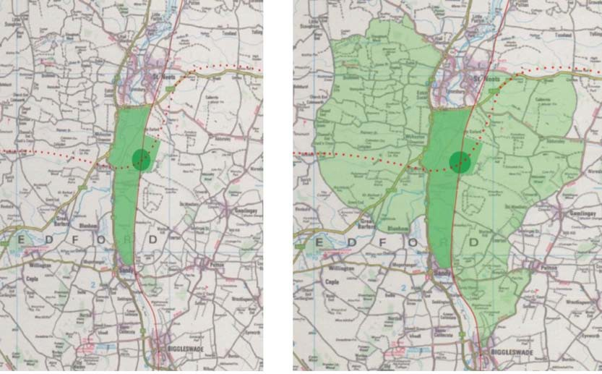
Fig 4 The compact inner new town / land where satellites would be located

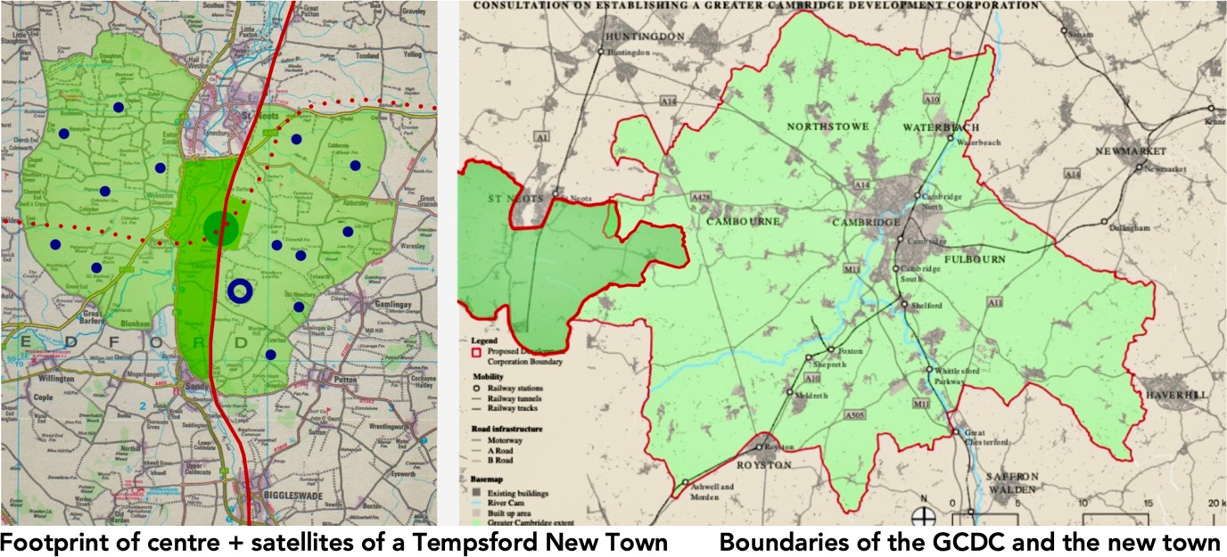
Fig 5 Integration of Tempsford New Town with the Greater Cambridge Development Corporation.
- As the figure above illustrates, these two initiatives lie immediately adjacent to one another. In terms of making the most of the planned East-West rail route connecting Oxford to Cambridge, the projected Tempsford rail interchange with the East Coast Main Line (within a dense town centre) will provide fast links to London, Edinburgh and beyond, making the new town a natural place for the location of science and technology campuses, and other enterprises. It seems logical that these two initiatives be conjoined by the extension of the boundary to the GCDC, thereby giving both the ‘Oxford-Cambridge Growth Corridor’ and Greater Cambridge peak impetus. It will also enable the GDDC to take a comprehensive view of investment opportunities and infrastructure priorities in the enlarged area.
10 July 2026

