Written evidence by Mrs Polly Coupee (ECA0007)
My evidence raises a wider concern than my son’s individual case. Through Freedom of Information requests, Subject Access Requests and formal complaints, I obtained disclosures from Kent County Council relating to its administration of Special Access Arrangements for the Kent Test. Those disclosures appear to show departures from the Council’s published process for determining reasonable adjustments for disabled children and raise questions about compliance with the Equality Act 2010.
The most significant issue is what happened after those concerns were identified. Despite detailed evidence being provided to the Council, the process continued unchanged. There was no independent regulator or government body able to require the Council to investigate the concerns, suspend the process, or implement corrective action while the issues were examined.
Instead, the only practical route available has been lengthy legal proceedings, including tribunal litigation. During that time, the same admissions process continues to be used for future applicants, meaning any systemic issues may continue to affect other children before they are independently determined.
In my view, this exposes a significant gap in the admissions system. Parliament has created statutory duties, including duties under the Equality Act 2010, but there appears to be no rapid and effective mechanism to ensure compliance where there is credible evidence that a local authority’s admissions practices may have departed from published policy or legal requirements.
I would ask the Committee to consider whether stronger independent oversight is needed where local authorities administer admissions processes affecting disabled children, so that concerns about legality and fairness can be investigated promptly, remedied where necessary, and prevented from affecting future applicants.

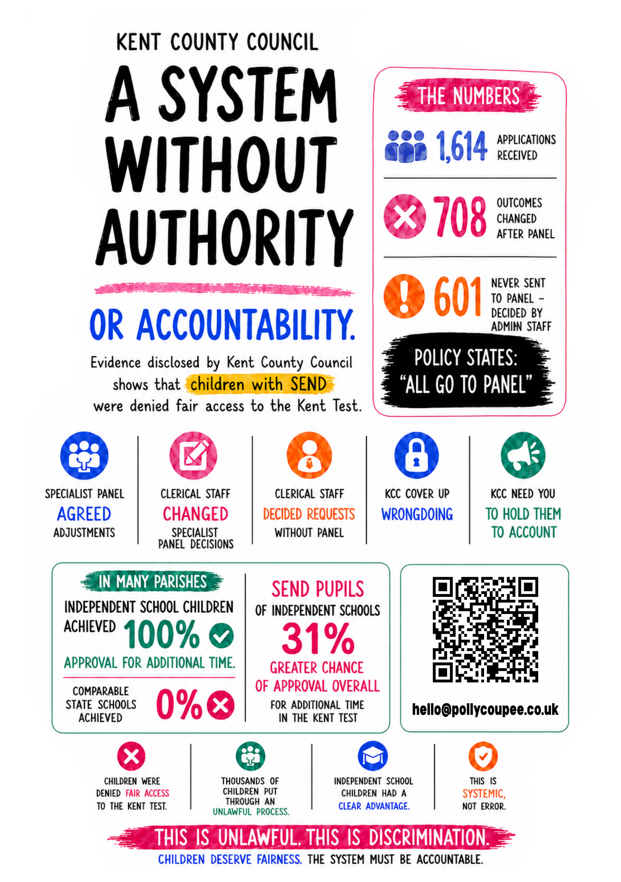
August 2026

