National Education Union – Written Evidence on Falling Primary School Rolls – FPS0017

Executive summary
England’s school population is falling. The number of pupils dropped by about 142,000 between 2023 and 2025, and the decline has further to run, with primary numbers down by around 9 per cent by 2030. A falling roll can be taken in one of two ways: as a saving, with teacher numbers cut to match, or as an opportunity to improve the schools children already attend. The government is taking the first path. This briefing makes the case for the second.
Two things make the case for using the falling roll to bring down class sizes and improve pupil-teacher ratios. First, England’s classes are among the largest in the developed world: the OECD puts the average class in the United Kingdom’s public primary schools at 27 pupils, against an OECD average of 21. Second, the schools White Paper, Every Child Achieving and Thriving, sets a clear direction towards including more children with additional needs in mainstream classrooms. That can only work if those classrooms have the capacity to give each child more attention, which means smaller classes and more adults for each pupil.
The evidence supports this. The two studies designed to test class size – Project STAR in Tennessee and Peter Blatchford’s work in England – find that smaller classes help most for younger, disadvantaged and lower-attaining pupils: the children the reforms bring into the mainstream. Smaller classes are also among the features parents most value. The government has committed to 6,500 more teachers and to a more inclusive mainstream. The falling roll is what makes both affordable; cutting teacher numbers as pupils fall forgoes that opportunity.
Recommendations
1. Raise the teaching workforce by 6,500. Add teachers as rolls fall rather than cut them, in line with the government’s own delivery plan.
2. Hold primary teacher numbers flat and let falling rolls reduce class sizes. England has the largest primary classes in Europe; holding numbers steady brings class sizes down without an increase in the primary teaching workforce.
3. Direct the additional teachers to special and secondary schools. This is where rolls and need are rising.
4. Reduce the size of over-large schools where it is sensible to do so. Use the falling roll to bring down the largest schools, rather than closing small schools by default.

Key Facts
England’s school population is falling, and the government plans to reduce the teaching workforce in line with it.
The headline numbers
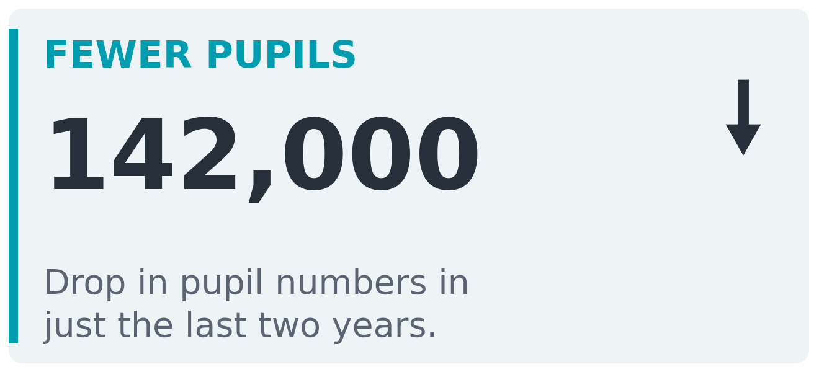 | 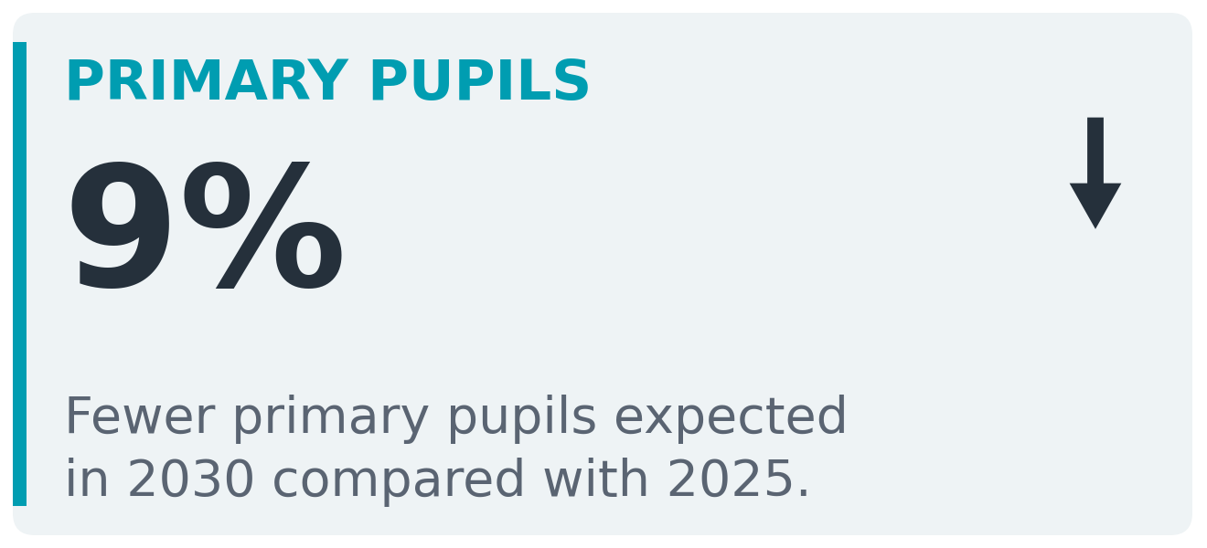 | 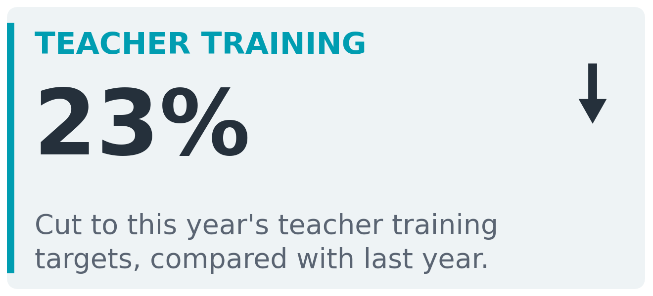

The government’s response to falling rolls is historically unprecedented
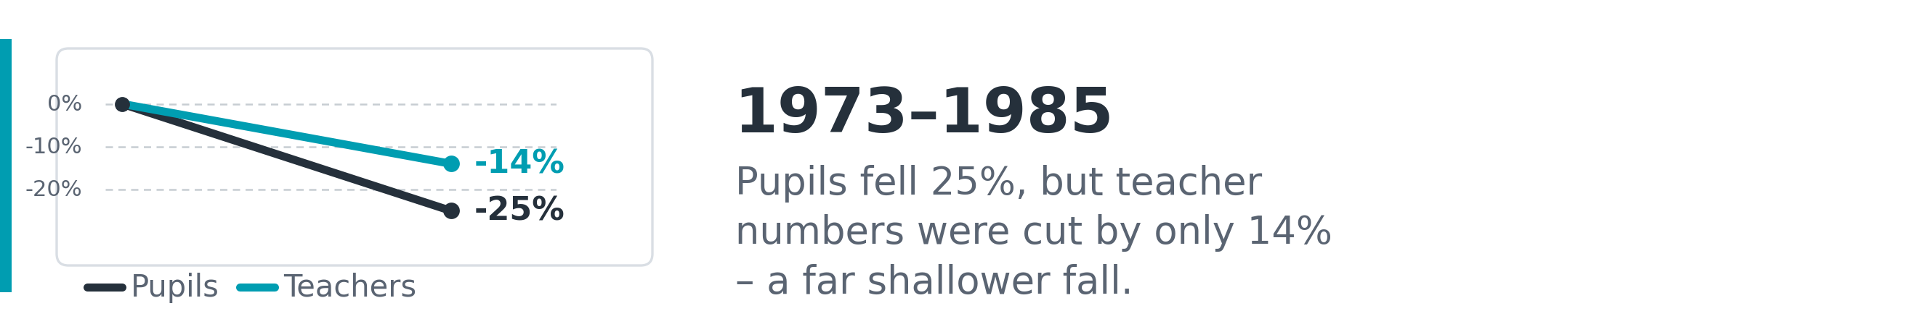
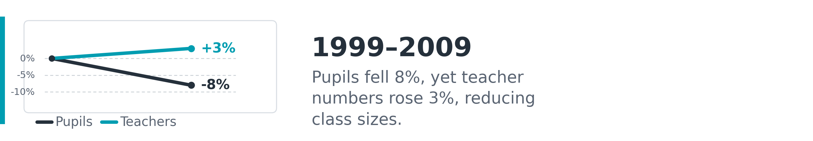
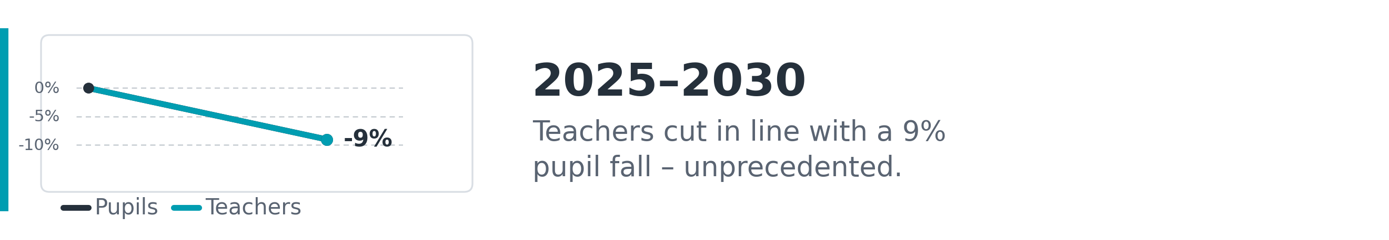

1. Introduction
Pupil numbers in state schools in England are falling, and they are falling slightly faster than the Department for Education (DfE) projected. This paper examines the scale and trajectory of that decline, how it is likely to affect demand for primary and secondary teachers over the coming decade.
The most recent funding census data makes the trend stark. The October 2024 school census recorded 7,523,541 state primary and secondary pupils, a fall of 44,387 (0.6 per cent) on the 2024-25 funding number. The figure used to set funding for 2026-27, drawn from the October 2025 census, falls further still, to 7,426,437, a further decline of 1.3 per cent. The combined two-year fall is almost 142,000 pupils, and the rate of decline is accelerating.
The decline is driven primarily by falling primary school numbers, which in turn reflect lower birth rates from the mid-2010s working through the system. This paper focuses on primary schools because that is where the demographic pressure is most acute now and where the workforce implications will be felt first. Secondary school numbers have been broadly stable but face their own structural challenge: a reduced pipeline of new teacher trainees, with initial teacher training targets for 2026-27 cut by over a fifth.
To project future pupil and teacher numbers, we use a ratio model that applies observed age-specific participation rates to the Office for National Statistics (ONS) 2024-based national population projections. Our model predicts a slightly steeper decline than the DfE’s own published projections, consistent with the actual DSG figures running below the DfE’s trajectory. Where our projections differ from the DfE’s, we treat both as informative bounds rather than seeking a single correct answer.
A note on data sources: the pupil numbers used to set school funding are taken from the October (autumn) school census, collected in the previous year. This figure is generally slightly lower than the equivalent number published as part of the DfE’s National Pupil Projections (NPP), which draws on the January (spring) census. To make like-for-like comparisons against the NPP series, we apply a scaling adjustment to the DSG figure; this is explained in the Methodology section.

2. Falling Pupil Numbers

2.1 The current position
England’s state primary school population peaked at approximately 4.62 million pupils around 2019-2020. By 2025, that figure had declined to around 4.48 million FTE, reflecting the demographic bulge caused by the early-2000s baby boom clearing the primary phase and entering secondary school. The ONS projects the number of children of primary school age to continue falling, driven by lower birth rates in the late 2010s and early 2020s, and this feeds directly into a sustained and accelerating decline in primary school rolls.
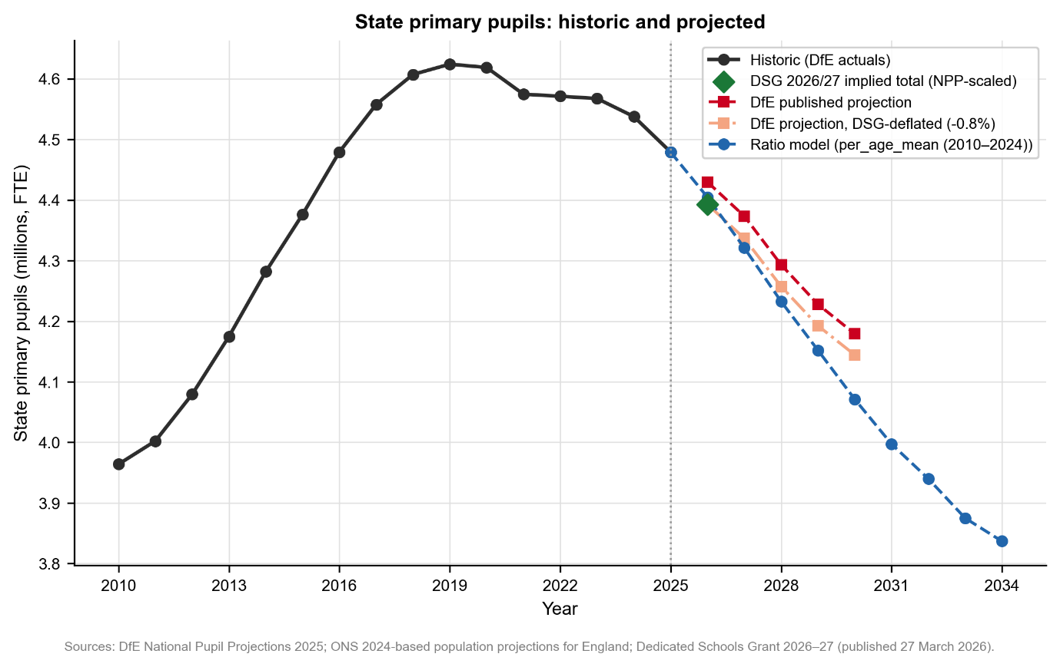
Figure 1: State primary pupils, historic and projected. The chart shows historic actuals (solid line), the DSG 2026–27 implied total after NPP scaling (diamond marker), the DfE published projection and its DSG-deflated variant, and the ratio model projection.
The DSG funding census data provides the most timely read on national pupil numbers. The October 2025 census, used to set the 2026-27 DSG, records a combined primary and secondary schools block count of 7,426,437, down from 7,523,541 in October 2024. That is a 1.3 per cent fall in a single year, compared with 0.6 per cent the year before: the pace is quickening. The DfE’s own National Pupil Projections (NPP) predicted a 7 per cent fall in primary pupil numbers by 2030; our ratio model predicts a 9 per cent fall over the same period. The steeper decline might be more likely since that is what the current DSG data trajectory suggests.

2.2 Comparing projections
Three projection lines are shown in Figure 1. The DfE’s published NPP projects a decline from around 4.5 million primary pupils in 2025 to approximately 4.2 million by 2030. Our ratio model projects a slightly steeper fall, reaching just below 4.1 million by 2030 and approaching 3.84 million by 2034. A third line applies a 0.8 per cent downward deflation to the DfE’s published projection, reflecting the gap between the scaled DSG data point for 2026 and the DfE’s NPP prediction for that year; this adjusted line sits between the two, closer to the DfE series but constructed to be consistent with the DSG evidence that the DfE may be slightly over-projecting.
The scaled DSG figure for 2026 is 0.8 per cent below the DfE’s NPP prediction and 0.3 per cent below our ratio model’s prediction. Both models are therefore broadly consistent with the actual funding data, but both also suggest the DfE’s headline projections are marginally optimistic. Given that the annual rate of decline accelerated from 0.6 per cent to 1.3 per cent between 2024 and 2025, the risk of further downside relative to the DfE trajectory is real.

3. Impact on Teacher Demand

3.1 Translating pupil falls into teacher numbers
To project future teacher demand, we apply the assumption of a constant pupil-teacher ratio (PTR). The primary PTR in 2025 was 20.80. Holding this ratio constant, a fall in pupil numbers translates directly into a proportional fall in teacher numbers. Under our ratio model, primary pupil numbers fall by 5.5 per cent by 2028, by 9 per cent by 2030, and by 14 per cent by 2034, implying corresponding falls in teacher demand of approximately the same (Figure 2).
The DfE’s own teacher workforce model predicts a 4 per cent decline in primary teacher demand by 2027-28, coupled with a 4.9 per cent fall in its primary pupil projection over the same period. The near equivalence of these two figures suggests the DfE is currently planning for teacher numbers to fall broadly in line with pupils, that is, to maintain rather than improve the PTR.

3.2 Historical context: the same pressure, different responses
History shows that demographic pressure does not determine workforce policy, but political choices do. Figure 3 compares the current period with two previous episodes of falling primary pupil numbers, using both the ratio model and DfE projections for the current period.
In the first episode, between 1973 and 1985, primary pupil numbers fell by 25 per cent as the post-war baby boom cohort worked through the system. Primary teacher numbers were cut, but at a slower rate: down 14 per cent. The government absorbed some of the demographic fall by tolerating more teachers per pupil, moderating the workforce impact.
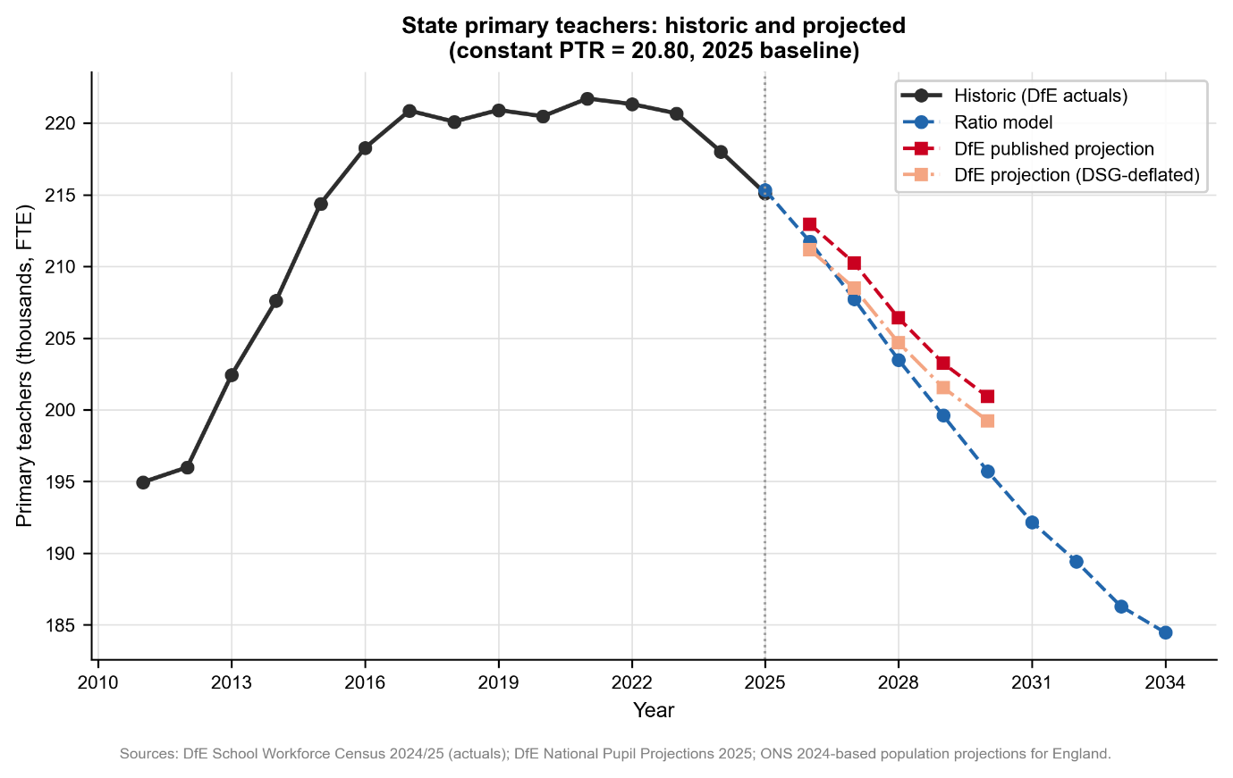
Figure 2: State primary teachers, historic and projected (constant PTR = 20.80, 2025 baseline). The chart plots historic teacher numbers (solid line), the ratio model projection, and DfE published and DSG-deflated projections.
In the second episode, between 1999 and 2009, primary pupil numbers fell by 8 per cent. Despite the fall, primary teacher numbers actually rose by 3 per cent, because the Labour government deliberately used the demographic headroom to reduce class sizes.
The current trajectory points to a completely different path. The DfE’s teacher workforce model projects a 4 per cent reduction by 2027-28, almost a mirror image of its pupil projection (down 4.9%), suggesting a broadly proportional planned reduction rather than any use of the demographic space to improve staffing ratios. Model projections show this decline will continue even after 2026-27 if the teacher numbers are to fall in line with pupil numbers. The government policy to cut primary teacher numbers at this rate is striking in that no post-war government has reduced the workforce so closely in line with falling pupil numbers.

3.3 Initial teacher training cuts
The planned reduction in teacher numbers is already being carried out through a sharp cut to initial teacher training (ITT) targets. The number of new primary teachers the DfE plans to train in 2026-27 has been cut by 27.8 per cent against the previous year. The secondary target has been cut by 20.7 per cent. In total, ITT targets have been cut by 22.7 per cent, to 20,800 trainees nationally.
For secondary schools, falling training targets are compounded by a pupil population that has already started falling, and the rate of decline will only accelerate as smaller primary cohorts move through. Fewer secondary trainees now will mean fewer experienced secondary teachers available when that secondary decline arrives, creating a second wave of workforce pressure with a lag of a few years.
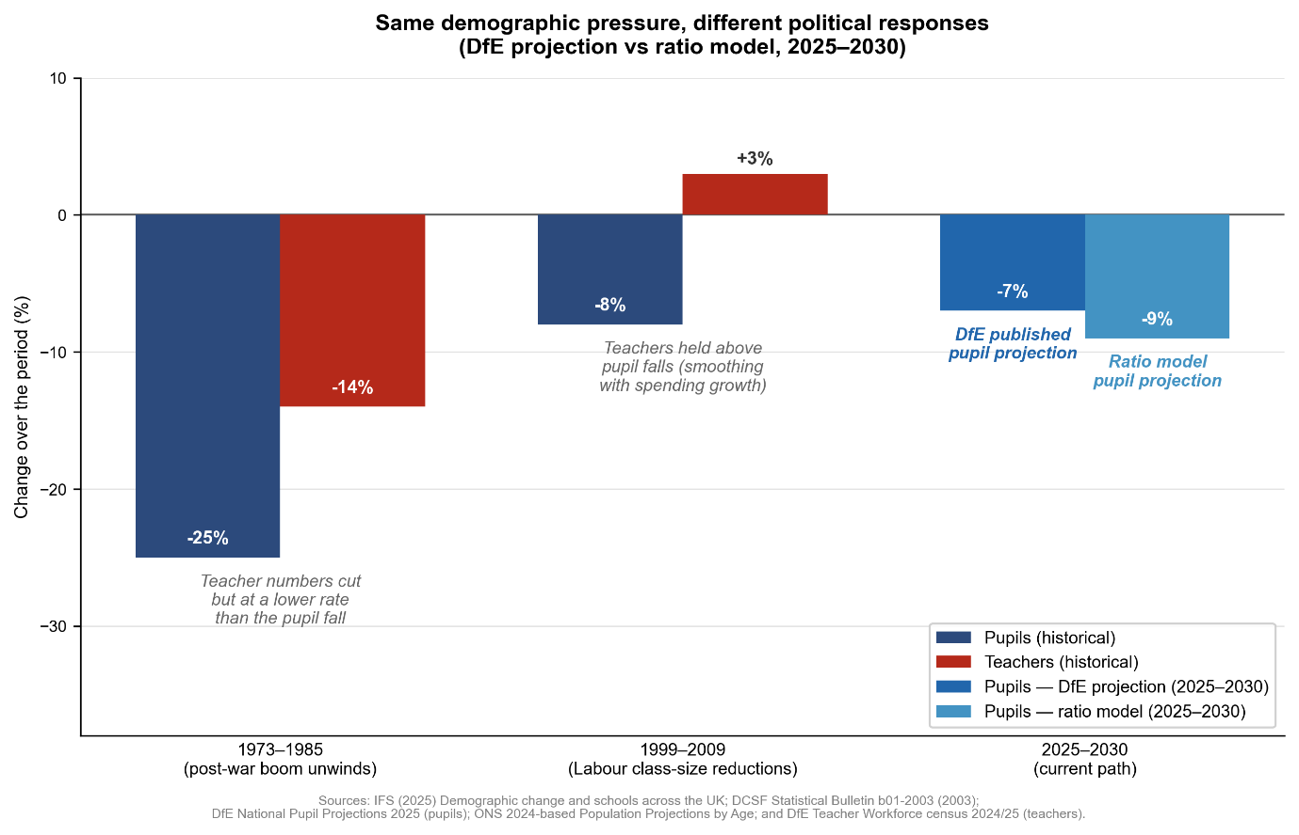
Figure 3: Same demographic pressure, different political responses – ratio model and DfE published projection, 2025–2030. Bars show percentage change in primary pupils (blue) and primary teachers (red) across three periods.
The supply of new teachers is already at a low point. The number of newly qualified teachers entering state-funded schools in England fell to 16,300 in 2025, the lowest on record and down from a peak of 26,300 in 2015 (Figure 4). The cut to training places will reduce this flow further in the years ahead.
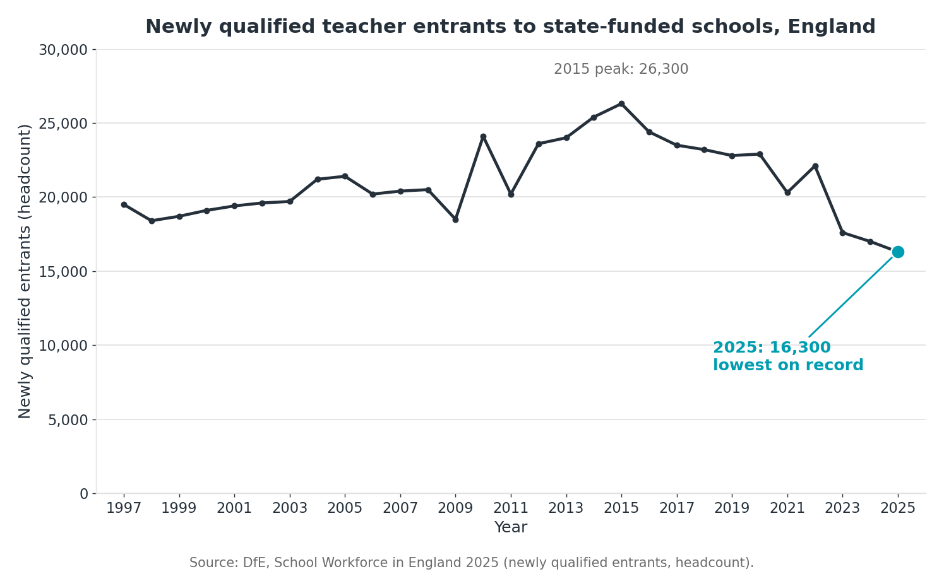
Figure 4: Headcount of newly qualified teacher entrants to state-funded schools in England, 1997 to 2025. The number entering in 2025 is the lowest in the series.

3.4 International comparison
International comparison reinforces the case. The OECD’s Education at a Glance 2024 shows that classes in the United Kingdom’s public schools are among the largest in the developed world. Comparing public institutions alone, and setting independent schools aside, the average primary class holds 27 pupils against an OECD average of 21, and the average lower secondary class holds 25 against 23. These classes have grown larger over time: the average lower secondary class in the United Kingdom rose from 20 pupils in 2013 to 25 in 2022, moving away from the OECD average rather than towards it. The ratio of pupils to teachers is 19 in primary and 17 in lower secondary, against OECD averages of 14 and 13. The gap is widest in primary, where the United Kingdom sits six pupils above the OECD average. The falling roll provides the means to narrow it: in primary, holding teacher numbers at their current level as pupil numbers fall would reduce class sizes without an increase in the workforce.
Indicator (public institutions) | United Kingdom | OECD average
Average primary class size | 27 | 21
Average lower secondary class size | 25 | 23
Pupils per teacher, primary | 19 | 14
Pupils per teacher, lower secondary | 17 | 13
Source: OECD (2024) Education at a Glance 2024. Figures are for public institutions and exclude independent schools.

3.5 The direction towards inclusion in mainstream
The case for smaller classes does not rest on international comparison alone. The schools White Paper, Every Child Achieving and Thriving, published in February 2026, sets a clear political direction: more children with special educational needs and disabilities are to be supported in mainstream classrooms rather than in separate settings. It backs this with new National Inclusion Standards, a new Inclusive Mainstream Fund, and a duty on every school to publish an inclusion strategy.
This direction has a consequence that the funding settlement has not yet addressed. A mainstream class can only include a wider range of needs if the teacher has the time and attention to meet them. With 30 or more pupils in a class, that time does not exist. Inclusion in name, without the capacity to deliver it, adds to the demands on the same teacher and risks failing the children it is meant to help. Alongside the comparison with peer nations, the move towards inclusion is the second reason to use the falling roll to reduce class sizes and improve pupil-teacher ratios, rather than to take teachers out of the system.

3.6 What the evidence shows
Class size is sometimes dismissed by reference to the Education Endowment Foundation’s Teaching and Learning Toolkit, which records reducing class size as a small average effect – about one month’s additional progress – for a high cost. This is commonly read as showing that class size does not matter. That conclusion does not follow. The Toolkit measures the average effect of the modest reductions found in most studies, typically of around ten pupils, which do not reach the point at which teaching itself changes.
The two studies designed specifically to test class size point in the other direction. Project STAR, a randomised trial in Tennessee that followed around 11,600 pupils, found that children placed in small classes of 13 to 17, rather than regular classes of 22 to 25, made measurably greater progress, with benefits that lasted into later schooling. The Class Size and Pupil-Adult Ratio study in England, directed by Peter Blatchford, reached a similar conclusion: class size matters most for the youngest pupils, and the gain is largest for disadvantaged and lower-attaining children. Those are the pupils the move to inclusion brings into mainstream classes. The evidence does not say class size is all that matters; it shows that substantial reductions benefit the children who need most support.
Parents reach the same view. The Department for Education’s own evidence review records smaller classes as one of the leading reasons parents give for choosing an independent school. Reduced class sizes are among the most popular uses of any new capacity in the system.

4. Regional variation

4.1 Projecting pupil numbers by region
Between 2016 and 2025, primary school pupil numbers fell by 9 per cent in London. That produced an 11 per cent decline in primary teachers and a 4 per cent fall in the number of classes; but the number of schools fell by only 2 per cent.
The fall in primary pupil numbers in inner London is projected to slow down in the next few years (Figure 5: Primary pupil projections by English regions. The chart shows DfE actuals from 2016 to 2024. Using the average participation ratio across 2022-2024, projections are calculated for 2025 to 2034. Actuals are plotted for 2025 and 2026 for comparison with projections.). However, fall in secondary pupil numbers is projected to accelerate for both inner and outer London as the smaller primary cohorts make their way into secondary classes (Figure 6).
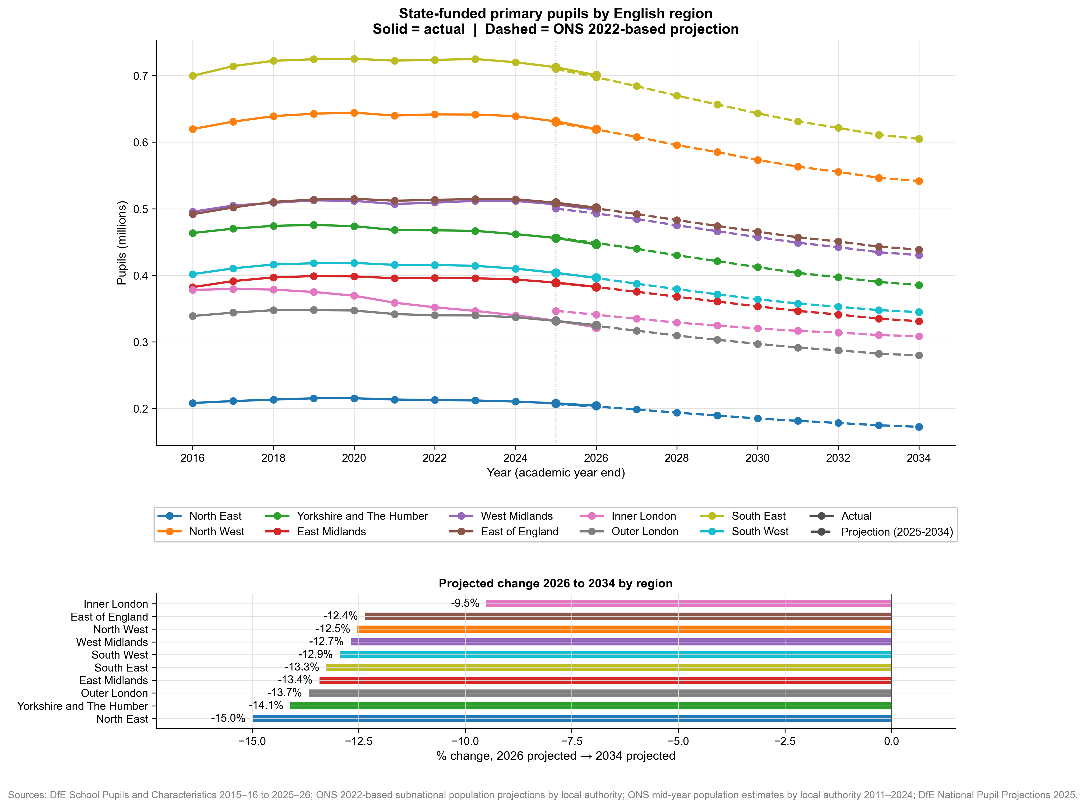
Figure 5: Primary pupil projections by English regions. The chart shows DfE actuals from 2016 to 2024. Using the average participation ratio across 2022-2024, projections are calculated for 2025 to 2034. Actuals are plotted for 2025 and 2026 for comparison with projections. Bottom chart shows projected change between 2026 and 2034 instead of a comparison with actual 2026 numbers to discount the impact of over- or under-projections in 2026.
London is projected to see the worst impact on its secondary pupil population compared to other regions, replicating the primary pupil fall of the past few years. All regions are projected to see large falls in primary pupil numbers over the next few years, but the bulk of the coming loss will fall on a small number of districts within specific regions. North east could see a 15% decline in its primary pupil population between 2026 and 2034 and inner London a similar decline among its secondary pupil population.
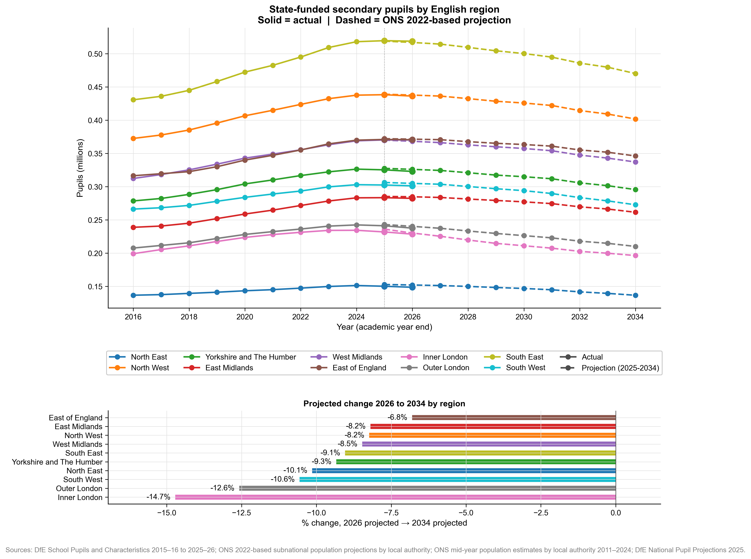
Figure 6: Secondary pupil projections by English regions. The chart shows DfE actuals from 2016 to 2024. Using the average participation ratio across 2022-2024, projections are calculated for 2025 to 2034. Actuals are plotted for 2025 and 2026 for comparison with projections. Bottom chart shows projected change between 2026 and 2034 instead of a comparison with actual 2026 numbers to discount the impact of over- or under-projections in 2026

5. Recommendations
The paper has set out a choice. Falling rolls can be taken as a saving, with teacher numbers cut in line with pupils, or as an opportunity to improve the schools children already attend. The recommendations below take the second path. Together they would raise the teaching workforce while the pupil population falls, and place that workforce where need is rising rather than where it is easing.
1. Raise the teaching workforce by 6,500. The government should add 6,500 teachers rather than cut numbers as rolls fall. Falling rolls create the room to do this: as the pupil population shrinks, the system can hold or raise teacher numbers without the funding pressure that growth once brought. This reverses the planned contraction described in section 3 and uses the demographic fall for children rather than as a saving. It also matches the government’s own commitment, set out alongside the White Paper in the 6,500 additional teachers delivery plan.
2. Hold primary teacher numbers flat and let falling rolls reduce class sizes. England has the largest primary classes in Europe: the OECD puts the average class in the United Kingdom’s public primary schools at 27 pupils, against an OECD average of 21. Primary rolls are also falling fastest. If primary teacher numbers are held at their current level rather than cut, the falling roll reduces class sizes on its own, without an increase in the primary teaching workforce. This is the course taken between 1999 and 2009, when teacher numbers were held up as pupil numbers fell and class sizes came down.
3. Direct the 6,500 to special and secondary schools. Special school rolls are rising, not falling, and the workforce has not kept pace with demand. Secondary schools face a shortage of specialist teachers, and the cut to initial teacher training targets described in section 3 will deepen it as smaller primary cohorts reach them. The additional teachers should go to these two phases, where need is growing.
4. Reduce the size of schools, managed strategically. Falling rolls also offer the chance to reduce the size of schools that have grown large, rather than letting schools shrink at random or closing them by default. Sibieta (2025) sets out the trade-off: a school allowed to fall too small cannot staff a full curriculum and becomes a worse place to teach and to learn. The aim should be a planned reduction in school size, guided by local need and the research, not closures forced by falling budgets.

6. Methodology

6.1 Pupil number data sources
Two separate pupil number series are used in this analysis, and it is important to understand their relationship.
National Pupil Projections (NPP). The DfE’s annual National Pupil Projections publication provides historic actual pupil numbers and forward projections. The historic series is based on the January (spring) school census. The most recent edition used here is the 2025 NPP release, drawing on January 2025 census data for the 2024-25 academic year baseline. The NPP covers all state-funded primary and secondary school pupils in England on a full-time equivalent (FTE) basis.
Dedicated Schools Grant (DSG) pupil counts. The DSG schools block pupil count is drawn from the October (autumn) school census of the preceding year and covers Reception to Year 11 pupils in mainstream state-funded schools and academies only. It excludes pupils in special schools, pupil referral units, nursery classes and alternative provision. It also counts Reception pupils as 1.0 FTE regardless of their part-time status. This contrasts with the NPP. The October 2024 census number used to set 2025-26 DSG funding was 7,523,541; the October 2025 census number used to set 2026-27 DSG funding was 7,426,437.

6.2 NPP scaling of the DSG figure
Because the DSG and NPP series use different census months (October vs January), a direct comparison would be misleading. To plot the DSG data point on the same axis as the NPP series and thereby test whether the DfE’s projections are tracking reality, a scaling factor is applied to the DSG figure.
The scaling factor is derived by comparing the DSG primary pupil count from the previous year (October 2024 census used to set 2025-26 funding) against the corresponding NPP primary pupil actuals for that year. This multiplier is then applied to the 2026-27 DSG figure to produce an NPP-equivalent estimate that can be plotted alongside the NPP projections.
After scaling, the DSG-implied figure for 2026 is 0.8 per cent below the DfE’s NPP prediction for that year, and 0.3 per cent below our ratio model’s prediction.

6.3 The ratio model
The ratio model is the primary analytical tool used to project future primary pupil numbers and teacher numbers.
Step 1: Age-participation ratios. For each single year of age from 4 to 10 (the primary school age range), the proportion of FTE children of that age who are enrolled as state primary school pupils is calculated from the NPP historic actuals. The average of these ratios is taken across the period 2010 to 2024, producing a stable set of age-specific participation rates. These rates reflect typical levels of state primary school attendance by age, averaging across years to smooth out any single-year anomalies.
Step 2: Application to ONS population projections. The ONS 2024-based national population projections for England provide annual estimates of the number of children at each single year of age from 2025 to 2034 (and beyond). For each future year, the age-specific participation ratios from Step 1 are applied to the ONS projected population at each age, and the results are summed to give a projected total number of state primary pupils.
Step 3: Teacher projection. The 2025 primary pupil-teacher ratio (PTR) of 20.80 is held constant throughout the projection period. Projected teacher numbers for each future year are derived by dividing the projected pupil number by 20.80. This is an explicit simplifying assumption: it does not account for possible future changes in government policy on class sizes, workforce planning targets, or teacher retention patterns.

6.4 DSG-deflated DfE projection
A third projection line is produced by applying a uniform 0.8 per cent downward deflation to the DfE’s published NPP projection for each future year. The 0.8 per cent figure is the gap between the scaled DSG figure for 2026 and the DfE’s NPP prediction for 2026. This adjusted line represents a scenario in which the DfE’s projections are systematically optimistic by the same margin currently evident in the 2026 data point. It should be interpreted as a sensitivity scenario rather than a separate model.

6.5 Historical comparisons
The historical comparisons for 1973-1985 and 1999-2009 are drawn from IFS (2025) demographic change and schools across the UK, and from DCSF Statistical Bulletin b01 2003 (2005). Percentage changes in pupil numbers and teacher numbers over each period are taken directly from these published sources and are not re-calculated here. The current-period (2025-2030) bars in Figures 3 and 4 are derived from the ratio model and DfE published projection respectively, using the 2025 PTR baseline.

6.6 Regional projections
Regional projections are based on a ratio model similar to the one used to calculate national projections. The regional projections, however, do not use age-based ratios. The ratios are calculated for all primary and all secondary pupils against primary and secondary aged populations, respectively. We start projecting from 2025 since we have population data by age and local authority until 2024. The participation ratio used to project into the future is calculated by taking the average participation ratio across 2022-2024. The projections are then based on ONS’s 2022-based population projections by age and local authority. The 2024-based projections are not available by region and age yet, which means the regional projections are based on different population projections than the national projections. To ensure numerical coherence across the paper, we scale the regional projections for each year so that the sum of all regional projections equals the national projections quoted in this paper.

6.7 Limitations
The ratio model assumes constant age-specific participation rates and a constant PTR. In practice, PTRs are subject to political choices about class sizes and staffing. Projections for later years (2031-2034) carry substantially greater uncertainty than near-term projections and should be treated as indicative of direction rather than precise forecasts. Furthermore, the regional and national projections are not inherently comparable since they are based on different population datasets and slightly different methodologies. They are forced to match by assuming that they are only proportionally different, when they are inherently different. Finally, the regional pupil projections are taken from School Pupils and their Characteristics data release, while the national pupil numbers are taken from the National Pupil Projections data release, which are calculated differently and the regional numbers do not sum to the national pupil numbers.

7. References
Blatchford, P., Bassett, P., Goldstein, H. and Martin, C. (2003) The Class Size and Pupil-Adult Ratio (CSPAR) study. British Educational Research Journal. London: Institute of Education.
Department for Education (2025) National pupil projections: 2025. Explore Education Statistics. Available at: https://explore-education-statistics.service.gov.uk/find-statistics/national-pupil-projections/2025.
Department for Education (2025) School Workforce in England, Reporting Year 2025 (data file: retention_1996_2025_nat.csv). Explore Education Statistics. Available at: https://explore-education-statistics.service.gov.uk/find-statistics/school-workforce-in-england/2025.
Department for Education (2026) Dedicated schools grant (DSG): 2026 to 2027. GOV.UK. Available at: https://www.gov.uk/government/publications/dedicated-schools-grant-dsg-2026-to-2027.
Department for Education (2025) Dedicated schools grant (DSG): 2025 to 2026. GOV.UK. Available at: https://www.gov.uk/government/publications/dedicated-schools-grant-dsg-2025-to-2026.
Department for Education (2026) Schools, pupils and their characteristics: 2025–26. Explore Education Statistics. Available at: https://explore-education-statistics.service.gov.uk/find-statistics/school-pupils-and-their-characteristics/2025-26.
Department for Education (no date) Teacher workforce analysis dashboard: teacher demand and PGITT need. Available at: https://department-for-education.shinyapps.io/teacher-workforce-analysis-dashboard/.
Department for Education (2026) Every Child Achieving and Thriving. Schools White Paper. London: Department for Education.
Education Endowment Foundation (2026) Teaching and Learning Toolkit: Reducing class size. London: Education Endowment Foundation.
Finn, J. D. and Achilles, C. M. (1999) Tennessee’s class size study: findings, implications, misconceptions. Educational Evaluation and Policy Analysis, 21(2).
Office for National Statistics (2026) 2024-based national population projections: table of contents [Dataset]. Available at: https://www.ons.gov.uk/peoplepopulationandcommunity/populationandmigration/populationprojections/datasets/2014basednationalpopulationprojectionstableofcontents.
Office for National Statistics (2025) Population projections for local authorities by single year of age and sex, England [Dataset]. Available at: https://www.ons.gov.uk/peoplepopulationandcommunity/populationandmigration/populationprojections/datasets/localauthoritiesinenglandz1.
Organisation for Economic Co-operation and Development (2024) Education at a Glance 2024: OECD Indicators. Paris: OECD Publishing.
Sibieta, L. (2025) Demographic change and schools across the UK: lessons from history. London: Institute for Fiscal Studies. Available at: https://ifs.org.uk/sites/default/files/2025-12/IFS%20Report%20-%20Demographic%20change%20and%20schools%20across%20the%20UK%20-%20lessons%20from%20history.pdf.

30 June 2026

Regional pupil numbers are taken from School Pupils and their Characteristics data release, while the national pupil numbers are taken from the National Pupil Projections data release, which are calculated differently and the historic regional numbers do not sum to the national pupil numbers. However, the regional projections are scaled to sum to the national projections.

