Department for Education – Written Evidence on Falling Primary School Rolls – FPS0016

Contents
Contents 2
Table of figures 3
Introduction 4
Part One – Context 6
Summary 6
Primary pupil numbers 6
Birth rates 7
Fertility rates 9
Births by age of the mother 11
Regional trends 12
Other significant drivers 13
Net migration 13
Population movement within England 15
Parental choice 17
Unfilled capacity 18
Unfilled capacity by school type 20
Forecast demand 21
Part Two – A sector wide response 24
Summary 24
Roles and responsibilities 26
Potential impacts 27
Pupil outcomes 27
Workforce 29
School finances 31
The importance of local strategic school place planning 34
Admissions and collaboration 34
School closures 35
Using surplus space 37
Conclusion 40

Table of figures

Figure 1 - Primary Pupil Numbers in England (1947-2026) 6
Figure 2 - Primary aged children in England estimates and projections (1971-2049) 7
Figure 3 - Live Births in England and Wales (1938-2025) 8
Figure 4 - Past and projected Total Fertility Rates (TFR) in the UK (1982-2049) 10
Figure 5 - Past and projected TFR, UK (2000-2049) 10
Figure 6 - National population projections, variant projections: 2024-based 11
Figure 7 - Total long-term net migration, immigration and emigration in the UK, (Year ending June 2012 to December 2025) 14
Figure 8 - Number of non-EU+ nationals coming to live in the UK long-term by reason, (YE December 2019-2025) 15
Figure 9 - Inner London Places and Pupils 16
Figure 10 - Net Migration for Inner London LAs 16
Figure 11 - Destinations of population migration from Inner London in 2021 17
Figure 12 - Places, Pupils and surplus capacity in rural primary planning area 19
Figure 13 - National level of unfilled places as % of capacity 19
Figure 14 - Forecast primary capacity in every planning area in England (2029/30) 22
Figure 15 – Actual and forecasted Primary Pupil Numbers vs Primary Teacher Numbers in England (2010 – 2027) 30

Introduction
Schools are at the heart of this government’s strategy to ensure every child can achieve and thrive. They play an integral role in communities, making them best placed to identify need early, signpost families to support and set children up for success.
The ‘Every Child Achieving and Thriving’ white paper, published on 23rd February, sets out our plan to improve the lives of all children and young people, building on support at home with a stretching, enriching and inclusive school experience to ensure every child has what they need to get on in life. Our ambition is that all children will be stretched to achieve higher standards and the disadvantage gap halved.
This inquiry comes at a time when the national birth rate trend is falling, a trend seen every ~25 years and last seen between 1990 and 2001 and, prior to that, between 1964 and 1977. Falling birth rates translate to a falling pupil population and primary pupil numbers have been declining since 2019. This declining population trend will flow through into secondary education, where the last pupil population peak is currently working its way through and is expected to move into Further Education nationally in 2028–29.
In Part One of this memorandum, we will set out how the primary pupil population has changed over time, largely driven by the cyclical nature of rising and falling birth rates. We will show how pupil numbers are due to change in the coming years at a national, regional and local level, explaining some of the drivers of this change and how those vary in different local contexts.
In Part Two, we will set out the different roles and responsibilities within the system at a national and local level and highlight the importance of local strategic planning in supporting schools to maximise the opportunities presented by demographic change.
This government understands that it plays a key role in helping local areas to respond to demographic change through its oversight of the schools system. We are clear that the system must respond to demographic change strategically to ensure it remains resilient and responsive both now and in the future.
There is no existing causal evidence of a direct link between falling pupil rolls in primary schools and attainment. However, we recognise that those schools affected by falling pupil numbers have to take steps to adapt. In practice, some schools may face pressures that require careful decisions to maintain strong outcomes, including potential impacts on finances, staffing stability, curriculum and enrichment opportunities. We are considering the wider impact that falling pupil numbers may have on educational quality and outcomes for children, including those from a disadvantaged background, in line with National Audit Office’s recent recommendation.
We are also considering how schools are and could be utilising space to meet changing needs in their communities.
These opportunities must also be balanced with a long-term view of school capacity required in local areas, to ensure the system is resilient to respond to any upturn in birthrates in future years.
As set out in our Education Estates Strategy, we have committed to developing a decision-making framework for the use of mainstream school space through demographic change, for publication in Autumn 2026. This will ensure that local areas are balancing the opportunity to repurpose spare space to deliver emerging priorities, such as support for children and young people with SEND, school-based nursery provision and Best Start Family Hubs, with an informed view of the short and long-term risks.
We are already backing the sector to respond with new funding, including £4 billion over three years to embed inclusive practice in mainstream schools and an additional £3.7 billion over five years to create tens of thousands of new places, including in mainstream schools, for children and young people with SEND.
We have also passed legislation through the Children's Wellbeing and Schools Act, to support greater co-operation between schools and local authorities on school admissions and place planning matters.
This includes introducing new duties for mainstream state schools and local authorities to co-operate regarding their respective school admissions functions, and for mainstream, special and alternative provision state schools to co-operate with local authorities regarding their place planning functions.
The Children's Wellbeing and Schools Act 2026 also includes a measure to enable the Schools Adjudicator, in cases where they uphold an objection to a school’s published admission number (PAN), to specify what it should be. This, alongside proposed changes to regulations, will help create a clearer, more transparent framework for decisions on school admission numbers.
The government expects schools and local authorities to help (and not hinder) each other on these issues and to behave in an inclusive way regarding school admissions and place planning. That is our best route to ensure we maintain a resilient primary school system which meets the needs of its communities both now and into the future.
This cohesive strategy that combines ambitious reform with funding, support and legislative change will provide local areas with the tools they need to respond strategically to demographic change.

Part One – Context

Summary
- This part of our written evidence collates centrally held data and evidence on primary pupil numbers and the drivers of change.
- Primary pupil numbers have been falling in England since they last peaked in 2019. This is largely driven by a 20% drop in the total number of births in England and Wales since the last birth rate peak in 2012. Other factors also play a part, including changing patterns of migration and local population movement. This combination of falling birth rates and migration factors compounding is particularly pronounced in London.
- Beyond the national headlines, there is significant local variation. Some areas have growing levels of unfilled capacity; some have historically stable levels of unfilled capacity and others are still forecasting a need for new places. For example, in 2025, where a decrease in pupil numbers was forecast at a Local Authority level, 66.2% of Local Authorities were forecasting an increase in forecasts in at least one of their school places 'planning areas', due to localised demand.
- How local areas experience and respond to changing demographics therefore varies across the country and within local communities.

Primary pupil numbers
- The number of pupils in primary schools peaked in 2019 and has been falling since. The number of primary pupils has followed a ~25-year cycle, with 4 periods of peaks and troughs since the second world war. The extent to which pupil numbers has ‘recovered’ has been variable, with reasons for that explored further below.
Figure 1 - Primary Pupil Numbers in England (1947-2026)
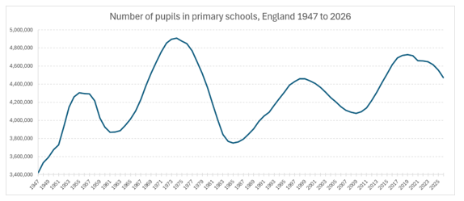
- Using Office of National Statistics (ONS) projections as a proxy, the number of children aged 5 to 10 is projected to continue declining until 2042 reaching a similar level to the recent low of 1984. After which ONS project a slight upturn in numbers, as show in Figure 2.
Figure 2 - Primary aged children in England estimates and projections (1971-2049)
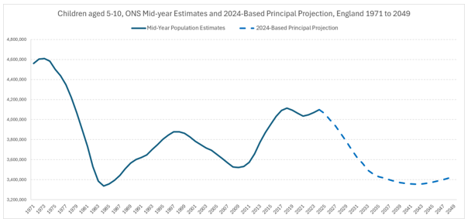

Birth rates
- Demand for school places is largely driven by birth rates – as can be seen by the similar trend in birth rates to pupil numbers in figure 3 below. Following the second world war there have been four periods of birth rate peaks and troughs cycles. The first period saw births peak in 1947 followed by a drop that lasted until 1955. Births then rose again to peak in 1964 reaching that post war level. The following drop between 1964 and 1977 was larger and dropped to the lowest numbers on record. Subsequent cycles have seen smaller peaks and falls over an approximately 10-year period between changes in directions.
Figure 3 - Live Births in England and Wales (1938-2025)
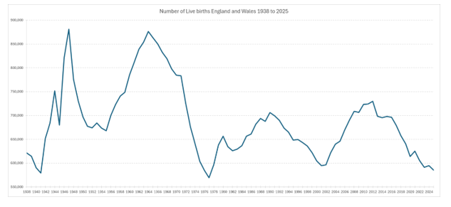
- The recent decline in births in England reflects a combination of changes rather than a single identifiable cause. The evidence points to a set of factors that interact to influence whether and when people have children, including the timing of family formation, economic conditions, labour market factors and longer-term shifts in social norms. Understanding the trend therefore requires assessing how these influences operate together, rather than attributing it to any one driver.
- A central feature of the recent decline is the timing of births. The Office for National Statistics reports that fertility rates in England and Wales are at record lows, and there has been a substantial shift towards later childbearing, with women having their first child significantly later than previous generations. This reflects a broader pattern of later transitions into adulthood, with milestones such as leaving home, forming partnerships and establishing financial independence occurring later than in previous cohorts. The timing shift is important. Where childbearing starts later, there is less time for subsequent births, and this can result in fewer children overall even where initial intentions have not changed. Evidence observed in advanced economies internationally, summarised by the Economics Observatory, notes that when declines in births at younger ages are not fully offset at older ages, completed family size tends to fall.
- This government is mindful that the cost of living and the accessibility of childcare can also impact birth rate trends and is taking action to support families with this.
- As set out in our Giving Every Child the Best Start in Life’ strategy, we will expand and strengthen family services, make early education and childcare more accessible and affordable, and improve the quality of early education and childcare, making real change happen for families and children across the country. In September 2025 we completed the full rollout of the 30‑hour childcare entitlement, saving families who use their full entitlement an average of £8,000 per eligible child per year.
- Alongside this, the Child Poverty Strategy looks at how the government can boost families' incomes through employment and the social security system, drive down the cost of essentials so parents can meet their children’s fundamental needs, and strengthen local support to ensure families can access vital services when they need them.
- We are also investing in the future of our children, taking pressure off front-line services and supporting better health and education outcomes for all children. The removal of the two-child limit on universal credit alongside other measures set out in our Strategy, such as the expansion of free school meals, will lift around 550,000 children out of poverty in the final year of the parliament.

Fertility rates
- One key contributor to recent falling births is the national fertility rate. In its latest round of projections based on 2024 population estimates, the ONS has set the short-term assumption for the UK total fertility rate (TFR) to reach 1.38 children per woman by 2029, before rising in the long term to 1.42 children per woman by 2049.
- England’s observed 2024 fertility rate was 1.42 and is projected to be 1.39 in the short term (to 2029), increasing to 1.43 in the long term (by 2049). Northern Ireland is projected to continue to have the highest total fertility rate, while Scotland has the lowest.
- Both the short-term and long-term fertility assumptions for the UK are below the equivalent figures in the previous round of projections. Each set of fertility assumptions has been lower than the last, for recent projection rounds, as shown in Figure 4.

Figure 4 - Past and projected Total Fertility Rates (TFR) in the UK (1982-2049)
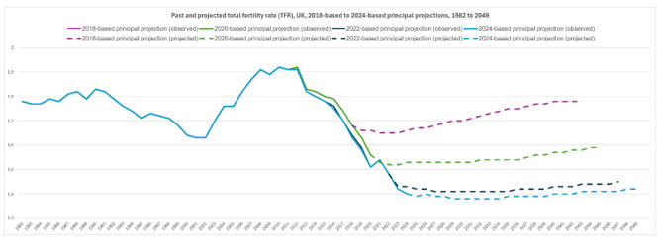

Figure 5 - Past and projected TFR, UK (2000-2049)⁸
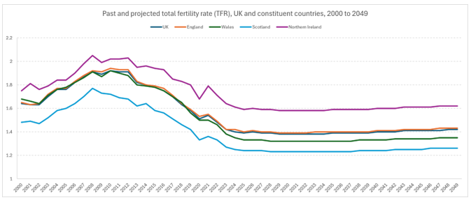

- The ONS produce alternative projections (called variants) using different sets of assumptions for level of future fertility, migration and life expectancy which include variant birth figures. The chart below illustrates how the uncertainty affects projecting future births. The scenarios outlined are illustrative and do not represent the absolute upper or lower limits for ONS’s projections.
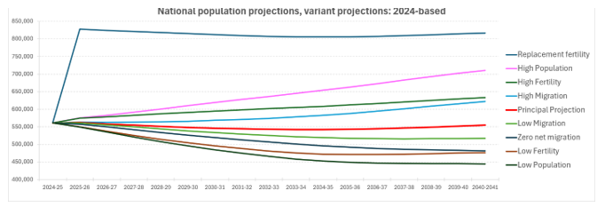
Figure 6 - National population projections, variant projections: 2024-based⁸

Births by age of the mother
- The second key driver of the changing pattern of births is the age of mothers. In 2012, over half of births were to mothers under 30 years old (50.5%). By 2025, nearly two thirds of births were to mothers over 30 years old (62.3%).
Table 1 - Live births by area of usual residence and mothers' age, England and Wales (2012 and 2025)
Age of mother | 2012 |  | 2025
Age of mother | Births | Percentage | Births | Percentage
Under 20 | 33,815 | 4.6% | 11,473 | 2.1%
20-24 | 132,456 | 18.2% | 60,127 | 10.8%
25-29 | 202,370 | 27.7% | 139,324 | 24.9%
30-34 | 216,242 | 29.6% | 196,804 | 35.2%
35-39 | 114,797 | 15.7% | 121,131 | 21.7%
40 and over | 29,994 | 4.1% | 30,059 | 5.4%
All | 729,674 | 100.0% | 558,988 | 100.0%

- Women are having children later in life and are having fewer of them. In 2013, of the women aged 25 to 29 who gave birth, and of whom the number of previously live-born children was known, 40% did not have a previous live-born child and 60% had one or more. By 2025, 54% did not previously have a live born-child and 46% already had one or more.

Regional trends
- Below the national birth rate trend, there is significant variation at a local level. London and the South West saw the largest percentage point drop in births between the peak of 2012 and 2025. London remains the region where the highest proportion of births occur. West Midlands and East of England are the regions that saw the lowest percentage point drop in births. Both areas in 2012 had TFR figures close to the ideal replacement rates (i.e. TFR of 2.1), and whilst their rates dropped by 2024, they remained the two regions with the highest rates nationally.
Table 2 - Number of live births and total fertility rate by region from 2012⁹
Region | Number of live births |  | Percentage of total |  | Total Fertility Rate (TFR) |  | % change between births in 2012 and 2025
Region | 2012 | 2025 | 2012 | 2025 | 2012 | 2024 | % change between births in 2012 and 2025
North East | 30,291 | 24,135 | 4.4% | 4.3% | 1.83 | 1.37 | -20.3%
North West | 89,211 | 73,597 | 12.9% | 13.2% | 1.94 | 1.44 | -17.5%
Yorkshire and the Humber | 67,408 | 53,639 | 9.7% | 9.6% | 1.94 | 1.45 | -20.4%
East Midlands | 55,645 | 44,933 | 8.0% | 8.0% | 1.95 | 1.40 | -19.3%
West Midlands | 73,940 | 62,237 | 10.7% | 11.1% | 2.04 | 1.59 | -15.8%
East of England | 74,571 | 61,866 | 10.7% | 11.1% | 2.02 | 1.50 | -17.0%
London | 134,186 | 103,144 | 19.3% | 18.5% | 1.84 | 1.35 | -23.1%
South East | 107,858 | 87,718 | 15.5% | 15.7% | 1.97 | 1.43 | -18.7%
South West | 61,131 | 46,926 | 8.8% | 8.4% | 1.96 | 1.31 | -23.2%
ENGLAND | 694,241 | 558,195 | 100.0% | 100.0% | 1.94 | 1.42 | -19.6%

Local authority births
- The top 5 areas for births in 2012 remained the top five in 2025. All, except for Hampshire, had smaller drops than the national average.
Table 3 - Top five areas by 2012 birth numbers⁹
Area of usual residence  Name | Area of usual residence  Geography | Region | Number of live births 2012 | Number of live births 2025 | % change 2012 to 2025
Kent | County | South East | 18,147 | 15,710 | -13.4%
Birmingham | Metropolitan District | West Midlands | 17,766 | 14,922 | -16.0%
Essex | County | East of England | 16,860 | 14,837 | -12.0%
Hampshire | County | South East | 15,400 | 12,090 | -21.5%
Hertfordshire | County | East of England | 14,913 | 12,228 | -18.0%

Table 4 - Bottom five areas by 2012 birth numbers⁹
Area of usual residence  Name | Area of usual residence  Geography | Region | Number of live births 2012 | Number of live births 2025 | % change 2012 to 2025
Rutland | Unitary Authority | East Midlands | 333 | 243 | -27.0%
Ribble Valley | Non-metropolitan District | North West | 475 | 469 | -1.3%
West Devon | Non-metropolitan District | South West | 507 | 379 | -25.2%
Derbyshire Dales | Non-metropolitan District | East Midlands | 555 | 421 | -24.1%
Maldon | Non-metropolitan District | East of England | 559 | 576 | 3.0%

Other significant drivers

Net migration
- A drop in total net migration may be exacerbating the current fall in pupil numbers, as this compounds with a falling birth rate trend.
- There has been a drop in net migration since year ending (YE) March 2023. Net migration in YE December 2025 was provisionally estimated at 171,000. This was down from the peak of 944,000 in YE March 2023.
Figure 7 - Total long-term net migration, immigration and emigration in the UK, (Year ending June 2012 to December 2025)
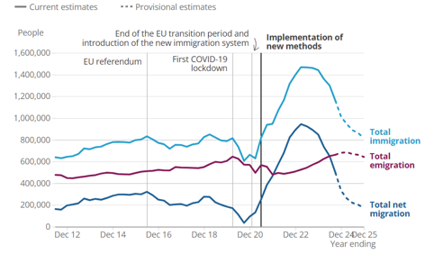
- The year ending (YE) December 2025 net migration estimates changes are mainly caused by decreases in non-EU+ net migration. Net migration for EU+ and British nationals remains negative, so more people left the UK long-term than arrived for these two groups. During that year:
  - Non-EU+ nationals’ net migration provisionally estimated at 350,000, a decline of 161,000 from the updated YE December 2024 (511,000) which continues to drive the decrease in total net migration.
  - British nationals’ net migration was provisionally estimated at negative 136,000, a fall of 19,000 from the updated YE December 2024 (negative 117,000)
  - EU+ nationals’ net migration was provisionally estimated at negative 42,000, an increase of 21,000 from the updated YE December 2024 (negative 63,000)
- The impact on pupil rolls is through immigrants bringing dependents with them for work or study purposes. In the year ending December 2025:
  - within the study-related arrivals, the number of main applicants (277,000) increased by 9% compared with YE December 2024, but arrivals of their dependants (17,000) fell by 17%.
  - within the work-related arrivals, just over half (74,000) were dependants, falling by 53% since YE December 2024, and 71,000 were main applicants, down by 38% for the same period
Figure 8 - Number of non-EU+ nationals coming to live in the UK long-term by reason, (YE December 2019-2025)
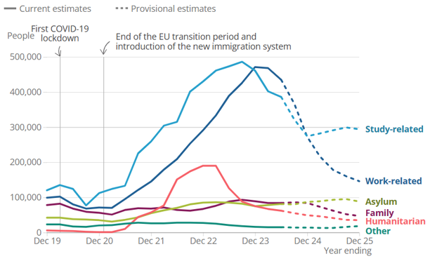

Population movement within England
- As well as national net migration, population movement within communities creates changing demand for school places. This type of population movement can be driven by individual family choices at any time and can be impacted by the affordability of housing in an area, new housing developments and wider social-economic factors.
- In some areas of the country, there have been sustained trends of outward migration that has had an impact on school place demand. This has been particularly pronounced in inner London.

Inner London Case Study
  - Inner London has experienced a decline in primary pupils since 2019.

Figure 9 - Inner London Places and Pupils
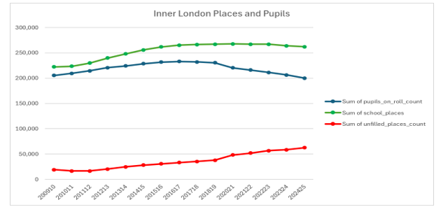

  - A key driver of falling pupil numbers is the increasing level of migration out of Inner London since 2019. There has been negative net migration from Inner London since 2012 with the spike in 2021, the impact of COVID. There was a reduction the following year in 2022 but net migration out of Inner London has increased again for 2023 and 2024.
Figure 10 - Net Migration for Inner London LAs
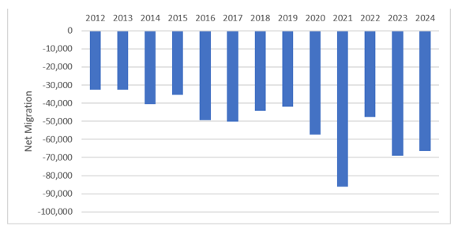
  - The destination of most people leaving Inner London in 2021 was Outer London, with the South East and the East of England being the next most popular destinations.
Figure 11 - Destinations of population migration from Inner London in 2021¹⁵
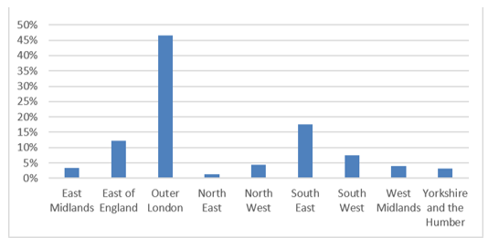

Parental choice
- At an even more local level, parental preference can drive local patterns of falling pupil numbers in some schools, and higher demand in others. This occurs even during periods of demographic growth and is even less predictable than national or regional factors.
- Parental choice is a key part of our diverse school system, enabling parents to express preferences for local schools where their children can achieve and thrive. Parental preference can also create incentives for schools to ensure that they are delivering the best possible outcomes for their communities.
- The proportion of primary applicants receiving an offer of their first-choice school decreased slightly from 93.2% in 2024 to 92.6% in 2025. This represented a return to 2023 levels following a series of small year on year increases in the rate since the 2020 figure of 90.2%.
Table 5 – Places offered at 1st preference school in England (2014-2025)
Year | Number of applications received | Percentage offered a place at their 1st preference school
2025 | 550,270 | 92.6%
2024 | 555,643 | 93.2 %
2023 | 568,560 | 92.5 %
2022 | 576,147 | 92.2 %
2021 | 580,771 | 91.8 %
2020 | 612,146 | 90.2 %
2019 | 608,957 | 90.6 %
2018 | 608,180 | 91.0 %
2017 | 620,330 | 90.0 %
2016 | 641,572 | 88.4 %
2015 | 636,279 | 87.8 %
2014 | 623,526 | 87.7 %

Unfilled capacity
- As primary pupil numbers fall, more schools have unfilled places, where the number of unfilled places is the difference between the capacity and the number on roll. We collect this data through the School Capacity Survey which collects data from local authorities (LAs) on school capacity as at 1st May each year, forecast demand for places, and planned future changes to capacity. LAs plan for school places using smaller localised ‘planning areas’ by grouping schools in smaller geographical areas that offer reasonable alternatives for pupils to attend.
- A proportion of unfilled capacity is always a feature of the system, even in times of peaking primary pupil numbers. It should therefore be considered within its local context.
- For illustrative purposes, the inquiry might think about the different ‘types’ of unfilled capacity in the system in the following ways:
  - Unfilled capacity for local flexibility – ensuring that there is some unfilled capacity across local schools is an important feature of local place planning systems. LAs, who hold the duty to ensure there are enough school places to meet demand, require there to be an element of unfilled capacity locally to ensure families moving into the areas can access school places.
  - Unfilled capacity in rural areas – Unfilled capacity is more pronounced in rural areas, with rural primary school places making up 17% of all primary places and 23% of all unfilled capacity in the system. The proportion of unfilled capacity in rural areas has been largely unchanged since the School Capacity (SCAP) survey began in 2009/10. Rural schools play an essential role in their communities, and a higher level of unfilled capacity must be balanced by the importance of these schools meeting the demand in rural catchment areas.
Rural Example
A rural primary planning area in Cornwall is such an example, containing 6 small primary schools including one school with a capacity of 56 and another with a capacity of 70. The largest school is a one form entry primary school where pupil numbers have varied between 133 and 175 since 2012.
Figure 12 - Places, Pupils and surplus capacity in rural primary planning area¹⁷
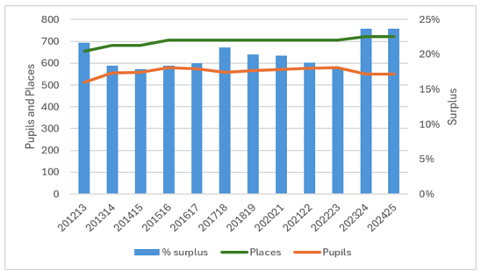
  - Unfilled capacity resulting from demographic change – this occurs when birth rates fall and capacity that was needed to meet demand previously is left unfilled. Falling birth rates may also coincide with internal/external population movement driven by social-economic factors and/or new housing developments. In some areas this might create a more lasting demographic change as communities evolve and unfilled school capacity is then unlikely to be needed in the longer term. In other areas, this unfilled capacity may only be short term, with capacity likely to be needed when birth rates rise in the future.
Figure 13 - National level of unfilled places as % of capacity¹⁸
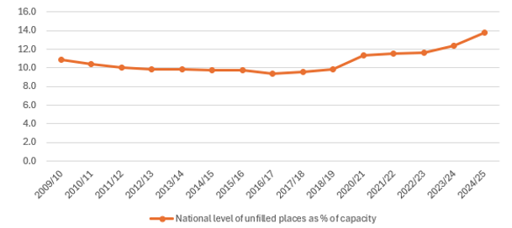
- Nationally, the proportion of unfilled places in primary schools has steadily increased since 2016/17 (9.4% of primary school places available). The current number and proportion of unfilled places is the highest since the School Capacity (SCAP) survey began in 2009/10. In primary schools, the total number of unfilled places was 685,000 in 2024/25 (13.8% of primary school places available).
- There is significant variation in how the total number of unfilled school places are distributed regionally. Most noticeably, in Inner London the rate of unfilled primary places has risen from 7.2% to 23.9% between 2011/12 and 2024/25, driven by the reduction in the primary population. All the remaining regions have between 10.4% (West Midlands) and 17.2% (South West) unfilled places.
- For some schools, this unfilled capacity will be managed by having fewer classes overall. For others, the number of classes will remain the same and the number of pupils in each class reduce.
- Average primary class sizes have only reduced slightly between the peak in pupil numbers and now.
Table 6 - Average Primary Class Size in England (2016-2026)
Year | 2016 | 2017 | 2018 | 2019 | 2020 | 2021 | 2022 | 2023 | 2024 | 2025 | 2026
Average state-funded primary class size | 27.1 | 27.1 | 27.1 | 27.1 | 27.0 | 26.6 | 26.6 | 26.7 | 26.6 | 26.4 | 26.1

Unfilled capacity by school type
- LAs are expected to report the capacity of a maintained school as calculated from a Net Capacity Assessment (NCA) and the capacity of an academy based on the capacity recorded in the academy’s funding agreement. Where academy capacity has changed, we expect LAs to report capacity based on a recent NCA or reflect the changes since the funding agreement was set. The department is currently conducting NCAs for all schools and expect all primary schools to have one by April 2029.
- Sponsor led academies have the highest proportion of unfilled places of all school types, at 19.7%. These schools have often converted to academy status as a result of a performance intervention. Although there is good evidence for the effectiveness of this programme, we would expect many of these schools to be on an improvement journey. This may contribute to lower numbers on roll, and therefore a greater level of unfilled capacity.
- In primary academy converters (including free schools which opened before 2019), the proportion of unfilled places in 2024/25 was 13.0%. For LA maintained primary schools, the equivalent proportion was 12.5%.
- The DfE is clear that a degree of unfilled capacity, when managed well, can support local choice and that high quality schools that have capacity should offer places to meet local demand. We are also clear that schools and local authorities should work together to ensure that excessive surplus capacity does not damage the quality of education in an area. This is being supported by new powers in the Children’s Wellbeing and Schools Act 2026.

Forecast demand
- Even in times of a declining population, there will still be increasing demand in some areas of the country. Primary shows an estimated total of 26,000 places are still needed to meet demand in 2029/30. This is largely driven by housing development (and, given we ask LAs to only report need arising from housing development where that development is sufficiently certain, there may be more need not yet reported). It is also, to an extent, driven by inward migration into certain areas of the country.
- In 2025, LA forecasts indicated that pupil numbers would increase between 2024/25 and 2029/30 in 11.1% of Local Authorities and in 28.1% of Planning Areas. However, even where a decrease in pupil numbers was forecast at a Local Authority level, 66.2% of Local Authorities were forecasting an increase in forecasts in at least one planning area, due to localised demand.
- LAs are therefore balancing growing levels of unfilled capacity in some of their planning areas, whilst building capacity in other planning areas to meet shifting demand as families move in and out and communities change over time. This very local nuance is critical in how LAs manage the system, and in how we as central government need to understand, support, and respond to local changes in demand.
Figure 14 - Forecast primary capacity in every planning area in England (2029/30)
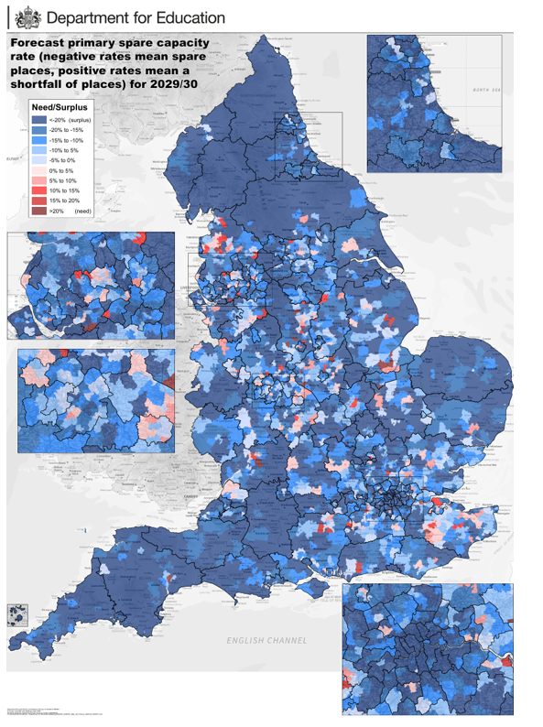
Table 7 - Top 10 planning areas with the largest proportion of places needed by 2029/30. (brown/red areas in Figure 14)
LA | Planning Area | Shortfall of places as % of capacity
Lancashire | Preston/Preston Rural Primary | 76%
Derbyshire | Mugginton Primary | 65%
Leicestershire | Old Dalby Primary | 38%
Peterborough | The Hamptons Primary | 33%
Devon | Cranbrook Primary | 31%
Derbyshire | Wigley/Cutthorpe Primary | 31%
Kent | Primary - Paddock Wood | 27%
Derbyshire | Longford Primary | 27%
Gloucestershire | Brockworth Primary | 26%
Lincolnshire | Moulton Chapel Primary | 25%
Table 8 - Top 10 LAs with largest proportion of expected unfilled places in 2029/30 in Planning Area (dark blue areas in Figure 14)
LA | Planning Area | Unfilled Places as % of capacity
Leicestershire | Hallaton Primary | -73%
Leicestershire | Newbold Primary | -69%
Lancashire | Ribble Valley/Dunsop Bridge & Slaidburn Primary | -66%
Dorset | Lyme Regis Pyramid Primary | -66%
Leicestershire | Buckminster Primary | -66%
Hertfordshire | Pelhams Primary | -65%
Wiltshire | Wroughton Primary | -62%
Durham | Weardale Primary | -61%
Lancashire | Lancaster/Silverdale & Yealand Primary | -61%
Cambridgeshire | St Neots Rural 3 Primary | -60%

Part Two – A sector wide response

Summary
- As we have set out in part one, demand for primary school places is changing and it is right that the sector responds strategically to that change. This section will cover the key roles and responsibilities held by DfE, LAs and the wider school system before highlighting the potential school level impacts associated with falling pupil numbers. It sets out the importance of strategic local planning, the work to drive standards across all schools, targeting funding towards disadvantaged areas and SEND system reform as key aspects of a sector-wide mitigation strategy.
- Demographic change will have a school level impact. It can also create an opportunity to redefine how primary schools deliver for the changing needs of their pupils and the wider community.
- The right strategic response to falling pupil numbers must be led locally. It is essential that LAs, who hold the legal duty to manage school places in their area, work in close collaboration with other local strategic partners, including schools, MATs and Dioceses, to co-design the right solutions for a local area.
- Early action is critical to supporting local schools through demographic change. The DfE recognises that this can create difficult strategic choices for local areas and this government is committed to supporting local areas through bold action, including:
  - Reforming school admissions legislation through the Children's Wellbeing and Schools Act 2026 which will introduce new measures that enable greater local collaboration on pupil admissions between LAs and schools. This includes a measure to enable the Schools Adjudicator, in cases where they uphold an objection to a school’s published admission number (PAN), to specify what it should be. School quality and parental preference will be key considerations in any decision on PAN. We are also introducing new duties for mainstream state schools and local authorities to co-operate regarding their respective school admissions functions, and for mainstream, special and alternative provision state schools to co-operate with local authorities regarding their place planning functions. These new legislative measures strengthen the vital aspects of managing school capacity and mitigating the impacts associated with falling pupil numbers locally.
  - Designing a new local decision-making framework for the use of mainstream school space through demographic change, for publication in Autumn 2026, which will support LAs to take a consistent approach to assessing need and managing capacity locally, including guidance on how spare space in primary schools could be adapted to meet rising SEND need and other community uses. This will aim to increase transparency over decision making and supporting early strategic conversations with local partners and the DfE, to provide support to schools and communities as early as possible.
  - New capital investment to enable local areas to repurpose spare space in schools effectively, including £3.7 billion over five years to create tens of thousands of new places, including in mainstream schools, for children and young people with SEND and £400 million capital investment to deliver the government’s manifesto commitment to create or expand thousands of additional school-based nurseries across England, increasing access to childcare in areas that need it most.
  - Significantly increased investment in the core schools budget, despite constraints on public spending, which is increasing by £1.7 billion in 2026-27. This includes funding to deliver SEND reform, which will total £4 billion over three years, to embed inclusive practice in mainstream schools.
- The Department for Education is clear that early and effective strategic planning will require local leaders to make difficult choices to mitigate the potential impact of falling pupil numbers on their local schools. This government remains committed to working with them as they respond.
- While there is no existing causal evidence of a direct link between falling pupil rolls and attainment, we know falling pupil rolls in some primary schools may present challenges. This may include funding pressures and staffing capacity, which could affect curriculum breadth and reduce enrichment opportunities for pupils. We are considering the wider impact that falling pupil numbers may have on educational quality and outcomes for children, including those from a disadvantaged background, in line with National Audit Office’s recent recommendations.
- The Every Child Achieving and Thriving white paper sets out our plans to build a school system that enables all children to achieve and thrive, regardless of where they live. It includes a commitment to review the targeting of disadvantage funding and measures to strengthen effective use of funding, including improving pupil premium strategy statements and introducing funded reviews for schools where outcomes for disadvantaged pupils are weaker.
- The key shifts set out in the white paper are built on strong foundations, learning from innovative leaders and teachers who have improved standards so that all their pupils are able to achieve and thrive.

Roles and responsibilities
- Local authorities have a statutory responsibility to ensure there are enough school places available in their area for every child of compulsory school age (the ‘sufficiency duty’). This is set out under section 14 of the 1996 Education Act. Local authorities are routinely monitored and challenged by the Department for Education in relation to this duty.
- The Department for Education’s ‘Sufficiency Framework’, sets out that local authorities, academy trusts and local partners are expected to balance the supply and demand of school places, in line with changing demographics locally. This means increasing the number of places in response to need, and reducing or repurposing capacity when those places are no longer required. Responding to falling rolls in this way, and managing surplus space, is an essential part of the planning needed to meet the sufficiency duty.
- We expect local authorities to engage collaboratively and constructively with schools, academy trusts, dioceses, religious bodies and other landowners, as well as the Department for Education, to produce proposals for reducing or repurposing spare capacity, where necessary, as part of their strategic place planning. Plans should be shared with the department, along with supporting evidence, to ensure that they align with the wider area-based commissioning process. Plans and data on primary school places, as well as the local authority’s strategic place planning document, should also be shared with multi-academy trusts and other local partners, so that they can make informed decisions about reducing capacity as needed.
- In turn, academy trusts are expected to work collaboratively and constructively with local authorities, and other partners. This includes ensuring that capacity data is up to date and being transparent about plans in relation to changing capacity or admission numbers, so that local authorities can effectively plan. They are also expected to ensure a fair and open local consultation on any significant changes they are proposing (for example, changing capacity by more than 30 places or removing a satellite site).
- The Department for Education’s role is to set clear expectations for local authorities, trusts and other partners, and to support local authorities to meet their sufficiency duty through advice and funding.
- The Department for Education provides capital funding through the Basic Need grant to support local authorities to provide mainstream school places, based on their own pupil forecasts and school capacity data. We have announced over £2.5 billion to support local authorities to create mainstream school places needed between May 2024 and September 2028, paid across the 2023-24 to 2027-28 financial years. Local authorities’ can use their allocations to provide places in new schools or through expansions of existing schools. They can collaborate with any school in their local area, including academies and free schools.
- Through its network of regional Pupil Place Planning Advisers, DfE offers support, advice and challenge to local authorities to meet their duty, and on broader place planning strategies. We monitor the risk of local authorities not meeting their statutory duty. While we expect different parts of the system to work collaboratively on strategic place planning, we can also encourage local authorities, academy trusts and other players in the system to work together.
- The department promotes transparency and data-sharing and expects to play a key role in discussions with local authorities about any plans to reduce provision in response to falling rolls.
- The department is also the decision-maker, on behalf of the Secretary of State, for any plans for academies to expand or contract by more than 30 places, and in making the decision, will take account of the local authority’s views and plans.

Potential impacts

Pupil outcomes
- When the generation born under this government finishes secondary school, it is our ambition that all children will be stretched to achieve higher standards and the disadvantage attainment gap halved at key stage 4. Alongside this, more children – including those disadvantaged or with SEND – will feel a strong sense of belonging in school.
- In addition, the Every Child Achieving and Thriving white paper set a target that by the end of this parliament, key stage 2 outcomes will reach their highest level since current assessments began. This means around 25,000 more children will leave primary school with strong foundations for secondary, including over 10,000 disadvantaged children.
- Outcomes at primary are improving. In 2025, 62% of pupils at the end of primary school met the expected standard in all of reading, writing and maths, up from 61% in 2024, and 59% in 2022, the first year of results following the pandemic. The percentage of children meeting the expected standard in 2025 increased by 1.6 percentage points compared to 2024, the largest increase between years since the pandemic.
- A number of different factors impact on pupils’ attainment outcomes, including in-school factors such as the teaching they receive and their school environment, their socio-economic background and home environment, their attendance and attitudes towards school, and their characteristics such as prior attainment and special educational needs status. These factors may include falling pupil rolls, but there is currently no direct evidence for a causal relationship between falling rolls and attainment. The relationship is likely to be complex and mediated through a multifaceted set of intermediate factors such as class sizes, school financial health and parental considerations when applying for school places.
- Analysis of KS2 results and data on school capacity shows a correlation between school occupancy and the percentage of pupils achieving the expected standard in reading, writing and maths in a school, with schools with higher attainment outcomes having, on average, a lower percentage of unfilled places (as shown in Table 9). This analysis does not show how changes in occupancy might impact on children’s attainment. The correlation also does not mean that having more unfilled places causes outcomes in a school to fall; it is possible that some parents are less likely to choose to send their children to a school with lower outcomes.
Table 9 – Average unfilled places by school KS2 attainment, mainstream schools, England, 2024/25
KS2 attainment | Average unfilled places
Group 1 – lowest attainment (43% or below) | 20.1%
Group 2 (44-50%) | 15.9%
Group 3 (51-56%) | 14.7%
Group 4 (57-60%) | 13.9%
Group 5 (61-64%) | 13.4%
Group 6 (65-68%) | 12.1%
Group 7 (69-72%) | 11.3%
Group 8 (73-76%) | 11.6%
Group 9 (77-82%) | 9.4%
Group 10 – highest attainment (83% or above) | 9.2%

- Analysis by NFER looks at how school capacity changed between 2017/18 and 2023/24, for schools with each overall effectiveness rating. The analysis shows that there was little change in the unused capacity of schools with an ‘Outstanding’ rating; schools with a ‘Good’ rating tended to see a small increase in unused capacity and schools with ‘Requires improvement’ or ‘Inadequate’ ratings had a larger increase in unused capacity, relative to school places, on average. As above, this may be because some parents are less likely to choose to send their children to a school with a lower Ofsted rating.
- We are considering the wider impact that falling pupil numbers may have on educational quality and outcomes for children, including those from a disadvantaged background, in line with National Audit Office’s recent recommendations.
- Through the Every Child Achieving and Thriving white paper we have set out our plan to build a school system with high standards, strong inclusion and improved outcomes for all children. We will build on support at home with a stretching, enriching and inclusive school experience to ensure every child has what they need to get on in life.
- For all children to achieve and thrive then we will need a particular focus on the significant proportion that the system has sidelined for too long: children with SEND, and children from disadvantaged backgrounds - including white working-class children. Their outcomes are still too often determined by background or circumstances, leaving significant attainment gaps between them and their peers.
- The white paper also sets out ambitious steps to address these challenges including generational reform to deliver an inclusive education system for children with SEND; rebuilding early family support to help more disadvantaged children to be school ready; reviewing the targeting of disadvantage funding; two place-focused missions in areas of disadvantage; changes to accountability measures to recognise schools that support children with the lowest prior attainment to progress, and support to strengthen school-family relationships.
- To deliver this change we are strengthening the foundations of our education system. We will support and invest in high-quality staff, support school collaboration, drive excellence and innovation and realise the opportunities from data, AI and technology.

Workforce
- Primary schools, and primary school teachers, play a crucial role in our communities, our education system and in child development. High-quality teaching is the biggest in-school factor that contributes to better pupil outcomes which is why are committed to attracting, retaining and developing the teachers needed to allow every child to achieve and thrive.
- The Department for Education uses the Teacher Workforce Model (TWM) to estimate future teacher demand. The TWM is a national, stocks and flows model covering all state-funded primary (including maintained nurseries attached to schools) and secondary schools (including post-16 provision within such schools), academies, and free schools in England.
- The model estimates the future number of qualified teachers needed by schools for both primary and each secondary subject; and by considering the future number of teachers that will leave or enter, estimates the number of postgraduate initial teacher training (PGITT) trainees needed to ensure a sufficient supply of teachers in the future.
- Teacher demand is estimated using pupil projections and assumptions about future Pupil to Teacher Ratios (PTRs). It is assumed that PTRs move in line with historic patterns: rising when pupil numbers rise and falling when pupil numbers fall. There is no “optimal” PTR; instead, the TWM reflects how schools have historically responded to demographic change.
- Despite primary teacher numbers decreasing, pupil to Teacher Ratios have been stable, the latest data reported that there were 20.7 pupils per teacher in nursery and primary schools in 2025/26. In December, our Initial Teacher Training Census reported that we recruited 128% of our postgraduate recruitment target for primary teacher trainees (compared to 90% in 2024/25).
- Our model estimates a 4.0% decrease in primary teacher demand between 2024/25 and 2027/28. This reflects changes in pupil demographics, with pupil numbers falling by 4.9% over the same period.
- The 2026/27 primary PGITT trainee need (the number we need to recruit) has fallen by 2,130 compared to 2025/26, from 7,650 to 5,520 (a 27.8% fall).
- While we use the TWM to calculate future need at national level, schools have autonomy over recruitment, so at the individual school level employment and deployment decisions are taken by school leaders.
- The recently published School Workforce Census data reported that in 2025/26, there were 212,800 teachers in state-funded nursery and primary schools – which is 2,900 fewer (1.3%) than the previous year.
- Figure 16 below shows the historical relationship between primary pupil numbers and primary teacher numbers over time, alongside projections of both future pupil numbers and the resulting demand for teachers.

Figure 15 – Actual and forecasted Primary Pupil Numbers vs Primary Teacher Numbers in England (2010 – 2027)
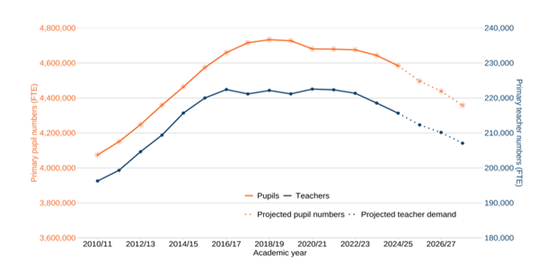
- But it’s not just a question of sufficiency, quality is key, and we are continuing to invest in our teachers, beyond their initial training. Our new Teacher Training Entitlement will ensure that every teacher and leader can access high-quality professional development opportunities to keep learning and developing at all stages of their career. This includes, from September 2026, a new training package of over £200 million over three years, available to all staff working across early years and schools to support staff in building inclusive environments.
- The Department for Education is investing to ensure all settings have the capacity, expertise and resources to support children with special educational needs and disabilities (SEND). On 15 April 2026, we announced the Experts at Hand & Local Authority SEND Transformation Fund. The overall grant provides £1.8 billion in Experts at Hand funding and £200m in transformation funding over the course of the three-year spending review period. It will take time to embed these changes, but we anticipate that by the end of academic year 2028 to 2029, this funding would mean a typical school could benefit from annual support which is equivalent to 40 days per average primary school.
- To support delivery, we are also investing over £40m in the specialist workforce, including £26m to train more educational psychologists and £15m to support more speech and language therapists to work in education settings.
- We are also re-instating the School Support Staff Negotiating Body (SSSNB), to recognise and reward the vital role that support staff play in children’s education and the smooth running of schools. The SSSNB will be a new statutory body specifically for school support staff, with a remit to negotiate pay, terms and conditions, and to advise on training and career progression.

School finances
- The schools national funding formula (NFF) is used to distribute core revenue funding to schools. It allocates funding based on a consistent assessment of need. Most of the funding is distributed based on pupil numbers and pupil characteristics.
- We recognise the pressures caused by demographic changes in some areas as schools with falling rolls will see a decrease in their funding levels. We have several inbuilt mechanisms in the system to support schools in this position.
- First, the lagged funding system, where schools are funded based on their pupil numbers in the previous October census, helps to give schools more certainty over funding levels to aid their planning. This is particularly important in giving schools with falling rolls time to re-organise their staffing (and costs) before their funding is impacted.
- The formula also provides a lump sum for every school (£152,700 in 2026-27), irrespective of their size. The lump sum is particularly beneficial to small schools more reliant on an element of funding that is not driven by pupil numbers.
- The NFF also provides funding to reflect costs associated with school premises and overheads through four separate factors: rates, split sites, private finance initiatives (PFI) and exceptional circumstances. This ensures that large overhead costs, which do not vary with pupil numbers, are funded for all schools – irrespective of pupil numbers.
- In addition, the NFF accounts for the challenges faced by small schools in rural areas through the sparsity factor. This recognises that some schools are necessarily small because they are remote and do not have the same opportunities to grow or make efficiency savings as other schools, and that such schools often play a significant role in the rural communities they serve. In financial year 2026-27, primary schools eligible for sparsity funding attract up to £58,600, and all other schools eligible for sparsity funding attract up to £85,200.
- In addition to the core funding allocated through the NFF, the department has also allocated £155 million in Growth and Falling Rolls funding to local authorities in 2026-27 through the Dedicated Schools Grant (DSG).
- While the responsibility for how this funding is allocated locally rests with the local authority, we have broadened the scope of growth and falling rolls funding to allow local authorities to use growth funding to meet the revenue costs of removing surplus places, including to create Inclusion bases or wraparound childcare provision in mainstream schools, activity which we know many local authorities already undertake. This supports local authorities with their sufficiency duty and helps them better balance the supply and demand of school places.
- Despite challenging choices about public spending, we are making a significant investment in the core schools budget, which is increasing by £1.7 billion in 2026-27. This includes funding that will enable us to reform the SEND system as announced in the school’s white paper.
- The Department for Education also recognises that it is the collective and ongoing responsibility of the government and the entire school system to secure best value for money, unlocking the full value of the substantial resources in the system to the benefit of children.
- We know there is excellent practice across the sector, with schools and trusts proactively finding ways to secure better value from their resources. We want to spread this throughout the system, seizing opportunities to go further.
- We established the Maximising Value for Pupils programme in December 2025 to help schools and trusts seize opportunities to maximise value from every pound in four key areas: commercial spend; assets, including reserves; workforce deployment; and developing capabilities, including digital and technology.
- The programme builds on the tools and services we already offer, providing an expanded level of support in the form of benchmark data, toolkits, commercial offers, capability building, case studies, and investment in areas such as technology. We have already made considerable progress, with live offers on energy, agency supply, and banking, and further work underway on Management Information Systems (MIS).
- There is already evidence this is working, with over 1,000 schools signed up to the DfE Energy for Schools service, and a new Supply Teachers and Education Recruitment (STeER) framework that caps agency mark-ups and delivers savings. The DfE banking comparison tool, launched in November 2025, helps schools and trusts compare savings accounts to ensure they are getting the most competitive interest rates.
- Schools and trusts are expected to engage fully with the opportunities we are opening up through the Maximising Value for Pupils programme. We expect all schools and trusts to use the new MIS framework and our new energy for schools service (or approved deals). This also applies to our new agency supply framework unless they have an alternative compliant agreement with rates which do not exceed those available through this framework. We will update the academy trust handbook by September to reflect these expectations.

The importance of local strategic school place planning
- Demographic change can have a school level impact, and it can create once in a generation opportunities to redefine how primary schools deliver for the changing needs of their pupils and wider communities. What is clear is that impacts can only be managed, and opportunities realised, through strategic local planning.

Admissions and collaboration
- Admissions numbers can play a key role in supporting schools to manage the impacts of falling rolls. Some schools – academies, voluntary aided and foundation schools – are their own admission authorities, meaning they decide on their published admission number (PAN); the number of students they admit. However local authorities are legally responsible for ensuring there are enough school places within their area.
- In areas of falling pupil rolls, own admission authorities may increase or retain PANs beyond what is needed. This can make it harder for the local authority and local school leaders to plan and can contribute to the financial pressures set out above. For example, a school may have a PAN of 60 but be routinely admitting 35 pupils, making it difficult to manage teacher numbers, financial viability, and space utilisation. Ultimately, this can damage viability of schools, including of good schools, limiting the choices available to parents.
- Without co-ordination on admission numbers there is an increased risk of negative outcomes. The Children’s Wellbeing and Schools Act 2026 therefore contained measures to increase co-operation between schools and local authorities on school admissions and place planning. These included new duties for mainstream state schools and local authorities to co-operate regarding their respective school admissions functions, and for mainstream, special and alternative provision state schools to co-operate with local authorities regarding their place planning functions.
- In addition, this includes a measure to enable the Schools Adjudicator, in cases where they uphold an objection to a school’s PAN, to specify what it should be. The government will also be updating the associated regulations and School Admissions Code to provide admission authorities with a clear framework on the requirements on admission authorities when setting their PAN. Consideration of school quality and parental preference will be at the centre of this framework, supporting the government’s ambition for all children to have access to a high-quality local school. In addition, the framework will make clear the process of objecting to the Adjudicator and the fundamental principles which all actors in the system (admission authorities, local authorities and the Schools Adjudicator) must have regard to.
- Our proposed framework will retain admission authorities’ ability to set the PAN for their school. However, it will require them to consider a number of factors including the demand for places, the number of children admitted in previous years, the views of the local authority, physical factors such as capacity but also finances and staffing and if the school has a religious designation the views of the person or body representing the religious denomination on their PAN.
- Once the PAN is set, if the local authority still has concerns, they can object to the Adjudicator, who will decide whether to uphold the objection by deciding whether the PAN is lawful. Only where they uphold the objection, will the Adjudicator be able to specify what the PAN should be. Before determining whether a school’s PAN should be reduced, the Adjudicator must consider the impact on school quality and parental choice, and must consult with the school, LA and Secretary of State on their views on alternatives to reducing the school’s admission numbers, such as opportunities for reorganisation or closure elsewhere.
- These changes should ensure that PANs are better aligned to local demand and prevent admission authorities setting PANs which have a negative impact on other high performing local schools. These proposed changes will require amendments to secondary legislation (the School Admissions Code and regulations) and will be subject to a full public consultation later this year.
- When a reorganisation or closure is judged necessary, this can be an opportunity to redeploy resources tied up in a certain primary school, particularly a small primary school, to provide a richer educational experience for all young people in the area. Nevertheless, the case for closure must support a sustainable and effective local school system.

School closures
- Guidance from the Department for Education is that before proposing to close a school, proposers should consider whether other types of changes, such as an amalgamation, reduction in the Published Admission Number (PAN), reutilisation of part of the school premises for other purposes (as set out in the Education Estates Strategy), or reorganisation of the school estate more broadly, could provide a realistic alternative to outright closure.
- Nonetheless, there are times when the closure of a primary school will be appropriate where places are not needed in the long term. The Government recognises that this can be a distressing and difficult decision for all those involved in the life of a school and its community. In particular, the Government recognises the impact the closure of a rural school can have, which is why there is a presumption against the closure of rural primary schools. The presumption does not mean that a rural primary school will never close, but it does mean that the case for closure should be strong and clearly in the best interests of educational provision in the area.
- The number of primary school closures remained low and broadly consistent between 2012 and 2022, with fewer than 15 closures in England per year. There has been a small uptick since, with a high of 25 primary school closures in 2024 (in addition to a smaller number of primary mergers, which may also result in the closure of provision).
- Responsibility for proposing and deciding school closures sits within locally initiated processes. For maintained schools, local authorities or governing bodies bring forward proposals and local authorities typically determine them, unless the proposal is referred to the Schools Adjudicator in specific circumstances. This allows local authorities to make decisions about maintained schools in line with their strategic place planning responsibilities.
- For academies, closure is proposed by the relevant academy trust, and the Secretary of State must agree to the closure before it can proceed, with the local authority engaged in the process from an early stage. This is because academies are maintained through a contractual arrangement between the Secretary of State and the relevant trust and the closure of an academy requires the termination of the funding agreement.
- Whilst this means that local authorities cannot propose the closure of academies, guidance is clear that the department expects academy trusts to engage constructively and collaboratively in discussions about strategic place planning; and the department has taken further steps to strengthen how local partners work together. As set out above, the Children’s Wellbeing and Schools Act 2026 introduces a new duty on academy trusts to cooperate with local authorities on place planning. We expect partners to work together to manage the supply of places, including engaging in constructive dialogue on the closure of a school where that is the right decision for the area.
- Communities must be involved in any school closure. Before closure of a maintained school, the proposer of the closure must conduct a consultation with appropriate parties before publishing the closure proposal, and any person or organisation must also be given the opportunity to comment on the specific proposals once published. Before making a final decision on the closure of an academy, the Department for Education (on behalf of the Secretary of State) must be satisfied that the local authority has been engaged in the closure decision, and that stakeholders and interested parties in the community have been given the opportunity to comment on how the academy closure can be managed.
- The Department for Education is developing its approach to area-based planning and commissioning. This includes regional teams working with local authorities, trusts and dioceses to take a more strategic approach to development of the local school system, taking account of financial sustainability; and plans to publish a framework to support local decision-making on the use of surplus space in the school estate. This will encourage all partners to consider the full range of options across both maintained schools and academies, and support brokering local solutions where needed.
- The Government is continuing to keep under review whether further changes may be needed to support effective local decision-making, including how national frameworks and regional support can best enable timely and fair decisions across all school types. It is important that changes to provision are managed in a way that supports a balanced and sustainable local system. In some areas, this requires careful coordination between maintained schools and academy trusts to ensure that decisions about the future of provision are taken in the round. Recent legislative reforms, including the duty to co-operate, alongside ongoing work on place planning, are intended to support this more strategic and collaborative approach, and to help local partners address emerging financial and organisational pressures at an early stage.

Using surplus space
- Strategic place planning can also help support primary schools to meet the evolving needs of their pupils and the wider community. While local areas must ensure that places continue to be added in areas where they are needed, we are committed to supporting the system to make effective use of the spare space that is already materialising from pupil number decline whilst consider future resilience for any potential future rise in birth rates.
- Exactly how spare space is utilised is a matter for local areas. Most of the school estate is owned locally and it is for school leaders and local authorities to work with leaseholders and land owners when making strategic decisions about space utilisation. Many local areas are already realising these opportunities and making effective use of the education estate.

SEND provision
- We want all children to have the best start in life, so that they have every chance to achieve and thrive regardless of their background or circumstance. As part of the ‘Every Child Achieving and Thriving’ white paper, we have outlined proposals to transform the SEND system so that support comes earlier, is easier to access, and works around children and families rather than forcing them to fight for help.
- As part of this, we will re-shape the system to make all mainstream early year’s settings, schools and colleges truly inclusive, ensuring that all children who can thrive in mainstream education will have every opportunity to do so.

The mainstream environment
- The physical environment can have a significant impact on pupils’ wellbeing, engagement and ability to access learning, particularly for those with SEND. Surplus capacity can create an opportunity for local areas to use existing space more strategically for all pupils, supporting early intervention.
- Adapting existing space can support more inclusive practice, for example by improving accessibility, creating breakout spaces and small-group teaching areas, or creating calm, quiet spaces or areas for sensory stimulation. These adaptations can enable earlier intervention and more flexible support within mainstream schools.
- This is supported by our upcoming guidance on inclusive estates, supporting local authorities, responsible bodies, and settings to identify targeted, high-impact adaptations aligned to their pupils’ needs and local context.
- These adaptations can be funded by the £3.7 billion in high needs capital funding between 2025-2026 and 2029-2030, which can in part be used to improve the accessibility and inclusivity of education estates.
- The Government is supporting local authorities and education settings to manage these changes effectively as part of wider SEND reforms, including through investment to strengthen inclusive provision in mainstream schools and improve the consistency and portability of support. For example, we are investing £1.6 billion in an Inclusive Mainstream Fund over the next three years to support settings to become more inclusive, enabling more children to have their needs identified and met earlier and more flexibly within mainstream settings.
- This means that, as provision evolves, pupils with SEND should be better able to continue receiving appropriate support within their local communities.
Inclusion bases
- A core component of our £3.7 billion high needs capital investment is to support the expansion of inclusion bases within mainstream settings, so that they become a more consistent part of every local education offer. Currently, access to this type of provision varies significantly between local authorities, with around 1 in 15 primary schools having a SEN unit or resourced provision.
- We are aware of many examples of inclusion bases that provide high-quality teaching, tailored learning environments and flexible access to specialist education and health support, enabling children to thrive academically, socially and emotionally where they would benefit from provision that bridges the gap between mainstream and specialist.
- Repurposing surplus classroom capacity to establish or expand inclusion bases allows local areas to increase specialist provision without requiring entirely new buildings. This can help improve the sufficiency of high needs places and reduce the need for pupils to travel longer distances to access specialist support.
- Inclusion bases will have specific areas of specialism, offering expert support for groups of pupils, such as those with complex SEND or those at risk of exclusion or low attendance. This enables them to strengthen capability within mainstream settings by sharing specialist expertise more widely across the workforce and local systems.

School-based nurseries
- The School-based Nursery (SBN) programme is a £400 million capital investment to deliver the government’s manifesto commitment to create or expand thousands of additional school-based nurseries across England, increasing access to childcare for families.
- Improving access to high-quality early years education is central to our mission to break down the barriers to opportunity and give every child the best possible start in life - essential to our Plan for Change.
- We are building and expanding nurseries in schools, providing £82 million of capital funding to over 600 primary and maintained nursery schools across phases 1 and 2 which will create over 11,000 new nursery places by September 2027, of which over 5,000 places were available from September 2025.
- In Phase 2, we have awarded £45 million of capital funding to 331 schools to create or expand school-based nurseries, with an increased focus in supporting families from disadvantaged areas to access nursery provision. Schools report they will create over 6,000 places, with more than half of these expected to be available from September 2026.
- In Phase 3 local authorities have a greater role to lead the programme in alignment with their duty to secure sufficient childcare places. We have invited LAs to develop multi-year funding proposals to deliver new and extended SBNs between 2027 and 2030, with almost £325 million available to allocate to future phases.

Wider community use
- There may also be potential in some areas to consider how surplus space on school sites could be used to co-locate family-focused services such as Best Start Family Hubs or neighbourhood health services to enhance the services available in local communities and provide a wider range of support to families.
- In our Education Estate Strategy, we have committed to developing a pathfinder project, in collaboration with local areas, that will explore how surplus space could be repurposed for wider community benefit.
- Schools can also consider how space could be used to generate income, for example by leasing space and sports facilities for local community use outside of the school day.

Conclusion
- Demographic change is a feature of the system. We must continue to support the sector to manage the impact and be prepared for the future and we are committed to going further with the support already outlined in this evidence pack.
- In our Education Estates Strategy, we have committed to developing a local decision-making framework for the use of mainstream school space through demographic change, for publication in Autumn 2026. This will support LAs to take a consistent approach to assessing need and managing capacity locally, increase transparency over decision making and supporting early strategic conversation with local partners and the DfE, to provide support to schools and communities as early as possible.
- Collectively, this will ensure that we are balancing the opportunities created by the current fall in birth rates and primary pupil numbers, with a collective view on the long-term resilience required.
- There are also still real opportunities to unlock better value from the resources already in the system, particularly across non-staff spend and workforce deployment. We are committed to expanding the practical support available in the areas that will make the biggest difference, including benchmarking, commercial frameworks, and tools to help schools act on those opportunities.
- As the demographic trend moves into secondary, we will learn from how the sector have collectively managed and responded to falling primary pupil numbers, and support them to think about workforce, curriculum, and space adaptations in secondary schools.

© Crown copyright 2026
This publication is licensed under the terms of the Open Government Licence v3.0, except where otherwise stated. To view this licence, visit nationalarchives.gov.uk/doc/open-government-licence/version/3.

Where we have identified any third-party copyright information, you will need to obtain permission from the copyright holders concerned.

25 June 2026

Source: SCAP 2024/25 (Local authority pupil forecasts - national, regional, local authority, planning area)
Source: School Census. Historical data pre-1996
Population estimates for England and Wales - Office for National Statistics
Source: Births in England and Wales: birth registrations 2025 - Table 6: Maternities, live births, and stillbirths by country, registration type, age of mother and age of father, England and Wales, 1938 to 2025.
Berrington, A. and Kulu, H. (2026) From costs to culture: what’s behind falling fertility in rich countries? Economics Observatory
Office for National Statistics (ONS) (2026) Births in England and Wales: 2025
Berrington, A. and Kulu, H. (2026) From costs to culture: what’s behind falling fertility in rich countries? Economics Observatory
Source: National population projections, fertility assumptions from the Office for National Statistics The total fertility rate (TFR) is the average number of children a woman would have based on current birth patterns. The TFR is a snapshot of fertility for one particular year. This measure is different from a birth rate which reflects how many children are born compared to the size of the total population. Historical TFRs used in the 2022-based and 2024-based assumptions differ as they make use of the latest available revised population estimates during the assumption setting process.
Source: Births in England and Wales - Office for National Statistics
Source: Long-term international migration, provisional - Office for National Statistics Note: Data in the chart combines; Borders and Immigration data from the Home Office, Registration and Population Interactions Database from the Department for Work and Pensions, and International Passenger Survey from the Office for National Statistics
Source: Long-term international migration, provisional - Office for National Statistics Note: Data is from the Borders and Immigration data from the Home Office
Source: SCAP 2024/25 (capacity – national, regional, local authority) Explore and download data - School capacity - Explore education statistics - GOV.UK
Source: Internal migration in England and Wales - Office for National Statistics
Source: Release home - Primary and secondary school applications and offers - Explore education statistics - GOV.UK
Source: SCAP 2024/25 (capacity – national, regional, local authority) Explore and download data - School capacity - Explore education statistics - GOV.UK and GIAS: Get Information about Schools - GOV.UK
Source: SCAP 2024/25 (capacity – national, regional, local authority) Explore and download data - School capacity - Explore education statistics - GOV.UK
Release home - Schools, pupils and their characteristics - Explore education statistics - GOV.UK
For example, An analysis of the performance of sponsored academies
Source: SCAP 2024/25 (Estimates of future school place demand (place planning) - national, regional, local authority, planning area) Explore and download data - School capacity - Explore education statistics - GOV.UK
Source: SCAP 2024/25 (Local authority pupil forecasts - national, regional, local authority, planning area) Explore and download data - School capacity - Explore education statistics - GOV.UK
Figure 14 is a planning area map of England. It shows planning areas that are forecast to have unfilled capacity (highlighted in blue) and planning areas that require additional school places to meet forecast demand (highlighted in red/brown) by 2029/30. Source: SCAP24/25
Note: negative values denote unfilled capacity
Responding to changing demand for school places
Making significant changes to an academy (Part One: Sufficiency Framework, pg. 6-14)
Sources and Methodology: This analysis brings together publicly available KS2 data from Compare school and college performance data in England - GOV.UK and school capacity data from School capacity - Explore education statistics - GOV.UK. Schools where KS2 or school capacity data were unavailable, not applicable, or suppressed were removed from the analysis. School capacity data was filtered by school phase to include primary schools only, and where multiple rows were present for a school, capacity values were aggregated by summing across rows to produce a single record per school. Schools were split into 10 groups of approximately equal size based on the percentage of pupils achieving the expected standard in reading, writing and maths. The average unfilled places was derived from the total number of unfilled places divided by the total available places, for schools in that group.
What happens when pupil numbers fall? - NFER
Note: These pupil projections data were used to estimate 2026/27 PGITT trainee need and will differ slightly to the department’s latest pupil projections. This chart does not include the recently published School Workforce Census data for 2025/26.

