Written evidence submitted by Dr. Dale Shaffer-Morrison, PhD (LUN0012)

Dr. Dale Shaffer-Morrison, PhD
Lecturer, Department of Psychology
University of Essex

Dear Environment, Food, and Rural Affairs Committee:

Please find below evidence submitted in answer to Question (3): “To what extent do the current Environmental Land Management (ELM) schemes and other support like the Farming in Protected Landscapes (FiPL) schemes support financially and environmentally sustainable land management in the uplands?”. This evidence is supported by peer-reviewed publications which utilised quantitative analysis and experiments to predict under what conditions farmers and landowners accept wetland restoration schemes, and how these schemes can be made more appealing. I warmly welcome any additional questions about this evidence.
Sincerely,
Dr. Dale Shaffer-Morrison, PhD

Evidence
(1) Context. Wetlands restoration is a unique nature-based land use change opportunity- they capture carbon, manage both flood and drought, and provide habitats to endangered birds and amphibians. Restoring wetlands presents a behaviour change problem-we need land managers to change their current land management strategies, accept wetland restoration policies, and both install and upkeep wetlands over time. Many of these land managers are in the agricultural industry, where wetlands present nature-based solutions for flood and drought resilience. As an environmental psychologist collaborating with agricultural engineers and farmers, my research shows that farmers and landowners have diverse mindsets towards wetlands, and designing policies with this in mind results in massive cost savings. When designed well, wetlands restoration policies may help address the strains that UK farmers currently face. From this evidence, I recommend that a wetlands restoration schemes be formed, with payments directly to farmers, to increase their availability and ease of sign-up; in line with the Sustainable Farming Incentive goals of “resilient businesses while caring for the environment”.

(2.1) Wetland restoration acceptance. Agriculture faces increasing pressures from flood and drought, which wetlands can help to mitigate as a water regulation strategy. Aside from these benefits, they also offer aesthetic and recreation potential, although farmers vary greatly in their perceptions of the benefits of wetlands, and their willingness to participate in wetlands restoration (Soldo et al., 2022). In particular, farmers were most accepting of wetlands schemes if: (1) the land was low-productivity, (2) they believe that wetlands provide hunting and aesthetic opportunities, and (3) they believe that a ‘good farmer’ cares about conservation. Further, financial considerations are important; larger farms and those with diverse income were more accepting of wetlands, likely because wetlands have a lower risk profile for them.
(2.2.) Given these diverse preferences for wetlands, my research further examined incentive strategies to encourage wetlands restoration. Using a choice experiment, we found that the above factors (farm size, conservation mindset, and beliefs about wetland benefits) also influenced the type of policies farmers were willing to accept. We used these factors to build farmer types or ‘profiles/classes’. Overall, the most popular scheme design was for 100% coverage of the upfront costs of wetland restoration construction, followed by an annual subsidy. However, farmers varied greatly on preferences for wetland size (see Figure below).

Figure 1
Probability of farmer enrolling in hypothetical wetland restoration scheme,
15-acre wetland on unproductive land, with scheme covering all construction costs
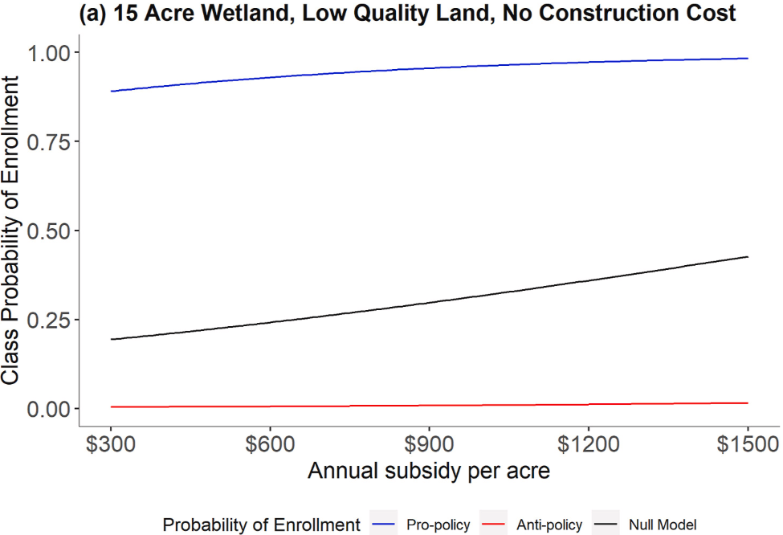
Source: Ashenfarb et al., 2022, shared with author permission.

(3) Cost-savings analysis and Scheme design. We found (Ashenfarb et al., 2022) that farmers hesitant towards wetlands schemes indicated they were extremely unlikely to install a 15-acre wetland on low-productivity land, and only a 25% chance of installing a 1-acre wetland even with annual subsidy of about £1100 per acre. But farmers who were supportive of wetland schemes indicated an over 90% chance of installing a wetland under these conditions, but with a much lower annual subsidy of £600 per year. This presents a massive cost-saving opportunity-by designing policies on the basis of who is likely to restore a wetland, the cost of annual incentives can be lowered substantially compared to average preferences across all farmers.
(4.1) Recommended changes to current schemes. By supporting the up-front costs, wetlands schemes can mitigate financial risks associated with such a large spend. Given that many farmers currently face mental health issues, burnout, and stress from financial strain (Palczynski et al., 2026), the evidence supports that schemes which minimize additional strain on farmers are more likely to be accepted.
(4.2) I recommend that SFI additionally support wetland restoration toward farmers and landowners directly, whilst still partnering with charities and keeping existing strategies towards reaching wetland goals. It is my understanding that wetland restoration is currently supported by either charitable partnerships or SFI grants, with availability varying greatly by region. Given that wetland restoration can be very costly, and upkeep includes long-term costs, in many cases wetland restoration costs cannot be covered with £10k (which can cost more than twice that; Defra, 2015), and probably cannot be considered complete by March 2029 due to annual maintenance costs. Further, if wetland restoration were scheme-based and more centralised rather than only grant-based, the application process would likely take less time and effort for already time-stressed farmers and land managers, increasing uptake. For instance, perhaps a national portal could be used to help farmers and landowners determine their eligibility, based on priority regions.
(5) Scheme communication strategies. Farmers who tend to think about and plan for the future are most likely to engage in conservation-focused land management practices (Shaffer-Morrison et al., 2025). Therefore, I recommend that communications about wetland restoration schemes appeal to farmers’ legacy and wildlife stewardship mindsets, concerns for preserving the countryside for future generations, and emphasize wetlands as a risk management strategy toward maintaining land value in the face of increasing flood and drought risk.

June 2026

