Local Councils Network – Written evidence FDE0024
About the Local Councils Network
The Local Councils Network (LCN) speaks up for 169 councils across England and supports them to build better places. We champion the critical role played by councils within a devolved system, asserting that power, responsibility and accountability should sit as close to communities as possible.
LCN was formerly known as the District Councils’ Network. We’ve evolved in response to local government reorganisation and our desire to build a bold new body that represent all councils, whether unitary or district. We remain a special interest group of the Local Government Association.
LCN member councils deliver services to 21 million people, cover 57% of England’s land area, and are home to 36% of all businesses.
We champion councils as the backbone of a truly devolved system. Power, responsibility and accountability must sit close to communities, which is why fiscal devolution must strengthen local, not just regional, control over resources and align funding with councils delivering services on the ground.

Executive Summary
England is hugely diverse. Some places are major global cities, while others are small rural communities. Some areas are growing and attracting investment, while others feel left behind. Although all face the same broad challenges, these pressures play out very differently from place to place.
Despite this diversity, England is one of the most centralised countries in the developed world. Very little tax is raised locally and most key decisions are taken in Whitehall, far from the communities they affect. This one-size-fits-all approach has contributed to significant and persistent inequalities between places. Policies that work well in one area often fail to reflect the realities of another.
We welcome the Chancellor of the Exchequer’s commitment to set out a roadmap for future fiscal devolution in the upcoming Budget. For devolution to be meaningful, it must involve real control over funding and revenue, not just the transfer of additional responsibilities.
The benefits of fiscal devolution will only be fully realised if local councils play a central role in delivering it. A focus solely on regional bodies is not sufficient. Placing real fiscal power with local government would bring decisions closer to communities and embed them within institutions that already operate across the whole country, have well-established governance arrangements, and enjoy higher levels of public trust than central government.
The Local Councils Network believes communities in England should enjoy the same fiscal freedoms seen in comparable countries. Our experience shows that local authorities are ready and well placed to act as the foundation of a system of fiscal devolution that delivers stronger local decision-making, fairer outcomes between places, and better services for residents.
Most comparable countries allow local and regional governments to supplement core taxes with locally set levies and the freedom to vary rates. England stands apart for how little choice it allows locally. Protecting taxpayers should not mean denying local voters the right to decide how their communities are funded and to hold local leaders accountable for those decisions.
A workable system of fiscal devolution must therefore combine shared national taxes, genuine local control over existing revenues, the ability to raise local taxes, and strong protections against unfunded mandates.
To deliver meaningful fiscal devolution, LCN believes the following key reforms are required:
- Council tax reform, including freedom over rates, bands and structures to reflect local housing markets and ability to pay.
- A review of the council borrowing regime to remove unintended barriers to responsible investment in housing, infrastructure and other essential local priorities.
- Greater business rates flexibility, including enhanced local retention and discretion over multipliers and reliefs.
- Robust safeguards against unfunded mandates, ensuring that new or expanded statutory duties are fully and sustainably funded.
- A clear role for local councils, alongside regions, in designing and operating devolved fiscal systems.
- Tourism and visitor levies, set locally, with revenue retained in the areas experiencing the pressures of tourism.
- Full cost-recovery powers for fees and charges, particularly for licensing and regulatory services.

Taken together, these changes would move England away from a highly centralised model towards a system that recognises diversity, supports growth, reduces inequalities, and enables local government to play its full role

- What are the general aims of fiscal devolution? What can it achieve?
For the Local Councils Network, fiscal devolution is about giving councils the power to act, not just the responsibility to deliver. It enables decisions to be made by those closest to communities, drawing on local knowledge and accountability, rather than relying on permission and funding from an over-stretched centre.
England is an exceptionally diverse country, but decisions about taxation and spending remain highly centralised. A one-size-fits-all system cannot reflect the range of economic, social and demographic conditions across places. Fiscal devolution would allow councils to tailor responses to local circumstances, support local growth, and address inequality between places more effectively. It would also strengthen democracy by making local leaders clearly accountable to local taxpayers.
International experience shows that greater local fiscal autonomy is the norm and supports both economic resilience and better public services. England’s low level of locally raised tax leaves councils with too little ability to shape outcomes in their areas. Fiscal devolution is therefore essential if councils are to act as genuine place-shapers rather than delivery arms of central government.

- At what level – combined or local authority – should devolution take place and should the nature of the devolution vary by type of authority?
LCN welcomes the Chancellor’s commitment to publishing a fiscal devolution roadmap and recognises the value of allowing places to retain a share of growth from national taxes.
However, LCN is concerned that the Chancellor’s Mais Lecture framed fiscal devolution primarily in terms of devolution to “regional leaders”. If this is intended to mean strategic authorities alone, excluding their local counterparts, it would represent a missed opportunity.
As a practical matter, only a minority of England’s population is currently covered by Strategic Authorities. Until such coverage is comprehensive, limiting fiscal devolution to the regional tier would exclude significant parts of the country from its benefits.
More fundamentally, the logic of rebalancing power away from the centre applies not only not only between central government and regions, but also between regions and their constituent localities. While certain policy areas are best addressed at a wider geographical scale, many fiscal and service decisions are most effectively taken at the level closest to the communities they affect.
This point is reinforced by the scale and internal diversity of many existing and proposed strategic authorities, several of which are comparable in size to nation states. For example, the GLA has a population one-and-a-half times larger than the Kingdom of Denmark. Within Denmark are regional councils which manage health, public transport and regional development and 98 municipalities able to levy their own income tax (at an average rate of around 25%) and property taxes.
Given the large size of current and proposed strategic authorities, there is inevitably significant variation within them:
- Greater Manchester would contain Manchester, which has the highest level of deprivation according to the Indices of Multiple Deprivation, and Trafford, which ranks 154th.
- Portsmouth’s population density per hectare would be twenty-seven times more than Winchester’s despite them both being in the proposed Hampshire & Solent authority.
- Within Greater Essex, the average house price in Epping Forest would be £289,000 higher than in Tendring.
- The median resident of North Norfolk is 21 years older than that of Norwich.
These variations illustrate the risk of distorting fiscal outcomes if devolution is focused solely at the regional level.
A clear example is the proposed visitor levy. The proposals consulted on in early 2026 suggested the revenue from this levy be allocated to strategic authorities. However, as the chart below illustrates, the distribution of overnight visits can be highly concentrated in relatively small areas. This is particularly true of district councils in rural areas, which are responsible for culture and tourism as well as environmental services such as street cleansing that are most affected by large inflows of temporary visitors. As a result, the costs associated with visitors are therefore unlikely to be evenly spread across a whole strategic authority area even if the levy from this sector is.

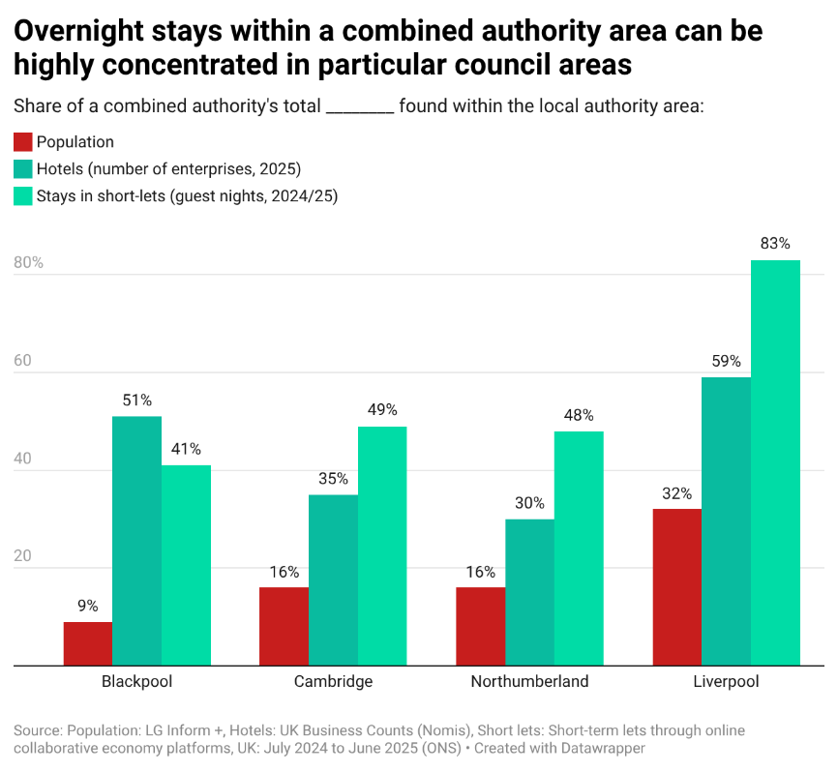

LCN believes fiscal devolution must be rooted in democratic accountability, public trust and fiscal fairness. This requires local councils to be central actors, not peripheral partners, in devolved fiscal systems, so that revenue, responsibility and accountability are properly aligned.
- What spending powers should be devolved to local areas?
The Government should move forward with full devolution of funding and delivery of affordable housing. The role for fiscal role for central government should be pared back to, where appropriate:
- matching need and resource levels across regions,
- macroeconomic stabilisation, and
- providing specialist services that economies of scale or free rider problems would make impractical to deliver at a regional level.
The allocation of funding within regions should reflect an agreement between the principal local authorities and, where present, the strategic authority. This would align responsibility for spatial planning with one of the most meaningful tools to proactively catalyse and shape development. The regionalisation of Homes England’s operating model would provide a strong starting point for implementing such a set-up.

- What revenue-raising powers should be devolved to local areas?
LCN believes immediate progress towards fiscal devolution could be made by loosening central control over existing local revenues, including by establishing:
- Local flexibility over council tax, including relaxing or removing referendum limits and allowing councils discretion over rates, ratios, bands and banding structures to better reflect local housing markets and ability to pay.
- Greater freedom over business rates, including an increased share of revenues retained locally and local discretion over multipliers, reliefs and exemptions so councils can respond to local economic conditions.
- Powers for councils to introduce locally determined tourism or visitor levies, with revenues retained in the areas experiencing the direct service pressures associated with tourism.
- Full cost-recovery powers for fees and charges, particularly for licensing and regulatory services, so that local taxpayers are not subsidising activities that primarily benefit specific users or sectors.
- A review of the council borrowing regime to remove unintended barriers to responsible investment in housing, infrastructure and other essential local priorities.
We see potential in the approach outlined in the Chancellor’s Mais lecture of reallocating fixed shares of national taxes. In particular, we would advocate that councils be allocated any Stamp Duty Land Tax payable on newbuild residential properties within their boundaries. This would both create a tangible financial incentive for communities for facilitating new housing in their area and a contribution towards any fixed costs of accomodating new households, which are not properly covered by s.106 agreements or the Community Infrastructure Levy.
However, we do not believe that relying on fixed proportions of centrally levied taxes is sufficient to is not enough, in and of itself, to create meaningful fiscal devolution. While shared taxes can play a role, experience in England and internationally shows that a resilient devolved system requires broader local fiscal freedom, including genuine discretion over revenue sources that councils already collect and the ability to introduce locally decided taxes.

- What mechanisms of equalisation between areas should the Government consider and how might these be updated as differences between regions change? What mechanisms might be needed to avoid inter-region tax competition leading to insufficient aggregate tax collection?
Differences in local revenue-raising capacity and need for services mean redistribution and equalisation remain essential to avoid widening inequalities. Mechanisms to redistribute resources between areas are already built into the current Local Government Financial Settlement. Councils are funded by a mixture of locally raised revenue and government grants. The amount of grant is adjusted in light of calculations about the level of need and resource available in each local area. In principle, this system could in principle be updated and adapted to reflect increased local revenue-raising powers, ensuring that fiscal devolution supports fairness and does not widen inequalities between places.
It is important that any discussion of further mechanisms of equalisation avoids equating it with harmonisation. A necessary upshot of fiscal devolution is that levels of tax and service provision will differ from place to place. If these contrasts reflect a relative lack of resources in a locality or region then that represents a genuine unfairness. However, if local voters make genuine choices – backed up by the resources to realistically make different decisions - and can hold their local leaders accountable for the outcomes of these decisions, then the contrasts that arise are an example of local democracy that Westminster should respect.

- What are the distributional consequences of further fiscal devolution?
LCN believes that further fiscal devolution is an opportunity to achieve a fairer distribution of outcomes between local areas. The UK is an outlier amongst peer countries both in how centralised its public finances are and in how geographically unequal it is. LCN believes that these two facts are connected: the same policy applied in different areas will lead to different outcomes. Rather than trying to flatten inequalities from above with one-size-fits-all policies, it would be preferable for government to enable ground up initiatives tailored to local circumstances to power catch-up growth in less affluent places.

- What governance arrangements are needed as more powers are devolved to local areas? How should local and mayoral strategic authorities be best scrutinised and held to account for the exercise of any new powers?
LCN believes that local authorities should play a central role in governing fiscal devolution. They are uniquely well placed to do so not only because they are the democratically elected bodies closest to communities, but also because of their substantial existing responsibilities for taxation and public spending.
In 2024-25, they were responsible for £131 billion of revenue expenditure, whilst collecting £41 billion in council tax and £26 billion of business rates.
Local councils in a recognisably modern form have existed for nearly 200 years, and their systems of governance are now well-established and robust. Regular local elections provide a strong democratic mandate and clear accountability. An ombudsman service offers a route for addressing individual complaints, councils are subject to judicial review, and all must publish audited accounts alongside regular, publicly reported budget monitoring. In institutional terms, local government is ready for fiscal devolution.
Public trust is a particularly important principle in the context of devolution. Evidence suggests that councils enjoy higher levels of trust than central government. A 2024 Survation poll found that 49% of respondents were more trusting of councils, compared to just 14% for the Government. This trust underpins the case for locating greater fiscal powers at the local level, where decisions are more visible and accountability is clearer to residents.
Therefore, the existing system of local authority governance would provide the most stable and effective foundation for scrutinising and creating accountability for the use of powers under fiscal devolution.

- Should devolution be paired with tax reforms, such as council tax revaluations, or can it be carried out separately?
LCN believes that the council tax is in need of significant reform, including updating valuations. However, changes such as removing referendum limits or allowing councils to add or change bands would not require this to happen.
As we indicated in our answer to question 4 on the devolution of revenue sources, we are also of the view that building a robust, sustainable local revenue base will ultimately involve expanding the range of sources available to councils. This would necessarily be somewhat separate to existing taxes and would, therefore, not rely on them being reformed.

- What transitional issues need to be considered in devolving fiscal powers to local areas?
Fiscal devolution is deliverable, provided reform focuses on removing unnecessary central controls rather than creating new layers of complexity. Many of the changes LCN has proposed build directly on existing systems for tax collection, budgeting and accountability that councils already operate, and could be implemented relatively quickly.
The main practical challenges are not technical, but institutional. Central government will need to shift from detailed control towards setting stable national frameworks, including redistribution and safeguards. Local authorities will need certainty and clear timelines to plan effectively, but councils already have significant expertise in managing public finances and taxation. A phased approach would allow capacity to build where needed while delivering early gains.
Many reforms could be introduced within existing legislation. Where fiscal devolution involves relaxing central controls, new primary legislation is not always required. For example, council tax referendum limits exist only because central government actively sets them each year. Current legislation provides that if no limit is set, no cap applies. Allowing this to lapse would simply restore the pre-2011 position for principal authorities and align them with parish councils, combined authorities and Police and Crime Commissioners, all without legislative change.
With regards to local fees and charges, in many instances these are set via secondary legislation. Therefore, councils could be given full flexibility over their level, or at least a significantly increased range of permissible levels, via the same route.

- What risks does the Government need to consider in any further fiscal devolution?
A key risk is that fiscal devolution becomes symbolic. If central government continues to impose new duties without fully funding them, or retains detailed control over how revenue can be used, local autonomy will be undermined. The New Burdens doctrine has not worked reliably in practice, as illustrated by recent examples such as weekly food waste collections and the long-term underfunding of temporary accommodation costs. Strong protections against unfunded mandates are therefore critical. The ability to raise local revenue means little if councils are still required to fund new or expanded statutory duties without adequate funding.

- Does fiscal devolution require wider constitutional change to be successful?
LCN takes no overall view on the interaction between devolution and the wider constitutional framework. However, we note that for much of Britain’s modern history local government in England has had much greater fiscal autonomy, both in principle and practice, than they have at present. This suggests that there would be opportunities for fiscal devolution that do not require constitutional innovation.
8 June 2026

English Devolution White Paper Explainer - CfGS
CoR - Denmark Fiscal Powers Local government personal taxation by region and tax rate - StatBank Denmark - data and statistics
All raw figures used in this list were obtained from the LGA’s LG Inform+ platform
Short-term lets through online collaborative economy platforms, UK - Office for National Statistics Nomis - Query Tool - UK Business Counts - enterprises by industry and employment size band
Levelling up: where and how? | Institute for Fiscal Studies
Local authority revenue expenditure and financing: 2024-25 budget, England - GOV.UK
Collection rates for Council Tax and non-domestic rates in England, 2024 to 2025 - GOV.UK
One in four planning committee members oppose the building of new homes in their local area, new Survation poll finds - apse
The Decline and Fall of Local Democracy

