The Productivity Institute, University of Manchester – Written evidence FDE0017

We welcome the opportunity to submit to the Economic Affairs Committee’s inquiry into fiscal devolution in England. Our latest research at the Productivity Institute, University and Manchester, and Queen Mary University of London focuses on the relationship between governance and productivity, and in particular whether the UK's governing institutions — given the degree of over-centralisation and siloed decision-making — are fit for the 21st century. Our research investigates how policies, the political system and institutions historically and contemporaneously shape the UK's poor productivity performance.

Introduction

In her Mais Lecture, the Chancellor, Rachel Reeves committed to publishing a "fiscal devolution roadmap" alongside this year's Budget. The Chancellor indicated in her speech that the roadmap would involve giving “regional leaders” control over a share of existing national tax revenues. She emphasised that the reforms would be “fiscally neutral” and focused on the retention of existing national revenues rather than the introduction of new taxes. The stated intention is to extend greater fiscal autonomy to those areas judged to have the capacity to exercise such powers effectively.

The commitment to fiscal neutrality has important implications for the scope and nature of any future devolution settlement. If additional tax revenues are to be retained locally without increasing the overall tax burden, it is difficult to envisage a model based solely on the transfer of financial resources. Rather, fiscal devolution will likely require a corresponding transfer of responsibilities and functions from central government to strategic and local authorities. In practice, this would mean devolving not only a share of revenue but also accountability for activities that are currently funded, administered, or delivered by Whitehall, given the limited headroom in the fiscal rules. While authorities may subsequently choose to organise or deliver those functions differently, it is possible that additional revenue will need to be at least partially offset by new responsibilities.
This development would require re-configuration of the English state. The transfer of fiscal powers and responsibilities would need to be accompanied by the development of institutional and administrative capacity at the appropriate institutional level. Effective devolution requires building capability to exercise new powers and manage associated burdens. It could, depending on the design of the roadmap, also alter the relationship between the public and the Government by bringing decisions about spending, if not taxation, closer to local electorates. In doing so, it would strengthen local democratic accountability, while simultaneously increasing the political salience of sub-national government.
Finally, any discussion of fiscal devolution must be situated within the context of the substantial territorial inequalities that continue to characterise England and the wider United Kingdom. Most regions and localities remain net recipients of fiscal transfers, with relatively few generating sufficient tax revenues to finance their existing levels of public expenditure. Fiscal devolution must, therefore, also address questions of re-distribution and equalisation. For this reason, the central challenge is less the creation of a radically different system of taxation and spending, and more the development of a more effective model of multi-level governance in which responsibilities, resources and accountability are aligned across different tiers of government.

- What are the general aims of fiscal devolution? What can it achieve?
International evidence suggests that fiscal devolution can deliver a broad range of economic, democratic and institutional benefits. These include:
- Strengthening local democracy and improving public accountability by giving places greater responsibility for raising and spending revenue;
- Encouraging policy innovation and more responsive public services through greater flexibility over taxation, investment and spending priorities;
- Building more resilient public institutions with greater local capacity and closer alignment to community needs;
- Supporting economic growth by enabling places to align fiscal incentives with local economic development strategies;
- Reducing regional and spatial inequalities through more tailored investment and long-term planning.
While Rachel Reeves has made clear that the Government sees fiscal devolution primarily as a tool for driving economic growth in her Mais Lecture, that focus is too narrow. A ‘growth-only’ approach risks limiting reform to a small number of devolved tax assignments, rather than addressing the deeper structural weaknesses created by England’s highly centralised state.
International comparisons demonstrate the scale of that centralisation. The UK remains one of the most fiscally centralised countries in the OECD. In 2023, central government raised 91.8 per cent of all government revenue, compared with an OECD average of 53.2 per cent. We welcome the Government’s focus on the Integrated Settlement and, more recently the Visitor Levy, which are steps in the right direction.

- At what level – combined or local authority – should devolution take place and should the nature of devolution vary by type of authority?

An important caveat to set out at the outset is that granting fiscal autonomy to strategic and local authorities does not necessarily mean those authorities will choose to use them. While the ability of those places to decide what works best for them is a central principle of devolution, in practice the reluctance to exercise revenue-raising powers that are available presents a critical risk.
Recent examples illustrate this tension clearly. The Mayors of Greater Lincolnshire and Hull and East Yorkshire have both indicated they do not intend to introduce the new Overnight Visitor Levy. Other Mayors have ruled out introducing a Mayoral Precept, but continue to seek investment from UK Government. Meanwhile, only one authority in England — Nottingham — has implemented a Workplace Parking Levy, despite powers existing since the Transport Act 2000. This reflects a broader point that politicians have been supportive of greater spending powers in principle but remain cautious about raising taxes or charges locally.

Nevertheless, there is a strong case for fiscal devolution to be shared between strategic and local authorities. It would be a missed opportunity if the Government only focused on strategic authorities.

At the level of strategic authorities, given their large functional economic geographies there is a compelling argument for assigning a percentage of large national taxes, such as Income Tax, VAT or Stamp Duty Land Tax, for example. Evidence from across the UK suggests that Income Tax is more predictable than VAT. This is the spatial scale at which, broadly speaking, given the variation in strategic authorities (from 9 million served by the Greater London Authority, to 500,000 served by Cumbria Combined Authority) that labour markets, housing, infrastructure investment and economic development operate most coherently. Strategic authorities are being given more responsibilities in these domains, such as developing Spatial Development Strategies, and operating at sub-regional or regional scale enables them to smooth intra-regional disparities between constituent local authorities.
On the other hand, local authorities should retain an important role through more tax-raising autonomy, and greater flexibility over existing taxes. England’s local tax base is increasingly outdated and distorted. Council Tax, for example, is still based on property valuations from 1991 — now 35 years out of date — despite dramatic changes in housing markets and wealth distribution since then. The current system is difficult to justify. Properties valued at millions of pounds in London and the South East (especially in more affluent places such as London’s Wandsworth and Westminster) face lower council taxes than properties in lower-value areas, particularly in northern England. In Wales, council taxes have been re-valued against property values more recently (though still dating back to 2003), while local authorities also have the autonomy to increase council taxes, unlike the Referendum Principles placed on local authorities in England, where a maximum of three or five per cent applies, depending on the authority.
It is at this level — improving the functioning of existing taxes and granting places greater autonomy over them — that the Government should focus on fiscal devolution to support local authorities. This would help improve the resilience of those authorities, which remain at significant risk of effective bankruptcy, known as a Section 114. According to the Local Government Information Unit 39 per cent of respondents to their survey anticipated they will need to seek Exceptional Financial Support in the next five years.

- What revenue-raising and spending powers should be devolved to local areas?

The key point to make is that places need flexibility to raise revenue to suit their needs. In Japan, for example, there are 23 local taxes. These taxes are broad in nature and include examples such as a Golf Course Utilisation Tax. In Kyoto, it accounts for approximately 30 per cent of total revenue.
We have listed some of the revenue-raising and spending powers places should have autonomy over, which include Income Tax, VAT and SDLT. An important principle is the administrative burden the collection and distribution of these taxes require, with evidence that Income Tax is administratively easier than, for example, VAT.

- What mechanisms of equalisation between areas should the Government consider and how might these be updated as differences between regions change?

The first point to make is that equalisation is not new in the UK context. The Government commonly uses equalisation mechanisms, such as through the Local Government Finance Settlement. The LGFS is £83.5 billion in 2026-27, representing a much larger figure than anticipated fiscal devolution in the short- and medium-term.

Internationally, equalisation is an embedded feature of fiscal devolution across Japan, France, Australia and others, and there is much the UK could learn from them. The Government will need to design the necessary mechanisms to ensure that, particularly in weaker growth areas with lower tax-raising capacities, do not lose out. This will require substantive work from HM Treasury, MHCLG and strategic and local authorities, and as an indication of the length of time it might take to design equalisation mechanisms, it took 26 months from the announcement of the Single Settlement, later renamed to the Integrated Settlement, until it came into force.

- What mechanisms might be needed to avoid inter-region tax competition leading to insufficient aggregate tax collection?

We do not agree that mechanisms are needed to avoid inter-regional tax competition at this stage. This is for two reasons.
First, the evidence does not suggest it is likely. Evidence from the OECD suggests that increasing tax autonomy does not induce a ‘race to the bottom’. In fact, it concludes, over recent decades sub-national taxes have “trended up rather than down and generally converged over time”. Given responsibilities for public services are broadly codified, through statutory services delivered by local authorities and explicit competencies for strategic authorities, it is likely that authorities will be obliged to set similar tax rates to continue to deliver them.
Second, the level of fiscal autonomy required to enable meaningful inter-regional tax competition is highly unlikely to emerge in the UK in the foreseeable future. The experience of the Greater London Authority illustrates the pace and scale of change. Nearly three decades after its establishment in 1999, London has secured only a relatively modest suite of fiscal powers, including the Mayoral Precept and the Mayoral Community Infrastructure Levy. Even these remain tightly constrained by national legislation and HM Treasury oversight.
As a result, concerns about aggressive inter-regional tax competition between English regions are overstated. The type of fiscal competition envisaged by the Committee is more characteristic of mature federal systems — such as Canada or the United States — where sub-national governments possess constitutionally entrenched fiscal authority. Canadian provinces can independently change personal rates of Income Tax, as well as their banding, while US states routinely compete through competitive sales, income and corporate taxes.

- What are the distributional consequences of further fiscal devolution?

Further fiscal devolution has major advantages, not least incentivising regions and places to grow. But it would represent a major change to the UK political system given the degree of current centralisation. Further fiscal devolution would almost certainly create ‘winners’ and ‘losers’: economically disadvantaged areas that tend to have a weaker tax base would be particularly vulnerable if tax-raising powers were devolved. The weakness of the local tax base would in turn undermine their ability to fund vital public services, even if local authorities were prepared to enact large rises in taxation. Were fiscal devolution to be poorly designed, further political and fiscal devolution would exacerbate inequality. Our research shows that the ad hoc ‘rollout’ of English devolution over the last 15 years has been shown to have exacerbated the imbalances between places in relation to powers, resources and capacity, threatening to worsen existing spatial disparities. Off-setting the adverse distributional consequences of fiscal devolution therefore requires corrective equalisation mechanisms to minimise the impact of certain places having weaker tax bases than others. There are three broad approaches that can be applied in that regard.

The first and most obvious mechanism is central government grants based on need that can transfer resources from surplus to deficit areas. This requires a formula to assess need based, for example, on the demographic profile of the local population and the demands imposed on local services. Think-tanks such as the Institute for Fiscal Studies have set out proposals for detailed transfer frameworks from national government to ensure that deprived areas are not left underfunded simply because their local tax bases are weaker. Federal governments such as Germany and Australia have well developed equalisation formulas that have partially succeeded in off-setting spatial inequality.

A second complimentary approach is to make local taxation itself more progressive, for example by taxing capital, assets and land. A reformed council tax based on an up to date re-valuation would be a good starting point for reform of local taxation, not least ensuring that the highest valued properties pay a larger share of council taxes. Redistributing some of that income could be allocated to areas of relative economic disadvantage. Other options for local and strategic authorities to strengthen local progressive taxation include taxes that capture land value.

The third strategy is targeted social and economic interventions that support those in greatest need within local area, for example through direct cash transfers to the most vulnerable residents through the welfare system, alongside devolution of employment support budgets to strategic authorities to equip working age populations with job-ready skills that protect them from economic failure, reinforced by effective industrial policy and government-led investment.

As such, fiscal devolution need not have adverse distributional effects if the system is designed to protect areas more at risk of long-term economic disadvantage.

- What governance arrangements are needed as more powers are devolved to local areas? How should local and strategic authorities be best scrutinised and held to account for the exercise of any new powers?

There is a widespread consensus that accountability has not kept pace with devolution. Previous research by The Productivity Institute highlights the forms that accountability should take.
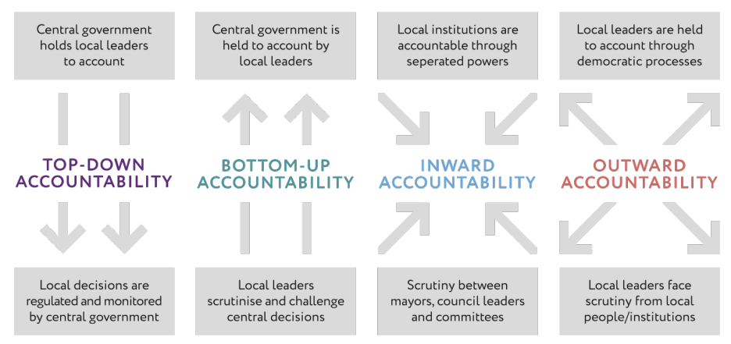

We make three short observations. First, we welcome that the Government has chosen to strengthen formal scrutiny arrangements for strategic authorities, as part of the English Devolution and Community Empowerment Act. That legislation mandates a Local Scrutiny Committee which will be implemented from April 2027 for strategic authorities with Established Status and from April 2028 for newer authorities. Central government intervention is designed to encourage a ‘culture of accountability’ within strategic authorities.

The LSC will have power to investigate issues, make recommendations to the Mayor, review the value for money of public expenditure, send reports to the MHCLG Secretary of State (or any SoS, for that matter), impose a civil penalty on individuals that fail to attend and, at least in theory, a Mayor can “cease to hold office” if they fail to attend the LSC repeatedly. The Chair is required to be an Independent Member or from one of the constituent local authorities, providing they are not from the same political party as the Mayor.

Second, the English Devolution Act increases the potential for bottom-up accountability, but it is currently weak. The Government has established a Right to Request to give Established strategic authorities the autonomy to submit requests for additional devolved competencies and funding. Early signs are that the Overnight Levy was approved, at least in part, because of the collective submission of a Right to Request. This is positive. While its early operation before the legislation was passed as a ‘shadow Right to Request’ has created friction and skepticism about its value, with a number of interviewees throughout our research describing the mechanism as a ‘Right to Refuse’, section 53 of the English Devolution Act does provide a framework for how Right to Request submissions should be handled. We are optimistic that the Government will take forward the Right to Request as intended.

Third, much like bottom-up accountability, outward accountability also remains weak. Strategic authorities are required to hold a Mayor’s Question Time every three months, chaired by an Independent Person under the arrangements set out in the Scrutiny Protocol, but there is limited outward accountability beyond that. The BBC’s Local Democracy Reporting service does assign Local Democracy reporters to strategic authorities, but only in the Greater London Authority is there one full time reporter assigned to the strategic authority: elsewhere in England reporters cover a strategic authority plus one or more local authorities. The BBC should rectify this spatial inequality and provide at least one full-time reporter to each strategic authority, to ensure that local residents are informed about their strategic authority and are better equipped to hold the Mayor to account. We believe greater public scrutiny is the most appropriate form of outward accountability, and improving media interest in strategic authorities is an important foundation.

- What transitional issues need to be considered in devolving fiscal powers to local areas?

There are currently major capacity and capability deficits in local and regional governance in England and across the UK. That makes it convenient — though misplaced — for central government to avoid further fiscal devolution on the basis that local and strategic authorities do not have the resources and capacities to cope with a system of devolved taxation.
In 2011, central government headcount overtook local government in 2011 and has widened since. In strategic authorities, their headcount has been steadily rising, but they continue to be revenue constrained and rely heavily on the Mayoral Capacity Fund.
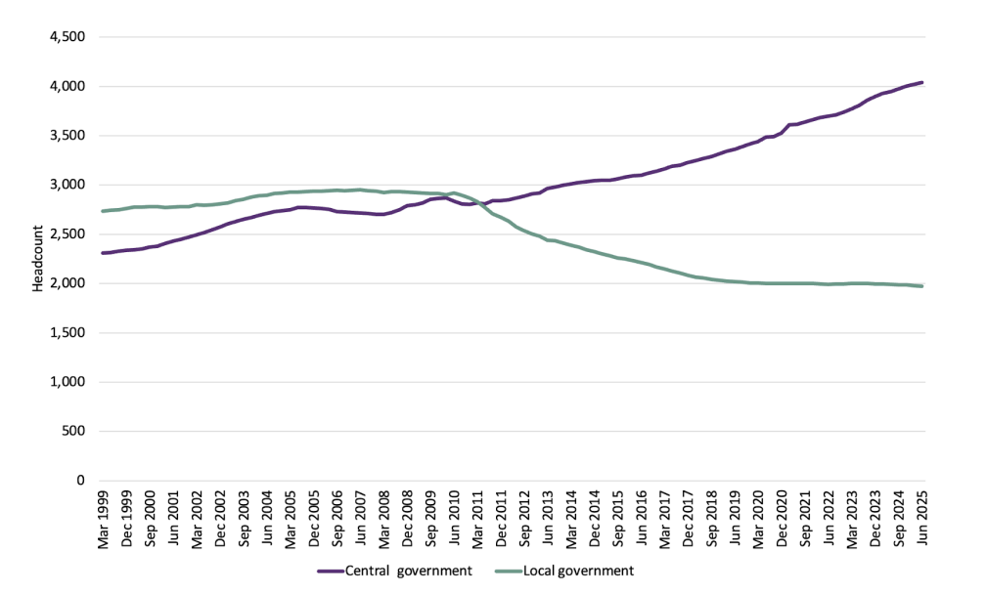
Source: Office for National Statistics, Public sector employment by sector classification

The last 15 years have critically undermined local authority resilience. This was severely compounded by rising inflation and rising service demands, undermining the financial sustainability of many local authorities. The UK's territorial divides and regional inequalities are worsened by the lack of technical and specialist expertise, such as in finance.

The most significant transitional issue in devolving fiscal autonomy is building capacity in local and strategic authorities to manage a system of local taxation effectively. Public authorities will need specialist expertise, not least being able to administer effective taxation locally while forecasting and modelling future revenue streams (although local authorities already have infrastructure and back-office functions to efficiently collect tax revenue from a range of sources). Central government would still need to support local authorities and city-regions in building further institutional capacity over time to take on the new devolved powers.

Another issue is the need for local authorities to have fiscal buffers to manage short-term revenue shocks where there may be an unexpected decline in local tax and business rate revenues without having to deplete their reserves. Given the precarious state of local government finances in many English councils, forcing them to rely on reserves would clearly be imprudent. But there is a case for looking at existing guidance to ensure that councils have the tools necessary to manage short-term shortfalls in revenues and cash flow, including where necessary making changes to existing arrangements for ring-fencing reserves.

Jack Shaw is a Policy Fellow at The Productivity Institute, University of Manchester, and Director of Groundwork Research.
Professor Patrick Diamond is Professor of Public Policy at Queen Mary University of London and a former UK government Special Adviser.
Professor Andy Westwood is Professor of Practice at the University of Manchester.

5 June 2026

Emmerson et al, How frequently should the OBR produce forecasts?, Institute for Fiscal Studies, 2025.
OECD, Government at a Glance, 2025.
Phillips, D. A rocket booster has been fired under the tax devolution debate, Municipal Journal, 23 March 2025.
The UK Government is creating strategic authorities that are, on average, smaller than international and European meso-level governance. For more information, see Shaw, J. Devolution and the importance of coterminosity, The Productivity Institute, 2024.
Ministry of Housing, Communities and Local Government, Referendum Principles for 2026-27, 2026.
Local Government Information Unit, 2026 State of Local Government Finance in England, 2026.
Velthuis, S. Geographical inequalities and sub-national funding in Australia, University of Birmingham, 2025.
The Integrated Settlement for West Midlands Combined Authority and Greater Manchester Combined Authority was first announced at the Spring Budget in March 2023 and introduced in April 2025, for the 2025-26 financial year.
OECD, Fiscal Federalism: Making Decentralisation Work, 2021.
OECD, Fiscal Federalism 2022, 2021.
Warner, S., Newman, J., Diamond, P. and Richards, D., 2024. The challenge of devolved English governance and the rise of political spatial inequality. Parliamentary Affairs, 77(4), pp.735-764.
For one example, see Institute for Fiscal Studies, Reforming local government funding in England: the issues and options, 2024.
Westwood, A. et al. Rebuilding local democracy: the accountability challenge in English devolution, The Productivity Institute, 2024.
English Devolution and Community Empowerment Act 2026, Schedule 5.
Ministry of Hosing, Communities and Local Government, Scrutiny Protocol, 2023.
The BBC publishes the distribution of BBC Local Democracy Reporters. As of July 2025, it had not assigned journalists to the newly established strategic authorities in May 2025.
Shaw, J. and Peck, J. Local productivity, national impact: the role of local authorities, The Productivity Institute, 2026. For more information on local capacity, see Shaw, J. Notes on Local Government, Substack, 2026.

