Written evidence submitted by the Peak District Moorland Group (CWR0169)

EFRA Committee – Call for Evidence: Wildfire Risk and Response Submission from the Peak District Moorland Group

Introduction and Credentials
This submission is made on behalf of the Peak District Moorland Group (PDMG), established in 2015 to represent the fourteen moorland shooting estates and their gamekeeping staff operating across the Peak District. I submit this evidence in my capacity as Group Coordinator, though I also draw on thirty-two years of personal experience as a predominantly moorland gamekeeper, sixteen of which were spent as gamekeeper and Conservation Manager on a high-footfall moor within the Peak District National Park.
The Group collectively represents approximately thirty full-time gamekeepers, supported by a further twenty regular volunteers who can be mobilised as required. The depth of knowledge held within this workforce should not be underestimated. While a number of our staff hold formal academic qualifications, the expertise that defines effective moorland management, and, critically, effective wildfire response, is accumulated over years of working the ground, informed by knowledge passed between generations of practitioners. Senior keepers, many now in their mid-thirties and above, have extensive hands-on experience of prescribed burning as a management tool. That experience gives them an intuitive understanding of how weather conditions, wind direction, humidity, aspect, and vegetation type interact to shape fire behaviour, knowledge that is directly and urgently applicable to the assessment and management of modern wildfire incidents.
As Coordinator, I have maintained long-standing dialogue with the Peak District National Park Authority and am one of the longest-serving members of the Peak District Fire Operations Group (PD FOG), giving me a perspective that spans numerous policy cycles and management approaches.

The Changing Wildfire Landscape
Whilst wildfires have always been a feature of the Peak District's history, the frequency and scale of incidents has increased markedly in recent years. The 2018 Saddleworth Moor fire represented a watershed moment for public and institutional awareness of this risk. Significantly, although the ignition point fell within an area managed for grouse shooting, restrictions on vegetation management imposed by Natural England had prevented the establishment of the uneven-aged heather mosaic that active management would ordinarily deliver. That mosaic, a consequence of rotational prescribed low intensity burning, has the additional and initially unintentional benefit of creating areas of low fuel load which, in wildfire conditions, provide responders with a genuine opportunity to limit the spread and scale of an incident.
In the 1980s and 1990s, wildfires were routinely suppressed using hand tools, heather beaters and fire pans. Today, despite the availability of considerably more sophisticated equipment, the same hand-tool approach would be entirely insufficient to bring incidents under control. That comparison is instructive: it tells us that fuel loads have reached a critical threshold. Without intervention, we face a trajectory toward greater injuries, infrastructure loss, public health impacts, business disruption, net biodiversity loss, and the very real possibility of fatalities. I believe we have been fortunate that recent significant incidents have been curtailed by rainfall or wind shifts; that luck cannot be relied upon indefinitely.

The Emerging Threat: Peat Ignition and the Shifting Wildfire Window
The seasonal window for wildfire has shifted; significant incidents now occur from February onwards, where historically April represented the start of the risk period. In many cases, fires during the earlier part of the season consume surface vegetation with limited peat damage, comparable in some respects to an uncontrolled management burn, albeit on a vastly greater scale.
However, the recent Snake Pass wildfire of 1 May 2026 is cause for serious concern. This event occurred on deep peat on a National Trust site that had been the subject of extensive, decade-long restoration works. Critically, the fire ignited following a very wet winter and only three days after significant rainfall yet consumed substantial quantities of peat. The resident gamekeeper subsequently dealt with a peat re-ignition twelve days after the original incident. These are not the conditions under which peat fires would historically have been expected to occur.
This strongly suggests that, alongside the shift in seasonal timing, we are now witnessing a shift in peat ignition thresholds. The explanation, in my assessment, lies in elevated fuel loads and changes in management practice that have resulted in hotter fires.

The Role of Fuel Load and Management Practice
Under historical management regimes, burning was routinely taken to walls, gullies, and rocky terrain. While this approach is now discouraged, the consequence of its abandonment is a substantial accumulation of fuel in precisely those areas where wildfires are most difficult and dangerous to fight. Natural gullies, which typically hold more moisture than upper slopes, now carry a far greater vegetation burden. This accumulated vegetation at gullies, often drives greater erosion and structural slumping, and it is in these locations, where drying and wind action create gaps in the peat soils, through which fire can travel down root systems, that peat ignition most commonly initiates ground fires which are resource heavy in dealing with. Any experienced moorland fire practitioner will recognise that gullies with heavy fuel loads generate longer flame lengths, increased fire spotting, and substantially elevated risk of peat ignition, along with heightened risks for fire personnel.
The accumulation of fuel in rocky terrain presents a different but equally serious problem: it creates hazardous conditions for personnel attempting suppression in those areas, along with significantly more wear and damage to fire fighting vehicles.
The most effective means of addressing both issues is the reinstatement of low-intensity burning in gullies and around rocky terrain, areas where mechanical cutting is not operationally feasible. Similarly, maintaining reduced fuel loads adjacent to moorland walls creates effective firebreaks and physical barriers. These must be actively maintained; even an accumulation of fine grasses at the base of a wall is sufficient to facilitate fire spread to adjacent areas..

Mechanised Cutting: Benefits and Limitations
Cutting has become the dominant tool for fuel load management, and it carries genuine advantages: it can be carried out in wet conditions, it offers relative precision where terrain allows, and it does not carry the public perception challenges associated with burning. However, its limitations must be acknowledged.
The costs are significant, in equipment purchase and maintenance, fuel, and staff time. Cutting causes damage to microtopography and risks peat compaction, peat preservation is the goal for moorland sustainability in these challenging times with greater climate shift predictions. Most importantly, leaving cut brash in situ has been consistently observed to increase smouldering and contribute to peat combustion, an outcome directly contrary to the objectives of peat conservation policy.

Case Studies: The Consequences of Inadequate Fuel Load Management
The Fiddle Wildfire, Goyt Moor — 30 April 2025
The Fiddle Wildfire provides a recent and particularly stark illustration of the consequences of prolonged restriction on vegetation management. The affected moorland is owned by United Utilities and has operated under an effectively no-burn policy for over twenty-five years, relying instead on an extensive cutting regime. When fire broke out on 30 April 2025, the resident gamekeeping team issued a call for assistance through the PDMG WhatsApp network. Within hours, staff from all Peak District estates had mobilised: twenty-three personnel attended, deploying equipment with a combined value of £969,950 and contributing 179 man hours, entirely at no cost to the public. The professionalism, skill, and situational knowledge of those attending was specifically noted by Fire and Rescue Service crews on the ground.
The fire burned 170 hectares. While some organisations expressed surprise at this scale, those working in moorland management had been warning of precisely this risk for decades. Had effective fuel load management been maintained across this site, it is our considered and knowledgeable view that this incident would have been substantially less severe.
I have a particular connection to this area, this is the area of the Peak District that I was employed for 16 years. In 2018, on the adjacent side of the road, within the same water catchment, the Ravenslow Wildfire burned 40 hectares of deep, restored peat. That fire started on the May Bank Holiday afternoon. Derbyshire Fire and Rescue Service left an appliance on site overnight, but it was the sustained effort of gamekeepers and farmers that ultimately extinguished the flames at Berry Clough, a deep gully where a well-worn footpath provided a modest natural firebreak. Combined with rising overnight dew levels, this was sufficient to prevent the fire from crossing into Wild Moor, which would have resulted in the loss of a further 120 hectares. Given the timing in May, significant numbers of nests, eggs, and chicks were lost in the fire that did burn.
I mention this incident not only because of the ecological loss involved, but as mentioned I was the gamekeeper on that moor at the time. The experience affected me psychologically for many months, with a tangible impact on my family life. The, as it transpired, unfounded, fear of losing my employment, simply because the grouse moor I managed had lost a significant extent of productive ground, compounded that burden considerably.

PPE, Training, and the Recognition of Moorland Gamekeepers
The increase in wildfire incidents, combined with policy-driven reductions in active vegetation management and the decline of sheep grazing, which historically reduced fuel loads and enhanced biodiversity through their dunging effect, has placed the PDMG at the forefront of frontline wildfire response. This has not been without challenge. Our Group faced criticism for engaging in firefighting activity without adequate personal protective equipment and following FRS incident protocol.
I am pleased to report that, through a successful Farming in Protected Landscapes grant application, facilitated by PD FOG, PDMG secured Flame Pro Wildland PPE coveralls for its members. A condition of that approval was that all PD FOG partner organisations also received PPE and undertook LANTRA Wildfire training. On paper, those individuals are now trained to the same level as our gamekeeping staff. In practice, however, the two are not equivalent. A formal training course cannot replicate the experience required to operate safely at the front of a live wildfire incident, given current fuel load conditions. Were untested personnel to arrive at an active fire sector, we would, in the interests of their safety, be unable to deploy them.
The recognition of our sector's capabilities is welcome, but it is notable, and frustrating, that many individuals, organisations, and media outlets continue to resist referring to our staff by their correct professional designation: Moorland Gamekeepers.

Supporting Testimony
To supplement this submission, I append below references from Dave Dobson - White Watch Manager at Oldham, Greater Manchester Fire and Rescue Service and Rob Kenning -Peak District National Park Authority Ranger Team Manager, both of whom have commented on the contribution of the moorland gamekeeping sector from their respective professional perspectives.

Dave Dodson – White Watch Manager – Oldham GMFRS
7th April 2026 around 5pm Oldham fire appliance was turned out to Uppermill (pots and pans) to a grass fire. Three fire fighters and an officer in charge, walked for a about 15 minutes up the moor to locate the fire, armed with 3 fire beaters. The fire was probably 300m by 50m on our arrival. We tried beating out the right flank, but the wind kept changing direction causing the fire to move towards our safe zone and safe exit. A quick assessment of the situation, we agreed we needed more resources from GMFRS. At that point a team came over the hill they were making great progress knocking the fire back. It was like seeing the cavalry come over. I thought this team was from GMFRS but once they were close realised they weren't. They were moorland gamekeepers and had the blowers and a water misting machine. They did not stop working and was impressive to see how they worked the moor and extinguished the fire. Without them we would have had to request extra resources from GMFRS which would leave resources short for any other type of incident within Greater Manchester. We had a quick chat with the Peak District Moorland Group team, as we did they noticed another fire some miles away probably attended by West Yorkshire fire and Rescue, they just casually said, right that's our next job, no moaning nothing just keen to move on.
Rob Kenning – PDNPA Ranger Team Manager and PD FOG Chairperson
Yes I agree the PDMG members definitely are out in front when it comes to response times. The advantages of not being burdened local government or charitable organisations!

The keepers’ experience and ability to respond so dynamically on these fires is not something FOG or PDNPA takes for granted. It’s first class what the guys can achieve and we are lucky to have them as partners

I have also included an overview from Bob James, a retired National Trust Ranger Lead and a man with clear historical knowledge on the Peak District and a follower of our group.
Having been associated with the Upper Derwent and Kinder Scout from my days walking and climbing since the early 70s and securing a job with STWA based at the Bamford depot in the mid 70s working from Bamford and becoming a member of Buxton Mountain Rescue Team and a dog handler with SARDA in 73 carrying out many searches and training exercises liaising with local farmers , gamekeepers and land owners I acquired a very deep understanding of the area and the working of the locals, throughout the 70s I assisted with many of the fires that occurred throughout the Peak and further afield working with Rangers, MR Personnel, Fire Service , Police and Gamekeepers.
In 1981 I was fortunate to secure a job working for the National Trust based in Edale at this time there were just two Wardens, David Wilson and myself, the Trust owned around 24,000 acreage of mainly all the watershed of the High Moors from the Derwent Valley to Snake Summit and round to Edale, Castleton down to Hope
Our role was the care and maintenance of all the land the Trust owned and this involved working with all the stake holders in assisting them in whatever capacity was required, sheep handling and gathering, Heather burning with the keepers, bracken control, walking, fencing liaising with the members of the public in fact any and anything to do with the land the Trust owned.
Over time the Trust acquired more land and farms so it became important to have more staff to assist with the day to day management, one of the biggest acquisitions was the Kinder Estate and around this time we set up an area warden system for the Derwent, Snake, Edale and Kinder Areas each warden being responsible for their area and fostering good relations with the farmers, keepers and stakeholders.
As you can imagine over the years we all gained a lot of knowledge about sheep grazing and the use of the High Moors together with Heather management and burning cycles, together with firefighting knowledge, access routes, water courses etc and of course the wildlife of the High Moors.
We were instrumental in pioneering moorland restoration work on Kinder Scout, we became an acting agency for the Manpower Commission Service employing long team unemployed young people from the surrounding cities of Sheffield, Buxton, Glossop and the training of them in all aspects of countryside work, which is what the countryside needs people on the ground who understands he land and how to manage it in all its various aspects
Over the years the Trust built up a very good understanding of moorland management, grazing regimes and the cycle of Heather management, I left the Trusts High Peak Estate to take up a role of Head Warden for the Trusts Long Mynd and We lock Edge Estate based in Carding Mill Valley, Church Street on, another Trust upland estate of a mere 6,500acres of Heather moorland compared to the Trust High Peak Estate which had grown to 36,000 acres. I came back to my beloved Derbyshire to take up a role working for the Peak District National Parks Eastern Moors Estate of 6,500 acres of Heather Moorland and working with the graziers who were part of an Agisted Grazing Scheme
As you can see I have for over 50 years been involved in all aspects moorland management and I find it very disturbing that the modern way of moorland management seems to be lacking in both its understand and required management skills required to ensure that Heather moorland continues to be cared for to promote the wider conservation objectives .
Allowing sheep and cattle grazing to be reduced together with lack of Heather burning will only lead to the degradation of the uplands and create a catastrophic build-up of vegetation that will eventually be subject to large wildfire as recently has been seen on the Snake , Howdens Moorlands and in the Elan Valley in Wales were grazing has been dramatically reduced over recent years.
In conclusion I feel that the uplands should be managed sympathetically but actively continued in the traditional way by grazing and controlled Heather burning which creates a rich and diverse habitat for wildlife.
Bob James

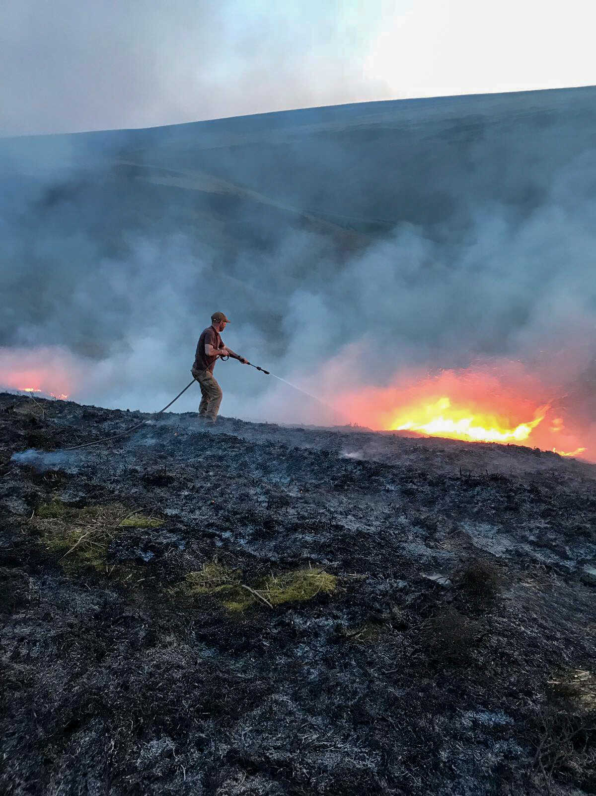
Ravenslow Wildfire 2018 – increased fuel load in gullies leading to dangerous suppression tactics for personnel
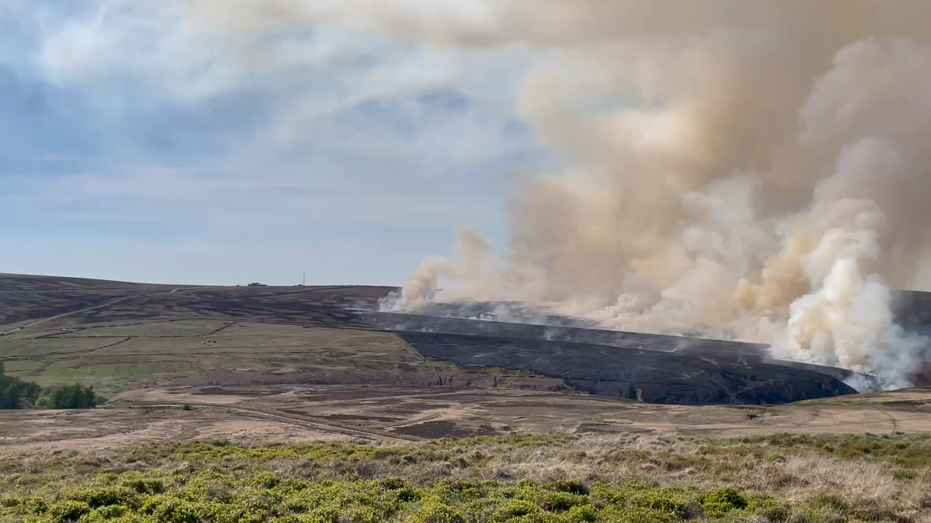
Fiddle Fire 2025, many said they were surprised at its spread, our sector had been warning of the severity for years
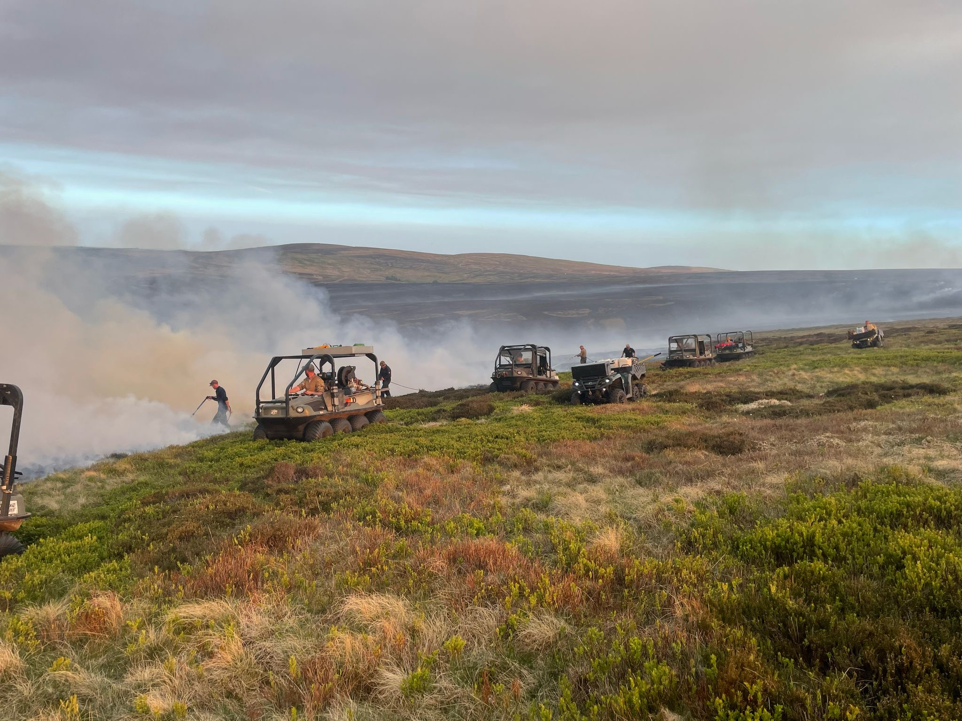
23 PDMG personnel and £969,950 worth of assets, contributing 179 man hours, at no cost to the public. PDMG sector congratulated in their skill and fire behaviour knowledge and what to do to help contain it
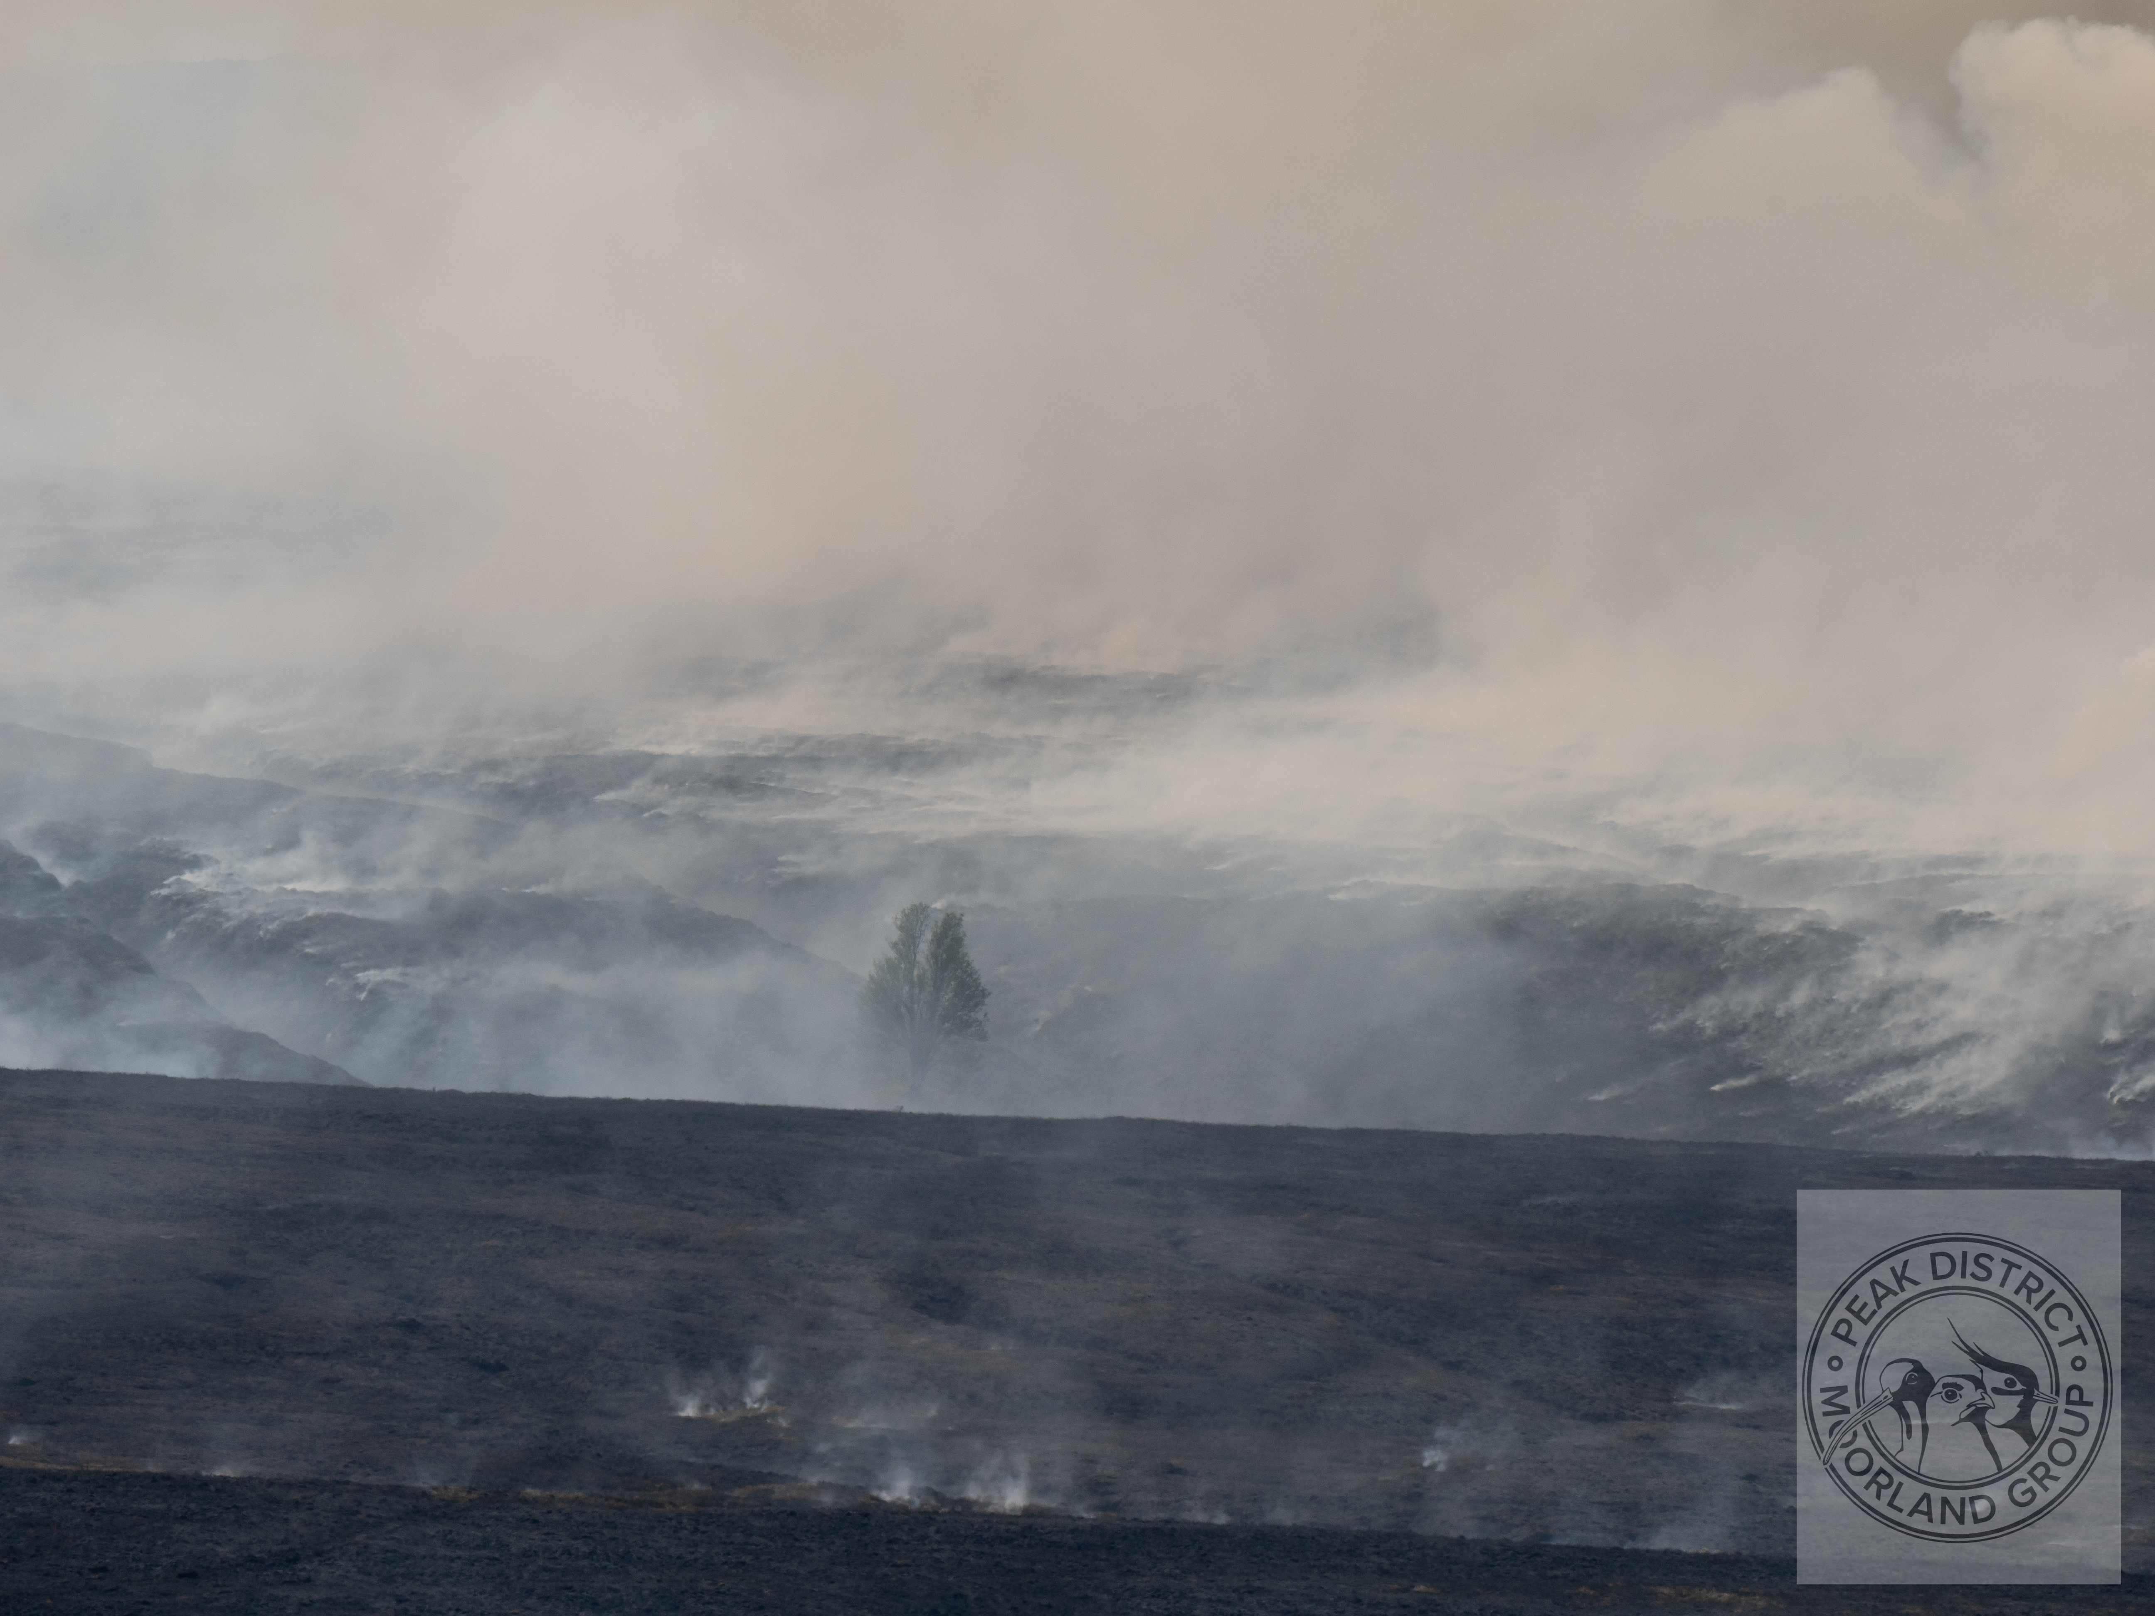
Fiddle Moor fire 2025 – biodiversity lost

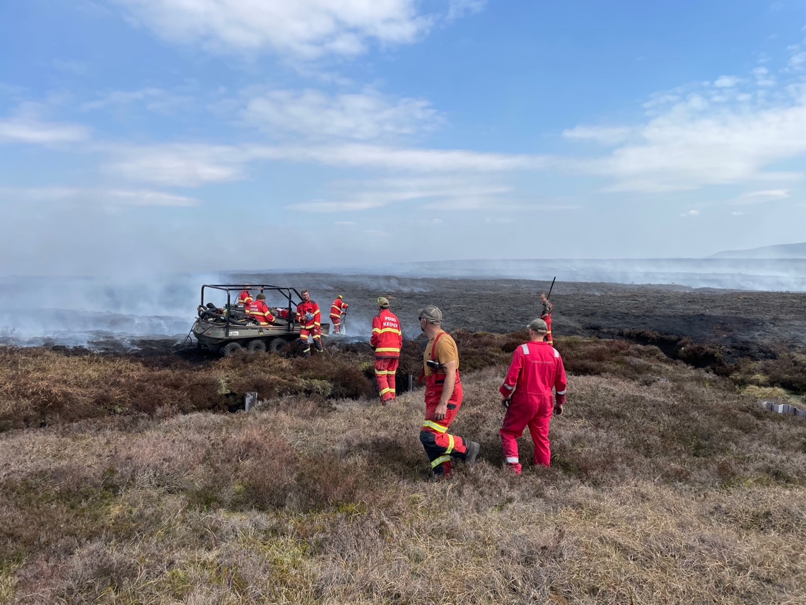
PDMG PPE and extensive knowledge at Snake Wildfire May 2026

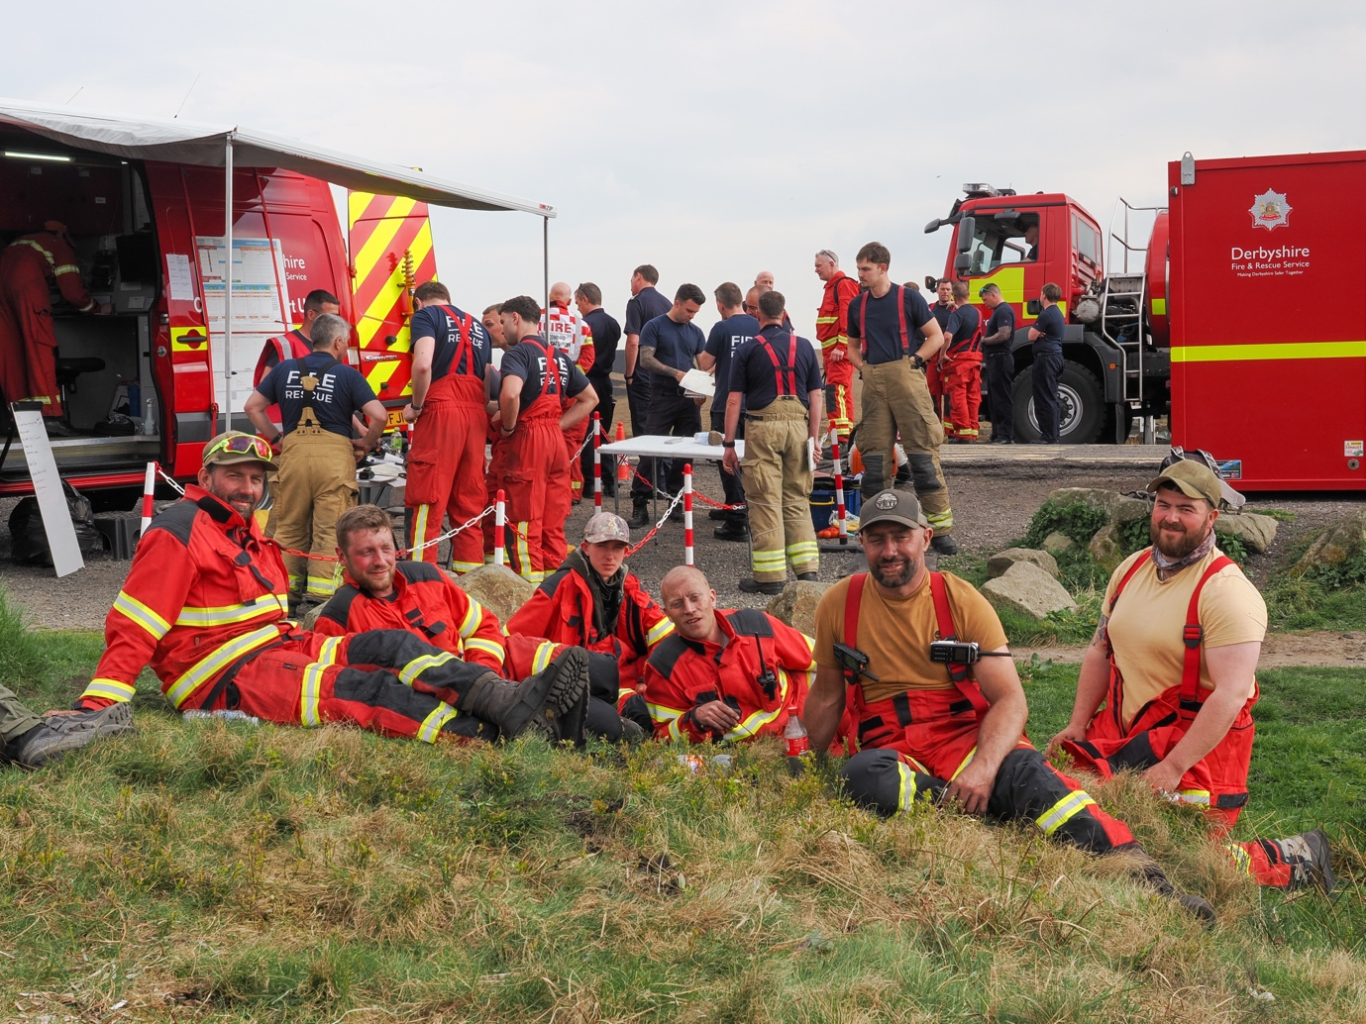
Snake Wildfire, 6 of our 14 man PDMG team taking a well earned rest, we contributed 153 daylight manhours and 60 nighttime manhours
Submitted by: Richard Bailey Coordinator, Peak District Moorland Group
I would happily discuss further and arrange site visits in the Peak District to look at the issues we are facing if required.

