Written evidence submitted by Geoff Eyre MSc MRPPA (Agric) (CWR0151)

I have been farming and managing moorland in the Peak District for over sixty-five years. I am a BASIS Agronomist specialising in uplands, and I have watched the situation go from bad to worse. I submitted a wildfire response to Natural England in 2017, having sat on the upland management group and been asked for evidence. That submission was ignored. We are now living with the consequences.

For twenty years, from 1988, the ESA scheme worked well. It was born out of genuine concern: we had lost so much heather from the Peak District through overgrazing and wildfires. The prescription was straightforward — pay farmers and landowners to burn ten per cent of the heather a year, spread sheep grazing, reduce wildfires, and push back bracken and molinia. It worked, under the control of one practical MAFF employee. Then a new wave of ecological thinking came through. Many of those moors were designated as SSSIs — because, we were told at the time, the management had been so successful. More EU income followed. English Nature produced studies and maps. Conflict with those in the ESA agreements began. Natural England arrived with new ideas, many of them held back until ESA agreements ran their course to 2013.

One of those ideas was wetting the moors. Most managers accepted it, given that water is scarce on many moors in dry conditions. But it was never going to recreate the wet bog moorland seen further north. The subsoil here is pervious gritstone. As the recent wildfires have shown, wetting has not stopped fires. I forecast back in 2004 that wildfires of this scale would come. English Nature was already restricting controlled burning to gulleys and valleys — natural firebreaks — but twenty years of unchecked growth in those gulleys has turned them into channels that spread fire rather than stop it.

I had been doing pioneering bare peat habitat work at Stalybridge and Anfield Moor, work that Natural England supported at the time. Those areas were fully revegetated. But they would not allow controlled burning to create firebreaks. In 2018 it all went up in a wildfire, with severe carbon loss. Moors for the Future then took on the bare peat revegetation methods at roughly ten times the cost. Large areas have since been brought back, but there has been no serious thought given to firebreaks. The strategy has relied on wetting, cutting, and sphagnum planting. It has failed. Marsden Moor, Dove Stones, Goyt, Howden, Roaches and Big Moor have all had wildfires. Fifty million pounds has been spent on Peak District moors by Moors for the Future. Much of that revegetated peat has now itself become a fire hazard, because their only firebreak method — wetting — does not work.

What we are seeing now is an unprecedented build-up of biomass. In this area alone it amounts to over half a million tons a year. When ESA agreements finished and Natural England gained more say, sheep numbers were further reduced. Today we have essentially uncontrolled vegetation growth, a lack of grazing, and larger wildfires — mostly on NGO moors, which were the first to stop reducing the fuel load. Heather is now waist-high in many areas with no breaks. When heather reaches three hundred millimetres it should be burnt on a rootstock return rotation. Natural England's advisors have refused to consider it.

Two species that Fire and Rescue find hardest to extinguish are molinia and bracken.

Molinia is one of the worst volatile plant species to control. This year in Wales alone, eight thousand hectares burnt in molinia-dominated ground. The photograph below shows the result of my own intervention: on the left, separated by an electric fence, is molinia grassland photographed in August. On the right is the heather I grew in its place — once equally dominated by molinia, now manageable heathland that carries a fraction of the fire risk.

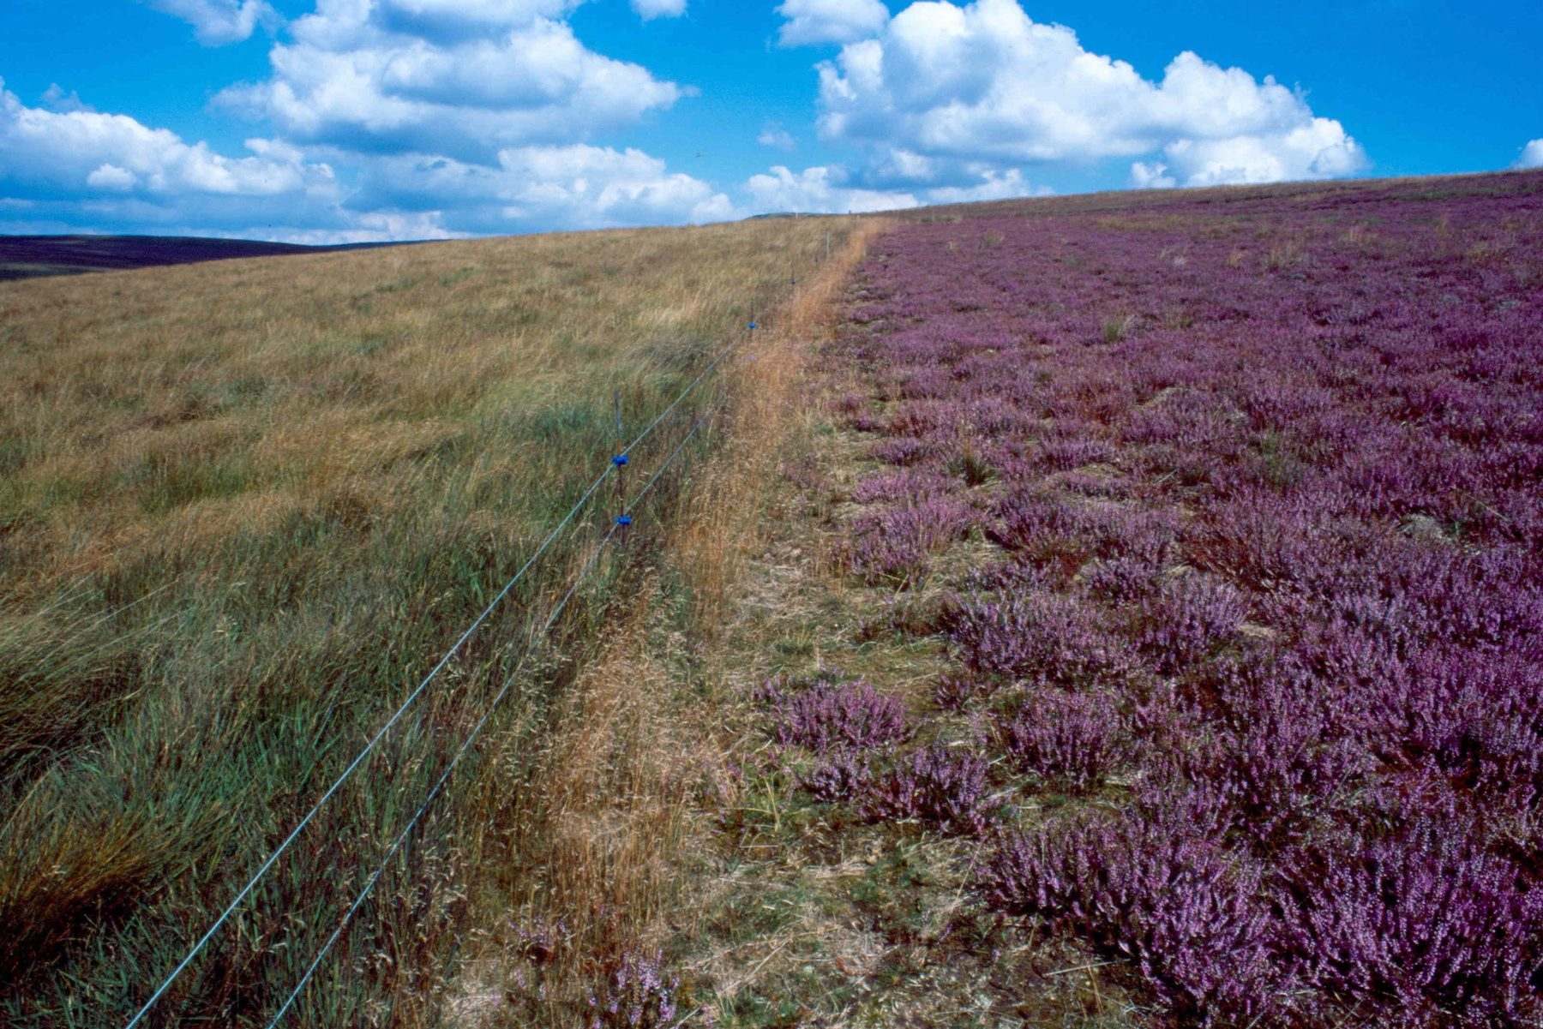
Before and after: molinia grassland in August (left of the electric fence) and heather grown in its place by the author (right). The right-hand side was once equally molinia-dominated. It is now productive, manageable heathland with far lower wildfire risk.
The satellite image below shows what happens when molinia is left unmanaged at scale. The Elan Valley wildfire in Wales burned across eight thousand hectares, with molinia as the primary fuel.

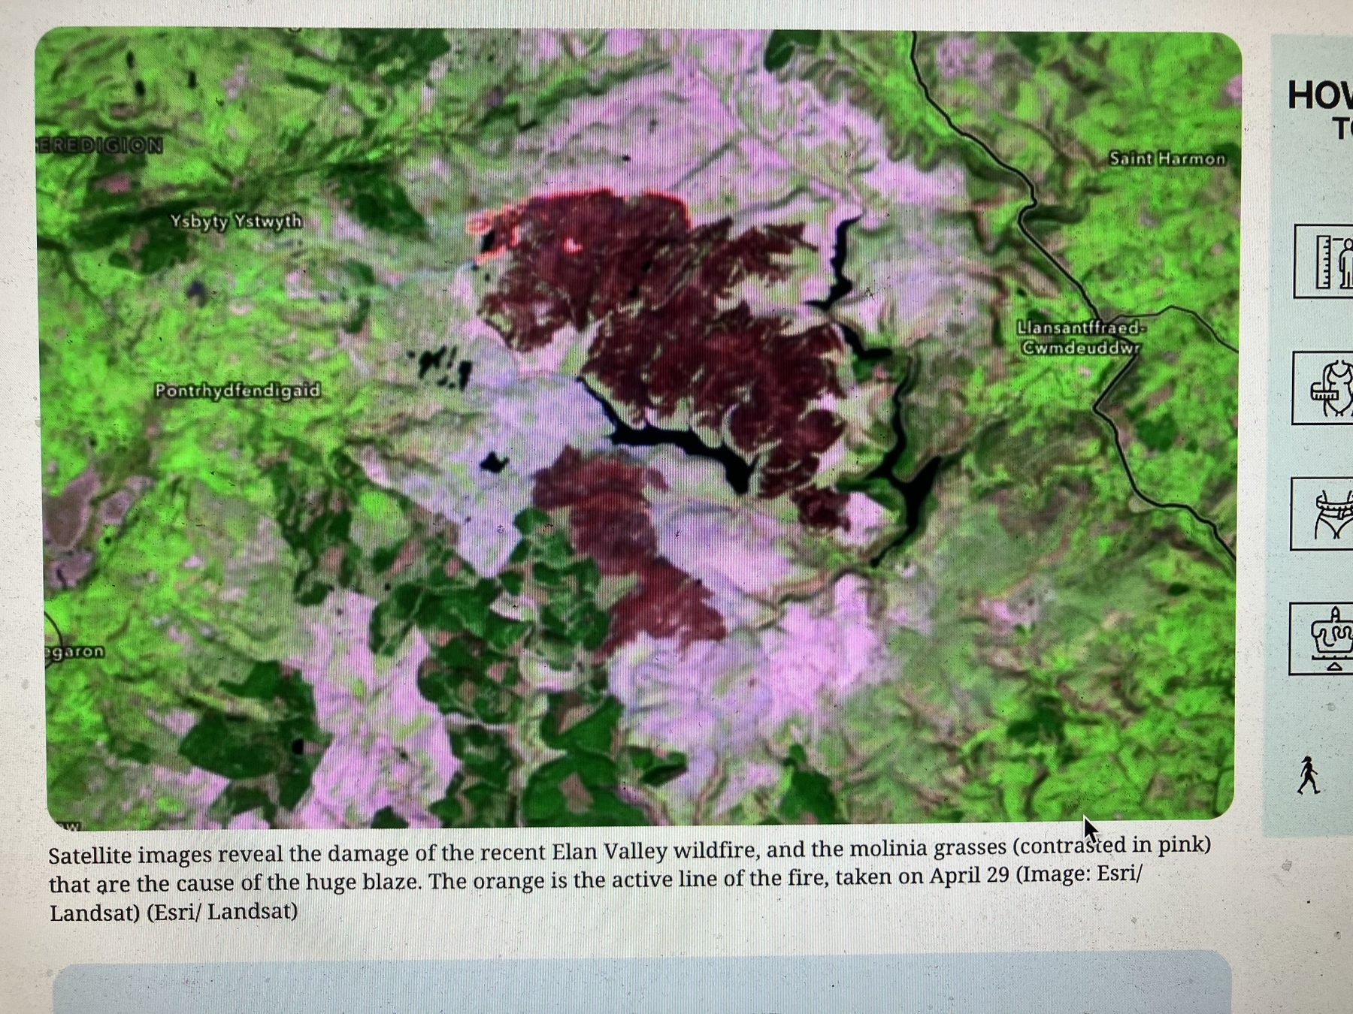
Satellite image of the Elan Valley wildfire damage. Molinia grasses (shown in pink) are identifiable as the primary cause of the blaze. The orange line shows the active fire front on 29 April. (Image: Esri/Landsat)
Yet molinia can be converted to mixed heath or species-rich grassland. I have had input into over thirty thousand hectares of such conversion across the United Kingdom, mostly on non-designated areas, largely undocumented. The Fursdon Dartmoor report appeared to be onboard with my habitat management submission, yet there has been no practical movement, and molinia there continues to increase yearly and burn.

Bracken is also a major fire hazard species. The photographs below are before-and-after pairs from my own work. The first pair shows a bracken-covered hillside — surveyed with a ranging pole — that has since been cleared and converted to species-rich grassland that stays green when molinia dies off and becomes a fire hazard. That ground is now grazed and eligible for SFI payments under species-rich grassland (SRG). The second pair shows another slope dominated by dense bracken that was later restored to heather — as the tree line in the background makes clear when comparing the two images.

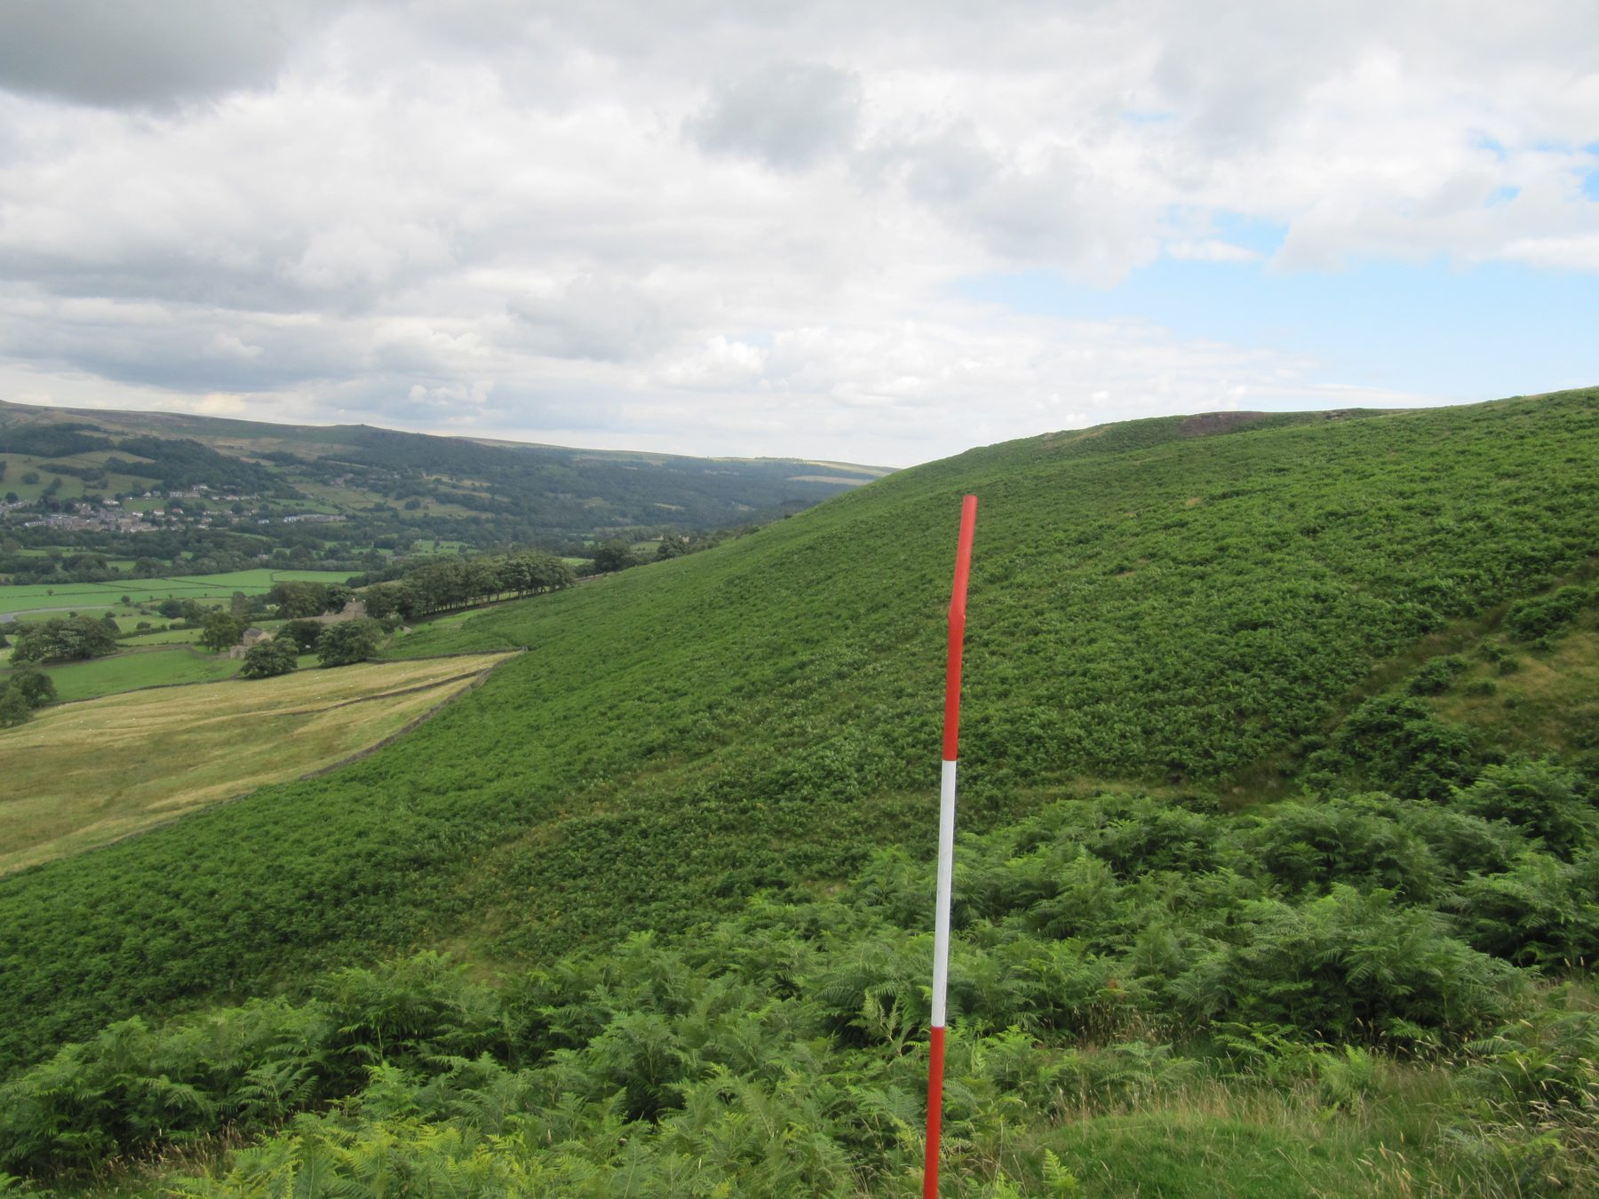
BEFORE: bracken-covered hillside surveyed with a ranging pole. This slope has since been cleared and converted to species-rich grassland — grazed, fire-resistant, and eligible for SFI/SRG payments.
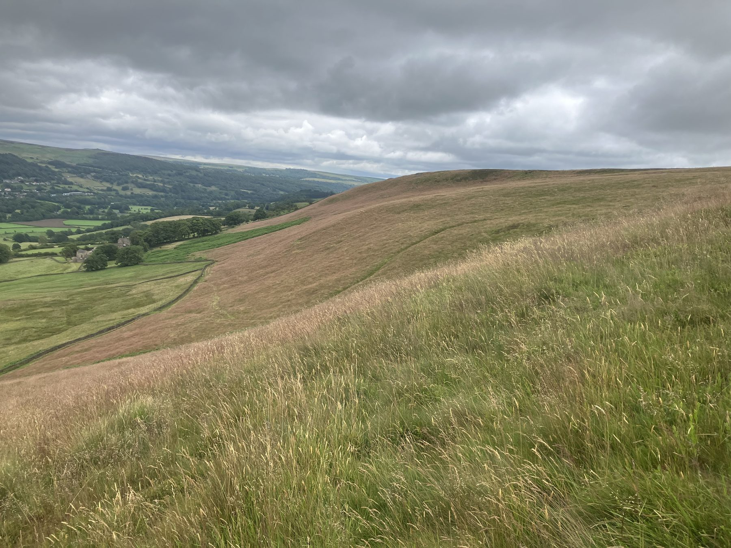
AFTER (same location): species-rich grassland in place of the bracken. Unlike molinia, this vegetation stays green through the dry season, greatly reducing wildfire risk.
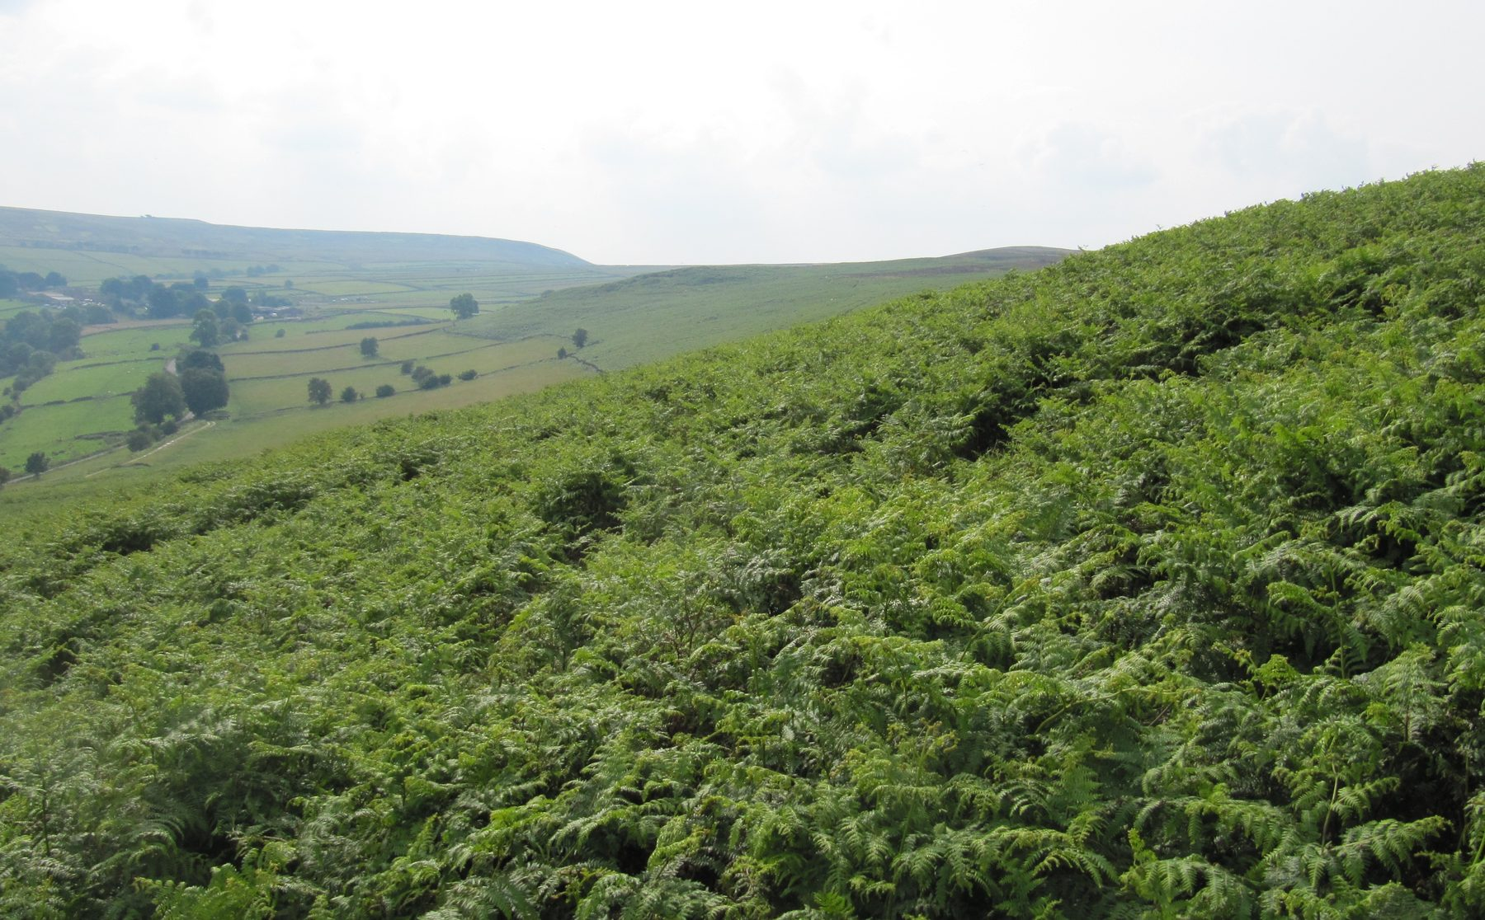
BEFORE: dense bracken covering a moorland slope — one of the species Fire and Rescue find hardest to extinguish. The tree line in the background provides the reference point for the photograph below.
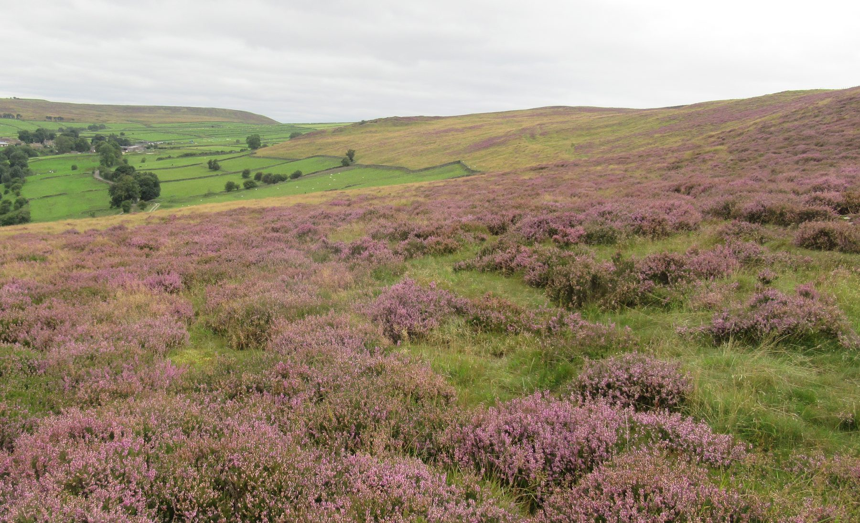
AFTER (same location): the bracken slope converted to heather moorland. Compare the tree line. This is the result that my methods make possible, and that Natural England's current prescriptions do not.
Kinder Scout is a case in point. Millions have been spent on revegetation and it looks good, but without effective firebreaks, that investment is sitting on a tinderbox. The area is full of wild campers. A wildfire on Kinder could undo all of that work in a few hours, with real risk to life.

My own cool burning method leaves eighty-five per cent biochar as a carbon sink. A faster rotation sees rootstock photosynthesis returning in the first year, with effective firebreaks established throughout. The Peak District moors are now in a net carbon loss position. The cost of restoring burnt-out areas runs into millions. Yet Natural England's advisors have refused to study this method. My own moor at Mill Farm is not designated. It is the only moor in the Peak District currently operating in rootstock rotation, capturing carbon and demonstrating proven fire mitigation. It is worth a visit.

You cannot wet more than half a per cent of the Peak District. The peat sits on free-draining gritstone or on very steep slopes. The physics simply do not work. Agricultural technology has been sidelined in the uplands, and agronomy has been replaced by ecological theory that is failing on the ground. I can only see the prospect of larger fires ahead if Natural England's current prescriptions of rewilding and inadequate firebreaks continue.

The Fire and Rescue Service should now inspect all moorland areas and carry out a risk assessment — burnable vegetation, access routes, possible firebreaks. They will be surprised by how many large blocks could burn out in various wind directions. Research, education, moorland studies, fire equipment, training, and climate change discussion are all secondary to reducing the annual fuel load increase. That fuel load will burn hotter and faster unless it is tackled as a matter of urgency.

What is needed is a well-balanced, practical team — not one composed entirely of ecologists, but drawing on agronomists, hydrologists, soil scientists, botanists, and those with genuine historical management experience and no wildfire record. Local knowledge should be listened to. The Fire and Rescue Service should be consulted. And those of us who have managed without wildfires should be allowed to carry on, unhindered, so that at least some protected areas survive what is coming.

The RASE motto remains as sound as ever: Practice with Science.
May 2026

