Written evidence submitted by the National Sheep Assocation (CWR0086)

Please find a response to a selection of your questions as part of the EFRA Committee Wildfire Risk and Response Call for Evidence. NSA has focused on grazing and upland management. NSA’s key role is in representing sheep farmers and advocating for pastoralism, so has addressed topics of this nature in its response.
Our response is embellished with images taken on Friday 8 May 2026 in West Yorkshire, following a fire on an upland moor on 8th April 2026 on Rishworth Common (Figure 1). Historically the common was grazed all year and in summer would carry up to 2,500 ewes. Today the farmer has 500 ewes on it.
How can land management techniques be best used at a regional level to prevent and control wildfires whilst balancing the needs of different land users? What evidence-gaps are there and how can they be filled?
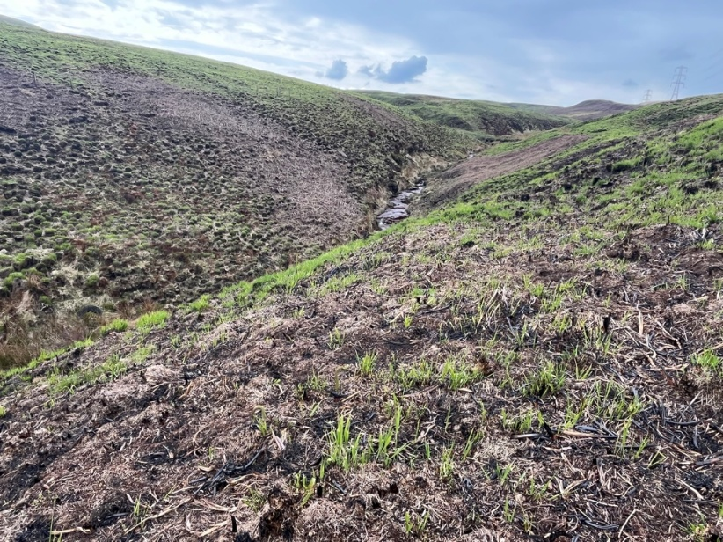
Prevention and control measures are specific to the unique challenges presented by vegetation, topography, geography and access of individual localities. For this reason, land management techniques are best honed locally and schemes and strategies designed with stakeholders on site. Knowledge of local settlements, road infrastructure, skillsets of local people, prevailing winds, and key landscape features like vegetation types or watercourses are all examples of why localised fire prevention and control groups are key to success.
Fire crews, wildlife groups, farmers, and game keepers, are all key stakeholders that have important insight and experience in the landscape, all offering different skillsets in preventing and controlling fire.
Figure 1Rishworth Common burnt with 4 metre flames. Fire crews are limited to containing anything above 2 metres. Vegetation is regenerating with spring warmth and moisture
However, there are broad principles and examples of best practice that can be acquired from operators in different areas.
NSA feels that evidence gaps may be filled by this call for evidence, dependent on the forthcoming response.
What role do nature-based solutions, such as improving biodiversity and more resilient landscapes, have in the prevention and control of wildfires?
NSA believes nature-based solutions can have an important role, although the details will depend on the location and landscape in question. For example, in some areas this means burning (“swaling”) and grazing. Heather moors, for example, have been maintained by swaling/burning/muirburn in different parts of the British Isles.
Traditional, environmentally sensitive grazing practices can be used to manage grazing to promote biodiversity in landscapes that have been shaped and managed by graziers for centuries, if not millennia in some cases.
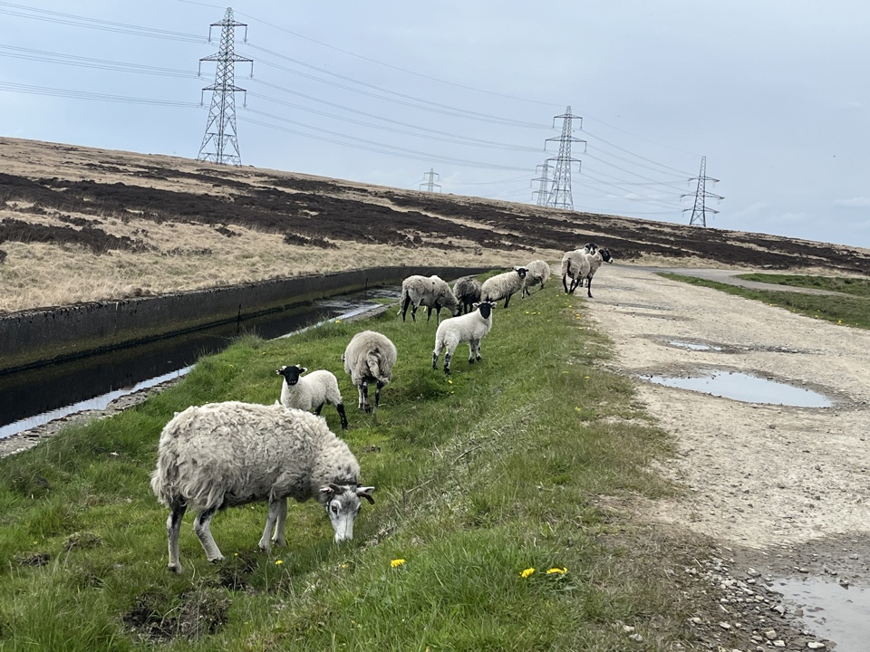
In pastoral environments, there are important discussions to have that have their legacy in the government-incentivised productivity schemes going back as far as the second world war. Liming, drainage, fertiliser and fencing grants increased the carrying capacity of many hills in the 1940s onwards, which was then compounded by headage payments in the 1980s and 1990s which paid farmers a set payment per animal. Farmers followed the money and government incentives, which led to overgrazing in many cases. More sheep meant more subsidy. The response by agri-environment schemes has been to reduce sheep numbers as a reaction to overgrazing. This has resulted in undergrazing, the accretion of lignified grass and stemmy heather, and the build-up or tinder material. NSA would like to see fire management group and farming clusters discuss how grazing can help promote wildlife, biodiversity in general, and a managed landscape with lower fire risk. NSA does not just advocate for sheep, but for mixed grazing in general, with ponies, cattle, and sheep. Some species are better equipped as managing certain vegetation types than others. It has been seen, for example that bracken can be controlled by bale grazing cattle. Molinia and other strong, rank grasses can be managed by cattle. Sheep, on the other hand, are more selective graziers (see figure 1), preferring sweeter grassers, herb, and forbs. Sheep are lighter graziers, and more suited to more tender ground, such as wet peatland environments for example.
Figure 2 Upland sheep showing preferences to lush, sweet grass. This is a production advantage, but frequently leads to overgrazing if not managed by active shepherding (something that has fallen into abeyance as farm economics have been challenged)
How best can Defra funding schemes be used to support land managers to adapt to the increased risk of wildfires?
In pastoral upland settings, NSA feels that funding schemes should follow the agri-environment principles of supporting businesses producing nutrient dense protein and fibre. This way a farmer can manage the landscape and is incentivised by their own business to steward the land, while being given the financial support needed to farm in a challenging place, designated by LFA or SDA nomenclature.
It may be beneficial to design such schemes as follows:
- A governance structure than brings stakeholders together to collaborate and communicate
- Sensitive traditional grazing management using hefting systems if already in place
- Rest periods afforded to ground, as opposed to set stocking in which sheep will selectively overgraze sweet areas of land. This can be achieved by more active day-to-day shepherding
- Mixed grazing - where appropriate to the landscape – may need capital support to fund infrastructure (handling equipment, stock trailers) and livestock (suckler cows) to diversify the grazing management on the hills to reduce dominant grasses such as Molinia in areas this is a challenge.
- Schemes rolled out on farmed ground should either be farmer-led or involve farmers in the design, monitoring, feedback and evaluation process. They see the landscape more regularly and over more years than QUANGO staff that can be promoted or change jobs. Land management is a long-term endeavour.
- Monitoring and baselining of biodiversity and landscape health is key to measure progress. Many farmers feel that this has not happened and there is insufficient evidence to attest to success or inform scheme design and adjustment.
- Schemes must be bespoke to the area to be relevant. This means staff on the ground, which has a cost, but can monitoring of flora and fauna be undertaken by farmers via smartphones and websites?
What impact does the monitoring of wildfires have on our understanding of the causes and risks of these events in the UK, and how can this be improved? Are there international examples or best practices that can be used in a UK context?
- MapaFogos provides interactive cartography MapaFogos - Real-Time Wildfires in Portugal
- EU Copernicus map EFFIS - Current Situation
- In an era of Treasury discipline and climate change NSA would suggest what existing schemes can be harnessed to monitor risk without cost to the tax payer.
What policies are in place, or are needed, to reduce the severity of wildfires and their socio-economic impacts on both agricultural land and at rural-urban boundaries?
Below are some key land management strategies NSA is advocating for in some circumstances:
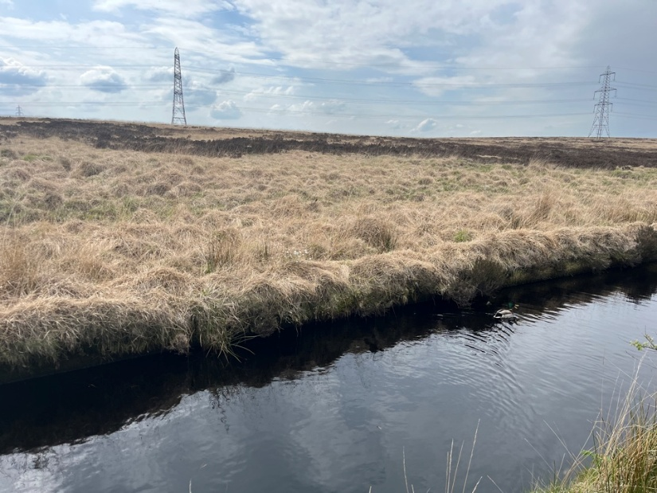
- Active land management – whether it be farming, game keeping, park keeping, or volunteers helping manage the landscape, the British Isles countryside needs management. There is very little, if any ground, that can be considered wild and self-regulating. Some hills have had stock reduced in summer and removed entirely in winter meaning more grass has become lignified and unpalatable (see figure 2a). In some cases this has suited semi-retired ageing farmers, but there is a young generation seeking opportunities. Grass will grow, lignify, and if ungrazed collapse on itself, reducing the nesting sites for ground-nesting birds and becoming a sterile environment. NSA has seen how grazed environments have livestock dung and more varied sward length and more insects and bird life as a result.
Figure 3 An example of an upland area in West Yorkshire that is unmanaged and ungrazed. The white grasses are tinder dry and represent a fire risk
- More active shepherding - Whether it be achieved with sheep only or with mixed (cattle and ponies) alongside sheep, NSA feels that more control over the grazing activity of the ruminant in question is valuable. Livestock have preferred areas, and this can change from year to year as vegetation structures alter, winds change. Areas will be preferred by livestock, but more active shepherding with dogs, bikes and people will help vegetation recover, removing preferential grazing of sheep that can produce homogenous landscapes.
- Mob grazing – A means to achieve the above is mob grazing. This can be achieved with virtual fencing collars or hefting up livestock and moving them to fresh grazing, allowing parts of the hill to rest. This is a more traditional form of upland stock management that has fallen into abeyance as the returns from hill farming and wool production have diminished.
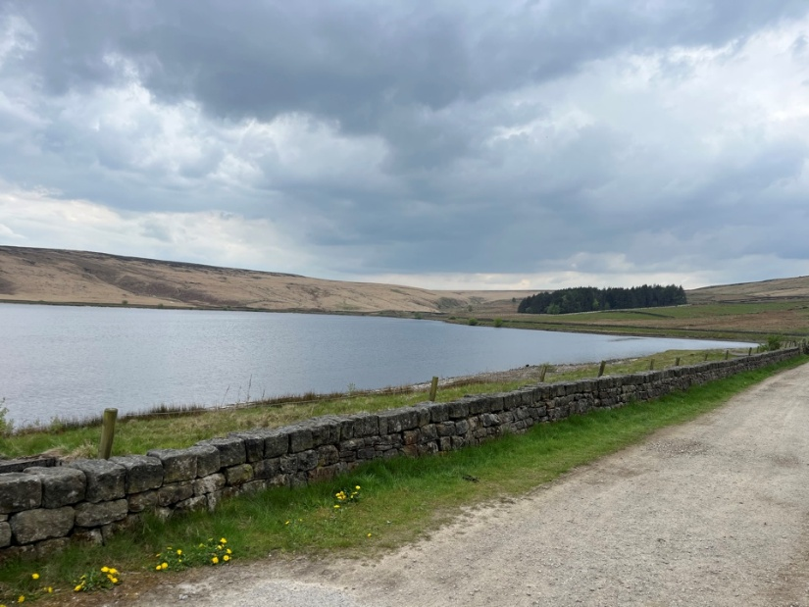
- Scrub clearance – Areas previously burned on rotation to manage dead lignified material may be being cut today. In some instances the dead, cut material is being left which desiccates in the wind becoming a dangerous fuel load, which is being managed by grazing animals abroad also. Land management policies may be advised to manage this fuel load. Landscapes created and maintained by fire, such as Dartmoor and heather moors in northern Britain should not have burning restricted. Some dead grass can be grazed by livestock, but a farm with only sheep will need to buy cows to graze out the dead, rank material (Figure 4)
Figure 4 Left hand side shows ungrazed white, dead grass that is tinder dry, while right hand is grazed and more verdant and less of a fire risk
- Controlled cool burns – NSA feels that planned, managed, controlled, burns undertaken by gamekeepers and farmers that rapidly burn vegetation, and not underlying peat, are far better than unmanaged, accidental wildfires that become difficult to control, endangering lives and burning hotter for longer, burning peat in the process.
- Mosaic of habitats – NSA believes a diverse range of habitats and landscape types is key. This provides wildlife with a varied structure, rather than a monoculture, but also helps prevent fires. Rewetted areas are less likely to combust, and small woods and shelter belts of native trees can reduce wind speeds that dry out landscapes.
- Flexibility – Designing upland stewardship schemes that pay farmers for delivering environmental benefit must be bespoke and flexible. Our members have seen firsthand how difficult – if not impossible – it is to design schemes “across a desk”. Instead, upland agri-environment schemes should be adaptive, and specific to the landscape in question. Even when a trained ecologist designs a scheme in year one, by year 3, 5 or 10, the vagaries of the livestock, weather and upland environment may call for the scheme to be reviewed, and that ecologist can have moved on to another role. The only constant person in this situation may be the farmer. Stocking rates throughout the year may vary from year to year with temperatures and rainfall. The ability to graze into the winter or through the winter with drystock can be important to get livestock to eat lignified vegetation and stop is building up (see
Given that responsibility is spread across government departments and bodies (e.g. Defra, Forestry Commission, MHCLG), how should the government coordinate a cross-departmental approach to tackle the increasing risk of wildfires?
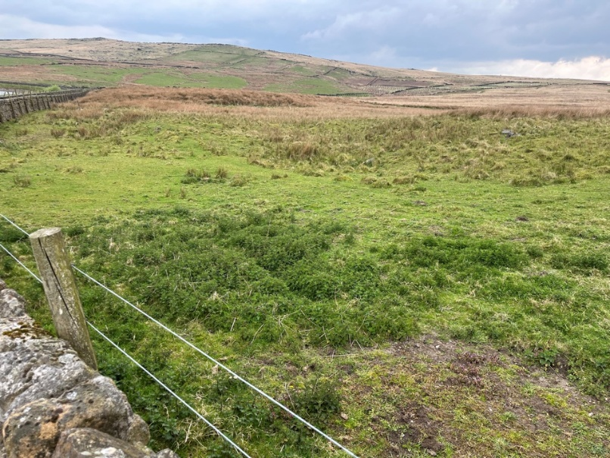
Governance structure is vital to successful land management. Many of our areas prone to fire risk are commons, being managed by multiple stakeholders. Successful stewardship comes from involving all stakeholders. Fire crews will benefit from a landscape that is delivering wildlife. An upland eco system that is alive and green will be less likely to combust. A farmer also benefits from this landscape. Tree planting and rewetting can support this. The suitability of grazing, be it by cattle, ponies, sheep, or a mix therein, the amount of burning, the suitability of woodland creation, and the need for rewetting all depends on the context of the location and varies year-to-year.
Figure 5 Greener hills present less of a fire risk. This farm is being grazed by an active grazier. This picture of in bye areas shows the varied vegetation structure

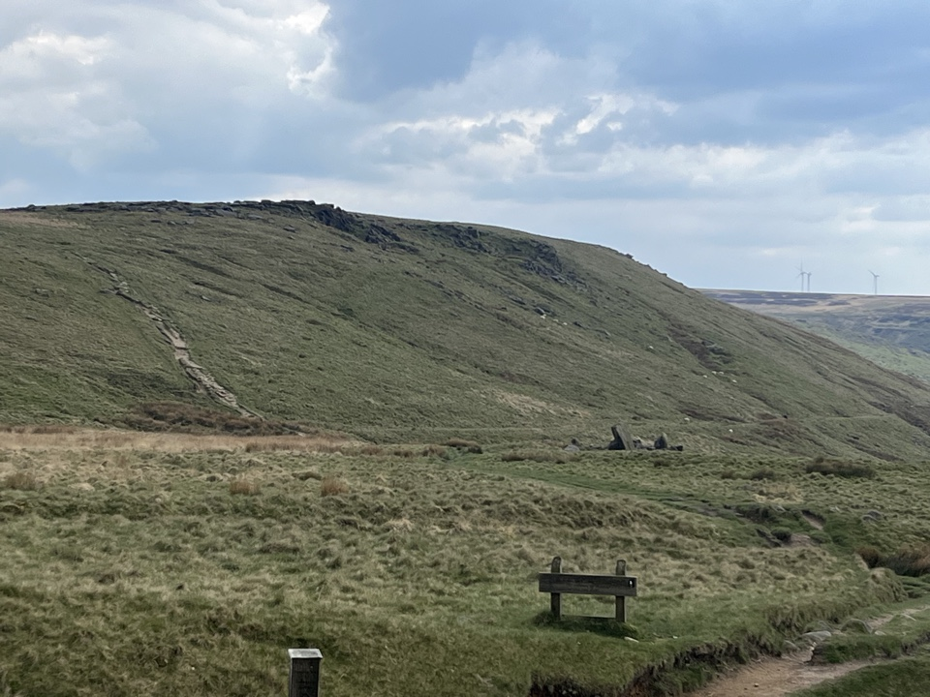
Figure 6 Open unfenced ground on Langfield Common showing the varied vegetation structure and greener tones of a landscape being managed by grazing animals

May 2026

