Written evidence submitted by Mr Jason Mann, Senior Managing Director, FTI Consulting (REM0044)
  - My name is Jason Mann, and I lead the global Energy Economics team at FTI Consulting. I am an expert with over 30 years’ experience in energy market design. At the start of my career in the 1990s, I worked closely on the development of the New Electricity Trading Arrangements (“NETA”) in Great Britain (“GB”) - the electricity market design that remains in place today. Since then and throughout my career I have worked extensively on electricity market design issues – both in GB and in over 30 jurisdictions globally.
  - I was closely involved in the recent GB debate on locational pricing – leading work on the matter for Ofgem, NESO and industry participants. I previously provided evidence to the Energy Security and Net Zero (“ESNZ”) Committee in late 2023 and early 2024, including two written statements and oral evidence panel session. In these statements, I elaborated on the benefits of locational wholesale electricity pricing in GB, as evidenced by my quantitative assessment, and complemented by the experience of other jurisdictions with locational pricing.
  - In response to the Select Committee’s current call for evidence, I provide three points of evidence:
- Firstly, a reminder of the importance of price signals in electricity markets, and the dangers of the lack thereof.
- Secondly, Department of Energy Security and Net Zero (“DESNZ”) has not prioritised consumers in GB in its decision making.
- Thirdly, locational pricing is, and will always be, a foundational benefit for the GB energy system.
  - I end with a consolidated summary in response to the ESNZ’s questions.

The critical importance of price signals in electricity markets
  - As well as a means of exchange, prices have also developed as a signal to manage scarcity until an equilibrium is reached – high prices convey information to encourage increasing production and reducing consumption, while low prices convey information to encourage reducing production and increasing demand. As such prices are influenced by any physical limits such as the cost of production, and in theory, the cost of transport.
  - In most respects, the trade of electricity in liberalised markets is similar to other commodities. However, the laws of physics place more onerous restrictions on the trade of electricity.
- First, the overall production and consumption of electricity must balance almost exactly at every location across the network, on a second-by-second basis.
- Second, while electricity is relatively easy to produce, it is difficult and costly to store.
- Third, the physical limits of electricity networks mean that the flow of electricity is often limited by bottlenecks and, in combination with the above, susceptible to changes at very short timeframes.
  - Failure to comply with these physical characteristics will lead, within seconds, to a black out – as evidenced recently in Spain. These physical characteristics mean that an electricity market needs to be formally designed and governed by rules to ensure that the system remains secure while, at the same time, the trade of electricity between producers and consumers is facilitated.
  - The current GB electricity market, by design, ignores to some extent these physical laws - for example electricity is traded in 30 minute “blocks”, thereby only roughly approximating the need for a second-by-second balance of the system. Critically, it also sets a national price, ignoring the physical limits of the transmission network. This means that the trade of electricity between buyers and sellers will only ever roughly approximate the need to adhere to the physical constraints of the electricity system.
  - Hence, it is the role of NESO to intervene in the market to ensure that the system remains secure and the lights stay on. To do this, the wholesale electricity market “closes” an hour ahead of physical delivery. This allows NESO the opportunity to adjust intended operating and consumption plans of participants, which had been determined through interactions in the wholesale market. NESO does this through buying and selling electricity in the Balancing Mechanism (“BM”), which is a market in which only NESO is allowed to trade with market participants. In turn, this allows NESO to ensure that the system is secure. The cost of NESO’s interventions to adjust wholesale market outcomes is an additional cost that is recovered through an additional charge to consumers.
  - Since the 1990s the GB system has markedly changed – notably expanding the market to include Scotland and the roll-out of renewable electricity generators often sited at the periphery of the network. One upshot of this is that trades in the wholesale market have become less and less reflective of the physical limits of the system – meaning NESO has to play a bigger and bigger role to reconcile the market outcome with the physical realities of the system. This leads to ever greater costs incurred by NESO that must be recovered from customers.
  - The main cause of this problem is that the design of the wholesale electricity market is now ineffective – in particular it does not reflect transmission limits. A solution – as adopted in the majority of OECD countries - is to subdivide the wholesale market into a number of zones (or nodes). This, at the stroke of a pen, means that wholesale market trading better approximates the physical realities of the system, reducing the costs incurred by NESO to balance the system.
  - Absent this, the wholesale price sends signals to the market that are often manifestly wrong, causing assets that could help balance the system do the exact opposite of what is needed to keep the lights on at lowest cost, as explained in Box 1 below.
Box 1: Current price signals are leading some assets to do exactly what we don’t want them to do - Real-life example from 1 January 2026, 1am.
This coordination problem is most pronounced in the scheduling and dispatch of two-way flexible assets, such as interconnectors and batteries.
The figure below demonstrates an actual hour in early-2026 when incorrect price signals led interconnectors to exacerbate transmission constraints, thereby increasing consumer costs.
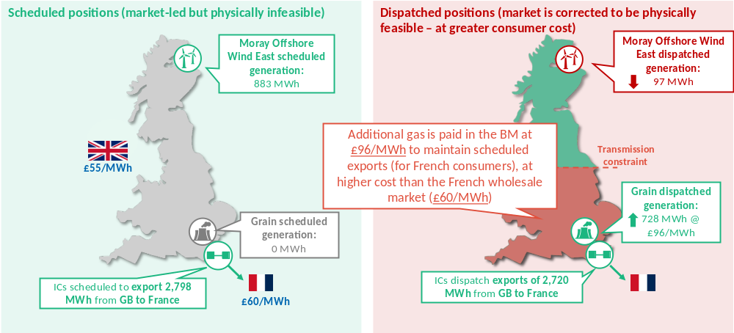
Source: FTI Consulting analysis of Elexon and ENTSO-E data.
In this hour, interconnectors were scheduled to export to France which had higher wholesale prices than GB (£60 in France vs £55/MWh in GB). However, as is often the case, the wholesale market schedule within GB was infeasible in this hour, as there was insufficient generation in the South to physically service the exports to France and insufficient transmission to transport power to the South. In order to maintain the export position, NESO had to take multiple actions in the BM. Firstly, NESO had to pay to turn off wind farms in the North, as their scheduled generation could not be physically delivered onto the system. NESO also then had to pay £261k to turn on gas plants in the South.
This £261k cost to GB consumers significantly outweighs the benefits to: (i) the IC owners, who receive £14k of congestion revenues; and (ii) French consumers, as cheap imports from GB depress the French wholesale price. As GB builds out more renewable generation capacity, GB wholesale prices are expected to fall, leading to more scheduled exports and hence more instances of interconnectors flowing the ‘wrong way’ as the wholesale market price signal ignores local transmission constraints.
While the example above shows one hour, this is a prevalent issue that is becoming more frequent for all two-way flexible assets.

DESNZ has not prioritised consumers in its decision-making
  - In this section, I highlight two areas:
- DESNZ appears not to have diagnosed that the price signals in wholesale electricity markets are frequently wrong, in that they do not reflect the supply-demand balance appropriately as the core issue.
- DESNZ’s decision to reject locational pricing was not made on economic and consumer grounds.
  - As a consequence, consumers have not been prioritised and face higher costs.

DESNZ’s incorrect diagnosis of price signals
  - From the start of the Review of Electricity Market Arrangements (“REMA”) process in 2022, DESNZ failed to diagnose that the primary issue of electricity markets is a coordination problem. For example, the case for change in the first REMA consultation highlighted the need to invest in new low-carbon electricity capacity, and viewed locational pricing as a means to facilitate the siting of resources. By failing to observe that flawed operational price signals from electricity markets are the primary issue, DESNZ saw locational pricing as one option to facilitate investment, rather than a solution in itself.
  - This approach became more pronounced in the second REMA consultation in 2024, where nodal pricing was dropped with no supporting justification. DESNZ asserted: “we believe the risks to investor confidence and deliverability of our 2035 decarbonisation targets are too great under nodal pricing… [and we] therefore decided to discount nodal pricing”. No assessment was published to show the impact of nodal pricing on investments. Additionally no reference was made to the fact that generation investments have continued in markets that have transitioned to nodal pricing with well-developed risk management mechanisms, nor that policy mechanisms (such as CfDs) can still complement nodal pricing.

Rejection of locational pricing was not made on economic and consumer grounds
  - In July 2025, after over three years of protracted debate, DESNZ rejected zonal pricing, which was deemed to “create unnecessarily high instability and uncertainty around future prices and zonal boundaries, which would be passed onto consumers in the form of higher prices”. DESNZ provided no evidence for this and has never published its own cost benefit analysis. The REMA decision also appeared to contradict DESNZ’s commissioned analysis, in addition to our analysis for Ofgem conducted before that, which showed that locational pricing could bring over £50bn of benefits to GB consumers.
  - DESNZ’s decision also opposed the views of NESO, Ofgem’s CEO, Citizens Advice and many other industry stakeholders who supported zonal pricing due to the expected consumer benefits. Certain generators and investors appear to have been afforded higher weighting in the decision-making process, inevitably influenced by stakeholder pressure and lobbying.
  - The renewable lobby, mostly led by major energy companies with significant commercial stake in the debate and vested interest in maintaining the status quo, and associated investors, mounted several public campaigns against locational pricing. Their main argument against locational pricing centred around the alleged harm on investments – whether on the increase in cost of capital, or the wider threat to the then upcoming CfD auction round (“AR7”). This ignored the fact that renewable investments have surged in jurisdictions with locational pricing (e.g. Texas and California), and indeed, many investors vocally against zonal pricing in GB have already made investments in other markets with locational pricing. In reality, my view is that they were concerned that the current practice of continuing to pay generators even if they are ordered to stop generating by NESO would end – thereby reducing the amount of revenue these companies are paid by customers.
  - For example, we estimated that payments to SSE from consumers would be £3.8bn higher from maintaining national pricing. This has come at a £13.9bn cost to Scottish consumers in foregone benefits of zonal pricing. In light of the magnitude of these seemingly windfall gains to shareholders from GB consumers it is perhaps unsurprising that maintaining national pricing was fiercely lobbied for by certain stakeholder cohorts.
  - Instead of providing a credible alternative, after over three years of work, DESNZ put forward the emerging components of Reformed National Pricing (“RNP”), as shown in Figure 1 below.
Figure 1: RNP policy package, DESNZ
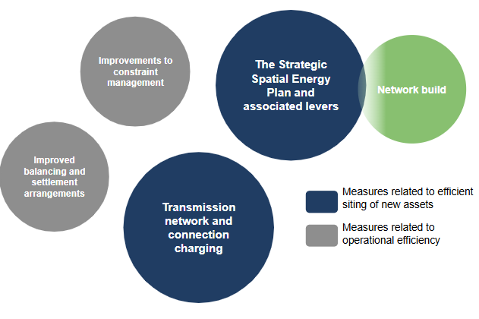
Source: DESNZ (2025), ‘REMA: Summer update’ (link).
  - The RNP package was introduced despite not being fully defined, and the proposed interventions above do not address any of the fundamental problems:
- Strategic Spatial Energy Plan (“SSEP”): The SSEP has been presented by DESNZ as the “centrepiece” of the RNP, to coordinate investment and reduce network costs. However, the SSEP relies on central planning, faces inherent uncertainties that will be borne by GB consumers and will inevitably be subject to extensive stakeholder lobbying.
- Transmission network and connection charging: Transmission Network Use of System (“TNUoS”) charging reform is also mooted. This can only influence the siting of assets, and not asset operations, which is the primary issue that needs to be resolved. In any case, any TNUoS reform will be resisted fiercely impacted stakeholders.
- Constraints management and improving balancing and settlement arrangements: NESO notes that “Reforms to balancing arrangements alone cannot address the underlying cause of high redispatch volumes […] in turn having a direct impact on consumer bills”.
  - Of the options highlighted above by DESNZ, transmission build is a substitute for locational pricing. Policymakers could either: (i) build the network out to match the market design (i.e. with significantly lower constraints as per the 1990s); or (ii) change the market design to be more representative of the electricity system.
- The first option involves several hundred billion pounds of investment in pylons across the country as well, of course, as scarring the British landscape for generations.
- The second option involves changing words on pages of rules on how market participants are paid, plus a few hundred million pounds to implement more sophisticated computing systems.
  - Furthermore, eight months on, very limited progress has been made on RNP. This is because there are limited options available. A lack of accurate price signals reflective of locational constraints means that NESO will always have to fundamentally correct for and financially settle schedules eventually. While there may be better ways of incentivising scheduling on the edges, or to give NESO more time to correct for these schedules, there will always be a high cost to consumers. In short – the mismatch between the outcome of the national priced wholesale market and physical realities of the system – which as we have explained is the driver of very material costs to consumers – will, by design, persist under RNP.
  - With a narrowing window of policy options, policymakers therefore face a dilemma between:
- Direct interventions aiming to proxy for locational pricing signals (e.g. the AI Growth Zones plan); or
- More drastic reforms to market arrangements, given that locational pricing is no longer available as a policy tool (e.g. hybrid dispatch).
  - DESNZ’s rejection of locational pricing has left GB with an energy system that is centrally planned, but driven by stakeholder lobbying to support their own investments – which will continue to be less efficiently sited and operated. Consumers will ultimately face ever increasing constraint costs that can only be partially mitigated through ever increasing costs of transmission build.

Locational pricing remains foundational for the future
  - Despite DESNZ’s decision, locational pricing continues to be a fundamental, well-established, proven pricing mechanism that GB can adopt.
- All assets would be used more effectively, notably two-way assets, reducing the need for more inefficient investment in generation and flexible assets.
- More efficient use of these flexible assets would also radically reduce network spend as it would greatly reduce the need for costly, controversial and likely delayed network reinforcements.
- Balancing costs would be greatly reduced (or eliminated with nodal pricing), resolving annual constraint costs forecast to reach £7bn per annum by 2030.
- Flexible demand would respond more easily to location-specific price signals to meet excess or scarce supply.
  - Contrary to claims by those in favour of the status quo, locational pricing does not crowd out or reduce the efficiency of any Government initiative to stimulate investment.
- Any policy to bring forward renewable investment (e.g. CfDs) could continue. In fact these policies would likely be more effective as they will complement more accurate locational wholesale price signals in dispatch.
- Transmission investments would also be deployed more effectively, as less investment would be required.
- Finally, locational pricing may also be attractive for larger demand users, such as data centres, or some types of industry, with lower electricity prices in north GB. This would complement the Government’s industrial strategy, both in terms of reducing the cost of subsidies required (under the Supercharger or BICS schemes), as well as improving inward investment according to the Government’s growth missions.
  - The established benefits of locational pricing mean there will always be a case to introduce it, irrespective of public policy objectives and timings.

Conclusion to ESNZ’s questions
- Did Government consider the most useful evidence in assessing the impact of different reform options? | - No, Government has failed to identify and prioritise the most significant challenge to a decarbonised energy system – to ensure that wholesale market price signals reflect the physical characteristics of the network and provide network users with the correct operational signals through the wholesale market itself.  - Instead Government has prioritised certain, typically incumbent, stakeholder groups over consumers and ignored evidence of continuing high investment rates in locational-price systems.  - Without accurate price signals, any forthcoming investments will be less well-sited and may operate against the system.
- Has Government given sufficient thought to what a reformed national pricing model could look like, as compared to the balance of risk and opportunity in a Locational Marginal Pricing model? | - No. The main problem with the GB wholesale market is that, because it is nationally priced, the traded outcomes increasingly frequently do not even vaguely approximate the physical realities of the system. This causes very material costs to consumers – estimated to reach £7bn by 2030.  - RNP simply cannot address this fundamental problem – all it can do is tinker around the edges of how NESO changes the outcomes of the wholesale market that are increasingly misaligned with the physical realities of the system.  - Unsurprisingly therefore, almost a year later, very limited details have been provided on the key components of RNP.  - In my view, the only credible alternatives to locational pricing are to: (i) overbuild transmission (at very significant cost to consumers); or (ii) scrap the wholesale market entirely and revert to a “command and control” approach by NESO (e.g. through ‘central-dispatch’).
- How do various options for market reform impact achieving zero carbon electricity generation and wider net zero targets? | - The key features described in RNP (such as greater central planning) are unlikely to be effective, as they do not address the fundamental issues of aligning the real-time energy market, and associated price signals, with the physical limits of the network.  - As such, all attempts to transition to a decarbonised system will end up with an escalating cost burden on consumers than would otherwise be required under locational pricing.  - It seems that these cost increases may also not be politically acceptable, risking the overall Net Zero ambition.
- Is there still a case for wholesale reforms towards a locational pricing model within the context of the government’s 2030 clean electricity mission and energy security aims? | - Locational pricing is a well-established, proven market arrangement that would benefit GB in any year.  - Without locational pricing, consumers will inevitably face greater economic and environmental costs with, it seems to us, adverse political consequences, increasing the risk that Net Zero ambitions will be diluted or rejected.
- How does the government intend to incentivise the energy sector to accelerate development and generation of clean power within its planned market reforms? | - Government mainly intends to continue incentivising investments via the status quo approaches (CfD and the Capacity Market mostly, with Cap & Floor and some bespoke RAB mechanisms).  - Alongside the mechanisms above will be: greater central planning through SSEP; connections reform; and accelerated network build. However, prior experience suggests that, compared to market mechanisms, central planning leads to a slower pace of investment, a greater risk of overbuild, less efficient use of existing assets, and greater susceptibility to stakeholder lobbying.
March 2026

Jason Mann (2023), ‘Written evidence submitted by Jason Mann (GRI0108)’ (link); Jason Mann (2024), ‘Supplemental written evidence submitted by FTI Consulting (GRI0126)’ (link); Energy Security and Net Zero Committee (2024), ‘7 February 2024 – A flexible grid for the future – Oral evidence’ (link).
‘Grid Incident in Spain and Portugal on 28 April 2025’, ICS Investigation Expert Panel, March 2026 (link).
Italy, Sweden, Denmark, Norway, Australia and Japan are all examples of markets with a zonal design. USA (including California, Texas and New York), New Zealand, Singapore and Canada (Ontario) are all examples of markets with a nodal design. FTI Consulting (2023), ‘Assessment of locational wholesale electricity market design options in GB’, Figure ES-14 (link).
£261k cost of constraining on gas = £96/MWh * 2,720MW, assuming a BM gas price of £96/MWh for all constrained on units (we only looked at Grain for simplicity).
£14k congestion revenues = (£60 - £55) * 2798MW, ignoring losses.
Our analysis of flagged BM actions of Northern batteries found that 59% of these actions were solely to reverse the batteries’ intended output, given the (national) price signals they received in the wholesale market. Source: FTI Consulting (2024), ‘The Curious Case of Batteries Flip-Flopping’ (link).
This coordination problem was the issue markets were originally designed to resolve.
DESNZ (2022), REMA: Consultation Document, p.26 (link).
Under nodal pricing, there are individual electricity prices for each major connection point on the system. The price at each node reflects the cost of meeting an incremental unit of demand at that specific node at that specific time.
DESNZ (2024), REMA: Second Consultation Document (link); and DESNZ (2024), REMA: Options Assessment (link).
In nodal pricing markets, Financial Transmission Rights (“FTRs”) and trading hubs are also commonly introduced to allow participants to hedge their price risk more effectively, and in doing so, support their investment case.
In fact locational pricing makes these investment mechanisms more complementary, because the additional investment price signals offered by these mechanisms will be integrated with locational wholesale price signals.
DESNZ (2025), REMA: Summer update, 2025 (link).
Report by LCP Delta and Grant Thornton for DESNZ (2024), ‘System Benefits from Efficient Locational Signals’ (link).
Our report for Ofgem found £51bn of consumer benefits from a nodal design (net present value (“NPV”), 2025-40). Our report for Octopus found £55bn of consumer benefits from a zonal design (NPV, 2030-50). Sources: Report by FTI Consulting and Energy Systems Catapult for Ofgem (2023), ‘Assessment of locational wholesale electricity market design options in GB’ (link); later updated for Octopus (2025), ‘Impact of a Potential Zonal Market Design in Great Britain’ (link).
See oral evidence from NESO (2024), ‘House of Commons ESNZ Committee meeting’ (link); Bloomberg on Jonathan Brearley (2025), ‘UK Energy Regulator Shifts Position in Favor of Zonal Pricing’ (link); and Citizen’s Advice (2023), ‘It’s all about location’ (link).
See the letter to the Energy Secretary Ed Miliband and the Business and Trade Secretary Johnathan Reynolds in February 2025, supported by Renewable UK (link).
For example, Schroders Greencoat has made investments in North Sweden (link).
This practice is needed to ensure that the physical limits of the system are respected.
Source: FTI analysis of modelling results used in February 2025 zonal pricing assessment for Octopus. All figures net present value 2030-50.
See also: FTI Consulting (2025), ‘REMA: What Now?’ (link).
DESNZ (2025), ‘REMA: Summer update’ (link), p.7.
As demonstrated through strong historical and current precedent. See Scottish Renewables (2026), ‘Ofgem must urgently reform network charges or risk Britain’s energy transition, says industry body’ (link).
NESO (2026), RNP Call for Input‘Reformed National Pricing’, pages 11-12 (link).
Our analysis identified at least £27 billion of transmission cost savings arising from a zonal design. FTI Consulting (2025), ‘Helping Hercules: How to Make Transmission Build-Out to Achieve Net Zero Easier’ (link).
NESO (2026), RNP Call for Input (link).
The AI Growth Zones Plan provides subsidies to data centres connecting in Northern England and Scotland. The subsidies offered are strikingly similar to the benefits we calculated these industries would have received from zonal pricing, without requiring any Government funding (£14-16/MWh and £24/MWh subsidies in Northern England and Scotland, respectively, compared to £19/MWh and £19-22/MWh benefits from zonal pricing). See DESNZ (2025), ‘Delivering AI Growth Zones ‘ (link); and report by FTI Consulting for Octopus (2025), ‘Impact of Zonal Pricing on Energy Intensive Industries in GB: Interaction with Supercharger policy’, slide 6 (link).
This reform would remove firm access to the grid for certain generation or storage assets, with NESO playing a larger role in scheduling assets. NESO (2026), RNP Call for Input (link).
NESO (2025), ‘2025 Annual Balancing Costs Report’ (link), p.55.
This is all the more important in the current circumstances of inflated transmission infrastructure costs because of constrained supply chains.
NESO (2025), ‘2025 Annual Balancing Costs Report’ (link), p.55.

