Written Evidence Submitted by Dr Emma Ashworth, Prof Lucy Bray, Dr Claire Hanlon, Dr Georgia Pavlopoulou, Dr David Moor, Dr Joanna Kirkby, Dr Gary Tebble (CYM0146)

Accessible and equitable mental health support for autistic children and young people

Dr Emma Ashworth (Liverpool John Moores University [LJMU]), Prof Lucy Bray (Edge Hill University), Dr Claire Hanlon (LJMU), Dr Georgia Pavlopoulou (Anna Freud/University College London), Dr David Moore (LJMU), Dr Joanna Kirkby (LJMU), Dr Gary Tebble (Edge Hill University)

A team of academics and lived experience advisors at Liverpool John Moores University, Edge Hill University, and Anna Freud/University College London have been conducting research into the accessibility of mental health support for autistic children and young people (CYP). 300 parents/carers and 36 autistic young people (aged 11-18 years) shared their experiences via an online mixed-methods survey.

Our evidence shows that many autistic young people find Child and Adolescent Mental Health Services (CAMHS) inaccessible and say that it does not meet their needs, despite them being more likely to experience mental health difficulties and need support. Our evidence shows children being refused help, discharged without support, and offered inappropriate/ineffective therapies without reasonable adjustments. Parents describe that their child can accumulate harms while waiting for engagement with CAMHS and the focus then can end up with crisis management. We outline recommendations below of ways that service provision can be improved, to help ensure equitable access.

Children and Young People’s Experiences

Before the Appointment

Just over half of children and young people (61%) said they did not get a choice of what kind of appointment they could have with CAMHS (for example, online or face-to-face), but 89% thought that they should get a choice:

“Me personally- I prefer face to face… Being given more of a choice. Over the phone was very damaging for me, as it felt like I was alone in my struggle, crying in a room in my school while someone across the country listened. The only good thing that came out of it was my diagnosis. I am lucky to be talking to a real therapist, who is helping me greatly” (CYP14)

63% of young people said they did not feel they knew enough about what would happen before they went for the appointment. They explained that they would like more information about what to expect and who their therapist was: “short, recorded introduction before to explain who they were and to see them” (CYP21). They thought the best way to get this information was by video (52%) or email (47%).

At the Appointment

Of those who had used a waiting room for a CAMHS appointment, 46% reported not liking the waiting area. Reasons for not liking the waiting area included it being too small, busy, and noisy, with uncomfortable seating and bright lights. Others mentioned that seeing others upset whilst they waited for their appointment was difficult: “People struggling after they had finished their session which was very triggering” (CYP19). Instead, young people told us that the waiting area should be quiet (n=28/36), have charging points for devices (n=25/36), sensory items to fiddle or play with (n=28/36), comfy chairs (n=25/36), lighting (e.g., not too bright) (n=22/36), temperature (e.g., not too hot) (n=22/36), and have an option to not wait in the waiting room (e.g., wait in the car) (n=26/36).

Similarly, of those who had used an appointment room for their CAMHS session, 47% told us that they did not like the appointment room. Reasons for not liking the appointment room consisted of the room being too “big and empty” (CYP13) and unfriendly:

“It was bare and cold looking not a friendly place. No table for the doctor so he had a laptop on his knees. Chairs far apart and scratchy. No furniture in it apart from that. Bright blue with strip lights. Noise from the staffroom bleeding in. Posters about social distancing left over from pandemic” (CYP13)

If young people were to create an appointment room it would be quiet (n=18/36), have comfy chairs (n=25/36), a choice of where to sit and what to sit on (n=24/36), the lighting (e.g., not too bright) (n=22/36), temperature (e.g., not too hot) (n=19/36), have a therapy animal (n=21/36), and sensory items to fiddle or play with (n=23/36).

Half (50%) of young people did not like the way their CAMHS worker communicated with them, and 23% did. Reasons for not liking how the CAMHS worker communicated with them included feeling patronised, dismissed and not listened to:
“She was very patronising, either dismissed me or was unhelpful. I never felt like I got anything useful out of the sessions” (CYP14)

“They talked as if I wasn't there” (CYP18)

“He talked to me like I was stupid, like a baby, about stupid uninteresting things” (CYP4)
“He didn't listen to me. He joked about my coat and my school. He spoke to my mum as though I wasn't there. He hinted at things but wouldn't let me listen. His voice was too loud. He made me feel fat.” (CYP13)

“She was ok but spoke to me a bit babyish saying ‘ah bless you’ when I talked” (CYP15).

One young person said that they found the emphasis on talking challenging: “Everything offered was talking. I find this hard.” (CYP20), and another said the CAMHS worker should have found alternate ways to help them communicate: “Initially they didn't talk to me as I have elective mutism and was too anxious, but they could have provided alternative ways to communicate” (CYP21). Another commented they would have liked their CAMHS worker to take time to build a relationship: “It would be good to be friendly, for the CAMHS worker to speak about themselves firstly and to find out about interests of the young person” (CYP19). There were a small number of positive comments from young people, largely around the CAMHS worker being friendly and supportive:

“She was nice and let me talk” (CYP16)

“I liked one out of the 3 I saw. He didn’t jump straight into what happened and understood that I needed to build trust before telling him everything” (CYP9)

“There was one superhero who was my psychiatrist who supported me constantly and went above and beyond to ensure my voice was heard” (CYP19)

Young people told us that the things CAMHS workers can do to help young people talk about how they feel include being friendly (n=31/36) having a therapy animal (n=24/36), giving the young person a choice in how to share (n=25/36), the young person can bring items from home (n=20/36), a quick ‘getting to know’ meeting with the young person and CAMHS worker before the sessions begin (n=17/36), drawing thoughts and feelings (n=18/36), and writing down answers to questions rather than saying it out loud (n=18/36).

69% thought that the CAMHS worker should ask young people whether they want their parents/carers join the appointment: “Sometimes I need my mum there to be able to share… sometimes I need to be private to say the worst things” (CYP13).

After CAMHS

Most commonly young people felt that the support they received from CAMHS was ‘very unhelpful’ (35%), followed by ‘unhelpful’ (14%), ‘not helpful or unhelpful’ (10%), and ‘helpful’ (14%). Three young people chose ‘not sure’, and two said the support was ‘very helpful’.

One young person said they did not feel heard by CAMHS: “I found the sessions very triggering as I was not seen/heard and my needs were not met” (CYP19). Another found the sessions detrimental to their health and wellbeing:

“The only good thing about the sessions was my diagnosis, apart from that it was just detrimental to my wellbeing and mental health. It just left me feeling worse then when I started the sessions.” (CYP14)

Some young people were unhappy about the way their CAMHS support ended due to a lack of continuity of care:

“They never gave consistent care from one practitioner... I got passed from the eating disorders team to child team to adolescent team to NDT team within a year. My mum said I was autistic from the first appointment and the dr said it wasn't relevant” (CYP13)

Several commented that support ended too soon and ended abruptly:

“They promised they would help me for longer. I am still not coping” (CYP20).

“It just ended as Psychologist left service, they said no one to replace and no one else qualified, it just stopped without saying goodbye and they signed me off school permanently as I couldn't cope with people” (CYP21).

“I was doing really well as a result of CAMHS for first time ever I began speaking to someone outside my family and enjoyed sessions it had taken 6 months to get to that stage, then they left service and we just got email to say no more sessions” (CYP21).

One young person said that CAMHS support was harmful: “I got my diagnosis- yay- but everything else was useless, and harmful” (CYP14), and another reported that they deliberately harmed themselves so that they did not have to go to CAMHS again:

“I can’t believe people now. They lied. They said they would help and they didn’t listen and didn’t care and made me do things I couldn’t. I hurt myself in the office so I didn’t have to go again” (CYP4)

CAMHS was experienced by these young people not simply as insufficient, but often as fragmented, poorly coordinated, prematurely withdrawn, and in some cases actively harmful. They point to the need for consistent relationships, better listening, autism-informed practice, proper transition planning, and endings that are gradual, thoughtful, and safe.

Overall CAMHS Experience

Young people chose an emoji to best describe their overall CAMHS experience (Table 1). Most commonly, young people chose a neutral face (43%), followed by very unhappy (37%), unhappy (9%), happy (9%), and very happy (3%).

Table 1. Children’s feelings about their overall CAMHS experience
 |  |  |  | 
Very Happy  3% | Happy  9% | Neutral  43% | Unhappy  9% | Very Unhappy  37%

Parents’ Experiences

Parents’ perspectives of the availability and accessibility of mental health support for their autistic children have already been published and are available online: https://doi.org/10.1177/13623613251335715. However, to summarise, many parents explained that the school environment contributed to the onset of their child’s mental health difficulties, with school also making these difficulties worse for many children. Children attended school an average of 2.7 days per week; this was thought to be due to anxiety around school, with autistic young people not feeling safe or understood in school, and struggling to manage in an environment that did not meet their needs. When they sought help from CAMHS, approximately half of parents said they were offered an appointment. Parents said that reasons for declined appointments included diagnostic overshadowing, a response that CAMHS do not provide mental health support for autistic children, and CAMHS not considering their mental health difficulties to be severe enough. For those who did receive an appointment, three-quarters said that no reasonable adjustments were made and 87% said their child did not feel comfortable explaining their mental health difficulties. Of those who were provided with further support, only one-quarter thought their child felt comfortable to engage with the support that was offered. 9% of parents said their child’s mental health improved as a result of seeking professional help.

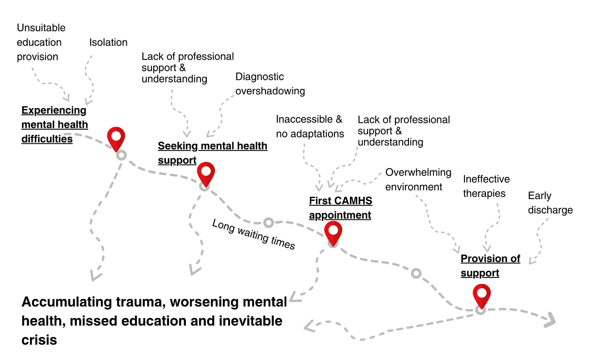
Figure 1. Parents’ explanations of barriers and factors contributing to their child’s mental health difficulties

Key Considerations

Parents and children provided a number of recommendations for strategies that could improve the provision of mental health support in school and in CAMHS. These were combined and are presented below in Table 2. All are underpinned by a need for further funding, resources, and training for professionals working in the field.

Table 2. Recommendations to improve mental health support
Issue | Recommendations
There is a vicious cycle for autistic children and young people (CYP) with schooling and their mental health | - Autistic CYP need access to learning in an inclusive, safe, and flexible environment, with trained staff, which does not cause trauma
There is a lack of post-diagnostic support for autistic young people in terms of their mental health | - Family-centred, community-based strategies to foster acceptance, belonging & connection
Diagnostic overshadowing – mental health difficulties are being conflated with autism by education & healthcare professionals, resulting in under/late/missed referrals and/or early discharge from CAMHS | - Neuro-affirming training and guidance for all school and health staff, including recognition/understanding of MHDs in autistic CYP and effective support strategies
‘Wait-to-fail’ model resulting in many autistic young people reaching crisis point​ | - Early access to identification of needs and reasonable adjustments at home and school.  - Thresholds for access to CAMHS need to be lowered, to allow CYP to receive help before difficulties worsen.  - Professionals should be able to recognise early signs of autistic burnout due to masking.
Waiting lists for CAMHS are long and no interim support is offered, exacerbating existing mental health difficulties | - Early intervention approaches  - Provision of alternative support for autistic CYP who are waiting for a referral  - Waiting lists for CAMHS need reducing, to ensure all CYP receive timely access to support when they first need it.  - There is a need to better capture the ways CAMHS provide helpful referrals or environmental support for autistic CYP.
CAMHS appointments are not appropriately adapted to autistic CYP’s needs, they do not feel listened to & they are being offered inappropriate therapies, resulting in CYP not being able to engage and poor mental health outcomes | - Neuro-affirming training for CAMHS professionals  - Provision of resources to allow for appropriate adjustments  - CYP should have flexibility and autonomy in how their care is provided  - Good practice guidance on appropriate adjustments & therapies  - Consider implementation of a ‘satellite’ service within CAMHS for autistic CYP  - Further research into and implementation of evidence-based neuro-affirming therapeutic interventions  - Autistic CYP may benefit from an extended and personalised assessment and therapeutic period, using alternative methods of communication to build therapeutic relationships and a deeper understanding of their mental health, worries and strengths.

March 2026

