Written Evidence Submitted by
Research Centre for Arts and Wellbeing, Edge Hill University (CYM0142)

Evidence in response to the following requests:

What role should staff in early years settings, schools, colleges and universities play in supporting the mental health of children and young people, what support and training do they need to enable them to take on this role?

What evidence is there that effective delivery of mental health support for children and young people in education settings and open-access provision reduces demand on CAMHS and acute NHS services?

Are there models or examples of approaches within CAMHS that have reduced crisis presentations or repeat attendances among children and young people requiring specialist mental health support?

Research Centre for Arts and Wellbeing, Edge Hill University

This submission comes from the Research Centre for Arts and Wellbeing at Edge Hill University, a centre with regional, national and international reputation due to its strong emphasis on high quality research with interdisciplinary character and impactful knowledge exchange activities. The Centre works closely with the WHO, it has received external funding from bodies such as NIHR, AHRC, ESRC, Arts Council, the Welcome Trust and the European Union, and explores the role of the arts to supporting the health and wellbeing of individuals across the life span and their communities.
We have based our submission on the following projects:
- AHRC-funded project Arts for the Blues: Towards integrating the use of the arts in healthcare and cultural settings to tackle depression and improve wellbeing in the NW (AH/W007983/1)
- NIHR-funded projects Arts for the Blues for children and young people (CYP) in health services (abc-f NIHR RfPB, NIHR207139 (SEC-0524-2001); e-arts-for-the-blues NIHR i4i FAST NIHR502360)
- Doctoral studies on Arts for the Blues in schools and health settings
Our extensive research in educational and healthcare settings suggests that arts-based interventions have an important role to play as universal, targeted and specialist provision, with varied levels of training depending on the expertise and skills of the staff delivering the interventions as well as the context and the need (figure 1).

Figure 1: Arts-based interventions as flexible options across MH need and stepped-care provision
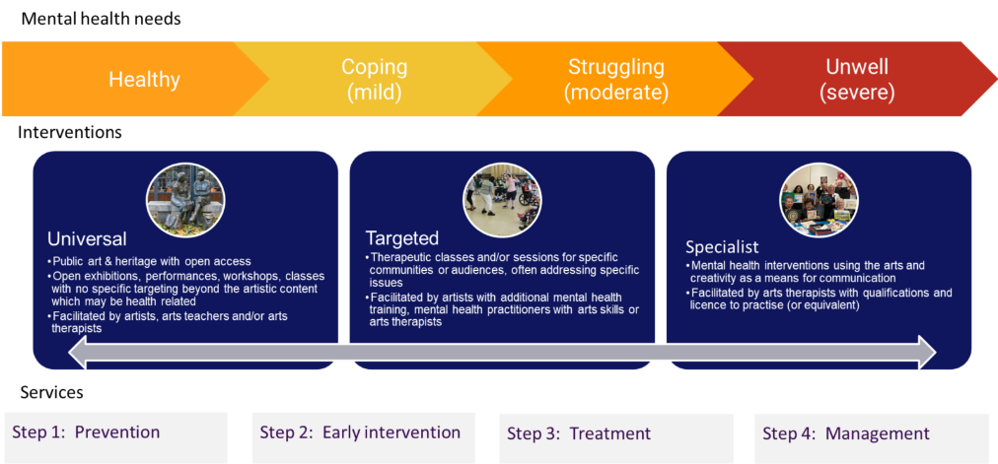

Here we use the Arts for the Blues model and associated research as an example of how arts-based interventions can be used as flexible options across a stepped care approach.
Arts for the Blues is an evidence-based psychological creative group intervention, drawing on cognitive behavioural therapy, humanistic psychotherapy and psychodynamic thinking, as well as on postmodern approach to therapy and integrative approaches. It also draws on arts therapies theory and practice and uses diverse art forms including music, dance, drama and visual arts in a structured way through a manualised (but flexible) approach.

We argue that Arts for the Blues, appropriately modified, can be delivered by artists, arts teachers and community practitioners/youth workers with varied levels and types of qualifications and expertise, as well as by regulated arts psycho/therapists (music, drama, dance movement and art therapists), qualified at a Masters level and registered with HCPC or UKCP and their separate professional associations (i.e. BAAT, ADMP UK, BAMP, BADth). Depending on who is delivering the intervention and what is the context and need, Arts for the Blues can be delivered as a psychoeducational promotion/prevention programme, an early intervention, or an intervention for treatment and management.
Arts for the Blues, as an arts-based intervention, can meet important MH needs (de Witte et al., 2026; Cheung et al 2026), including those of marginalised children and young people (CYP), and requests for creative interventions by CYP, their parents and mental health (MH) workers (Liverpool et al 2026). Additionally, there is an economic value from using this type of interventions as recent reports and studies demonstrate (Flynn et al 2026; Davies et al 2026) (see separate evidence submitted for this).

Arts for the Blues: What is it?
Papers on the model:
- Karkou V et al (under review) Arts for the Blues for children and young people: the development and testing of a manual of an evidence-based creative psychological group intervention, in S Hackett and J Bourne (eds) Advancing Arts Therapies through Manualized interventions for Treatment and Training, Cambridge Scholars Publishing
- Omylinska-Thurston, J, Karkou, V, et al (2020). https://doi.org/10.1002/capr.12373

Following guidelines from the Medical Research Council on how to develop and evaluate complex interventions (Skivington et al 2021), a team of arts therapists, psychologists and artists from Edge Hill University and the University of Salford, developed Arts for the Blues, an evidence-based psychological creative intervention. Arts for the Blues is a pluralistic model, drawing on more than one theoretical school of thought. It is influenced, for example, by cognitive behavioural therapy, humanistic psychotherapy and psychodynamic thinking, as well as social constructionism and integrative approaches. Pluralism allows these different therapeutic approaches to sit next to one another, whilst offering conceptual support to the facilitators. In all cases, it draws on arts therapies theory and practice and uses diverse art forms, singing and song-writing, movement and dancing, drawing and painting, role playing and drama.
As a manualised intervention, Arts for the Blues has certain characteristics that define it as a model. It is normally delivered over 12 sessions following four phases and eight ingredients (Figure 2):
Figure 2: Arts for the Blues model
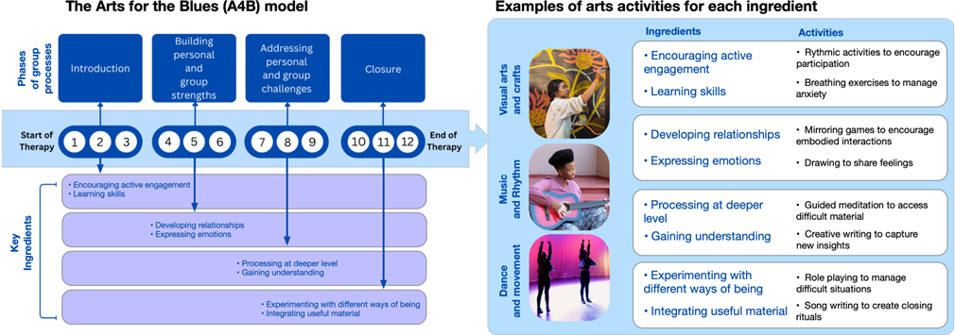While the phases and ingredients define the model and shape its overall structure, the activities used are flexible, allowing the work to be personalised to the needs of the group members. As such, it has been adapted as universal, targeted and specialist provision with associated evidence as follows.
- Universal delivery
Sources of evidence:
- Curious Minds: https://curiousminds.org.uk/harnessing-the-power-of-poetry-df19
- Fancourt D, Karkou V and Fonagy P (2026). Inherent commonalities between arts-based leisure activities and psychological therapies. Accepted for publication in the Lancet.

In 2024, the Rhyme and Reason project adopted, adapted and delivered the Arts for the Blues project to five secondary schools as a 10-week programme within PSHE for whole classrooms. This model was developed to address depression, low mood, and anxiety through arts-based interventions by Edge Hill and Salford Universities. Co-delivered by teachers and poets, Rhyme and Reason reached 200 plus young people helping them to explore their emotions and develop tools for good mental health.
More recently, in an opinion paper accepted for publication at the Lancet (Fancourt, Karkou and Fonagy 2026), links between psychotherapeutic principles and leisure activities via the Arts for the Blues ingredients have been proposed.
Training: Facilitators involved five teachers and five professional poets jointly receiving a 3-day training on mental health first aid and trauma-informed practice as well as a 2-day training on Arts for the Blues. This allowed teachers and poets to develop further MH awareness and training and to co-design and deliver workshops.
Further, large scale research is currently under development to establish if Arts for the Blues can be indeed delivered as a MH promotion programme for whole classrooms.
Recommendations:
1.1 Immediate action to strengthen prevention of developing MH problems is needed that requires universal provision of arts education. Arts education requires no specialised MH training (appropriate safeguarding and local oversight being sufficient) and can reach all CYP offering general wellness.
1.2 Low-level training is required when specific MH promotion/psychoeducational programmes are delivered for all, such as Arts for the Blues, offering slightly more specialised support that will avoid issues escalating.

- Targeted delivery
Sources of evidence:
- Moula, Z, Powell J, and Karkou V (2022). https://doi.org/10.3390/children9060890
- Moula Z, Karkou V and Powell J (2020). https://doi.org/10.3389/fpsyg.2020.586134
- Pringle et al (in preparation). Trauma-informed Arts for the Blues groups in Schools. Prepared for Journal of Child Psychology and Psychiatry

Arts for the Blues has also been delivered in schools as a targeted intervention for children at risk of developing MH problems. The first pilot trial included 62 children aged 7-10 years suggesting high levels of acceptability (Moula et al 2022). Some children shared that they were able to articulate their feelings through the use of creative media, while others talked about regulating their feelings better. Quantitative results (Moula et al 2020) suggested improved emotional and behavioural difficulties (SDQ), wellbeing (CORS: small/moderate effect (Cohen’s d=0.37)) and health-related quality-of-life (EQ-5D-Y: small effect (Cohen’s d=0.22). Children attending Arts for the Blues groups also saw improved sleep quality with overall positive outcomes sustained for at least six months, making this the first study capturing long-standing impact of arts therapies on CYP MH. However, this preliminary study remained under-powered with limited capacity to generalise to this young population.
Training: qualified arts therapists (a music, a dance/movement, a drama and an art therapist) were trained over two days in the use of the model. They were supported by a play therapist who acted as a co-facilitator. They also received 3-4 supervision sessions for each group delivered.
Lessons learnt from this pilot study have informed the current study that aimed to evaluate the delivery of Arts for the Blues with 9–11-year-olds in five schools in the Northwest (Pringle et al under review). 175 children participated in this pragmatic cluster randomised controlled trial (RCT). Findings showed a medium-to-large effect (cohen’s d=0.6) for WEMWBS, small-to-medium effect (cohen’s d = 0.4) for the General Mattering Scale (GMS) and a large effect (cohen’s d = 1.42) for the outcome Me&My Feelings (M&MF). Minimum Clinical Important Differences (MCID) were found for the Arts for the Blues intervention group but not for the waiting list control group for both the anxiety and depression scales on RCADS.
Training: in this case, students in the MSc in creative psychotherapy programme from Edge Hill University delivered the interventions following a 2-day training on Arts for the Blues. They delivered the intervention in twos and were supported by a psychologist for the data collection.
Recommendations:
2.1 Early intervention needs to include a wider range of MH interventions within CYP MH services that are developmentally appropriate and attractive to CYP, relieving avoidable escalation into higher-intensity services. Arts for the Blues can be one of those options.
2.2 Consider diverse workforce mix including arts therapists (i.e., regulated practitioners delivering arts-based early intervention groups such as Arts for the Blues); if these are not available, additional training is required to build capacity and skills amongst MH practitioners.

- Specialist delivery
Sources of evidence:
- Karkou V, edt al (2024). https://doi.org/10.1371/journal.pone.0296178
- Karkou V et al (2022). https://onlinelibrary.wiley.com/doi/10.1002/capr.12544
Arts for the Blues has also been delivered in CYPMHS in several NHS trusts in the North West (Karkou et al 2024). Preliminary work with adult mental health service users in community and charity organisations and in primary care services in hospitals suggested the model was robust enough to be delivered with more vulnerable groups (Karkou et al 2022). However, we needed to establish whether this was also true for CYP with either symptoms or diagnoses of depression and/or anxiety.
The first CYPMHS study, conducted in a children’s hospital, aimed to find out if the intervention needed minor, or more substantial changes. To accommodate for their higher level of need we worked with smaller groups of children and young people (5-6 in each case). We also delivered the intervention over twelve sessions, a common number of sessions for group work in these services and longer than the length of our intervention in schools. The interventions appeared acceptable with children rating highly their experience of the intervention, describing the sessions as “welcoming” and “helpful” and their experience after sessions as “energising”. The positive experience of the group was mirrored by parents, with one parent noting that while their child struggled to attend school, they felt able to attend the group sessions: “he had a bit of a bad night so he didn’t go to school, but he still went to the session in the afternoon”.
Training: The group was delivered by two arts therapists (a drama and an art therapist) already employed in the trust. One of them received a two-day training in the Arts for the Blues and this appeared sufficient to adhere to the protocol and to provide an engaging group with only one person dropping out.
In parallel to this, we began delivering Arts for the Blues as routine delivery to several (adult and) CYP MH services. Delivery in CYPMHS has taken place in three NHS trusts in Greater Manchester (GMMH, MFT, Pennine Care), and two in Liverpool CYPMHS (Mersey Care and Alder Hey). Outside the Northwest, two more trusts received training engaging arts therapies teams (Avon and Wiltshire MH Partnership NHS Trust and Cumbria, Northumberland, Tyne and Wear NHS Foundation Trust). Between 2023 and 2026, at least 14 groups have been offered in CYPMHS reaching over 60 CYP 9-16 years old. A report from the South Manchester MFT CYPMHS with nine young people (13-18) from two groups suggest that participants valued the groups because of the actual engagement in the art and creativity, social connections, the development of a sense of belonging, and suggestions made for change, indicating an overall acceptability of the intervention.
Training: training was offered to counsellors, psychotherapists and clinical psychologists in three NHS trusts and to arts therapies teams in two more. Longer training was requested by the first group and intense supervision. In contrast the 2-day training offered to the arts therapies teams along with routine supervision was regarded as sufficient to allow them to run Arts for the Blues groups with confidence.
Finally, with funding from the National Institute for Health and Care Research (NIHR), we are currently conducting a CYPMHS study in three different hospitals in the Northwest of England, two groups in each trust. The study follows a feasibility randomised controlled trial design allowing us to test not only the manualised intervention but also the research design, prior to applying to conduct a nation-wide study. Group are planned to be delivered by at least one arts therapist in each case, supported by a mental health practitioner with a different professional background including counsellors, psychologists and psychiatrists. While this study does not have results as yet, it has produced a logic model (see figure 3) that describes input, the intervention, activities, and mechanisms of change as well as immediate outputs and long-term outcomes.
Figure 2: Logic model for Arts for the Blues in Children and Adolescent Mental Health Services in hospitals
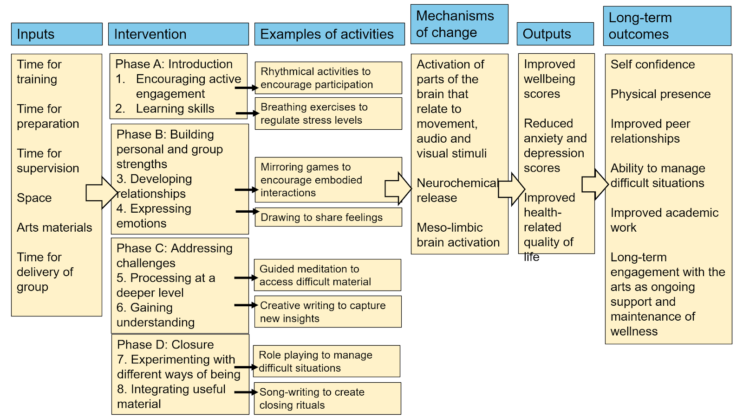
Training: Arts therapists along with their supporting mental health practitioners have received a regular 2-day Arts for the Blues training. When the groups start, they will also receive clinical supervision as would be expected for any therapy delivery. So far, this type of training and supervision is deemed sufficient.
Recommendations:
3.1 NHS provision needs to include a wider range of regulated MH interventions within CYP MH services that are developmentally appropriate and attractive to CYP. Arts/creative therapies can make an important contribution to this, enriching current provision and diversifying the workforce.
3.2 NHS providers need to employ regulated MH/psychological practitioners with arts therapies qualifications (or equivalent); for those with appropriate qualifications and experiences only brief training (e.g., 2 days) is needed for specific arts-based interventions such as Arts for the Blues.
3.3 The NHS MH services for CYP need to include arts therapists as core practitioners, given that they are psychological practitioners and allied health professions with CYP experience, a minumum of 2-year Masters-level training and licence to practise, regulated by HCPC and UKCP.

- Wellbeing of staff
Sources of evidence:
- Karkou V et al (2024). https://doi.org/10.1080/17454832.2024.2376710
- Sharma D, Clark R, Hewson T, ... and Karkou V (2026) Using a creative arts-based intervention to support the wellbeing of doctors: A mixed methods feasibility study. Medical Education. In preparation.
In 2022-2023 we conducted a feasibility study (Karkou et al 2024) in a local hospital using a pre/post mixed methods design, a multi-levelled creative psychological package targeting the diverse needs of clinical staff in a local trust. The intervention was adapted from a 12-session group therapy into a three-level package that included: (i) one-off drop-in sessions to release tension, (ii) workshops for staff development, (iii) group sessions for psychological support. It was delivered by qualified arts psychotherapists (i.e., art, drama and dance movement psychotherapists) and used brief evaluation forms, arts-based data and standardised outcome measures to establish acceptability. The 49 staff participating placed high value on the different levels offered. All the outcome measures used identified positive change and indicated medium to large effects of the multi-levelled intervention on improvement of wellbeing and resilience, as well as reduction of distress, anxiety, depression and trauma.
Following this, we evaluated an arts-based psychoeducational programme, specifically developed for doctors (Sharma et al 2026) using a pre-post mixed-methods design. Doctors in England participated in a six-hour intervention delivered online or in person. Fifty-two completed the pre-post measures showing significant reduction in moral distress (p=0.013), with small-to-moderate effect sizes for wellbeing measures. Qualitative findings indicated high acceptability, particularly regarding perceived benefit, coherence, and facilitation. Participants valued practical, portable techniques but reported variability in engagement depending on personal preferences. Time constraints and opportunity costs were key barriers, while embedding the intervention within teaching programmes improved access.
Finally, in Avon and Wiltshire Mental Health Partnership NHS Trust, following training on Arts for the Blues offered to arts therapists, a dance movement psychotherapist and an art psychotherapist, from a team of nine arts psychotherapy staff from inpatient services, offered groups of Arts for the Blues as part of weekly creative arts-based reflective practice for the ward staff. This group complemented monthly creative arts-based reflective practice and quarterly creative arts wellbeing sessions for staff. Sessions offered a regular opportunity for ward staff to express themselves, support their wellbeing and reduce staff stress and burn out. It was also an opportunity for staff to reflect from an embodied internal perspective as well as an external group reflection to support them in their role as mental health practitioners.
Recommendations:
4.1 NHS services should include arts-based interventions, delivered by trained practitioners such as arts therapists, in staff wellbeing programme. As enabling creative ways of supporting the wellbeing of staff, including prevention and treatment of burnout they need to be considered for routine practice.
4.2 Creative wellbeing interventions can complement system-level reforms by providing accessible and non-stigmatising support.

Based on the above research experiences, we propose the following training for staff across a stepped-care approach.

Table 1: Step-care approach with associated types of arts-based interventions (specialist) and proposed training
Steps | Governance | Setting | Population | Type of intervention | Typical format | Workforce | Training | Core outcomes
Step 1 (prevention) | Education; local authorities; VCSE; cultural sector; ICB oversight where relevant | Schools, Community (neighbourhood models and hubs) | All CYP | Universal arts enrichment embedded in school/community life | Ongoing provision (school term of community programme) | Artists / arts teachers | Arts education; no specialised MH training, but appropriate safeguarding and local oversight is needed | Healthier, more connected schools/community environments; reduced social isolation; improved wellbeing; reduced inequalities in participation and access
Step 1 (prevention) | Education, MHSTs interface where relevant | Schools | All CYP | Universal MH-promoting arts activities (e.g., within PSHE/whole school approaches) | Structured sequence of sessions across half-term/term (or integrated curriculum activity) | Teachers / arts teachers / artists/arts therapists or MH practitioners where relevant. | Training on the specific programme is needed. | Improved wellbeing/quality of life;  MH literacy and help-seeking confidence; social-emotional skills (e.g., emotional understanding, communication)
Step 2 (early intervention) | ICBs, MHSTs, Education, Local authority, VCSE, NHS partners where relevant | Schools, Community (neighbourhood models and hubs) | CYP at risk of developing MH problems | Targeted: small groups | 8-24 sessions | Arts therapists / MH practitioners | Arts therapies qualifications are needed. If these are not available, additional training is required. In all cases training on specific interventions are needed. | Improved wellbeing/quality of life; reduced mild-moderate anxiety/ depressive symptoms; support for specific concerns (e.g., bullying, transitions, bereavement, marginalisation, neurodivergence).
Step 3 (treatment) | NHS lead with multi-agency interface (education, social care, VCSE) as required | NHS services (CYPMHS) | CYP with MH problems/diagnosis | Specialist individual or group arts therapies as part of a formulation-led plan agreed with MDT | Frequency and duration determined by clinical judgement, and service model; MDT-supported where needed | Arts therapists / creative therapists | Arts therapies qualifications (or equivalent) with additional brief training (e.g., 2 days) for specific interventions such as Arts for the Blues. Longer training for specific evidence-based interventions if arts therapies qualifications are not available. | Reduction of moderate-severe symptoms of depression/anxiety where relevant; improved functioning and engagement;
Step 4 (management) | NHS lead with multi-agency interface (education, social care, VCSE) as required | NHS and specialist clinics; PRUs; forensic units; residential care; community specialist pathways | CYP with complex needs; chronic relapsing presentations | As above | As above | As above | As above. Training on specific MH conditions may also be required for all to address complexity | Improved engagement; support for co-morbid/complex needs (e.g., ED, SUD, ASD, ADHD); relapse prevention and sustained recovery.
Crosscutting (all steps) | All sectors | All settings | CYP, families, staff | Universal, targeted and specialist: Diverse arts-based interventions | Varied formats: one-off workshops to ongoing programmes | Artists / arts teachers / arts therapists | Training on specific programmes is needed. | Creative tools for self-care;  stress reduction; relationship building; workforce wellbeing and burnout reduction

March 2026

