Written evidence by Dr Lawrence Howells, Professor Frances Maratos, Michelle Robinson, Dr Richard Slinger and Elizabeth Williams (CYM0088)
Education Committee
Children and Young People's Mental Health

We are a group of expert professionals all specialising in child and young people’s mental health, with decades of experience in the field as specialist researchers, providers and/or government employees (or previous employees) in this area.
Professor Frances Maratos, Professor of Psychology and Affective Science, Compassion in Education Lead, University of Derby
Dr Richard Slinger, Clinical Psychologist, Lancaster Emotional Health in Schools and Colleges Lead, Lancaster University
Michelle Robinson, Derby City Public Health Manager: Children and Young People’s Mental Health and Wellbeing
Elizabeth Williams, Mindfulness Wales Chair and previously Head of Children and Young People’s Strategy in the Welsh Government.
Dr Lawrence Howells, Clinical Psychologist specialising in Youth Mental Health

The role of education and community settings in support and delivery
How effectively are education and community providers identifying and responding to children and young people’s mental health needs?
We would argue that responding could be vastly improved if the directive is to move from a deficit-based model of wellbeing and mental health to a model that equally recognises good quality social and emotional learning as a fundamental essential of wellbeing and mental-health. This is a bifurcated (i.e. two-pronged) approach that recognises the importance of both: i) a proactive (i.e., preventative) strength-based model; and ii) a reactive deficit-based model.
A deficit-based model is the prevalent model across both the UK education and medical sector. It is based on fixing something that is wrong. Hence why it is a mainstay of NHS practice and therefore also a mainstay of NHS led mental-health provision in schools and the community. A strength-based model focuses on cultivating existing strengths and creating new strengths. A strengths-based model is entirely appropriate for educational and community settings. However, a strength-based (preventative) model is rarely incorporated into education and community setting wellbeing and mental health provision.
To sum, to identify and respond to children and young people’s mental health needs adequately. education and community setting delivery needs to incorporate strength-based, as well as deficit-based approaches, materials, programmes and/or interventions. This will become clear, through research and practice examples in our further answers.
What role should staff in early years settings, schools, colleges and universities play in supporting the mental health of children and young people, what support and training do they need to enable them to take on this role?
Maratos (2025) put forward a call to action to ensure that in primary and secondary schools: i) Mental-health Interventions (based on a deficit model) and Social and Emotional Learning (based on a strengths model) are not conflated; and ii) that both approaches are regulated.
Focusing on the second point of regulation, as depicted in Figure 1, schools need quality age-appropriate Social and Emotional Learning (SEL) materials that have been designed and rigorously evaluated by relevant experts in those areas (e.g., social psychologists, affective science psychologists, developmental psychologists working with teachers, etc.). Then, only those materials demonstrated to be beneficial should be shared with children; with these materials and lessons delivered at the class level as part of standard education and learning. Crucially, delivery should only by those teachers, or mental-health leads, with the relevant training. If teachers do not have the relevant training and/or underpinning knowledge, there is the potential for harm – and the worsening of mental-health - through problems of fidelity and miseducation of children and youth (Durlak & DuPre, 2008; Montagne et al., 2025; Wilde et al., 2019). A widespread example of SEL miseducation having the potential to cause harm is a focus of our answer on “What factors are driving recent trends in children and young people’s mental health?”.
Two, where school-based mental-health interventions are needed, these should be the domain of specialist clinical and/or educational psychologists. These interventions should be delivered by these specially trained individuals, or appropriately qualified individuals, such as mental-health leads (under the guidance of these psychologists), and only at the one-to-one or small group level.
Here, the delivery model that Lancaster County Council (LCC) use is an exemplar. In this model all specialist provision across LCC schools/colleges is provided by a small team of clinical psychologists, who are professionally trained and HSCP registered. So quality of both materials and delivery is assured (see https://wp.lancs.ac.uk/lehsc/).

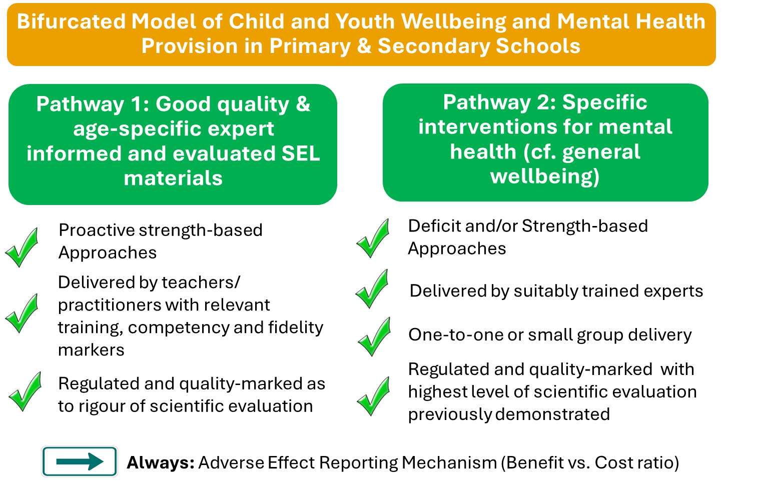
Figure 1: The Maratos Model of Wellbeing and Mental-Health Provision
Importantly, it takes years of training to become a medic, deliver medical information, and/or conduct medical interventions. Why should psychology-based SEL materials, pedagogy and mental-health interventions be any different? For example, why is the delivery of suicide prevention in schools unregulated? [Expanded upon in our next answer]
To sum, training and support is absolutely required for any staff delivering social and emotional learning materials or mental-health interventions. However, the support and training requirements for each are necessarily, and should be, different.
How do inspection and accountability frameworks such as Ofsted, the Office for Students or DfE guidance support or hinder education settings in prioritising mental health provision and should any changes be made?
To answer this question, an overview of some of what is currently offered in schools needs to be presented, before we can then suggest a solution.
Considering first the Department for Education, their guidance on RSHE/PSHE materials (which covers SEL) and school-based mental health interventions is confusing. In example, why is the Department for Education calling for Suicide Prevention to be included in Universal provision (RSHE, 2025) when their own research has demonstrated such universal (i.e. whole-class delivery) provision has the potential for harm (Deighton et al., 2025)? To expand in a trial of a specifically designed suicide intervention programme (Youth Aware of Mental Health; YAM), results revealed this intervention led to increased emotional difficulties at the long term follow up, 9-12 months after intervention deliver
Concerningly, it is not only YAM that has the potential for harm. In extension, the ‘Zones of Regulation’ curriculum developed in the US, does not meet the USA’s own evidenced-based practice guidance. A recent research review revealed no effectiveness of this SEL/PSHE provision, with some of the included studies revealing pupil wellbeing was worse after its delivery (Mason et al., 2024). Thus, this SEL/PSHE has the potential to cause harm. Yet in UK schools the ‘Zones of Regulation’ is gaining in popularity. For example, Norfolk County Council, highlight its use in their school services (ZoR OMG) and it is further supported/recommended by the NHS (NHS Borders). Yet, there is no rigorous trial of the curriculum, which would perhaps explain why the company still refer to ‘pilot’ data in their commercial brochure; and why they themselves have never published any trial evidence in reputable scientific journals. Despite this, the curriculum is sold world-wide across 40 countries and has been delivered to over 800,000 children. This is alarming, as the few independent research trials of the Zones of regulation, demonstrate at best it is potentially ineffective and at worst it negatively affects child wellbeing.
There are currently many more unregulated, but popular SEL/mental-health courses ‘sold’ to schools across the UK including Bounce Forward, My Happy Mind and those delivered by charities such as Compass. However, trial of Bounce forward was not rigorous, which they themselves state limits any beneficial effects being a consequence of the curriculum (Kara et al., 2021), and for My Happy Mind – no objective research has ever been collected or published to demonstrate this is effective SEL. Yet this again is NHS backed/commissioned! Other models, include supporting charities to deliver provision across whole counties (e.g. Compass, also NHS backed). In some cases, what these charities deliver may be very beneficial, especially at the one-to-one level. However, again there is no scientific evaluation of the universal whole-class provision such charities have then developed. Additionally, if this universal provision is based on a deficit-model of wellbeing/mental-health it has the potential to result in poorer child wellbeing. Again, why this can happen is expanded upon in our answer on “What factors are driving recent trends in children and young people’s mental health?”.
As UK parliament itself is calling for more high-quality evidence in respect to what are the most effective school-based wellbeing approaches and how best to measure their impact (Carey & Webb, 2025), there is now greater awareness that many school-based (and community) programmes and interventions may not be effective.
Our solution, or the change that should be made, is that any SEL material or mental-health provision delivered, or sold-into school-setting, should be properly evaluated as to its scientific rigour/evidenced-base and its level of benefit over harm. Populations under the age of 18 are classed as vulnerable, requiring special care and support. They are susceptible to environmental factors. These environmental factors not only include those related to their home environment but also those related to schooling. This includes the quality of SEL materials and mental-health interventions. The Department for Education and OfSTED have a responsibility to ensure that schools and community providers can make well informed decisions as to what programmes or materials they choose to use as SEL and mental-health provision with their children and young children. This is especially important, as PSHE provision is not typically subject to the same level of inspection focus or academic weighting as other core subjects, and it is not a formal qualification. Yet, presently, navigating the scientific evidence for programmes is extremely difficult for schools and authorities. Thus, the DofE need to work with a team of academics and clinical psychologists specialising in child wellbeing (i.e. create a ‘taskforce’) to design a rating scale and the relevant guidance for assessors. SEL, PSHE, RSHE and mental-health intervention providers can then submit documentation to this team/taskforce to be awarded a rating.
This rating system could be based on the US evidence-based practice in psychology (EBPP) system but applying OFSTED categorisation language. To allow for regulation of the field, the final scale (combining the EBPP with OFSTED language) might resemble something along the lines of:
1 = Exceptional. The programme/intervention has been subjected to the highest level of scientific rigour, with meta-analyses and systemic reviews of randomised controlled or cluster trials of the specific programme/intervention in relevant populations demonstrating benefits over no effects/negative effects (harm).
2 = Strong Standard. The programme/intervention has been subjected to a high level of scientific rigour, through well-designed randomised or cluster-controlled trials of the specific programme/intervention in relevant populations demonstrating benefits over no effects/negative effects (harm).
3 = Minimum Standard. The programme/intervention has been subjected to some quasi-experimental studies or well-designed observational studies of the specific programme/intervention in relevant populations demonstrating benefits over no effects/negative effects (harm).
4 = Needs Evidence. The programme/intervention has been subjected to independent expert opinions, case studies, pilot studies (with no control group), observational studies (with significant limitations) of the specific programme/intervention in relevant populations demonstrating benefits over no effects/negative effects (harm).
5 = Urgent Improvement. The programme: i) has no data supporting its specific effectiveness/benefits in relevant populations, or ii) published data does not reveal benefits, or benefits reported do not outweigh any negative effects (harm).
This is the change that is needed to ensure mental-health provision is effective. We/Maratos would be happy to form part of this taskforce, if the idea is taken forward.
What is required to achieve the Government’s manifesto commitments on provision of mental health support in schools and colleges?
Regulation of the entire field of SEL and Mental health provision, as suggested in our above answer. Importantly regarding their manifesto, the government states “Embedding an evidence-based, holistic, whole school or college approach to mental health and wellbeing helps to achieve this.” (Gov.UK, 2025). ‘Evidence-based’ has simply become a confusing buzz word. It’s a word that is banded about by every provider no matter how reputable they are, or what scientific evidence they have to support their programmes/interventions.
SEL and mental-health interventions with populations classed as vulnerable (i.e. children and youth) need to have a rating as to the evidence of their effectiveness with those relevant populations. Only then can schools, authorities and academies etc. make fully informed decisions about which to use/purchase. Many companies have profited out of child and youth mental health provision, without the evidence to support what they are doing is making a positive difference. This needs to change, those companies now need to invest their profits into high quality trials. Charities need to invest income into the same. Making unsubstantiated claims regarding the benefits of a said programme/intervention, without the scientific evidence to support such is not only unethical but could be damaging the very wellbeing and mental health of those children and youth the programmes and interventions are delivered to.
To what extent does the rollout of Education Mental Health Practitioners and Mental Health Support Teams support in delivering on this commitment?
When Education Mental Health Practitioners and Mental Health Support Teams are delivering only those programmes, interventions and materials with robust effectiveness evidence (i.e. materials or interventions rated as 1=Exceptional or 2=Strong Standard), will such provision and commitment make a difference.
Integration between education, NHS and community provision
What factors are driving recent trends in children and young people’s mental health, and how have changes in service thresholds influenced both the presentation of need and access to early support?
To answer this question, we first explain and provide a further example of where deficit-based models can potentially lead to poorer mental health, this then allows for us to explain how changes in service thresholds influence the presentation of need and access to support.
As previously suggested, universal provision of mental-health materials underpinned by deficit-based models have the potential to cause harm (e.g., the government’s own research on the universal suicide programme YAM, discussed in an earlier answer). The reason why deficit-based models are not always appropriate, especially for universal delivery, is because they come from a point of ‘something is broken and needs to be fixed’ and, therefore, amongst other things, they can pathologize what is essentially normal behaviour. In specific relation to YAM, the goal of the programme is to increases adolescents’ awareness and knowledge of mental health and mental health problems, stress and crises, depression and suicidal thoughts. Whilst this is appropriate for children and youth showing vulnerability to depression and suicide, in general populations it could potentially introduce, prime and normalises the idea of suicidal thoughts.
In further example, one of the biggest miseducation of our children and youth in most mental-health and wellbeing provision, is the idea that we have a ‘flight or flight’ system. This is simply incorrect and comes from a deficit-based approach. To expand, the factually correct psychobiology is that we have a sympathetic nervous system (SNS) which prepares us to take action (e.g. increases heart-rate and blood flow etc.). This could be to fight or flee or, alternatively, have fun. Maratos has written/presented talks on this extensively, but for a lay explanation see Maratos, 2024. Importantly, if we only educate children and youth (and adults) to misinterpret bodily responses such as raised heart rate and trembling etc. as a ‘stress’ fight or flight response, then those bodily responses are misattributed to stress and anxiety. In other words, through processes of misinterpretation and misattribution we are priming poor wellbeing and mental-health. However, if we correctly educate children (and adults) to how body physiology influences emotions (i.e. the SNS helps us prepare for flight, flight and fun behaviours), then we allow children to: i) correctly interpret those bodily responses for what they are (i.e. the SNS preparing us to take action) and ii) allow children to correctly attribute what they mean. For example, as one child has stated that the "100 pterodactyls running around in my tummy are because I am excited not scared”. [See Figure 2]
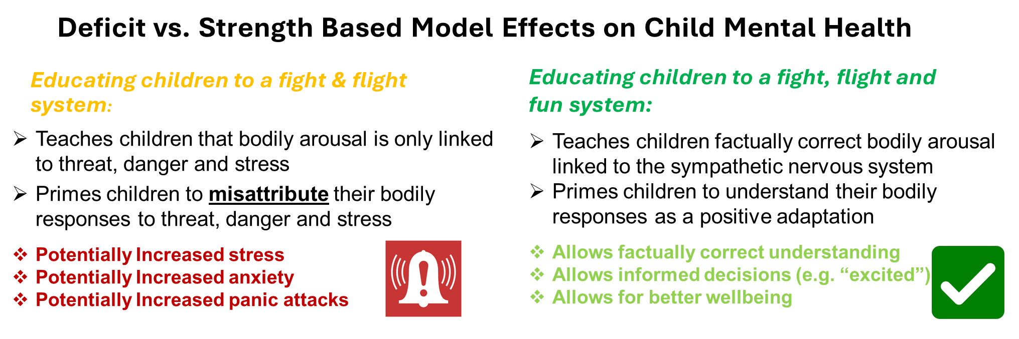
Figure 2: Understanding potential effects of deficit and strength-based models of wellbeing and mental-health
The above is just one example of how a deficit-based approach to understanding wellbeing and mental-health can cause harm. It is an example that we as psychologists, public health experts and practitioners are trying to address through either our own materials for schools and public health teams, or through general awareness raising of the dangers of unregulated/non-expert informed materials.
So, in respect to how service thresholds have influenced both the presentation of need and access to early support, a key factor is that deficit-focused provision has become a mainstay of universal (e.g. class-based) wellbeing provision - and not just targeted one-to-one or small group delivery. This is not appropriate and may be exacerbating service needs. To expand, anecdotally Maratos has spoken to many practitioners, individuals and parents who have suggested that wellbeing provision by charities or through school has left their children, or children they work with, in poorer mental-health, escalating the need for CAMHS intervention, because of this ‘early-support’. These individuals have suggested that concerns need raising. However, there is currently no method for psychological harm reporting. For medical interventions there is the gov.uk yellow card scheme …but nothing similar exists for psychological interventions.
Additionally, this prevalent deficit-model may also be priming teacher and parent responding. For example, what do teachers (and parents) do when children approach them with the difficulties they’re facing? Do they default to the deficit-model and speak about anxiety and seeking a referral to health services? Or do they focus on a strengths-based approach and think about how children can embrace these experiences as a part of learning about themselves and building confidence? Given the prevalence of a deficit-based model of mental health across school and community settings, we are priming all – teachers, parents and society – toward the former.
What evidence is there that effective delivery of mental health support for children and young people in education settings and open-access provision reduces demand on CAMHS and acute NHS services?
To our knowledge there are very few robust high-quality trials (i.e. studies that would be graded 1: Exceptional or 2: High Standard) demonstrating effective delivery of mental health support for children and young people in education settings and/or open-access provision. That does not mean those studies (and therefore programmes/interventions) do not exist, just that at present – without any assessment of the quality of the scientific evidence – it is difficult to ascertain effectiveness. For example, a charity or provider may suggest that data revealed a “19% reduction in referrals to CAMHS”, but this data is meaningless without statistical comparison to a control group, as that CAMHS referral trend could reflect other factors rather than the specific intervention itself. For example, it could reflect general interindividual differences overtime or other environmental factors (such as changes in life circumstances or world-events e.g. recovery from the aftermath of Covid-19).
One SEL lesson suite, however, produced by psychologists and researchers at the University of Derby, has early evidence of its effectiveness to reduce anxiety. This is ‘Wellbeing: Our Brains, Our Bodies” a proactive strength-based emotion and compassion-based lesson suite. Through two high quality small, randomised cluster-controlled trials, this SEL lesson suite has been demonstrated to: i) prevent anxiety increases in children aged 11-12 (Maratos et al., 2024) and ii) decrease anxiety and increase wellbeing in children aged 10-11 (Maratos et al., submitted). This preventative intervention is delivered as part of standard primary or secondary RSHE or PHSE entailing minimal costs. To our knowledge, no comparative efficacious preventative anxiety PSHE/RSHE exists, limiting comparisons.
We will shortly be progressing wider trial of this SEL via Lancaster Emotionally Health Schools, where we will collect data on school avoidance and/or CAMHS referrals from schools both involved in delivery of WoBoB and those serving as control, using a cluster-controlled design. However, preventing just one child per each setting needing access to CAMHS, via provision of WoBoB to Lancashire schools could be associated with a cost-saving of around £2 million per year. This is based on 2021 figures, where total annual UK societal costs per anxious child were £4040.
So, in sum, progress could be being made towards this aim, but without any form of regulation or quality-rating of scientific rigour of current programmes and/or interventions*, what is high-quality reliable research evidence cannot be discerned from that which is low-quality, spurious and/or unreliable.
*See again here our above suggested rating system and task-force idea as a cost-effective, low burden form of regulation.

April 2026

