Written evidence submitted by the SUV Alliance (RSS0060)

- The SUV Alliance is a coalition of think tanks, campaign organisations and parent-led groups working to reverse the trend towards ever-bigger, ever-heavier cars and sports utility vehicles (SUVs).
- We are grateful to the Committee for this call for evidence and are glad to provide our evidence below, particularly in response to part 2(l):
- “What is the right approach to strengthening vehicle safety standards? What measures should the Government prioritise in response to issues such as headlamp glare, increasing vehicle size and any broader issues not currently being considered by the Government’s consultation?”
Summary of our response
- Cars in the UK are growing heavier, wider and taller year-on-year, a phenomenon termed ‘carspreading’.
- Carspreading is exemplified by the growing sales of sports utility vehicles (SUVs), which made up 66% of new car sales in the UK in 2025.
- The negative impacts of carspreading on road safety, air quality and congestion are well documented and evidenced by a growing body of academic literature.
- Successful and effective policy measures to tackle carspreading are in place across Europe. These include weight-based taxation, weight-based parking surcharges, child-centred safety testing, and IVA reform.
- Public support for such policies in the UK is high, with 59% of UK YouGov poll respondents agreeing that large cars are unnecessary in towns and cities.

Context: carspreading
(3) Page 32 of the Road Safety Strategy 2026 states that “The government will collaborate with stakeholders and vehicle manufacturers to further understand safety concerns regarding increasing vehicle size.”
(4) Cars in the UK have on average become heavier and are growing wider year-on-year. Each year over 1 million cars are sold that are too wide for a typical roadside parking space.
(5) The term “carspreading” has been coined to describe this trend towards ever-bigger, ever-heavier cars. Driving the carspreading phenomenon is the surging popularity of sports utility vehicles (SUVs), and increasingly US-style pickup trucks. SUVs are typified by larger bodies, taller wheels and, often, higher bonnets than traditional smaller cars. All of which together serve to make them heavier than a regular car as well. From less than 5% of UK vehicle sales in 2000, SUVs made up 66% of new vehicle sales in 2025 and now constitute 32% of all cars on the road.
Examples of common SUVs include the Ford Puma, Nissan Qashqai, Volvo EX90, BMW X-series, and Range Rover and Land Rover models.
Examples of common pickup trucks include the Ford Ranger, Toyota Hilux and Dodge RAM.

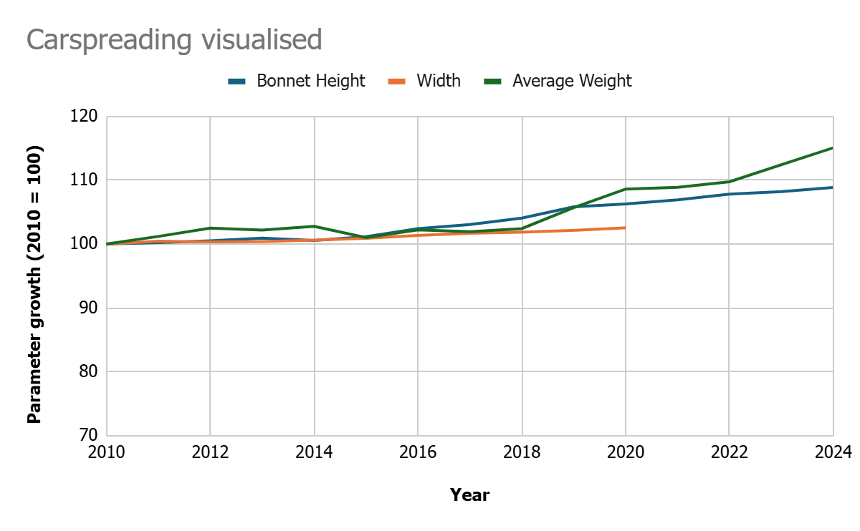 | 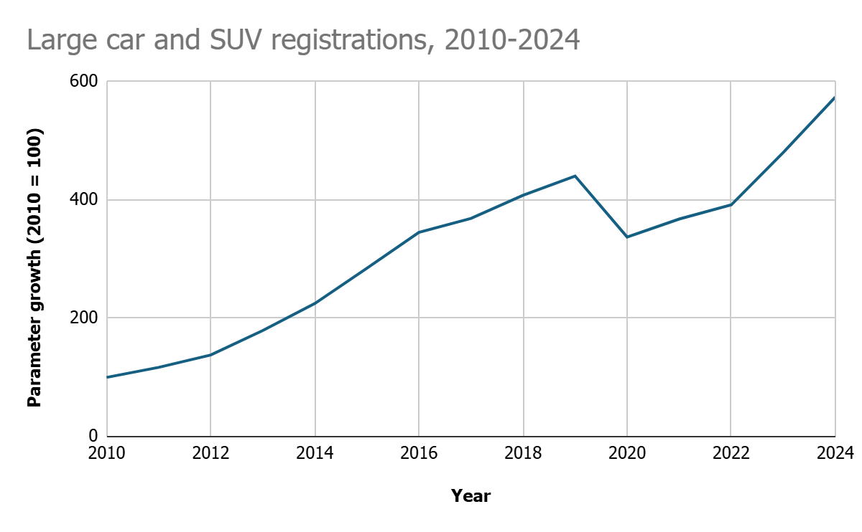
Fig 1: graphs show (left) increasing bonnet height, weight and width of cars in the UK, and (right) surging sales of SUVs and pickups. All yearly values indexed: 2014=100.
Issue: road danger
(6) A growing body of research is emerging on the dangers associated with greater vehicle size. We summarise this literature in Table 1 below.
Citation | Key findings
Goodman, Edwards, and Laverty. 2025. | Being hit by an SUV increased the odds of fatality by 77% for children aged 0-18 years, and by 209% for children aged 0-9 years.
Transport and Environment. 2025. | In the UK, average bonnet heights have increased from 76.9cm in 2010 to 83.8cm in 2024.
Carlson, Dadashzadeh, Ekmekci. 2025. | As car weight increases, the number of fatal collisions per million cars rises, peaking at 26.2 for the heaviest cars (2001-2500kg).
Nuyttens and Ben Messaoud. 2023. | A 10cm increase in bonnet height is found to increase the risk of fatal injuries for vulnerable road users by 27%.

Table 1.

Policy measures to address growing vehicle size
Policy framing: passive vs active safety
(7) ‘Active safety’ measures refer to technologies such as Automatic Emergency Braking and Lane Assist that keep drivers safer. The RSS currently prioritises active safety (Theme 2 of the strategy). Whilst this is welcome, it ignores the growing concerns we, and other stakeholders, have around declining passive safety due to the growth in average car size and weight.
(8) For instance, speed limit assistance is an important active safety feature. Yet a 3-tonne SUV like the Land Rover Defender carries twice the kinetic energy as a 1.5-tonne Ford Fiesta travelling at equal speed. In this case it is the weight of the vehicle that matters more than the speed.
(9) Consequently, we urge the government to ensure passive safety is given equal weighting to active safety when exploring vehicle safety standards, and would welcome opportunities to collaborate with DfT and other stakeholders to discuss this further and to elaborate concrete policy proposals. We note, respectfully, that our efforts to make contact with DfT have, to date, not been reciprocated.

Large Vehicle Levy
(10) The government is advised to introduce a Large Vehicle Levy under which new cars are taxed - as part of first-year Vehicle Excise Duty (VED) - an additional £10 per kg over a minimum threshold of 1600kg kerb weight. This would ensure that common small cars like the Ford Fiesta are unaffected by the levy, whilst heavier cars like the Land Rover Defender pay their fair share.
(11) UK car owners pay up to 20 times less tax on the heaviest cars compared to those in European nations.
(12) It is estimated that a Large Vehicle Levy could raise £1.72 billion annually for HM Treasury. This money could be used to support social licensing of electric vehicles for key workers and families on low incomes.
Child-centred vehicle safety testing
(13) Raised bonnets common to many SUVs and pickups create blind spots for the vehicle driver. See Fig. 2 below. Despite this, high-bonneted cars are frequently awarded top safety ratings by the European New Car Assessment Programme (NCAP).
(14) Over the last 5 years of Euro NCAP ratings, new cars over 2000kg (which includes all large SUVs and pickup trucks) have, on average, received higher scores for pedestrian safety than less heavy cars. The Land Rover Defender, for instance, enjoys a 5-star safety rating from NCAP. This does not align with the most recent research on vehicle safety and risks misleading consumers who choose a vehicle based on its safety rating.
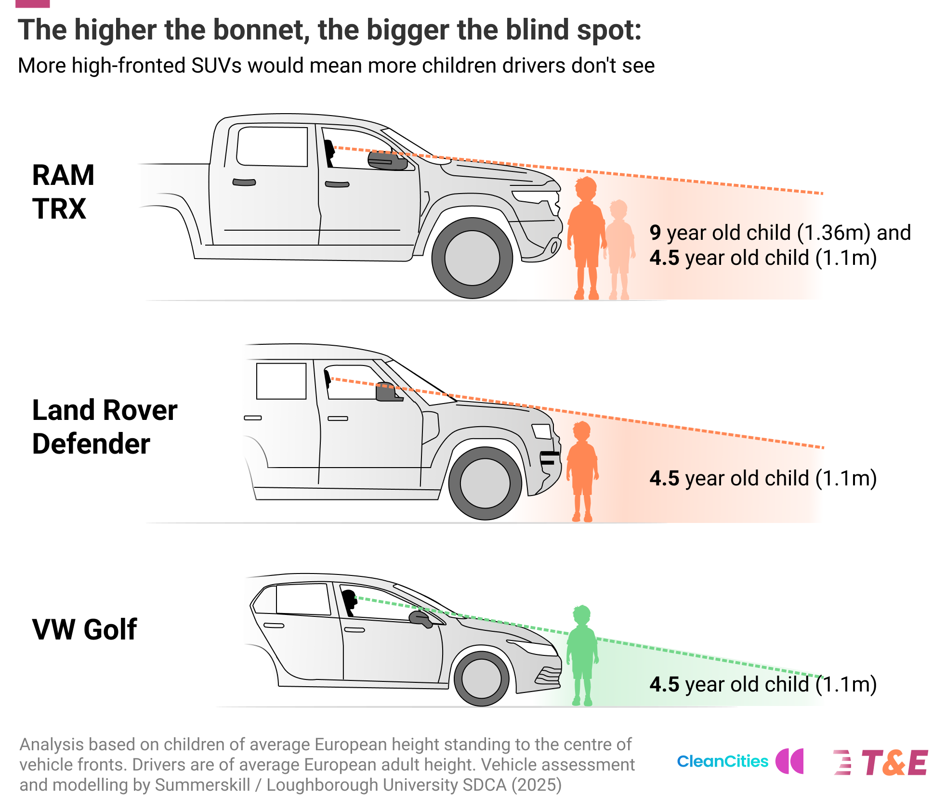
Fig. 2: higher bonnets reduce driver visibility of small children.

(15) The government is advised to
- Work with Euro NCAP to incorporate a “child visibility test” into their testing regime whereby the visibility to the car’s driver (assuming an average height female driver) of a child standing in front of the car’s bonnet is measured and under which cars performing poorly by this metric cannot be awarded top safety ratings.
- Tighten the Individual Vehicle Approval (IVA) scheme. The EU is currently acting, and after it has tightened its IVA regime, the UK risks being exposed to mass market imports that do not comply with European standards.
Ending the importation of vehicles with substandard safety protections
(16) Under Individual Vehicle Approval (IVA) vehicles in classes N1 and M1 (including large SUVs and pickups) are able to be imported from the US which do not meet UK or EU pedestrian protection standards (UN-R127). Such importation manifestly undermines the UK’s world-leading safety regulations for vehicles.
(17) The government is advised to urgently review the IVA scheme to ensure that any imported vehicles meet the highest standards of pedestrian protection, in line with vehicles manufactured within the UK and EU.

Weight-based parking surcharging
(18) In October 2025, Cardiff City Council became the first UK local authority to approve a weight-based parking policy on resident parking permits.
(19) The Cardiff City Parking Plan includes: "A surcharge for vehicles over 2,400kg Revenue Weight will be introduced to encourage drivers to switch to smaller vehicles. In time, this will be reduced to 2,000kg (for non-electric vehicles). Very large vehicles (vehicles over 3,500kg Revenue Weight) will not be entitled to permits."
(20) In doing so, Cardiff follows the examples of numerous European cities, most notably Paris. Other UK local authorities are known to be considering weight-based parking surcharges. The national government can support and encourage this.
(21) The government is advised to work with the Department for Transport to ensure local authorities have access to reliable data linking vehicle registration to weight and other critical dimensions such as width and bonnet height as currently exists for CO2 emissions (via which policies such as emissions-based parking charges and low emissions zones are enforced).

March 2026
Endnotes

https://www.suv-alliance.org.uk
https://assets.publishing.service.gov.uk/media/695e2cff8832ab3a48513809/road-safety-strategy.pdf
https://www.autocar.co.uk/car-news/new-cars/average-weight-new-cars-rises-nearly-400kg-seven-years
https://www.transportenvironment.org/articles/ever-wider-why-large-suvs-dont-fit-and-what-to-do-about-it
https://cleancitiescampaign.org/1-million-cars-sold-every-year-too-big-to-park/
https://www.theguardian.com/world/2026/jan/27/us-style-pickup-trucks-uk-roads-up-data-shows
https://cleancitiescampaign.org/wp-content/uploads/2025/03/Carspreading-Key-Facts.pdf
Available at doi.org/​10.32866/​001c.141647
Available at https://www.transportenvironment.org/articles/ever-higher-the-rise-of-bonnet-height-and-the-case-to-cap-it
Available at https://static1.squarespace.com/static/67177e7d1cb5f2188265827f/t/683d6d70ffbad01446e555c5/1748856176648/UK+Car+Weight+Prelim+Findings+-+2+Pager.pdf
Available at https://www.vias.be/publications/Impact%20voertuigkenmerken/Impact_des_caract%C3%A9ristiques_des_v%C3%A9hicules.pdf
https://www.transportenvironment.org/te-united-kingdom/articles/t-e-uks-large-vehicle-levy-explained
https://uploads.transportenvironment.org/production/files/No-one-left-behind_Final_TE-UK_March26.pdf?dm=1773156671
See page 75: https://www.iamroadsmart.com/road-safety-content/articles/iam-roadsmart-road-safety-report-2025-the-motoring-public-has-its-say/
https://cardiff.moderngov.co.uk/documents/s89475/2025-10-16%20City%20Parking%20Plan%20Appendix%203%20-%20The%20City%20Parking%20Plan.pdf
https://www.transportforqualityoflife.com/reports/suv-toolkit-for-cities-options-for-defining-and-addressing-oversized-vehicles/

