Written evidence submitted by Angelica Solutions Services Limited (RSS0049)

1. Executive Summary
- Sufficiency of the Strategy: While the current Strategy is a constructive step, Angelica Solutions argues it is insufficient to meet 2035 targets because it lacks a robust framework for the ‘post-test’ transition of young drivers.
- The Young Driver Gap: 2024 data shows collisions involving young drivers result in 44% more Killed or Seriously Injured (KSI) casualties than those involving older drivers.
- Proposed Strengthening Measures: The Strategy should be strengthened by mandating telematics-based insurance for the first two years of licensure and facilitating the integration of private-sector insurer data into national road safety analysis and monitoring.

2. About the Authors and Organisations
- This evidence is submitted by Sarah Vaughan, Founder and Director of Angelica Solutions, and draws on research carried out in collaboration with Howden Driving Data (HDD).
- Sarah Vaughan is a qualified Actuary with over 20 years experience in the UK General Insurance market. Prior to founding Angelica Solutions, she served as Head of Pricing at insurethebox, where she was the guardian of a dataset comprising 4 billion miles of driving data and 80,000 claims. Her career has included using data insights not just for retrospective analysis, but for risk prevention and positive driver behaviour change.
- Angelica Solutions is an independent consultancy established in 2019 to help the insurance industry and related businesses harness the power of data to support strategy and decisions making. The organisation has conducted research using Department for Transport (DfT) Stats 19 data, including:
  - The Younger Driver Gap: Identifying that collisions involving young drivers result in 44% more Killed or Seriously Injured (KSI) casualties than those involving older drivers.
  - Environmental Risk: Analysing the ‘Darkness Factor’ (finding collisions are 80% more likely to be fatal in the dark) and the ‘Airport Risk’ (identifying that roads near major airports are twice as risky as the national average).
  - New Mobility: Investigating safety trends in the evolving eBike and delivery rider sectors.
- Howden Driving Data (HDD) is a provider of telematics technology and data analytics. HDD provides the proprietary ‘HDD Driver Score,’ a tool proven to be a significantly stronger predictor of claims risk than traditional insurance rating factors (such as age or location) alone.
3. Reason for Submitting Evidence
- We are submitting evidence because our joint research provides ‘actuarial-grade’ proof that telematics insurance can have a material impact on road casualty rates.
- Specifically, our independent study of over 1.2 billion miles of telematics data—the first of its kind to be made public—demonstrates that:
  - Driving behaviour data can identify ‘high-risk’ drivers who are three times more likely to crash than traditional models suggest.
  - Claims risk can be accurately identified with just 30 days of driving data.
  - Proactive interventions through telematics could reduce loss ratios (and therefore casualty frequencies) by 5% or more, depending on effectiveness and timeliness of action.
- We believe that by omitting a formal role for telematics and insurer-led data sharing, the Government is missing a powerful lever for reducing the ‘post-test surge’ in young driver casualties and for creating more targeted interventions at all ages. We wish to share these insights to ensure the Committee considers a ‘Safe System’ approach that includes the insurance sector as a core partner in road safety.

4. Our Submission
Focussing on Questions:
(c) Are the measures set out in the Strategy collectively sufficient to deliver its targets? What further measures, if any, would strengthen its impact?
and
(f) What measures would be most effective in reducing deaths and serious injuries involving new and novice drivers? What are the likely impacts of introducing a minimum learning period for learner drivers?
- Angelica Solutions believes that the measures currently set out in the Government’s Road Safety Strategy are a positive foundation but are collectively insufficient to deliver the step-change required for the 2035 targets.
- The primary omission in the current Strategy is a failure to address the ‘Post-Test Surge’ in risk. Our analysis of Stats 19 data from 2024 demonstrates collisions involving young drivers result in 44% more Killed or Seriously Injured (KSI) casualties than those involving older drivers. The strategy includes measures targeted at the older driving population but leaves young drivers with relatively light interventions.
- Current proposals focusing on ‘minimum learning periods’ (3–6 months) assume that pre-test experience translates directly to post-test safety. However, insurance claim data shows a significant spike in month one post-test. Driving under supervision—regardless of the duration—does not replicate the behavioural risks of solo driving.

5. Evidence: Why Further Measures are Required
- To strengthen the impact of the Strategy, the Committee must address the disproportionate casualty rates linked to younger drivers. Our 2024 analysis reveals:
  - KSI Disparity: Collisions involving young drivers led to 4,740 KSI casualties, compared to 3,300 involving older drivers (a 44% difference).
  - Total Casualty Volume: When including all injuries, the gap between younger and older driver involvement reaches 75%.
  - Exposure vs. Rate: While older drivers (80+) may have higher collision rates per mile, the higher road exposure and passenger occupancy of younger drivers result in a significantly higher absolute volume of serious harm.

6. Proposed Measures to Strengthen the Strategy
6.1 Mandating Telematics for Novice Drivers
- We recommend the Strategy be strengthened by introducing a ‘Supervised Probationary Period.’ Instead of restrictive Graduated Driver Licensing (GDL) curfews and difficult to police passenger limits, the Government should mandate telematics insurance for the first 24 months of driving. This period would align with other probationary measures such as the tighter restriction on penalty points and the proposed lower drink-drive threshold.
- Data from our Howden Driving Data study indicates a 10-fold difference in claim frequency between the highest and lowest-scoring telematics users. Telematics acts as a ‘digital supervisor,’ with the potential to provide timely feedback and accountability. Furthermore, the data shows that regular night time drivers are 17 times more likely to have a large loss (incurred claim cost in excess of £50,000) than those that only drive in the daytime. These are just the beginnings of the insight that this data offers.
- It is worth noting that a recent ‘Prevention of Future Death’ coroner’s report also cited the potential benefits of telematics insurance policies and highlighted the gap left by voluntary adoption of such policies whereby young and inexperienced drivers are still able to access ‘cheap’ non-telematics insurance policies in the current market, particularly if they declare an older driver as the main driver on a policy. Thus I do not believe that natural market dynamics can be left to promote telematics adpoption.
6.2 Integration of Insurer Data into the ‘Safe System’
- The Strategy’s impact is currently limited by a ‘data silo’ between the public sector and the insurance industry. Insurers hold the most granular data on drivers and their backgrounds, ‘near-misses’ (in the form of non-injury causing collisions) and in the case of telematics insurance, on-road driver behaviour. Insurers are reluctant to share this data given GDPR and data sharing concerns and they are similarly reluctant to invest in getting over these data hurdles for no financial benefit to themselves.
- We propose that the Government establishes a formal framework to pool anonymised insurer and telematics data. This would allow the Department for Transport to identify driver training gaps, infrastructure ‘blackspots’ and risky behaviours with a level of precision that Stats 19 data alone cannot provide.

7. Conclusion
- The current Strategy for novice drivers relies too heavily on pre-test education and traditional enforcement. To deliver on its targets, the Government must adopt a data-led, technology-first approach that focuses on the two-year window following the driving test. Recognising the insurance sector as a core part of the road safety ecosystem is essential to this evolution.

Appendix

Angelica Solutions and Howden Driving Data Case Study
Definitive Proof in the Power of Telematics Data – Insurance Data Experts Angelica Solutions share independent analysis of Howden Driving Data from multiple years of trip and claims data

Executive summary
Angelica Solutions assessed the relationship between 1.2 billion miles of Howden Ingenie policy trip and related claims data from their large UK young driver motor portfolio, retrospectively applying the Howden Driving Data (HDD) behaviour scoring to identify correlations between the score and claims rates.

Their independent analysis clearly evidenced that the HDD Driver Score is proven to be highly predictive of claims, above and beyond the traditional rating factors used by insurers.

The analysis shows that integrating driving data into pricing could reduce insurer loss ratios by 13% or more.

The scored data can be applied to insurance products in a variety of ways to realise the value:

For new business: The analysis showed that as little as 30 days of driving data provides this highly predictive power, enabling insurers to take action early in the policy to drive significant benefits to underwriting profit in year 1 of the policy.

For renewal: Use of the customer driving data from the previous year is again shown to be a strong predictor of future claims, providing insurers a major competitive advantage against those making renewal decisions with only traditional rating factors.

Pay per mile: The data highlighted the clear advantage of accurately tracking policy mileage, emphasising the value of mileage top-ups and usage-based products.

The analysis proves that the HDD Driver Score is immensely powerful and will definitively give insurers a significant edge on loss prevention if the data is captured and acted upon during the initial term and at renewal. This focuses solely on using the data for pricing and underwriting, omitting the significant additional benefits of using the data to reduce claims costs when an incident occurs.

Background and context
The aim of this exercise was to both prove and quantify the value of the HDD Driver Score and HDD’s telematics services for insurers. Whilst most intuitively see that telematics should add value, there has been very little robust insurance claims analysis shared to both prove and quantify.

A key focus was to ensure the true incremental value of the driving data is established, to avoid simply finding correlations with already known rating factors.

Angelica Solutions performed actuarial analysis to the high standards they would expect of an insurer, utilising the team’s vast experience of both working in-house and advising on pricing for some of the UKs largest motor insurers (including telematics schemes).

Angelica Solutions focuses on delivering data-driven and actuarial solutions tailored for the insurance sector. As the Managing Director of Angelica Solutions, Sarah Vaughan brings decades of expertise in transforming the financial performance of major insurance accounts through innovative strategies in risk pricing, claims analytics and price optimisation.

Working with established multi-national insurers, brokers, insurance software providers, start-up MGAs and growing niche underwriters, Angelica Solutions provides indispensable insights into personal lines insurance. Sarah’s acumen in pricing, underwriting, and product management has positioned her as a vital resource for more than 25 clients since 2019. As pricing lead at the pioneering telematics insurer insurethebox, she spent several years utilising driving data insights in not just pricing but to drive risk reduction and behaviour change, seeing tangible results across the board.

Howden Driving Data is Howden Group’s connected insurance provider, transforming real-world driving behaviour into actionable insights. By analysing telematics, policy, and claims data collected for over a decade, its solutions and continual risk validation enable insurers and brokers to improve risk selection, reduce claims frequency, and incentivise safer driving. Howden Driving Data’s risk scoring, driver engagement, and proactive intervention strategies unlock the full value of behavioural data, across personal and commercial motor portfolios, across Europe, and internationally across the Howden Network.

Ingenie was launched in the UK in 2011, positioning itself as one of the early adopters of telematics-based car insurance for young and new drivers. It aimed to make insurance more affordable and safer by using driving data collection from Howden Driving Data’s original solution to offer personalised feedback and adjust premiums based on behaviour.

Data and methodology
Angelica Solutions were provided with historic policy, claims and telematics driving data from the young driver telematics insurance broker Ingenie. Data from the 2016 to 2021 underwriting years was processed into a structured dataset for risk modelling.
The policy dataset contained £250m of written premium associated with 200,000 policy years across this time period. An associated claims dataset was joined to the policy data, containing over 20,000 claims.

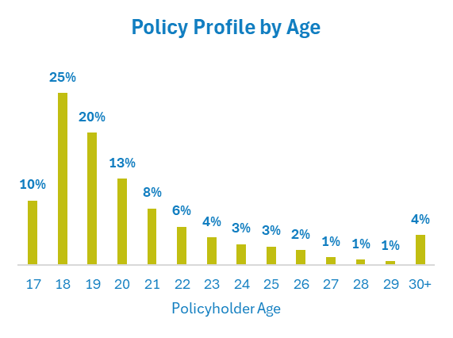
Being an insurance proposition targeted at young drivers, the profile had a significant age bias with 90% of policyholders being aged 25 or under.

Highly granular telematics data associated with over 1 billion miles of driving was available for customers in the policy dataset. Angelica Solutions were able to apply the HDD algorithms to generate the HDD Driver Score and its underlying components for each customer. This telemetry data was then merged with the policy and claims data for modelling.

The HDD Driver Score is an evolution of over 13 years of driving behaviour data modelling and analysis. It is focussed on behavioural factors that present the highest risk to loss ratio.

The HDD Driver Score is calculated using multiple Score Factors, each weighted based on their relative correlation with claims frequency and cost. The scores of each individual factor are summed to calculate a Driver Score out of 100 (100 representing a perfect score). Some key drivers of the score include speeding, harsh braking, harsh cornering and night time driving.

Angelica Solutions made use of Generalised Linear Models (GLMs) to assess the HDD Driver Score, whilst standardising for traditional non-telematics factors to ensure only the incremental value was assessed.

Insights
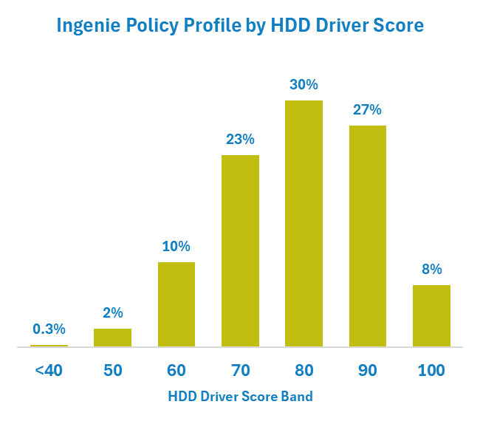
HDD Driver Score
Applying the HDD Driver Score algorithm to the Ingenie policies showed a spread of policies across the score bands. A GLM of fault claim frequency was built using only standard rating factors (as would be available to a non-telematics insurer).

When assessed against the HDD Driver Score, this model only predicted a modest difference in claim frequency across the score range: 7% frequency for the best driver scores vs 10% frequency for the worst.

When compared to the actual claims frequency, it is clear that the model substantially underestimates the real difference in claim frequency between the best and worst HDD Driver Scores. As a result there is a large residual, with the worst scoring drivers having a claim frequency more than 3 times higher than the non-telematics model prediction.

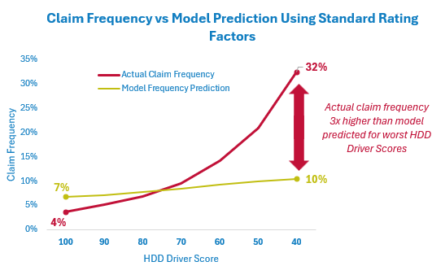
Loss Ratio Implications
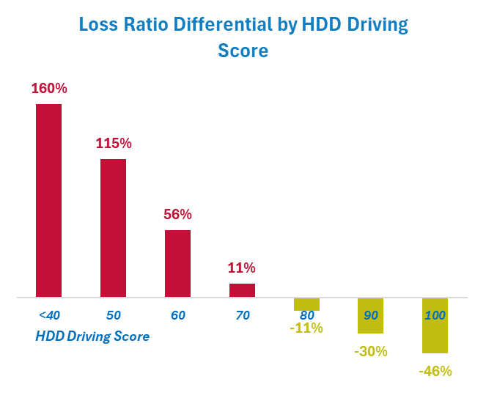
The inability to accurately understand driver behaviour when using pricing algorithms based on standard rating factors alone manifests itself in substantial loss ratio differentials across the HDD Driver Scores.

Using a non-telematics price shows that customers with the best HDD Driver Scores would have a loss ratio 46% better than the average, whilst those with the worst HDD Driver Scores experienced loss ratios exceeding 150% above the overall portfolio average.

HDD Driver Score Components
Analysis of underlying components of the HDD Driver Score again illustrates the value that is found in each element behind the score.

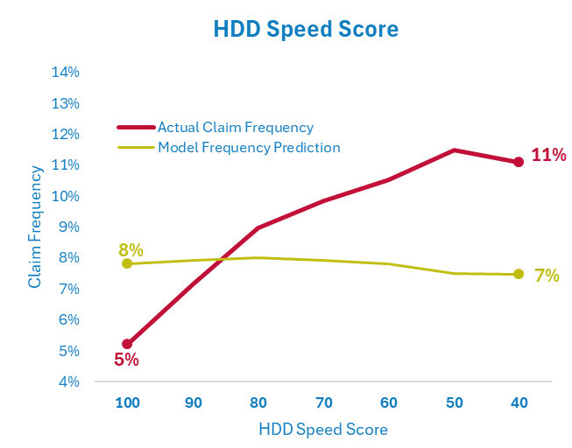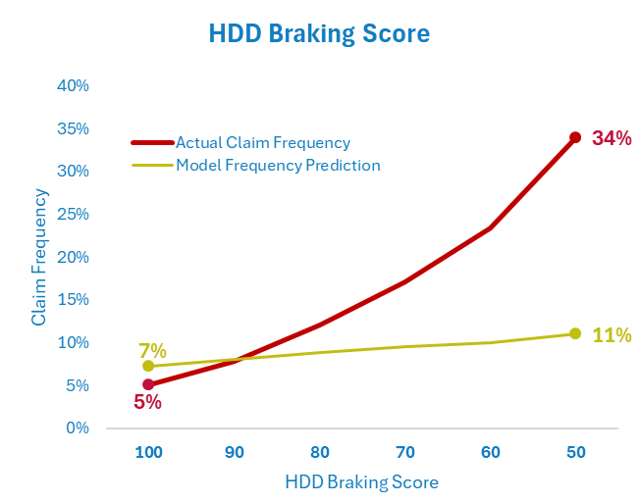

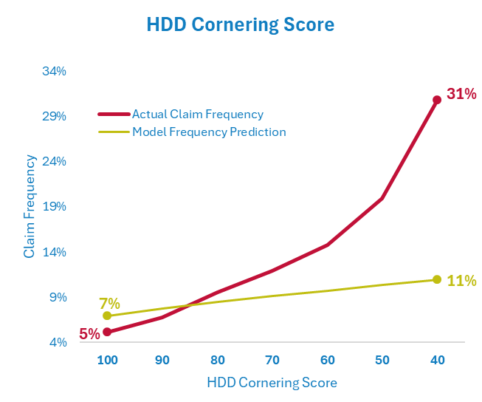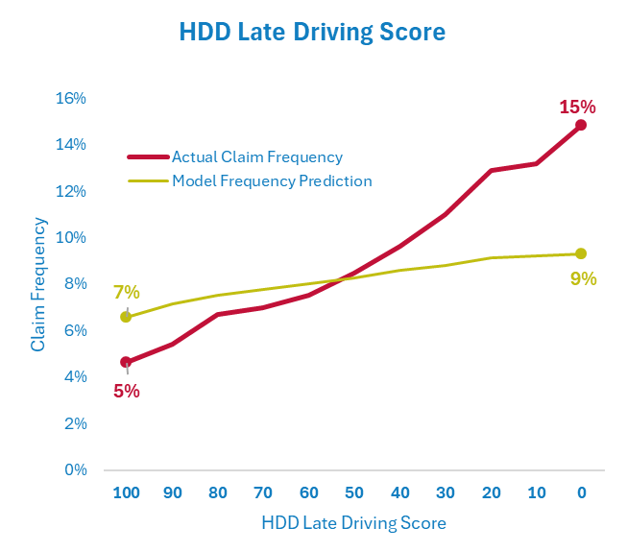
The model with only the standard rating factors is again unable to predict the difference in customer claim frequency across the component scores, proving the importance of these driving behaviours in understanding the riskiness of customers.

First 30 Days HDD Driver Score
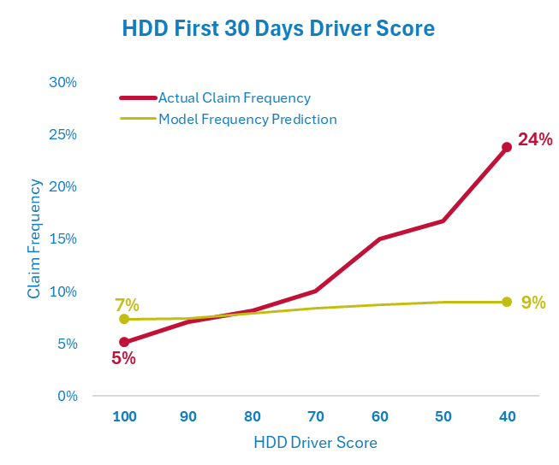
Angelica Solutions also assessed the predictiveness of the HDD Driver Score based on driving data from the first 30 days of a policy.

Despite such a small driving time period, the analysis showed that an HDD Driver Score after just 30 days provides a powerful predictor of the claim frequency for the overall policy term. This gives insurers the opportunity to start realising the benefits of the HDD Driver Score very soon after the policy starts.

Night Driving Large Loss Risk
The risk associated with night time driving is well known, however very little robust claims analysis exists as non-telematics insurers have no measure of the policy exposure to night time driving.
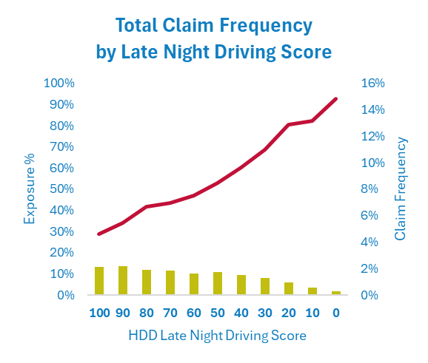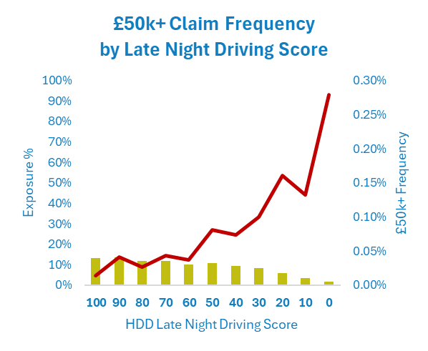
The HDD Late Night Driving Score provides this highly important insight into customer behaviour. The analysis shows that it correlates very strongly with both the overall claim frequency but also the frequency of larger losses (£50k+). Regular night time drivers are 17 times more likely to have a large loss than those that only drive in the daytime.

Business Benefits
As established in our analysis, the HDD Driver Score is highly predictive of insurance claims after only 30 days of driving data. This therefore provides a powerful tool that can be used to almost immediately start improving loss ratios.

Intervention in Year 1 - Cancellation
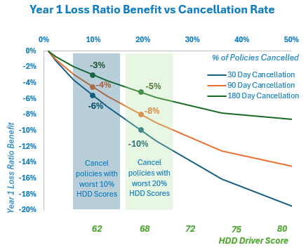
The simplest form of intervention would be to cancel policies that are exhibiting the poorest HDD Driver Scores.

This provides a highly targeted way to improve the year 1 account performance by removing the customers that will have the highest claim rates. This clearly requires compliance consideration and appropriate product design to ensure customers are aware of the consequences of their driving actions however, we have observed successful implementation where active communication is made with customers, both early warning of the consequences of their driving and clear explanations regarding the reasons where cancellation has been enforced.

We have modelled the impact of cancelling policies based on their HDD Driver Scores at 30, 90 or 180 days into the first policy year.

This modelling confirms the value of early intervention, where cancelling the policies with the worst 10% of HDD Driver Scores after 30 days would deliver a 6% overall loss ratio benefit in year 1 alone. Intervening on this 10% of policies at 30 days delivers twice the loss ratio benefit compared to mid-year at 180 days.

Intervention in Year 1 – Behaviour Change
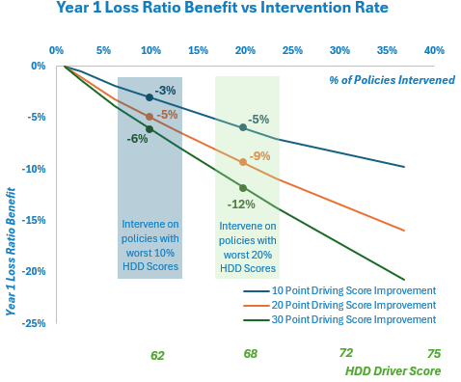
We also assessed the impact of intervention strategies to improve driving behaviour. We have again seen successful strategies where active communication to customers warning them of their poor driving behaviour, supported by the risk of cancellation or financial penalties if customers continue to drive poorly, delivers significant risk reduction and therefore loss ratio improvement.

The above chart shows the loss ratio benefit if an intervention at 30 days achieves differing levels of improvement in HDD Driver Scores for varying proportions of policies.
This illustrates that if a strategy intervenes on the 10% of policies with the worst HDD Driver Scores and achieves a 20 point HDD Driver Score improvement, this would deliver a 5% loss ratio benefit to the portfolio in the first year alone.

Renewal Pricing
An obvious use of the HDD Driver Score is for improved pricing accuracy at renewal. This gives both the opportunity to improve the loss ratio of drivers with poor HDD Driver Scores but will also improve the profile of retained customers, biasing the renewal portfolio towards better risks.

We have modelled the impact of implementing price increases for drivers with poor scores to reduce their loss ratios to be in line with the portfolio average. This has been balanced with price decreases for drivers with the best scores to reward good driving and improve the retention rate for these customers.
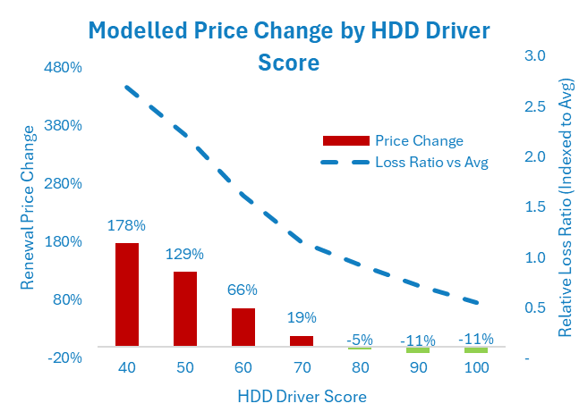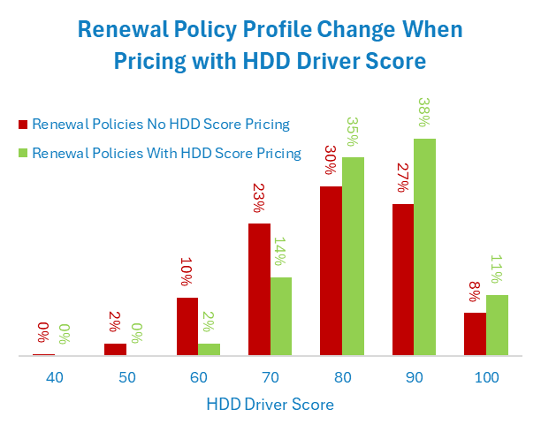
Assuming a price elasticity of 3 at renewal (reflecting the typical high price sensitivity at 1st renewal of a young driver profile), this theoretical price change maintains the same overall retention rate and delivers a 13% improvement in loss ratio for renewal business.

Due to the highly targeted nature of the price changes, it also improves the customer profile by HDD Driver Score, increasing the average score by 5 points.

Further Benefits

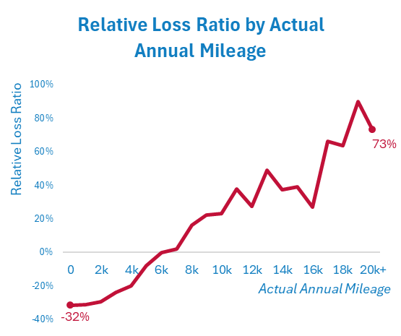
Telematics data provides many other potential applications not explicitly assessed by Angelica Solutions. For example, when looking at the actual annualised mileage as measured by the telematics boxes for the Ingenie dataset there is a very strong loss ratio trend present. This clearly demonstrates the power of knowing the real mileage covered by a customer, above and beyond that declared at the time of purchasing the policy. The HDD telematics solution alerts where policies appear to be exceeding their declared annual mileage, giving the insurers or brokers opportunity to collect additional premiums where excess mileage occurs.
Claims management is another area that can significantly benefit from telemetry data. In the UK market it is well established that early intervention is essential to manage repairs before the potential involvement of other third parties (insurers, accident management companies, credit hire companies etc). Delays in notification of claims to insurers and a lack of information about other parties involved in a claim are a major hinderance to claim management and subsequent failure of insurers to successfully intervene. HDD provides accident alerts to insurers, using crash detection algorithms. A key challenge historically with such crash detection has been a very high level of false alerts, adding significant cost to insurers unnecessarily contacting drivers and the subsequent annoyance for policyholders. Howden have successfully developed a sophisticated algorithm that detects c. 60% of motor insurance claims by analyzing driver behavior and telematics data, with a false positive rate of 1 in 2. This means that while the system accurately identifies a majority of genuine claims, it also flags some non-claims as potential incidents. By leveraging machine learning and real-time driving data, the algorithm enables proactive intervention and more efficient claims management that delivers significant value.
Telematics data can also provide valuable insight for tackling both policy and claims fraud. Detecting address fronting is an obvious benefit from the location data available. We have seen examples where 0.5% improvement in loss ratio has been obtained through detection of address fronting and subsequent collection of additional premiums to reflect the correct risk in place. The HDD proposition is able to flag to insurers where the location data shows there is a high risk of address fronting but is also sophisticated enough to remove false-alarms, thus removing the wasted effort and customer distress that results from false accusations. Data provided by Howden Driving Data showed that 0.5% of policies were detected with risk address fronting severe enough for policy cancellation.
Driving patterns can also provide insight into other potential types of misrepresentation such as the vehicle class of use (social domestic & pleasure, commuting, class 1 business use etc). The HDD propostion flags where driving patterns are not consistent with that declared helping insurers to identify incorrectly declared use. This has increased importance with the fast growing ‘gig economony’, where there is an increasing risk of drivers using private car products for business purposes.
Finally the data can be highly powerful for the detection of claims fraud. Knowing the location, speed and g-force before, during and after an incident is hugely advantageous for understanding and investigating the circumstances of a crash. There has been high profile examples of insurers identifying staged accidents, where for example the telemetry data has proven both parties involved in a claim to have known each other. There have also been examples where the data has shown that the incident has not occurred where it was declared and that the damage was actually created in a staged collision elsewhere.

Conclusion
The analysis shows that the HDD Driver Score is a powerful tool that can be applied to a variety of product structures to deliver significant value for pricing and underwriting. Experience shows it will hold significant value for claims management.
Recently there has been some questioning in the market about the future of telematics based products. We believe this is an important reminder of the huge benefits available from telemetry data, but only if the data is actively used. Developing the capability to process, analyse and make sense of the telemetry data in-house is highly challenging. This often becomes a huge task and a significant barrier to insurers actually using the data to manage policies; thus failing to realise the clear benefits known to be there.
The Howden Driving Data solution enables insurers to benefit from a data platform, established processes and algorithms that this exercise has now shown are proven to work. We see this as hugely beneficial, as it allows insurers to immediately focus on actively applying these insights and to realise the significant benefits of telematics based products.

March 2026

https://angelicasolutions.com/research/
Full Angelica Solutions and Howden Driving Data study included as an appendix to this document
https://www.judiciary.uk/prevention-of-future-death-reports/matilda-seccombe-and-harry-purcell-prevention-of-future-death-report/

