Professor Aditya Goenka, Professor of Economics at Department of Economics, Birmingham Business School, University of Birmingham – Written evidence UKFA0013

This submission argues that the UK fiscal framework has become excessively rigid, overly dependent on volatile five-year forecasts, and narrowly focused on gilt-market signalling. Drawing on the intellectual history of fiscal rules, international best practice, the structure of the UK rule set, the OBR’s modelling framework, and new empirical evidence, central points are:

The UK’s fiscal rules are unusually tight and structurally fragile
- Since 1997, the UK has introduced ten fiscal-rule regimes; nine since 2008. Frequent changes weaken credibility and reduce transparency.
- The current rule—requiring debt to fall in year five of the OBR forecast—is exceptionally sensitive to small revisions in economic assumptions.
- “Fiscal headroom” has become a central political indicator despite being highly volatile; its levels have remained historically low since 2022.
- The focus on stabilising gilt markets is not aligned with OECD guidance, which emphasises medium-term expenditure control and state-contingent flexibility.

Academic evidence shows that rigid rules can create instability

The academic literature highlights desirability of fiscal rules to counter discretion and uncertainty of fiscal policy, credibility of policy announcement, credibility of policy setting, and countering deficit bias.

However, tight, binding, state-invariant rules can generate self-fulfilling fluctuations.
- The UK’s framework exhibits the conditions under which this mechanism arises: tight constraints, no state contingency, and reliance on fixed assessment dates.

The OBR’s forecasting and dynamic scoring are not suitable for binding rules
- The OBR’s large macro-econometric model (MEMM) is not structural, relying heavily on judgement, and is based on the premise that past behaviour will remain invariant to policy changes.
- Dynamic scoring (introduced in 2023) is not robust enough to anchor statutory debt targets.
- When rules depend on a single point forecast five years ahead, forecast revisions drive policy, creating a forecast–policy feedback loop that heightens self-fulfilling volatility.

New empirical evidence

Fiscal-rule salience stabilises gilt yields but depresses real activity and consumer sentiment
- Media and political salience of fiscal rules and “headroom” has increased sharply since 2022, especially around Budgets, Autumn Statements, and OBR EFOs.
- This pattern is consistent with the self-fulfilling mechanism: the rule stabilises one margin (bond markets) at the cost of self-fulfilling greater uncertainty and weaker activity elsewhere.

Policy recommendations
- Replace the “debt falls in year five” rule with a medium-term debt anchor plus a multi-year expenditure rule, consistent with OECD best practice. Introduce state-contingent escape clauses with transparent triggers and independent oversight.
- Base assessments on ranges rather than point forecasts to reduce sensitivity to small revisions.
- Use dynamic scoring only for scenario analysis, not for rule compliance.
- Reduce reliance on “fiscal headroom” as a headline indicator.
- Enhance transparency around OBR judgement while preserving independence.
- Ensure coordination across HMT, OBR, DWP, HMRC, the DMO and the Bank to align fiscal rules with macroeconomic stabilisation, not gilt-market signalling.
The UK’s fiscal rules, in their current form, risk becoming a source of macroeconomic instability rather than a solution. A more flexible, state-contingent and expenditure-anchored framework would better support fiscal sustainability, credibility, and economic performance.
Background and theoretical underpinnings

The earliest theoretical justifications for strict, rule‑based macroeconomic policy is based on the premise that discretionary fiscal and monetary policy is prone to political manipulation and poor timing. Mechanical, state‑invariant rules, including a full‑employment balanced budget, automatic fiscal responses determined by fixed formulas, and a prohibition on discretionary borrowing will eliminate these effects and anchor expectations through transparent and automatic behaviour.

Policy announcements that are thought to be desirable ex-ante, may not be ex-post introducing an incentive to deviate from the pre-announced policies (“keeping to the Manifesto”). Rule based policy making is a way to eliminate this potential credibility problem. Subsequent research showed why governments may persistently run deficits even when they recognise the costs of high debt. This deficit bias arises in democratic societies due to incumbents seeking to constraint future government with different agendas. Fiscal rules and institutions are needed to counteract time‑inconsistent behaviour and strategic use of debt.

However, non-state contingent tightly binding fiscal rules themselves become destabilizing. Such rules can lead to self-fulfilling beliefs: as the rules become binding, beliefs about future actions such as increased taxes can reduce current economic activity. This necessitates increased taxes so that rules are not breached, i.e. the beliefs about future changes become self-fulfilling. These self-fulfilling beliefs are called “sunspots” as they are not fundamental uncertainty but just beliefs on which actions are coordinated. Normally, fiscal policy acts as an automatic stabilizer as the size of deficit is anti-cyclical, that is in an economic upswing, tax receipts go up and social welfare payments fall reducing size of deficit, and the reverse in a recession. With non-contingent, binding policy rules, it becomes destabilizing – in a recession, as tax receipts fall and social welfare payments increase, the reduction in the fiscal headroom implies that either taxes are increased or social welfare payments reduced both of which exacerbate the recession. This insight is directly relevant to the present UK framework, which combines tight constraints with limited flexibility.

Evolution of UK Fiscal Rules and the Current Framework

Since 1997 the United Kingdom has experienced a high degree of change in its fiscal framework. The early Labour Government adopted the “golden rule” (current budget balance over the economic cycle) and the “sustainable investment rule” (public sector net debt below 40 per cent of GDP). After the global financial crisis, successive governments replaced these with various rolling deficit and debt targets, including cyclically‑adjusted balance mandates and debt‑fall requirements over fixed horizons. In total, there have been ten distinct rule regimes since 1997, nine of them introduced after 2008. This frequency of change is unusually high by OECD standards and weakens the credibility and clarity of the system.

The current framework, set out in 2024, comprises some main rules. First, a stability rule requires the current budget to be in balance, or in surplus, by 2029–30. Secondly, an investment rule requires public sector net financial liabilities (PSNFL) to be falling as a share of GDP by 2029–30. Thirdly, expenditure on welfare is contained with a predetermined cap and margin. Compliance is assessed on a rolling basis using the OBR’s medium‑term forecasts rather than outturns, so the rules are binding on the basis of model‑based projections for a specific future year. The horizon for meeting budget balance (which is as a surplus or deficit within 0.5% of GDP rather than “be in surplus”).

Fiscal policy has also been shaped by the rising cost of servicing public debt. In 2024-2025 the Government spent £104.9 billion on debt interest, equivalent to approximately 8.2 per cent of total public expenditure. Official projections indicate that debt‑interest costs are likely to remain elevated over the medium term. This has increased the sensitivity of the fiscal position to movements in gilt yields.

The September 2022 “mini‑budget”, which contained large unfunded tax cuts and was not accompanied by an OBR forecast, triggered a sharp rise in gilt yields, a fall in sterling to historic lows against the US dollar, and an emergency Bank of England gilt‑purchase programme to stabilise liability‑driven investment (LDI) pension strategies. In the aftermath, fiscal rules came to be used explicitly as a signalling device to reassure gilt markets that fiscal policy would remain disciplined. While understandable, this has tilted the framework towards a narrow focus on debt‑market credibility rather than macroeconomic stabilisation and expenditure control.

International guidance from the OECD and IMF stresses several design principles for effective fiscal frameworks. These include: (i) a clear medium‑term fiscal anchor, typically expressed as a debt or balance objective; (ii) operational rules based on multi‑year expenditure ceilings under direct government control; (iii) explicit, state‑contingent escape clauses for large shocks; and (iv) avoidance of excessive reliance on single‑year point forecasts. By these benchmarks, the UK diverges in important respects. It lacks a formal, legislated multi‑year expenditure ceiling; it relies on a rolling requirement for PSNFL to be falling in a single target year; it has no fully codified escape clause; and compliance depends on OBR point forecasts rather than on ranges or multi‑year averages.

Because the key rules are assessed based on a single five‑year‑ahead forecast, small revisions in assumptions about growth, inflation, interest rates or energy prices can produce large changes in projected “headroom”. This structure generates volatility in political narratives and expectations about future tax and spending policy, especially at Budgets and Autumn Statements. It is precisely in such environments that the mechanism of belief‑driven fluctuations arising from rigid constraints can become relevant.

The OBR’s Forecasting Framework - Strengths and Limitations

The OBR uses a large macro‑econometric model, maintained jointly with HM Treasury, as one of the tools in producing its Economic and Fiscal Outlook (EFO).This model uses detailed estimated behavioural relationships based on past observations (reduced form modelling) rather than structural modelling which is based on the decision rules of economic agents – households, firms, etc. However, behavioural relationships are not invariant to policy changes as economic agents will change their behaviour if the environment in which they function changes. That is economic agents are not planets with invariant laws of behaviour. This limits the model’s suitability for rigorous policy evaluation and forecasting, especially for long-term forecasts which underpin compliance with fiscal rules as they do not consider the changing policy and economic landscape.

Since late 2023 the OBR has incorporated dynamic scoring into aspects of its analysis, modelling behavioural responses to certain tax and spending changes. While this represents a step towards a more comprehensive assessment of policy impacts, dynamic scoring in a macro‑econometric framework remains highly sensitive to specification choices and assumptions about how agents respond to policy. It is therefore best suited to scenario analysis and broad judgement rather than to determining compliance with binding statutory rules.

The deeper issue is that forecast‑based rules create a structural feedback loop: forecasts drive compliance assessments; assessments influence policy decisions; and policy decisions in turn affect the forecasts. When compliance hinges on a single five‑year‑ahead point estimate, this loop can amplify the effect of forecast revisions on the perceived need for fiscal tightening or loosening, or the feedback loop becomes self-fulfilling.

New Evidence - Fiscal‑Rule Salience, Market Stability and Real Activity

Since 2022 there has been a marked increase in the public and media salience of fiscal rules, debt targets and “fiscal headroom”. Peaks in salience coincide closely with key fiscal events: Budgets, Autumn Statements, OBR EFO releases, major rating‑agency announcements, and prominent reports by institutions such as the Institute for Fiscal Studies and the National Institute of Economic and Social Research. In practice, fiscal rules have become narrative anchors shaping how fiscal policy is reported and debated.

A constructed media‑based salience index and a range of high‑frequency indicators suggest a striking pattern. Periods of elevated fiscal‑rule salience are associated with in lower gilt‑yield abnormal returns (AR) and abnormal volatility (AV) since 2024, indicating that markets draw reassurance from the Government’s adherence to its current rules. 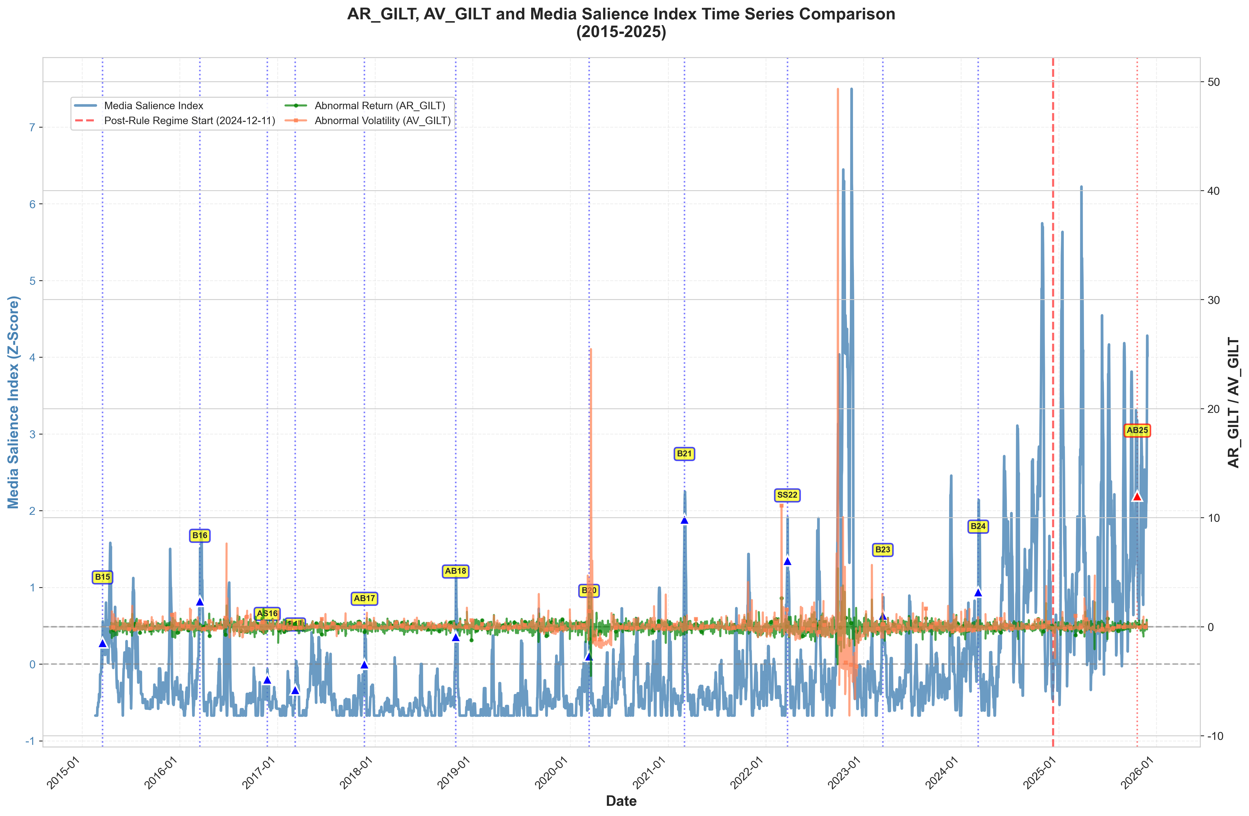
Figure 1: Time Series Evolution of Fiscal Rule Salience and Gilt Market Indicators (2015–2025)

Note: The blue line represents the Composite Media Salience Index (Z-score). The green and orange lines represent the Abnormal Returns (AR_GILT) and Abnormal Volatility (AV_GILT) of UK Gilts, respectively. Labels (e.g., B21, SS22) indicate key fiscal events such as Budgets and Spring Statements. The vertical dashed line marks the start of the current fiscal rule regime.

At the same time, higher salience is associated with weaker indicators of real activity, including retail sales volume and consumer confidence. While GDP remains statistically insignificant due to transmission lags, Business and Consumer Confidence, and Retail Sales shows a highly significant negative response. This indicates that the adverse impact of media salience is broad-based, affecting not just household sentiment but also corporate decision-making. Media salience acts like a coordinating device for consumers and business to anchor their expectations. It acts like sunspots.

One interpretation is that tight and highly salient rules stabilise gilt markets by convincing investors that fiscal policy will remain constrained, but that this expectation of constraint leads households and firms to reduce spending, hiring and investment. This is consistent with the theoretical insight that rigid fiscal rules can calm one margin of the system—debt markets—at the expense of greater fragility in the wider economy.

The evidence also indicates that media salience has a negative dynamic impact on retail sales with impact peaking after 2 months, and it acts like a stagflationary shock, i.e. real economic activity is dampened but inflation pressures remain unanchored.

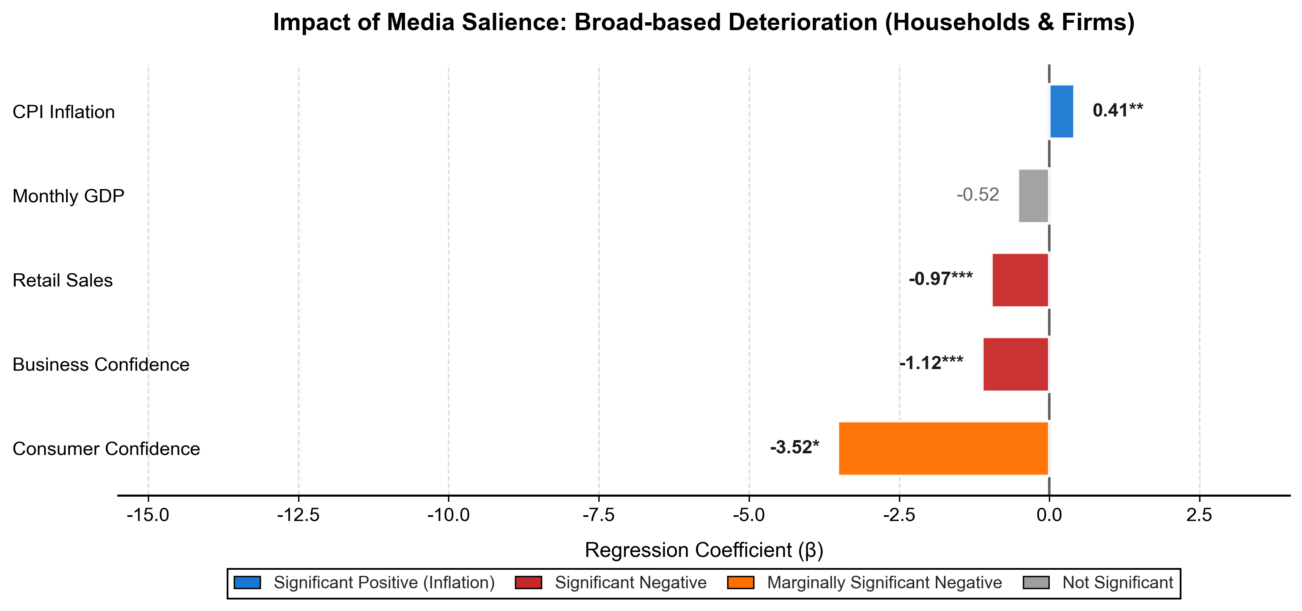
Figure 2: Estimated Impact of Media Salience on Real Economic Indicators (Multivariate Model)

Policy Recommendations
In light of the above, several reforms could bring the UK fiscal framework more closely into line with international best practice while preserving credibility:
• Replace the “PSNFL falling in year five” rule with a medium‑term debt anchor combined with a multi‑year expenditure ceiling under direct government control.
• Move from point‑estimate compliance tests to assessments based on forecast ranges or multi‑year averages, reducing the sensitivity of policy to small revisions.
• Introduce explicit, codified and state‑contingent escape clauses for large shocks, with clear triggers and independent oversight.
• Use dynamic scoring as a supplementary analytical tool rather than as the basis for statutory compliance.
• Reduce the prominence of “fiscal headroom” in political discourse and media reporting, focusing instead on broader measures of fiscal sustainability and investment.
• Use structural rather than reduced form modelling to anchor OBR forecasts, without undermining its operational independence.
• Strengthen the alignment of the UK framework with OECD and IMF principles of durability, countercyclicality and expenditure control. C

Conclusion

The UK’s fiscal framework is at a critical juncture. The combination of tight, forecast‑driven rules, heightened media and political salience, and a judgement‑heavy OBR modelling framework has created a system that risks generating the very instability it is intended to prevent. While the current rules have helped to reassure gilt markets in the aftermath of the September 2022 mini‑budget, this stabilisation has come at the cost of flexibility and macroeconomic responsiveness, particularly when fiscal headroom is narrow.
A modernised framework aligned with OECD and IMF best practice would rebalance the system. Moving towards a combination of a medium‑term debt anchor, credible expenditure ceilings, codified escape clauses and assessment based on forecast ranges rather than point targets would reduce volatility, improve policy stability and strengthen public understanding of the Government’s fiscal strategy. Fiscal rules should support sustainable growth and macroeconomic stability, not act as a source of unnecessary constraint or uncertainty.
Reforming the framework along these lines would ensure that fiscal rules continue to anchor expectations and maintain market confidence, while also allowing the flexibility needed to respond to shocks, support investment and promote a more resilient UK economy.

Appendix 1
1) Time coverage (2015–present)
Rationale: GDELT-based coverage and UK media digitization are substantially more usable and consistent after 2015.

2) Construction of Salience Index
Pre-defined keyword dictionary (exact terms)
1. Rule
Fiscal rule; fiscal framework; fiscal mandate; debt must be falling; balancing the current budget; borrowing rule; fiscal anchor; fiscal credibility.
2. Space
fiscal headroom; fiscal headspace; fiscal space; room for maneuver; buffer against the fiscal rules; close to the limits; up against the rules.
3. Adjustment
Tax rises; tax increases; stealth tax; tightening; consolidation; spending cuts; difficult decisions; tough choices
3) Data sources
Market / financial data
    - Yahoo Finance (as the primary market-data source).
Note: Bank of England series often rely on model-based constructs rather than purely market-traded measures, which may not fully capture real-time market volatility for my purpose.
News media data
- GDELT Project (GDELT 2.1; accessed via Google BigQuery)
Leetaru, K., & Schrodt, P. A. (2013). GDELT: Global Data on Events, Location, and Tone, 1979–2012. ISA Annual Convention. The GDELT Project. Dataset accessed via Google BigQuery on November 28, 2025. https://www.gdeltproject.org/
- Nexis Uni (LexisNexis) (full-text news database)
LexisNexis. (2025). Nexis Uni [Electronic database]. Retrieved November 28, 2025, from https://www.lexisnexis.com/
- The Guardian Open Platform (API)
The Guardian. (2025). Guardian Open Platform: UK News Article Corpus (2010–2025) [Data set]. Retrieved November 28, 2025, from https://open-platform.theguardian.com/
Economic Indicator Data
- DBnomics
DBnomics Team. (2025). DBnomics: The open economic data platform [Data set]. CEPREMAP. https://db.nomics.world/
- Definition of AR and AV
Gilt return where $P_{t}$ is the Gilt price at date t:
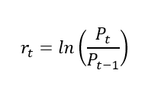
For the Abnormal Return and Abnormal Volatility calculation
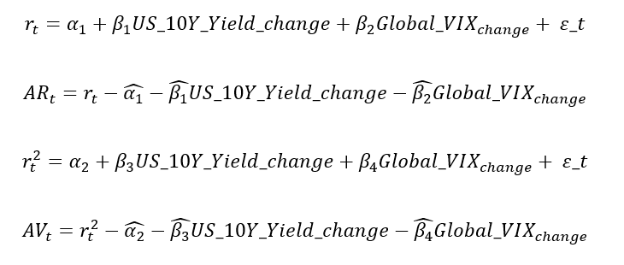
Impact of media salience on economy
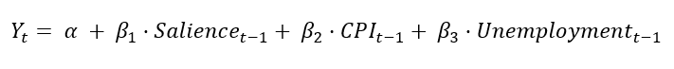
Robustness to specifications
Dependent Variable | (1) Baseline Model (Strict Lag Structure) | (2) Contemporaneous Model (Immediate Impact) | (3) Deep-Lag Controls (Robustness Check)
Retail Sales Volume (YoY Growth) | -0.97** | -1.05*** | -0.98***
 | (p=0.0019) | (p=0.0013) | (p=0.0002)
Consumer Confidence (Index Level) | -3.52* | -4.63*** | -4.31**
 | (p=0.0542) | (p=0.0006) | (p=0.0174)
Model Specification
Salience Timing | Lag (t−1) | Current (t) | Lag (t−1)
Control Timing | Lag (t−1) | Lag (t−1) & (t−2) | Deep Lag (t−2)
Controls Included | CPI, Unemployment | CPI, Unemployment | CPI, Unemployment

Appendix 2
Dynamic persistence of media salience
To examine the dynamic persistence of the media salience, we employ the Local Projections (LP) method.
Local Projections
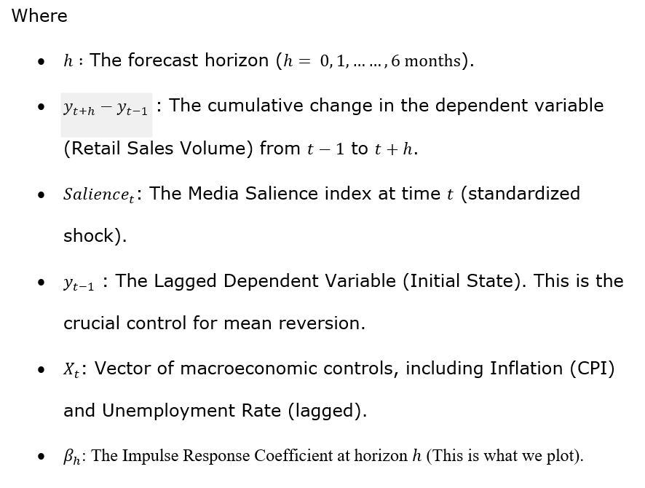
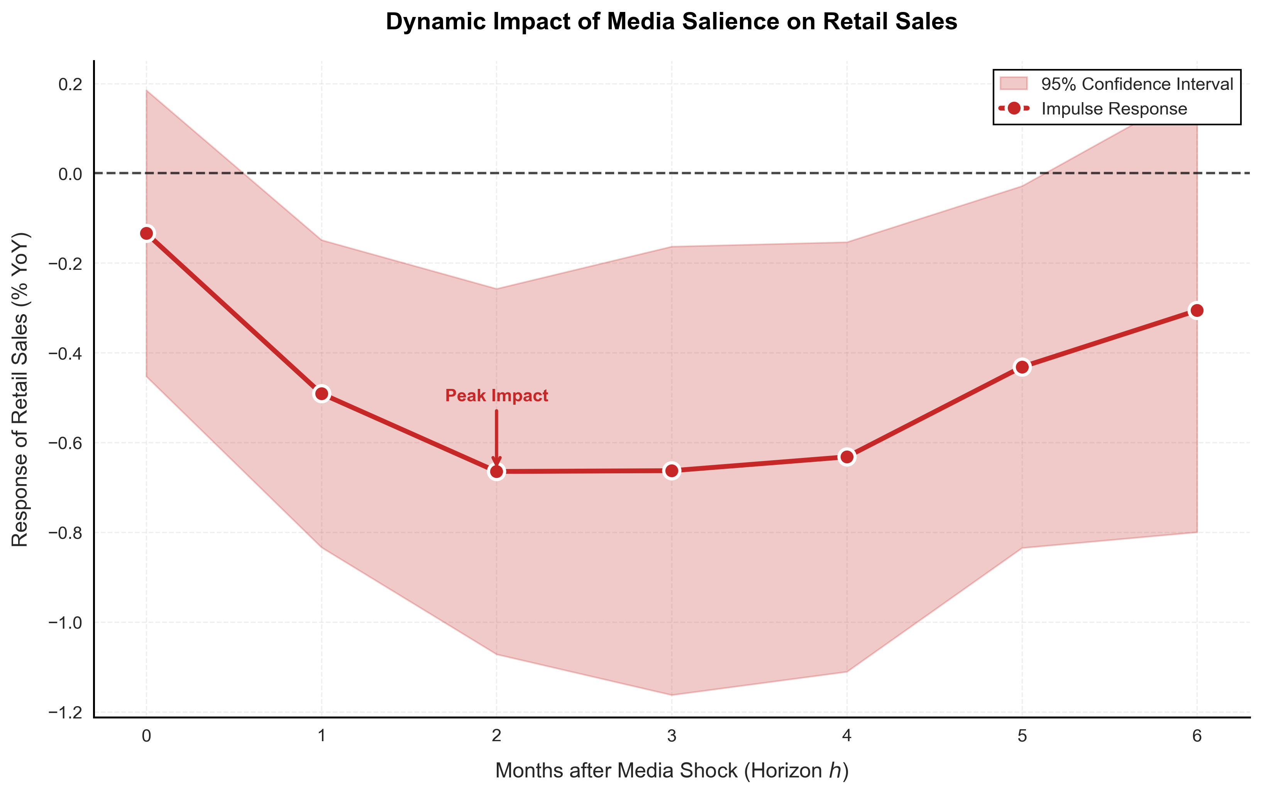
Figure 3: Dynamic Response of Retail Sales to Media Salience Shock (Robust Local Projections)

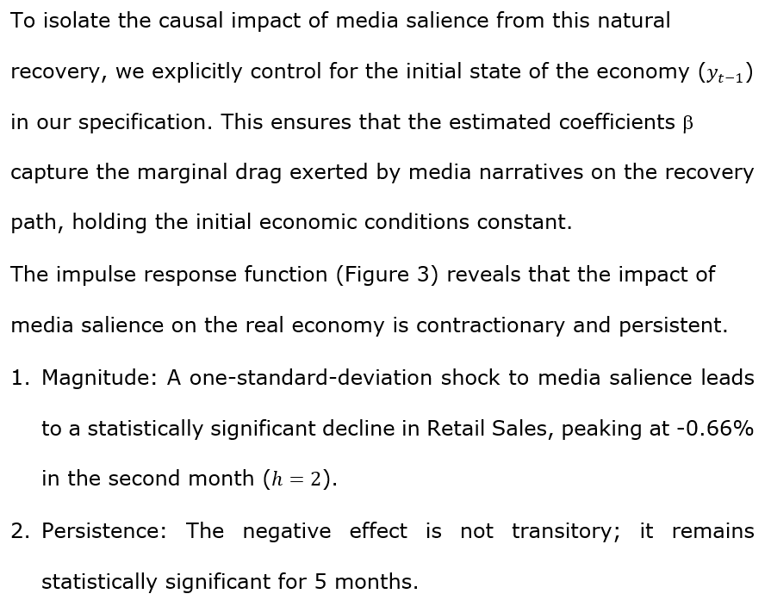
- The ‘Drag’ Effect: Since the model controls for the initial state, these negative coefficients imply that media salience acts as a headwind to recovery. Even if the economy attempts to recover from a trough, the ‘austerity narrative’ propagated by the media significantly dampens consumer spending power, effectively flattening the recovery curve. This confirms the hypothesis that while fiscal rules may satisfy bond markets, the associated media salience imposes a tangible medium-term cost on the real economy.
This is related to the decline in consumer confidence.

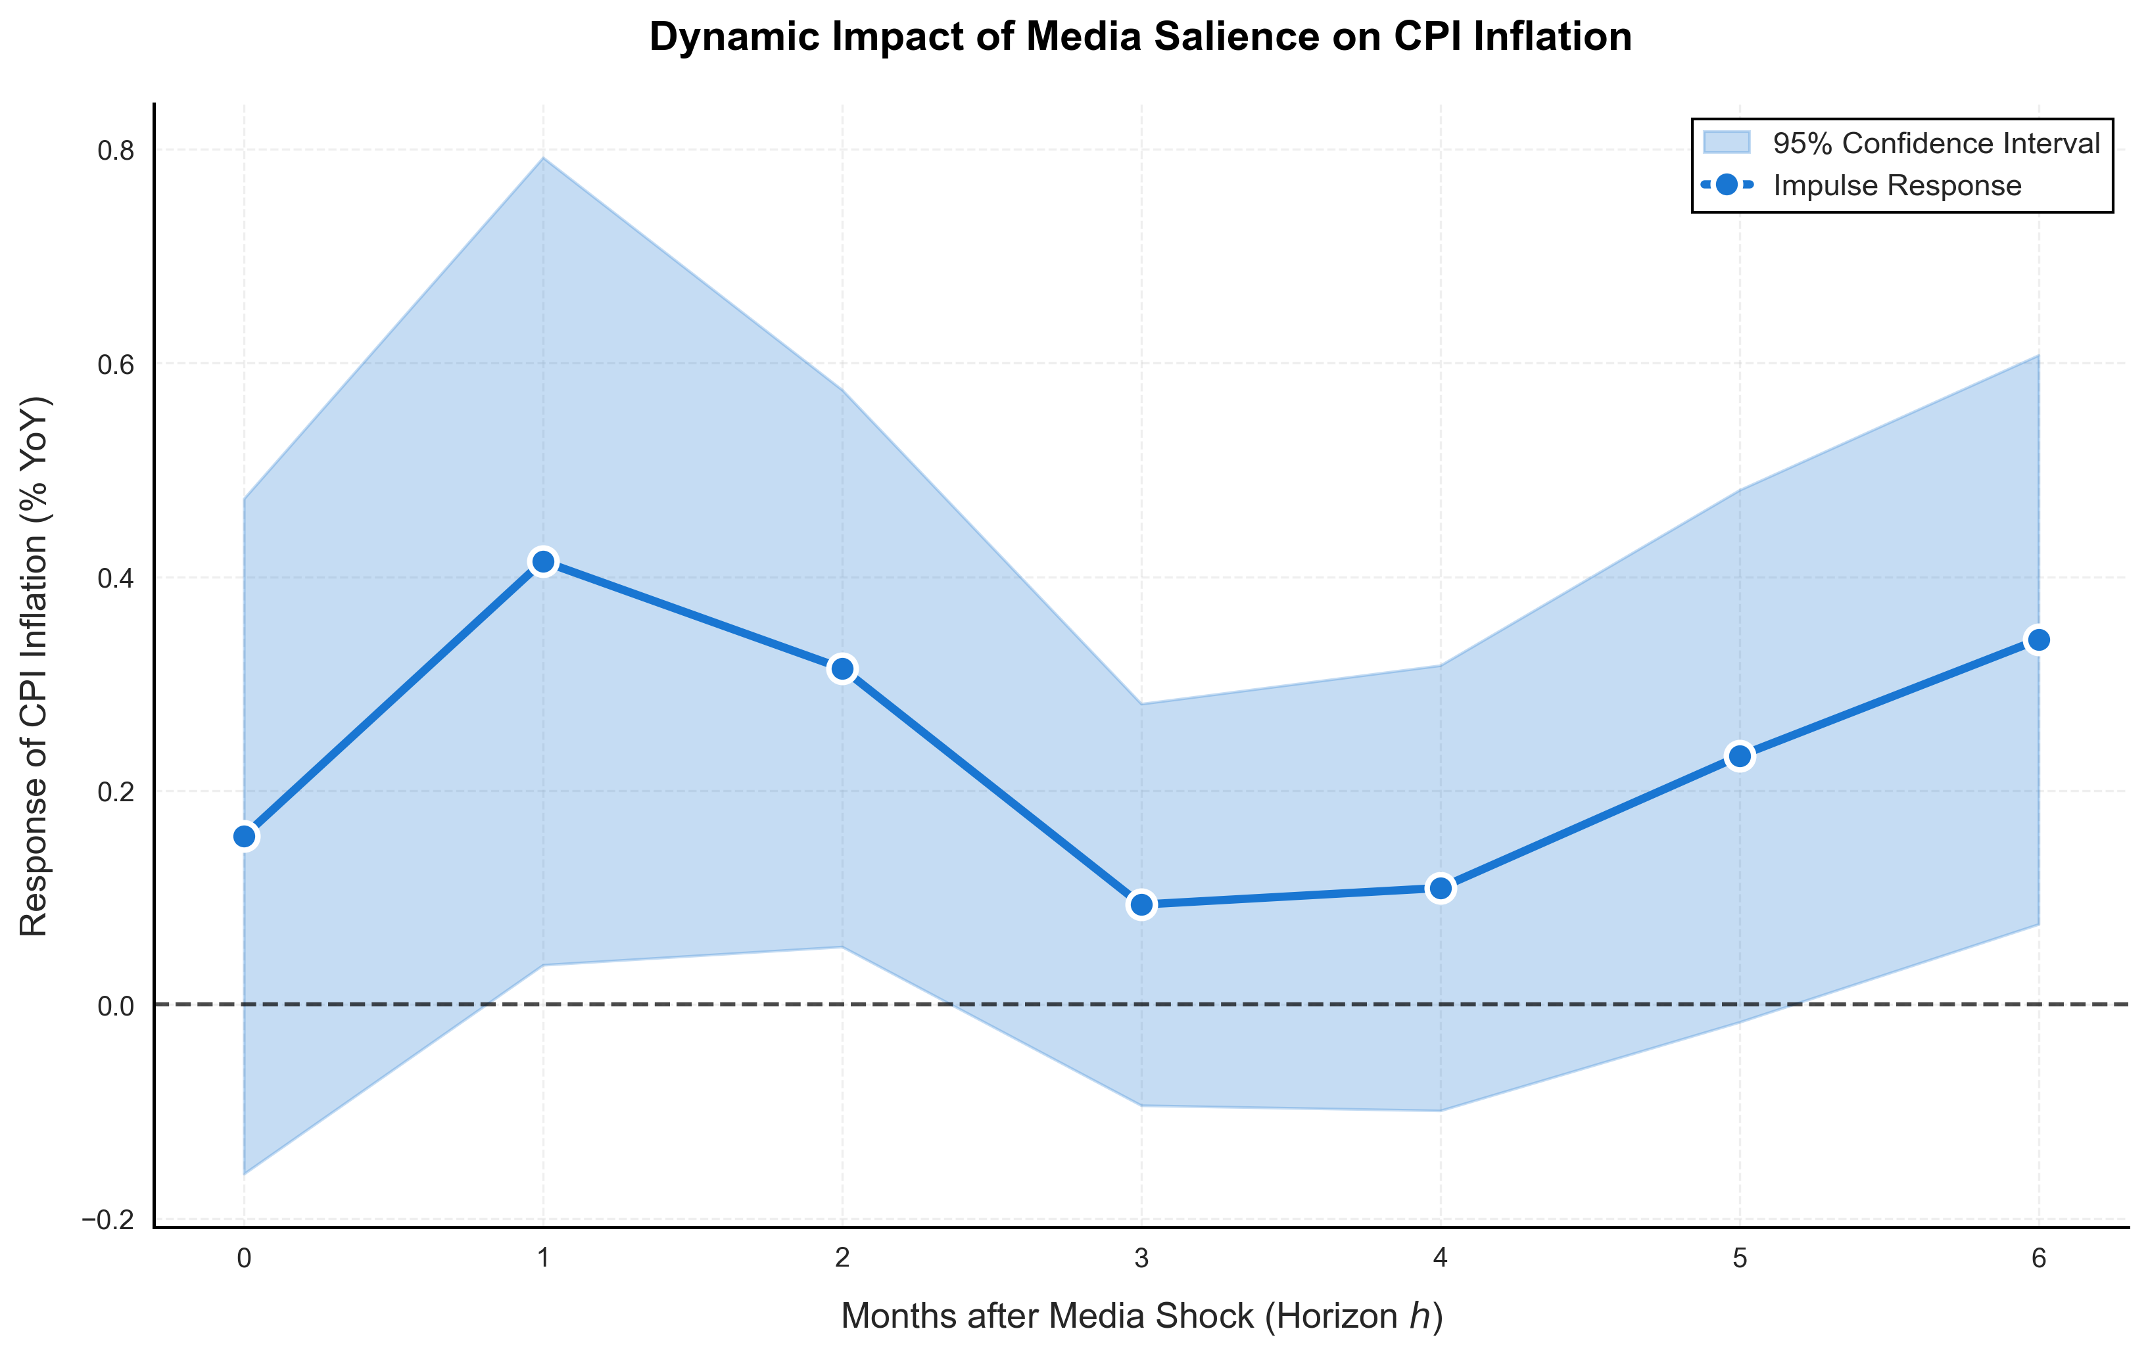
Figure 4: Dynamic Response of CPI Inflation to Media Salience Shock (Robust Local Projections)

Inflationary Pressure: Figure 4 shows that media salience shocks differ from standard demand shocks. Instead of lowering prices, high salience is associated with an immediate and significant surge in CPI Inflation.

These divergent dynamics—falling real activity coupled with rising prices—suggest that media salience regarding fiscal rules operates akin to a supply-side shock. It creates a ‘stagflationary’ trap where the real economy suffers contraction while inflationary pressures remain unanchored.
1 December 2025

Friedman, M. (1948). A Monetary and Fiscal Framework for Economic Stability. American Economic Review, 38(3), 245-260 https://www.jstor.org/stable/1810624
Kydland, F.E. and Prescott, E.C. (1977) Rules rather than discretion: The inconsistency of optimal plans, Journal of Political Economy, 85(3), 473-491 https://www.jstor.org/stable/1830193
Alesina, A. and Tabellini, G. (1990). A Positive Theory of Fiscal Deficits and Government Debt. Review of Economic Studies, 57(3), 403-414 https://www.jstor.org/stable/2298021, Persson, T. and Svensson, L.E.O. (1989). Why a Stubborn Conservative Would Run a Deficit: Policy with Time-Inconsistent Preferences. Quarterly Journal of Economics, 104(2), 325-345, jstor.org/stable/2937850
Goenka, A. (1994). Fiscal Rules and Extrinsic Uncertainty. Economic Theory, 4(3), 401-416 https://www.jstor.org/stable/25054772
Cass, David, and Karl Shell (1983) Do sunspots matter? Journal of political economy 91(2), 193-227. https://www.jstor.org/stable/pdf/1832054.pdf
HMT (2024) Charter for Budget Responsibility: Autumn 2024. https://www.gov.uk/government/publications/draft-charter-for-budget-responsibility-autumn-2024
Institute for Government (2024) Current UK fiscal rules. https://www.instituteforgovernment.org.uk/explainer/current-fiscal-rules
OBR (2025) Brief guide to the public finances, 3 April 2025. https://obr.uk/forecasts-in-depth/brief-guides-and-explainers/public-finances/
OECD (2015). Recommendation of the Council on Budgetary Governance, OECD Legal Instruments, OECD-LEGAL-0410, OECD, Paris, https://ppp.worldbank.org/sites/default/files/2022-04/Recommendation-of-the-Council-on-Budgetary-Governance.pdf
IMF (2009). Fiscal Rules—Anchoring Expectations for Sustainable Public Finances. IMF Policy Paper. https://www.imf.org/external/np/pp/eng/2009/121609.pdf
The Macroeconomic Model, Briefing Paper No. 5. https://obr.uk/docs/dlm_uploads/Final_Model_Documentation.pdf ; OBR–HMT (2025). Memorandum of Understanding on Macroeconomic Models. https://obr.uk/docs/dlm_uploads/MOU_between_OBR_and_HMT_for_macroeconomic_models_April_2025.pdf
Lucas Jr, R.E. (1976) Econometric policy evaluation: A critique. Carnegie-Rochester conference series on public policy, 1, 19-46 https://www.landsburg.org/LucasCritique.pdf
See Appendix 1.
See Appendix 2.
Jordà, Òscar. Estimation and inference of impulse responses by local projections. American economic review 95.1 (2005): 161-182. https://www.jstor.org/stable/4132675

