Written Evidence submitted by Lydia Leon at Nesta ( FWM0087)

Health & Social Care inquiry: Food and Weight Management
Nesta submission

About Nesta: The UK’s innovation agency for social good.
We design, test and scale solutions to society’s biggest problems.

One of Nesta’s three missions is to increase the average number of healthy years lived in the UK. Our ambition is to do this by halving the prevalence of obesity in the UK by 2030. We have chosen to focus on obesity, because it is one of the most common causes of preventable death and ill health in the UK.

Nesta plays a significant role in influencing health and food policy across the UK. Our CEO, Ravi Gurumurthy, was co-chair of the 10-year plan prevention working group, alongside the deputy chief medical officer, Jeanelle de Gruchy. Ravi is also a member of the Defra Food Strategy Advisory Board. Our mandatory health targets for large retailers policy proposal was a key component of the 10-year plan healthy food standard announcement. Alongside policy, we work with businesses such as Asda and Starbucks, to show that healthier practices can be commercially viable, and to reduce government concerns that could block progress on obesity.

This document is Nesta’s response to the call for evidence announced by the Health & Social Care Committee in July 2025.

For more information about Nesta’s work, please contact: thomas.bunting@nesta.org.uk

About Nesta: The UK’s innovation agency for social good. 1
Response summary 3
Nesta’s recommendations to the committee 4
Nesta’s relevant research 6
The case for action on obesity 8
The health and economic impacts of obesity in the UK 8
Tackling obesity is key to achieving government health ambitions 8
The public support action to tackle obesity 9
Why past obesity policies have failed and why changing the food environment is essential 10
Why previous political action to tackle obesity has failed: learning from former prime ministers and health secretaries 10
Only small changes are needed to halve the prevalence of obesity in the UK. 12
Comparing the cost and impact of obesity-reduction policies: Nesta’s Blueprint to halve obesity. 13
The 10-year plan: Healthy Food Standard 17
Mandatory targets for large food businesses 17
Expanding access to weight loss drugs. 22
The current delivery model presents a number of challenges for the effective delivery of GLP-1s 22

Response summary
- Alongside smoking, obesity is a leading cause of preventable death in our country.
- Reshaping the UK's food environment with population-wide policies is the most effective path to halving obesity.
- Nesta calculates that obesity could be cut in half in three years if the daily calorie intake of those with excess weight was reduced by ~8.5%, ~216 calories per person per day. This is a small, almost imperceptible change - a person’s calorie intake varies from day to day by more than this amount.
- In 2024, Nesta published a Blueprint to halve obesity in the UK, a toolkit that ranks the impact and cost of over 30 obesity-reduction policies, from food environment interventions, to weight loss drugs and weight management services.
- The Blueprint toolkit highlights that in a fiscally constrained environment, introducing regulation to shift incentives for big food businesses is the most effective and cost effective way to improve health and reduce the prevalence of obesity. Policies focussed on individual behaviour change such as education or public campaigns are ineffective.
- Nesta welcomes the government’s healthy food standard policy, announced as part of the 10-year plan, which draws on our proposal to introduce mandatory health targets for large supermarkets.
  - The government must now act swiftly to implement the policy within this parliament, ensuring its impact is not lost to delay or dilution of intent.
- Nesta’s Blueprint toolkit shows that there are several interventions that, when combined, could help the government halve obesity in the UK. New weight-loss drugs, GLP-1s, are a significant tool in this effort, but they are not a ‘silver bullet’.
  - A treatment-only strategy centered on these drugs would be prohibitively expensive for the government and would not address the root causes of obesity.
  - GLP-1s can be most impactful when they are provided to people with highest clinical need, and as part of a wider package of policies that prevent people from gaining weight in the first place.

Nesta is a member of the Obesity Health Alliance and supports their submission, which we recommend is considered alongside our own evidence.

Nesta’s recommendations to the committee
- The Committee should recognise the severe impact obesity and overweight has on the nation’s health, the NHS, and the UK economy.
- The Committee should acknowledge that despite decades of obesity policies centred on education and information provision, obesity rates have doubled in the last 30 years, showing these approaches are ineffective.
- The Committee should therefore endorse an approach to reducing obesity that reshapes the food environment. It should acknowledge that this is the most effective way to reduce obesity, narrow health inequalities, and meet the government’s target of halving the gap in healthy life expectancy.
- The Committee should acknowledge the pivotal role of the food industry in shaping the nation's diet and that mandatory policies are required to ensure businesses are part of the solution to reducing obesity. The Committee should also affirm that voluntary initiatives have been repeatedly tried and have proven insufficient to tackle the problem.
- The Committee should endorse the government’s obesity commitments in the 10-year health plan and press for their timely and full delivery, especially the healthy food standard announcement.
- The Committee should acknowledge that for the healthy food standard to be effective the government must:
  - Commit to set up mandatory reporting for larger food businesses and set a feasible and ambitious mandatory target for supermarkets within this Parliament.
  - Set up a penalty and enforcement regime that is a sufficient deterrent to drive corporate change.
- The Committee should recommend that there is no further delay to the HFSS advertising restrictions on TV and online, and that government should consider whether further restrictions to other media channels or unhealthy food brands - could deliver greater benefits.
  - The Committee should also note that this policy, first consulted on in 2019, remains unimplemented six years later and, in its current form, is likely to deliver less impact than originally intended. To achieve meaningful progress on obesity, future policies - such as the healthy food standard - must avoid this pattern by closing the gap between announcement and implementation, and between ambition and real-world impact.
- The Committee should recognise that whilst weight loss medication and weight management services play a key role in helping individuals with greatest clinical need to lose weight, they are most effective and financially sustainable when integrated within a wider prevention-led strategy that tackles the root cause of obesity - the food environment.
  - The Committee should welcome the roll out of weight loss drugs on the NHS but acknowledge that NICE’s 12 year timeline for full patient roll out fails to match the urgency of the obesity crisis.

Nesta’s relevant research
This response will draw on several of Nesta’s publications. We have listed some of the most relevant reports below. Further information on Nesta’s ongoing projects is available here.

Blueprint to halve obesity: This toolkit evaluates and compares over 30 different obesity-reduction policies based on their impact, cost, and strength of evidence.

Targeting the health of the nation: This proposal formed the basis of healthiness targets for supermarkets announced as part of the Government's healthy food standard.

Nourishing Britain: a political manual for improving the nation’s health: This report by Henry Dimbleby and Dr Dolly van Tulleken draws on interviews with former prime ministers and health secretaries to identify political and public obstacles to tackling obesity.

Modelling ways to improve our health: what would be required to halve obesity?: This analysis estimates the changes required to halve obesity prevalence in the UK.

Improving diets to halve obesity across the UK: This research calculates the average per person calorie intake across Great Britain (GB). It is used to show what small changes to the food we buy are needed to reduce obesity prevalence by 50%.

The economic and productivity costs of obesity and excess weight in the UK: Nesta commissioned Frontier Economics to quantify the economic cost of these conditions and the potential economic gains from addressing them.

Taking action on obesity: what do the public think?: This research with More in Common explores public opinion on obesity and the action required to tackle it. The project surveyed around 6,000 adults across GB and ran six focus groups in England in spring 2025.

What will it take to halve the gap in healthy life expectancy (HLE)?: This analysis identifies which conditions are the biggest drivers of the gap in healthy life expectancy between the richest and poorest regions.

Building a clear picture of obesity rates in minoritised ethnic groups: This analysis explores how to better estimate obesity rates using updated NICE BMI thresholds.

Why has it become so hard to eat healthily?: A report outlining how the food that surrounds us has become less healthy over time

UPF and HFSS: different labels, same foods: This report assesses the overlap between foods categorised as HFSS and UPF.

The case for action on obesity
This section outlines the significant health and economic impacts of obesity, how tackling obesity relates to the Government’s current health ambitions, and public support for government action. This section will help the Committee answer questions 1, 2.1, and 3.

The health and economic impacts of obesity in the UK
UK obesity rates have doubled since 1991.
- Currently, an estimated 29% of all adults in England are obese, and 64% are living with excess weight (overweight or obesity).
- Obesity is a population-wide issue, but inequalities are stark: prevalence stands at 22% in the least deprived areas and rises to 36% in the most deprived.

A healthy population is the foundation of a strong economy and a sustainable NHS.
- Nesta commissioned Frontier Economics to quantify the economic cost and financial impact of excess weight.
- This report estimated the total UK economic impact of excess weight at £126 billion in 2025, a figure that encompasses costs to the NHS, social care, lost productivity, and welfare. This cost is projected to rise to £150 billion by 2035.
- Excess weight costs approximately £31 billion in annual productivity losses, driven by increased unemployment (£12.1bn), presenteeism (reduced productivity at work, £9.7bn), and absenteeism (increased sick days, £8.3bn).
- The NHS (across the UK) spends £9.3 billion annually on treating obesity-related ill health and £1 billion on providing formal social care.

The drivers of obesity are complex, but changing the food environment - how food is promoted, advertised, and accessed - is critical to achieving impact. Nesta modelling estimates that obesity could be cut in half in three years if the daily calorie intake of those with excess weight (obesity and overweight) was reduced by 8.5%. This equates to removing around 216 calories from the daily intake of people who are overweight or obese. This is a small, almost imperceptible change, a person’s calorie intake varies naturally from day to day by more than this amount.

Tackling obesity is key to achieving government health ambitions
The UK government has identified a shift "from sickness to prevention" as one of three major objectives for its cross-government health mission, noting that a greater focus on prevention is vital for the long-term viability of the NHS. The government has specifically committed to two key objectives for this mission that can only be achieved with significant obesity reductions:
- Halving the gap in healthy life expectancy between the richest and poorest regions in England.
- Creating the healthiest generation of children ever.

Nesta analysis has found that tackling obesity is key to halving the healthy life expectancy (HLE) gap. HLE is the number of years people can expect to live in good health, calculated by combining overall life expectancy with self-reported health (how people describe their own health when asked). We found:
- Every common condition (prevalence > 5% in the population) is more prevalent among the most deprived communities (see figure 1).
- There is a nearly seven-year difference in healthy life expectancy between England's regions. This gap is even more stark between local areas in a region, with an 18-year difference between areas like Wokingham and Blackpool.
- The government cannot achieve its HLE ambition without tackling obesity and musculoskeletal (MSK) conditions. These two issues are the biggest drivers of poor self-reported health, a key component of HLE.

Figure 1: Prevalence of common conditions in the most vs. least deprived areas
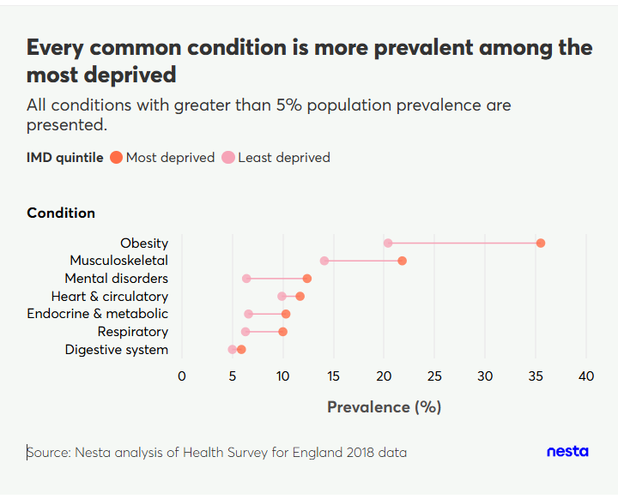

The public support action to tackle obesity
In the past year, Nesta’s polling with More in Common and Opinium has found public support for action on obesity:
- 42% of people believe the government should make tackling obesity an important or top priority.
- The Opinium poll revealed clear public support for government intervention to make food healthier. Every policy proposed in the survey had more people supporting it than opposing it.
- 54% cite the strain on the NHS as the primary reason for action.
- 78% recognise that supermarkets have a significant influence over their diets.
- 63% think supermarkets have the influence to help reduce obesity.
- 59% support the idea of health targets for supermarkets.
- 67% of those surveyed wanted to lose weight and, on average, people wanted to lose 9.2kg.

Why past obesity policies have failed and why changing the food environment is essential
Past policies, focused on individual behavior change, failed to impact the prevalence of obesity. This section provides first-hand accounts from prime ministers and health secretaries on why taking action on obesity is a political challenge; presents evidence for the small changes needed across the population to achieve significant reductions in obesity; and introduces Nesta’s Blueprint toolkit to compare the effectiveness of different obesity-reduction policies. This section will help the Committee answer questions 1 and 2.

Both academic evidence and real-world experience show that policies focussed on individual behavioural change (such as media campaigns, information provision, or education in schools) have not reduced obesity rates. To make a meaningful impact, we need policies that reshape the food environment - much as tobacco legislation reshaped our relationship with smoking - by regulating how food is promoted, advertised, priced and accessed, and by shifting business incentives towards health. A recent Nesta report outlines how changes to the food environment over recent decades have made it progressively harder to eat healthily.

The focus to date on voluntary policies has failed to deliver the level of change needed to improve the nation’s health. For example, the voluntary Public Health England reformulation programme aimed to see 20% reductions in sugar across a variety of food categories; whilst there was some reformulation, the total tonnes of sugar sold increased by 7%. By contrast, the Soft Drinks Industry Levy (SDIL) achieved a 46% reduction in sugar in drinks within its scope.

Why previous political action to tackle obesity has failed: learning from former prime ministers and health secretaries

In 2024, Henry Dimbleby and Dr Dolly van Tulleken published "Nourishing Britain: a political manual for improving the nation’s health," a report providing practical advice for politicians on addressing obesity. The report, created for Nesta and Impact on Urban Health, is based on interviews with three former prime ministers, one deputy prime minister, ten former health secretaries and six other former and current politicians. All those interviewed overwhelmingly support more government intervention to tackle rates of obesity, drawing on their personal experience in government.

Interviewees identified four major political obstacles to tackling diet-related ill health:
- Attempts to influence what people eat were attacked by libertarians in Westminster and derided in the media as interfering, nanny statist or joyless - although the fear of this was generally worse than the reality.
- Governments face a conflict of interest in their relationship with industry, oscillating between champion and regulator. Attempts to legislate are often stymied by industry lobbying and fears about the impact on business.
- The obesity crisis has overwhelmed us gradually. As a result, it has never received the necessary focus and energy given so many other pressing issues competing for attention in the 24-hour news cycle.
- Responsibility for the food system sits across multiple government departments, making it harder to create the collaborative momentum needed to drive through change.

Despite these significant obstacles, none of the politicians interviewed for this report were at all defeatist. On the contrary, they were brimming with optimism, ideas and advice for today’s generation of politicians.

Quotes from former prime ministers on the causes and severe impacts of rising obesity rates:
- “[We] can directly see the causal link between the unhealthy food environment that has grown with the rapidly increasing rates of obesity that we see in young children, teens and adults.” Sir Tony Blair
- “If you had to rank issues Britain faces, chronic disease is right up there - and obesity is a significant driver of so many of our biggest killers.” - Lord David Cameron
- “There's no doubt at all that people’s life expectancy has been greatly shortened by obesity.” - Boris Johnson

Reflections on barriers to political action whilst in office:
- “When we introduced stricter regulations on the advertising of unhealthy foods to children - the food industry were strongly opposed at the time, arguing that it would impact profits, harm the economy and infringe their commercial freedoms - but we did it anyway because it was the right thing to do.” Sir Tony Blair
- “When I first instructed TfL to bring these plans forward, there was concern that it would impact on our advertising revenue and that companies would completely stop advertising on the TfL estate. But one of the most successful things about the ad ban, from my perspective, is that this did not happen.” Sir Sadiq Khan
- “There’s been a tendency to try and focus on more voluntary arrangements, which by definition don’t really have much teeth.” Sir Sajid Javid

You can access the full transcripts from the interviews here.

Only small changes are needed to halve the prevalence of obesity in the UK.
Previous research from Nesta has shown that a reduction of just 8.5% in the daily calorie intake of those living with excess weight, the equivalent of around 216 calories per person per day or a 500ml bottle of cola, could halve the prevalence of obesity.

We have since analysed dietary habits using a representative sample of food purchases in Great Britain. Key findings from this work were:

- Daily calories purchased per person at the population level are much higher than in previous national surveys, and we are still likely underestimating true consumption.
Our analysis shows that Britons purchase on average ~2,730 calories per day (not including alcohol purchased for consumption outside of the home and not accounting for food waste).

- We get the majority of our calories from supermarkets, making them critical partners in shifting our food environment.
Our analysis estimates that on average, we get ~2,390 (88%) of our daily calories from food and drink prepared and consumed in the home (in-home) and 95% of these calories are from the largest 11 retailers. The remaining ~340 (12%) of our daily calories come from food cooked or prepared out-of-home (OOH). This is considerably lower than the 25% figure often cited in the literature.

- Relatively minor changes are required to reduce the calories in a weekly shopping basket by 8.5%.
Based on our analysis, we’ve created examples of what the weekly shop of a typical person looks like when eating ~2,730 calories per day (or 19,110 calories per week). We modelled that a 8.5% overall calorie reduction is achievable by making small changes to just 10 out of 28 products. These changes could be achieved either through sales shifts (facilitated through interventions such as price promotions, advertising, product placement and availability changes), reformulation, or portion size reduction. Many of the changes are relatively small (see figure 2) - either unlikely to be noticed at all by a consumer, or unlikely to represent a significant change in their weekly shop.

Figure 2: Visual representation of what an 8.5% reduction in calories in the average shopping basket looks like (Top: before, Bottom: after, swaps include switching from a crispy chicken & bacon wrap to grilled chicken and bacon wrap)

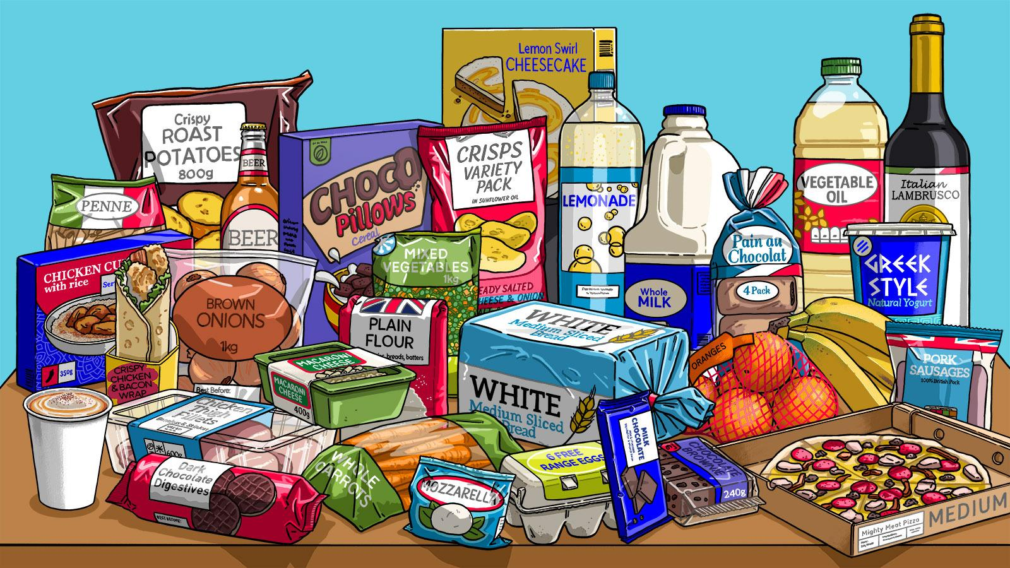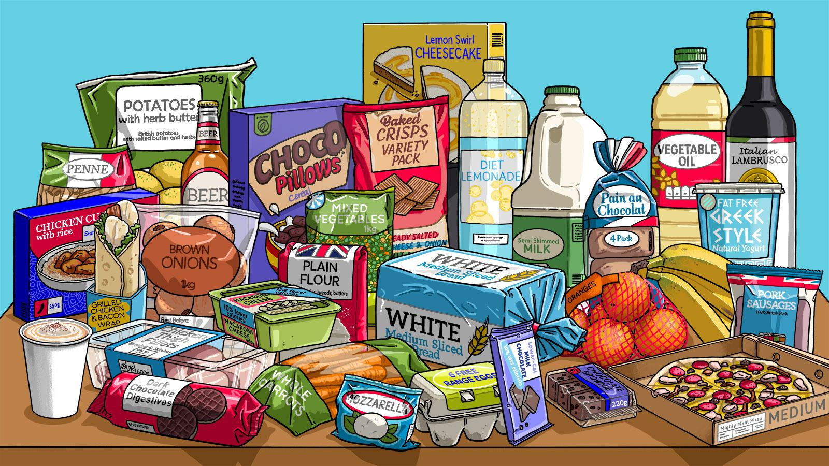

- Similar changes can be applied to the weekly shop of people in lower income groups, with an 8.5% reduction in calories still being reached.
This highlights that changes to the healthiness of products does not need to make them more expensive for those who can least afford it.

Comparing the cost and impact of obesity-reduction policies: Nesta’s Blueprint to halve obesity.
Until recently, there was no easy way to compare the impact and costs of different obesity-reduction policies, limiting the ability of governments to pursue the most effective obesity reduction strategies. This has resulted in a lack of understanding of what works to tackle obesity and the implementation of low-impact policies that fail to meet the scale of the challenge. To fill this gap, Nesta has collaborated with academic experts to build the Blueprint to halve obesity: a toolkit that evaluates over 30 obesity-reduction policies and helps policy makers design effective obesity reduction strategies.

The Blueprint is the result of a two-year collaboration with academic experts working across obesity, health and the food system. It is the most comprehensive impact and costing assessment of obesity policies to date (see technical appendix for detailed methodology).

We ranked policies according to the following:

- Impact
- Strength of evidence
- Cost to governments
- Benefits to society

What did we find?
At Nesta, our ambition is to halve national obesity rates, a goal we think is both urgent and achievable. Our analysis shows that there are several feasible and cost-effective routes to realise this goal. Some will require deeper pockets, and others greater political will.

To illustrate how the toolkit could be used by policymakers designing an obesity reduction strategy, we have estimated the total cost and impact of four potential policy packages, two of which get us to our target of halving obesity (see graph below for the impact and cost of each policy package). You can see what policies are included in each package here. The packages are:

- Tax, regulation and treatment: this is an option that would be high impact and low cost for governments. While this is a package we would endorse, mandating a new tax on food will require significant political will that may be unlikely within the current context.

- Treatment only: this package would extend access to recently approved weight loss drugs to 3 million people living with obesity (compared to ~150,000 in packages 1 and 4). While a highly effective option for those already living with obesity, this package has a lower impact than packages 1 and 4 as it will not address obesity in children nor the need for preventive action. This treatment-only approach will also be prohibitively expensive at around £42 billion over five years.

- Education, exercise and services: this package is relatively low cost and includes many well-known policies that have been the repeated focus of governments to date (e.g. education in schools or active transport), but these policies would not have sufficient impact on obesity rates, despite being beneficial for other goals.

- Prevention and treatment: this achieves the same impact as package 1 at a lower financial and political cost. This package includes regulations to shift food business incentives towards healthier sales, restrictions on the marketing of unhealthy products, and the expansion of access to weight loss drugs. We think this package strikes the best balance between impact, low costs to governments and feasibility within the current political context.

Impact vs. cost of the four policy packages
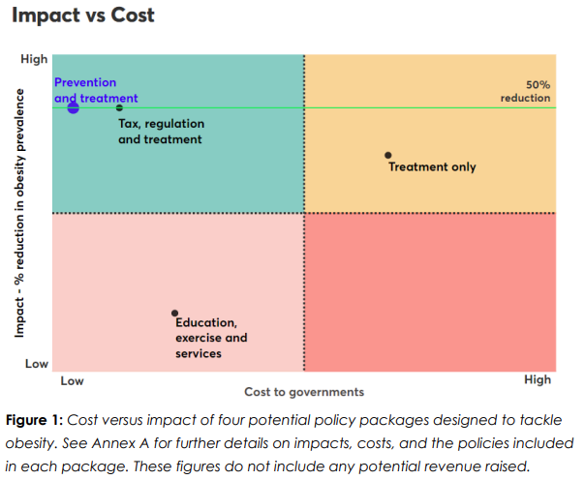

Packages 1 and 4 result in around a 50% reduction in obesity by 2030, both of which are low-cost policy options that are focused on reshaping the food environment. In contrast, the ‘treatment only’ strategy is prohibitively expensive for a lower overall impact. Furthermore, policy packages centered on altering individual behavior through education and exercise have a minimal impact and are insufficient to address the scale of the crisis.

We believe the prevention and treatment package is the most politically palatable and economically viable route to halving obesity within a single term of government. Within this package, the policy with by far the greatest impact is our proposal for health targets for supermarkets - a key component of the government’s healthy food standard. This policy shows we can achieve the scale of impact required, even without taxes, as long as there is sufficient incentive for big business (in this case a fine if businesses fail to meet the target) to prioritise health.

The 10-year plan: healthy food standard
The Government’s healthy food standard for large food businesses, including supermarkets, will introduce mandatory healthy food sales reporting and set new mandatory targets on the average healthiness of sales. This represents a significant shift in UK government obesity policy, focusing on the food environment and mandatory measures. If implemented effectively, this policy could greatly reduce national obesity rates. Robust, swift, and effective implementation is crucial to prevent delay or dilution. This section details the policy and outlines key implementation steps, helping the Committee answer question 2.

Mandatory targets for large food businesses
The commitment to mandatory reporting across all large food businesses builds on years of work across health and food civil society organisations. Reported data will be used to set mandatory health targets for all food businesses, including supermarkets. This idea draws on Nesta’s health targets for supermarkets policy. Setting mandatory targets across a supermarket's whole portfolio of products offers a practical roadmap to reduce obesity without hurting the pockets of retailers or consumers. While the policy announcement implies future application of targets to all large food businesses, supermarkets are currently the most suitable and practical starting point, given their consistent business models, existing use of the NPM (nutrient profiling model) metric under current legislation (e.g. HFSS end of aisles restrictions), and strong data reporting capabilities.

The health target should be set at a level that should be achievable for business, while driving meaningful improvements in national health. According to Nesta's modelling, if the healthiness target is set at a level similar to today's best-performing supermarkets, it could reduce obesity prevalence by around a fifth over time. To meet this goal, businesses can use a variety of existing strategies, including targeted promotions, product reformulation, and adjusting in-store placement. For example, they might tweak sandwich recipes to contain less fat, or give more shelf space to lower-sugar cereals. Nesta’s analysis highlights that only a series of small, imperceptible changes are needed to an average basket to meet their recommended target.

This policy is designed to support a shift the supermarket sector is already embracing. While most major supermarkets have set voluntary health targets, this mandate will level the playing field, enabling them to pursue health goals more ambitiously without risking a competitive disadvantage. Furthermore, an independent economic assessment, commissioned by Nesta and conducted by a former Senior Director of the Competition and Markets Authority (CMA), concluded the policy should have a minimal financial impact on businesses and consumers. Due to the small nature of changes required to hit the target for many retailers and the intense price competition within the retail sector, any additional cost to businesses is expected to be negligible and consumers should not face extra costs.

Public support for this initiative is both strong and resilient. In a June 2025 poll by More in Common, three in five people (59%) agreed that health targets for supermarkets are a good idea. This support grew to 69% when the policy was framed positively and, crucially, a majority still approved even when presented with negative messaging, indicating the policy's robustness against potential negative framing and criticism.

Setting targets for supermarkets could be a vital part of the solution for driving a generational shift in the nation's health. As the major link between food producers and consumers, large supermarket chains hold considerable power and influence over the whole food system. They've been vocal in their support for customer health - now is their chance to lead the way. If everyone - food retailers, government, the NHS and individuals - plays their part, we can turn the tide on obesity and offer our children a better, healthier future.

Targets for out-of-home?
To maximise public health impact, the government should implement mandatory targets across all large food businesses on separate timelines, starting immediately with supermarkets. This priority is based on a significant difference in potential outcomes. Our modelling shows targeting retailers could reduce obesity prevalence by ~20% in three years - compared to just ~2.5% for the out-of-home (OOH) sector - because supermarkets account for over 80% of calories consumed. The path forward for supermarkets is clear and the groundwork is in place, so we recommend expediting these targets without delay.

While extending targets to OOH businesses is an important goal, critical policy questions about the best metrics and implementation methods remain unanswered. Progress is currently blocked by a lack of commercial sales data from these businesses. Therefore, the government should mandate the reporting of this data, building on proposals from the Food and Data Transparency Partnership (FDTP). This will provide the evidence needed to design effective OOH targets in the future without slowing the immediate and substantial health gains waiting to be made in the retail sector.

To ensure swift and effective implementation of the healthy food standard, we recommend the following:

- The government must commit to set up mandatory reporting and set a specific mandatory target for supermarkets within this Parliament

Delay is the main risk facing this policy - either as a result of pressure from industry, legislative hold-ups, or competing political priorities. While we recognise that industry engagement is essential, prolonged debate or uncertainty could dilute the impact of this opportunity. To ensure this opportunity is not lost to delay, the government must work to ensure the mandatory targets are legislated and enforced before the end of this Parliament. We recommend this timeline:

- Introduce legislation within 12 months that establishes in law the necessary powers, such as ability to collect data and set a mandatory target with suitable enforcement mechanisms, with the aim for it to come into force at the earliest opportunity.
- Inform business as early as possible on the timeline for implementation of the policy to provide certainty and so they can begin to prepare. Begin consultation or engagement with industry - whether formal or informal - as soon as possible. Ask business to start to comply voluntarily from the earliest opportunity.

The government must choose a body to oversee the enforcement of the healthy food standard. Nesta recommended that this should be the Food Standards Agency (FSA). The FSA currently provides enforcement for other elements of the food system concerning public health, particularly in food safety and standards. Enforcing mandatory targets would require an expansion of FSA’s existing statutory powers.

- The government must agree a penalty and enforcement regime that is a sufficient deterrent to drive corporate change

It is for the government to decide what level of ambition this target is set at. However, for the target to be effective, straightforward, and minimise the burden on business, the government should mandate a single, headline metric.
- Recommended metric: the government should use a sales-weighted average Nutrient Profile Model (NPM) score. The government outlined in the 10-year plan that they wish to update the NPM model, a decision we welcome. The healthy food standard reporting framework should be future-proofed to enable updates as nutritional science develops. The legislation should allow for changes to the model in the future and set review points.
- Proposed target: Using the 2004/5 NPM, the supermarket sector’s 2021 average converted NPM score on health was 67 out of 100.If a supermarket target was set at or around the level of the current best performing supermarket, NPM = 69, this could lead to a reduction in obesity by around one fifth.
- Achievability and flexibility: A target of 69 is similar to the score of the current best-performing supermarket. However, DHSC should consider different levels at which the target could be set, including a more ambitious target or a less ambitious one that could be enforced more quickly.
- Penalty: An effective enforcement framework requires a credible penalty for non-compliance. The Groceries Code Adjudicator's power to fine retailers up to 1% of their UK turnover provides a clear precedent for granting a regulator statutory power to impose substantial fines. The government must therefore designate an enforcement body and determine the appropriate fine level.

- The government must put in place a strong data reporting system that enables oversight of the policy’s impact, including on health inequalities and industry implementation.

While we support mandatory data reporting for all food businesses - enabling wide-ranging policy development and assessment of health inequalities - our focus at Nesta has been on a critical first step: identifying the metrics required to enable effective targets for large supermarkets.

Since mandatory healthy sales reporting and the mandatory healthiness target must be in place by the end of this parliament, consensus on the primary metrics must be established quickly. The approach must be pragmatic and potentially iterative. Supermarkets should be able to provide NPM and its constituent parts now.

Minimum metrics required to administer health targets would be:
- Sales-weighted average NPM score (SWA NPM, headline metric)
- % sales from HFSS products
- Sales-weighted average energy per product - required to expand targets to out-of-home.

Alongside this, mandating companies to report the constituent parts of the NPM (saturated fat, sugar, protein, fibre, etc) would enable a more granular analysis of public health challenges and allow for the development of more targeted and effective policy interventions.

As recommended in the Eating Better report, sales-weighted average NPM should be based on volume sales (tonnage), which is the gold standard for reporting and the most accurate measure of the composition of people’s shopping baskets.

Data should also be disaggregated by the lowest possible geographical area, or by store, to enable comparisons between populations with different socioeconomic makeup. This will be an important tool to check that policies do not exacerbate existing inequalities in the healthiness of food sold across the country.

While Nesta welcomes the government’s commitment to the healthy food standard, we recognise that this policy alone is not sufficient to “end the obesity epidemic”, the government’s stated aim in the 10-year health plan. We call on the Committee to urge the government to deliver on its other outstanding commitments to create a healthier food environment. It is vital that the government robustly implements the upcoming restrictions on TV and online advertising, and delivers on the promises in the 10-year health plan such as to uplift the Soft Drinks Industry Levy and expansion of access to weight loss medications on the NHS.

Expanding access to weight loss drugs.
New weight-loss medications such as GLP-1s represent a major medical breakthrough, but they are not a silver bullet. As part of Nesta’s Blueprint to halve obesity, we analysed different scenarios for their rollout. Our analysis shows that if weight loss drugs were to be rolled out to 3 million people living with obesity each year, the prevalence of obesity would reduce by 41% but it would cost an unfeasible £42 billion over five years. The Blueprint highlights that the use of weight loss drugs is most impactful and cost-effective when combined with measures that prevent obesity in the first place.

GLP-1s are already helping people with obesity, particularly those with high BMI or co-morbidities. They can deliver meaningful health benefits, but a treatment only approach would be prohibitively expensive and would fail to address the root causes of obesity.

A prevention-first approach therefore remains essential. System-wide interventions - such as healthiness targets for supermarkets - are needed to reshape the food environment, prevent obesity, and deliver long-term benefits for society. Within this wider strategy, GLP-1s provide an important additional tool, and Nesta’s recommended prevention and treatment policy package proposes targeted rollout to those with the greatest clinical need alongside robust prevention policies.

Provision and funding for weight-loss medications, however, remain limited. NICE approved Tirzepatide for NHS use in 2024, but rollout is being phased over up to 12 years, with only around 220,000 patients expected to gain access in the first three years before expansion is reviewed. This pace is not sufficient given the scale of the challenge, and stronger action is needed to ensure equitable access for those most in need.

The current delivery model presents a number of challenges for the effective delivery of GLP-1s

- Demand outstrips public supply

Under current NICE guidelines, there are more than three million people eligible for NHS England GLP-1 treatments for obesity, but the number of people that are issued NHS prescriptions each month for GLP-1s for obesity is estimated to be in the low thousands. The NHS pathway is clinically intensive with multiple appointments delivered by a multidisciplinary team. Weight management pathways typically include regular touchpoints with GPs, diet and exercise professionals and psychologists. Semaglutide (Wegovy) is delivered through Tier 3 weight management services, while Tirzepatide (Mounjaro) has been approved for delivery in primary care with a tiered implementation plan seeking to deliver the medicine to 220,000 people in the first three years (of the 3.4 million eligible).

- The cost of private purchase is prohibitive and may be driving inequalities in access

Limited capacity on the NHS pathway means the majority of people who access GLP-1s for obesity do so privately, at a cost of approximately £200 per month - with Mounjaro expected to rise to £330 a month on 1st September 2025. This cost is expected to be prohibitive to some of the eligible population, creating inequalities in access and potentially exacerbating existing health inequalities. A December 2024 Ipsos survey found that one in five British people would be likely to access GLP-1s for weight management on the NHS (if available), while one in ten would be likely to pay for them privately (at £180-£220 per month). The cost to privately purchase GLP-1s is expected to reduce in approximately the next decade, after patents expire.

- Sustaining weight loss after treatment ends.

The roll out of GLP-1s must acknowledge a primary challenge which is that individuals regain weight after treatment. For policies in Nesta’s Blueprint, we used trial data to estimate the amount of weight regained (estimated at two-thirds of initial weight loss) in the year following end of treatment. This means that individuals who were taken off the drugs after their two-year treatment period regained two-thirds of their lost body weight in the following year. We don’t have information on their body weight trajectory beyond the third year. Publicly provided services around GLP-1s should work to ensure that weight loss can be sustained after treatment ends.

For more information on the impact of expanding access to weight loss drugs, please check Nesta's Blueprint to halve obesity.

See Nesta report “Improving diets to halve obesity across Britain” for breakdown of every change made to the basket.
Analysis of additional policies will be added to the Blueprint in the coming months. The impact of each obesity-reduction policy on child obesity rates will also be added to the Blueprint in the coming months.
All package information is up to date as of the 28th of August. We are continuously updating our toolkit to integrate new evidence. Please check https://blueprint.nesta.org.uk/ for the most up-to-date version of the toolkit.

