Community-led energy: a proven pathway for universal electrification
Call for Evidence - Aid for community-led energy
Kevin Johnstone (IIED) and Frank Bergh (NRECA International)

The International Institute for Environment and Development (IIED) and NRECA International are pleased make this joint submission to the UK Parliament’s Call for Evidence under the topic “Aid for community-led energy”. Our experience in energy access across the globe shows the enormous socio-economic and environmental benefits that “community-led energy” offers, particularly in rural communities in the Global South.

Executive summary
Historically, community-led energy has been the main pathway to achieve universal electrification within nation-states around the globe. It has been largely supported by public sector programs and international development assistance. However, over the past three decades, community-led models have become lost in the modern electrification discourse, which has focused almost exclusively on private sector delivery for reaching so-called “last mile” communities and a myopic focus on delivering “profitable” systems—when energy systems have been historically and continue to be subsidised. Yet, localised control and benefits have proven to be a powerful formula for deploying energy systems, particularly to places where private sector delivery models have not been able to reach.
Indeed, IIED’s, NRECA’s, and many others’ experiences across geographies and time show that at the very least, community-led energy should be utilised as a proven and indispensable model, alongside other more experimental and private sector-led models. Moreover, with the correct mix of support from important donors like the UK government, community-led energy can bring unique benefits such as community autonomy, retaining and reinvesting profits within local economies, while offering a genuine pathway towards a just transition.
There is a huge opportunity in aligning the UK’s existing domestic strategy on community-led energy with its strategy for international development assistance. The UK’s recent commitment of £20 million for domestic community-led energy, its ambitious clean power by 2030 plan, the Great British Energy initiative, the Local Power Plan, and other initiatives could all be linked and synergised into its ODA budget, resulting in the UK government at the forefront of a bold vision for a just energy transition around the world, with communities driving it.
What is community energy
Community energy – also referred to as “local energy communities” or “renewable energy communities” – refers to locally based, small-scale renewable energy projects that are set up, owned by, and in service of different types of communities, from neighbourhoods and cooperatives to nonprofits and small businesses.
Walker and Devine-Wright (2008) explore various interpretations of community energy in their study, and identified two main elements, which remain relevant and important for distinguishing between energy systems that are community-led and energy systems that are merely in proximity to community:
- Process - who is designing, implementing, managing, and owning the energy system
- Outcomes - who reaps the social and economic benefits derived from the energy system.
There are further questions such as how much control, who bears the risks associated with unanticipated and undesirable outcomes, and how equitably benefits are distributed within the community, among others. However, this initial framing allows us to differentiate and explore community energy further. Today, community energy programs and initiatives provide reliable, affordable and renewable energy to communities around the world.

The cooperative model: A social and economic advantage
There are variations of community energy, which offer different degrees of control and outcomes for communities depending on the contextual need. While there is no ‘one-size-fits-all’ model, one specific model has been widely successful: the Rural Electric Cooperative (REC). Indeed, it has been widely practiced in the Global South since the 1960s, with the creation of USAID being the impetus for this movement.
RECs are people-centred enterprises that are owned, controlled and run by and for their members to receive services that benefit each other, or achieve common goals. Cooperatives are democratically managed by the 'one member, one vote' rule. Members share equal voting rights regardless of the amount of capital they put into the enterprise.

In1844 the Rochdale Pioneers founded the modern cooperative movement in Lancashire, England, to provide an affordable alternative to poor-quality and adulterated food and provisions, using any surplus to benefit the community. Since then, the cooperative movement has flourished, extending across the globe and encompassing all sectors of economy. The UK has its own storied history of community energy, with the Baywind Energy Co-op and Isle of Eigg being prominent modern examples, among others.

Today there are three million cooperatives around the world³, and all are based on values of self-help, self-responsibility, democracy, equality, equity, and solidarity. The International Cooperative Alliance (ICA) is the global steward of the Statement on the Cooperative Identity – the values and principles of the cooperative movement. In a similar vein, the principles for locally led adaptation, an initiative that IIED co-developed, offers similar ideals coming from the climate adaptation space, but also emphasize a need to address structural inequalities faced by different groups experiencing marginalisation. Integrating climate considerations among others will be critical to the sustainability of modern cooperatives.

A community-owned solution to power poverty: electric cooperatives
Rural electric cooperatives are private utilities owned by their customers and operated as sustainable businesses. Each cooperative member owns an equal share in the business regardless of their connection type or how much electricity they purchase. Rural electric cooperatives are typically established:
- When access to electricity is recognized as imperative to improving the quality of life for a given community; and/or
- As an alternative to private or public service providers who may be unwilling or unable to invest in dispersed electricity service; and
- Where and when community members agree to collaborate at a sufficient scale to obtain services that would otherwise be unavailable to them.
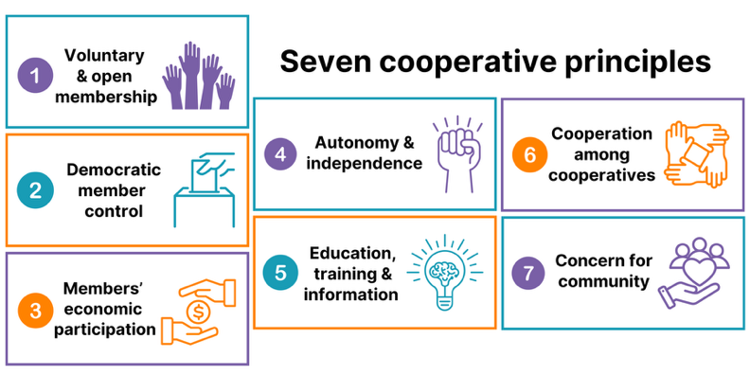
Like all cooperative businesses, the rural electric cooperative model is rooted in the Seven Cooperative Principles (See Figure 1). When successful, rural electric cooperatives can be the building blocks for autonomy, independence, self-reliance and democracy in the communities where they operate.
Figure 1 Seven Cooperative Principles

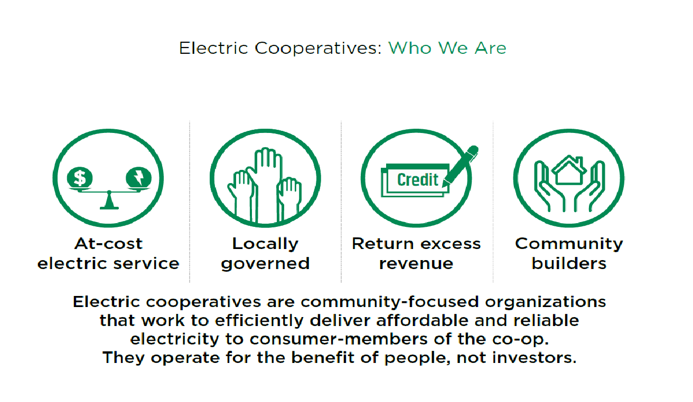
Figure 2 highlights that as a member-owned power distribution utility, rural electric cooperatives are not profit oriented and reinvest any excess revenue back into their service infrastructure. After a period of years determined by the bylaws, excess revenues are then returned to members through capital credits.
Figure 2 Cooperative Advantage

Community engagement is critical for the success of an electric cooperative. Ensuring the lasting viability and delivering on the promise of decentralized power distribution systems begins with a holistic co-design with the community. It is critical to understand the characteristics and needs of the population it serves and ensure that the system can meet their differentiated priorities. This means getting buy-in from different stakeholder groups within the community, determining what they can afford to pay for power, investigating with them opportunities for generating more income with electricity, and more.

Success stories: Electric cooperatives empower people
Historically, community energy models have been a successful approach to expand electricity access, particularly in rural and hard-to-reach areas. For instance, in the US, after the private sector refused to expand into rural areas, the American government streamlined a programme of support for community-owned electric cooperatives in the 1930s, and rapidly expanded access nationally (Barnes, ESMAP 2007). Today, these rural electric cooperatives serve approximately 42 million Americans, including 92% of “persistent poverty” counties, and own over 40% of the distribution lines (by mileage) in the USA.

In 1962, NRECA International was established when the National Rural Electric Cooperative Association (NRECA) and the newly established U.S. Agency for International Development (USAID) signed an inaugural grant for technical assistance for cooperative development. This began NRECA’s overseas involvement to share lessons learned in the electrification of the rural United States with the Global South around the world.

In the EU, the 1970s oil crisis and antinuclear movements helped catalyse the formation of various community energy models to achieve localised energy independence. Notably, UK cooperatives were not primarily responsible for energy access or rural electrification, yet they offered community ownership of decentralised renewable energy systems for decarbonization and democratization of power supply. Berka (2017) argues they emerged in the UK because of failures of commercial and government electric initiatives to tackle issues of environmental degradation as well as basic community distrust of those initiatives.

In the 1970s to 1990s, the public sector, via national utilities around the world, largely administered rural electrification. And since the 1960s, electric cooperatives thrived with public grants and concessional debt and widely practiced in the Global South.

Madriz-Vargas et al (2018)⁸ argues that experience from Panama, Nicaragua, and Costa Rica shows that energy cooperatives, when appropriately supported, can tackle several challenges that hinder electrification:
- Lack of utility interest and investment
- Barriers relating to social integration and acceptance of RE technologies
- Limited end-user education and after-sales servicing
- Lack of local maintenance capabilities

Though not the only successful community energy model, rural electric cooperatives have had a significant impact on eradicating poverty and economic growth in Asia and Latin America. This continues to be a model to expand electricity access today, particularly in sub-Saharan Africa, yet RECs are often overlooked.

In Bangladesh, the government established the Rural Electrification Board (BREB) in 1977, and several electric cooperative pilot projects were launched to help increase access to electricity in the country’s rural areas. With funding from the USAID, NRECA International played a key role in implementing this program. In 1980 about 13,000 people living in the rural areas had access to electricity. By the end of that year, 13 local electric co-ops or PBS (Palli Bidyut Samities) were established. Today, 80 PBSes serve more than 100 million people across the country, and the average annual income for Bangladeshi homes with electricity increased by 250%.

In the Philippines, a small electrification program was established also with funding from the USAID. With NRECA International's support, this led to the creation of the nation's National Electrification Administration, and subsequently the country's electric cooperative movement. Today 119 electric co-ops spread throughout the archipelago bring electricity to more than 56 million people in 36,000 rural villages and rural towns.
The largest electric cooperative in the world was established in 1962 with the help of NRECA, to meet the electric service needs of the people living in Santa Cruz, a large urban area in central Bolivia, that were not being satisfied by the government or the private sector. The city is now the most populous in Bolivia. Today, the Cooperativa Rural Electrificación serves more than 800,000 members.
The cooperative and rural electrification development in Costa Rica has been active since 1963. NRECA International helped establish four electric cooperatives that represent approximately 15 percent of the total electric distribution market in the country and roughly 40 percent of the rural-area service. The four cooperatives are completely self-sustaining, earn margins on their operations and are continually expanding their scope and range of consumer services into telecommunications and other areas.
On the next page, Table 1 summarises experiences across four contexts, showing the remarkable trajectory in growth and strength of the cooperative model.

Table 1. Four case studies of successful community energy models
Country | Bangladesh | Philippines | Bolivia | Costa Rica
Program Commencement | Rural Electrification Board established in 1977 | National Electrification Administration established in 1969 | Cooperativa Rural de Electrificación formed in 1968 in Santa Cruz. | Founded in 1965
Original number of cooperatives and customers | 13 cooperatives  13,000 consumers | 2 pilot cooperatives | 1 cooperative  10,000 consumers | 4 cooperatives  5,000 consumers
2020 number of cooperatives and customers | 80 cooperatives  25 million consumers | 119 cooperatives  12 million consumers | CRE now serves over 800,000 consumers in Santa Cruz and surrounding regions. | 4 cooperatives now serve over 200,000 consumers
Additional Comments | Estimated 2 million customers added annually serving over 100 million people in 58,500 villages. | Gross revenues of electric cooperatives exceeded $1 billion in 2015. | CRE is now recognized as the largest electric cooperative in the world. | The cooperatives own and operate more than 100 MW of hydro and 25 MW of wind and solar generation capacity.

Challenges to deploy successful community energy systems
In 2023, the International Energy Agency (IEA) estimated that 80% of the 675 million people without access to electricity lived in rural areas. Energy is a critical ingredient in supporting socioeconomic development, but energy alone is insufficient to do so. The same report warned that without more comprehensive demand and supply planning, increased investments, better policy alignment, and so forth, SDG 7 (access to affordable, reliable, sustainable and modern energy for all) is unachievable.

Small, often isolated grids that power villages, so-called minigrids, are playing an important role in expanding energy access. Indeed, the World Bank estimates through least cost modelling that 217,000 minigrids will be needed to reach 490 million people to attaint SDG 7 by 2030, costing US$127 billion. Cooperative structures for minigrids make sustainable sense.

But stimulating energy access is challenging and complex. General barriers to reach universal access electricity include:
- High upfront capital expenditure associated with renewable energy systems
- Limited access to affordable and appropriate infrastructure capital
- Related to the above, tariffs that are often higher as a result- for example, mini-grids will require unit costs of 3-5x higher $/kWh than national utility tariffs.
- Limited affordability for consumers with limited ability to pay.
- Lack of access to productive equipment and financing.
- Capacity gaps in awareness and technical knowledge.
- Social tension arising from lack of acceptance of cost reflective tariffs.
- Limited funding for productive uses of energy (PUE) and rural industries to leverage modern, reliable electricity access.

Evidence also shows that deploying electricity systems without considerations for existing political economy can favour incumbents. IIED has experience and methodologies that work with different groups of stakeholders in communities for example, Pamoja Voices, SAGE, and Enery Delivery Models, to parse through local power dynamics and elevate the preferences and voices of traditionally marginalised groups like women.

There are many community co-design methodologies out there, which show how to engage communities in appropriate, participatory, and inclusive manners,

While these general challenges of energy access are applicable to both public and private models, there are some challenges specific to community-led energy. These include:
- Requires access to concessional finance, ideally public sector low-cost debt.
- Requires continuous capacity building and apprenticeship programs in rural areas.
- May require exceptions to regulatory oversight regarding tariffs to ensure sustainability of systems via local autonomy in determining cost reflective tariffs.
Historically, rural electrification was funded by infrastructure finance, principally public-sector debt via ODA. However, there are structural barriers to accessing electrification subsidies and incentives offered by the private sector. Presently, rural electrification programs require private-sector investment via for-profit and (primarily) foreign-controlled corporations. These investors seek market rate returns that are incompatible with infrastructure finance, and Board-level authority, which is incompatible with cooperative governance. Thus, in rare cases where community institutions overcome the information and resource gap to form proto-cooperatives, they are often ineligible for infrastructure subsidies and incentive programs that cater to exclusively private investment and profitability.

In addition to the general challenges listed above, community-led energy systems face difficulty to design and fund energy systems that are scalable to meet demand growth and remain resilient and reliable in the long-term.

Key factors for long-term success
Despite the historical evidence of successful community energy programs in many continents in the last century, this model is rarely considered a solution for expanding electricity access, particularly in rural communities where it is needed the most. Today there are two primary business models for electrification expansion. Grid expansion is in almost all cases managed by government-owned utilities that own and operate the grid infrastructure. Off-grid electrification is often owned and implemented by private developers who invest in solar minigrids and small solar home systems.

The cooperative business model arose from the need to organize community self-interest, where market dysfunction failed to channel resources where they are needed. In the case of community-owned energy initiatives, there are 6 key factors for long-term success.

- National laws and regulations that are supportive of cooperatives ensure that rural electric cooperatives can operate independently as private entities.
- Strong internal governance and operating rules in the cooperative bylaws solidify the sole business purpose of meeting the members' interests.
- Strong buy-in from the community where the rural electric cooperative is located is critical to its long-term success.
- Structure of a rural electric cooperative: Community elects board members, determines tariff, collects revenue transparently, and plans grid expansion.
- Access to finance in the form of grants or long-term, low interest loans is essential to compensate for the lack of capital in most rural communities for construction, and the unwillingness of commercial lenders to provide financing.
- Access to technical assistance to build capacity in local, community-based staff to perform specialized technical, managerial, and administrative activities.

The UK ODA's support for energy access: Impact
There are many options for evaluating how community-led energy projects can account for their full environmental and social benefits and impacts. Some might include:
- Increased community autonomy and empowerment
- Retaining and reinvesting profits within communities
- Less outside control and influence from foreign ‘investors’
- Avoiding neo-colonialist outcomes with foreign control of infrastructure and exporting profits from African investments to UK (or other foreign) banks. Focus on recirculating energy expenditures within local community economy to maximize socioeconomic benefit.
- Distributed socio-economic returns from energy systems with governance structures designed for equity
- Collateral benefits of proto-democratic institution building with local autonomy
- Increased climate resilience with community-based control and capacity building.
- Decreased climate vulnerability with decentralized, autonomous energy resources and social cohesion.

Funding a model that promotes people over profit: Who pays?
The success of renewable energy systems, particularly minigrids, hinges on a complex recipe of ingredients: from suitable financing and regulatory frameworks to consumer incentives, community engagement, and local capacity building, among others. This complexity of financing minigrids reveals a tension between achieving universal access and ensuring financial viability. Traditional financing models tend to overlook rural areas and focus on the most financially viable, densely populated sites.

To achieve this, innovative financing models are needed to weave together the tapestry of different economic, demographic, and environmental fabrics of Sub-Saharan Africa, and investors must be willing to look beyond traditional profit-making models. Supportive and consistent electrification policies must be coupled with streamlined regulatory processes to dismantle the entry barriers for mini-grid developers while nurturing bottom-up electrification initiatives within marginalized populations.

NRECA International has helped establish more than 250 electric cooperatives and utilities globally since 1962, providing power access to more than 220 million people. Many of these programs were underpinned by steady public-sector financing including USAID and national governments. This is reminiscent of the Rural Electrification Act and the Rural Utility Service (RUS) in the USA that provided the capital needed for rural electric co-ops in the U.S. to provide access in the rural areas. Despite multiple attempts to subsidize private-sector infrastructure in American rural communities, it was not financially viable for investor-owned utilities to serve these areas, so rural farmers took advantage of federal loan funds under the Rural Electrification Act of 1936 to form electric co-ops. By 1953, more than 90 percent of rural areas had electricity.

To develop the huge opportunity that RECs offer, they require funding and financing across four pillars:
- Startup costs - soft costs for community engagement, membership drive, formation/registration, capacity building, and establishing public sector partnerships (Cooperative Development best placed to provide this catalytic funding)
- CAPEX funding - grants and concessional debt to build infrastructure. Could be raised as blended finance leveraging Startup costs as co-finance (grant) or collateral (debt).
- OPEX funding - cooperative members' contributions through membership dues and cost reflective tariffs.
- PUE financing - programs to extend end user finance for rural industrialization.
UK international development assistance could play a catalytic role in funding these Startup costs and CAPEX funding, enabling the development of community-led energy systems.
Cooperative principles in action: No one is left behind
Community energy, specifically electric cooperatives, operate under the seven Cooperative Principles. When successful these electric cooperatives can be the building blocks for autonomy, independence, self-reliance and democracy in the communities where they operate. The cooperative model can help develop local leaders and empower everyone in the communities to have a voice (and a vote) to how the utility is managed, operated and governed. This can serve as the foundation to powerful collective action.

With the cooperative model, 100% of the electrical infrastructure is owned by its members, and the cooperative's board of directors is democratically elected and is comprised exclusively of member-owners. This results in a sense of responsibility among member-owners, promoting disciplined operations, high customer satisfaction, reduced power theft, increased willingness to pay, and reinvesting utility revenue in community benefits, rather than extracting profits to offshore shareholders. All this should be inspired by a strong commitment from the international energy development community to right-size the funding mechanisms for decentralized power systems, while re-investing support through local capacity-building.

Why energy cooperatives
Recently, USAID had once again stepped in with catalytic funding to support the development of energy cooperatives, this time in sub-Saharan Africa. The recent and sudden loss of USAID funding offers the UK an opportunity to fill the gap and globally highlight its own, home-grown community energy success examples (The Isle of Eigg: The community-owned island that powers itself - BBC Travel and About Us - Energy4All). Indeed, the UK government is already boldly supporting domestic, community-led energy projects, with the recent confirmation of £20 million over the next year to do so and committed via its ambitious clean power by 2030 plan, the Great British Energy initiative, and the Local Power Plan.

But the UK government should go further, earmarking significant budget in international development assistance for community-led energy, and linking that into the lessons emerging domestically from UK government programmes and British communities. This will highlight UK experience, expertise, and technology abroad, and link communities in solidarity across the globe. IIED and NRECA International are ready to support such an initiative, using our combined decades of experience working with communities around the globe, to strengthen the UK’s position on the global stage as a leader with a bold vision for a just energy transition and better, fairer future for communities around the globe.

Bibliography
Barnes, Douglas F. (2007) The Challenge of Rural Electrification: Strategies for Developing Countries. ESMAP. https://www.routledge.com/The-Challenge-of-Rural-Electrification-Strategies-for-Developing-Countries/Barnes/p/book/9781933115436?srsltid=AfmBOopn_DEYBS0326F_0bIHRswePUBzlgglGYa64AVVDVd_sDhkFLue

Barnes, D., Tuntivate, V. (2009) The Challenge of Grid Rural Electrification: Experience of Successful Programs. AEI Practitioners Workshop Presentation, Maputo Mozambique.
Zomers, A. The challenge of rural electrification.

Berka, A. (2017) A Short History of community energy in the UK: development and characterisation from 1870-2015. Handbook on Energy Transition and Participation, Chapter: 59, Springer Verlag, Wiesbaden.
Department for Energy Security and Net Zero (2025) Call for evidence outcome - Barriers to community energy projects: government response. https://www.gov.uk/government/calls-for-evidence/barriers-to-community-energy-projects/outcome/barriers-to-community-energy-projects-government-response

Hao, Y., Li J., Li T. (2024) Executive Summary: Toward a Shared Zero-Carbon Energy Future: A Global Analysis of Rural Energy Cooperatives. Rocky Mountain Institute, Boulder, Colorado.

International Labour Office (2013) Providing clean energy and energy access through cooperatives. ILO Cooperatives Unit, Geneva.

International Energy Agency (2023) Tracking SDG7: The Energy Progress Report, 2023. https://www.iea.org/reports/tracking-sdg7-the-energy-progress-report-2023

Lee, K., Miquel, E., Wolfram, C. (2020) Does Household Electrification Supercharge Economic Development? Journal of Economic Perspectives—Volume 34, Number 1—Winter 2020—Pages 122–144

Madriz-Vargas, R., Bruce, A., Watt, M. (2018) The future of Community Renewable Energy for electricity access in rural Central America. Energy Research & Social Science 35 (2018) 118–131.

Madriz-Vargas, R., Bruce, A. Watt, M., and Rojas Y.A. (2016) Energy with Development: 50 years’ Experience of Community-driven Rural Electrification and Future Challenges for COOPEGUANACASTE in Costa Rica

NRECA (2024) Electric Co-op Facts & Figures. https://www.electric.coop/electric-cooperative-fact-sheet.

NRECA International (2025) Cooperative Development - Promoting the electric cooperative model to deliver electricity to rural areas in developing countries. https://www.nrecainternational.coop/what-we-do/cooperative-development/

Omole F.O., Olajiga, O.K., and Olatunde, T.M. (2018) Challenges and successes in rural electrification: A review of global policies and case studies. Engineering Science & Technology Journal Volume 5 , Issue 3 No. 1031-1046

Walker, G., and Devine-Wright, P. (2008) Community renewable energy: What should it mean? Energy Policy, Volume 36, Issue 2, February 2008, Pages 497-500

NRECA International is an affiliate of the National Rural Electric Cooperative Association (NRECA) created in 1962 to share lessons learned from the American cooperative movement with the Global South
Smith, Megan (February 2024) - Power to the People, An Overview of Community Energy, EARTH.ORG
International Cooperative Alliance - What is a cooperative?
IIED - Principles for locally led adaptation
US Agency for International Development (2022) - Partnering with Rural Electric Cooperatives
NRECA - Electric Co-op Facts and Figures
Madriz-Vargas, R. et al - The future of Community Renewable Energy for electricity access in rural Central America
Berka, A. - A Short History of community energy in the UK: development and characterisation from 1870-2015.
NRECA International
NRECA International - What is an electric cooperative?
Cooperativa Rural de Electrificación
IEA - Tracking SDG7: The Energy Progress Report, 2023
See IIED’s selected work on inclusion in Kenya and Tanzania: https://www.iied.org/21156iied, https://www.iied.org/16681iied
Other examples include Community-Driven Mini-Grids and Sharing the Power (RMI, Nigeria).
Waddle, Dan - NRECA International, remarks at NRECA's 2024 PowerXchange
NRECA International - What is an electric cooperative?
NRECA - Electric Co-op Facts & Figures - America's Electric Cooperatives
Department for Energy Security and Net Zero - Call for evidence outcome - Barriers to community energy projects: government response.

