Findings from a citizens’ jury on reforming the UK’s points-based immigration system

Written evidence submission to the Skilled Worker visas inquiry
Submitted by Marypaz Ventura-Arrieta, Tianne Haggar, Kirstie Hewlett and Suzanne Hall from The Policy Institute at King’s College London, and Heather Rolfe from British Future on 24 April 2025.

About the evidence

This submission presents the views of a citizens’ jury convened in November 2023 to discuss the UK’s points-based immigration system. The jury was convened and run by the Policy Institute at King’s College London, in partnership with British Future, a think tank conducting research into public attitudes towards issues like immigration.
Citizens’ juries are a deliberative approach that involve a small group of members of the public (usually between 12-25), who are selected to reflect the diversity of the population. Jurors work together over two or more days to deliberate on a specific question, reaching a collective, informed verdict in response. Citizens juries are often used to address values-based dilemmas or controversial questions.
Taking place three years after the UK’s points-based immigration system was first introduced, the jury was an opportunity to reflect on whether the UK’s economic migration system was seen to be fit for purpose, fair and/or delivering what people in the UK value about those who move to the UK for work. We asked our jurors to deliberate on the following question, culminating in a vote at the end of two days:
Does the UK’s points-based immigration system capture what the public value about people coming to the UK to work, or should it be reformed?
The Jury took place over two consecutive weekends in November 2023 in St Albans – an area chosen because its immigration rate broadly matched that of the UK average. 15 people living in
St Albans and the surrounding area were recruited to take part, spending a total of 12 hours working together to scrutinise evidence, exchange views and come to recommendations about whether and, if so, how the system should be reformed.
The work was funded through a research grant from Unbound Philanthropy as an exploratory, proof-of-concept exercise, testing the potential for deliberation on migration in the UK.

Key findings
Although a points-based system was generally welcomed, there was general consensus among jurors that the system was ineffective, overly complex, slow and rigid. The ways in which points are allocated were widely seen as failing to realise the potential of a points-based system to attract the necessary skills and talent for the UK to thrive, and to help people build a life here.
Jurors largely viewed the potential of the economic migration system through the lens of how it supports the UK’s economy. This included building a skilled workforce – though not necessarily focused on ‘high skills’, but rather on filling labour market shortages, particularly in roles that are vital for society, such as health and social care.
Jurors advocated for a person-centred approach. For people who want to
move to the UK for work and who meet a high barrier to entry, jurors felt that they should be treated fairly, and supported to build a life in the UK. Jurors emphasised the importance of pathways to permanent residency, reducing visa costs, introducing flexibility around fees, and assisting those contributing to the economy to bring their dependents with them.
Jurors expressed concerns about compliance, particularly regarding health and criminal checks. They suggested the Home Office should take on the role of monitoring compliance and providing greater transparency about the checks that people who move to the UK to work undergo.

Changes to the Skilled Worker route in spring 2024
The inquiry invites evidence on the impact of the spring 2024 changes to the Skilled Worker route, addressing the following four changes:
A list of jobs for which it is possible to sponsor someone for a Skilled Worker visa at a reduced minimum salary was shortened and renamed the Immigration Salary List.
The baseline minimum salary to be sponsored for a Skilled Worker visa increased from £26,200 to £38,700, while the ‘going rate’ minimum salary requirement, specific to each job, also went up significantly.
The minimum income normally required for British citizens to sponsor a spouse/partner visa rose from £18,600 to £29,000.
Social workers were no longer allowed to bring dependants (that is, partners and children) on their visa (House of Commons Library, 2024)
While the citizens’ jury took place before these changes came into force, the ideas and priorities that jurors had for reforming the system remain relevant for understanding how the 2024 changes land with the public and the acceptability of potential reforms in the future. The following sections take each of these points in turn.
Jobs eligible for a Skilled Worker visa and on the Shortage Occupation List
There was substantial debate over the type of roles that economic migrants should fill. Different jobs were perceived to require different types of skills (e.g. manual labour, healthcare, technology), all of which are valued differently. Jurors highlighted that what counts as a ‘skill’ is subjective, and that different skills are not necessarily comparable, though many are highly important.
“I think we should take into consideration what value the job provides economically, for example, with doctors we know that provides to the economy, but also brick laying and construction, and even hospitality” –Juror, second generation immigrant
These findings are consistent with survey data, which indicates that the public generally don’t favour increasing or reducing immigration along the lines of high- or low-skilled labour. In the figure below, support for occupations such as nursing, care home work, and seasonal fruit and vegetable picking are not dissimilar, and are ranked consistently within political groups. Moreover, twice as many people (52%) believe that addressing shortages at all skill levels should be prioritised, as those who prioritise high-skilled migration (26%) (British Future, 2024: 27).
During the citizens’ jury, filling labour shortages was deemed a major priority for the UK economy, and immigration a key means of doing this. Labour shortages were identified in several sectors, including teachers, lorry drivers, construction workers and seasonal agricultural workers, but the most pressing need identified was in the health and social care sector, which dominated much of the discussion. Jurors wanted to see a more meaningful allocation of points to those who take on roles that fill labour market shortages, or with social value. For example, people coming to work in the health and social care sector were seen as not only filling labour shortages but helping to support the NHS – a contribution to society that was considered highly valuable.
“I work for a GP surgery, and we cannot get GPs. There’s nobody to recruit. So, consequently they recruit overseas.” –Juror, born in the UK
“We started talking about there being a bit too much of a focus on higher education or higher skilled people, but actually that’s not matching a shortage. Is it adding to the UK economy? Is it helping us long-term?” –Juror, born in the UK
“I believe the factor is, if you can’t do a job and if there is someone else who can do it, why not hire them. At the end of the day, getting the job done is the key for any employer – doesn’t matter if it is a British national or an overseas foreign national. So I’m okay with hiring people from abroad as long as they can do the job right.” –Juror, first generation immigrant
Conservative and Labour supporters’ preferences for reducing migration into selected occupations (British Future, 2024: 15)
Q: Would you prefer the number of migrants (from any country) from each of the below groups coming to live in the UK to be increased, reduced, or remain about the same? % saying reduced
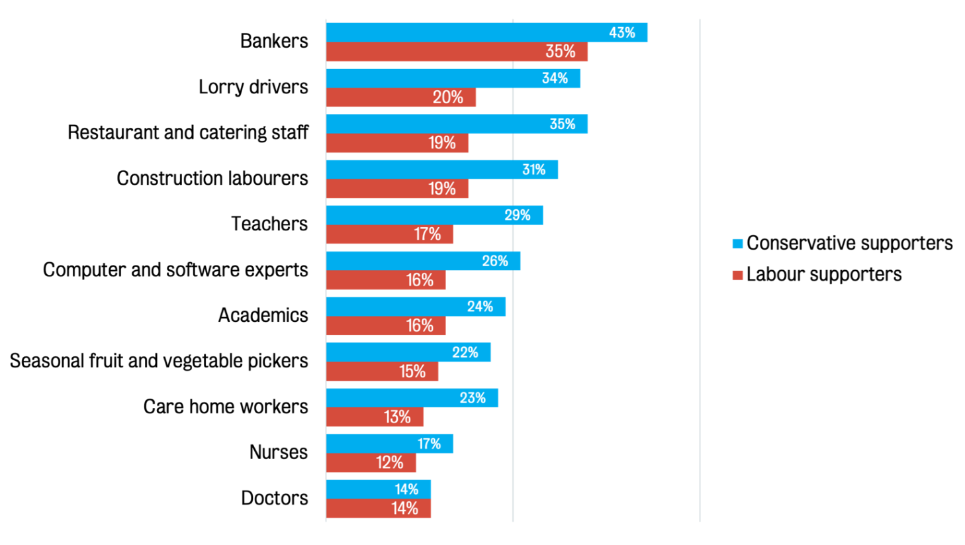

Jurors also raised the potential volatility of labour market shortages. For example, an economic migrant could be granted a visa one year based on filling a labour shortage, but a comparable individual may not be granted a visa the following year for the same role, if demand has changed. Some jurors felt there needs to be a degree of flexibility in the system to be responsive to changing economic needs. As a result, it was agreed that offering additional points for filling a labour market shortage or a role with social value, but not making it mandatory to take on such a role, is one way of accommodating such complexity within the system.
Overall, jurors also favoured a system that allocates points to a broader range of attributes – looking beyond the job offer itself in determining eligibility. It was suggested that points could be allocated for qualifications, work experience, filling shortage occupation roles, and potentially for factors pertaining to an individual’s wider circumstances, such as if they are bringing dependents with skills, or if they have preexisting connections to the UK (e.g. family in the UK, previous study in the UK). Jurors also called for more complexity and detail in points allocation, drawing inspiration from the Australian migration system. There was near consensus in the group in wanting to see a more graduated range of points for each desirable criteria, recognising individual nuances.
In parallel, jurors wanted to see greater investment into training and development of people already within the UK, to strengthen the labour market and alleviate pressures to hire immigrants as a quick fix to labour market shortages.
Baseline minimum salaries (and associated visa costs)
A minimum salary requirement was briefly acknowledged during discussions about points allocation but overall given little importance, on the basis that most job offers should provide a salary that meets the “going rate” for their occupation.
A more in-depth discussion focused on visa fees, and how they are linked to salary requirements. Jurors emphasised fair treatment and suggested greater flexibility in how visa fees are paid. The upfront fees (set at between £625 to £1,423 in November 2023) and health surcharge (set at £624) were seen as costly and unfair. Jurors felt these costs could make visas inaccessible for many and argued that costs should not make moving to the UK for work inaccessible for those with the right skills who meet a high entry standard. One suggestion was to adjust fees dynamically based on the type of job and salary of the person immigrating. For example, fees could be lowered for social care workers, whose roles were viewed as important but low-paid.
“I think the price needs to be based on the type of job. So, if you’re having a business analyst maybe charge them £4,000, if they’re a bricklayer charge them £500.” –Juror, first generation immigrant
“I think they should have a system where it’s matched up against what you’re earning. If you earn a certain amount of money a year through employment, then if you can afford it, you can pay the full surcharge for the NHS. … I think it’s unfair to suggest that everyone who comes over should pay that.” –Juror, first generation immigrant
“It needs to be a fair system. If you look up the salary for workers in care homes… it’s minimum wage.” –Juror, born in the UK
Dependents and spouse/partner sponsorship
As part of a more personalised approach to points allocation, jurors spoke about incorporating points for dependents’ skills. They felt it was important to consider how dependents will contribute to the economy.
“I think that it’s fair because as the data showed, it hasn’t had an effect on social housing or education, so them bringing dependents won’t have that impact on the economy. And then, like you say, at the end of the day, most people won’t want to move without their families regardless. And they’re not taking anything, like any state payments or public funds or anything. And eventually, they could be contributing once they eventually work or study.” –Juror, second generation immigrant
Throughout the jury, participants also placed significant value on the work done by those in the social care sector. We share this with the inquiry, as this sector was subsequently the only sector affected by the spring 2024 change that made it so they could no longer bring their dependants to the UK when they migrate.
“I think we need to do a reassessment of how we’re placing value on certain jobs in our society. Why are we paying teachers, and health and social care workers such low wages? Because we need them all our lives from, you know, a young age to an old age.” –Juror, born in the UK

How the Home Office ensures compliance with the system
The inquiry invites evidence on how the Home Office ensures compliance within the system. This section will briefly address the issues jurors discussed regarding compliance from employers, and the perspective of immigrants adhering to entry regulations.
Employer adherence
The issue of adherence to regulations largely centred around verifying the validity of qualifications, and the health and background of individuals applying for the Skilled Worker visa. There was substantial debate on how extensive a health check should be, with jurors emphasising the importance of both physical and mental health so those immigrating are fit to work. It was also recognised that immigrants from some countries are already required to undergo health and criminal checks, especially if a person has a job in sectors such as education, defence, health or social care. However, jurors wanted to see such checks rolled out more widely, at the responsibility of the Home Office.
Jurors also expressed worries about employer exploitation, and as such emphasised that the need for checks on immigrants would fall better in the hands of the Home Office, than on the employer.
“Again, the job situation would worry me a bit with the employers. It may be the NHS or someone you trust but there may be other routes that are not so transparent.” –Juror, born in the UK
Immigrant adherence
In the final session of the citizens’ jury, jurors worked in three groups to develop and share policy proposals for a new economic migration system. All three groups aimed to welcome immigrants with the most to offer in terms of desirable skills and contributions to the UK. All three proposals also endorsed health and criminal checks for immigrants.
While checks fit with the person-centred approach favoured by jurors, they were also motivated
by concern and a want for more thorough assessments of those moving to the UK for work. Putting in place a more personalised and thorough assessment was therefore perceived as a mechanism to guard against people abusing the system. Some suggestions on how to assess individuals included seeking employment references, considering the institution that a qualification is awarded by, and implementing job-specific tests.
“You want to avoid any loopholes where someone could lie and be like, yeah, 10 years’ experience in this, when they’ve only had one.” –Juror, born in the UK
“I think you can show if you have a certified qualification… a degree, or maybe if it’s based on experience, if you had like 10 years in a profession… then there must be some sort of test you can
do. I know that cab drivers, they have to take a test… there must be something they can do to prove.” –Juror, first generation migrant

Recommendations
When considering policy trade-offs, there was a clear preference among jurors for longer-term, more sustainable change that addresses the root causes of issues such as labour market shortages, although it was recognised that some short-term action is necessary alongside this. Jurors also favoured policy action that takes a personalised approach towards immigrants and provides routes to permanent residency. Other trade-offs were more nuanced. For example, jurors felt it was important for immigration policy to be responsive to changing needs but equally felt that stable criteria were important. Jurors also indicated that policy should neither aim to deter nor incentivise people to immigrate to the UK.
In general, the jurors advocated for the following changes to the Skilled Worker visa:
Focus should be on skills shortages, rather than favouring high skills.
The allocation of points to determine eligibility for a Skilled Worker visa should go beyond their current remit and acknowledge a wider set of criteria such as work experience and the applicant’s wider circumstances, such as if they are bringing dependents with skills, or if they have pre-existing connections to the UK.
Visa costs should be more dynamic with changes based on type of occupation and wage.
Changes made to the allowance of dependants should not target those in sectors most valued by the public.
Health and criminal checks should be mandatory for anyone applying for a Skilled Worker visa and should be the responsibility of the Home Office rather than employers.

Acknowledgments and further information
This work was funded by Unbound Philanthropy. This response has been prepared by The Policy Institute at King’s College London and British Future. The citizens’ jury was carried out with contributions from experts from the House of Commons Library, The Migration Observatory at the University of Oxford and British Future.
Further information about the jury’s findings can be found here: https://www.kcl.ac.uk/research/citizens-jury-economic-migration

