- Introduction
  - The Universities and Colleges Employers’ Association (UCEA) represents 169 Higher Education (HE) employers, providing them with advice and guidance on employment and reward matters. Universities UK (UUK) represents 141 universities and works with universities, the government and stakeholders to continue improving the UK's world-leading higher education sector and promote the important role universities have in our society and globally.
  - UCEA and UUK welcome the opportunity to submit evidence to this PAC Call for Evidence on the impact of the Spring 2024 changes made to the Skilled Worker (SW) visa route.
- International staff and the Higher Education (HE) sector
  - The recruitment of talented international staff helps to underpin the UK’s reputation for world-leading higher education which is integral to the global research eco-system. The success of the UK’s Higher Education (HE) sector is dependent on a large and varied base of skilled staff – many of whom are recruited from overseas – including world-leading experts and research leaders but also laboratory technicians, language assistants and early career researchers. These are roles that cannot easily be filled by the domestic labour market and are also not areas in which it is easy to upskill quickly.
  - International staff have made up a third of all academic staff in UK HE over the past five years (2019/20 to 2023/24), with the number of international academic staff increasing by 17.2% over this period. Meanwhile, the number of UK nationals working as academic staff in UK HE has increased by 7.1% between 2019/20 to 2023/24. International staff have made up between 10 and 15% of all non-academic staff in UK HE over the past five years, with numbers growing by 32.1% over this period. Meanwhile, the number of UK-domiciled non-academic staff has increased by 1.8%.
- Financial challenges facing the HE sector
  - The UK HE sector is currently facing increasing financial challenges. Given domestic tuition fees have remained effectively frozen for the past decade, the real-term value of university income has been significantly eroded.
  - According to the Institute for Fiscal Studies (IFS), per-student funding for teaching home undergraduate students has now fallen by 18% in real terms since 2012/13. Had the fee cap instead been linked to economy-wide inflation it would have reached £12,700 this academic year. The erosion of domestic tuition fees means that, on average, HEIs are losing around £1.7bn on teaching home students, with this deficit increasing by £710 million in a single year between 2021/22 and 2022/23 according to TRAC data from the Office for Students (OfS). This is particularly acute for those HEIs who provide more higher-cost subjects, such as STEM courses, which cost significantly more to deliver than the domestic fee cap.
  - As the regulator for higher education, the OfS has also warned that without HEIs taking significant mitigating actions, 72% of English HEIs would be in deficit by 2025/26, and 40% would have low liquidity. Should international student fee income decrease further (as many HEIs fear it may following reforms trailed in the Government’s upcoming Immigration White Paper) the OfS estimate 84% of English HEIs will be in deficit by 2026/27, and 73% would have low year-end liquidity.
  - This data is worth highlighting in the context of recent immigration policy changes which have increased the cost of the UK’s immigration system for both sponsors and individuals alike.
  - In addition to the above, analysis by UUK international shows that international student enrolments decreased for two consecutive years in 2023/24 and 2024/25, resulting in a drop of over £1.1bn in fee income since 2022/2023.
  - This drop in student fee income combined with the 1.2 percentage increase in employers’ national insurance contributions in April 2025 will add around £372m to the sector’s pay bill means that HEIs continue to face a cumulative effect of increased costs and reduced income. This is further compounded for post-1992 HEIs by the increases in employer contribution rate for the Teachers Scheme (TPS) which have risen by 12 percentage points in the five years. The increased cost of the UK’s immigration system for employers and individuals amplifies these challenges.
- Visa costs have increasing significantly in recent years
  - Between 2021 and 2024, visa costs for skilled workers in the UK increased by 22% from £9,746 to £11,933. Research commissioned by the Royal Society found UK SW visa costs to be 506% higher than the mean total upfront visa costs for skilled workers across all other leading science nations. Upfront costs for a one-year extension of the visa have been estimated to be 513% higher than the average total costs for extending a SW visa for a year across all leading science nations.
  - Over this same period, France and Israel reduced the cost of their skilled worker visas by 92% and 83%, respectively. The United States increased skilled worker visa costs between 2021 and 2024, however the UK’s costs remain higher. Between 2019 and 2024, UK SW visa costs increased by 41% to £11,933 whereas US equivalent costs increased by 34% to £8,219.
- Changes to immigration rules Spring 2024
  - UCEA surveyed members in late 2024 following the changes to the immigration rules in February and April 2024, to evaluate the impact on the ability of higher education institutions (HEIs) to recruit and retain international staff. Our response to this call for evidence is based on the responses from 93 HEIs to the survey.
  - In April 2024 changes were made to the immigration rules including:
- The baseline minimum ‘general’ salary threshold for sponsorship of a SW visa rose from £26,200 to £38,700 per annum.
- Under the changes to the SW route, the job-specific ‘going rates’ for eligible SW occupations were increased from the 25th percentile to the 50th percentile (median) of eligible SW occupations alongside an update to the latest nominal wage data (Annual Survey of Hours and Earnings (ASHE)) – in other words the ‘going rate’ minimum salary specific to each job also went up significantly.
- Individuals already in the SW route or who had a Certificate of Sponsorship (CoS) assigned to them before 4 April 2024 are not subject to the new £38,700 general salary threshold when they: (i) submit applications to extend their stay; (ii) change their employment in the UK or (iii) apply to settle in the UK. However, they must meet the new minimum ‘general’ salary threshold of £29,000 based on the 25th percentile (which is equivalent to the current level of £26,200 adjusted for inflation) or the going rates based on the 25th percentile.
- The Shortage Occupation List (SOL) was removed and replaced by the Immigration Salary List - a list of occupations where a reduced salary threshold applies in the SW route.
- The minimum income requirement for partners applying under Appendix Family Members of the immigration rules increased from £18,600 to £29,000. Further increases to the MIR are under consideration pending a review by the Migration Advisory Committee (MAC).
  - Another significant change was the 66% increase in February 2024 to the Immigration Health Surcharge (IHS) which rose from £624 per year to £1,035 per year of the visa, paid in advance. The amount of IHS to be paid depends on the length of the visa, for example, it would cost £3,105 for a 3-year visa (with these costs needing to be paid in advance, in full).
- UCEA survey response - recruitment of international staff
  - Below are the responses from HEIs to the survey questions about the SW route and bar charts which illustrate those responses. In the survey HEIs were asked to provide responses for three categories of international staff: Researchers, Professional Services staff and Academic staff subdivided into Non-European Union (EU)/ Non-European Economic Area (EEA) and EU/EEA international staff. The Researchers category refers to those who have research only contracts.
  - HEIs reported experiencing difficulties in recruiting international staff in the last 12 months with the most difficulty reported in recruiting professional services staff i.e. those staff that do not have an academic employment function including managers, professional and technical workers.

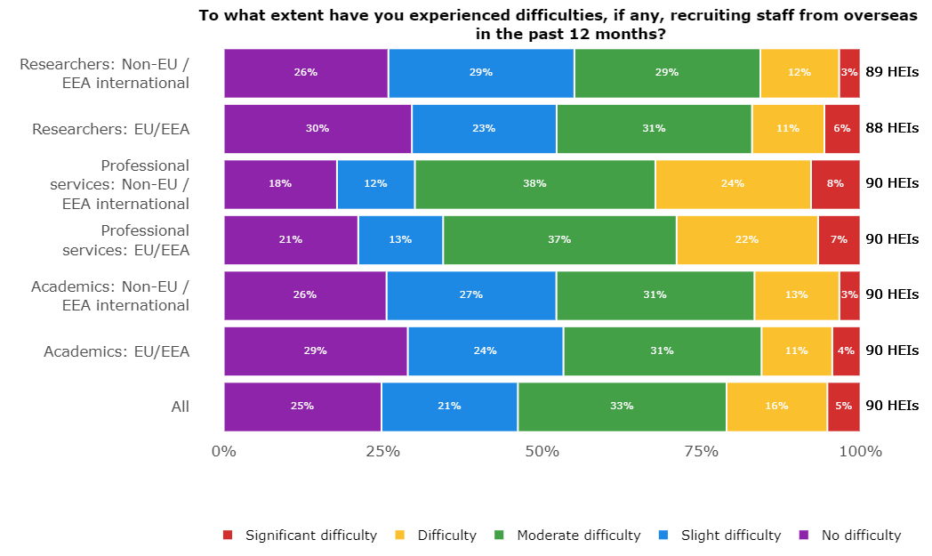
Figure 1
  - For all staff categories, responding HEIs reported moderate to significant difficulties in recruiting international staff. The main causes of difficulty in in recruiting international staff are shown in figure 2 below.
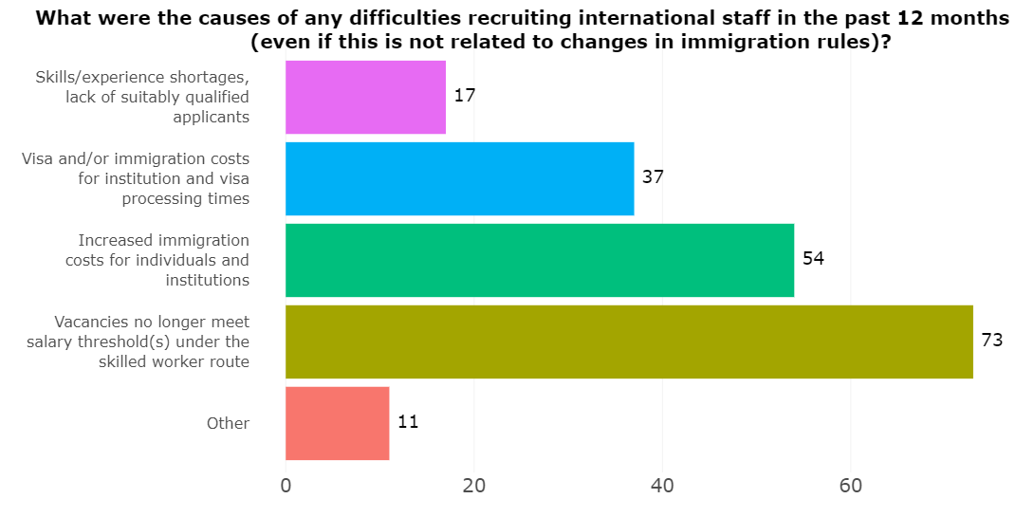
Figure 2
  - The responses from HEIs cite the main cause of difficulty in recruiting international staff as vacancies no longer meeting the salary threshold under the SW route, 73 HEIs said this. 54 HEIs said increased immigration costs for individuals and institutions were a cause of difficulties and 37 said visa and immigration costs and visa processing times had caused difficulties.
  - In addition to the causes of recruitment difficulties shown in the chart, other causes included:
- Delays in processing time for applications under the Academic Technology Approval Scheme (ATAS).
- It no longer being possible to sponsor some professional services roles due to the rise in the general salary threshold and going rates.
- Increased immigration costs for individuals' dependants.
- A reduction in applications - especially from EU and EEA researchers.
- Salary thresholds
  - Changes to the salary threshold were deemed by a large majority of HEIs to explain the difficulties in recruitment they had experienced in the last 12 months for every staff category. HEIs felt that changes to SW salary thresholds explained the difficulties that they had experienced in recruiting research staff, professional services and academic staff. For Non-EU/EEA international staff 57%, 69% and 54% respectively of responding HEIs believed this to be the case. Please see figure 3 below.
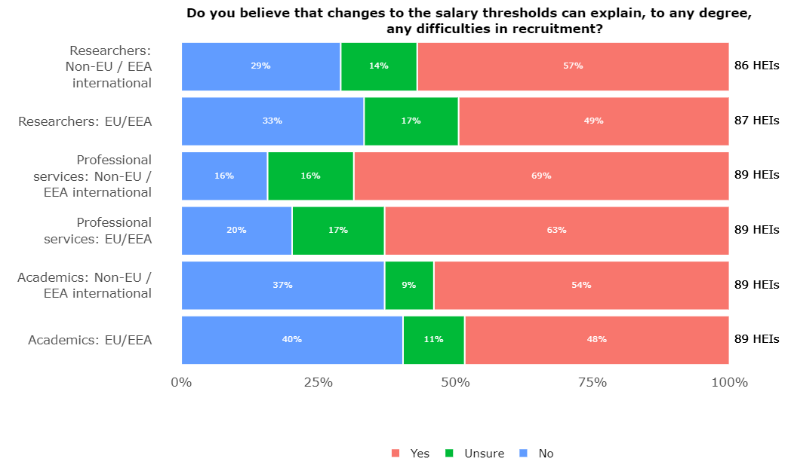
Figure 3

- UCEA survey response - retention of international staff
  - HEIs reported less difficulty in retaining international staff than for recruiting international staff i.e., the rate at which ‘no difficulty’ was reported was lower than for recruitment, The lower level of difficulty may be explained by the increases in the SW salary threshold and the IHS having less impact on international staff in the UK at the time of the survey. It may have been too soon after the increases in the SW salary thresholds (and IHS) to assess the impact on retention.
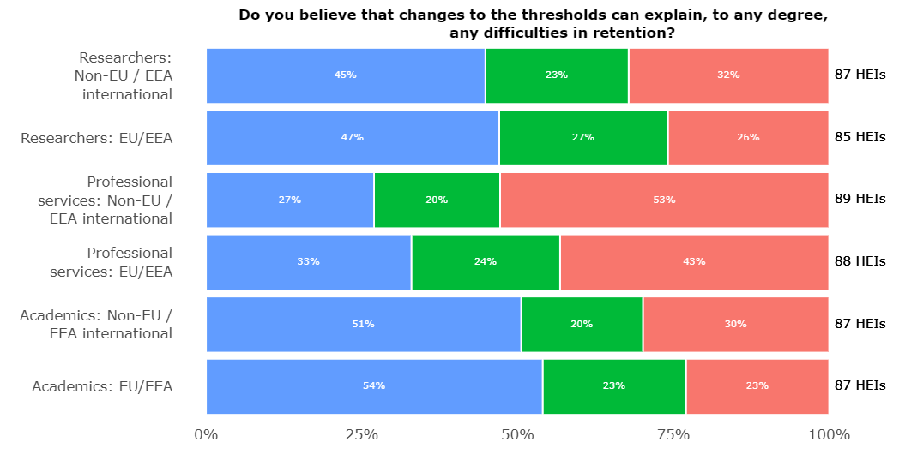
Figure 4
  - HEIs had a level of uncertainty about the impact of the salary threshold changes on retention at the time of the survey. The responses from HEIs shown in figure 4 above indicate that the recruitment and retention difficulties are at the highest level for professional services staff.
- Action by HEIs in response to the changes to the SW threshold
  - UCEA’s survey data shows other routes are being used to mitigate the increased threshold. Before the changes became effective, it was anticipated the Global Talent visa route would to an extent potentially mitigate the negative impact of the salary threshold increases because it avoids issues with the minimum salary threshold. However, there are clear eligibility criteria limitations on the use of this type of visa for many staff categories.
- General trends - uptake of Skilled Worker visa
  - The uptake of the SW visa has clearly slowed since the salary threshold increased.
  - The most recent data from the Home Office shows a decline in SW uptake since the threshold increased. The increase came into effect in the second quarter of 2024, but there is likely to have been an increase in SW visa applications around that time before the threshold increase. The real decline can be seen from the third quarter onwards and this is clear from the charts attached in the Appendix (below).
- Impact of changes to SW route on workload and complexity
  - The complexity of the rules surrounding the SW and other visa routes has impacted as follows:
- Increase in queries: HEIs reported more queries from international applicants (including speculative applicants) and internal employees about sponsorship due to complex eligibility assessments and transitional arrangements. More time and resources are required for case-by-case evaluations to ensure sponsorship requirements are met - it takes longer for HEIs to assess eligibility.
- Skilled Worker visa: HEIs reported the assessment of eligibility for SW visas has become more complex and challenging due to the new salary thresholds and point-based requirements. Additional resource is needed to gather evidence for tradeable points where salary thresholds are not met, particularly for academic and researcher posts.
- Increased complexity: The overall complexity demands extensive resource allocation and deeper knowledge of the rules. Increased complexities and a lack of clear guidance from Government departments regarding sponsorship eligibility, lead to higher workloads for staff in Human Resources/immigration teams.
- Further changes to the SW route – March 2025
  - The change to the immigration rules in March 2025 to the SW route under which deductions from salary will be made for loans for immigration related costs will impact further. We believe this rule change will entail a significant amount of work for sponsoring employers to assess and report changes in salary arising from loans for immigration costs. We fully understand the Government’s concerns about sponsors passing costs to migrant workers and note the explicit changes that have been enacted to combat sponsors passing on costs to migrant workers that they should not. For example, if a business wishes to recruit internationally, they will be required to pay for certificates of sponsorship, sponsor licences and the associated administration themselves.
  - Many HEIs offer interest free loans to migrant workers for immigration costs such as visa fees or the IHS to ensure they continue to attract international talent. Interest free loan schemes offered by HEIs to cover applicant related costs help to mitigate the financial burden of high immigration costs on individuals coming to work in the UK on the SW visa. Such schemes are also voluntary, ensuring applicants retain full autonomy over whether to access this support. However, the additional work involved for organisations in reporting and administering salary deductions for the Home Office in implementing and monitoring this new rule regarding immigration loans seems disproportionate to the risk.
- Conclusion
  - The responses to UCEA’s survey and feedback via our immigration HR network indicate that the increases to the SW salary thresholds, visa and IHS costs are negatively impacting the ability of HEIs to attract and afford the best academics, researchers and professional services staff in the world. This is a serious issue. Any further increases to the salary threshold, ‘going rates’, discounted salary rates or other changes to the SW or other visa routes could have the potential to bring academic and research positions (in greater numbers) into scope which would be extremely detrimental.
  - Whilst the volume of recruitment had generally decreased at several HEIs in 2024 due to financial constraints, there is no doubt that the immigration rules impacted negatively on the attraction of global talent which is essential to the success and reputation of the UK’s HE sector. Specific concerns include:
- It is not unusual for those applying with a family under the SW or Global Talent routes to have fees of more than £10,000 – this is a deterrent for potential applicants.
- New hires, particularly recent graduates, struggle with the high visa costs.
- The changes have resulted in candidate losses during the visa process due to high immigration costs, requiring additional recruitment campaigns.
  - HEIs work to ensure they offer competitive salaries to attract global talent however the increases to the ‘going rates’ for several HE roles in the context of the current significant financial challenges facing the sector has resulted in HEIs not being able to appoint international staff. The UK may be less competitive in research and innovation as a result which impacts on potential for income generation and the reputation and impact of the UK HE sector more generally.
  - UCEA will survey members later in 2025 to further understand the impact of immigration rule changes and visa and other costs and we would be happy to share the findings with the PAC.
  - We ask the PAC to take this evidence into account in their consideration of the impact of the changes to the SW route and in particular the negative impact on the ability of the UK’s HE sector to recruit high calibre international staff.

Appendix

Figure 1 – Skilled Worker (main and dependants combined), year on year 2021-2024

Figure 2 – Skilled Worker (main applicant only), year on year 2021-2024

Figure 3 – Skilled Worker (main and dependants combined), quarter on quarter 2021-2024

Figure 4 – Skilled Worker (main applicant only), quarter on quarter 2021-2024

Figure 5 – Skilled Worker (main and dependants combined), 2021-2024

Figure 6 – Skilled Worker (main applicant only), 2021-2024

The terms “HEI(s)” (Higher Education Institution(s)) and “university/universities” are used interchangeably throughout to describe UCEA’s membership which consists of Higher Education providers which are active in teaching, research and scholarship including universities, colleges, and conservatoires, and associated organisations.
https://www.bankofengland.co.uk/monetary-policy/inflation/inflation-calculator
TRAC – Transparent Approach to Costing – an activity-based costing system
The standard SW visa minimum general salary is £38,700, where no salary discounts are applicable. This means that to be eligible for the SW visa, most applicants will need to earn at least £38,700 per annum and meet or exceed the relevant going rate for their occupation code.
For skilled workers who qualify for the transitional provisions, the general salary requirement is £29,000 or the ‘going rate’ of the 25th percentile for the occupation code, whichever is higher.

