Written evidence submitted by Lieutenant Commander Matthew Brown

How vulnerable is the UK to undersea cable attacks?
Author and context of submission:
This note is submitted to the Committee on an individual basis by the author, as a former full-time member of the Armed Forces, having conduced a combined study as part of their routine employment within the Royal Navy in parallel with completing an MSc thesis.
Specifically, the author was invited to investigate the rationalisation of the organisation’s current approach to the development and acquisition of Seabed Warfare capability by their employing unit. This afforded a unique opportunity through the synthesis of privileged access, combined with over a decade of professional experience in military seabed operations, and the application of academic process.
Its output was the generation of thematic observations made via privileged access to open-source and protected materials, working groups, workshops, planning estimates and interviews. These, in turn, were used to generate insights and recommendations from the perspective of a neutral, independent observer with no specific agenda or mandated output.
Those insights believed to be relevant in response to the questions detailed in the Committee’s call for evidence and permissible for publication are detailed here. They represent the view of the author as an individual, with the support and endorsement of the tasking unit, not that of the wider organisation or policy; and are submitted to the Committee in a complimentary, constructive, and collaborative spirit of good will, not as a critique.

Introduction
The applicable observations and insights drawn from the investigation are broken down into two sections, each of which addresses one of the questions posed by the Committee.
They discuss issues pertaining to the protection of critical national undersea infrastructure in a generic context, not exclusively through the lens of “seabed warfare” as per the initial mandate of the investigation.
The first section discusses issues of scope, bounding, and primacy relating to the subject matter as a broad topic. The second, addressing observed gaps in the current approach to fielding a credible and effective deterrent through economy of effort.
They are intentionally written in plain English for the purposes of accessibility.
Section 1: Scope, bounding and primacy.
This section pertains to discussions relating to Question 6 posed by the committee:
(6). How well is policy and co-ordination working across Whitehall departments, law enforcement and private sector actors? Are any changes needed?
1.1 General Issue.
The first and principle thematic observation omnipresent across all documentation reviewed and workshops observed, regardless of if they were discussing seabed warfare (SBW), underwater domain awareness (UDA), or a broader dialogue relating to the protection of critical undersea infrastructure at a generic level, was the difficulty in framing the issue/topic being discussed. And subsequently, a lack of bounding and scope throughout.
This was for myriad reasons attesting to the severe complexity of the problem set and human factors. However, there was a clearly observable link between this phenomenon and a lack of clarity or understanding attributable to issues of primacy and jurisdiction across government departments and/or stakeholder groups.
It also points towards a broader difficulty in conceptualising roles and responsibilities linked to the protection of critical undersea infrastructure at a more generic level, both publicly and privately.
Employing a level of creative licence to highlight this issue through an intentionally simplified analogy for illustrative purposes: let us briefly imagine that a nefarious actor were to commit an attack on a piece of critical national infrastructure on British soil, such as severely damaging an electrical sub-station so as to interrupt energy supply to a geographical area.
In this instance, it is not difficult for most people (policy makers, academics, media, members of the public, or otherwise) to conceptualise the departments and/or functions that would be employed in response to this scenario and their primacy. In the immediate aftermath, this would be the emergency services (fire, police, and ambulance), other category one responders, such as the environment agency, national grid, power company, and an emergency planning officer (EPO) on behalf of the local authority. A local Command would be established in order to oversee the response using the UK’s Gold/Silver/Bronze hierarchy, and in extremis this would report directly to the Cabinet Office and COBRA. And, thereafter, the investigations and attribution will be a combined effort with, or handed over completely, to the UK Intelligence Community (UKIC) if necessary.
In short, the majority of the response would be a civil issue. Or, put another way, in all but the most extreme circumstances, it would not be the MOD or Army being called to protect this infrastructure preventatively in advance by patrolling or guarding it; nor be part of the immediate response; nor to be responsible for the repair of the infrastructure assets thereafter.
By contrast, let us now imagine a comparable scenario where an attack were to take place only, in this instance, it is on a fibreoptic telecommunication cable in the Atlantic Ocean running between the UK and USA, at a depth of 4000m, and located outside of territorial waters (TTW) or exclusive economic zones (EEZ). Here, the author suggests, it is significantly harder for people (again: policy makers, academics, media, members of the public, or otherwise) to conceptualise the organisations and/or functions that would be employed in prevention or response, their jurisdiction, and their primacy.
In this absence of understanding and clarity, there is an observable propensity for individuals and organisations to default to the assumption this is therefore a military issue in isolation. Primarily, under the jurisdiction of the MOD and Royal Navy. Which, when compared to the role of the MOD and Army in the former scenario, is a paradoxical contradiction – with the inherent risk of collective groupthink.
This is not to say the MOD and the Royal Navy do not have a central role to play in response to this increasing threat vector. Quite to the contrary. However, it is vitally important to recognise that this is as much a civil issue as it is a military one. And thus, the response requires collaboration and coherency across Whitehall departments, of which the MOD is a fundamental component, but not so in isolation. This issue of primacy and jurisdiction is addressed further at (1.3).
1.2 Use of the Seabed Warfare moniker.
Prior to proceeding, it is also important to address issues pertaining to the adoption and use of the term “Seabed Warfare” (SBW) when discussing the protection of critical undersea infrastructure, and the contributions this makes to the observed issues around perception, primacy, and jurisdiction.
Principally, this is derived from the fact that the term “SBW” is a neologism with no unilaterally agreed or ratified definition across partner nations, allies, industry, or academia; only ad-hoc national definitions, such as that of the French Ministère des Armées (Ministry for the Armed Forces) exist; and that a UK national definition, drafted in late 2024, remains protectively marked and inaccessible in the public domain.
Subsequently, the term is often used synonymously and interchangeably with the protection of critical undersea infrastructure, without a clear or concise understanding of what this means, what is being discussed, or its bounding.
Resultantly, this often manifests in the observable phenomenon of parallax when the term “SBW” is discussed in meetings, workshops, or working groups – with every party having a different, subjective perception of what is being deliberated, depending upon their personal experience, understanding, or position on what constitutes “SBW”. Thus, further compounding issues when comprehending the provision of jurisdiction and primacy.
Furthermore, the inclusion of the word “Warfare” in the term is again synonymous with this being a military issue in isolation. Especially when this is used to characterise the collective national response to the threat vector, such as the “whole of system seabed warfare strategy” proposed by Hendriks and Halem. Here, it may be beneficial to use more inclusive alternatives, such as “protection” or “operations” in pace of “warfare”, to enhance collective conceptualisation and responsibility.
1.3 Jurisdiction and Primacy
Collectively, these causal factors contribute to a palpable uncertainty that appears to transcend Whitehall both horizontally and vertically with respect to ambiguity of jurisdiction and primacy between departments when viewed through the optics of a neutral and impartial observer.
Figure (1) below depicts this phenomenon visually, noting the caveats that it is non-exhaustive and only intended to illustrate this observation.
Vertically, it is broken down into three tiers at the macro, meso, and micro levels from the viewpoint of the author from within the MOD.
From an organisational perspective, at the top, macro level there are no less than 9 government departments and/or organisations with vested interests in the provision of the protection of critical undersea infrastructure. These include, but are not limited to, The Cabinet Office; Home Office; The Foreign, Commonwealth, and Development Office; Ministry of Defence; Department for Science, Innovation, and Technology; Department for Energy Security and Net Zero; Department for Transport; Department for Business, Energy, and Industrial Strategy; and The Crown Estate (HM Treasury). However, of these stakeholders, it is not overtly clear which is responsible for the different components of the collective response, or ownership of how this is distributed across them from published policy or the literature.
Below this, at the meso level, the effect is duplicated and multiplied. Using the MOD as the example in Figure (1), there are a minimum of a further 7 sub-divisions/sub-departments in the MOD with potential interests or responsibilities. These include but are not limited to: STRATCOM; The Royal Navy; Defence Intelligence; The UK Intelligence Community / Government Communication Headquarters; The Defence Science and Technology Laboratory; United Kingdom Hydrographic Office; and the Joint Maritime Security Centre. Here, again, there lacks clarity on the provision of jurisdiction across these.
Finally, at the micro level, this effect is then magnified and compounded further within sub-departments. Using the Royal Navy (RN) as the example in Figure (1), its collective response to the requirement is conceptualised using the “Seabed Warfare” neologism. However, the organisation has yet to decide if “SBW” is a component, extension, or evolution of one of organisation’s existing branches, such as Mine Warfare, Hydrography, or Anti-Submarine Warfare; an amalgamation and evolution of a number of these into a new hybrid; or, if “SBW” will form its own new standalone Branch that sits in parallel to these entirely.
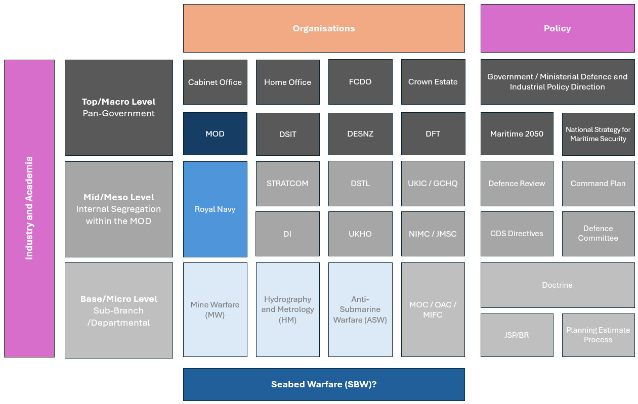
Figure 1: Ambiguity of jurisdiction and primacy across departments.
In summary, you have multiple layers of complexity, that are then subsequently amplified further when considered against the provision of policy, which mirrors the organisational tiers on one side, and the interfaces with both academia and industry, that interact with the stakeholder groups across the different levels, on the other.
Without the application of clear a strategy, comprehensive stakeholder mapping and management, and a systems approach to manage governance and leadership across this extensive and complex ecosystem, there exists the potential for significant risks to coherency, efficiency, and collaboration across the collective undertaking.
1.4 Recommendations: Choice Vocabulary and the adoption of a Programmatic Approach.
The author supports the recommendations made by Hendriks and Halem that there is requirement for a “whole of system” strategy to cohere the response to the collective protection of critical undersea infrastructure across Whitehall departments as discussed by the Committee. However, this is with two notable caveats as recommendations.
Firstly, as previously discussed, it is the view of the author that the collective undertaking should be overtly de-latched from the conceptualisation that because this is a security issue, it therefore defaults to being a military issue under the jurisdiction of the MOD by default. And that this may be achieved by ensuring the use of choice language to reflect this. Including, but not limited to: replacing military linked terminology such as “warfare” to more inclusive language in recognition of the broad church of stakeholder departments involved; and/or, clearly bounding the use of the terms such as “Seabed Warfare” exclusively to the operational components of the collective response to which they apply, in order to avoid instances of parallax and ambiguity.
Secondly, that this “whole of system” strategy should be complimented by the parallel creation of a United Kingdom Seabed Protection Portfolio through the adoption and application of a programmatic approach, drawing on the UK’s extensive and highly successful heritage in project, programme, and portfolio management (P3M).
This may then be used map the military and civil programmatic components of the collective response through the employment of a formalised work breakdown structure (WBS), such as below in Figure (2) as an illustrative example:
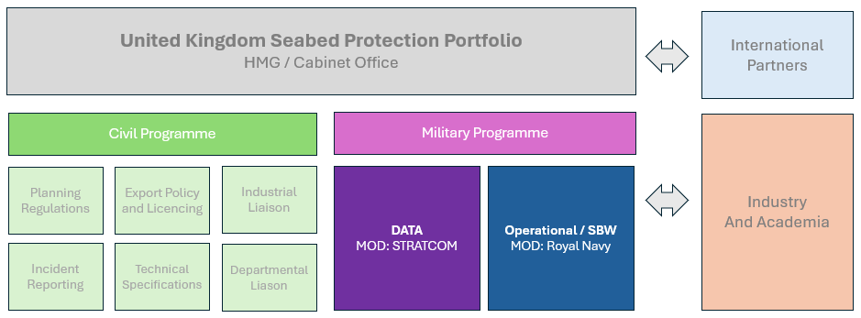
Figure 2: UK Seabed Protection Portfolio.
The author believes the adoption of this as approach would have myriad benefits. Firstly, a directorate to act as a singular point of authority for the oversight and execution of the proposed holistic strategy across stakeholder government departments, including providing clarity over which departments hold primacy and jurisdiction over which components of the collective response, whilst simultaneously providing a focal point and interface for coordination with internation partners.
Furthermore, the application of governance and stakeholder mapping/management would improve collective understanding across government, academic, and industrial partners; help identify opportunities for collaboration; reduce the possibility of duplication or contradiction; and increase efficiency.
Such an approach would not be without challenges, notwithstanding the sensitive nature and security considerations involved with such an undertaking, but with consideration for these and application of considered management and systems leadership, the author believes these can be overcome and commends this as a constructive proposal to the committee’s consideration.
Section 2: Asymmetry, Attribution, and Efficiency
This section pertains to discussions relating to Question 7 posed by the committee:
(7). In the context of limited resources, what is the appropriate balance to strike between enhancing domestic resilience on the one hand, and improving detection and interdiction on the other? How should these be accounted for in the Strategic Defence Review, and the Resilience Review?
2.1 General Issue
Section 2 responds to the question posed by the committee through the lens of generic context, suggesting that a polarising view pitting domestic resilience on one hand, versus detection and interdiction on the other in light of limited resources, may not be the most effective narrative. And, instead, a focus on economy of effort, based upon a conceptualisation of why such activity is appealing to an adversarial peer, may be more effective. It intentionally builds upon and compliments the recommendations outlined in Section 1.
2.2 Asymmetry and Attribution
Here it is important to ask the question: Why is interacting with, and holding at risk, the UK’s undersea critical national infrastructure attractive to adversarial actors?
In the view of the author, this is for two principal reasons:
- Asymmetry. It is an asymmetric threat. The cost of developing and fielding such a capability is not a small investment. However, proportionally relative to level of threat/risk it imposes upon the United Kingdom, and the cost of mitigating against it – as is being discussed in this review – is disproportionately high.

- Attribution. Such activity is also extremely hard to attribute. Evidencing activity that has taken place in thousands of metres of water is exceptionally hard to decern. This is then multiplied when considered against the threshold of reasonable doubt in the international theatre, and therefore such activity resides within the ‘grey zone’ of sub-threshold actions.
With this context in mind, if we were to reverse our position to that of an adversaries’ and consider what mitigations may deter us from such activity from the perspective of an adversarial aggressor, the author argues that negating these two factors may be the most effective form of deterrence.
Thus, the greatest threat to the attractiveness of this activity from the perspective of an aggressor would be the requirement to have to scale it.
That is to say, if an adversary had to increase the scale of such activity by either volume and/or frequency, firstly it would no longer be asymmetric: the cost ratio of the investment relative to the effect would no longer be so disproportional in favour of the aggressor; and, secondly: it would increase the probability and risk of attribution.
Based upon this, it may be beneficial for the Committee to consider the most effective way of militating the risks posed, with consideration for the context of limited resources, through this lens.
2.3 Fielding a credible deterrence
Here, this conceptual observation may be synthesised with the second principal observation drawn from the author’s investigation, specifically with respect to the procurement of a “Seabed Warfare” capability. It is also a further echo of the Hendriks and Halem’s paper, and supports their observation and proposition that a holistic approach to strategy, synthesising and leveraging different components of an operational response, is necessary to field an effective and credible deterrence.
The nuanced observation here, however, being that currently there has been a disproportional focus to respond to the now well-articulated threat vector through the procurement and development of material capability, relative proportionally to how effectively field and task it.
Or, in plain language: that possessing hardware in isolation, such as the MROS programme/platform(s) and associated capabilities, is not enough. It is only useful if the platforms are able to be in exactly the right place, at exactly the right time. Be this preventatively, or reactively, in order to mitigate against the attractiveness of asymmetry and attribution to an aggressor. Especially considering the tens of thousands of miles of infrastructure that they any defensive “Seabed Warfare” capability is required to protect.
2.4 Recommendations
The recommendation to the committee here, at the grass-roots level, is that complimentary ISR and Data capabilities such as those that may be used as force multipliers to effectively position material capability, are just as - if not more - important than the acquisition/development of “Seabed Warfare” platforms and their embarked capabilities in isolation. And that this should form a standalone component of the miliary programme within a UK Seabed Protection Portfolio, as detailed in Figure (1). Especially when considered against the necessity to mitigate against the factors of asymmetry and attribution through fielding a credible deterrence.
Furthermore, that this logic of mitigation may also be extrapolated out and applied to other components and aspects of the collective response, in light of the committees consideration for limited resources within the context of its review. In short, that it is the economical, effective, and efficient use of what we have that is important, vice the acquisition of new capability by process of volume, which is both expensive, and ineffective in isolation.

12 March 2025

French Ministry of Armed Forces (2022) Seabed Warfare Strategy. Ministère des Armées. Online.
Hendriks, M., S. and Halem, H. (2024) From Space to seabed. Protecting the UK’s undersea cables from hostile actors. Policy Exchange. London. Online.
HM Government (2023) Systems Leadership Guide: how to be a systems leader. DESNZ, DBEIS. Online.
Hendriks, M., S. and Halem, H. (2024) From Space to seabed. Protecting the UK’s undersea cables from hostile actors. Policy Exchange. London. Online.
Hendriks, M., S. and Halem, H. (2024)
Brooke-Holland, L. (2023) Seabed warfare: Protecting the UK’s undersea infrastructure. House of Commons Library. Online.

