Written evidence submitted by Windward AI
Windward is a leading maritime intelligence company specializing in predictive analytics and AI-driven risk assessment for global maritime operations. Our expertise spans vessel tracking, behavioral analytics, and security threat detection, providing actionable intelligence for governments, defense agencies, and commercial entities. Our data-driven insights help mitigate risks associated with undersea infrastructure, maritime security threats, and illicit activities at sea.
We submit this evidence to support the Committee’s inquiry into the security and resilience of the UK’s undersea cable infrastructure. Our submission draws upon proprietary data analytics, risk assessments, and real-time tracking of maritime activities that may pose a threat to critical subsea assets.
Summary:
This document provides an evidence-based assessment of the security risks facing the United Kingdom’s undersea cable infrastructure. As a global leader in AI-driven maritime intelligence, Windward presents proprietary data analytics, behavioral risk assessments, and real-time vessel tracking insights to support the UK’s inquiry into the protection of its critical subsea assets.
The report outlines the growing risks posed by commercial maritime activities and state-sponsored operations. Accidental damage from fishing vessels and merchant ships—often operating with outdated navigation practices—remains a persistent threat. In parallel, intelligence suggests an increase in state-backed surveillance and potential sabotage efforts, particularly from Russian-affiliated naval assets. These vessels employ deceptive tactics, including AIS signal spoofing, prolonged loitering near critical infrastructure, and covert mapping of undersea assets.
Key findings include:
- A significant increase in high-risk vessel activity over undersea cables, including anchoring and drifting behaviors in sensitive areas.
- A rise in state-sponsored operations targeting critical maritime infrastructure, including subsea communication cables and offshore energy assets.
- The use of deceptive shipping practices by military-affiliated vessels, making early detection and intervention increasingly complex.
This submission aims to provide the UK government with actionable intelligence on these evolving threats, reinforcing the need for enhanced monitoring, advanced maritime risk assessment, and strategic policy measures to address vulnerabilities in undersea infrastructure.

United Kingdom’s reliance on Undersea cables and infrastructure
The UK depends heavily on undersea cables for internet connectivity, financial transactions, and energy distribution. This reliance is expected to increase due to:
- Growing data transmission needs: Increasing digitalization and cloud computing demand more bandwidth and redundancy in subsea infrastructure.
- Expansion of renewable energy projects: Offshore wind farms and interconnectors for energy exchange rely on robust subsea networks.
- Strategic role as a data hub: The UK serves as a crucial link between Europe and North America, making it a primary target for adversarial interference.
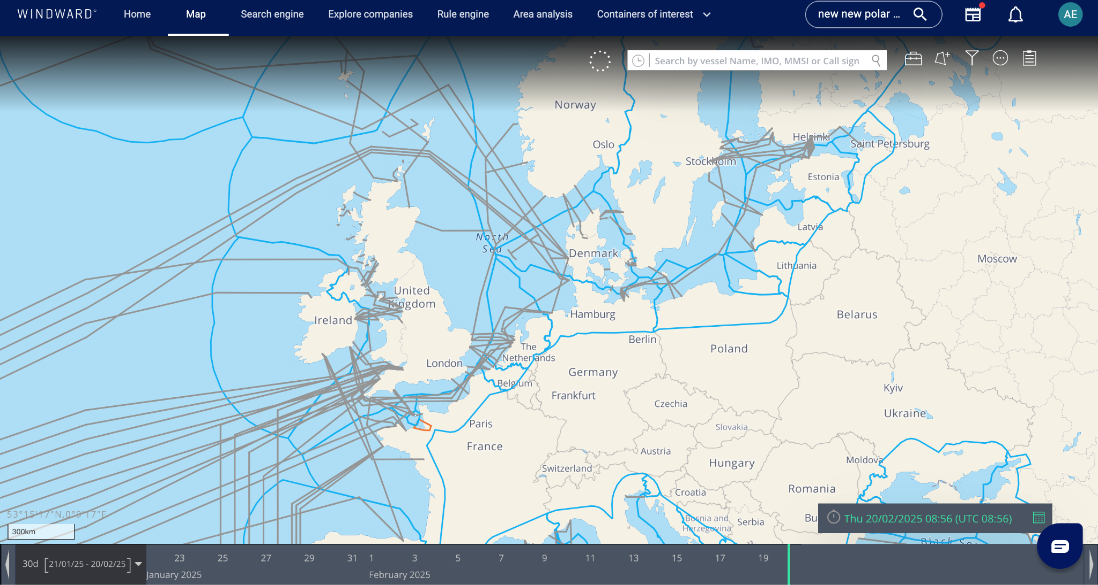

Key vulnerabilities:
Undersea cables in UK waters face several key vulnerabilities. Accidental damage from fishing vessels and commercial ships remains a significant threat, particularly when these vessels operate with outdated nautical charts. This risk is compounded by the fact that many cables are long and remote, making them difficult and costly to monitor. State-sponsored subversive activities have become an increasing concern, with Russian spy ships like the Yantar observed mapping critical underwater infrastructure near the UK coast. Other threats include natural events and deliberate sabotage attempts. The vulnerability of on-shore cable landing stations to potential attacks is also a growing worry. These risks are exacerbated by the UK's heavy reliance on approximately 60 cables for its international connectivity, highlighting the potential for significant disruption if multiple cables were to be damaged simultaneously.
Accidental Damage:
In the past year according to Windward Intelligence data (Feb 24 - Feb 25) 4,574 Individual vessels conducted an accumulative 36,236 anchoring activities.
91 of the aforementioned vessels were involved in maritime accidents including grounding, collisions and mechanical failures prior to their anchoring activities in UK waters. Although in some circumstances maritime incidents are unavoidable, the fact remains that unsafe and unreliable vessels are conducting anchoring patterns above sensitive and vulnerable areas year on year increasing the risk of accidental damage. An increase in the amount of cables will exacerbate the issue of accidental breaks unless a change in situational awareness by commercial fleet operators is increased.
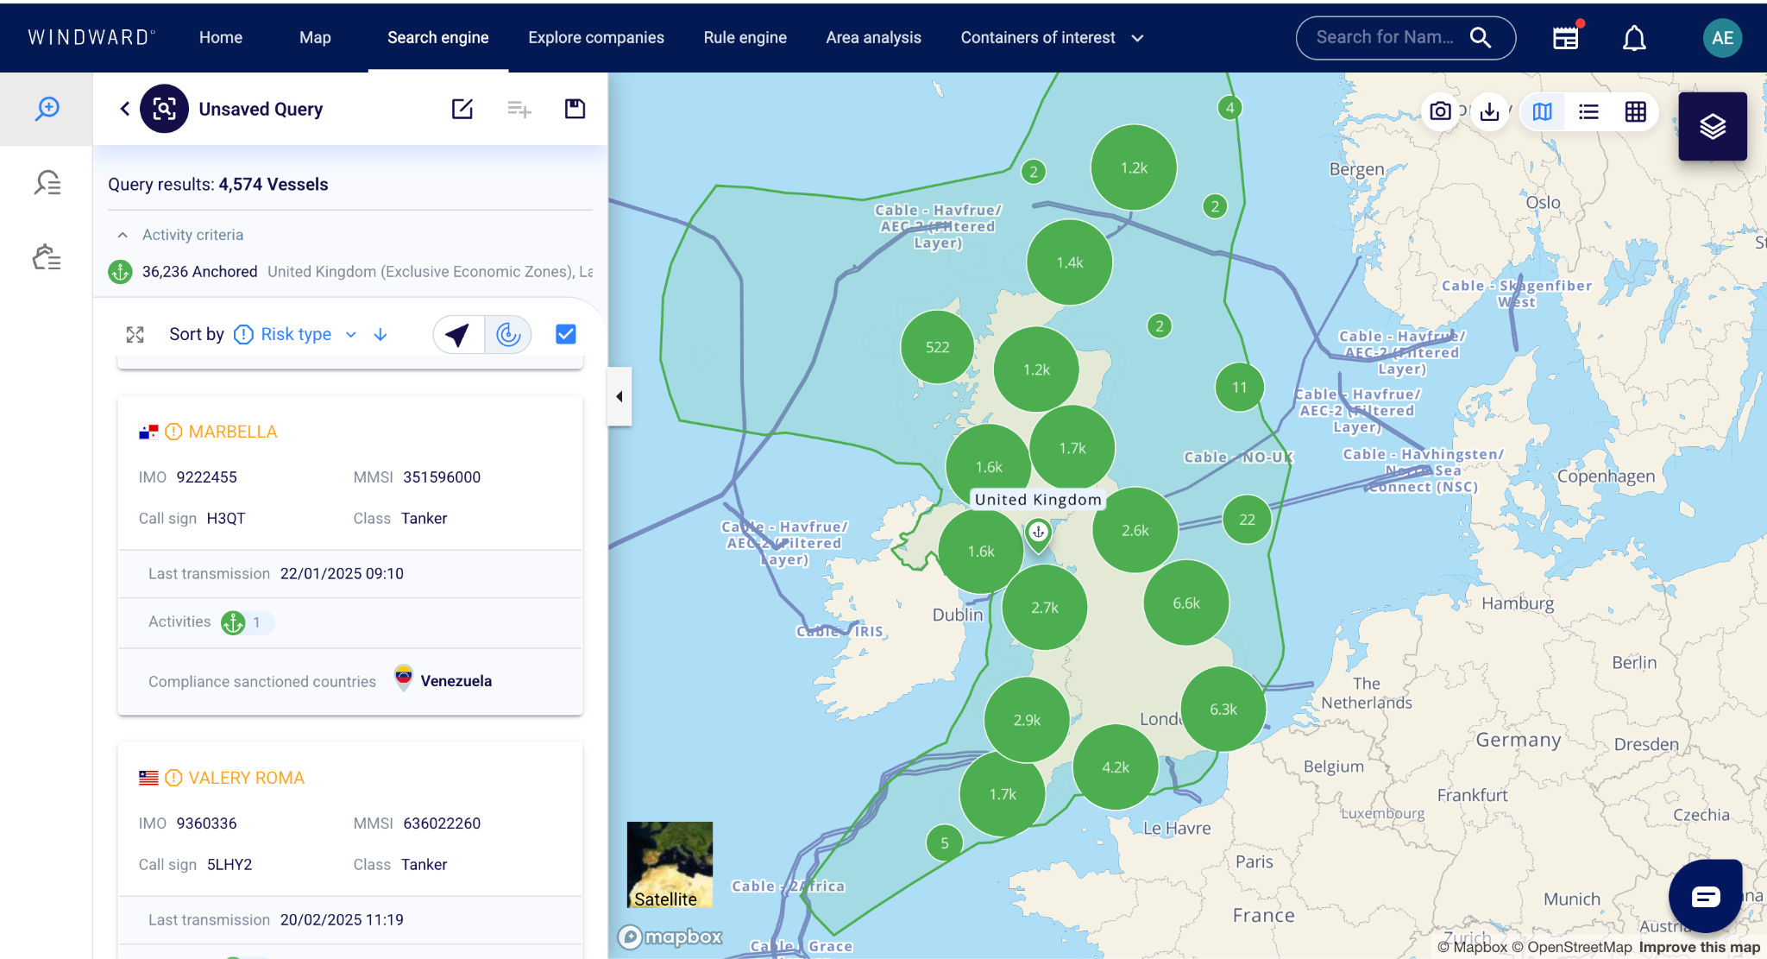
Locations of anchoring activities Feb 24 - Feb 25

State-sponsored subversive activities:
Over the past five years, there has been a significant increase in subversive military and state threat activity targeting critical national infrastructure (CNI) in the North Sea, particularly in the maritime domain. This includes covert operations aimed at disrupting offshore energy assets, undersea cables, and key shipping lanes. There has been a significant increase in behavioral risk patterns, including increased dark activity, anomalous loitering near sensitive infrastructure, and deceptive shipping practices linked to state-backed actors. These evolving threats underscore the urgent need for advanced predictive intelligence to detect and mitigate risks before they escalate into full-scale disruptions.
In 2020 a total of 512 “Drifting” activities (vessels without anchoring and engines off) were conducted directly above undersea Cables connecting to the United Kingdom. 31 of the vessels conducting these activities were labelled as high risk due to various factors and behavioral patterns in line with deceptive shipping practices.
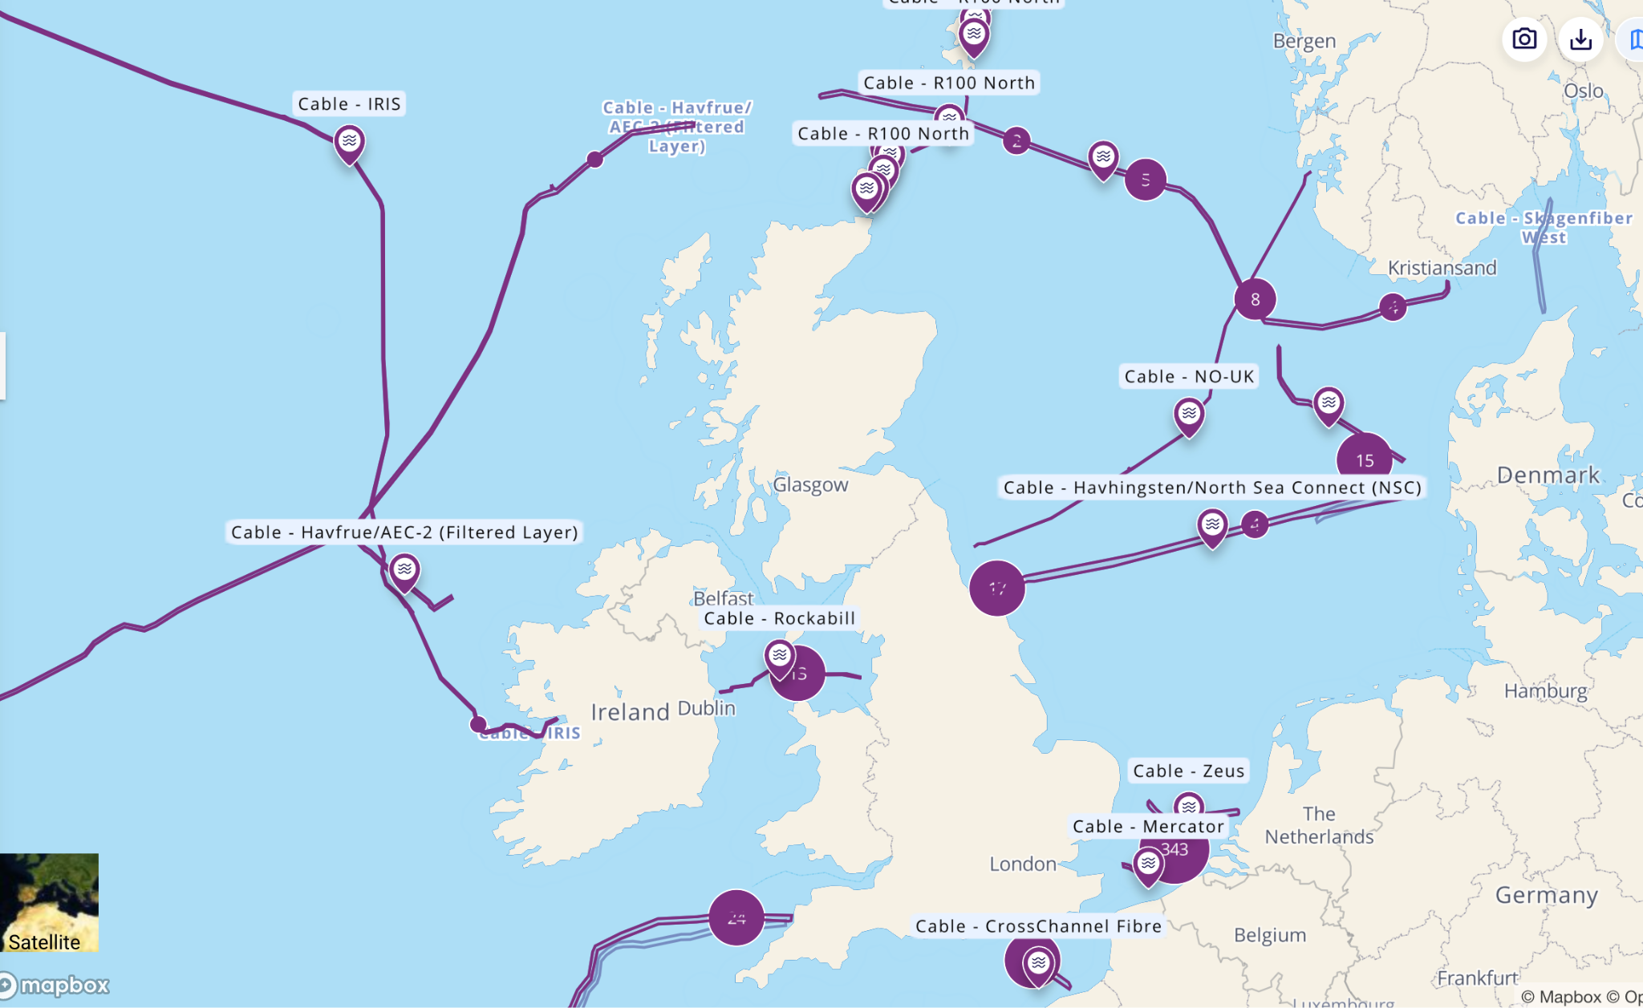
Locations of Drifting activity in 2020

Comparatively in the last 12 months (Feb 24 - Feb 25), the total number of activities had increased by 90.6% whilst the total number of contributing vessels stayed roughly the same at 32, representing a clear increase in the activity and not just traffic in those areas.

Threat Actors
State Actors
The primary threat actors targeting underwater cables and critical infrastructure are state-sponsored entities, with Russia being the most prominent. Russia has demonstrated a strategic focus on subsea infrastructure as part of its hybrid warfare doctrine, leveraging naval capabilities to map, surveil, and disrupt critical assets such as fiber-optic communication cables, energy pipelines, and offshore wind farms. Russian state-backed vessels, often operating under the guise of research ships, fishing trawlers, and service vessels, have been observed conducting mapping operations in the North Sea, Baltic region, and transatlantic cable routes. These vessels, including the Yantar, Losharik, and Belgorod, have been suspected of being equipped with autonomous underwater vehicles (AUVs) and remotely operated vehicles (ROVs) capable of scanning, tampering with, or severing submarine infrastructure
In the last 12 months (Feb 24 - Feb 25), 150 individual vessels associated with Russian military activity visited the United kingdoms Economic zone, Ireland Economic zone and the North Sea. Only 111 of these vessels were sailing under the Russian flag, making it difficult to distinguish between normal commercial fleets and those with current and previous behaviors connecting them to Russian military activity.
Using a collection of validated ownership data, of those remaining 39 vessels from the initial 150, only 12 are registered to companies in Russia. This leaves 27 vessels with no pre-existing traits connecting them to Russia that can sail unnoticed and unassuming through UK waters ready to perform covert mapping and potentially offensive operations. Using 10 years of historic behavior patterns and activities we can identify all 150 due to their involvement in Russian military activities.
Capabilities
The capabilities of military-affiliated vessels extend far beyond standard naval operations. They leverage cutting-edge subsea intelligence gathering, sabotage techniques, cyber warfare tools, and strategic hybrid warfare tactics to undermine critical infrastructure. By mapping undersea assets, conducting covert sabotage, and disrupting global networks, these vessels pose a severe and persistent threat to national security. Advanced AI-driven maritime monitoring is essential to counter these threats, as real-time risk profiling can detect anomalous loitering, AIS dark activities, and deceptive operational patterns before damage occurs.
Specialized Intelligence Vessels: Ships like the Yantar, Losharik, and Belgorod—operated by the Russian Navy’s Main Directorate of Deep-Sea Research (GUGI)—are equipped with cutting-edge surveillance and mapping technologies.
Extended Loitering Time: Unlike other commercial vessels, Research vessels and service vessels often hide in plain sight. These ships spend prolonged periods in strategic maritime zones, often near critical infrastructure, engaging in slow-speed activity under the pretense of research or fishing operations​.
Covert Anchor Dragging & Cutting: vessels have been observed using their anchors or specialized equipment to drag across subsea cables, causing damage while maintaining plausible deniability.
Jamming & Spoofing AIS Signals: Many of these vessels conduct AIS dark operations, turning off their tracking systems while operating in sensitive areas to avoid monitoring by maritime security platforms​.

SubSea infrastructure developments
Over the next decade, subsea technology will advance significantly, particularly in autonomous underwater surveillance, real-time monitoring, and cyber resilience. AUVs and ROVs will enhance deep-sea patrols and infrastructure repair, while fiber-optic-based sensor networks will enable real-time detection of tampering or sabotage. However, these advancements will benefit both defenders and aggressors. Defenders will gain improved physical threat detection, automated response systems, and enhanced infrastructure resilience, but adversaries will leverage stealth AUV operations, AIS spoofing, and hybrid cyber-physical attacks to disrupt global communications and energy networks. Russia has already demonstrated expertise in undersea mapping, covert sabotage, and electronic warfare, using both naval assets and civilian-disguised vessels.
The UK is currently vulnerable due to its limited subsea monitoring capabilities and lack of advanced AI-driven behavioral threat detection. While it benefits from strong intelligence-sharing through NATO and 5EYES, it lacks the ability to autonomously track and analyze anomalous vessel behavior at scale. Recent incidents in the North Sea and Baltic have demonstrated the urgency for AI-enhanced surveillance and risk profiling to detect covert threats before they escalate. Unlike the US, the UK also relies on third-party providers for subsea repairs, delaying responses to attacks. To secure its critical infrastructure, the UK must invest in AI-powered maritime threat detection, independent repair capabilities, and real-time behavioral risk monitoring, ensuring it can counter emerging maritime threats before they cause widespread disruption.
As technology advances and subsea infrastructure evolves, so too will the tactics and vulnerabilities exploited for intentional disruption. The rapid pace of technological integration within industry often outstrips that of the public sector, creating security gaps that adversaries can exploit before mitigation strategies are fully established. This disparity presents a critical national security risk, as emerging threats may materialize before effective countermeasures are in place.

Resilience in future events
To ensure resilience, the UK must maintain real-time situational awareness of evolving threats, enabling a rapid and proactive response to prevent major outages and infrastructure compromise. The growing reliance on subsea cables increases the risk of economic disruption and national security breaches, making it imperative to enhance detection and response capabilities.
By adopting AI-driven maritime security solutions, the UK can effectively identify and assess emerging threats in real time, addressing unknown vulnerabilities before they escalate. This approach will allow for proactive risk management, ensuring that critical infrastructure remains protected without overextending the Royal Navy’s operational fleet. Integrating AI-based threat detection will not only enhance national security but also enable a sustainable, cost-effective defense strategy within the constraints of the UK’s defense budget.
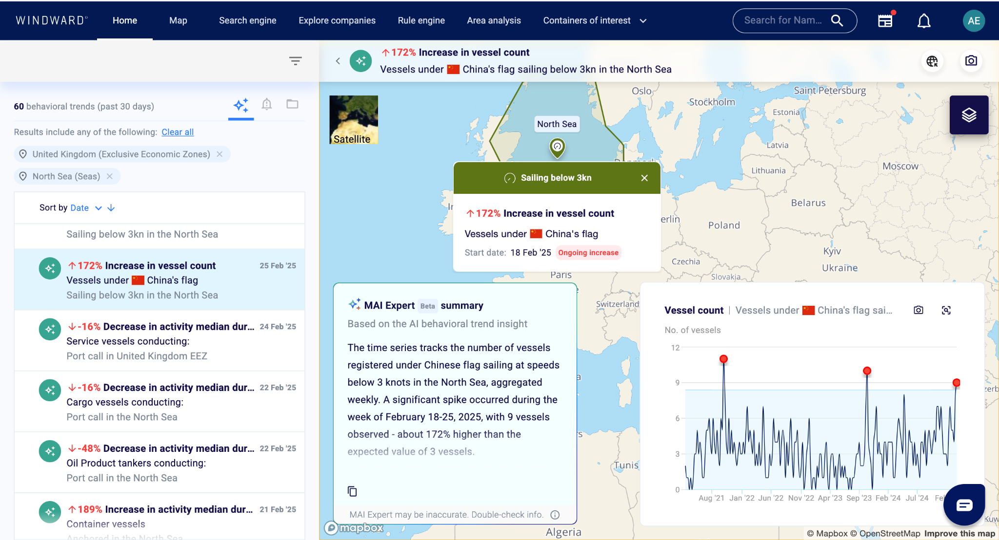
Image showing new threat patterns in real time

Relying solely on physical assets like Coast Guard and Navy ships to protect vessels and critical infrastructure is impractical due to the vast area that must be covered. AI-driven threat detection provides real-time risk analysis, identifying suspicious behavior and prioritizing threats before they escalate. By coordinating naval resources more efficiently, AI ensures that limited physical assets are deployed where they are needed most, rather than attempting to patrol every cable and energy asset at unsustainable costs.
The UK faces significant challenges in enforcing maritime security in the North Sea, particularly due to the complex ownership structure of undersea cables and unclear protection responsibilities. While these cables are critical to national security, they are primarily owned and operated by private companies, meaning the Royal Navy has limited jurisdiction to proactively defend them. Responsibility for protection falls across multiple organizations, including private operators, telecom regulators, law enforcement, the Royal Navy, and Coast Guard, creating overlapping and fragmented accountability. This lack of a unified strategy weakens the UK’s ability to deter and respond to threats effectively. Additionally, the recent push for new security frameworks and initiatives, while well-intentioned, overcomplicates enforcement by introducing further bureaucratic layers. This disjointed approach ultimately benefits aggressors like Russia, who exploit these gaps to conduct mapping, loitering, and potential sabotage operations with minimal resistance.

Deterrents and improvements
Effective cooperation with allied partners and the establishment of clear legal frameworks are essential for protecting the UK’s subsea infrastructure from emerging threats. Strengthening partnerships with NATO, 5EYES, and EU maritime security initiatives will enable greater intelligence sharing, coordinated monitoring, and joint rapid-response efforts against state-backed aggression and hybrid warfare tactics. Collaborative investment in AI-driven surveillance, real-time threat detection, and autonomous maritime defense systems will enhance collective resilience, ensuring a unified approach to deterring and responding to undersea threats. At the same time, clear legal frameworks must be established to define ownership responsibilities, enforcement authority, and accountability for hostile activities in international waters. Current international maritime laws are insufficient in addressing covert sabotage and state-sponsored disruptions, leaving gaps in attribution and legal recourse. The UK should lead efforts to strengthen international regulations on subsea infrastructure protection, ensuring that hostile actions carry diplomatic, economic, or military consequences, while also enhancing domestic legislation to grant greater enforcement power over privately owned critical infrastructure.
While organizations like the Joint Maritime Security Centre (JMSC) play a crucial role in the centralized coordination of maritime security assets, they are not fully equipped to address the rapid progression of technology and the evolving nature of future threats. Their effectiveness is limited by outdated monitoring capabilities, reliance on physical assets, and fragmented oversight over privately owned undersea infrastructure. The private ownership of subsea cables and the shared responsibility between public and private sectors create significant gaps in threat detection, response coordination, and long-term security planning. Without AI-driven surveillance and predictive threat analysis, the current structure risks becoming unsustainable and reactive, rather than proactive. To ensure future resilience, integrating advanced technological solutions alongside centralized command structures is essential for maintaining security in an era where adversaries are leveraging covert cyber-physical tactics and autonomous underwater capabilities.
The growing crossover between military threats and white shipping threats demands a fundamental shift in maritime security strategy. Traditionally, military threats have been handled by defense and intelligence agencies, while white shipping—commercial and private vessels—has fallen under civilian maritime authorities. However, state-sponsored actors increasingly exploit commercial shipping routes, vessel disguises, and hybrid warfare tactics to conduct covert operations, including mapping subsea infrastructure, cyber intrusions, and sabotage. This blurring of lines between military and commercial threats requires a new, integrated approach that leverages AI-driven behavioral threat analysis, real-time vessel monitoring, and closer collaboration between military, intelligence, and private sector stakeholders. Without adapting to this evolving landscape, the UK risks missing critical early warning signs, allowing adversaries to operate in gray zones where traditional military deterrence is ineffective. A modernized maritime security framework must bridge the gap between defense and commercial risk management, ensuring a unified, technology-driven approach to identifying and mitigating emerging threats.

Policy and coordination across government and industry
Effective maritime security requires the ability to share intelligence with non-government organizations, including private infrastructure operators, shipping companies, and cybersecurity firms. Restricting critical threat data to government agencies creates blind spots, whereas secure, real-time intelligence sharing ensures all stakeholders can proactively defend against emerging risks.
Effective maritime security and subsea infrastructure protection require a robust intelligence-sharing framework that extends beyond government agencies to include private infrastructure operators, shipping companies, cybersecurity firms, and other key stakeholders. Restricting critical threat intelligence to classified government channels creates operational blind spots, leaving private sector entities vulnerable to emerging risks. Given that undersea cables, offshore energy assets, and shipping networks are largely owned and operated by private companies, these organizations must have timely access to actionable intelligence on potential threats, such as state-sponsored vessel movements, cyber intrusions, and sabotage attempts. Establishing secure, controlled information-sharing channels—while maintaining classified protections where necessary—will allow for better coordination, faster response times, and stronger collective defense against evolving maritime security challenges. Without such integration, adversaries will continue to exploit security gaps between public and private sector responsibilities, further increasing the risk to national security and economic stability.

Balancing Domestic Resilience and Detection/Interdiction Efforts

Strategic Priorities
- Investment in enhanced maritime surveillance technology, including UUVs for real-time threat mitigation.
- Deployment of AI-powered intelligence to detect high-risk vessel behaviors and intrusion patterns.

Incorporation into Strategic Defence Review and Resilience Review
- Emphasize undersea infrastructure security as a national security imperative.
- Expand operational collaboration between intelligence agencies, law enforcement, and the military.

***The activity data in this document is generated and analyzed using advanced AI, machine learning, and deep learning models. These models process AIS data from multiple sources, including coastal and satellite AIS. The raw data is cleaned, verified, and fused through AI-driven processing to ensure accuracy and reliability.

DISCLAIMER
The results presented in this report were produced by the Windward Intelligence System. While the Windward Intelligence System is proven to yield outstanding and reliable results, these contain by nature statements, and conclusions based (inter alia) on estimates, predictions, assumptions and data which are subject to uncertainties beyond the control of the supplier and therefore might possibly include inaccuracies. The user is therefore encouraged to examine the results and consider additional means to augment conclusions in case any action is taken.

5 March 2025

