Written evidence submitted by Roderick Beck

I have been in telecommunications since 1992 when I joined AT&T and I had a fruitful and long career at the Hibernia Atlantic cable system (now part of EXA Infrastructure) which consisted of three Trans-Atlantic cables two in the Irish Sea. Today I help clients procure their subsea cable needs such as financials, ISPs, and carriers.
There are three key points to keep in mind:
- It is standard best practice to bury fibre optic subsea cables one to two meters under the sea floor, sometimes more, in the shallow waters of the continental shelves. A rule of thumb is to bury when the depth is less than a thousand meters. For example, Facebook's 2Africa cable follows that rule.
- Cables in deep sea waters like oceans usually lie exposed on the sea floor. Burial is rare.
- There are no recorded or documented examples of communication cable sabotage since the end of WWII.
The fact that cables are buried on the continental shelf makes it much more difficult for a malevolent third party to find them. It can be done with magnetic detectors, but it is an arduous task. Cable ships doing repairs often struggle to locate fibre optic cables despite detailed route information including GPS coordinates. Currents can expose buried cables which then drift many kilometres from the original path. A SWM5 cable repair in 2024 shows the cable had moved 17 kilometres from its original path. So it is unlikely that sabotage would target cables close to shore given close monitoring of territorial waters as well as the difficulty in locating them.

Deep sea is entirely different. The cable lies exposed on the bottom floor and should be easy to pinpoint. An unmanned sea drone could locate the cable, land near it, and self destruct. Given that Trans-Atlantic cables like the old Apollo system are well over 10,000 kilometers long protecting these cables in time of a hot war seems a Quixotic undertaking. Undoubtedly the Committee will receive an avalanche of comments about how new cable sensor technologies can alert the authorities in real time. Lots of technology companies will take the opportunity to pitch their wares. The problem is that one must deploy a very large fleet to respond quickly to a sensor alert. Doing so would take away naval resources from other missions. It is important to remember that the US naval operation Ivy Bells during the Cold War used a sub and divers to tap a Russian subsea cable. A first strike in a hot war could eliminate many of the Trans-Atlantic cables by deploying subs in international deep sea waters. Let me add that sabotage of cables in a hybrid operation makes little sense because the existing global telecommunications is already very resilient. The anchor dragging incidents in the Baltic Sea had no perceptible impact on network performance according to a RIPE (Europe’s Internet registry responsible for issuing IP addresses and managing them) study. A slight uptick in latency, but not perceptible to uses in countries like Estonia.

My overall conclusion is that deep sea cables in a hot war will take lots of casualties and that preventing them is near nigh impossible just like in WWI and WWII. Undersea drones have taken out many Russian ships in the Ukrainian war. They are cheap and stealthy. However, the map below shows that there are so many UK subsea cables that it would be difficult to sever most of them in a war. Since the ultimate goal is to ensure UK telecom connectivity with the rest of the world, the best approach to encourage more cable building. The US Digital Titans continue to build physically diverse cables into the UK thus ensuring that telecommunications traffic can be rerouted from a cable gone dark to those still operating. The more cables that land in the UK and more diverse landing points, the more resilient the British telecommunications network becomes. Right now too many cables land near Bude, UK. Landing diversity is remarkably poor for the UK. Secondly, the British government and military should have capacity on multiple satellite constellations, particularly the numerous LEO satellites. There will be eventually tens of thousands of these birds connected with free space laser links to reroute traffic from one bird to another. A very resilient low latency network in the Sky. Another technology that should be adopted would be direct ground laser to satellite communications. Free space lasers send and narrow beam infrared light. It is impossible to eavesdrop on these links. Only the end points can read the data. This technology is already used in the US air force for plane-to-plane communications. Reasonably high bandwidth (100 gigabits per second) and secure. NASA is developing such a network for deep space communications. The main drawback is the signals can be scrambled by clouds and rain. So it improves resiliency, but it is not a golden bullet. The main message is similar to what any good financial advisor would give about your investments: diversify your communication assets.

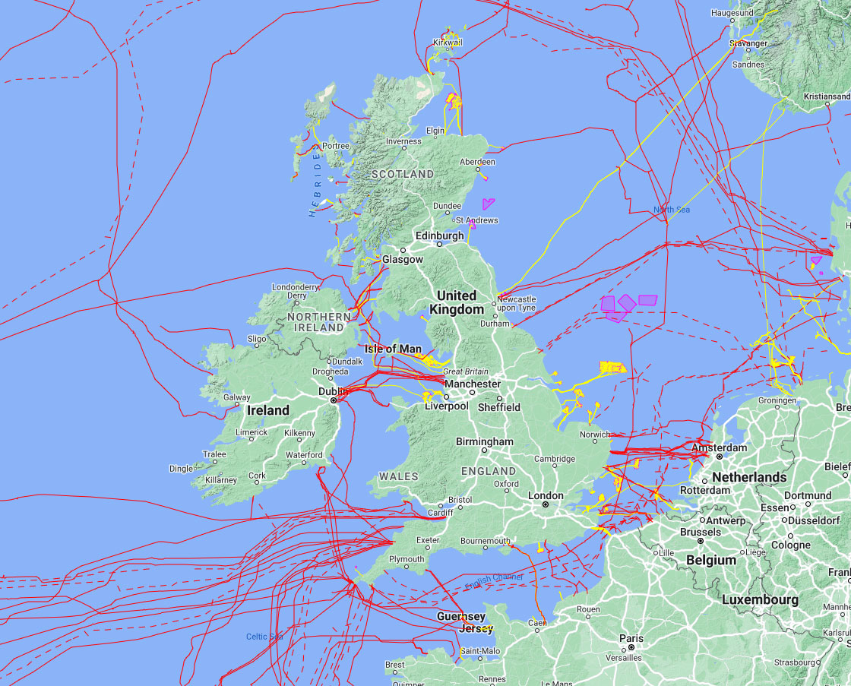
4 March 2025

