Written evidence submitted by SYSTRA UK (BCC0048)

Executive Summary
Overview
This report examines the role of bus services in rural England, evaluating the impact of government policies and proposing recommendations to enhance their delivery and sustainability. Rural bus services are essential for social inclusion, economic development, and environmental goals but face challenges such as funding disparities, declining patronage, and operational inefficiencies.

Introduction to SYSTRA
Among other organisations, SYSTRA was approached to provide the Committee with evidence. We will draw from the considerable experience and expertise of our team to support the Committee with its work. Our colleagues in the Bus team all worked directly with bus operators and local authorities before going into consultancy, giving us a practical understanding of how Government policies impact the day-to-day delivery of bus services.

Key Recommendations
- Increase BSIP funding for rural areas to match urban per-capita levels
- Create Regional Transport Authorities (RTAs) to consolidate resources and improve planning
- Develop a dedicated County Bus Strategy
- Provide long-term funding commitments for the bus industry
- Adopt a statutory definition of essential bus services and provide resources to sustain them
- Replace fuel duty with a progressive road pricing model to invest in public transport
- Clarify which “targeted measures” will replace the fare cap for young people and rural residents
- Abolish the peak-time restriction on concessionary travel
- Support rural LTAs to convert current tendered networks into franchises or municipal operations
- Assist LTAs in adopting technologies to optimise services and meet net-zero targets

England’s Rural Population
Over 12 million people live in rural England, where residents face unique challenges. The older-than-average demographic (25% over 65) disproportionately relies on bus services for social inclusion, access to healthcare, and economic participation. Transport poverty is prevalent, with rural households spending more on transport compared to urban households. Rural areas have historically faced underfunded bus services despite higher operating costs. For FY2022/23, non-metropolitan bus services received just £17.73 per capita, compared to £35.91 in metropolitan areas and £105.80 in Greater London. Geographic and operational challenges exacerbate this disparity.

The Decline of Rural Bus Services
Rural buses provide crucial links to employment, education, and healthcare. However, challenges such as low density, longer routes, and funding cuts threaten their viability. Rural services have declined by over 25% since 2010 due to austerity, rising costs, and declining demand. Subsidy reliance is common, but shrinking budgets and tendering inefficiencies leave gaps in service.

Impacts of Government Policies
Structural reforms introduced by current and previous Governments include:
- BSIPs: Strategic plans for implementing reforms
- Enhanced Partnerships: Agreements between LTAs and operators to set service standards
- Franchising: LTAs set routes and standards, offering operators contracts to deliver services
- Municipalisation: Council ownership and operation of local bus services

Fares Initiatives
The fare cap (introduced in 2023) increased non-metropolitan patronage by 10.4%, but its 2025 increase from £2 to £3 exacerbates regional disparities. The Government’s plans for new “targeted measures” aimed at young people and rural residents once the cap expires in 2026 remain unclear, leaving uncertainty on access and affordability in rural areas.

Proposal: Regional Transport Authorities (RTAs)
The report recommends creating 31 RTAs to replace the current 75 LTAs, by consolidating rural and urban councils under transport partnerships in the model of Strathclyde. RTAs would:
- Improve planning by integrating rural and urban networks
- Reduce costs through economies of scale
- Improve competition by being more attractive to prospective bidders
- Facilitate cross-boundary services through unified management

Case Study: Translink in Northern Ireland
Translink’s integrated model manages urban and rural services under one authority, combining central planning, unified ticketing, and government subsidies to sustain rural routes. This demonstrates how centralised public ownership can maintain service quality and coverage across diverse geographies.

Conclusion
Rural bus services are critical for social, economic, and environmental goals but face systemic challenges. Addressing funding disparities, fostering collaboration through RTAs, and adopting innovative models like Translink can reverse the decline and ensure sustainable, inclusive networks. Immediate action is essential to protect and enhance rural connectivity

Recommendations
- Bring BSIP funding for rural areas up to par with urban areas (beginning with per-capita parity, and factoring in the relative economic challenges posed by higher operating costs) and take corrective action to address the disparities of previous allocations, recognising rural buses as a public service and an economic enabler

- Create Regional Transport Authorities (RTAs) by linking larger towns and cities with their ceremonial counties as a means of pooling funding and resources, scaling up operations, and aiding the task of planning and managing networks (including rural services) oriented around urban centres

- The Government should develop a dedicated County Bus Strategy, using BSIPs as a comprehensive starting point

- Give England’s bus industry a long-term funding settlement for at least the life of this Parliament

- Adopt a statutory definition of essential bus services, with funding and resources to match so that rural LTAs can step in sustainably where commercial operators withdraw

- Recognise that freezing fuel duty is regressive and should be replaced with a progressive alternative (such as road pricing) which raises new revenue to invest in public transport (the most popular mode of which is buses)

- Clarify which “targeted measures” designed to benefit young people and rural residents will take the place of the cap on single fares from 1 January 2026

- Abolish the peak-time restriction on concessionary travel for pensioners and disabled people across England, as peak demand requires less management (thanks to post-Covid changes in commuting patterns) and there have been benefits to lifting this restriction in Scotland; a scheme could be piloted as a means of stimulating patronage on low-volume services in rural areas

- Encourage, empower and equip rural LTAs to convert current tendered routes into either a unified franchise or a municipal network to streamline delivery and achieve better economies of scale

- Provide operators (especially SMEs) with financial and logistical assistance for the deployment of new technologies to optimise service delivery and meet net zero targets (ranging from network analysis and fare capping to depot modernisation and fleet electrification)

Introduction
Following the 2024 General Election, the UK Parliament’s new Transport Select Committee will examine the role of bus services in connecting rural communities with essential services and amenities. This includes evaluating the effectiveness of recent Government policy in achieving its aim of reversing the decline in patronage. The suitability of policies and spending decisions which have been announced (but not yet enacted) are likewise relevant.

Examples of recent Government policies relating to bus services in England include:
- Introduction of franchising powers for Mayoral authorities in the Bus Services Act 2017
- Provision of more than £2bn in emergency funding to protect services during the pandemic
- Publication of the National Bus Strategy in 2021, which introduced:
  - Bus Service Improvement Plans (BSIPs)
  - Enhanced Partnerships (EPs) between authorities and operators
- Capping single fares at £2 (in response to the cost-of-living crisis) in 2023
  - The cap was raised to £3 on 1 January 2025, and will likely expire in 2026
- Announcement of a Better Buses Bill in 2024, which will:
  - Extend franchising powers to non-Mayoral authorities in England
  - Open the door to municipalisation, allowing councils to own and operate bus services
  - Empower LTAs to enforce the terms of BSIPs and raise delivery standards
  - Devolve more control and flexibility over transport spending by LTAs
- Announcement of £1bn investment in bus services for FY2025/26

Sectoral reforms pursued by both the current and previous Governments alike recognise and aim to enhance the social, economic and environmental benefits of bus services. This report will examine the likelihood that such reforms will succeed and will recommend a series of complementary steps.

Among other organisations, SYSTRA was approached to provide the Committee with evidence. We will draw from the considerable experience and expertise of our team to support the Committee with its work. Our colleagues in the Bus team all worked directly with bus operators and local authorities before going into consultancy, giving us a practical understanding of how Government policies impact the day-to-day delivery of bus services.

On the topic of rural connectivity in particular, in 2024, we supported the County Councils Network in producing and publishing a report which examined the state of county bus networks as they recovered from a ‘perfect storm’ brought on by austerity in the 2010s, the Covid-19 pandemic in 2020/21, and a range of other industry pressures resulting in lower revenue and higher costs.

Background Context
England’s Rural Population
Rural communities are defined by the UK Government as areas located outside of settlements with more than 10,000 residents. Additionally, small settlements (with 10,000-30,000 residents) may be designated ‘hub towns’ where they provide services and amenities for rural hinterlands. England’s rural population exceeds 12 million, which accounts for a fifth of the overall populace.

The rural population is older-than-average, with over-65s making up a quarter of the figure (compared to 17% in urban areas). Pensioners are a section of society that disproportionately relies on bus services as a lifeline for the purposes of social inclusion, economic activity, and accessing healthcare. This stems from the fact that many older people choose to give up their cars (or are forced to for financial or health reasons) and take advantage of concessionary travel schemes which allow them to travel free of charge after 09:30am. As reported by Age UK, this demographic is therefore heavily impacted by reductions in public transport provision. A common argument made by advocates is that there is little point in having a free bus pass if there is no bus service on which to use it.

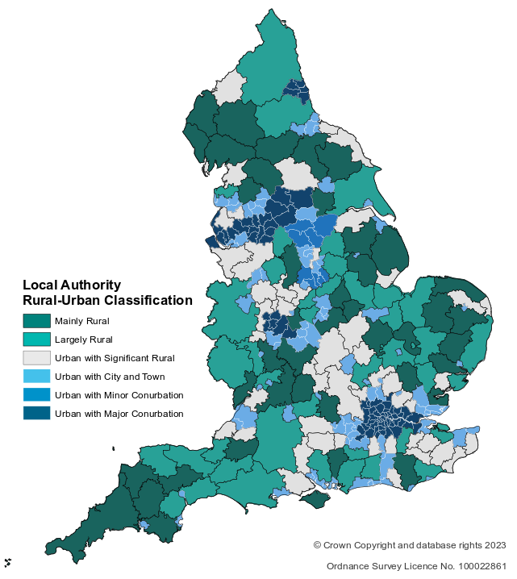
Figure 1: Map showing the rural-urban classification of local authorities across England, as designated by the 2011 census
(source: DfT and Defra analysis in Defra’s statistical digest of rural England)

There has long been a disparity between urban and rural areas where services are concerned, and public transport is no exception. That disparity has widened significantly, thanks to more than a decade of austerity. According to the Health Foundation, real-terms funding for bus services in England’s non-metropolitan counties has reduced by 28% since 2008 (compared with a 25% reduction in metro areas). Whereas the scale differs only slightly in percentage terms, in reality any such reductions are felt much more acutely in places which had smaller budgets to start with.

For reference: the £2.2bn for supporting bus services in FY2022/23 was spent as follows:

Area Type | Amount Spent | Share of Population | Spending per capita
Greater London  Metropolitan areas  Non-metropolitan areas | £938m  £474m  £622m | 16%  23%  61% | £105.80  £35.91  £17.73

Per capita, state funding for buses was almost three times higher in London than in the next six largest cities; and spending in metro areas was twice that of non-metropolitan areas. A major factor driving the disadvantage faced by rural areas is therefore how the DfT allocates its budget across the country.

Research by the Social Market Foundation found that rural communities are hit the hardest by the effects of ‘transport poverty’ (defined as when bearing the costs of transport pushes households below the poverty line) as annual costs are £5,944 for the median British household – compared with £9,200 for the typical rural household. In urban areas, the biggest household expenditure is housing, whereas in rural areas it is transport. This is the compound effect of lower public transport provision and higher mileage driving up the costs of owning and operating a car. Transport poverty affects some five million people across the UK.

By its very nature, transport policy is often geared towards large metro areas: they have the scale, density and passenger demand to sustain more robust networks. In addition to imbalanced spending, this also results in frameworks which do not always account for the challenges especially (or even uniquely) faced by rural areas, peri-urban areas, or smaller urban areas. As the new Labour Government looks to expand devolution across the country, considerable opportunity lies with ensuring that local leaders have the powers and the resources to improve their public transport networks. Research by the Centre for Cities found that transport-related policies enacted by Mayors had the most ‘cut through’ in terms of public recognition. The CfC report likewise found that seven-in-ten people favour the devolution of transport policy powers from central government to local councils or mayors, making it the second most popular choice (just 4% behind housing).

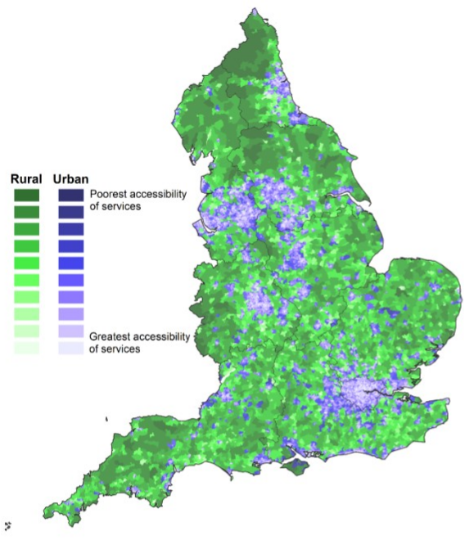
Figure 2: Map showing the urban-rural split in accessing services, based on minimum travel times using public transport
(source: DfT and Defra analysis in Defra’s statistical digest of rural England)

So-called ‘provincial’ bus services have long been operated and administered separately to larger urban networks – dating back to the establishment of the National Bus Company (NBC) in 1969 as a separate entity to London Transport and the Passenger Transport Executives (PTEs) of the six metro areas. In the deregulated era, the NBC was broken up into 52 subsidiaries which were privatised and (for the most part) later acquired by the ‘Big Five’ bus groups in their consolidation phase during the 1990s. In recent years, as the economics of operating bus services has gradually proven more challenging, those groups began dispensing with loss-making subsidiaries – most severely affecting networks in rural communities and smaller urban areas.

The Role of Rural Bus Services
In rural and urban areas alike, local bus services bring enormous economic, social and environmental value. They provide essential links to employment, education and healthcare, as well as facilitating social inclusion for those who would otherwise be isolated without other means of travelling (such as older people, young people, disabled people, and those on lower incomes). However, rural bus services face challenges which threaten viability – such as funding cuts, low demand, and operational inefficiencies.

One of the primary functions of rural bus services is reflected in how they are designed: providing links to the nearest towns and cities. Buses therefore enable rural residents to access public services (such as schools and hospitals) and other amenities without relying exclusively on cars. As such, many rural bus routes tend to generate at least some of their revenue on corridors running in/out of major settlements.

Type | Definition
Inter-urbans  Rural connectors  Locals  Community transport  DRT  Patient transfer | Long-distance routes which link villages, towns and cities together – although limited stop services may bypass smaller settlements in the interests of time and efficiency  Long/mid-distance routes which make local stops and link rural areas to ‘hub’ towns (where passengers can access basic services or transfer for onward travel) or directly into major cities  Short routes which run entirely within a town or village, connecting residents to local amenities or to an interchange where they can access longer-distance routes for onward travel  Not-for-profit services that help people who do not drive and cannot access mainstream public transport; it can take various forms, such as DRT (see below), dial-a-ride schemes, voluntary driver schemes, or minibuses run by organisations such as schools or charities  A shared, flexible transportation system that adapts according to passenger demand, rather than following a fixed route or timetable  Non-emergency transportation for eligible patients unable to access healthcare by other means
Table 1: Names and definitions for the types of bus services which typically serve rural areas across the UK

Expectations and best-practice standards differ between rural and urban settings. For example, in large towns and cities, the accessibility standard for bus stops is up to 400m (or, approximately a five-minute walk), whereas in smaller towns and villages it is up to 800m (or a ten-minute walk). The gaps between departures are likewise longer, reflecting lower demand; turn-up-and-go frequencies are reserved for the densest urban corridors (and, even then, that is not necessarily the norm following the pandemic).

By offering an alternative to driving, rural bus services help to reduce congestion and emissions on inter-urban corridors and in urban centres. Encouraging greater reliance on public transport aligns with the UK’s commitments to sustainable development and net-zero carbon targets.

Rural areas may be less deprived on average than their urban counterparts, but the risk of social isolation nevertheless arises from their geography: some communities are so remote, residents may be forced to change jobs or miss out on interacting with friends and family if they cannot rely on local bus services. Half of England’s rural population lives in areas that have poorest-decile access to services based on minimum travel times, compared with 2 per cent of the urban population.

The Decline in Rural Bus Services
Patronage on bus services has been in decline across the UK since the mid-50s, when the use of private cars overtook that of public transport for the first time. This trend has persisted despite numerous efforts to restructure the way bus services are delivered.

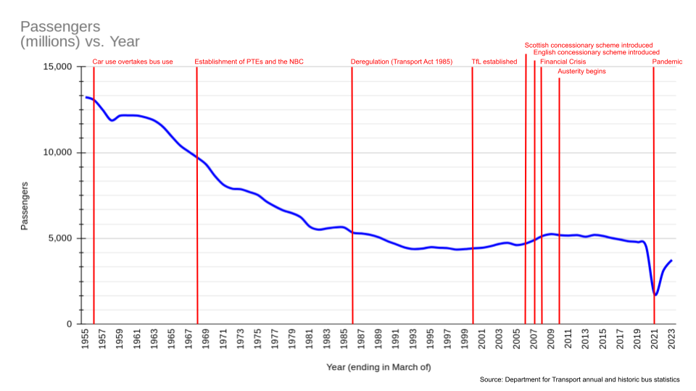
Figure 3: Graph showing the decline in bus patronage across the UK and major milestones in bus-related policy since 1955
(source: DfT annual and historic bus statistics)

The rate of decline slowed after deregulation in the mid-80s, before levelling off in the early-90s and then gradually reversing in the late-90s and throughout the 2000s. The uptick (largely driven by growth in London’s regulated and more heavily subsidised network) was halted by the effects of the recession and was followed by a gradual decline throughout the 2010s before falling off a cliff-edge in 2020 amid the Covid-19 pandemic.

The sector has made a slow, steady recovery in the three years since restrictions were lifted, with some places performing better than others. Nevertheless, numbers overall remain short of 2019 levels, thanks to significant and lasting changes to the way we work, shop and socialise.

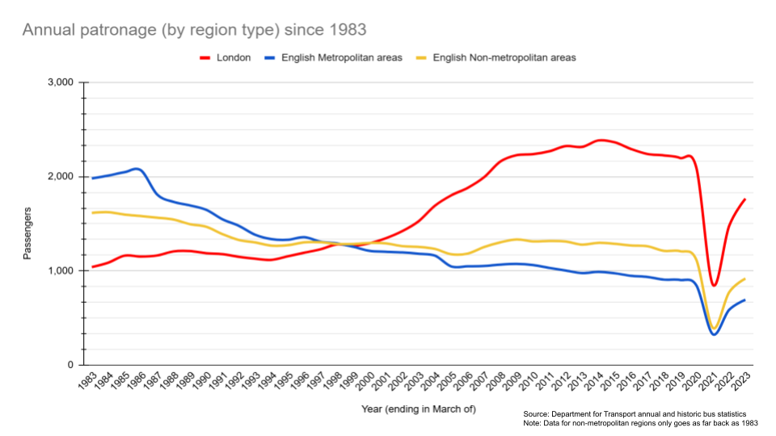
Figure 4: Graph showing annual bus patronage in London, English Metros and non-Metro areas since 1983
(source: DfT annual and historic bus statistics)

Rural bus services have fared worse than those in major towns and cities, despite total bus use in non-metropolitan areas exceeding that of the largest metro areas every year since 1998. Our research for the County Councils Network found that rural bus services had reached a ‘historic low’ by 2023. The number of registered bus services in rural areas dropped by more than a quarter between 2010-22 – a higher rate than in urban areas. This is because the economics and logistics of operating bus services in rural areas are much more challenging than in urban areas:

- Lower density: Rural areas have smaller populations spread over a larger area, leading to fewer potential passengers per route. Unlike urban areas where high density ensures buses operate close to capacity, rural buses often run with empty seats, reducing fare revenue per mile.

- Longer routes: Rural bus routes are typically longer and cover greater distances between stops, with higher speeds on inter-urban trunk roads. This leads to higher fuel consumption, which operators struggle to offset against lower revenue.

- Longer journeys: Longer routes also mean longer journey times, which has significant influence over whether discretionary travellers choose to travel by bus.

- Cross-boundary routes: Passengers often flow from rural areas into urban centres. This means rural LTAs do not have exclusive jurisdiction over the routes which serve their area.

- Higher fares: Higher operating costs combined with lower patronage forces operators to pass that cost on to fare-paying passengers in the form of higher prices. This is currently mitigated by the £3 cap on single fares, but this is set to expire in 2026.

- Infrequent service: To match lower demand in rural areas, timetables are usually much less frequent. This makes it less convenient to travel by bus, leading to discretionary travellers to choose different modes.

- Scheduling inefficiencies: Infrequent or irregular schedules make it harder to optimise vehicle and driver utilisation.

- Maintenance: Rural buses often travel at higher speeds on less maintained roads, increasing the wear on vehicles and requiring more frequent maintenance. Additionally, servicing these vehicles might involve longer trips to centralised facilities, further driving up costs.

- Subsidy dependence: Rural routes often rely heavily on government subsidies or contracts to remain viable. Whilst subsidies help keep services running, there is a relatively weak incentive for commercial operators to bid for contracts which may not last long-term and provide limited profitability.

- Smaller scale: Operators tend to structure themselves as one entity with multiple subsidiaries, which generally requires each to run self-sufficiently with minimal centralised support. Whereas subsidiaries benefit from collective procurement and streamlined policies and procedures, rural communities are also more likely than cities to be served by small, independent operators which do not have those cost-saving capabilities built in.

- Comparison to urban areas: Urban services benefit from economies of scale. Higher passenger volumes, shorter routes, and frequent stops ensure buses operate efficiently and generate more revenue per trip.

Where revenue falls below the level required even to cover costs (let alone generate profit), commercial operators are not obliged to keep running loss-making services; in fact, under the rules of deregulation, they are prohibited from doing so as it would be anti-competitive. Where losses are substantial enough, operators may decide to shutter depots and withdraw entire networks; the challenges of recent years have prompted the ‘Big Five’ groups to discard poorly performing subsidiaries in order to concentrate on protecting the more viable parts of their business. In such circumstances, it falls to LTAs to step in and ‘rescue’ socially necessary routes with subsidised contracts. But this is fraught with challenges:

- Funding cuts: 90% of LTA-supported bus services in England have been lost due to budget cuts since 2010 (compared with 50% across the board), with regional disparities affecting the North of England more than the South. This issue was compounded by the expiry of Covid-era funding to temporarily protect services.

- The urban/rural divide: In the 2023/24 round of BSIP funding, the 37 largest county councils (representing half of England’s population) received just a third of the money, with the lion’s share going to unitary authorities covering larger towns and cities.

- Diminished demand: Operators only withdraw commercial services where they fail to generate sufficient patronage and revenue to cover costs. Unless LTAs step in immediately with a like-for-like service, there is significant risk that the passenger base will shrink even further as people travel less often or find permanent alternatives.

- Lack of competitive bidding: Costs are driven up by tendering because commercial operators are wary of the obligation (they can be a lot of effort for relatively little reward). It is not unusual for some places to only have one or two bidders, weakening the LTA’s position as a buyer. Some operators bid for contracts as a formality, supplying inflated prices as a means of mitigating the perceived inconvenience; post-Covid, their focus is on recovering core markets, so diverting drivers and vehicles to low-volume, low-value rural tenders has to be worthwhile.

- Disjointed contracts: As a result of commercial routes being withdrawn at different stages, LTA contracts do not always necessarily align with each other (in terms of when they begin or how long they last). Tenders are also often awarded individually, rather than as a tranche of routes forming a mini network, which adds to the administrative burden of delivering contracts.

A key feature of rural bus services is that they typically feed into nearby towns and cities. Many rural LTAs are ‘anchored’ by at least one major settlement (such as Carlisle in Cumberland, or Worcester and Redditch in Worcestershire) which the network is oriented around, and which makes it easier for the LTA to more properly define how it would like the local network to look. Many counties, however, are administered separately to the cities they are intrinsically linked with (such as Leicester functioning as an island in the centre of Leicestershire, or Telford having been carved out of its ancestral Shropshire), making it difficult for predominantly or significantly rural areas to pursue their interests on their own.

The UK’s bus industry has weathered a ‘perfect storm’ of challenges in recent years; it brewed during a decade of austerity in the 2010s before reaching its climax during and immediately after the pandemic. A combination of higher costs, lower revenues, cuts and caps to Government funding, labour shortages, and societal changes has left the industry weakened and vulnerable to future shocks. SME operators –the kind that disproportionately serve rural communities – are less likely than their larger counterparts to be able to withstand these pressures, as evidenced by recent business closures.

The Impact of Government Policies
Structural Reform Options
Across the partisan divide, the current Labour Government and previous Conservative Governments have committed to a series of structural reforms in England’s bus industry. As stated in the National Bus Strategy (published amid the pandemic in 2021), “If we are not to abandon entire communities, services cannot be planned purely on a commercial basis.” This was reiterated in updated guidance concerning BSIPs in January 2024, showing that that was not a temporary point of view. Following Labour’s coming into office in July 2024, that direction of travel will only continue, with Labour’s long-established position in favour of re-regulating bus services.

The headline mechanisms for reforming the delivery of local bus services, as set out in various pieces of legislation and Government strategy adopted since 2017, are as follows:

Mechanism | Definition
BSIP  Enhanced Partnerships  Franchising  Municipalisation | Bus Service Improvement Plans are a statutory document which sets out the case for reform in an LTA area. With a BSIP as its strategic foundation, the LTA can then determine whether to enact reform using the options of an Enhanced Partnership, franchising, or (pending passage of the Buses Bill) municipalisation.  A legal framework in which authorities and operators collaborate on measures to deliver BSIP objectives to improve the quality of bus services in their area(s). Measures may include policy changes or infrastructure upgrades.  Empowers LTAs to assume direct control of setting the routes, frequencies, fares, and other standards for bus services in their area. Operators bid to run the services and are accountable for the delivery of defined standards.  The process by which an LTA may assume not just control, but also ownership and operation, of their own bus companies. Ther has been a legal ban on the creation of new municipal bus companies since 1985, but the Buses Bill will overturn that prohibition.
Table 2: Mechanisms for reforming the delivery of local bus services across England

One of the benefits of the National Bus Strategy is that, for the first time in many years, it created an organising principle for the mission of improving bus services. Its adoption followed the earliest attempt at reform (franchising in Mayoral authorities) and rolled out a more comprehensive framework across England by making BSIPs a precondition for receiving Government funding and introducing Enhanced Partnerships as a more light-touch method of enacting reforms. The new Labour Government is building on that foundation with its own set of wide-ranging reforms.

Although, prior to the General Election, the former Secretary of State for Transport expressed that the new Labour Government would “presume in favour of franchising” as its preferred model of reform, a crucial aspect is that the legislation is neither prescriptive nor overly restrictive in terms of how powers are used. This enables LTAs to decide which model(s) best suit the circumstances of their area.

Bus Service Improvement Plans (BSIPs)
BSIPs form the strategic baseline for enhancing service delivery in an LTA area, regardless of the model it ultimately chooses. Existing legislation requires LTAs to enact BSIP objectives via franchising (in eligible areas) or an Enhanced Partnership, whilst pending legislation will extend access to franchising powers and add the option of municipalisation.

All 75 LTAs in England adopted BSIPs following their introduction in 2021, and subsequently refreshed them to unlock further funding allocations. BSIPS are therefore treated as ‘living documents’ which may be adapted according to changes in circumstances such as funding, new challenges and opportunities, or collaboration between neighbouring authorities.

Whereas the allocation of funding for BSIPs was subject to competitive bidding between 2021-24, the allocations for FY2025-26 were instead made based on need (see ‘Funding’ on page 14 for more).

Enhanced Partnerships
As an agreement between authorities and operators, EPs empower LTAs to set standards on anything from routes and branding to maximum fares and multi-operator ticketing. The same benefits of urban EPs are largely applicable to rural EPs (albeit subject to disparities in funding and scale).

Although operators are nominally obliged to comply with standards, and there are some regulatory provisions designed to aid enforcement (such as making compliance a condition of registering services, under threat or rejecting new applications or even cancelling existing registrations), EPs are nevertheless not legally binding. Operators may therefore end their participation and, in the process, withdraw their services. In this event, LTAs would lack the security of franchising (whereby contracted operators could be heavily penalised for premature cancellations, and the LTA itself could establish an operator-of-last-resort to step into the breach and keep services running until a new contractor can be mobilised).

As revenue risk remains with commercial operators under an EP, this model therefore exposes the same risk that services or networks no longer deemed commercially viable will be withdrawn – effectively the status quo position – with rural areas more vulnerable to this eventuality than urban areas.

Franchising Powers
Franchising allows local authorities to take control over the planning, operation, and funding of bus services, as opposed to relying on commercial operators. While urban areas have seen more immediate benefits, the impact on rural areas remains mixed, presenting both opportunities and challenges.

The impact of franchising powers on rural areas is as-yet untested because Greater Manchester is, to-date, the only LTA to have enacted these powers – and less than 1% of Greater Manchester’s population of 2.9m is considered rural. Other Mayoral authorities are at various stages of considering franchising as of January 2025, with rural populations ranging from 1.3% (Liverpool) to 62.0% (York and North Yorkshire). As plans are developed and deployed in these areas, the benefits and challenges alike for rural communities will become clear.

City Region | Franchising Status | Population | (of which rural)
Cambridgeshire and Peterborough  East Midlands  Greater Manchester  Liverpool  London  North East  South Yorkshire  Tees Valley  West of England  West Midlands  West Yorkshire  York and North Yorkshire | In public consultation  N/A  Fully franchised as of January 2025  Committed to franchising  Fully franchised  Committed to franchising  Committed to franchising  No plans  No plans  Committed to franchising  Committed to franchising  N/A | 689,109  2,230,289  2,911,744  1,571,045  8,866,000  1,994,284  1,392,105  688,756  962,883  2,953,816  2,378,148  828,052 | 61.5%  21.5%  0.9%  1.3%  0.0%  29.2%  9.5%  1.7%  11.5%  1.6%  11.9%  62.0%
Table 3: The status of franchise consideration (as of January 2025) among Mayoral authorities in England (source: Centre for Cities)

Currently, the powers to introduce franchising are only automatically available to Mayoral authorities; non-Mayoral LTAs require secondary legislation and ministerial permission on a case-by-case basis. Once the Buses Bill becomes law, however, those powers will be available by default. This will open the possibility of franchising in rural areas and smaller urban areas.

In theory, the benefits of franchising in these areas are the same as those that apply in London and Greater Manchester: co-ordinated, equitable network planning; simplified bus services and multi-modal integration; lower, simpler fares; and clear, democratic accountability. However, as outlined previously, the economics of operating rural bus services differ significantly to those of running urban networks. Large, sparsely populated counties lack the scale or concentration of demand needed for efficient and financially viable operations (hence the heavier relative decline already underway in rural areas). Further, as rural networks are often oriented around larger towns and cities, rural LTAs would not enjoy universal jurisdiction over the services they would aim to administer; cross-boundary collaboration would be vital to avoiding the creation of ‘two-tier’ services.

The appetite for franchising will likely be limited in places where bus networks are already struggling. For instance, elected officials in Cambridgeshire and Peterborough (the population of which is 61.5% rural) have expressed wariness over the costs and financial risks associated with taking control of bus services – as authorities would have the same obligation to ‘balance the books’ as commercial operators. The matter has been on the authority’s agenda since 2018, and, if agreed, likely would not take effect until the autumn of 2027 (with no indication yet of when a completed roll-out would be expected). This points to a relative lack of capacity in all but the very largest, densest LTAs; even Greater Manchester took almost seven years and spent £135m (£46.36 per capita) on its transition.

A key difference between the deregulated market and franchising concerns cross-subsidy: competition laws prohibit commercial operators from using profits from one route to underwrite losses on another, whereas franchise authorities would be permitted to do precisely that. However, though useful, this tool has limited utility: in an era of higher costs and lower revenues, commercial services are mostly marginal at best – producing profit margins of 5-8%. Overstating the value of cross-subsidy therefore carries two major risks: 1) there is only so much profit to redistribute, meaning it may be insufficient to sustain the entirety of a rural network; and 2) even if it were sufficient, it would be commercially reckless for an LTA to extract every penny of profit from strong services to sustain weak ones, as ‘throwing good money after bad’ could be a waste with no guarantee of success. As much as possible, revenue surpluses should be invested in general improvements such as fleet upgrades, priority infrastructure, waiting facilities and a range of other essential features of world-class bus networks. High-volume, high-value corridors have always been the ‘bread and butter’ of commercial operators. As such, passengers are accustomed to a certain standard of frequency, investment and the like on the busiest routes; diverting that money elsewhere risks a perception among those passengers that quality has regressed rather than improved. Cross-subsidy must therefore be carefully considered, balancing the needs of rural communities with the expectations of urban residents.

Bus networks are not necessarily wholly contained within the boundaries of a single LTA; this is especially true of rural services. Whereas urban networks are often compact and contained within municipalities, rural services typically run from small towns and villages into larger town and city centre, which usually means crossing a boundary. As franchising likely becomes more common across England, it will become increasingly necessary for LTAs to develop a way to collaborate on cross-boundary services: whether because of two separate franchises neighbouring each other, or because of one area franchising whilst its neighbour continues to allow commercial operation. In the latter case, there are already provisions for permits whereby a franchising authority allows an out-of-area route to run alongside its contracted network, subject to certain conditions such as co-ordinated scheduling or integrated ticketing. In the former, however, a more refined process may be required to facilitate LTAs collaborating on cross-boundary routes without necessarily sharing the responsibility for contracting or operating them. This would involve joint service agreements, shared ticket acceptance and harmonised network design (to avoid inefficiencies such as duplication or imbalanced frequencies). Another potential solution is with the creation of ‘Regional Transport Authorities’ comprising multiple council areas, in the mould of the Strathclyde Partnership for Transport in western Scotland (see ‘RTAs’ on page 18 for more).

At present, LTAs must satisfy a range of criteria to demonstrate their capability to implement franchising. Given the smaller budgets and limited resources of rural LTAs, this necessary step may act as a barrier to officials seeing it as a viable option for their area. An alternative could be a dual exercise: rigorously assessing not only the feasibility of franchising but also the suitability of the status quo. As set out in the NBS, the cross-party consensus is clearly that the status quo is no longer fit for purpose; if it were, structural reform would not be the subject of debate and policy development it has become. It is logical to view the transition away from four decades of operational orthodoxy as a significant risk and potential disruption, and LTAs should proceed with due caution when moving to assume direct control. However, if a dual exercise found shortcomings in both the status quo and the potential for franchising, then the Government should develop and deploy additional measures to aid the LTA in addressing those short-comings and managing the transition more effectively.

There are various methods of structuring franchising contracts, with the most common models being ‘gross cost’ and ‘net cost’:

- Gross cost: The LTA pays the operator a fixed fee to provide services, while the authority retains all fare revenue. This model gives the LTA greater control over how services are designed, with operator incentives tied to service quality metrics rather than revenue performance. Without a stake in the revenue, there is little incentive for operators to economise costs – or to even track costs at all.

- Net cost: The operator retains fare revenue and receives a smaller subsidy or payment from the authority to cover the difference between revenue and operational costs. This model allows LTAs to take advantage of operators’ commercial acumen to drive innovation and efficiencies. Where the farebox falls short, the LTA provides subsidies to make up the gap. This model fosters genuine partnership between the LTA and contracted operators as both parties share a stake in the risks and rewards.

The Bailiwick of Jersey introduced a franchise (called ‘Liberty Bus’) using the gross cost model in 2002. Over the course of the inaugural 10-year contract, officials in Jersey concluded that the quality incentive was insufficient because its operator, Connex, had no ‘skin in the game’. In 2010, a major review resulted in a change of approach: adopting a net cost model as a means of stimulating network coverage and capacity. The tendering process was also reoriented in favour of quality (60%) over cost (40%).

In the years 2013-2017 (the first four years of that contract), Liberty Bus patronage increased by 32%. This, in turn, boosted profitability and reduced subsidies by some £800k per year. The co-ordination of planning, ticketing and other aspects of service delivery culminated in a 5% improvement on satisfaction scores, plus the introduction of new routes and higher frequencies on key corridors.

Updated guidance issued by the UK Government allows for the ‘direct award’ of franchise contracts to incumbent operators. This will benefit LTAs with minimal experience in dealing with large-scale public transport contracts (most LTAs’ experience is limited to tendering a small number of subsidised routes alongside commercial networks, rather than taking overall responsibility themselves). Direct award is a ‘light touch’ method of implementation, giving both the authority and operators a few years to become familiar with how franchising works before committing to tendering the entire network from scratch. Once the initial term of the ‘shadow’ franchise is completed, all contracts would be subject to a normal competitive tendering process, wherein new entrants would have the opportunity to bid.

Whereas big group operators (e.g. Arriva, First, Go-Ahead, and Stagecoach) are familiar with the bidding process thanks to their experience in Greater Manchester or more mature markets like London or even international settings, SME operators typically lack the knowledge and resources to prepare competitive bids. This is why SME operators are often cautious about the prospect of franchising: they fear it may put them out of business. Under direct award, SMEs will be better equipped when the time comes to bid for a second term as a contractor.

Municipalisation
Municipalisation would be the process by which an LTA may assume not just control, but also ownership, of their own bus companies. The creation of new council-run bus companies has been prohibited since 1985, despite the success of existing municipal operators in Blackpool, Ipswich, Nottingham, Reading, and Warrington – plus other examples outside England, such as Lothian Buses in Edinburgh. As set out in the Buses Bill, the Government intends to permit LTAs to pursue this option. This follows a course already charted by recent legislation in Scotland (although no Scottish council has yet activated these new powers).

Under competition law, municipalisation would not preclude a private operator from running alternative services which compete with council-run for-profit services. This creates a potential risk in markets which lack the volume to sustain multiple service providers – and it would require lots of money, resources and effort from LTAs which have no hands-on experience in operating local bus services. There is no recent precedent for creating a major municipal bus company from a standing start, rendering this an as-yet untested concept. Further, if commercial operators already struggle to run viable rural services, there is no guarantee that a municipal operator would be able to make it work either.

Funding
The Government has committed billions of pounds to the bus industry in recent years – beginning with emergency funding to protect services from collapse during the pandemic, and followed by significant investments aid their recovery and facilitate enhancements.

In 2021, the Government announced that £3bn would be spent to enact local BSIPs as part of the National Bus Strategy. However, in FY2022/23, only £1.2bn was made available, with fewer than half of all LTAs receiving any funding. Among those that received no funding were seven of the ten most rural LTAs in England. In fact, of the 17 LTAs with predominantly rural population, only four (Cornwall, Devon, Norfolk and Somerset) were successful.

More money was earmarked for phase two of the BSIPs, but it amounted to just £156m, and was spread over the course of two years (FY2023/24 and FY2024/25). Every LTA received funding, but it was not evenly distributed: two-thirds of the funding went to the largest towns and cities, with only one-third going to rural areas (despite representing half of England’s population). Consequently, cities saw a 7.4% reduction in bus miles in the four-year period between 2019 and 2023, whereas counties saw a reduction of 16% (more than twice the rate).

Although this new Government has pivoted away from competitive bidding in favour of allocations based on need, regional disparities persist:
- “Need” was defined primarily be levels of deprivation (which is indeed higher in urban areas than in rural areas), but the relatively worse position of rural services should likewise have been considered when defining the need for enhancement
- The above notwithstanding, making this year’s allocation more equitable does not fully rectify the imbalances in the allocations of previous years, thus leaving rural areas at a disadvantage

Category | Rural Population Share | Funding per capita
Predominantly rural  Significantly rural  Slightly rural  Small urban (pop. <500k)  Large urban (pop. >500k) | >50%  20-50%  5-20%  <5%  <5% | £14.91  £13.84  £13.73  £22.53  £15.89
National average | … | £15.24
Table 4: Funding allocations per capita in FY2025/26, according to LTA rurality

An analysis of the per-capita allocations of the £1bn funding announced for FY2025/26 show that small urban areas (with fewer than half a million inhabitants) are the biggest beneficiaries, whereas rural areas on the whole fare worse than the national average. This is despite rural bus services being more expensive to operate per-capita due to longer distances covering sparser populations, with higher maintenance costs and less efficient scheduling. Therefore, although the Government is correct to point out that many areas are receiving unprecedented levels of funding in this round, there are nevertheless flaws in the allocation mechanism as far as rural areas are concerned.

Prior to the general election, the Confederation of Passenger Transport (CPT) published ‘Driving Britain Forward’: a list of priorities to strengthen bus services throughout the lifetime of this new Parliament. At the top of that list was a five-year funding settlement, citing that “a lack of clarity over the existence and size of future funding streams” prevents operators and authorities alike from investing in much-needed, longer-term improvements. This is not just a matter of free market confidence: if the state wants to play a bigger role in the delivery of local bus services, it needs a full toolkit – the resources, the funding and the stability – to do so.

The Government has additionally spent more than £500m capping single bus fares since 1 January 2023 as a means of alleviating the cost-of-living crisis. The cap increased from £2 to £3 on 1 January 2025, and is due to expire on 31 December 2025 (see ‘Fares Initiatives’ on page 16 for more).

To raise new revenues which can be invested in the enhancement of public transport, the Government should recognise that freezing fuel duty since 2011 has been regressive and consider its replacement by a more progressive alternative such as road pricing. Not only does it disproportionately benefit wealthier drivers over those on lower incomes, there are concerns over its long-term sustainability with the transition to electric cars (since fuel duty is levied on the basis of emissions output). The Government could lose up to £25bn per year if it does not find a replacement. This ‘burning platform’ is therefore a golden opportunity for the Government to live up to its professed commitments to net zero and modal shift by charging motorists to cover the negative externalities of driving and to invest in public transport.

Fares Initiatives
The last Government invested £23.5m in a ‘Bus Fares Pilot’ in Cornwall (a first-in-the-nation experiment to test the hypothesis that reducing fares will increase patronage). The pilot began in 2022 and will last until 2026. It includes a multi-operator initiative called ‘Any Ticket, Any Bus’, plus the capping of day tickets at £2.50 for town networks and £5 for the whole county. An intermediate survey by Transport Focus found that 75% of respondents were satisfied with the value for money (versus a 67% national average). Further research found that half of respondents were using the bus more regularly because of cost savings and service improvements. And, at the end of 2023, Cornwall was one of only seven LTAs in England where bus patronage was higher than it was a decade prior. It should be noted that, despite these subsidies (in addition to £23.5m of separate funding for Cornwall’s BSIP), rural routes with low passenger numbers remain financially challenging to sustain, and the long-term viability of the scheme hinges on continued financial support from central Government, which is not permanent.

The most significant Government intervention concerning bus fares is of course the cap on single fares. It was introduced on 1 January 2023 during the height of the cost-of-living crisis, with fares capped at £2 across England (outside London). The scheme was subsequently twice extended, before rising to £3 with effect from 1 January 2025. The former Secretary of State for Transport, Louise Haigh, said that the cap will be allowed to expire on 31 December 2025 – after which it would be replaced by “targeted measures” aimed at young people and residents of rural communities. There is no indication yet of what form those measures would take, or how much funding will be earmarked for them; indeed, in the context of persistent economic challenges, the Government may yet decide to let the cap expire and introduce nothing new in its place.

Location | Single Fare Cap from 1 January 2025
Greater London  Cambridgeshire, Greater Manchester, Liverpool and West Yorkshire  Rest of England  Scotland, Wales and Northern Ireland | £1.75  £2  £3  No Government-funded fare cap

When it announced the ‘billion-pound boost for buses’ in FY2025/26, the Government expressed its aim of “ending the postcode lottery” concerning affordable, accessible bus services. However, the decision to raise the nominal fare cap has exacerbated – not lessened – the disparity between different parts of the country. In certain city regions (i.e. Greater Manchester, South Yorkshire and Liverpool), Mayors have pledged to keep the cap at £2. In most of England, smaller cities and counties which lack the same powers to raise and spend revenue have seen it rise to £3. London, of course, remains cheapest of all at £1.75. And in Scotland, Wales and Northern Ireland, there is no cap at all (and there never was one). The state of play has therefore gone from being (reasonably) equitable to once again disadvantaging predominantly or significantly rural areas and smaller urban areas.

In FY2023/24, bus patronage increased by 12% in England (outside London). This is likely largely due to the generative effects of the fare cap. That growth contributed significantly to the industry’s ongoing recovery from the pandemic; overall demand is now around 90% of 2019 levels. Indeed, the data shows that the increase was higher in non-metropolitan areas (10.4%) than in the conurbations (7.6%) – and yet those non-metropolitan areas are the ones that have experienced a 50% price hike, whereas some of their urban counterparts have been spared thanks to the Mayoral interventions. Research by the New Economics Foundation found that maintaining the cap at £2 for a third year would have cost just a tenth of the bill associated with maintaining the freeze on fuel duty for yet a 15th year (£300m vs £3bn).

Other Initiatives (DRT)
Demand Responsive Transport (DRT) offers a flexible and cost-effective alternative to conventional bus services in rural areas where low patronage makes regular routes financially unviable. DRT services use smaller vehicles that operate on flexible routes and schedules, adapting to passenger requests rather than following fixed timetables. It can serve remote rural communities not covered by traditional bus networks, ensuring residents can still access essential services like healthcare, education, and shopping. By only running vehicles when and where needed, DRT reduces operational costs compared to fixed-route buses, which often run underutilized in rural areas.

Challenges include technology barriers (as many prospective passengers, especially the elderly, do not have access to smartphones, which are required to book journeys using digital platforms) and finances (as DRT usually requires some form of subsidy to continue operating, given the difficulty of cost recovery from a small, sparse pool of passengers).

Proposal
New Regional Transport Authorities (RTAs)
A key feature of this Government’s agenda is the expansion of devolution across the UK – including in the regions of England. The Deputy Prime Minister, Angela Rayner, has noted her ambition to introduce “devolution by default” in a bid to “create a new era of local power”. One such solution is to consolidate two-tier county/district councils into larger unitary authorities; a complementary measure would be to empower more regions with Mayoral systems such as those seen in the largest conurbations (and which have since been rolled out to more rural areas such as York and North Yorkshire).

In this vein, this report proposes the creation of a new generation of ‘Regional Transport Authorities’ (RTAs). They would comprise multiple councils in the same manner as the Strathclyde Partnership for Transport, which is composed of 12 council areas. Constituent councils would retain their independence in the provision of all other local services; they would just collaborate on the matter of transportation, which largely transcends boundaries.

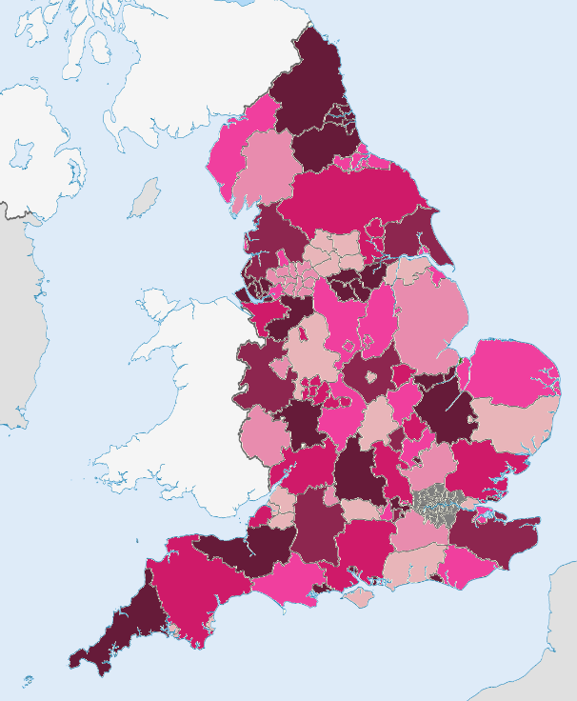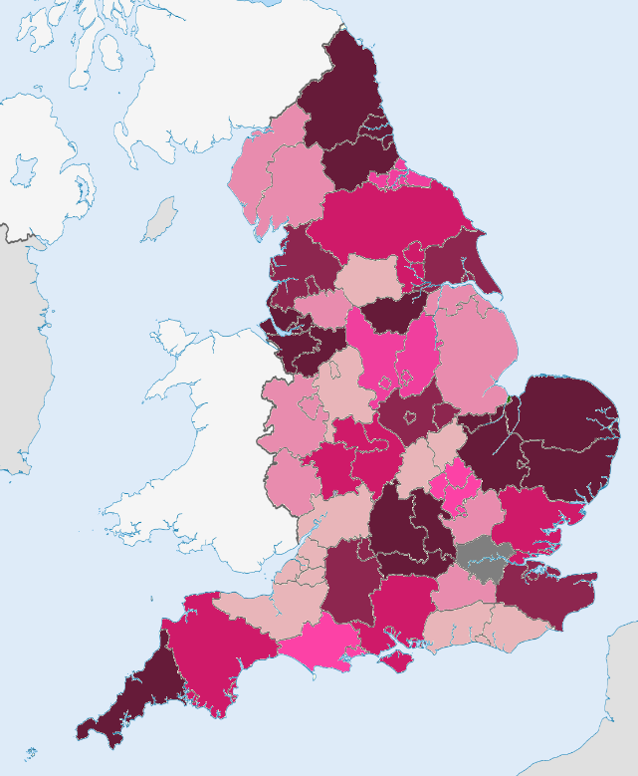
Figure 5: Maps showing current Local Transport Authorities (LTAs) and proposed Regional Transport Authorities (RTAs)

Most RTAs would be formed by ‘reuniting’ larger towns and cities with their ceremonial counties. Some exceptions would be made where justified by population distributions and travel-to-work areas (e.g. linking Milton Keynes to the ceremonial county of Bedfordshire, and linking the rest of Buckinghamshire with Berkshire, given that much of its population lies closer to Reading than to Milton Keynes).

The total number of LTAs is currently 75; whereas this proposal would result in just 31 RTAs, more than halving the number. Since councils largely lack the experience and expertise needed to manage local bus services among their current workforces, it follows that a major recruitment drive would be needed to bring those skills in-house; recruiting to staff 31 organisations would be easier, cheaper and more efficient and effective than 75 smaller units competing in a finite talent pool. If smaller-scale rural LTAs were to try and compete for new staff on their own, they would likely lose out to larger conurbations which may pay better and provide a more fulfilling professional challenge (not to mention being places potential recruits may prefer to live in).

Moreover, as noted previously, one of the key challenges associated with bus services in rural areas is that they are not wholly contained within rural counties – they cross boundaries into urban centres, as that is where passengers largely want and need to travel. By formalising the collaboration between rural and urban areas through RTAs, the issue of managing cross-boundary services (for example under a franchise) resolves itself, and improves the likelihood of more robust networks taking shape by avoiding unnecessary duplication and preventing local boundaries from becoming barriers.

Regional Transport Authority | Current LTAs
Bedfordshire and Milton Keynes  Cornwall  Cumbria  Devon  Dorset  East Anglia  East Midlands  East Yorkshire  Essex  Greater Manchester  Hampshire  Hertfordshire  Kent  Lancashire  Leicestershire  Lincolnshire  Merseyside  North East  Northamptonshire  Ox, Berks and Bucks  Shropshire and Herefordshire  South Yorkshire  Staffordshire  Surrey  Sussex  Tees Valley  West of England  West Midlands  West Yorkshire  Wiltshire  York and North Yorkshire | Bedford, Central Bedfordshire, Luton, and Milton Keynes  Cornwall  Cumberland and Westmorland  Devon, Plymouth, and Torbay  Bournemouth, Christchurch and Poole, and Dorset  Cambridgeshire and Peterborough CA, Norfolk, and Suffolk  East Midlands CA  East Riding of Yorkshire and Hull  Essex, Southend-on-Sea, and Thurrock  Greater Manchester CA  Hampshire, Isle of Wight, Portsmouth, and Southampton  Hertfordshire  Kent and Medway  Blackburn and Darwen, Blackpool, and Lancashire  Leicester, Leicestershire, and Rutland  Lincolnshire, North Lincolnshire, and Northeast Lincolnshire  Liverpool CA and Warrington  North East CA  North Northamptonshire and West Northamptonshire  Bracknell Forest, Buckinghamshire, Oxfordshire, Reading, Slough, West Berkshire,  Windsor and Maidenhead, and Wokingham  Herefordshire, Shropshire, and Telford and Wrekin  South Yorkshire CA  Staffordshire and Stoke-on-Trent  Surrey  Brighton and Hove, East Sussex, and West Sussex  Tees Valley CA  Gloucestershire, North Somerset, Somerset, and West of England CA  Warwickshire, West Midlands CA, and Worcestershire  West Yorkshire CA  Swindon and Wiltshire  York and North Yorkshire CA
Table 5: List of proposed Regional Transport Authorities (RTAs) and the existing Local TAs that would constitute them

Combining smaller LTAs into larger RTAs would improve scale – both in terms of pooling resources and capacity to implement structural reform, and achieving economies of scale. Whereas urban areas are more likely to manage franchising on its own, for example, rural areas would benefit greatly from this sort of joint effort as it would ‘level’ the playing field: not only would it enable more holistic network design and simpler ticketing, it would likewise make it more attractive for operators to bid for contracts which include rural services. A regionalised franchise authority could bundle rural routes into the same tranche as urban corridors; operators would not be able to ‘cherry pick’ the types of routes that they want to run, and it would more readily facilitate cross-subsidy between stronger and weaker routes.

As shown in Table 6, the per-capita allocation of BSIP funding in FY2025/26 would improve by 6-8% in areas with considerable rural populations, albeit mostly by cross-subsidising rural areas with money from small urban areas – but these are the ‘anchor’ destinations around which rural networks are already oriented, which is the fundamental rationale behind these proposed RTAs. It should be noted that the economic success of a large settlement like Plymouth, for example, depends at least in part on good access to/from smaller towns and villages in the rest of Devon. Therefore, in this scenario, creating an RTA should not be viewed as ‘taking’ money from Plymouth and ‘giving’ it to Devon – but sharing the money more equitably across two areas that are intrinsically linked.

Category | Rurality | £ per capita (current) | £ per capita (proposed) | % improvement
Predominantly rural  Significantly rural  Slightly rural  Small urban (pop. <500k)  Large urban (pop. >500k) | >50%  20-50%  5-20%  <5%  <5% | £14.91  £13.84  £13.73  £22.53  £15.89 | £16.16  £14.64  £14.57  …  £16.68 | 8.4%  5.8%  6.1%  …  5.0%
National average | … | £15.24 | £15.24 | …
Table 6: Funding allocations per capita in FY2025/26, according to rurality, contrasting current LTAs with proposed RTAs

Almost all council areas across England (outside London) include at least some share of rurality – even some of the largest conurbations – which suggests that collaboration between neighbouring councils would be worthwhile, especially since peri-urban fringes are often served by the very same routes which also serve rural communities.

Case Study
Translink in Northern Ireland
In examining how structural reforms can be applied to significantly or predominantly rural areas, there are examples of existing and best practice the Government and transport authorities can study without defaulting to heavily urbanised environments like London or Greater Manchester. One such example is that of Translink in Northern Ireland.

Translink is a centralised holding company, owned by Northern Ireland’s Department for Infrastructure (DfI) which comprises several subsidiaries:
- Metro (serving Belfast and its suburbs)
- Ulsterbus (serving rural areas and smaller towns with local and inter-urban routes)
- Foyle Metro (serving the city of Derry-Londonderry)
- Glider (a bus rapid transit system in Belfast)

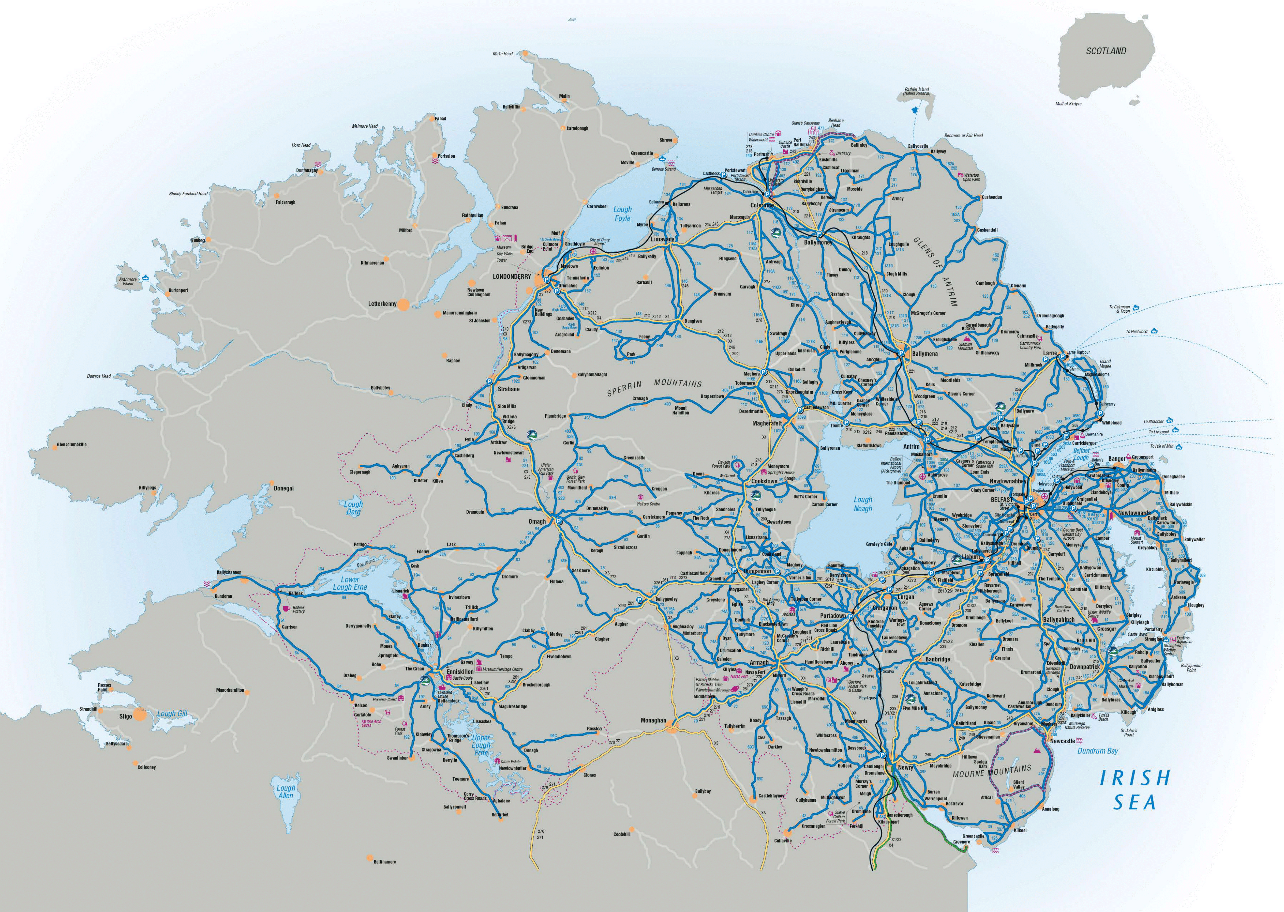
Figure 6: Map showing the rural and inter-urban bus network of Northern Ireland, operated by Ulsterbus

The DfI regulates the network, setting service standards, fare structures, and accessibility requirements; routes and schedules are centrally planned to ensure comprehensive coverage across Northern Ireland. Translink therefore operates as a public corporation, ensuring services are not solely profit-driven but focused on public needs; there is also no market competition given Translink’s monopoly. Services are funded through a combination of government subsidies and fare revenue. The subsidies help sustain unprofitable routes, particularly in rural areas. Bus services are integrated with other modes of public transport, such as trains, offering unified ticketing systems like the Smartlink card.

County councils (or RTAs) in England could draw inspiration from Northern Ireland’s Translink model to sustain and enhance bus services; in the case of proposed RTAs, the composition of Northern Ireland (a large, significantly rural area anchored by a major settlement) is particularly comparable.

Though the Government has expressed a general preference for franchising, there are justified concerns that a model which only exists in two of England’s largest conurbations is not easily applicable to large semi-rural areas. Northern Ireland, however, demonstrates that a publicly owned model (which aligns with the Governments support for municipalisation) can deliver effective, efficient bus services in vast geographies by combining urban and rural services under one authority.

Conclusion
Summary and Recommendations
Rural bus services are a lifeline for millions of people across England, providing essential access to employment, education, healthcare, and social connections. However, these services are under threat due to funding cuts, declining patronage, and structural inefficiencies. Addressing these challenges is not just a matter of improving transportation – it is essential for achieving social inclusion, economic stability, and environmental sustainability.

This report highlights the unique challenges faced by rural bus services, including the higher costs of operation, lower passenger demand, and imbalanced funding allocations compared to urban areas. It also underscores the critical role these services play in connecting rural residents to essential amenities and reducing transport poverty. Without immediate and sustained action, many rural communities risk being further marginalised, with devastating social and economic consequences.

The Government has made strides in recognising the value of bus services through initiatives such as the National Bus Strategy, the introduction of franchising powers, and plans to allow municipalisation. However, these efforts have yet to deliver truly positive outcomes for rural communities. Policies and funding mechanisms have often prioritised cities, leaving counties at a disadvantage. The £1bn funding boost for FY2025/26, while significant, continues to reflect these disparities, emphasising the need for more targeted, long-term solutions.

This report proposes several actionable recommendations to address these issues. The creation of Regional Transport Authorities (RTAs) would be a critical step forward, by consolidating resources and fostering collaboration across rural and urban areas. RTAs would enable holistic planning, streamline operations, and ensure that rural routes are integrated with larger transport networks, creating a more equitable and efficient system.

Innovative models such as Translink in Northern Ireland offer valuable lessons for England. A unified approach to managing urban and rural bus services, combined with centralised planning and funding, has proven effective in maintaining service quality and coverage. Adopting such practices, tailored to England’s diverse regional needs, could significantly enhance rural transport networks.

Another key recommendation is to ensure equitable funding distribution. Rural areas face higher per-capita costs for bus services due to lower density and longer distances, which should be reflected in allocation mechanisms. Introducing sustainable revenue streams, such as road pricing, could further support these services while advancing environmental goals.

The role of demand-responsive transport (DRT) as a complementary solution is also noted. DRT can fill gaps in conventional services, offering flexibility and cost-effectiveness for low-demand areas. However, it must be supported by accessible technology and adequate subsidies to ensure long-term viability.

Ultimately, the future of rural bus services depends on a collaborative approach involving central Government, devolved authorities, operators, and communities. The Government must act decisively to provide the resources, powers, and policy framework needed to reverse the decline in rural bus services.

January 2025

