Written evidence submitted by the Policy and Innovation Group, University of Edinburgh (NRG0017)

Call for Evidence: GB Energy and the net zero transition
The Policy and Innovation Group (hereafter referred to as the P&IG) is a research group contained within the School of Engineering at the University of Edinburgh. The Policy and Innovation Group combines expertise in offshore energy technology, energy system organisations and institutions, and the wider policy and regulatory landscape. They apply a range of quantitative and qualitative research tools and methods including energy system modelling, future transition scenarios, techno-economic analysis and innovation pathways. This leads to the development of policy guidance reports, energy system roadmaps and economic and energy system analysis for technology developers, public and private investment and government departments.
The Policy and Innovation Group welcomes the opportunity to contribute its view, supported by its own findings, to the Scottish Affairs Committee’s investigation into Scotland’s Net Zero energy sector transition. The Policy and Innovation Group will provide a response to questions 3, 4 & 5. While the P&IG specialises in energy policy research for the ORE, with a particular focus on the tidal stream and wave energy sectors, we believe that the analysis presented within this response is widely applicable to a range of renewable energy technologies that Scotland may be considering as part of its future Net Zero energy system.
3. Are Scotland’s energy industry and associated supply chains well-placed to transition to clean energy generation, or is more support needed?
The Policy and Innovation Group believe that Scotland’s supply chains require careful management in order to be ready for the forecasted increase in offshore renewable energy (ORE) deployments that will be required to meet both short-term and medium-term energy transition targets. This presents an immediate need to develop the supply chain to support these projects, since developers are already placing orders for components and considering infrastructure upgrades with long lead time items. In addition, the development of strong and robust domestic supply chains is essential to ensure that projects benefit from high levels of Scottish content and retain the socioeconomic gains associated with increases in GVA and jobs. For example, the Scottish economy can expect to gain approximately £8.7 billion in GVA from a successful domestic wave and tidal stream sector by 2050, a sector with huge export potential, potentially £28 billion by 2050, and one in which Scotland is currently considered a market-leader.
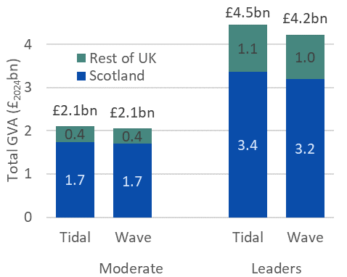
GVA from projects in Scotland and rest of the UK
In order for Scotland to remain amongst the leading nations developing ORE technologies and continue to deliver devices with a high level Scottish content, it is important to assess Scottish capabilities with regards to the development of key device subsystems and areas of expertise. The manufacture, configuration, assembly, and deployment of ORE devices is a complex systems integration process and one that varies depending on the design and location of the device in question. Regardless, it is essential that the Scottish supply chain be able to develop the ability to competitively manufacturer and supplying volume key subsystems required for ORE devices.
However, to maximise the development of the Scottish supply chain, careful thought must be given to the choices behind which technologies, components or services/skills to support. This should include consideration of the level of policy support offered versus the potential socio-economic impact and benefit that they will bring to the Scottish supply chain. In order to identify areas that should be prioritised for policy and/or financial support it is important to identify Scotland’s current capability and capacity to operate at the state-of-the-art. To assess the supply chain opportunity represented by each technology, component or service/skill one of four ranking criteria should be applied:
Classification | Description
Leading  the Sector | The Scottish supply chain already holds a high level of expertise, both in competitive manufacturing and the potential for volume production. Policy recommendations should aim to maintain and expand this position, while maximising international export opportunities.
Matching the Sector | The Scottish supply chain holds a moderate level of expertise in the manufacture of this subsystem, however other nations are at a similar level with regards to their ability to manufacture competitively and at volume. Policy recommendations should focus on providing support so that this sector continues to grow at a rate consistent with the supply chain opportunity that it represents.
Following  the Sector | The Scottish supply chain already faces strong international competition with regards to the competitive manufacture and volume production of this specific subsystem. Policymakers should carefully consider the credibility of developing the supply chain for this subsystem.
All to  Play For | Currently no one country holds a world-leading position with regards to the competitive manufacture and volume production of this subsystem. Policy recommendations should aim to accelerate the growth of this sector in Scotland, positioning the Scottish supply chain to emerge as a world-leader.
Supply chain opportunity ranking classifications
These four classifications are further illustrated below, where the vertical axis represents the current strength of Scotland’s supply chain, and the horizontal axis shows both the strength of other counties (increasing towards the left) and conversely the potential opportunity for Scotland (increasing towards the right).
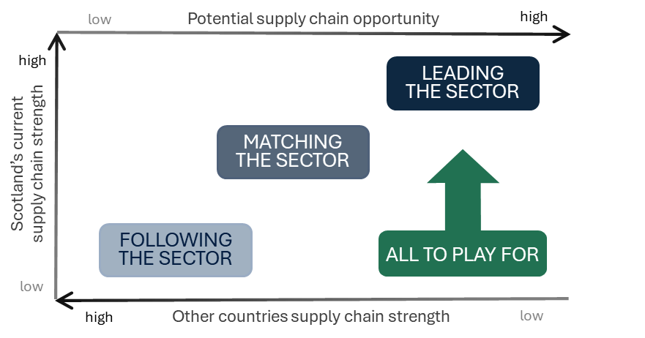
Supply chain opportunity ranking classification
Assessing the supply chain opportunity through an overview of the current state-of-the-art for each technology, component and service/skill is only the first step in developing a comprehensive understanding of the Scottish ORE sector’s supply chain capabilities. The development of the supply chain areas representing the greatest opportunity to the Scottish economy and renewables industry will require the development of comprehensive and informed recommendations. These recommendations should aim to ensure that the underlying factors which may determine Scotland’s ability to produce each technology, component and service/skill competitively and at volume are addressed. This can be done through the application of a competitiveness framework, such as the one designed by the P&IG. This has been designed with the intention of outlining several key factors by which the competitiveness of the ORE stream sector can be assessed and measured:

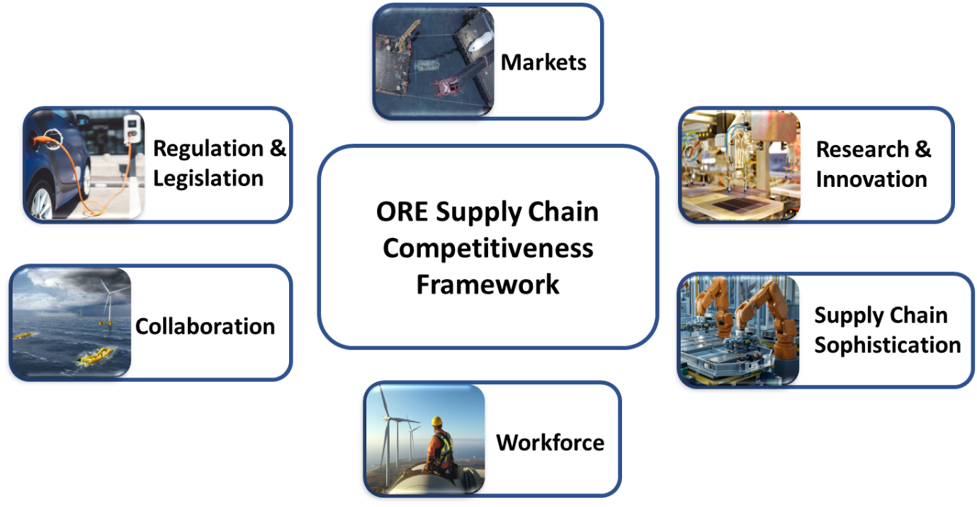
ORE supply chain competitiveness framework
Factor | Description
Markets | Providing a highly visible and supported route-to-market for underpinning innovations, from technical equipment to manufacturing processes, is essential to increase sector and investor confidence
Research & Innovation | Research and innovation efforts are pivotal for the future progression of tidal stream helping to provide sustainable solutions to societal, economic and environmental challenges
Supply Chain Sophistication | Modernising the entire Scottish supply chain, focusing policy and financial support towards areas such as automation and digitisation, to ensure competitive and volume delivery of key subsystems
Workforce | Assessing the ongoing availability of a skilled workforce across all education levels, bolstered by the availability of focused training to maximize workforce potential and ease the transition from other sectors and countries
Collaboration | The ability to facilitate knowledge exchange and collaborative working between different sectors and stakeholders, combined with the development of innovation clusters
Regulation & Legislation | Designing a fit-for-purpose regulatory and legislative framework that helps rather than hinders the accelerated development and deployment of new wave energy technologies and employs appropriate financial tools to support and protect the sector.
ORE supply chain competitiveness framework factors

4. What actions should the UK and Scottish Governments take to ensure the necessary generation and transmission infrastructure to support the development of Scotland’s renewables sector?
While the P&IG understands that there are a number of high-level and competing actions that should be considered to support Scotland’s Net Zero transition, above all it, is important to ensure that, where possible, Scottish companies and businesses lead on thy physical building and provisioning of relevant technology, component and service/skills. This is essential to ensuring that the GVA and jobs associated with these developments is retained and provides value to the Scottish economy and society.
The P&IG is able to provide a series of high-level policy recommendations, tailored to support the growth and success of Scotland’s ORE industry, and the supply chain that will underpin it.
The first three of these recommendations to enable the development and growth of the ORE sector. These recommendations target the challenges directly facing the capabilities and capacities of both ORE developers and the supply chain that supports the sector.
- The continuation of a well-funded market support mechanism, such as the CfD, is the foundational step to ensuring a market into which Scottish ORE developers can supply and deploy their devices. This should be coupled with the establishment of a highly visible and accountable future deployment ambition, which will bolster the growth of the domestic market, provide clarity with regards to supply chain requirements and increase investor confidence in a range of supporting sectors.

- Targeted and sustained research and innovation support for ORE technology developers is essential to ensure that Scotland builds upon and maintains the competitive edge that it has established in this sector. This is vital to ensure that Scottish companies continue to innovate, reduce costs, win projects and deploy their devices, in both domestic and international markets.

- The modernisation of Scottish supply chain capabilities, from the manufacture and
utilisation of novel materials to the adoption of automation and digitalisation, should be embraced and supported at all levels of the supply chain. In areas where Scotland already possesses a world-leading status or is matching the competitive performance of other nations, policy and financial support should aim to nurture, strengthen and maintain this position. In areas of subsystem manufacture with no clear market leader, Scotland should position itself to maximise the benefit of investments into supply chain sophistication and seize these all-to-play-for markets. Policy support should be tailored to ensure that there is a straightforward route towards the commercialisation of new ideas, translating early-stage innovation into supply chain expertise and manufacturing capability.
The next three recommendations aim to target the challenges surrounding the development of infrastructure that underpins the future of both ORE device developers and the supply chain that supports them.
- Investment into device innovation and supply chain capability should be coupled with an equal investment into domestic workforce capacity and skills. This should not solely target higher education graduates from a STEM background, who are an important consideration of any future skilled workforce. It should also consider the roles of apprenticeships and existing workers transitioning from oil & gas and other relevant sectors, who often have transferable skillsets and exposure to the challenges of working in a marine environment.

- The maturity of the offshore wind sector, in terms of fabrication facilities and supply chain depth, should serve as both an inspiring template and a serious opportunity for collaboration with the tidal stream sector. Active collaboration between ORE developers and their supply chain, where competition allows, could also lead to the creation of innovation clusters.

- Significant grid upgrades will be required alongside the continued development of renewable energy in Scotland, to avoid transmission bottlenecks and potential curtailment of renewable output. These planned upgrades must also factor in the requirements and potential energy system benefits of the ORE sector. Port and harbour infrastructure upgrades across the country, currently being planned for offshore wind, should also factor in the additional requirements from the growing pipeline of tidal stream projects.
The final recommendation, detailed below, outlines a potential pathway by which the successful delivery of the previous six recommendations can be led and championed by existing enterprise and innovation agencies within Scotland.
- Tasking and funding existing innovation and support organisations to oversee the
well-coordinated and accelerated delivery of innovation in domestic ORE devices
and improvements in Scottish supply chain capabilities. This will help to ensure that Scotland maintains its position as a world leader in the delivery of ORE projects with high Scottish supply chain content.

5. How can GB Energy, and other ways of backing industry (including funding), most effectively support employment, economic growth and the development of clean energy supply chains in Scotland?
The P&IG believe that while the policy recommendations outlined above go some way to answering question 5, particular attention should be paid to recommendations 1 and 2. A careful balance of market pull mechanisms, such as the long-term continuation and expansion of the CfD programme, and technology push policies, such as increased funding for technology innovation, are the primary way in which clean energy technologies and their supply chains may be developed. However, given the scale of the anticipated rollout of ORE technologies, domestic supply chains must also be prepared to meet demand at both the scale and volume required, embracing technological modernisation that will allow us to compete with nations who have established or are establishing a similar foothold in the ORE sector.
This in turn will require ever-closer collaboration between technology developers, commercial manufactures, research organisations and government departments, all of whom will have an important role to play. Identifying early, the most impactful areas to which funding and innovation support can be directed, is essential to deliver accelerated innovation in a cost-effective manner. Without taking targeted steps, there is the real possibility that the socioeconomic benefits associated with the ORE sector could be led by, or even lost to, overseas competition.

The P&IG hope that the committee finds this information helpful and informative and would be delighted to engage directly if further information is required.
January 2025

