Written evidence submitted by the Global Systems Institute, University of Exeter
The Global Systems Institute (GSI) has a leading track record in high-impact research. It is judged to have five of the most influential climate scientists in the UK. We had lead authors on all three Working Groups of the IPCC 5th and 6th Assessment Reports. We’re leading contributors on 4 of the 11 top climate papers in 2022 for news and social media attention. Led by Professor Pierre Friedlingstein FRS, we also host the internationally renowned Global Carbon Budget Office which provides an authoritative annual assessment of carbon emissions, sources and sinks. GSI is also a world-leading centre of expertise on tipping points – the focus of this submission – and led the 2023 Global Tipping Points Report, an authoritative assessment of the risks and opportunities of both negative and positive tipping points in the Earth system and society.
The GSI welcomes the opportunity to provide written evidence to the Environmental Audit Committee’s inquiry into climate change and security. This submission has been prepared by Mr Laurie Laybourn (University of Exeter and Chatham House), Dr Jesse F. Abrams (University of Exeter), and Dr Joshua Buxton (University of Exeter).

Summary
- This submission explores the threats to UK security resulting from tipping points in the climate system.
- These go beyond traditional issues of defence to encompass threats to a full range of UK security concerns, including food supply, economic stability, and public health.
- Evidence suggests that the triggering of some climate tipping points could lead to severe or even catastrophic impacts on the UK’s security.
- Best estimates of climate impacts often guide government approaches to risk assessment, instead of extreme threats. This means that tipping points are often under-appreciated in risk assessments.
- Addressing this blind spot is an urgent priority in any effort to improve the UK’s assessment and management of the security implications of climate change.
- The threats posed by tipping points underline the need for rapid decarbonisation before 2030 and significant improvements in UK climate resilience.
- There are many no-regrets actions that will improve UK security while also reducing carbon emissions and increasing resilience to a range of climate-security threats.

Introduction
- This submission focuses on the role of tipping points in the interaction between climate change and security issues. Environmental stresses - particularly those caused by climate change - could become so severe that large parts of the natural world are unable to maintain their current state, leading to abrupt and/or irreversible changes. These moments are called Earth system tipping points.
- We focus on tipping points because their potential effects pose profound implications for security. Yet tipping points are under-appreciated in risk assessments of climate change. Addressing this ‘blind spot’ is an urgent priority in any effort to improve the UK’s assessment and management of the security implications of climate change.
- Tipping points are moments when something changes abruptly. Consider leaning backwards on a chair. You can do so until the point at which the chair suddenly falls to the floor. This is the tipping point. The previous state – in which the chair was balanced precariously – has given way to a new state: you and the chair are now lying on the floor.
- Tipping points exist in the natural world. For example, coral reefs are being stressed by rising ocean temperatures, which are caused by climate change. This stress can become intolerable, a point beyond which the reefs transition to a new state, leading to their die-off. This has consequences for wider ecosystems and human security, such as loss of food supply and economic opportunities through tourism.
- Tipping points also exist within societies. They can be destructive, like if the cumulative effects of a changing climate interact with and multiply existing social and economic problems, helping trigger unrest or conflict, degrading security. They can also be constructive, as has been the case with some renewable energy technologies, which have passed a tipping point to become cheaper than carbon emitting alternatives. This has enabled rapid growth in decentralised energy production, which can improve security.
- This submission explores the threats to UK security resulting from tipping points in parts of the climate system that are under stress as a result of human actions. These go beyond traditional issues of defence and hard security to encompass threats to a full range of UK security concerns, including food, the economy, health, geopolitics, and the political system.
- This submission draws on evidence from the landmark Global Tipping Points Report - a comprehensive global assessment of tipping points published in 2023 - among other sources. We consider the challenges and potential solutions in turn, exploring many of the questions set by the Committee’s Call for Evidence.
Question area 1: What challenges to UK national and human security are posed by climate change in the next five, ten, and twenty years?
- Earth is a complex system made up of interconnected parts supporting life, such as living organisms (plants and animals), icy regions, oceans, and the atmosphere. These parts do not always respond gradually to human impacts such as greenhouse gas emissions.
- Instead, pressure on some parts of these systems can become unbearable, with self-sustaining feedback mechanisms leading to a point – the tipping point – where their function abruptly shifts into a new state. Climate change is a major driver of this pressure.
- Scientists have identified 26 potential tipping points in the Earth's systems based on observational data, historical evidence, and computer models. Alarmingly, evidence shows that some major tipping points are at risk of being triggered at the current levels of global warming. These are listed below and marked with corresponding letters on the diagram (Figure 1):
  - The die-off of warm-water coral reefs (A)
  - The runaway melting of Greenland and West Antarctic ice sheets (B and C)
  - The thawing of permafrost regions (D)
  - The collapse of the North Atlantic subpolar gyre’s circulation (E)

Figure 1: Location of Earth system tipping points
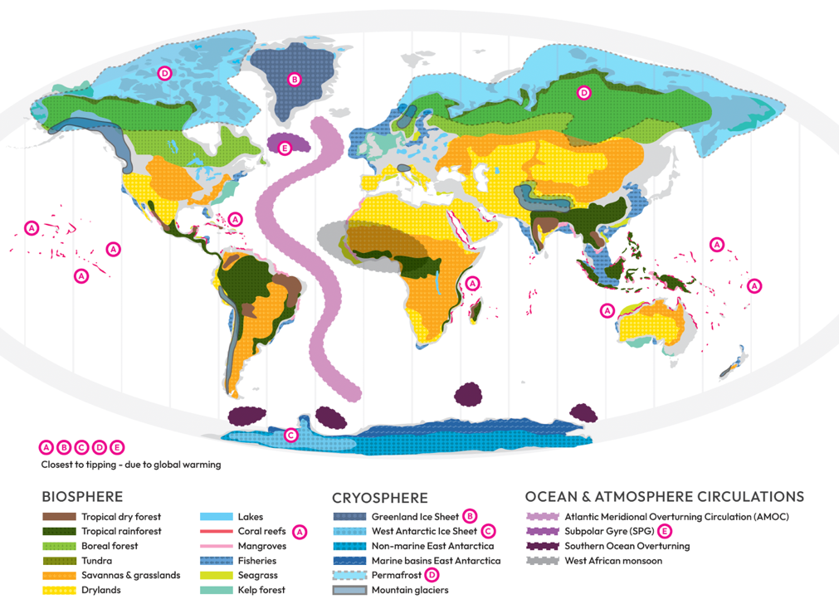
- Evidence suggests that the triggering of some tipping points could lead to severe or even catastrophic impacts on the UK’s security, with profound consequences for areas of concern to the Committee’s inquiry. These include access to the UK’s natural resources such as water, food, and energy, as well as significant effects on infrastructure and land use, including military assets, in ways that create and exacerbate insecurities – among many other consequences.
- To illustrate these, we inspect a tipping point that has received growing media attention. This is the potential collapse of the Atlantic Meridional Overturning Circulation (AMOC) (as marked in pink on Figure 1), which could pose severe risks to security at local to global scales. The AMOC operates like a “great conveyor belt”, carrying warm, salty water from the tropics into the Northern hemisphere, where heat is lost to the atmosphere, leading the current to sink, returning colder water southward.
- Climate change is impacting the circulation and might trigger a tipping point, causing the AMOC to collapse. This would lead to a profound reorganisation of the ocean circulation, with major impacts on the climate system. The timescale for the collapse process to playout could be in the order of decades. This means that, after the tipping point is passed, it takes decades for the collapse process to occur, after which a new, post-collapse climatic state emerges. The change to this new state could be irreversible.
- In this new state, the UK’s weather patterns could be considerably different to current patterns, bringing extremes that are far beyond what people, infrastructure, and nature are currently adapted to. For example, one study has projected that in the post-collapse state, average temperatures in London could be 10ºC lower compared to the current day, with even colder conditions further north.
- While significant knowledge gaps exist in understanding the impacts of an AMOC collapse (and other tipping points) on societies, evidence suggests the consequences for UK security could be catastrophic. For example, one study estimated that the effects of an AMOC collapse on the UK’s domestic food production are ‘likely to include widespread cessation of arable farming’ in Britain. These losses are of course far greater than those expected as a result of climate change without an AMOC collapse.
- The impacts on food production would be partly driven by changes in temperature but also a severe reduction in water availability - leading to a far drier growing season - with significant cascading consequences beyond food production. Large-scale adaptations, particularly irrigation, might help restore some water availability to UK arable farming after an AMOC collapse but the costs were estimated at ‘more than ten times the value of the arable production it would support.’ In all, the amount of water and costs would be prohibitive.
- The impacts on UK food security from an AMOC collapse would not just come directly from the consequences for domestic agricultural production. They would also come from abroad as a result of destructive impacts on crop growing around the world. For example, a study commissioned by the OECD estimated that in a scenario where AMOC collapsed at around 2.5ºC of global warming, more than half the suitable land for growing wheat and maize could be lost compared to a world without climate change, including severe reductions in key UK food import markets, such as Europe. These impacts are illustrated in the diagram below (Figure 2), with deeper shades of purple indicating greater losses for crop suitability.

Figure 2: Modelled impacts of AMOC collapse plus global warming on crop suitability
Difference in crop suitability between no AMOC collapse (present day) and the effects of an AMOC collapse plus 2.5C of global warming.
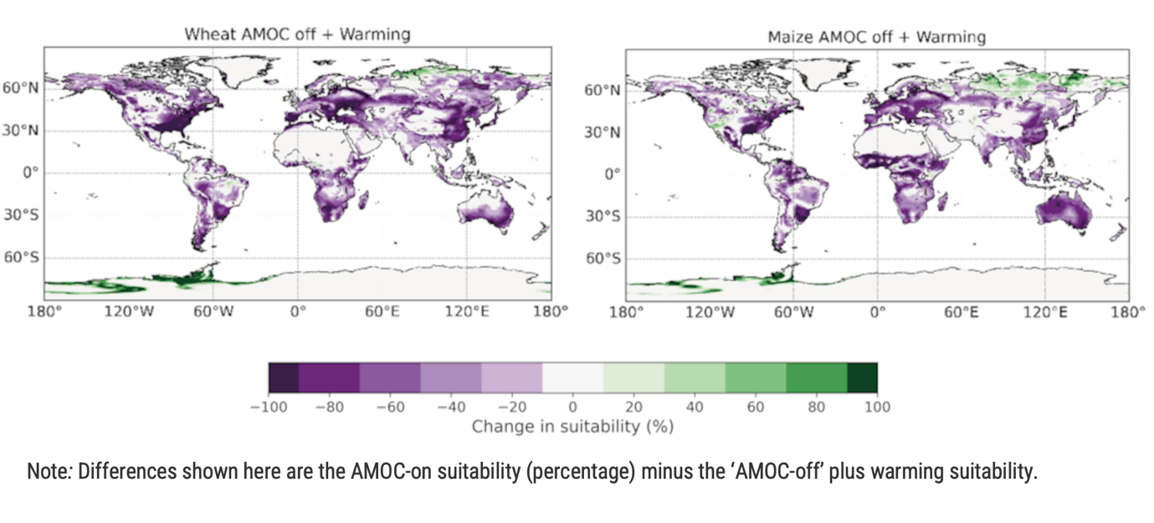
- These crops are critical to global food systems and so the OECD has concluded that ‘an AMOC collapse would clearly pose a critical challenge to food security, and combined with other climate impacts would have a catastrophic impact.’
- The other direct impacts of an AMOC collapse beyond agriculture could include severe damage to nature, public health, and infrastructure, and large increases in energy demand for heating. In turn, these would impact economic, social, and political stability in the UK and around the world, among many other factors. In turn, these effects would interact, creating further systemic consequences.
- These cascading shocks play out relatively quickly, on timeframes that could present severe challenges to the capacity of some societies and socio-economic systems to adapt, potentially presenting a profound challenge to the UK’s ability to maintain sufficient levels of national and human security.
- As with any tipping point, the likelihood of an AMOC collapse is highly uncertain. Yet uncertainty does not offer reassurance. IPCC assessments consistently conclude that a collapse cannot be ruled out this century, with the most recent assessment noting that it only has ‘medium confidence that the decline [of the AMOC] will not involve an abrupt collapse before 2100’. A number of studies have identified evidence suggesting that the AMOC is approaching a tipping point, with a paper this year identifying an ‘early warning signal show[ing] that AMOC is on [a] tipping course’. Another recent study estimated that a collapse might occur by the middle of the century (over a two-decade time horizon), if not earlier.
- There will continue to be significant uncertainties over the timings of a potential collapse. However, there is evidence that the security impacts of an AMOC collapse could be catastrophic. Security risks that are plausible and high impact but also uncertain require a policy response guided by the precautionary principle. As a previous US Vice President noted when considering uncertain but high impact threats: even ‘if there's a 1% chance [of a severe security threat], we have to treat it as a certainty in terms of our response. It's not about our analysis...It's about our response.’
- Other tipping points might also pose risks to UK security on five- to twenty-year time horizons. One example is the potential collapse of the North Atlantic subpolar gyre (SPG) convection - specifically the overturning circulation in the Labrador-Irminger sea - a subsection of the AMOC that is being stressed by climate change and could abruptly weaken (a tipping point referred to as “SPG collapse”). It is marked by the letter ‘E’ in Figure 1 (on page 3 of this document).
- An SPG collapse was identified by the Global Tipping Points Report as a tipping point that cannot be ruled out even at today’s 1.2°C of global warming. In the latest generation of climate science models, an SPG collapse occurs in 36.4% of models that are best at simulating the complex behaviour of the North Atlantic Ocean. Collapse typically happens around 2040 or earlier and in scenarios of moderate global greenhouse gas emissions. An SPG collapse could occur even if the world is on track to meet its Paris Agreement goals. A 2022 review determined 1.8°C of global warming to be the best estimate of the temperature threshold that might trigger an SPG collapse.
- An SPG collapse could occur without an AMOC collapse. It could also play out far quicker. While the process of AMOC collapse could take decades to play out, an SPG collapse could play out over a period of a single decade, if not as little as a few years. This is a parliamentary timescale.
- The impacts of an SPG collapse are under-studied and deserve immediate attention. The very limited literature currently available points to implications for agriculture in western Europe, albeit seemingly less severe than AMOC collapse, but non-negligible nevertheless. Given the apparent relatively high likelihood and possible early occurrence of an SPG collapse, there is an urgent need to assess potential impacts on food production and other domestic factors, as well as indirect impacts such as on key markets and partners in Europe and North America, which could also be negatively affected by an SPG collapse. Other parts of the world might be far less directly affected, with implications for the UK’s strategic advantage. Not investigating this is a potentially dangerous oversight, the reasons for which are discussed more in the next section.
- These are just two of many tipping points that are now possible as a result of escalating climate change and which threaten the UK’s security. As the 2023 Global Tipping Points Report concluded: ‘tipping points show that the threat posed by the climate and ecological crisis is far more severe than is commonly understood and is of a magnitude never before faced by humanity. [Yet] there is no adequate global governance at the scale of the threats posed by [these] tipping points. The world is on a disastrous trajectory.’
- It will take time to remedy this situation and so - unfortunately - some tipping points might still be triggered even as the world accelerates action to reduce this risk by ramping up reductions in greenhouse gas emissions. If societies are not sufficiently resilient to the severe consequences for their security, then the impact of a tipping point being triggered could distract significant energy and resources from reducing emissions. Aggregated at the global level, this could increase the chance that further tipping points would be triggered, a vicious cycle that could critically degrade security prospects into the long term.
- This is “derailment risk”: the risk that the consequences of climate change (including tipping points) could get in the way of tackling the causes of climate change, derailing the world from the path to avoiding unmanageable security outcomes.
Question area 2: What is the UK Government’s current approach to anticipating, preventing and responding to the threats in part 1? How could that approach be strengthened?
- Tipping points are mentioned in government risk assessment processes. For example, the independent input for the government’s Climate Change Risk Assessment process (collated by the Climate Change Committee) repeatedly mentions tipping points, including in a technical report exploring the impacts of tipping points on the UK. Tipping points also feature in foresight and other such analyses, including in the latest edition of the Global Strategic Trends report produced by the Ministry of Defence’s Defence, Concepts and Doctrine Centre (DCDC). These studies draw on the significant expertise in the public sector and academia in the UK and abroad.
- However, tipping points and their security risks are generally under-assessed in government risk assessment processes. In the latest government Climate Change Risk Assessment, there is only one mention of tipping points, which is found in annex two in a discussion of research priorities. There is no mention of tipping points in the Third National Adaptation Programme and the Fourth Strategy for Climate Adaptation Reporting presented to Parliament last year. While climate change is a key theme in the Integrated Review Refresh 2023, there is no direct mention of tipping points. Tipping points are not mentioned in the latest National Risk Register.
- This is a common problem across the world, with the OECD warning that ‘despite marked improvements in the understanding of the high risks associated with climate tipping points, global policies explicitly targeting risks of tipping points remain virtually non-existent.’
- A key issue identified by the OECD is that standard risk assessment principles are not being consistently applied to the security risks from climate change, particularly tipping points. For example, in risk assessment best practice, low- or uncertain-likelihood outcomes that could have severe, even catastrophic consequences are routinely considered to constitute material risks. However, prevailing approaches to assessing the security implications of climate change largely focus on higher-probability outcomes. These are usually lower-impact, which can lead to the marginalisation or even exclusion of tipping points.
- In general, uncertainty can be misconstrued as meaning a threat is so low likelihood as to be ignorable, even if it is clear the impact might be severe. As a recent report from the Institute and Faculty of Actuaries - the UK’s chartered professional body for actuaries - and the University of Exeter concluded, it is best practice to align risk management to tail risks and not best estimates.
- There are a range of other methodological, structural, and political challenges that impact government assessment and management of the security risks posed by tipping points. These include:
  - Time horizons. National security risk assessment processes use methods that struggle with the timeframes and uncertainties associated with tipping points threats. For example, tipping points might not neatly fit into the binary distinction used by security assessments of risks that are considered ‘acute’ (discrete events presenting threats over a two-to-five-year horizon) or ‘chronic’ (long term challenges gradually threatening security). Tipping points are caused by a chronic risk (climate change) and when triggered, the process of change could play out over years to decades (a timeframe sitting awkwardly between acute and chronic), depending on the tipping point. The post-tipping state will create a new set of acute and chronic risks to security. Better consideration of the interdependencies between chronic and acute risks is therefore needed.
  - Cascading risks. The consequences of tipping points also create cascading risks that spread across sectors and borders, with impacts that can be an order of magnitude higher than impacts that occur from the initial threat. Yet the National Risk Register (for example) does not assess risks within and across systems. Instead, it focuses on single events and single sectors, excluding risks that occur concurrently or are connected. This is a critical blind spot. Much scientific assessment of climate change focusses on first order physical impacts. So, an additional layer of cascading risk analysis is needed to identify the implications of first order physical impacts for key areas of security, like food security and geopolitics. Yet government climate risk assessments also under-assess cascading risks. For example, reporting of food supply chain risks is not mandated, preventing evaluation of the overall levels of systemic risk in the UK food system, a key determinant of UK food security. This is a problem in other countries including in Europe, where a recent study concluded that ‘cascading climate risks are, as yet, little understood and seldom assessed or managed. This is extremely dangerous. Without action, the risks will continue to grow in the coming years’. This problem has led the Climate Change Committee (CCC) to conclude that ‘due to the potential for hidden tipping points and the unpredictability of systemic risks, the current model of conventional risk governance in the UK that focuses on single events, single sectors and characterisation of reasonable worst-case scenarios should be reviewed’. A more systematic assessment of these risks is held back by a lack of ‘clear responsibilities and mechanisms for cross-Government collaboration’.
  - Economic modelling. Economic approaches to risk assessment, which predominate in government, do not often account for cascading impacts and nonlinear risks (like tipping points). This is partly because cost-benefit analyses struggle to cope with high-uncertainty, high-impact threats. In general, modelling of the economic costs of climate change generally does not consider the possibility of tipping points and other large-scale nonlinear threats, as well as cascading risks, meaning these estimates are severely limited and likely biassed heavily downwards.
  - Siloed risk assessment. There is a lack of harmonisation between the Climate Change Risk Assessment (CCRA) and the National Security Risk Assessment processes, with the CCC previously having warned of a ‘mismatch in the timescales considered by the [National Risk Register, NRR] and CCRA which means that the NRR does not assess the impact and likelihood of climate trends’.
  - Cultural and training issues. Climate change challenges national security risk assessors to navigate complex scientific information and translate its implications for security. Alongside limitations to methods for identifying cascading risks (and therefore the security implications of climate change), it might be difficult for risk assessors to develop a ‘feel’ for the cultural differences between scientific evidence and risk assessment. In particular, definitions of ‘conservative risk assessment’ may differ. For a climate scientist, this might mean focussing on outcomes that are most certain. For a risk assessor, this means focussing on the most extreme events, even if they are uncertain. This is a potentially troublesome cultural and analytical difference. Greater investment in climate risk assessment competencies among security risk assessors and managers is needed to navigate this and other cultural and technical challenges between climate science and national security.
- As successive CCC assessments of the government’s adaptation planning highlight, the UK is acutely ill prepared for even the current level of threat from climate change, let alone the security risks posed by tipping points. Adaptation to threats from climate change is often seen as a marginal or separable issue, distinct from and not a foundational condition for the UK’s security. Overall, the CCC has reached the striking conclusion that ‘consistent minimum resilience standards across sectors … are largely absent’ and that ‘no sectors are yet well adapted to the risks of climate change’ as they stand today, let alone to future risks.
- Consequently, our first main recommendation is that the government urgently address the poor state of UK climate adaptation governance and action. The security threats posed by tipping points provide an additional impetus to rapidly improve UK climate resilience. The uncertainties associated with tipping points present challenges to UK adaptation planning. The possible range of conditions to which the UK may have to be adapted goes beyond the chronic increase in temperature and extremes currently considered by adaptation planning to include the potential impacts of an SPG or even AMOC collapse. Those bounds are large and will remain uncertain. But the severity of the security threats of tipping points means action should be taken. Thankfully, there are many ‘no-regrets’ adaptation actions that can improve resilience no matter the scenario, including nature restoration, improvements in insulation, and making critical infrastructure robust to a wider set of extremes. All of these adaptations would improve resilience even without an SPG and/or AMOC collapse.
- Secondly, it is critical to reduce tipping point risks by expediting decarbonisation. It is now understood that the risks of triggering tipping points increases markedly at global warming beyond 1.5C. As such, the threat posed by tipping points means it is vital to limit global temperature increases to 1.5C with no or extremely limited overshoot. As the OECD has warned, this means that ‘committing to net-zero emissions by mid-century is not enough in itself; it is about achieving net-zero with urgent, early and deep reductions in emissions already this decade.’ Importantly, actions to improve resilience to tipping point risks and to decarbonise can be synergistic. For example, improved insulation and nature restoration could make the UK more resilient to the potential impacts of tipping points being triggered while also reducing carbon emissions and improving social and economic outcomes. Moreover, the security threats posed by tipping points shows that climate change policymaking should be made with the national security implications in mind. The scale and pace of global decarbonisation is a critical determinant of the risks of tipping points being triggered and, therefore, a key determinant of the UK’s security. This goes for all areas of climate change, not just tipping points. In turn, decarbonisation can improve UK security across a range of dimensions, including improving energy and food security.
- Thirdly, changes to the machinery of government can improve the assessment and management of security threats resulting from climate change in general and tipping points in particular. Tipping points are indicative of the new security context facing the UK and the world. Climate change is not just a worsening series of events but also a new era of high uncertainty and high impact threats. These have implications for all areas of security, acting to both multiply and create security threats. This new context requires a paradigm shift in how the security implications of climate change are understood, assessed, and managed. Structures at the heart of government are needed to connect the wide range of risk assessment and management capabilities across the public sector and beyond. In particular, it is unclear who ‘owns’ the threat posed by, say, an AMOC collapse in government, while no one department has the capabilities nor can have the responsibility to manage a threat with implications for all of society. Instead, leadership at the highest levels is needed to reorganise the government in response to these complex challenges. Such an effort could be based on the ‘three lines of defence’ approach used commonly in private sector risk management, with explicit and separate functions for risk management, oversight and assurance.
- In relation to risk management, we recommend:
  - Undertaking a rapid National Climate and Nature Security Risk Assessment to establish a full picture of the threats to UK security from climate change and other environmental problems, like nature loss. There is no explicit UK risk assessment of the national security implications of climate change that caters primarily for a national security audience at the highest level. Other nations have undertaken such assessments, notably the US government, where within a week of inauguration President Biden ordered the intelligence community to undertake a National Intelligence Estimate – the highest risk assessment of a national security issue – on the national and economic security impacts of climate change within 120 days, which subsequently identified high risks to national security. An explicit UK national security assessment could both fill the gap between and complement the CCRA and NSRA processes. The assessment can draw on the world-leading expertise held within the UK government and public sector agencies, academia, private sector, and beyond. It would also have to navigate the considerable methodological difficulties of undertaking risk assessment of tipping point threats, which are inherently uncertain, highly complex, and exist at large scales.
  - Ensuring the security implications of climate change (and other environmental drivers of threats, including biodiversity loss) are a key pillar of any Strategic Defence and Security Review (SDSR) and National Security Strategy process, making sure a climate-security lens is applied to security and resilience strategies in economic security and industrial strategy, health security, supply chain resilience, foreign and development policy, and so on.
  - Establishing a standalone Deputy National Security Adviser on Climate Change and Security, also acting as the Prime Minister’s official Adviser on Climate Change and Security.
  - Creating an independent Centre for Climate-Security to provide the government with regular security risk assessments, horizon-scanning, and all-source intelligence on climate-security risks, complementing and working in collaboration with other agencies. Additionally, it should be mandatory for major government policy proposals to contain an assessment of climate-security risks by the Centre, including financial implications.
  - Investing in research and early warning systems, priorities for which could be identified by the Centre in collaboration with existing agencies and government bodies. Closing knowledge gaps and improving early warning of tipping point risks is a pressing need.
- In relation to the oversight of risk, we recommend:
  - Establishing a National Security Council subcommittee on climate change and security with membership including the chancellor and all senior ministers to improve management, oversight, and accountability across departments.
  - Creating a Minister for Resilience in the Cabinet Office with a brief that includes climate-security issues and cross-government coordination.
- In relation to assurance, we recommend:
  - Expanding the strategic aims of the Climate Change Committee to include an explicit focus on security to bolster external challenge, advice, and assurance, with an increase in funding to support this expansion.

April 2024

https://global-tipping-points.org
Ibid
For example, see: https://edition.cnn.com/2024/02/09/climate/atlantic-circulation-collapse-weather-climate/index.html
https://www.oecd.org/environment/climate-tipping-points-abc5a69e-en.htm
https://www.science.org/doi/10.1126/science.abn7950
https://www.science.org/doi/10.1126/sciadv.adk1189
https://www.nature.com/articles/s43016-019-0011-3%20
Ibid
https://www.oecd.org/environment/climate-tipping-points-abc5a69e-en.htm and https://doi.org/10.1787/55ea1cc9-en
https://www.oecd.org/environment/climate-tipping-points-abc5a69e-en.htm
Ibid
https://www.ipcc.ch/report/ar6/wg1/chapter/chapter-9/
https://tos.org/oceanography/article/is-the-atlantic-overturning-circulation-approaching-a-tipping-point
https://www.science.org/doi/10.1126/sciadv.adk1189
https://www.nature.com/articles/s41467-023-39810-w
https://tos.org/oceanography/article/is-the-atlantic-overturning-circulation-approaching-a-tipping-point
https://time.com/archive/6677574/the-untold-story-of-al-qaedas-plot-to-attack-the-subway/
https://www.epoc.u-bordeaux.fr/indiv/Didier/public_html/Papier/Swingedouw_et_al_NYAS_2021.pdf
https://www.science.org/doi/10.1126/science.abn7950
Ibid
https://esd.copernicus.org/articles/14/1171/2023/
https://www.theccc.org.uk/wp-content/uploads/2021/07/Independent-Assessment-of-UK-Climate-Risk-Advice-to-Govt-for-CCRA3-CCC.pdf
https://www.ukclimaterisk.org/wp-content/uploads/2021/06/Effect-of-Potential-Climate-Tipping-Points-on-UK-Impacts.pdf
https://www.gov.uk/government/publications/global-strategic-trends
https://assets.publishing.service.gov.uk/media/61e54d8f8fa8f505985ef3c7/climate-change-risk-assessment-2022.pdf
https://assets.publishing.service.gov.uk/media/64ba74102059dc00125d27a7/The_Third_National_Adaptation_Programme.pdf
https://www.gov.uk/government/publications/integrated-review-refresh-2023-responding-to-a-more-contested-and-volatile-world
https://assets.publishing.service.gov.uk/media/64ca1dfe19f5622669f3c1b1/2023_NATIONAL_RISK_REGISTER_NRR.pdf
https://www.oecd-ilibrary.org/environment/climate-tipping-points_abc5a69e-en
https://www.ipcc.ch/report/ar6/wg1/downloads/report/IPCC_AR6_WGI_AnnexVII.pdf
https://www.oecd-ilibrary.org/environment/climate-tipping-points_abc5a69e-en
https://actuaries.org.uk/news-and-media-releases/news-articles/2024/mar/14-mar-24-climate-scorpion-the-sting-is-in-the-tail/
https://www.theccc.org.uk/publication/progress-in-adapting-to-climate-change-2023-report-to-parliament/
https://www.cascades.eu/publication/cascading-climate-risks-strategic-recommendations-for-european-resilience/
https://www.theccc.org.uk/wp-content/uploads/2021/07/Independent-Assessment-of-UK-Climate-Risk-Advice-to-Govt-for-CCRA3-CCC.pdf
https://www.theccc.org.uk/publication/progress-in-adapting-to-climate-change-2023-report-to-parliament/
https://actuaries.org.uk/emperors-new-climate-scenarios
https://agupubs.onlinelibrary.wiley.com/doi/10.1002/2016EF000362
https://www.oecd-ilibrary.org/environment/climate-tipping-points_abc5a69e-en and https://carbontracker.org/reports/loading-the-dice-against-pensions/
https://www.theccc.org.uk/wp-content/uploads/2021/06/Progress-in-adapting-to-climate-change-2021-Report-to-Parliament.pdf
https://fivetimesfaster.org/
https://www.theccc.org.uk/publication/progress-in-adapting-to-climate-change-2023-report-to-parliament/
https://www.ukclimaterisk.org/wp-content/uploads/2021/06/Effect-of-Potential-Climate-Tipping-Points-on-UK-Impacts.pdf
https://www.science.org/doi/10.1126/science.abn7950
https://www.oecd-ilibrary.org/environment/climate-tipping-points_abc5a69e-en
https://www.cascades.eu/publication/cascading-climate-risks-strategic-recommendations-for-european-resilience/
https://committees.parliament.uk/publications/7375/documents/77226/default/
https://www.dni.gov/index.php/newsroom/reports-publications/reports-publications-2021/3575-national-intelligence-estimate-on-climate-change

