Written evidence submitted by Innovate Finance

Innovate Finance is pleased to submit evidence to the Treasury Committee’s Call for Evidence regarding SME Finance. Innovate Finance’s membership includes a large number of SME Lenders who are critical to the provision of lending to UK SMEs. These include Challenger Banks and Alternative Lenders, all of whom have a common purpose to deliver SME lending using leading-edge technology.

About Innovate Finance
Innovate Finance is the independent industry body that represents and advances the global FinTech community in the UK. Innovate Finance’s mission is to accelerate the UK's leading role in the financial services sector by directly supporting the next generation of technology-led innovators.

The UK FinTech sector covers businesses from seed-stage start-ups to global financial institutions that embrace digital solutions, playing a critical role in technological change across the financial services industry. FinTech has grown strongly since the Global Financial Crisis of 2007/8, which led to mistrust in traditional banks and coincided with an explosion in the use of smartphones, widespread adoption of the use of apps, the advent of blockchain technology, and significant investment in FinTech start-ups.

FinTech is synonymous with delivering transparency, innovation and inclusivity to financial services. As well as creating new businesses and new jobs, it has fundamentally improved the ways in which consumers and businesses, especially small and medium-sized enterprises (SMEs), access financial services.

Summary
- The SME lending market has undergone significant structural change since the Financial Crisis: while the market has continued to grow, Large Banks, which previously dominated the sector, have reduced their lending to the sector. Innovate Finance estimates this combination of market growth and Large Bank funding decline created an additional aggregate funding requirement of c.£95bn between 2015 and 2022
- This funding requirement has been met mostly by new market entrants: Challenger Banks and Alternative Lenders (together with Asset Finance companies), many of which did not exist prior to the Financial Crisis. The Large Banks share of lending is now down to c.31%.
- This change in market structure from Large Banks to other SME Lenders is a clear success of policy decisions made post the Financial Crisis to stimulate new SME lenders through a range of initiatives, and is a demonstration of the success of the UK’s FinTech market, where many of these lenders reside. However, there remains a funding gap in SME Lending, estimated at c£10bn, which is unlikely to be closed through market actions alone
- Looking forward, policy decisions need to focus on how to enhance wholesale funding for Alternative Lenders and regulatory capital for Challenger Banks, because these lenders the marginal funding to the sector. However, Policy-makers must also recognise that this group is not homogeneous, and that Challenger Banks are different to Large Banks, and one-size-fits-all policies are no longer appropriate for this sector
- We recommend Government initiatives to provide a long term (non-crisis) guarantee scheme to help funding reach all corners of the SME market, and a term funding scheme (wholesale funding) for non-bank SME lenders to increase lending and level the playing field versus the Large Banks
- On regulation, we recommend that bank capital rules impacting SME lending (Basel 3.1 and SME support factor) are amended from the PRA’s initial proposals which would otherwise see a substantial reduction in SME lending by Challenger Banks by 2025; that MREL regulatory requirements should be revisited; and, that small SME loans to unincorporated businesses should be taken outside of the FCA’s consumer lending (or consumer credit) rules. We do not recommend bringing SME Lending within the regulatory perimeter
- One of the barriers to SME access to appropriate finance is the information and data that underpins credit decisioning, which does not always recognise the specific risk profile and cash flow of individual businesses - unduly penalising many. Policy makers can build on open banking to support the development of smart data credit decisioning, by opening up third party access to all data on an SME, with the SME’s consent, to access to data which will produce better credit decisions. This should include data held by public authorities such as HMRC.
- An important area of debt finance which many lenders are currently unable to offer SMEs is finance for investment in net zero transition (eg heat pumps) - the payback period is too long or the asset class is too new for normal term loans; a lending intervention that enabled longer loans (eg lending guarantees or co-investment from the British Business Bank) will unlock significant green finance for SMEs.
- We are very supportive of the British Business Bank and would support an expansion of its remit and funding base. The BBB should play a core role in all initiatives to expand SME lending

Market context
Key to making policy recommendations for the future is to understand the structure of the SME lending market today and how it has changed since the Financial Crisis. Firstly, this is how we classify the different types of SME lenders in the market today:

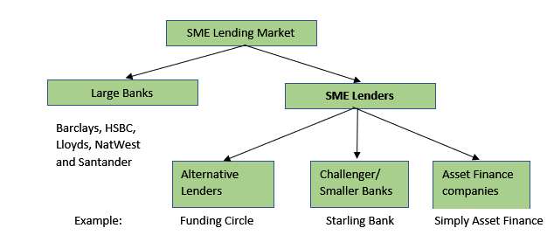

The decline in Large Bank lending
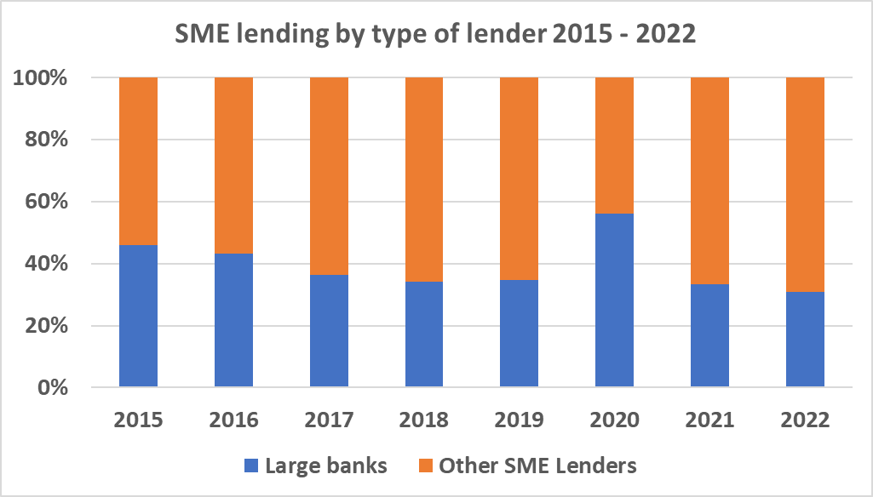
Prior to the Financial Crisis, SME lending was dominated by the Large Banks. Most Alternative Lenders and Challenger Banks had not been established prior to 2008. However following the Financial Crisis the Large Banks have been subject to significantly tighter capital requirements (Basel III) which has led to a re-allocation of capital away from SME lending. By 2015 Innovate Finance estimates that Large Bank lending to SMEs was c.46% of the total SME lending, and that this has fallen steadily to c.31% in 2022 (see chart above), with a blip in 2020 due to the Covid loan schemes being skewed towards the Large Banks.

The new normal in SME lending
The market has grown during this period even though funding from Large Banks has been falling. Innovate Finance estimates the aggregate additional funding requirement for the SME lending market from 2015 – 2022 was c.£95bn, being aggregate annual the growth in the market plus replacing the decline in Large Bank lending over the period (normalising 2020). How has this market growth been funded, and how has the Large Bank funding decrease been replaced?

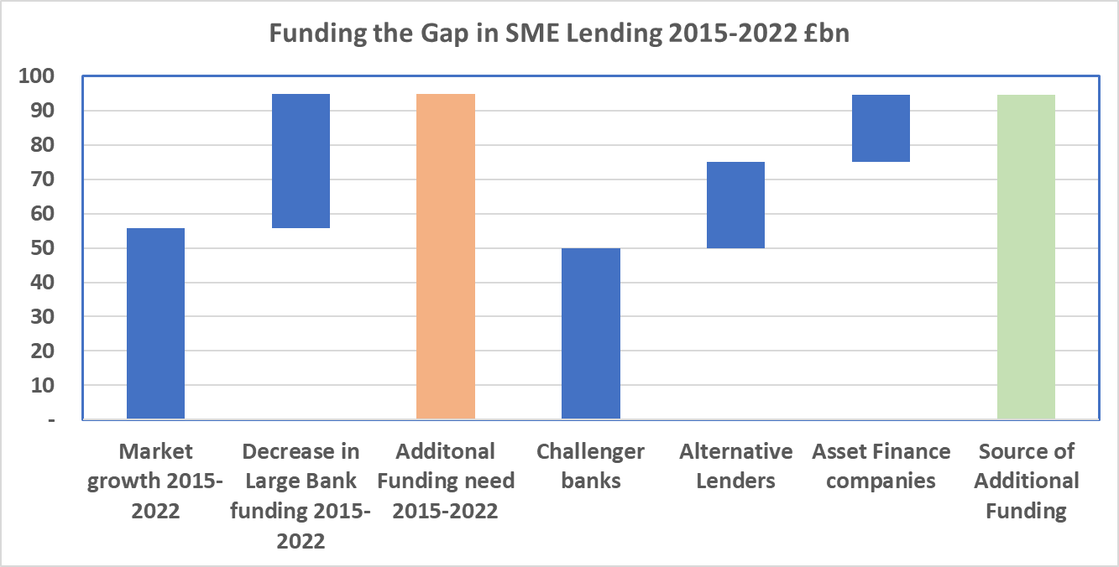
The chart opposite reveals that this change in market funding has been financed by a combination of Alternative Lenders, Challenger Banks and Asset Finance companies increasing their lending materially every year. The underlying data also shows that in 2022 for the first time the Challenger Banks provided more SME lending than the Large Banks. Without these SME Lenders it is likely that the UK would have struggled to fund its SMEs over the last 10 years.

What happened during Covid?
SME Lenders played a major role in supporting the Government with ensuring finance continued flowing to small businesses during the Covid crisis. For example, Alternative Lenders provided over 20% of Coronavirus Business Interruption Loan Scheme (CBILS) loans, more than double their pre-Covid market share, despite only being accredited to CBILS several months after the start of the programme. However most non-bank SME Lenders were in effect excluded from delivering Bounce Back Loan Scheme (BBLS) loans to SMEs by a combination of the 2.5% p.a. mandated interest rate and the banks’ access to Term Funding for SMEs scheme (TFSME) which provided funding to banks at an interest rate of close to zero%. Despite SME Lenders’ growing role in the SME finance ecosystem over recent years and their key role during the Covid crisis, incumbents still enjoy a number of structural advantages, dampening competition

The SME funding gap
Over and above the current volume of SME lending, it is well documented that many SMEs are unable to access finance. Estimates vary, but evidence points to a long-term, sizable gap in UK SME finance. In 2013, this was estimated to be between 10% - 20% of total annual SME lending. While progress has been made and the gap has been reducing, it is far from being eliminated and recent studies estimate it at between 7% - 15% of annual lending, or roughly £10bn p.a. Looking forward, there are supply-side initiatives that could increase this gap: research into the creation of Central Bank Digital Currencies (CBDCs) has warned that banks may lose deposits to CBDCs over time which in turn may restrict that source of credit supply to the economy, which would likely further reduce the volume of Large Bank lending to SMEs

Observations for policy-making
- Despite the progress of the last 10 years, a sizeable funding gap remains in the SME lending market which is unlikely to close through market actions alone. The current providers of SME lending will not meet the potential demand.

- Policy decisions made after the Financial Crisis were highly important to stimulating additional capacity in the SME lending market. These included funding facilities provided by the newly-created British Business Bank, the encouragement of the development of the P2P lending sector, the EIS tax reliefs for early stage companies and the New Bank Start-up Unit launched jointly by the PRA and the FCA. However, more recently we have seen the marginalisation of the P2P sector by new regulations, and the PRA’s Basel 3.1 proposals that will penalise Challenger bank risk weightings and capital requirements for SME lending. Overall the regulatory environment for SME lending is less favourable than it was 5 years’ ago

- It is clear that the additional SME lending required in the foreseeable future, either business-as-usual and/or to close the funding gap, must be sourced from this group of Challenger Banks, Alternative Lenders and Asset Finance companies, and therefore Policy actions going forward should be expressly focused on assisting these lenders. Furthermore, policymakers should recognise that this group of lenders is not homogenous: they have differing capital structures, differing regulatory positions, differing products, and as such their Policy needs will vary, and that a range of Policy initiatives with greater flexibility than in the past is required

Questions in the Call for Evidence

Industry issues
- What are the key challenges Small Medium-sized Enterprises (SMEs) face when seeking finance?

In recently published research, three-fifths of small and medium enterprises said that they currently need funding to ease day-to-day cash flow issues. However, over half of the businesses surveyed said that banks were too slow in assessing business loan applications. 60% of SMEs are not currently confident they can secure finance from banks. Small businesses present lenders with wide-ranging and complex risks. Historically, this segment of the market has been poorly served and when compared to consumers, there is less data available to help lenders assess these risks both individually and collectively. Traditional solutions to these challenges often result in poor customer outcomes: credit strategies focused on existing banking customers, larger or secured loans; manual underwriting processes; onerous document requirements; cumbersome and lengthy application processes.

- Through which channels do SMEs find the most success when seeking funding and why?

SMEs traditionally think high street bank-first when it comes to funding, particularly where they have an existing relationship. However, there is evidence that SMEs are increasingly starting to shop around: finance facilitated by brokers increased from £41bn in 2021 to £45bn in 2022, a 10% increase. This is supported by the data earlier in this submission which shows that Large Bank funding has declined to c.31% of the total market in 2022. One unintended benefit of the Covid loan schemes was that many SMEs applied for a loan online for the first time, which may have increased SMEs preparedness to use digital channels for borrowing. Additionally, the growing use of embedded finance—where borrowers access financial services through third-party applications or platforms ‘embedded’ with another financial service provider’s product—is also increasing access to finance for SMEs.

The Bank Referral Scheme was launched in 2016 to help re-route SMEs whose loan application is rejected by the Large Banks towards alternative lenders. The aim of the scheme is laudable however it has not achieved any meaningful volumes of executed loans for SMEs. The scheme needs to be amended in order to become more successful in delivering SME loans, in particular by focusing on those applicants who drop out of the process before they reach a formal credit decision.

- What role can financial innovation play in SME finance? Is there more the government and the regulators can do to improve access to finance through innovative firms?

The UK has a world-leading FinTech industry. The development of a thriving ecosystem of Alternative Lenders and Challenger Banks has both helped reduce the long-standing SME finance gap, and significantly improve customer outcomes. Alternative Lenders have used technology and data to introduce streamlined processes, tailored financing solutions and improved risk assessment to the market.

Data and credit decisioning - Innovation can also play a significant role in improving credit decisioning to unlock SME finance. There are several data sources which if unlocked would allow better and faster credit decisioning. These include improving the scope and data of Open Banking from its existing base, expanding and improving the Commercial Credit Data Sharing Scheme, accessing Government-held data such as VAT returns, improving the data reported to and available from the Credit Reference Agencies, and the possibility of an “SME finance passport” to make it easier for SMEs to deliver their financial information to a range of lenders. All of these data sources can and should be unlocked through innovative technology-driven solutions, and would deliver better outcomes for SMEs. We welcome the Centre for Finance, Innovation and Technology’s first coalition focused on Open Finance with a specific work stream for SME financing and a focus on accessing new or currently inaccessible data.

Net zero - the path to Net Zero raises a number of issues for SMEs looking for finance. There are SMEs looking to fund their path to Net Zero, for example to finance a heat pump or an electric vehicle fleet, but existing lending products are not always compatible with the risk characteristics of the borrowing proposal. The Government, via the British Business Bank, should consider incentives and/or guarantees that could help bridge this gap. There are also upcoming requirements for SMEs to report to lenders on their emissions, and this will need to be standardised to allow aggregation and reporting by lenders. Innovate Finance is a member of Project Perseus, led by Bankers for Net Zero, whose objective is to develop a pragmatic whole-of-market solution to create a rapidly scalable, low effort, low friction sustainability reporting for SMEs. This is a very important project without which SME lending take up rates are at risk if SMEs are daunted by the emissions reporting requirements. This is also a first step towards further unlocking Net Zero transition finance for SMEs - which will be aided by combining emissions data with credit decisioning.

Tokenisation of financing markets - In the longer term, there is scope for greater development of digital debt markets, especially for SMEs, with enhanced lending in digital assets and/or secured against digital assets. Blockchain and digital assets could be used to reduce the structuring costs for financial instruments such as bonds or other fixed income debt, creating digitised versions of these debt instruments that can broaden the base of firms capable of raising such products to include the wider small business (SME) segment, and thus help to address gaps for funding in that space. New participants will be able easily to take on positions or risk by purchasing digital assets, for a fee. Building and communicating the contractual terms applicable to digital smart contracts means that the fixed costs to issue such instruments can be significantly reduced. We anticipate the costs to structure such instruments will decrease considerably, using the efficiencies of blockchain, which could open access to bond financing at a reasonable price point for the likes of SMEs, and so create a more predictable new source of lower cost debt financing for British businesses.

Digital corporate identity - There are also further steps Government can take to advance (corporate) digital identity. The Companies Act could be reformed to better enable digital signatures and a central database of beneficial ownership information which firms can rely upon, for example.

See our later responses to What more can Government and the regulators do?

- How accessible is finance for SMEs of different sizes?
The key size-based segments of SMEs are:
• Micro business: <10 FTE (and the vast majority are just one person)
• Small business: 10-49 FTE
• Medium business: 50-250 FTE

Micro businesses represent c.95% of the number of SMEs, however they represent only 40% of SME GDP
Survey data consistently shows that SMEs planning to apply for finance with 0-9 employees are less confident of success than those with 10 or more. This confidence gap also exists across the broader SME population.

Micro businesses typically have simple financing needs, borrowing relatively small amounts of money (typically <£100k) on an unsecured basis. There is a diverse range of options here for SMEs including credit cards (eg Capital on Tap), unsecured loans (eg Funding Circle), or merchant cash advance (eg Liberis). Where the loan is secured it is typically for a vehicle on hire purchase (eg Simply Asset Finance) or for property development (eg CrowdProperty). For sole traders they may use consumer finance as it is may be cheaper than the SME lending options and often has a simpler application process than SME lending. The shift in micro business current account market share away from the high street banks (to challengers such as Tide, Starling, Monzo) in the last 3-4 years has significantly improved the awareness of alternative financing providers for those businesses

Small businesses struggle as they typically have more complex borrowing than individual consumers (as the company typically has multiple directors and legal entities, and will be borrowing against property, asset and invoice security) but has no professional CFO at this size to manage the process. Like micro businesses they will tend to approach their current account bank for finance, however small business current accounts remain dominated by the high street banks. So while there are a wide range of borrowing options available, given the complexity of options compared to SME sophistication, this is where the services of a broker can be particularly important to help the client access the right solutions.

Medium businesses further develop the complexity dimensions of a small business, but typically have a professional CFO (certainly if >100FTE) and so have more expertise to navigate the market themselves, though they may well still employ a broker or corporate finance advisor for debt raising.

- Is finance available to allow SMEs to scale up from venture capital funding?

Scaling up from venture capital funding may take the form of equity, such as growth capital, or debt. In this response we focus only on debt financing. Innovate Finance’s views on equity funding were provided in our response to the Treasury Select Committee’s call for evidence on the Venture Capital Market in July 2022 which can be found here [link].

- How successful has the Bank of England’s Term Funding Scheme with additional incentives for SMEs (TFSME) been at encouraging banks to lend to SMEs?

The Bank of England data on TFSME drawings reveals that
- 65% of the £208bn drawings were made by the Large Banks (including Nationwide Building Society), averaging c.£22bn each
- The median draw down by Challenger banks was only £395m each
- C.£43bn of drawings has been extended by the bank borrowers from 4 years to 6 years

TFSME has been very successful in providing the Large Banks with flexible, cheap term funding for their SME loan books. While this was probably important for the funding of BBLS loans during Covid, it is likely to have distorted competition in the SME lending market in recent years as non-bank SME lenders have had no access to TFSME or equivalent funding and operate with much higher funding costs. We understand that in the US during Covid, the Federal Reserve’s facility was open to FinTechs and allowed them to play an important role in the Paycheck Protection Programme.

- What role do credit reference agencies play in supporting SME finance?

Credit reference agencies (CRAs) play an important role on SME finance - credit decisioning information is a fundamental part of the economic and finance infrastructure. They provide financial and credit data on a specific borrower together with credit scores. They provide risk assessment tools and fraud prevention databases, and they help with identity verification. However, they are an imperfect source of data and information as no CRA has a full market view. In the consumer credit space in particular, alternative credit information service providers are increasingly entering the market, utilising open banking to provide more accurate and real time analysis drawing on a wider set of data and the specific circumstances of the individual business. Innovate Finance has called for reform to develop a UK credit information market, that properly treats credit information as a utility that supports societal and economic outcomes; that is open to innovation and support the UK’s primacy in FinTech; that provides fair competition and access; and that supports good consumer outcomes, ﬁnancial stability and ﬁnancial inclusion.

- What impact has the RBS bailout state aid Alternative Remedies Package and its various funds for SMEs (implemented by Banking Competition Remedies Ltd) had on SME access to finance?

This has led to a significantly more diverse ecosystem of Challengers and Fintechs servicing the SME market. Challenger bank and Fintech awardees in the BCR have committed to providing in excess of £6bn of funding through their own balance sheets and facilitating loans from other providers, with Public Commitments now running close to this. For example, Atom Bank, by Q1 2023 – the latest BCR reporting period - had completed £423m of BCR attributable secured lending, with an additional £150m in the pipeline.

- Is securing access to SME finance particularly challenging for women, people from ethnic minorities, people from certain social classes, or any other group? Is so, what should be done about it?

The British Business Bank could consider leading a marketing campaign to raise awareness of how to access funding, working closely with Alternative Lenders. This may also include a BBB guarantee scheme for lenders to the extent that the lack of credit data and experience for some customer cohorts limits the risk appetite of the lenders

Regulatory issues
- Do SMEs have adequate and appropriate access to a complaints procedure when in dispute with their bank or lender?

Member feedback suggest that the majority of SME complaints are resolved to the satisfaction of the borrower in-house without need for recourse

- How effective has the Lending Standards Board’s Standards of Lending Practice been?

No response

- How well does the Financial Ombudsman Service (FOS) work for small business complaints?

The FOS process for small business complaints largely works as designed. Feedback from members is that FOS recognises appropriate affordability and credit scoring processes for SME loans. However this does not mitigate the unfairness of the FOS case charging structure whereby the lender is charged £750 for every case (after the first 3 p.a.) irrespective of whether the case is upheld or not. This charging structure penalises smaller financial services businesses across all sectors and is a risk to competition.

- Is the FOS’s existing role in SME finance appropriate? If not, how should it change?

No response

- How effective has the Business Banking Resolution Service been, and what lessons can be learnt from it?

No response

- Should SMEs have the same level of consumer protection and deposit insurance limits as retail consumers?
Consumer protection – see question 7 below

Deposit insurance limits – We do not believe SMEs should have different deposit insurance limits compared to individuals although we do believe a review of the deposit insurance limits for all depositors is needed following the Silicon Valley Bank collapse. No depositor (SME or otherwise) views a bank deposit as an equity risk and it is important that SMEs can place deposits without fear of loss. The alternative is that, for example, an SME with fluctuating monthly cash balances of £200,000 spends time every week shuffling cash between 3 different banks to keep their single name risk below £85,000. This would be unnecessarily time-consuming for SMEs, and it raises the question of how much banks will charge to provide such back-up bank accounts which offer no other prospect of business revenues to the bank. One area that may be worth exploring is how deposit insurance limits can be raised through an additional commercial insurance product (rather than the pre-funded FSCS approach which in itself reduces available capital for lending).

- Should commercial lending to SMEs be brought into the regulatory perimeter?

Innovate Finance is supportive of appropriate regulation, although we are not aware of any issues in the SME lending market which would improve customer outcomes as a result of greater regulation. We do not believe that SMEs require the same level of consumer protections as retail customers. In comparison to consumers, businesses tend to be more financially sophisticated and often have access to professional support, particularly Limited Companies that make up the majority of lenders’ business portfolios
The majority of SME lenders (by £ lent) including Large Banks are in any event subject to regulation in one form or another, such as a banking authorisation and/or SM&CR, and so in those cases the PRA and/or FCA does have regulatory oversight over SME lending conduct, as was highlighted by the FCA during the Covid crisis. There have been historical systemic issues within individual organisations such as the sale of complex interest rate products where SMEs suffered harm, and we note that these issues took place in regulated businesses.

Bringing some, or all, of commercial lending within the perimeter would also increase costs; these would likely be passed on to SME customers. It would also make it harder for new lenders to enter the market, reducing competition; stifle innovation from FinTech firms and prevent new products from being developed; and lower the commercial incentive for traditional lenders to serve less-profitable customers (these are often the smallest businesses). This would lead to lower levels of SME lending overall.

Regulatory change to stimulate more lending
The regulatory perimeter could be relaxed for SME loans less than £25,000 granted to sole traders/unincorporated businesses. These are currently treated as Consumer loans by the FCA rules even though they are business loans (because technically they are a loan to an individual), but the borrowers have a significantly different affordability profile compared to typical consumer loans. Many lenders choose not to lend in this market because the FCA rules for consumer lending are not designed for business loans and the protections afforded to consumers are not appropriate for SMEs. This reduces finance capacity at the smallest end of the market which, as stated above, is the most challenging segment for borrowing. One suggestion is that unincorporated businesses that are above the VAT threshold (as a proxy for more sophisticated small businesses) should be outside of the scope of FCA Consumer lending rules for borrowing, with the least sophisticated (very smallest) SMEs remaining within the scope.

Unintended consequences of tighter regulation
A number of the largest Alternative Lenders were able to become established after the Financial Crisis through setting up as a P2P lender, a capital- and funding-efficient means of starting an SME lending business. The FCA has tightened the regulatory rules for P2P lending in recent years such that nearly all of the major platforms have left the P2P market in favour of institutional funding. This was only possible because they could establish a track record of low risk lending funded by P2P lenders, and institutional investors have shown they are very willing to fund these loans once they have seen the track record. We believe that this tightening of the P2P rules has choked off an important route for new SME lenders to enter the market

- What impact will the PRA’s proposed Basel 3.1 capital requirements framework, and in particular the proposed removal of the SME support factor, have on SMEs in the context of the PRA’s objectives?

Governments tend to consider the interests of the ‘big-five’ incumbent banks as synonymous with the “UK banking sector”. As Challenger Banks now lend more to SMEs than the Large Banks, they merit better representation in formulating regulation. The diversity of their business models also reduces systemic risk and increases financial stability but this also means that regulators need to be attuned to the variety of challenger-bank business models.

The PRA’s initial proposals on Basel 3.1 as they relate to SME lending are potentially disastrous. The PRA states it expects "very small increases" in capital requirements for small banks. However, based on our members' input, we predict SME lending is likely to see a jump of over 30% in regulatory capital requirements. This significant increase in regulatory capital requirements will either reduce the supply of credit or raise its price.

Economic analysis by leading consultancy Oxera concludes that the PRA’s proposals (if implemented in their current form) could result in a up to £44bn drop in lending to UK SMEs, if capital levels are held constant. Alternatively the price of SME lending would need to increase by 1-1.6%.

In particular lending to SMEs secured on property, the largest SME lending category in the UK, is heavily penalised in the PRA’s proposals, receiving a higher capital requirement than an unsecured SME loan. This is illogical and deviates inexplicably from the international rules which set a lower capital requirement for secured loans than for unsecured.

The PRA is also proposing removing the SME Support Factor, with no transition period. The SME Support Factor provides a capital reduction to incentivise lending to SMEs, and has correlated strongly with the rise of challenger bank lending to SMEs since it was introduced in 2014 as shown in the chart below:

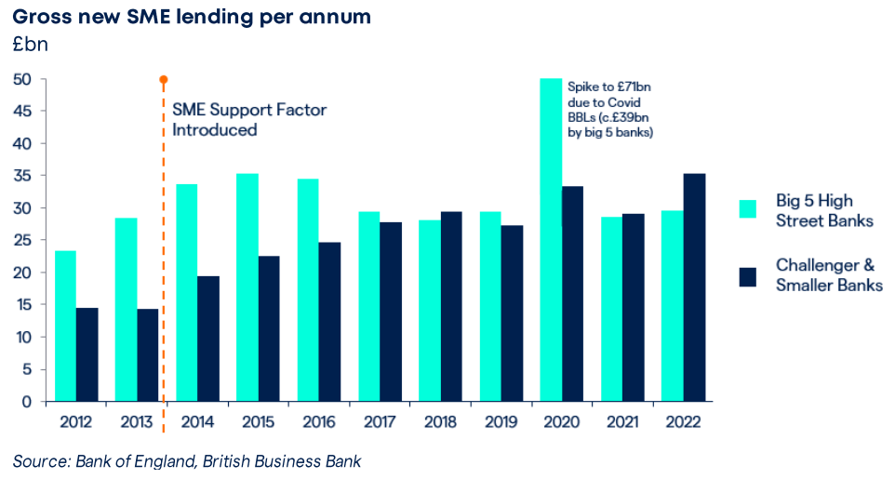

The PRA's 'one-size-fits-all' approach and failure to use several permitted national discretions feels like a missed opportunity to ensure UK capital requirements are sensitive to the risk profile of smaller UK banks and their exposures. As a result, for SME lending, the PRA is likely to go against one of the Basel Committee's overarching goals for Basel 3.1, namely to enhance the robustness and the risk sensitivity
of the standardised capital requirements approach. Innovate Finance’s full views on this can be found in our response to the PRA consultation “Implementation of the Basel 3.1 Standards” here.

We recommend that all future UK banking regulation should include a ‘challenger bank lens’: a specific assessment of implications for challenger banks, digital business models and their customers. There should not be a ‘one-size fits all’ approach and regulations should recognise the diversity of challenger-bank business models. Where appropriate, waivers should apply.

Government Policy issues
- Should the Government do more to enhance SME access to finance? And, if so, what?

A combination of market factors, being the Large Banks reduction in SME funding over time and the ability of the Alternative Lenders to access market funding sources, means that it is unlikely that the SME funding gap can be closed through market actions alone. There are several key Policy actions the Government could take to enhance SME access to finance:
- Term Funding Scheme – the British Business Bank (BBB) should provide term facilities for Alternative (non-bank) Lenders equivalent to TFSME for banks. £176bn of TFSME funding was still drawn at 31st March 2023 and as noted above £43bn has been extended from 4 to 6 years. This continues to distort the market and places Alternative Lenders at a disadvantage. Noting that TFSME is structured only for bank counter-parties, we believe there are alternative structures that could be deployed to deliver such a scheme via the BBB to non-banks.
- Long term guarantee scheme - while the latest iteration of RLS is set to end in June 2024, countries such as the US and Germany have also deployed guarantee schemes outside of crisis periods to boost SME lending. There is a significant opportunity to take the BBB’s existing guarantee scheme (Recovery Loan Scheme) and repurpose it to support ongoing, non-crisis, economic growth and green financing. Research by Frontier Economics suggests that adopting a similar long term scheme in the UK could increase overall SME lending by almost 5%, reducing the SME lending gap by 33% - 70% while generating £7 of economic benefits for every £1 invested. Incorporating flexibility into the scheme’s design would allow the Government to quickly adjust its parameters in response to economic conditions, allowing the scheme to be ramped up or down as the cycle turns.
- British Business Bank products – the BBB provides a number of financing products to players in the SME Lending market. However, these products can be narrow in design and not suited to the business model of many SME Lenders. Noting our earlier comments that this sector not homogeneous, the BBB should be provided with a wider mandate to deliver funding to SME Lenders using structures that are designed for the individual SME Lender. This could include first and second loss participation in securitisation transactions which with appropriate risk transfer reduce Challenger Bank capital requirements, thereby freeing up capital for further SME lending

These policy actions will help lenders to
- Provide additional business-as-usual funding to SMEs, enhancing economic growth
- Continue to fill the funding gap created as Large Banks reduce their funding in the sector; and
- Lend into markets which have traditionally struggled to obtain finance such as such as green lending, female-led businesses and businesses led by people from ethnic minorities, also enhancing growth

- What has the impact of the Covid Bounceback Loan Scheme (BBLS) which was followed by the Recovery Loan Scheme, been on SME finance?

The Government guarantee loan schemes played a vital role during the pandemic, successfully providing small businesses with the finance they needed both to survive and thrive. The role which Alternative Lenders played in distributing these schemes demonstrates their increasing importance to the SME finance market.

The various schemes performed distinct roles in supporting the market during that period. The vast majority of additional lending generated during the pandemic—the amount above levels originated during a typical year—came through BBLS. This lending largely went to smaller SMEs, who required a swift injection of capital to survive through trading restrictions. CBILS and CLBILS were largely substitutive of ‘business as usual’ lending, maintaining the flow of finance to businesses where lenders were unable to have any certainty of the pandemic-induced credit risk for the borrower and needed the Government guarantee to manage this risk.

From a structural perspective, the SME finance market has now largely normalised since the pandemic. Lenders have fully restarted their business-as-usual lending operations, with the latest iteration of RLS providing them with confidence to lend to a further range of businesses than they otherwise would be able to. There is some anecdotal evidence that the Covid lending schemes have pulled some demand forward from when it would have naturally occurred, although overall SME demand for finance has broadly returned to pre-pandemic levels. There was one-time structural shift caused by BBLS loans: many small businesses refinanced a more expensive finance facility with a cheaper BBLS loan, crowding out temporarily lenders whose funding cost prevented them from offering BBLS loans

However, the macroeconomic environment continues to generate headwinds, with survey evidence revealing an increased level of caution; 50% of SMEs said they had paused, cancelled, or delayed an investment decision in 2022.

- In the US the Treasury approved a fund, (State Small Business Credit Initiative (SSBCI)) for incentivising and supporting underserved businesses. Does the UK need similar provisions?

No response

- How useful is the British Business Bank? Does its finance hub improve SME access to finance?
Innovate Finance is very supportive of the BBB and the role it plays in SME Finance, both debt and equity. The Covid crisis required the BBB to engage with a wide range of SME Lenders and ultimately most of them became delivery partners for CBILS and/or BBLS. The BBB now has a very broad market reach in debt finance and venture capital, and we would support an expansion of BBB’s mandate and funding capability – for example to provide non-crisis guarantees to underpin SME economic growth and green financing. As noted above, we believe BBB should have greater funding and greater autonomy to structure funding facilities, managed through risk objectives and risk limits.

September 2023

Source: British Business Bank data and Innovate Finance estimates. Large banks = Barclays, HSBC, Lloyds, Santander, NatWest.
Source: British Business Bank data and Innovate Finance estimates
RBS independent lending review (2013) and Improving access to finance for small and medium-sized enterprises – National Audit Office (2013)https://www.nao.org.uk/wp-content/uploads/2013/10/10274-001-SMEs-access-to-finance.pdf
SME finance in the UK: past, present and future, UK Finance, December 2018; Closing the Finance Gap, Civitas, February 2018; Financing SMEs and Entrepreneurs 2020: An OECD Scoreboard, Organisation for Economic Cooperation and Development (OECD), April 2020
Source: BIS https://www.bis.org/publ/othp33.pdf
https://cfit.org.uk/open-finance/
NACFB (2022)
https://www.bankersfornetzero.co.uk/perseus/
SME Finance Monitor, BVA-BDRC (April 2023)
https://www.bankofengland.co.uk/-/media/boe/files/markets/term-funding-scheme-sme/tfsme-data.xlsx
https://www.innovatefinance.com/consultation/fca-credit-information-market-study-interim-report-and-discussion-paper-ms19-1-2-innovate-finance-response/
https://www.oxera.com/wp-content/uploads/2023/03/Impact-of-the-PRA-proposals-for-Basel-Standards-in-UK_FINAL_edit.pdf
The case for an enhanced Enterprise Finance Guarantee Scheme: Frontier Economics (2021)
Powering SMEs and the economy: Funding Circle’s 2022 impact

