Written evidence submitted by Action on Smoking and Health

Introduction

- This consultation response has been written by Deborah Arnott and Robbie Titmarsh from Action on Smoking and Health (ASH) and Dr J Robert Branston, Senior Lecturer in Business Economics, University of Bath, on behalf of ASH.

- ASH is a public health charity set up by the Royal College of Physicians in 1971 to advocate for policy measures to reduce the harm caused by tobacco. ASH receives funding for its full programme of work from the British Heart Foundation and Cancer Research UK. ASH has also received project funding from the Department of Health and Social Care to support delivery of the Tobacco Control Plan for England. ASH does not have any direct or indirect links to, or receive funding from, the tobacco industry.

- ASH is responding to this inquiry because of the substantial benefits increasing tobacco taxation would deliver in light of the COVID-19 pandemic. Increased tobacco taxation would strengthen the UK’s tax base and support the delivery of government objectives, including those for England to be smoke-free by 2030; to ‘level up’ society; and to increase disability-free life years significantly, while reducing inequalities.

- The effects of COVID-19 have not been felt equally across society, with those living in the most deprived areas more than twice as likely to die from the virus as those living in the least deprived areas. People from the lowest socio-economic groups are also those who disproportionately bear the burden of harm caused by smoking.

- While the average adult smoking rate has steadily declined during the current century as a result of effective tobacco control, the differential between socio-economic groups has widened significantly. In 2001 33% of those in routine and manual employment jobs smoked, compared to 19% of those in professional and managerial jobs. In 2019 these rates had fallen to 23.4% and 9.3% respectively.5 While both have fallen by about 10 percentage points, professional and managerial smoking rates in 2019 were only 48% of those in 2001, while they were 71% for those in routine and manual employment.5,6

- Half of the difference in life expectancy between the richest and poorest in society is due to differential smoking rates, so ending smoking, in line with the Government’s smoke-free 2030 ambition is essential if we are to reduce inequalities and deliver an equitable recovery from the coronavirus pandemic.

- ASH has responded to the following questions set out in the call for evidence, grouping together questions with common responses:

Question: Which areas of the tax system are most in need of reform, and which are best left alone?

Question: What reforms should be considered in response to the pressures on the tax system?

- Smoking remains the leading cause of preventable death and disease in the UK, killing 78,000 people in England a year and nearly 100,000 in total in the UK .,, For every death caused by smoking, another 30 people are living with a serious smoking-caused disease. The health harms caused by smoking have a significant economic impact. An estimated £14.1bn is lost in productivity costs alone from the UK economy each year resulting from reduced earnings and unemployment caused by smoking. Further costs estimated annually for England include:
  - £2.4bn to the NHS in treatment costs for ill-health caused by smoking
  - £880m of social care costs arising from additional social care needs due to disease and disability caused by smoking
  - £325m arising from the cost of fires caused by smoking

- COVID-19 has highlighted the extent to which a productive and resilient population is reliant on a healthy population. Tax increases are one of the most effective population interventions available for reducing smoking prevalence and are the only tobacco control intervention proven to reduce inequalities.,,

- The tobacco industry consistently argues that tax increases will lead to an increase in the illicit trade, but data analysis demonstrates that the industry always increases its prices beyond that required by tax changes, but that the increases were notably smaller when tax rises were larger and unexpected. This suggests first that the industry is not really concerned by the threat of illicit, especially since handrolled tobacco had the highest levels of industry driven price increases despite higher levels of illicit, and secondly that there remains scope for further tax increases.

- The potential for rebalancing taxes is also backed up by the most recent HMRC analysis of the illicit trade, which shows that the market share for illicit has remained stable in recent years, despite annual declines in smoking prevalence. These data are for 2018-19, and since COVID-19 the indications are that illicit and cross border shopping has declined even more rapidly, leading to a significant increase in tax receipts for the period January to July 2020, which are estimated by HMRC to have increased from £4.986 billion to £5.495 billion, a rise of 9.3% year on year.

Reforms needed to increase the effectiveness of tobacco taxes

- The Government has committed to “maintain high duty rates for tobacco products to make tobacco less affordable” and this commitment should definitely be maintained.

- Measures such as a tax escalator of 2% above inflation and a minimum excise tax for manufactured cigarettes are in place to help deliver on this commitment. However, these are undermined by the significant disparity in rates of taxation, and price per cigarette, between factory made (FM) cigarettes and hand rolled tobacco (HRT), which encourage downtrading to HRT. This disparity has encouraged smokers to downtrade from factory made, rather than quit, with a negative impact on tax revenues, and without the associated health benefits.

- In 1998 25% of male and 8% of female smokers mainly used HRT compared to 40% of men and 23% of women in 2013. Questions on use of HRT are no longer asked by in government surveys, but have been asked by the Smoking Toolkit Study, conducted by UCL since 2007. In 2019 43.2.% of past-year smokers predominantly used HRT, compared to 48.4% who predominantly used factory-made cigarettes.

- The STS also found that an increasing proportion of the population were using HRT, while the proportion using FM cigarettes was declining. In 2008, the prevalence of any, predominant and exclusive use of FM cigarettes was 16.4%, 15.3%, and 14.3%, respectively. In 2017, it was 9.7%, 9.2%, and 8.8% (a 40.9%, 39.9%, and 38.5% decrease), respectively. By contrast, RYO cigarette use increased (Figure 1). In 2008, the prevalence of any, predominant and exclusive use of RYO cigarettes was 7.7%, 6.7%, and 5.6%, respectively. In 2017, it was 8.4%, 8.1%, and 7.5% (a 9.1%, 20.9%, and 33.9% increase), respectively.

Figure 1: Trends in prevalence of roll-your-own (RYO) and factory-made (FM) cigarette use in the adult (≥16 years) population in England 2008-2017
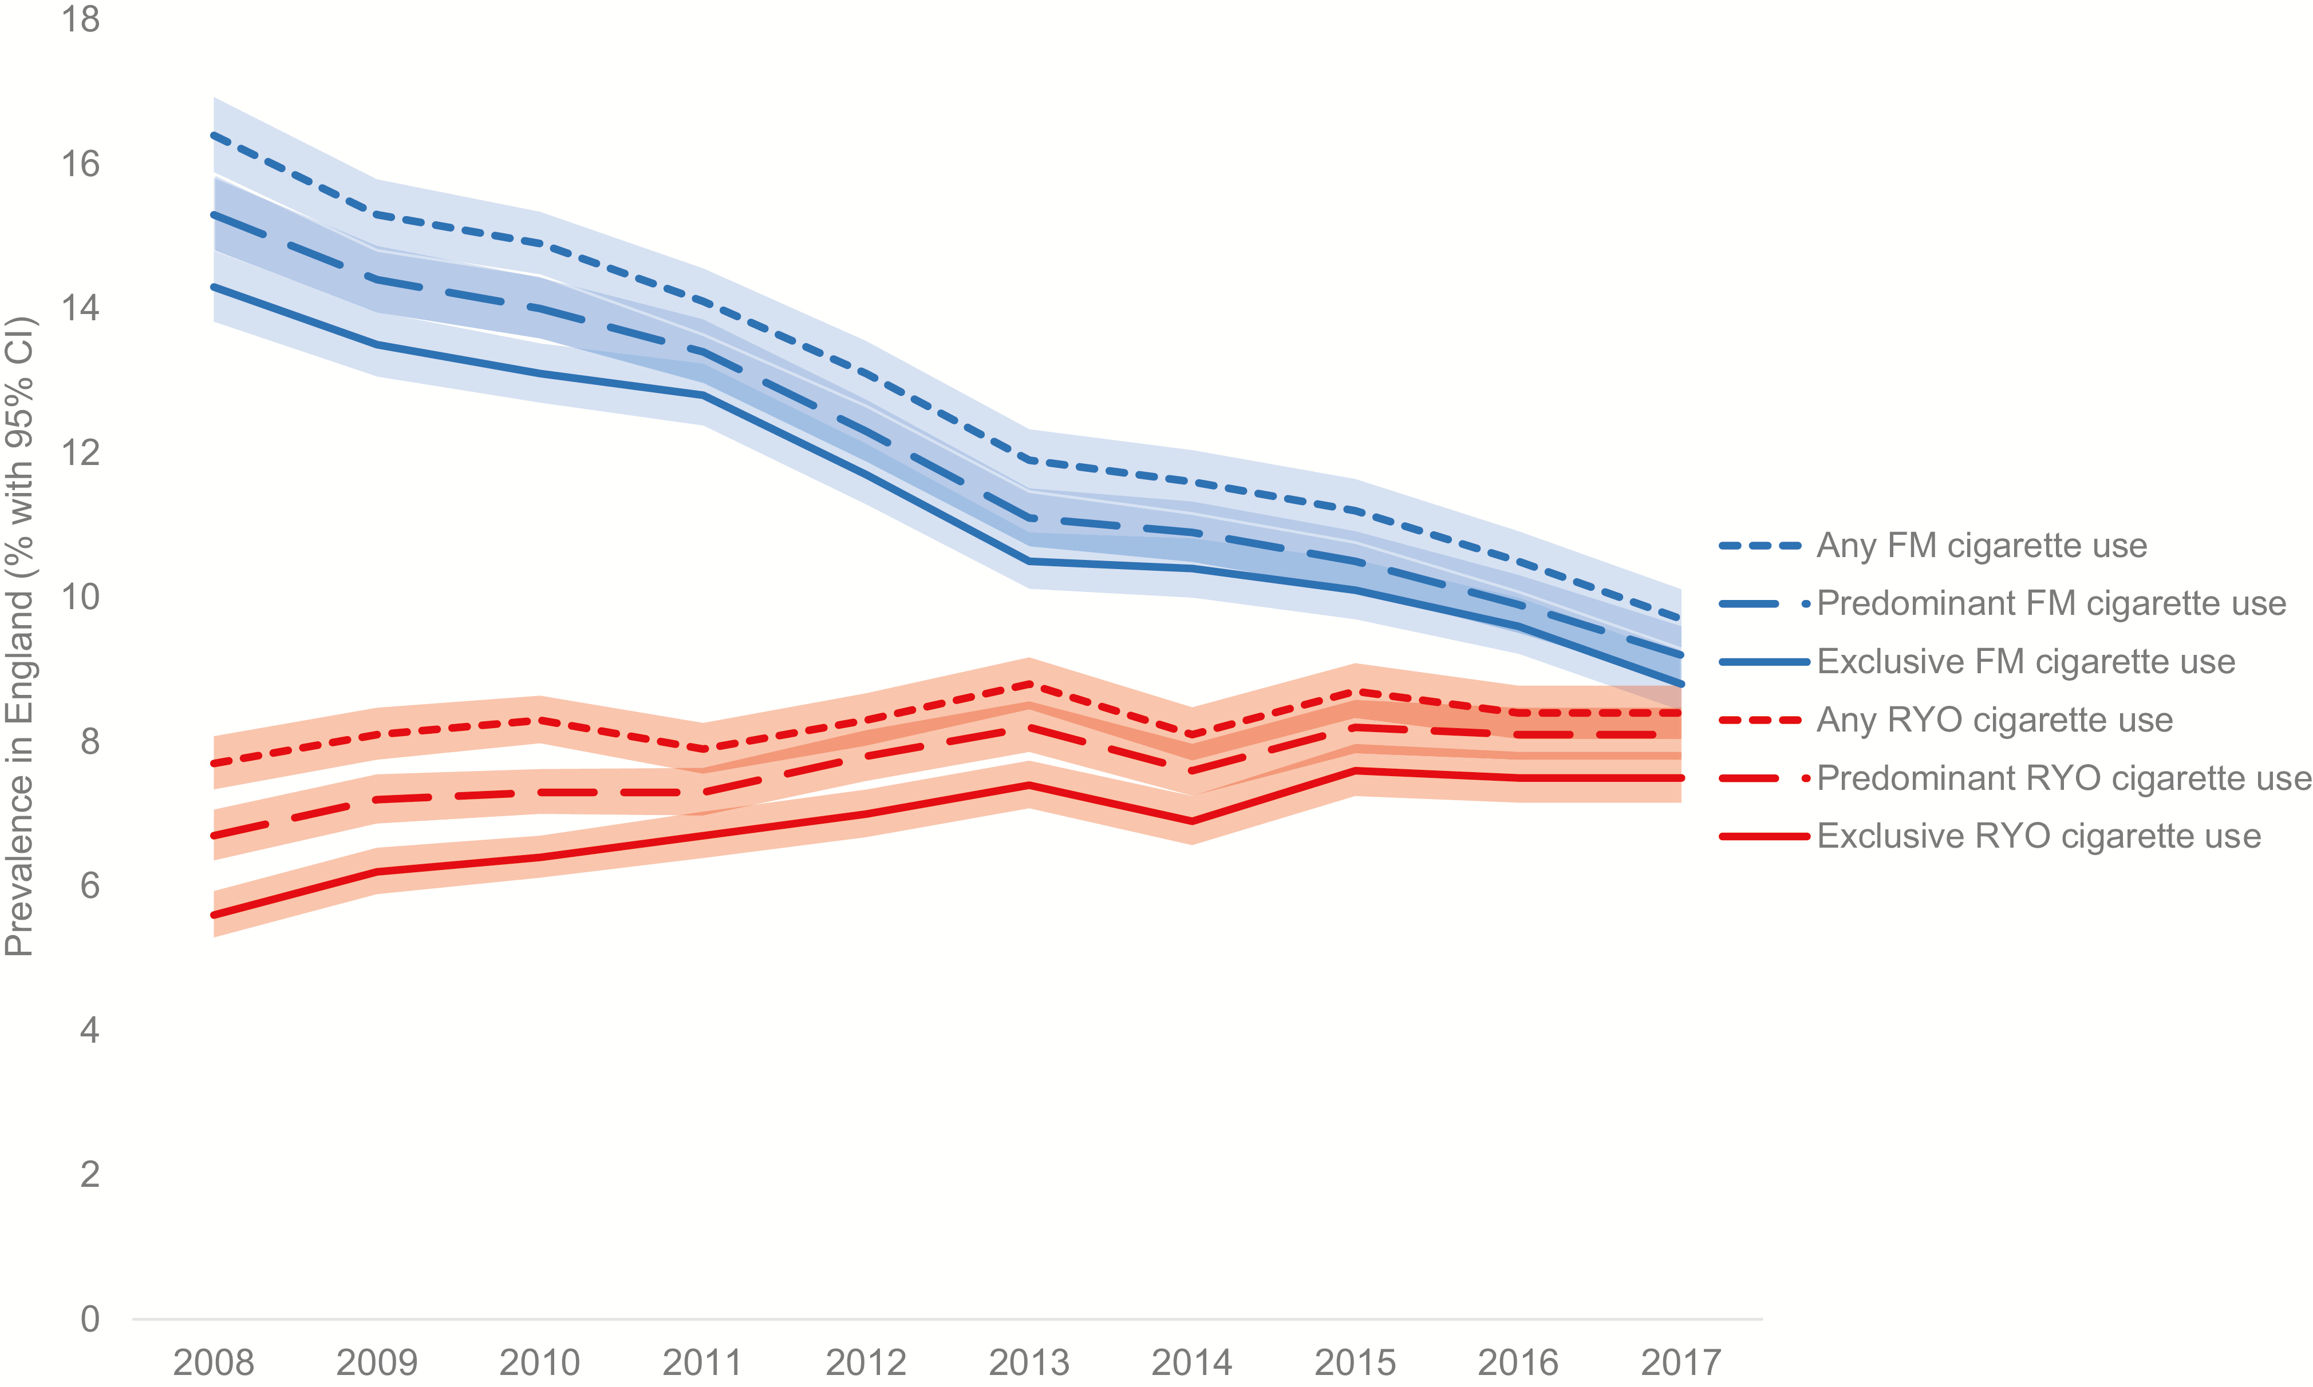

Source: Trends in and Correlates of Use of Roll-Your-Own Cigarettes: A Population Study in England 2008–201725

- These trends are in line with evidence showing consumption of HRT increases as the price differential between factory made and HRT increases and that countries which tax factory made and HRT similarly do not see downtrading from factory made cigarettes to HRT whilst those with a taxation differential do.

- Although the renewal of the tobacco tax escalator until the end of this parliament was welcome, we would urge the government to go further. In the 2020 Budget the increase applied was 2% above inflation for cigarettes and the additional one-off 4% increase for hand rolled tobacco (HRT) which still left a significant differential in taxes between the two products.

- To address the continued significant differential in taxation of factory made and HRT, we recommend that the annual tobacco tax escalator should be raised from 2% above inflation to 5% above inflation. Furthermore, the annual escalator for HRT should be increased to 15% above inflation. The escalators should be aligned once tax on HRT, as measured by the tax paid per stick containing the typical weight of tobacco used, is equivalent to that on factory made cigarettes.

- Increasing tobacco prices through taxation reduces smoking prevalence, increases tax revenues, and reduces costs to public finances.28 It was estimated at the time of the 2020 Budget that implementation of the ASH/UKCTAS recommendations on tax increases would deliver a -0.17 percentage point reduction in smoking prevalence and a net benefit to public finances of £439.7 million in year 1 alone.

- The uprating of minimum excise tax (MET) on cigarettes to £6.10 (previously £5.88) for a pack of 20 at the last Budget was a welcome measure. Research shows the introduction of MET had an impact on pricing of factory made cigarettes, but it needs to be regularly updated if it is to continue to be effective. We therefore recommend that Minimum Excise Tax be updated annually to ensure that the minimum tax for tobacco products is the rate due for products sold at the weighted average price (WAP).

- We also recommend that tobacco tax rules are enhanced after we leave the EU, and are therefore no longer subject to the requirements of the EU Tobacco Tax Directive. This should include:
  - making excise tax on factory made cigarettes specific only;
  - eliminating all duty free and any tax paid tobacco allowances from EU member states;
  - applying the announced “Global UK tariff” to all imported tobacco products; and
  - increasing the taxation on cigarillos so that cigarette-like cigarillos cannot be used to avoid tobacco duty (alongside other cigarette regulations).

- These measures would substantially reduce the affordability of tobacco thereby reducing smoking rates, improving the health and economic wellbeing of the UK population, strengthening the UK’s tax base and supporting Government ambitions to deliver a smoke free England by 2030, deliver effective recovery from the pandemic and level up society.

Tackling the abnormal profitability of the tobacco industry

- Furthermore, tobacco manufacturers make far higher profits than producers of other consumer staples. Indeed tobacco manufacturers are particularly profitable in the UK, despite having some of the highest taxes in the world. For example, while net operating profit margins for Imperial Brands globally in 2018 were 46%, in the UK they were 63%, much higher than for most consumer staples such as food, beverages and household goods of 12-20%.

- Despite this tobacco manufacturers pay little in corporation tax in the UK, and yet are estimated to have made over £900 million in profits in the UK market in 2018.31 Given its abnormal profitability and the uniquely harmful source of its profits, we recommend that the Bank Corporation Tax Surcharge (BCTC) be extended to tobacco manufacturers, thereby imposing an additional 8% corporation tax surcharge on profits.

- This surcharge would be supported by the use of existing frameworks such as the Diverted Profits Tax (including the higher rate currently paid by banks given the BCTC), which would help prevent the transfer of profits outside of the UK in response to the extension of the surcharge, and the OECD Base Erosion and Profit Shifting (BEPS) framework that co-ordinates countries addressing tax avoidance. Under the BEPS framework, the UK requires companies to report profits on a market by market basis, allowing government to respond to attempts by tobacco manufacturers to move profits from the UK.

- Additional changes that should be made in the light of the government’s smokefree 2030 are:
  - Removing tobacco companies right to reclaim against corporate tax for marketing (including CSR) and promotions.
  - Eliminating duty free for all tobacco products.

Question: Is there a role for windfall taxes in the post coronavirus world?"

- Yes. In light of the aforementioned abnormal profitability of the tobacco manufacturers, and the link between smoking and ill-health, the tobacco industry would be an obvious target for a windfall tax. Profits made on UK sales could be made subject to a one-off windfall tax to help the public finances.

- A windfall tax on tobacco companies could be applied in many different ways. It could be a charge related to the volume of past tobacco sales, it could be a one-off addition to corporation tax, or it could be a specific multiple of the price-earnings ratio in line with the 1997/98 UK tax on privatised utility companies.

- Windfall taxes are often rejected because they are either seen to be unfair, or because of concerns they might negatively impact the operation of an industry going forward. Neither of these possible concerns apply to the tobacco industry. As outlined above the industry currently causes significant harm to society, which is not entirely offset by current tobacco excise duties, so should pay more. Furthermore, any negative impact on the future sales of tobacco is to be welcomed as lower rates of tobacco use would enhance the public health, and therefore reduce the burden of ill health on the exchequer.

Question: What is the best way to tackle tax reform, including what changes might be needed at HMRC to support implementation, and how should the Government consult with stakeholders and parliament?

- In consulting on any of the above proposed measures or any matter relating to tobacco, we recommend that any respondents should be required to declare any indirect or direct links to the tobacco industry, in accordance with the UK’s obligations under Article 5.3 of the Framework Convention on Tobacco Control and its guidelines,, which the UK has adopted.

- This could be achieved by employing the same wording used in consultations issued by the Department for Health and Social Care, as follows:

Declaration of direct or indirect links to the tobacco industry by respondents
As a Party to the World Health Organisation’s Framework Convention on Tobacco Control (FCTC), the United Kingdom has an obligation to protect the development of public health policy from the vested interests of the tobacco industry. To meet this obligation, we ask all respondents to disclose whether they have any direct or indirect links to, or receive funding from, the tobacco industry. We will still carefully consider all consultation responses from the tobacco industry and from those with links to the tobacco industry and include them in the published summary of consultation responses.

September 2020

References

DHSC and Cabinet Office. Advancing our health: Prevention in the 2020s. July 2019.
HMT. Budget 2020: Delivering on our promises to the British people. March 2020.
BEIS. The Grand Challenges: Ageing society. September 2019.
ONS. Deaths involving COVID-19 by local area and socioeconomic deprivation: deaths occurring between 1 March and 30 June 2020. July 2020.
ONS. Adult smoking habits in the UK: 2019. July 2020.
ONS. General lifestyle survey, 2010. March 2012.
NHS Digital. Statistics on smoking, England – 2019. July 2019.
Public Health Wales Observatory. Smoking in Wales. Accessed August 2020.
The Scottish Public Health Observatory. Tobacco use: Key points. March 2020 [accessed August 2020].
U.S. Department of Health and Human Services. The Health Consequences of Smoking—50 Years of Progress: A Report of the Surgeon General. January 2014.
ASH. Smoking, employability and earnings. September 2020.
ASH. Ready Reckoner 2019 edition. November 2019.
ASH. ASH response to BEIS Committee super-inquiry into post-pandemic economic growth. September 2020.
Brown, T., S. Platt and A. Amos (2014). Equity impact of European individual-level smoking cessation interventions to reduce smoking in adults: a systematic review. European Journal of Public Health. 2014 May 31;24(4): 551-556.
International Agency for Research on Cancer. Effectiveness of tax and price policies for tobacco control. 2011.
Amos A, Bauld L, Hill S, Platt S, Robinson J. Tobacco control, inequalities in health and action at the local level in England. London, UK: Public Health Research Consortium; 2011 Mar 31.
Hiscock R, Branston JR, Partos TR, McNeill A, Hitchman SC, Gilmore AB. UK tobacco price increases: driven by industry or public health? Tobacco control. Published Online First: 25 July 2019. doi: 10.1136/tobaccocontrol-2019-054969
HMRC. Measuring tax gaps. Accessed September 2020.
The Grocer. Wholesalers push for HMRC rule change as tobacco sales spike. September 2020 [accessed September 2020].
HMRC. Tobacco bulletin: Tobacco statistics tables July 2020 – Table 1. August 2020.
DH. Towards a smoke-free generation: A tobacco control plan for England. July 2017.
JR Branston, A McNeill, AB Gilmore, R Hiscock, TR Partos. Keeping smoking affordable in higher tax environments via smoking thinner roll-your-own cigarettes: Findings from the International Tobacco Control Four Country Survey 2006–15. Drug and alcohol dependence 193, 110-116.
ONS. Opinions and Lifestyle Survey. Adult Smoking Habits in Great Britain, 2013. November 2014.
University College London. Smoking Toolkit Study. Accessed September 2020.
Jackson SE, Shahab L, Garnett C, Brown J. Trends in and Correlates of Use of Roll-Your-Own Cigarettes: A Population Study in England 2008–2017, Nicotine & Tobacco Research, Volume 22, Issue 6, June 2020, Pages 942–949, https://doi.org/10.1093/ntr/ntz082
Mindell JS, Whynes DK. Cigarette consumption in the Netherlands 1970 – 1995: does tax policy encourage the use of hand- rolling tobacco? The European Journal of Public Health. 2000 Sep 1;10(3):214-9.
Partos TR, Branston JR, Hiscock R, Gilmore AB, McNeill A. Individualised tobacco affordability in the UK 2002–2014: findings from the International Tobacco Control Policy Evaluation Project. Tobacco control. 2019 May 1;28(Suppl 1):s9-19.
ASH & UKCTAS. HM Treasury Budget 2020: Representation from ASH and the UK Centre for Tobacco and Alcohol Studies to the Chancellor of the Exchequer. January 2020.
Hiscock R, Augustin NH, Branston JR, et al. Longitudinal evaluation of the impact of standardised packaging and minimum excise tax on tobacco sales and industry revenue in the UK. Tobacco Control Published Online First: 12 July 2020. doi: 10.1136/tobaccocontrol-2019-055387
Branston JR, Hiscock R, Silver K, et al. Cigarette-like cigarillo introduced to bypass taxation, standardised packaging, minimum pack sizes, and menthol ban in the UK. Tobacco Control Published Online First: 26 August 2020. doi: 10.1136/tobaccocontrol-2020-055700
Branston JR. Tobacco industry response to taxes: “what do we know and what can we anticipate?. 8th ECToH Conference, Plenary 6. February 2020.
HMRC. Diverted profits tax: Guidance. December 2014.
OECD. International collaboration to end tax avoidance. Accessed August 2020.
WHO. Guidelines for implementation of Article 5.3 of the WHO Framework Convention on Tobacco Control. Accessed September 2020.
WHO. Framework Convention on Tobacco Control. 2003.

