Lord Grimstone of Boscobel Kt
Minister for Investment
Department for International Trade
Old Admiralty Building
Admiralty Place
London SW1A 2DY 29 October 2021

Dear Gerry,
Thank you for your letter of 20 October on the Agreement in Principle with New Zealand, which arrived on the day of my first meeting of the Committee. I look forward to working with you and your department on this and other agreements.
As you will know, the Committee is keen that the Impact Assessment to be published after signature will be sufficiently granular for respondents, especially the devolved governments, to be able to judge the effect on their particular areas or sectors. We also look forward to the EM detailing the feedback from your consultations with the devolved governments.

Yours sincerely,

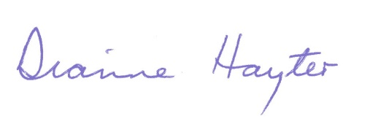
Baroness Hayter
Chair, House of Lords International Agreements Committee

