Lord Grimstone of Boscobel Kt
Minister for Investment
Department for International Trade
Old Admiralty Building
Admiralty Place
London SW1A 2DY 29 October 2021

Dear Gerry,
Climate commitments in Australia FTA
With COP 26 now only a couple of days away, the Committee would like to raise the issue of references to climate commitments in the free trade agreement with Australia. As you will be aware, it has been widely reported in the press that while the final treaty text will mention the Paris Agreement, the explicit reference to specific temperature commitments has been removed.
We would be grateful if you could write to the Committee to explain whether and, if so, how the Agreement in Principle has been changed; and what assessment you have made of the impact of such change.
As usual, we look forward to your response within 10 working days.
I am copying this letter to Angus Brendan MacNeil MP, Chair of the Commons International Trade Committee; and the Minister for International Trade, Ranil Jayawardena MP.

Yours sincerely,

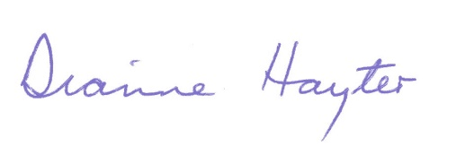
Baroness Hayter
Chair, House of Lords International Agreements Committee

