Written Evidence submitted by Prof Tim Benton (COV0156)
Energy, Environment & Resources Programme, Chatham House
Expertise
- I am Research Director in Emerging Risks and Director of the Energy, Environment and Resources Department at the Royal Institute of International Affairs at Chatham House, UK. Chatham House is an independent research organisation and policy think tank, whose Mission is to help governments and societies build a sustainably secure, prosperous and just world.
- I have many years of experience as a researcher in sustainability and food systems. From 2011-2016, I was the “Champion” of the UK’s Global Food Security programme which was a multi-agency partnership of the UK’s public bodies (government departments, devolved governments and research councils) with an interest in the challenges around food. I am also an Agenda Steward for the World Economic Forum on food and agriculture, and a lead author for the IPCC Special Report on food, climate and land, and the UK Climate Change Risk Assessment 2017 and 2021 Evidence Reports.

Our food systems are fragile
- I was asked to comment on the resilience of the UK food system in the light of COVID-19, and government preparedness.
- The events of 2007/8 and 2010/11 highlighted that the UK’s food system (based, as it is, on globalised economic flows – finance, goods, people) is fragile in the face of shocks. A small perturbation from a climatic event can, in interaction with other factors, lead to significant market amplification of the supply shock, that can cascade through connected markets across space and lead to significant global impacts arising from food prices spiking. The 2007/8 and 10/11 price spikes have been analysed extensively and conclusions published in multiple places - including in the IPCC Special Report on food land and climate change, and the UK’s Climate Change Risk Assessment.
- The key conclusion from such analyses is that our food systems are fragile. Food security – a secure supply of food to feed a country – arises as a combination of local supply and global trade. Trade has become more important with growing globalisation - especially over the last 30 years - creating a real dependency on the inward flow of goods to deliver any specific country’s overall food supply. As food depends on agriculture, water, land, supplies of chemicals and energy, and increasingly communications (satellite navigation in precision agriculture and transport networks) perturbations to food systems can occur far wider than through disruptions in farming. Additionally, especially in high-income countries, food systems are increasingly “just-in-time”, so any disruption has immediately implications in supply. In other words, food security requires a range of sectors, infrastructure, complex logistics, finance, and so on to work in concert across the world in order to supply a nation’s requirements.
- This co-dependency across sectors, and just-in-time supply, means that a shock (a climate change impact) can interact with a very large range of other factors - a change in energy policy, a geo-political disruption, changes in trade-policy etc etc - to propagate through the system creating worldwide impacts on food security. Furthermore, the co-dependency (across space and sectors) means that there are a very large combination of potential shocks and places they could happen, and pathways they could propagate through to create a high impact. (See Figure 1 for an example: the pathway of impacts in 2010 from Russian drought to global price spike).
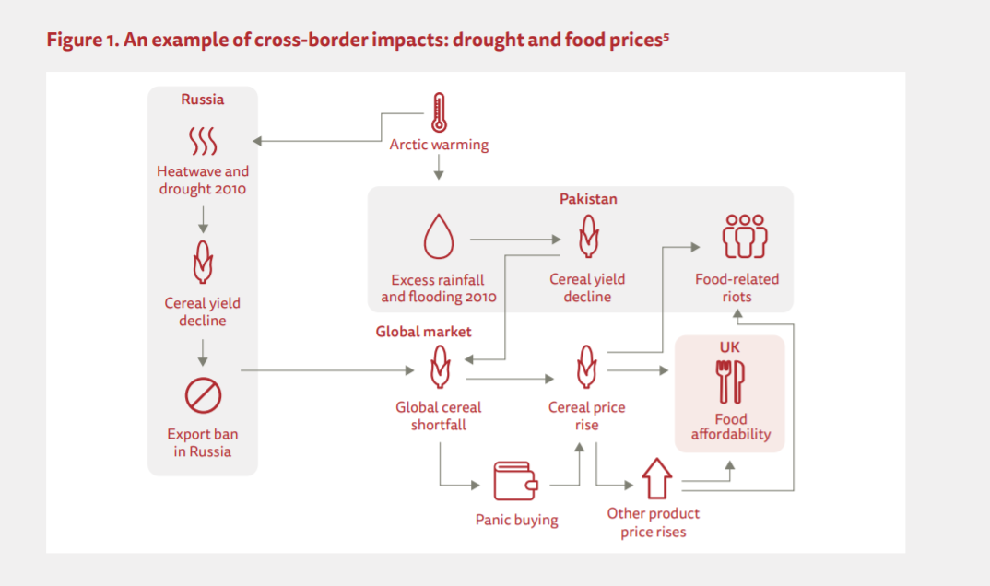

Shocks – like COVID-19 and other climate impacts – are likely to get worse.
- COVID-19 is a zoonosis, arising from wild animals. The recent trend in emerging infectious diseases over the last decades, coupled with theoretical expectations, suggests such zoonoses are going to become more common with climate and environmental change. As IPCC SRCCL highlights, the rising incidence of extreme events will increasingly undermine the stability of agricultural yields (both directly and indirectly by changing the incidence of pests and diseases), as well as the ability to transport them across the world.
- The pandemic is a demand-side shock and not a supply-side shock affecting production (like Fig 1). Nonetheless, in addition to previous “food crises” it is highlights a range of issues; despite the fact that, with some considerable efforts, largely unseen to consumers, our just-in-time supply chains have functioned for the majority who can access supermarkets and are not constrained economically. Nevertheless, COVID has highlighted:
  - That economically and medically vulnerable people have struggled to access food during the crises, which has led to an increase in the scale of food insecurity in the UK. [It also has brought to the fore how significant food insecurity was for a very significant proportion of the UK population under “normal” conditions.]
  - That super-efficient, highly centralised, food systems are fragile, because if they go “wrong” they fail. This includes centralised processing facilities (e.g. large scale meat-packing plants that have had to close as they become hotspots of disease transmission). It also includes the fact that rapid changes in demand (e.g. closing hospitality, increased stocking up by citizens) cause disruption to supply chains due to sudden changes in demand that the distribution system is not designed to cope with.
- The fragility of a given system to a shock – such as a climate, pest or disease hazard – depends on exposure and vulnerability. Even if hazards stay the same (NB they’re increasing) if our exposure or vulnerability changes, the risks increase. Exposure and vulnerability are affected by a huge range of socio-economic factors. The more we rely on food trade to backstop our food system, the more exposed we are to interruptions to food trade. In addition, Brexit creates largescale changes in food trade, alongside increasing trade from countries outside EU which have perhaps lower environmental governance and greater exposure to climate hazards. Thus, even without climate change, Brexit and the move away from the post-war multi-lateral architecture of international cooperation, increases our exposure and vulnerability.
- Given climate change and given the rapid changes in global geopolitics and trade (breakdown of multilateralism; trade-wars; increasing people movements; increasing international friction, partly caused by increasing inequality) the overall chance of risks, cascading across borders, and interrupting our food supplies is increasing.

Building resilience
- The above summary suggests we need to build resilience in the food system – so we are better able to cope with the increasing volatility arising from the interactions between climate and a changing world, including its economies and politics.
- Resilience encompasses notions of robustness (will a shock perturb food supply?), and, if so, how much will it be perturbed, and will it return to previous functionality, and over what time frame? Resilience typically arises through two conceptual notions: functional redundancy and diversity. The first typically would arise from having spare capacity (e.g. food stores for supplies, or decentralised processing – so there is no single point of failure). The second would include diversity in food suppliers, geographies and products. Both notions are typically antithetical to standard notions of “efficiency” – which rely on just-in-time supply chains, from preferred suppliers, highly specialised with no scope for substitution of products. Resilience, is thus, and necessarily, an excess cost to the current way our food systems are constructed.
- Resilience is not the same as self-sufficiency. In a stable world, maximising comparative advantage by growing what we’re really good at, exporting the excess and buying in what we’re less good at growing, is economically sensible. However, as the risks that may perturb food supply increase in magnitude – and are outside our control – the more trade exposes us to risks. These may be greater than the risk of ensuring more self-reliance: were the UK to be self-sufficient, only events in the UK could disrupt our supply; whereas events anywhere in the world can disrupt our supply if we are fully globalised. There is therefore an academic question about the optimal balance of local vs global risks, and the degree to which we should enhance our local supplies of food (notably the diversity and amount of fruit and vegetables) as a resilience-building bet-hedge.

Previous advice to HMG
- The UK’s Climate change risk assessment process in 2017 provided independent assessment of climate change’s risks to government, including our food supply. In that report there was a recommendation that government should focus on building greater resilience in food supplies, to guard against perturbations arising from the interaction of climate hazards (which include pests and diseases) and globalised supply chains:
Managing the risk to food prices is likely to require strategic, national coordination and planning to manage the resilience of the UK food system, encompassing domestic and international production and trade. There is currently no Government strategy encompassing domestic and international food systems and no overarching role coordinating expertise and actions from the large range of government departments (BIS, DECC, DFID, FCO, FSA, DoH, etc.), academia and industry required to ensure systemic food system resilience.
- The formal response from government in 2017 was:
The Evidence Report’s recommendation that new policy is needed to manage risks to UK food prices […] does not align with the findings from our own research, including that carried out for the UK Food Security Assessment in 2009 and reviewed in 2012. The Government takes a more optimistic view of the levels of resilience that are achieved through functioning markets and diverse sources of supply.
- With Brexit planning in 2019 and COVID-19, I think there is a wider recognition that (12) above is too narrow a framing: COVID-19 would have had far wider impacts had the state not recognised the need and intervened. I note that Henry Dimbleby has commented that food security (and implicitly resilience) has to be a key area for the cross-government National Food Strategy. If Government takes the advice offered by the NFS review, it would be a recognition of the issues highlighted above and recommended in (11).

Global Food Security Programme Report: https://www.foodsecurity.ac.uk/publications/extreme-weather-resilience-global-food-system.pdf; UK Climate Change Risk Assessment Report https://www.theccc.org.uk/wp-content/uploads/2016/07/UK-CCRA-2017-Chapter-7-International-dimensions.pdf; Challinor et al (2018) https://doi.org/10.1098/rsta.2017.0301; IPCC Special Report on Food, Land and Climate https://www.ipcc.ch/srccl/chapter/chapter-5/
Figure from CASCADES https://www.climate-diplomacy.org/publications/cascading-climate-impacts-new-factor-european-policy-making, based on analysis in Challinor et al (2018) https://doi.org/10.1098/rsta.2017.0301
https://www.bbc.co.uk/news/health-51237225
https://www.ipcc.ch/srccl/chapter/chapter-5/
But note, we waste approximately 30% of food produced. This is potentially a “buffer stock”: if we bought the “right amount”, consumers would pay less, allowing them to pay more for food without affecting household expenditure.
http://eprints.whiterose.ac.uk/112876/1/BritishFoodReportFeb2017.pdf
Page 3 in https://www.theccc.org.uk/wp-content/uploads/2016/07/UK-CCRA-2017-Chapter-7-International-dimensions.pdf
Page 16 in https://assets.publishing.service.gov.uk/government/uploads/system/uploads/attachment_data/file/584281/uk-climate-change-risk-assess-2017.pdf
https://www.fginsight.com/news/news/food-strategy-will-have-renewed-focus-on-food-security-after-pandemic-plan-chief-says-108272

