 | Tom Scholar Permanent Secretary  HM Treasury 1 Horse Guards Road London SW1A 2HQ
 | www.gov.uk/hm-treasury
Rt Hon Mel Stride MP
Chair of the Treasury Committee House of Commons
London SW1A 0AA
[By email]

18 June 2021
Dear Mr Stride GREENSILL
At the oral evidence session of the Treasury Committee on 27 May, I undertook to ask Mr Cameron to let me have a copy of the text messages I sent him in relation to Greensill, and to release them in accordance with the Freedom of Information Act. We are releasing that information this afternoon: please find attached a copy of our letter.

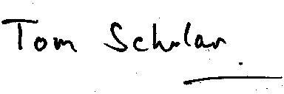
Tom Scholar

The letter, published by HM Treasury, can be found here

