

ESTIMATES MEMORANDUM
DEPARTMENT OF HEALTH AND SOCIAL CARE
2020-21 SUPPLEMENTARY ESTIMATE

TABLE OF CONTENTS

- Overview 3
1.1 Objectives 3
1.2 Spending Controls 3
1.3 Main Areas of Spending 4
1.4 Comparison of Spending Totals Sought 6
1.5 Key Drivers of Spending Changes Since Last Year 6
1.6 New Policies and Programmes 6
1.7 Spending Trends 7
1.8 Funding: Spending Review and Budgets and other spending announcements 9
- Spending Detail 14
2.1 Resource DEL 14
2.2 Capital DEL 16
2.3 Resource AME 17
2.4 Ring Fenced Budgets 18
2.5 Changes to Contingent Liabilities 18
- Priorities and Performance 20
3.1 Major Projects 20
- Other Information 21
4.1 NHS England 21
4.2 DHSC Inter-Group Transactions 21
4.3 DHSC Revenue Expenditure Analysis 23

- OVERVIEW

  - Objective
The Department of Health and Social Care (DHSC) supports ministers in leading the nation’s health and social care to help people live more independent, healthier lives for longer.

Departmental priorities for 2020-21 are summarised below:

- Respond to Covid-19 and health protection;
- A stronger and more integrated health and care system;
- Transformation in social care;
- Healthier nation;
- Digital revolution;
- Workforce that is fit for the future;
- Building infrastructure for the future; and
- Well-managed end to EU transition.

  - Spending Controls
DHSC’s spending is broken down into the different spending totals, for which Parliament’s approval is sought. The spending totals which Parliament votes are:

- Resource Departmental Expenditure Limit (Resource DEL) – day to day running costs;
- Capital Departmental Expenditure Limit (Capital DEL) – investment in infrastructure;
- Resource Annually Managed Expenditure (Resource AME) – non-fiscal less predictable expenditure, in DHSC’s case this is mainly litigation provisions for clinical negligence cases managed by NHS Resolution (NHSR); and
- Capital Annually Managed Expenditure (Capital AME) – in DHSC’s case this covers the specific budgeting treatment relating to Credit Guarantee Finance.

In addition, Parliament votes a net cash requirement, designed to cover the elements of the above budgets which require the DHSC Departmental group to pay out cash in year.

  - Main Areas of Spending
The graphics below show the main components of DHSC’s proposed Resource DEL, Capital DEL and Resource AME spending plans, included in the latest Supplementary Estimate, and the proportions spent by the different bodies within the group. The letters in the graphics below denote the letter attributed to each Estimate Subhead.

The RDEL budget allocated to the core department has increased significantly since Main Estimate, this is due to increases for Covid-19 – this includes funding for NHS Test and Trace, personal protective equipment and Covid-19 vaccines deployment. Further details are included in paragraphs 1.8 and 2.1.

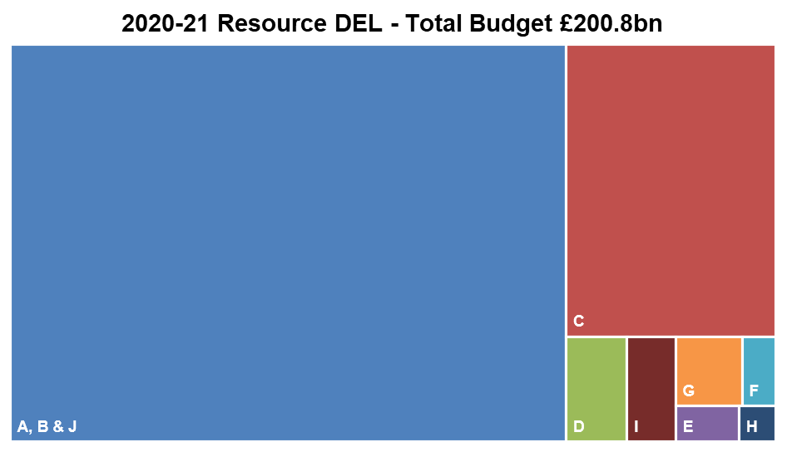

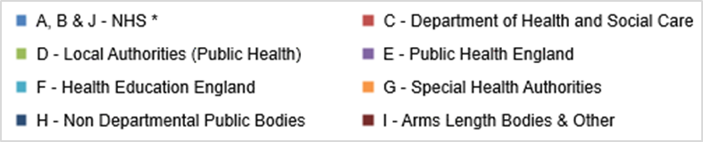

* NHS – this section represents the funding available for the NHS and consists of the following Estimate lines:

- A – NHS Commissioning Board (known as NHS England);
- B – NHS Providers; and
- J – NHS Commissioning Board (known as NHS England) net expenditure financed from National Insurance Contributions.

Details of the spending plans for each Estimate line can be found in section 2.1.

Please note the core funding for NHS Improvement (NHS TDA and Monitor) is not currently included in the *NHS funding block above. Instead it is included in block G (NHS TDA) and block H (Monitor).
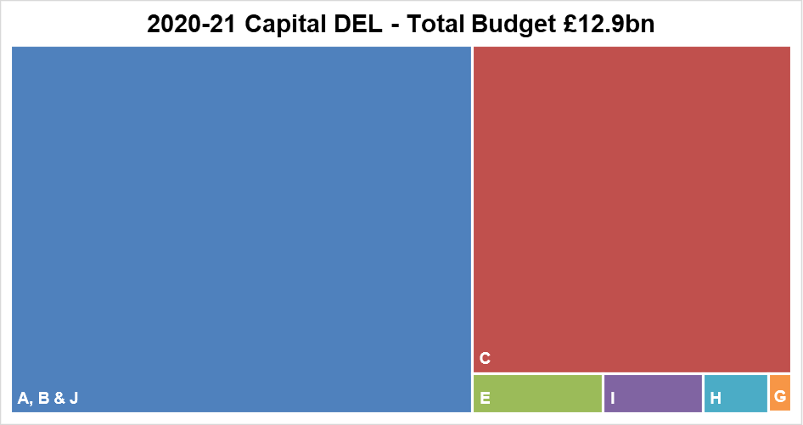

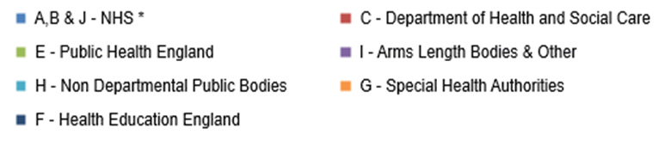

Please note the capital for Health Education England (line F) is not shown in this illustration due to relatively small size of the budget (£2m). Details of the spending plans for each Estimate line can be found in section 2.1.
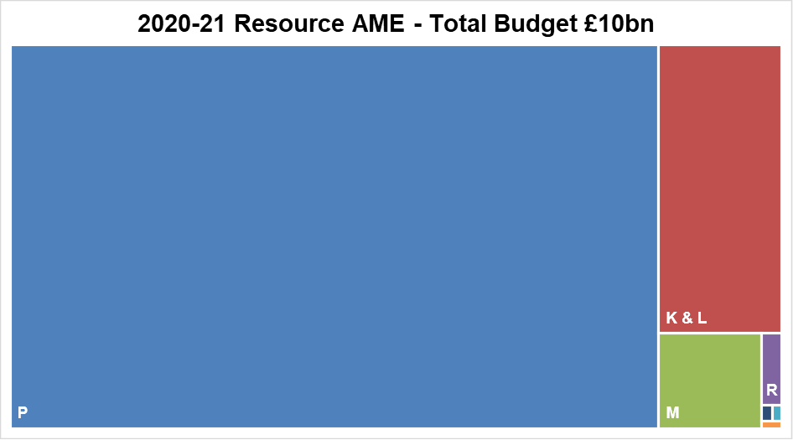

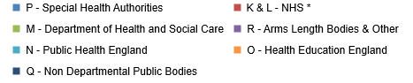
  - Comparison of Spending Totals Sought
The table below shows how the 2020-21 Supplementary Supply Estimate (SSE) spending plans compare with the 2020-21 Main Estimates and the 2019-20 Outturn.

DEL Type | 2020-21 Supplementary Estimate | 2020 Main Estimate | Variance to  2020-21 Main Estimate |  | 2019-20 Outturn | Variance to  2019-20 Outturn
DEL Type | £m | £m | £m | % | £m | £m | %
Resource DEL | 200,755 | 144,836 | 55,920 | 38.6% | 134,183 | 66,572 | 49.6%
Capital DEL | 12,918 | 8,231 | 4,687 | 56.9% | 7,015 | 5,903 | 84.1%
Resource AME | 10,002 | 10,002 | 0 | 0.0% | 2,848 | 7,154 | 251.2%

  - Key Drivers of Spending Changes Since Original Budget
This section identifies the key drivers of change since the 2020-21 Main Estimate for Resource DEL, Capital DEL and Resource AME. Further analysis of changes between 2020-21 Main Estimate and 2020-21 Supplementary Supply Estimate can be found in section 2.

- Resource DEL - the Resource DEL increase of circa £55.9 billion includes:
  - £55.8 billion additional funding allocated for the Department’s response to Covid-19;
  - Additional funding of £445 million primarily for technical budget adjustments such as expected credit loss, depreciation and impairments;
  - a £43m RDEL to CDEL budget switch; and
  - budget transfers to other government departments of £244 million
further details can be found in paragraph 1.8

- Capital DEL
The Capital DEL increase represents of circa £4.7 billion includes:
  - £3.29 billion additional funding allocated for the Department’s response to Covid-19, net of £684m NHS Provider and Non-NHS savings;
  - £1.39 billion net additional funding allocated as part of Plan for Jobs 2020, net of £112m NHS Provider savings;
  - a £43m RDEL to CDEL budget switch; and
  - budget transfers to other government departments of £29 million.
further details can be found in paragraph 1.8

- Resource AME
The Departments Resource AME is demand led and the 2020-21 £10 billion reflects our best estimate of provisions and impairments expenditure for the DHSC group.

  - New Policies and Programmes
The DHSC makes all announcements on new policies and programmes during the year on the government website, details can be found at DHSC announcements. Information on the latest announcements on Covid-19 can be found on the above website and further details on the funding requirement for these policies are included in paragraph 1.8 and within the accompanying Table B.

  - Spending Trends
The graphs show the outturn for the last 3 years (2017-18 to 2019-20), plans presented in Estimates for 2020-21, and future spending plans for 2021-22 for Resource DEL and Capital DEL, future Resource AME spend was not considered as part of the Spending Review 20 and will be set at Main Estimate 2021-22.

- Resource DEL
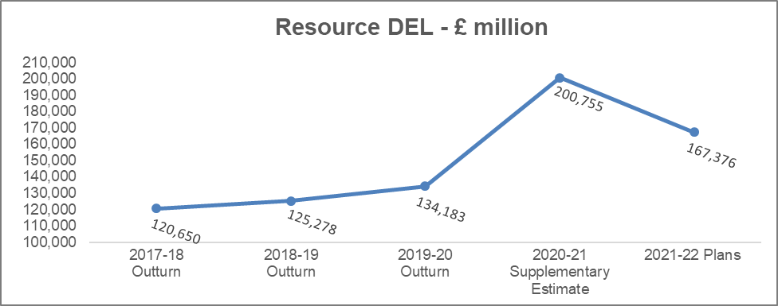

At Main Estimate 2020-21, DHSC was given an additional £3.37 billion for the emergency response to Covid-19. Due to the timing of Main Estimates, it was agreed that further budget cover would be provided at Supplementary Estimates. The Government continues to support the NHS and other public services to access the resources they need to tackle Covid-19 and a further £55.8 billion has been provided at Supplementary Estimate in response to the Covid-19 Pandemic. Further details of the programmes this additional funding covers are provided in para 1.8.

Increases from 2019-20 follow the multi-year funding commitment announced by the Prime Minister in June 2018 and the NHS Long Term plan, published in January 2019. This plan was published on the basis of it being affordable and deliverable within the final cash settlement that was provided to the NHS. More details can be found in the NHS Long Term Plan.
Details on how the NHS’s Long Term Plan will be implemented can be found at NHS Long Term Plan implementation.

2019-20 and 2020-21 also include an additional £2.85 billion in each year for NHS pensions, and this is funding that is over and above the Long Term Plan Settlement, further details were set out in the Main Estimate Memorandum.

The DHSC Spending Review 2020 settlement included £147.1 billion core revenue funding and £20.3 billion Covid-19 funding for 2021-22.

The core revenue settlement provides a £6.6 billion cash increase from 2020-21 to 2021-22, delivering a 3.5 per cent average real terms increase per year since 2019-20. The government remains committed to the previously agreed plans included in the historic long-term settlement for the NHS which provides a cash increase of £33.9 billion a year by 2023-24. This takes the NHS England budget from £114.6 billion in 2018-19 to £148.5 billion in 2023-24, with an increase of £6.3 billion in 2021-22.

Spending Review 2020 supports the country’s ongoing response to Covid-19, providing funding of £20.3 billion. This includes; £15 billion for Test and Trace, £2.1 billion to continue to maintain and distribute stocks of personal protective equipment, and £163 million for medicines and therapeutics. It also provides an additional £3 billion to support the NHS’s recovery from the impact of Covid-19:
  - this includes around £1 billion to begin tackling the elective backlog, enough funding to enable hospitals to cut long waits for care by carrying out up to one million extra checks, scans and additional operations or other procedures
  - around £500 million to address waiting times for mental health services, give more people the mental health support they need, and invest in the NHS workforce
  - around £1.5 billion to help ease existing pressures in the NHS caused by Covid-19.

Spending Review 2020 indicated the government’s commitment to ensure the NHS has the certainty it needs to plan and further funding for operationally necessary direct Covid-19 costs will be agreed with the NHS.

- Capital DEL
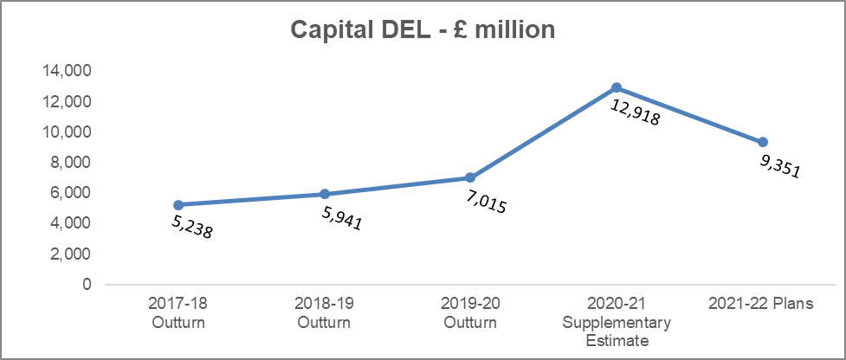
In the 2020 Spring Budget the Chancellor announced an additional £1.16 billion of capital funding for 2020-21. £1.11 billion to allow NHS Providers to continue investing in estate refurbishment and building maintenance. This includes funding for 20 hospital upgrades and to kick start the delivery of 40 new hospitals, £40 million is for Covid-19 related workstreams. Multi-year capital funding will be provided through the spending review later this year.

As part of a Plan for Jobs 2020 £1.5 billion additional capital for 2020-21 was awarded as follows:
- £1.05 billion for NHS critical maintenance and A&E Capacity across England;
- £250 million for Mental Health Dormitories; and
- £200 million for accelerating the Health Infrastructure Plan.

Funding to cover the department’s response to Covid-19 of £3.9 billion is included within the 2020-21 Supplementary Estimate, this is in addition to the £40 million included at Main Estimate. Further details of the programmes this additional funding covers are provided in para 1.8.

Spending Review 20 provides capital investment to continue to improve the NHS estate, including:
- multi-year capital funding commitments of £3.7 billion until 2024-25 to make progress on building 40 new hospitals by 2030 and £1.7 billion until 2024-25 for over 70 hospital upgrades to improve health infrastructure across the country over the long term. These projects will span the length and breadth of England, supporting the government’s levelling up agenda
- £4.2 billion in 2021-22 for NHS operational capital investment to allow hospitals to refurbish and maintain their infrastructure. Additionally, the government will provide £165 million in 2021-22, ringfenced to replace outdated mental health dormitories with single en-suite rooms.

- Resource AME
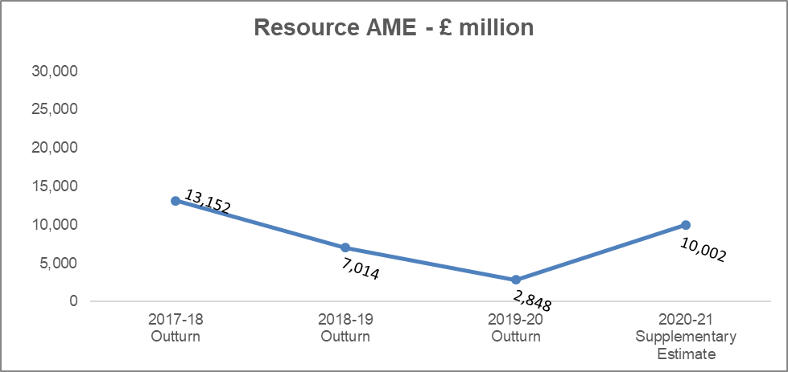

The Department’s AME doesn’t have an immediate impact on the fiscal framework or need for taxes to be raised to cover spending. It relates to provisions and impairments that are demand-led and volatile, being subject to many variables outside the Department’s direct control, such as changes to the discount rates to measure the value of long-term provisions liabilities.

  - Changes to 2020-21 Funding: Spending Review and Fiscal Events and other Spending Announcements
The Department’s 2020-21 spending plans were announced in the 2019 Spending Round, see paragraph 2.1 of the Government announcement in September 2019. Since that time, changes to 2020-21 spending plans include announcements of additional funding in the 2020 Spring Budget and for the Covid-19 outbreak. A summary of the changes can be found below, and further details of funding changes are set out in the excel tables at Annex B.

Resource DEL

Resource DEL - main changes since 2019 Spending Review | £m
2019 Spending Review | 139,823
2020 Spring Budget (a) | 1,062
2020-21 Routine transfers of funding from other Government Departments (b) | 566
2020-21 Supplementary Estimate in-year funding (c) | 445
2020-21 Supplementary Estimate Revenue to Capital transfer (d) | (43)
2020-21 Main Estimate Covid-19 (e) | 3,373
2020-21 Supplementary Estimate Covid-19 (e) | 55,762
2020-21 Covid-19 transfers of funding to other Government Departments (f) | (232)
TOTAL | 200,755

- 2020 Spring Budget: DHSC was allocated £1,062 million revenue funding to cover Manifesto commitments in the 2020 Spring Budget, which includes:
  - £638.5 million for nurse recruitment, training and retention;
  - £335.6 million for 50 million more appointments in General Practice; and
  - £78.2 million for hospital car parking.
- £566 million routine transfers from other Government departments;
- In year funding of £445 million primarily for technical budget adjustments such as expected credit loss, depreciation and impairments.
- Revenue to Capital switch: £43 million transfer from revenue to capital in line with HMT convention to score R&D costs as capital for budgeting purposes.
- Covid-19: Government committed to provide the NHS what was needed to tackle the pandemic and in the Main Supply Estimate £3.373 billion (revenue) funding was allocated for Covid-19, with the commitment to finalise funding for the year in the Supplementary Supply Estimate and the Chancellor’s indicative funding announced in the 2020 Spending Review 2020.
The Supplementary Supply Estimate provides further revenue budget cover of £55.762 billion based on a taut and realistic forecast of cost available at the time the Estimate was produced. As the course of the pandemic changes, Government’s strategic response is required to adapt and evolve, it is acknowledged that actual costs for 2020-21 could be significantly different.
Information on the Departments Covid-19 response and any announcements can be found at DHSC announcements.
Covid-19 funding illustrated below, includes
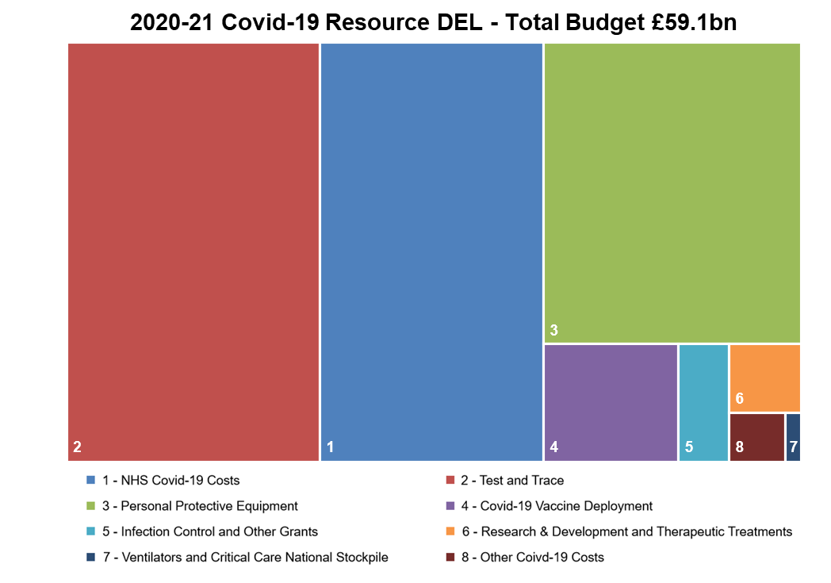
- NHS £15.021 billion, this is in addition to the c£3 billion included in Main Estimates. This will support the frontline response to the pandemic by funding the consequences of the adjusted and simplified financial regime, implemented to allow maximum operational focus on Covid-19. The funding also supports specific initiatives to temporarily increase NHS capacity, such as increasing staffing numbers, extending the use of Independent Sector providers, enhancing patient discharge schemes and the Nightingales programme. Additionally, NHS commissioners will provide support to primary care providers, such as GPs, Dentists and Pharmacists, to compensate for the impact of the pandemic on their service provision

- Test and Trace £20.1 billion, this is in addition to £300 million already included in Main Estimate. This budget cover has been secured to fund the wider roll out of mass testing, the scale up of testing to meet demand over the winter, contact tracing, the Joint Biosecurity Centre and additional support provided to Local Authorities via the Contain Outbreak Management Fund. £22 billion of Test and Trace funding was announced by the Chancellor as part of Spending Review 2020, the announced funding has since; increased to £23.1 billion (including £300m ME) and has been apportioned between revenue £20.4 billion and capital £2.7 billion.

- Personal Protective Equipment £14.8 billion, for the purchase of PPE and the freight and logistic costs of delivery, this funding is in addition to £100m already included in Main Estimate. This funding was announced in the Chancellor’s Summer Economic Update.

- Covid-19 vaccine deployment £3.045 billion, this funding has not previously been announced and covers the roll out costs of deploying the Covid-19 vaccines. This funding does not cover the purchase of the vaccines, the costs of which are covered by the Department for Business, Energy and Industrial Strategy.

- Infection Control and other grants £1.144 billion, funding predominantly given to local authorities to help cover the costs of implementing measures to reduce transmission. This was first introduced in May 2020 and was then extended to March 2021.

- Covid-19 research and development and therapeutic treatments £946 million, this funding has not previously been announced and covers the research & development and purchase costs of therapeutic Covid-19 treatments.

- Ventilators and Critical Care National Stockpile £145 million, £600 million of this funding was announced for purchases of ventilators in the Summer Economic Statement, the required funding has since; reduced by £16 million, due to a HM Treasury decision as to when this spend hits the resource budget, and been apportioned between revenue £145 million and capital £439 million.

- Other Covid-19 Costs £531 million, this mainly includes: £290m funding to cover the depreciation of assets purchased in response to Covid-19 and £120m for adult social care.

- £232 million Covid-19 transfers to other Government departments, mainly DHSC’s reimbursement for PPE purchases.

Capital DEL
The extra capital resources provided by the Government since the 2019 Spending Review are set out in the table below. The government has provided further funding for NHS infrastructure, investment for the response to Covid-19 and has reflected the impact the pandemic has had on the NHS’s capital plans, priorities and levels of expenditure, including national delivery programmes through redistributing forecast underspends.
The main changes since the 2019 Spending Review are:
Capital DEL - main changes since 2019 Spending Review | £m
2019 Spending Review | 7,060
2020 Spring Budget (a) | 1,155
2020-21 Routine transfers of funding from other Government Departments (b) | 15
2020-21 Supplementary Estimate in-year funding (c) | 1,500
2020-21 Supplementary Estimate surrender of in-year underspends (c) | (824)
2020-21 Supplementary Estimate Revenue to Capital transfer (d) | 43
2020-21 Supplementary Estimate Covid-19 (e) | 3,969
TOTAL | 12,918

- 2020 Spring Budget: The Government announced an additional £1,155 million in the 2020 Spring Budget, £1,115 million is for Manifesto commitments and £40 million is for Covid-19.
- £15 million of routine transfer of funding from other Government departments.

- In-year funding: The Government announced an additional £1.5 billion as part of a Plan for Jobs in July 2020, this is to fund NHS maintenance and A&E capacity, modernising the mental health estate and accelerating the Health Infrastructure Plan. The funding provided at Supplementary Estimate is net of underspends of £761 million against NHS Providers initial 2020-21 capital plan, with some expenditure delayed due to Covid-19; £28 million against DHSC Official Development Assistance budget and £35 million against the non-NHS initial capital plan.
- Revenue to Capital switch: £43 million transfer from revenue to capital in line with HMT convention to score R&D costs as capital for budgeting purposes.

- Covid-19: Government committed to provide the NHS what was needed to tackle the pandemic and in the Main Supply Estimate £40 million (capital) funding was allocated for Covid-19, with the commitment to finalise funding for the year in the Supplementary Supply Estimate and the Chancellor’s indicative funding announced in the 2020 Spending Review 2020.

The Supplementary Supply Estimate provides further capital budget cover of £3.969 billion based on a taut and realistic forecast of cost available at the time the Estimate was produced. As the course of the pandemic changes, Government’s strategic response is required to adapt and evolve, it is acknowledged that actual costs for 2020-21 could be significantly different.
Information on the Departments Covid-19 response and any announcements can be found at DHSC announcements.

Covid-19 funding illustrated below, includes:

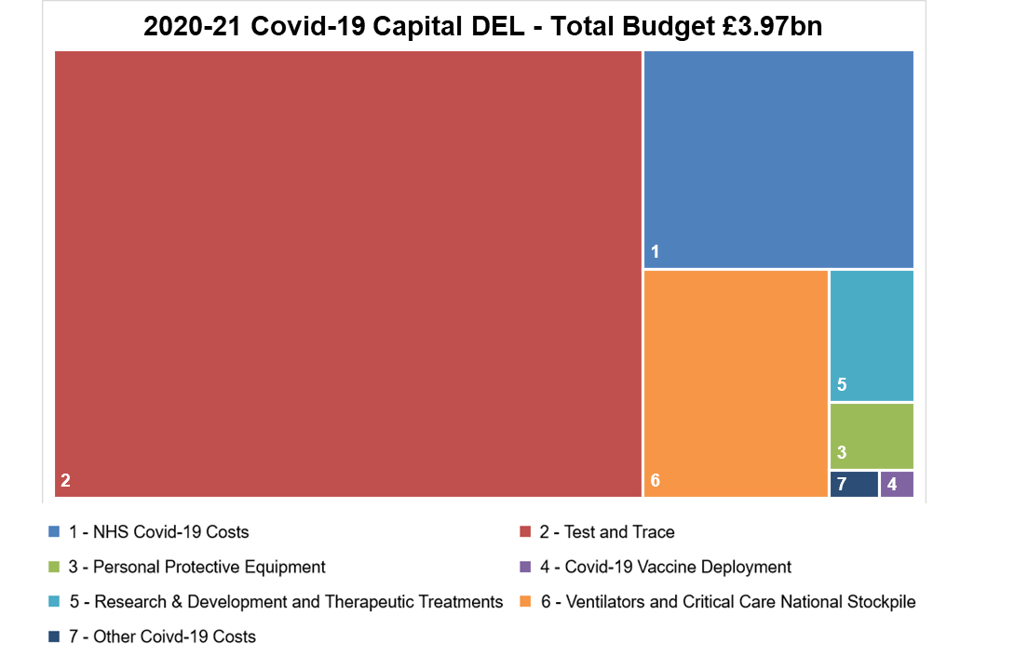
- NHS £613 million, funding for the locally incurred expenditure by NHS for minor capital modifications to existing premises for adapting facilities for Covid-19, including for example: improving oxygen infrastructure, purchasing medical equipment and IT assets to enable smarter working including remote consultations.
- Test and Trace £2.716 billion, funding to cover laboratory set up costs, the capital equipment purchased to enable the wider roll out of mass testing and to further increase the scale and speed of the programme. Capital budget is also required for the costs of unused inventory held at the year-end in line with HMT convention for large inventory purchases. £22 billion of Test and Trace funding was announced by the Chancellor as part of the Spending Review, the announced funding has since; increased to £23.1 billion (including £300m ME) and been apportioned between revenue £20.4 billion and capital £2.7 billion.

- Personal Protective Equipment £60 million.

- Covid-19 vaccine deployment £10 million.

- Covid-19 research and development and therapeutic treatments £117 million.

- Ventilators and Critical Care National Stockpile £439 million, £600 million of this funding was announced for purchases of ventilators in the Summer Economic Update, the required funding has since reduced by £16 million and been apportioned between revenue £145 million and capital £439 million.

- Other Covid-19 Costs £14 million.

- SPENDING DETAIL

The tables below detail the changes in the 2020-21 Supplementary Estimate compared to the 2020-21 Main Estimate. As per Estimates Memorandum convention, explanations for any changes, which are over both £10 million and 10% or over £200 million and 5% are provided in a referenced note under each table.

Further details of what is included in each of the Estimate lines can be found in the excel Tables A (i) and (ii).

  - Resource DEL
The table below shows how DHSC’s 2020-21Supplementary Estimate spending plans for Resource DEL compare with the 2020-21 Main Estimate.

Subhead | Description | Resource
Subhead | Description | 2020-21 Supplementary Estimate | 2020-21 Main Estimate | Change from  2020-21 Main Estimate |  | See Note 2.1
Subhead | Description | £m | £m | £m | %
A | NHS Commissioning Board (known as NHS England) net expenditure | 33,757.5 | 21,811.9
B | NHS Providers | 89,240.0 | 81,538.0
J | NHS Commissioning Board (known as NHS England) net expenditure financed from National Insurance Contributions | 22,823.2 | 23,676.5
Sub Total - NHS |  | 145,820.6 | 127,026.4 | 18,794.2 | 15% | a)
C | DHSC programme and admin expenditure | 40,429.7 | 5,628.6 | 34,801.1 | 618% | b)
D | Local Authorities (Public Health) | 4,205.0 | 3,279.0 | 926.0 | 28% | c)
E | Public Health England (Executive Agency) | 1,498.8 | 813.9 | 684.9 | 84% | d)
F | Health Education England | 1,545.7 | 1,851.6 | (306.0) | -17% | e)
G, H & I | Special Health Authorities, NDPB's and ALB's and Other Bodies | 7,255.4 | 6,236.0 | 1,019.5 | 16% | f)
TOTAL (Voted and Non Voted) |  | 200,755.2 | 144,835.5 | 55,919.7 | 39%

Estimate lines A, B and J represents the funding available to the NHS as detailed in section 1.3.

For estimate line A, NHS England, an explanation of how the estimate spending plans reconcile to the NHS England Mandate can be found in section 4.1.

- NHS: The increase is in line with the NHS Covid-19 funding provided at Supplementary Estimate and the redistribution of Covid-19 funding provided at Main Estimate.
- DHSC Programme and Admin Expenditure: The increase since Main Estimate relates to funding allocated by HM Treasury of £38.2 billion for the Department’s response to Covid-19 and in year funding of £603 million. This is offset by a change to the inter-group transaction forecast between Main and Supplementary Estimate (see paragraph 4.2).
- Local Authorities: A net increase of £926 million comprising;
  - an increase of £1.1 billion in line with the Government’s Covid-19 Infection Control Fund in place to support adult social care providers; and
  - a reduction of £213 million to the Public Health Grant as Manchester received its funding instead via retention of business rates.
More details can be found in the 2020-21 grants to Local Authorities publication.
- Public Health England (PHE): The increase of £685 million is as a result of Covid-19 funding of £499m and £186 million other funding mainly because HM Treasury did not include RDEL ring-fenced funding for impairments in 2020-21 Main Supply Estimates, as they planned to allocate this as part of the 2020-21 Supplementary Supply Estimate.
- Health Education England (HEE): HEE provide national leadership and coordination for the education and training within the health and public health workforce within England. The decrease reflects a change to the inter-group transaction forecast between Main and Supplementary Estimate (see paragraph 4.2).

- Special Health Authorities, NDPB's and ALB's and Other Bodies: The changes in funding relate to a redistribution of resources between Main and Supplementary Estimate (see paragraph 4.2), changes to the inter-group eliminations and additional funding of £258 million allocated to NHS Digital to cover NHS Test and Trace activity.

Further details of the distribution of Covid-19 funding across the departmental group are included in Annex A.

  - Capital DEL
The table below shows how DHSC’s 2020-21 Supplementary Estimate spending plans for Capital DEL compare with the 2020-21 Main Estimate.

Subhead | Description | Capital
Subhead | Description | 2020-21 Supplementary Estimate | 2020-21 Main Estimate | Change from  2020-21 Main Estimate |  | See Note 2.2
Subhead | Description | £m | £m | £m | %
A | NHS Commissioning Board (known as NHS England) net expenditure | 475.7 | 305.0
B | NHS Providers | 7,165.5 | 5,741.5
J | NHS Commissioning Board (known as NHS England) net expenditure financed from National Insurance Contributions | 0.0 | 0.0
Sub Total - NHS |  | 7,641.2 | 6,046.5 | 1,594.7 | 26% | g)
C | DHSC programme and admin expenditure | 4,701.7 | 1,821.0 | 2,880.7 | 158% | h)
D | Local Authorities (Public Health) | 0.0 | 0.0 | 0.0 | 0%
E | Public Health England (Executive Agency) | 235.7 | 124.9 | 110.8 | 89% | i)
F | Health Education England | 2.0 | 2.0 | 0.0 | 0%
G, H & I | Special Health Authorities, NDPB's and ALB's and Other Bodies | 337.3 | 236.8 | 100.5 | 42% | i)
TOTAL (Voted and Non Voted) |  | 12,917.9 | 8,231.1 | 4,686.8 | 57%

- NHS: The increase of £1.6 billion in funding reflects the Government’s commitment to invest in the NHS capital infrastructure and additional £1.5 billion was announced as part of a Plan for Jobs, in July 2020. £862 million of funding has been allocated to the NHS in response to Covid-19, these increases are offset by £761 million capital underspends;
- DHSC Programme and Admin: DHSC received additional capital funding in the 2020 Spring Budget. The increase of £2.9 billion in funding reflects the additional capital requirement of the department’s Covid-19 response, this predominantly relates to Test and Trace, new funding is offset slightly by the redistribution of Main Estimate capital across the departmental group.
- Public Health England (PHE) and Special Health Authorities, NDPB’s & Arm’s Length and Other Bodies: Capital expenditure for these bodies varies year-on-year and the plans reflect the expected capital expenditure for these bodies following the redistribution of Main Estimate capital across the departmental group.

Further details of the distribution of Covid-19 funding across the departmental group are included in annex A.

  - Resource AME
The table below shows how DHSC’s 2020-21 Supplementary Estimate spending plans for Resource AME compare with the 2020-21 Main Estimate. It should be noted that DHSC’s AME relates to provisions and impairments, which have no immediate impact on the fiscal framework or need for taxes to be raised to cover spending.

Subhead | Description | Resource
Subhead | Description | 2020-21 Supplementary Estimate | 2020-21 Main Estimate | Change from  2020-21 Main Estimate |  | See Note 2.3
Subhead | Description | £m | £m | £m | %
K | NHS Commissioning Board (known as NHS England) net expenditure | 100.0 | 100.0 | 0.0 | 0%
L | NHS Providers | 1,100.0 | 1,875.2 | 0.0 | 0%
Sub Total - NHS |  | 1,200.0 | 1,975.2 | (775.2) | -39%
M | DHSC programme and admin expenditure | 329.3 | 706.7 | (377.4) | -54% | i)
N | Public Health England (Executive Agency) | 5.0 | 5.0 | 0.0 | 0%
O | Health Education England | 5.0 | 5.0 | 0.0 | 0%
P, Q & R | Special Health Authorities, NDPB's and ALB's and Other Bodies | 8,462.6 | 7,310.0 | 1,152.6 | 16% | i)
TOTAL (Voted and Non Voted) |  | 10,001.9 | 10,001.9 | 0.0 | 0%

- The changes between the years reflect the fact AME is demand led and the 2020-21 £10 billion reflects our best estimate of provisions and impairments expenditure for the DHSC group, funding has been redistributed since Main Estimate.

  - Ring Fenced Budgets
Within the totals, the Official Development Assistance (ODA) and following elements are ring fenced i.e. savings in these budgets may not be used to fund pressures on other budgets.

 | 2020-21  Supplementary Estimate | 2020-21 Main Estimate | Variance to  2020-21 Main Estimate |  | 2019-20 Outturn | Variance to  2019-20 Outturn
 | £m | £m | £m | % | £m | £m | %
ODA Total | 225.0 | 254.1 | (29.1) | -11% | 241.6 | (16.7) | -7%
EU Exit | 115.1 | 50.0 | 65.1 | 130% | 74.7 | 40.4 | 54%

- Official Development Assistance (ODA) - The DHSC ODA funding for 2020-21 is in line with current planning.
For international comparability and consistency, the Organisation for Economic Co-operation and Development (OECD) and the Development Assistance Committee (DAC) requires ODA reporting to be on a cash and calendar year basis
- EU Exit –DHSC was allocated £50 million for EU Exit related spend for 2020-21 at Main Estimate, this has increased by £65 million at Supplementary Estimate to cover the funding requirement to 31 March 2021. This includes funding for staff resource, continuity of supply commitments and supporting costs relating to the implementation of the withdrawal agreement.

- Covid-19 reserve funding included in the Supplementary Supply Estimate will be subject to ring-fence arrangements. As funding for Covid-19 is now fixed for the year in the Estimate, if further costs are incurred in responding to the pandemic, it may be necessary to agree with HMT that specific ring-fences can be relaxed to accommodate the spend.

  - Changes to Contingent Liabilities
There are five new contingent liabilities in 2020-21 in the Supplementary Estimate. These are:

- A contingent liability for an agreement the Department entered into with the Ministry of Defence, following the Ebola outbreak in 2013 to 2016, to cover the costs of specialist quarantine equipment in the event of an outbreak of a highly infectious disease.
- A contingent liability to cover a number of Employment Tribunal cases and contractual liabilities in respect of redundancy payments and entitlements.
- A contingent liability in respect of commercial contract obligations entered into as part of the Covid-19 response.
- A contingent liability for potential costs to be met by Health Education England in connection with a change in terms of the GP contract in August 2019 regarding trainee’s expenses for home to workplace mileage.
- A contingent liability for potential costs to be met by the Health Care Professionals Council in relation to the anticipated cost of concluding the backlog of Fitness to Practise concerns. The backlog is expected to be cleared in 18 months.

Four contingent liabilities have been removed; these are:
- A contingent liability disclosed in the Care Quality Commission 2018-19 Annual Report (note 19 on page 127) in connection with a compliance check in relation to employees who may have more than one permanent workplace.
- A contingent liability in relation to the Ian Paterson inquiry.
- A contingent liability in relation to equipment purchases within the Managed Equipment Service contract held by Derby Teaching Hospital Foundation Trust with Althea.
- A contingent liability in relation to funding for certain European Union projects receiving funding after the United Kingdom has left the European Union.

- PRIORITIES AND PERFORMANCE

  - How Spending Relates to Objectives
See section 1.1.

  - Measures of Performance against each Priority
The Department’s priorities are set out in the SDP as detailed in paragraph 1.1. Each of the DHSC priorities has a DHSC Lead official responsible for the priority. The Lead official will work with Ministers and bodies within the Departmental group to achieve the objective.

For example, the priority to ‘keep people healthy and support economic productivity and sustainable public services’ involves a number of bodies within the group, such as NHS England, NHS Improvement, Public Health England, NHS Blood and Transplant, the Human Fertilisation and Embryology Authority and the Human Tissue Authority.

The bodies mentioned above are a combination of NHS Bodies, Executive Agencies and Public Corporations and therefore are detailed on numerous DHSC Estimate lines. The DHSC has certain performance indicators it uses to ensure the objectives are being met. One such indicator is the NHS Outcomes Framework.

The NHS Outcomes Framework (NHSOF) is a set of indicators developed by the DHSC to monitor the health outcomes of adults and children in England. The Framework provides an overview of how the NHS is performing. The NHSOF comprises five domains: preventing people from dying prematurely, enhancing quality of life for people with long-term conditions; helping people to recover from episodes of ill-health or following injury; ensuring people have a positive experience of care; treating and caring for people in a safe environment and protecting them from avoidable harm.

More information can be found on the NHS Digital website at Link to NHS Outcomes Framework.

More information on the SDP and performance against the 2019-20 DHSC objectives can be found in the DHSC 2019-20 Annual Report.

  - Major Projects
The DHSC has several major projects which are financed from Resource and Capital DEL. Details of the project aims, Departmental commentary on actions planned or taken and timescales for implementation can be found at DHSC Government Major Projects Portfolio data 2019.

- OTHER INFORMATION

  - NHS England
The resources made available to NHSE in the 2020-21 Supplementary Estimate will be set out in the Financial Directions to the refreshed Mandate to be published in Spring 2021. The figures in the 2020-21 Supplementary Estimate will not reconcile to those in the original Financial Directions published on 25 March 2020 or the revised Financial Directions for the following reasons:

- In line with HM Treasury Estimates conventions, figures are presented on a consolidated basis i.e. adjusted for intra-group trading transactions;
- NHSE expenditure is part-financed by non-voted National Insurance Contributions; and
- Differences between the figures in the Estimate and those in the Mandate caused by timing differences, these are large for 2020-21 due to the inclusion of the majority of Covid-19 funding in the Supplementary Estimate.
Link to the 2020-21 NHSE Mandate

The table below reconciles the NHSE Estimate provision to the current published 2020-21 NHSE Mandate.

Reconciliation between the Estimate and the Mandate |  | Resource | Capital
 |  | £m | £m
Total Mandate (sum of the below) |  | 129,847 | 305
Less:
a) | Transactions with other bodies within the group | 91,740
b) | NHSE net expenditure financed from National Insurance Contributions (non-voted) - Estimate line J | 22,823
c) | Covid-19 funding - timing difference between Estimate and Mandate | (18,736) | (190)
c) | Other - timing differences between Estimate and Mandate publication | 263 | 20
NHSE net expenditure - estimate line A |  | 33,757 | 476

  - DHSC Inter-Group Transactions
HM Treasury designates that Estimates are prepared on a consolidated basis, meaning that all intra-group transactions are removed.

Across Government, the DHSC ‘Internal Market’ of circa £90 billion is unique to the DHSC and adds an additional layer of complexity, as all inter-group trading needs to be eliminated on consolidation when preparing the DHSC Estimate. These mainly relate to transactions between NHS Commissioners and NHS Providers.
NHS Providers are not directly funded, instead they generate income to cover their spending via trading activity with Commissioners. Commissioners pay Providers for each patient seen or treated, considering the complexity of the patient's healthcare needs, under a national tariff system.

The DHSC takes a pragmatic approach and eliminates only the material transactions between Departmental group bodies. The table below illustrates how the funds flow between the different bodies within the DHSC Group.
Please note – this table does not include the funding that flows to NHS Providers from the Public Health Grant, as that funding is allocated to Local Authorities (outside the DHSC Group)

  - DHSC Revenue Expenditure Analysis
The majority of the DHSC’s budget is allocated to fund the NHS. Circa £85 billion of revenue expenditure in the Departmental group sits in the NHS Provider sector, spent on staff costs, drugs and procurement of supplies and services to deliver healthcare. Other significant expenditure includes primary care (including general practice, dentistry, ophthalmology, pharmaceutical) and prescribing costs.

Further information on the NHS Provider sector can be found:

- in the 2019-20 Provider consolidated accounts; and
- NHSE/NHSI now issue combined Board Reports.

The chart below shows the 2015-16 to 2019-20 revenue expenditure broken down to show the material categories as per the DHSC Annual Report in the Departmental Group Summary tables (2.2 Expenditure and 2.3 Income) for the relevant financial year.

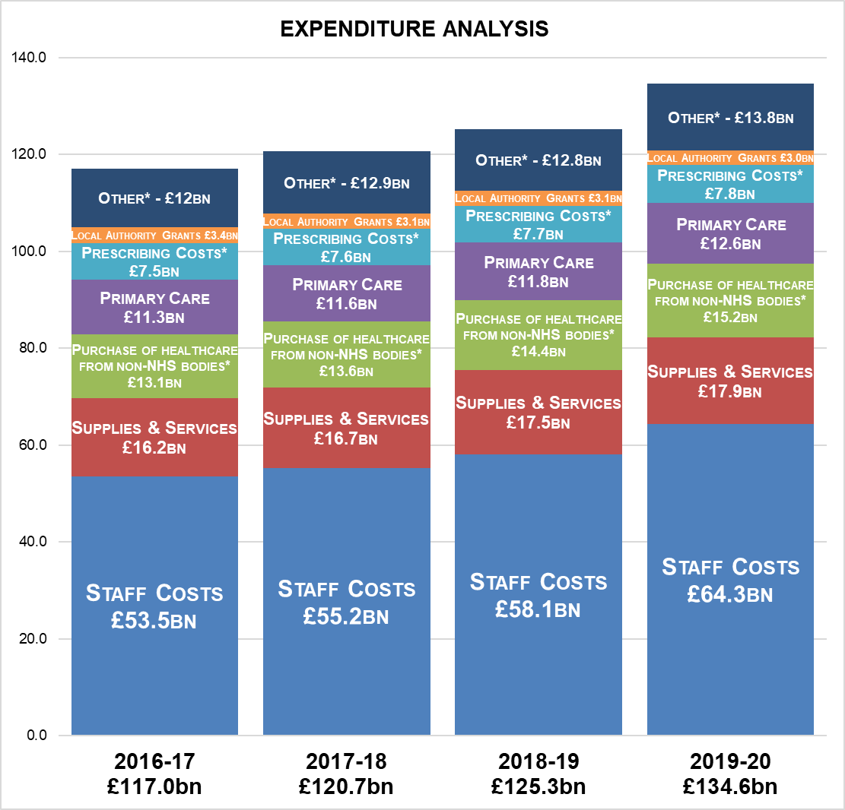
*These figures are net of income.

ANNEX A
DETAILS OF 2020-21 FUNDING ACROSS THE DHSC SUPPLEMETARY SUPPLY ESTIMATE

