Annex B

Armed Forces Pension & Compensation Schemes

Main Estimate 2021-22: Estimates Memorandum

1 Overview

1.1 Objectives

The Armed Forces Pension Scheme (AFPS), incorporating the Armed Forces Compensation Scheme (AFCS), is an unfunded defined benefit scheme, in which payments to pensioners are funded by employer contributions, with the shortfall being financed by the Exchequer. The AFPS is free to its members, and therefore, the scheme receives no employee contributions. The AFCS provides compensation for injury, illness and death that are caused by service on or after 6 April 2005.

1.2 Spending controls

The AFPS budgets are not subject to pre-set Departmental Expenditure Limit (DEL) control totals; they sit within a category of spending known as Resource Annually Managed Expenditure (AME), which can be revised and reforecast regularly. This is because net expenditure and cash payments are largely outside the control of the scheme administrators on a day to day basis, instead being affected by factors such as membership numbers; salary levels; mortality rates; the age profile of members, and annual pension increases.

The Resource AME sought under the AFPS Estimate is essentially the amount by which liabilities under the pension scheme are estimated to increase during the year, less the contributions paid by employer towards those liabilities.

In addition, the net cash requirement represents the estimated net cash required for the year to cover payments of pensions, after taking account of estimated contributions and transfer values paid in. Over time, these amounts are intended to balance, but in a particular year they will not. A negative value means that more is forecast to be received than paid in year.

1.3 Comparison of net spending totals sought

The table below show how the totals sought for the AFPS compares with last year:

Net Spending total  Amounts sought this year  (Main Estimate 2021-22) |  | Compared to final budget last year  (Supplementary Estimate 2020-21) |  | Compared to original budget last year  (Main Estimate 2020-21)
 |  | £ m | % | £m | %
Resource AME | £6,490.8m | -£291.2m | -4.3% | -191.2m | -2.9%

1.4 Key drivers of spending changes since last year

The provision sought under Resource AME is lower than last year’s final budget, largely due to the reduction in the Treasury set discount rate for interest on scheme liabilities, from 1.80% to 1.25%. This has reduced Resource AME but the impacts have been partially offset by the impact of an increased Current Service Cost (CSC) percentage from 100.7% to 116%.

1.5 Spending trends

The charts below show overall spending trends for the last six years and plans data presented in Estimates for 2020-21.

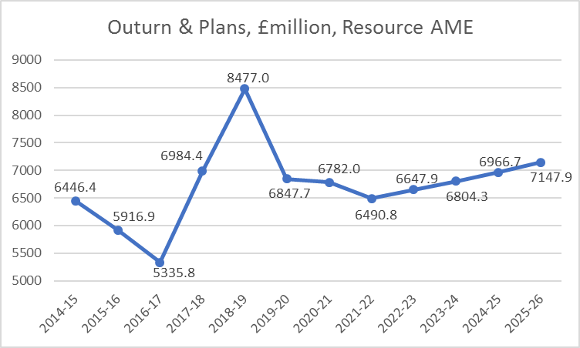

In general terms, the year on year changes to Resource AME, shown in the above chart, are largely as a result of annual changes to the Treasury set discount rate for long term liabilities, aside from 2018-19 and 2019-20 whereby the total Resource AME is also heavily influenced by Past Service Costs associated with McCloud (£1.9bn in 2018-19) and GMP and the Langford judgement (£1.1bn in 2019-20).

1.6 Administration costs and efficiency plans

The costs of the administration of the AFPS are borne by the Ministry of Defence, the employer, and are reflected in the Department’s Estimates and Annual Report and Accounts.

2 Spending detail

2.1 Explanations of changes in spending

Note – due to rounding, the totals in the above table may not equal the sum of the parts.

Differences which are above 10% and/or £10 million are explained below:

1a – An increase in current service cost is due in the main to the reduction in discount rate (real rate in excess of pension increase) from (0.5%) to (0.95%). As a result, the Government Actuary’s Department (GAD) have calculated the current service cost (calculated as a percentage of pensionable pay) as 116% for both Officers and Other Ranks (previously 100.7% for both Officers and Other Ranks).

1b – A decrease in interest on scheme liabilities due to a decrease in the interest rate from 1.80% to 1.25%.

1c – The scheme is forecasting an increase in Employer (SCAPE) contributions as a result of an increase in the estimated pensionable pay.

2.2 Net Cash Requirement

The 2021-22 net cash requirement (NCR) is £1,297m, a £74m decrease (5.4%) from the 2020-21 requirement of £1,371m.

2.3 Estimated scheme liabilities

The latest valuation of the scheme liabilities for accounting purposes was £233.1 billion, as at 31 March 2020. At the time, there were 298,760 Active member benefits, 519,763 Deferred member benefits, and 442,954 Pensioner benefits.

Details of the latest scheme liabilities can be found within the 2019-20 AFPS accounts, report of the Actuary page 22, at the following link: https://www.gov.uk/government/publications/armed-forces-pension-scheme-annual-accounts-2019-to-2020

