Annex A
MEMORANDUM FOR THE MINISTRY OF DEFENCE
MAIN ESTIMATE 2021-22

Overview
This Memorandum covers the Main Estimate (ME) for the Ministry of Defence (MOD) and should be read in conjunction with the Central Government Main Supply Estimates 2021-22. The Department’s spending plans for 2021-22 are based on the Spending Review 2020.
The Department’s Expenditure Limit (DEL) (Resource and Capital) for 2021-22 is £45.8Bn (including net budget cover transfers to Other Government Departments (OGDs) in 2021-22 but excluding ring fenced (depreciation and impairments) expenditure). This figure is also inclusive of initial funding provided by HM Treasury’s (HMT) Reserve for the net additional costs of Military Operations and Peacekeeping.
There are no contingencies funded in this Estimate, and contingent liabilities are reported in a separate table in the Main Supply Estimate.
There is a separate Estimate Memorandum for the Armed Forces Pensions and Compensation Schemes vote.
Section 4 contains explanations for each new request for resources.
Please note, the figures in the tables within this memorandum have been rounded to one decimal place. In some cases, this has caused a minor discrepancy between the figures in the tables and the totals shown due to the rounding of the figures.

Objectives
The Ministry of Defence’s priority outcomes that guide Defence Planning, as set out in the Spending Review 2020, are:
- Protect the UK and its Overseas Territories
- Enhance global security through persistent engagement and response to crises
- Contribute to NATO collective deterrence and defence
- Modernise and integrate defence capabilities by taking a whole force approach to our people and increasing the use of technology and innovation.
MOD’s spending is designed to support its objectives. The budgetary structure of the MOD does not show separately the exact costs or budgets for the four individual objectives as set out above. This is because large parts of the Armed Services operate as fully integrated joint organisations in which elements from the Navy, Army and Air Force work closely together and share land, buildings and facilities and sometimes equipment. Detail of these areas of spending is given at Section 3.1.

Spending controls
MOD’s spending is broken down into a several different spending totals, for which Parliament’s approval is sought.
The spending totals which Parliament votes are:
- Resource Departmental Expenditure Limit (“Resource DEL”)- day to day running costs
- Capital Departmental Expenditure Limit (“Capital DEL”): - investment in infrastructure
- Resource Annually Managed Expenditure (“Resource AME”): less predictable day to day spending: in MOD’s case, mainly provisions, depreciation and impairment and movements in financial instruments
- Capital Annually Managed Expenditure (“Capital AME”): in MOD’s case, nuclear provisions.
In addition, Parliament votes a net cash requirement, designed to cover the elements of the above budgets which require MOD to pay out cash in year.

Main areas of spending
The graphic below shows the main components of MOD’s proposed budget for the current year, included in the latest Main Estimate, and the proportions of funds spent on its main activities.
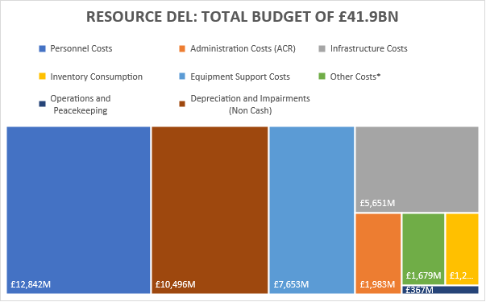
* Includes Other Costs and Services, Receipts and Other Income, Cash Release of Provisions, Research and Development Costs related to Provision of Defence Capability, DE&S (BTE) Costs, Arm's Length Bodies and War Pension Benefits Programme Costs.

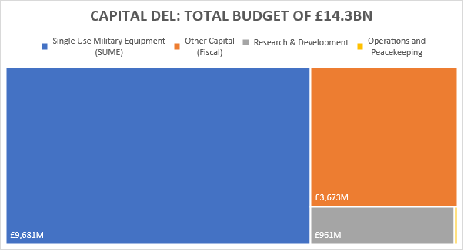

Comparison of spending totals sought
The table and graphic below show how the totals sought for the MOD compare with last year:
Table 1: Main Estimate total sought for MOD compared with last year¹
Spending total - Main Estimate |  | Increase Compared to |  | Increase Compared to
2021-22 |  | 2020-21 SE |  | 2020-21 ME
 | £M | £M | % | £M | %
Resource DEL | 41,943 | 687 | 1.7% | 2,695 | 6.9%
Capital DEL | 14,333 | 2,616 | 22.3% | 3,798 | 36%
AME | 1,519 | (1,200) | -44.1% | 0 | 0

Note 1: Total include spends for Operations and Peacekeeping.

Key drivers of spending changes since last year
The main causes of the changes in Resource DEL are:
- Initial funding for Operations and Peacekeeping driven by ongoing Counter-Daesh operations;
- Additional budget cover received at Spending Review 20, to invest in priorities and modernise, such as our offensive cyber capabilities, anti-submarine warfare, establishment of a new Space Command, and transformation; and
- Budget cover transfers to/from other government departments due to transfer of responsibilities.
The main causes of the changes in Capital DEL are:
- Initial funding for Operations and Peacekeeping driven by ongoing Counter-Daesh operations;
- Additional capital funding received at Spending Review 20 to invest in priorities and modernise, such as capital investment, nuclear deterrent;
- Additional funding for infrastructure projects announced in the Chancellor’s Fiscal stimulus package;
- Budget cover transfers to/from other government departments due to transfer of responsibilities.
The initial Resource AME is set at £1.5Bn based on available information.

New policies and programme; ambit changes
The Department made no revisions to the ambit.

Spending trends
The charts below show overall spending trends for the last five years, plans presented in Estimates for 2020-21 and 2021-22.

- Totals include spends for Operations and Peacekeeping.
- Resource AME, due to its nature, is volatile and reflects the changing Treasury Discount Rates on provision and fluctuations in financial instruments.

Administration costs and efficiency plans
The Department SR20 settlement set out the Administrative Cost Regime (ACR) budgets for the settlement period.
Table 2: Main Estimate total sought for Administration Costs
 | Spending total - Main Estimate  2021-22 |  | Compared to  2020-21 SE |  | Compared to  2020-21 ME
 |  | £M | £M | % | £M | %
 | Administration costs | 1,983 | 1 | 0.1% | 1 | 0.1%

Funding: Spending Review and Budgets
The levels of DEL funding for MOD for 2021-22 are based on plans published in the Spending Review 2020 settlement for the Ministry of Defence. Since that time, the Government has announced that further £10m was made available to support the work of the Armed Forces Covenant Fund Trust.

Other funding announcements
There are no other spending announcements made during the year.

Spending detail

Explanations of changes in spending

Resource DEL
The table below shows how MOD’s spending plans for Resource DEL compare with last year.
Table 3: Main Estimate total sought for MOD compared with 2020-21 Supplementary Estimate
Resource DEL |  | 2021-22 ME | 2020-21 SE | Change from  SE
Subheads | Commodity Block | £M | £M | £M | %
A, B | Personnel Costs | 12,841.8 | 12,138.5 | 703.3 | 5.8%
C | Infrastructure Costs | 5,651.1 | 5,152.1 | 499.0 | 9.7%
D | Inventory Consumption | 1,272.9 | 1,188.3 | 84.6 | 7.1%
E | Equipment Support Costs | 7,653.3 | 7,387.0 | 266.3 | 3.6%
F,G,I,N,AA,AC,Y | Other Costs and Services* | 1,678.9 | 2,381.3 | (702.4) | -29.5%
O,P,Z | Administration Costs | 1,982.6 | 1,982.0 | 0.6 | 0.0%
Q-X,AC | Operations and Peacekeeping (incl. CSSF) | 366.5 | 531.0 | (164.6) | -31.0%
H | Depreciation and Impairments Costs | 10,496.3 | 10,496.5 | (0.1) | 0.0%
 |  | 41,943.3 | 41,256.6 | 686.6 | 1.7%
* Includes Other Costs and Services, Receipts and Other Income, Cash Release of Provisions, Research and Development Costs related to Provision of Defence Capability, DE&S (BTE) Costs, Arm's Length Bodies and War Pension Benefits Programme Costs.

With this Main Estimate, the initial commodity block cost allocations reflect the latest information on the Department’s spending plans for 2021-22 as per the Spending Round 2020 published in November 2020. Changes will be made in the Supplementary Estimate to reflect the latest in-year forecast, along with subsequent funding adjustments. The main elements of these changes are:
- An initial Reserve increase for Operations and Peacekeeping of £282M to cover additional costs of operations.
- Budget cover transfers to/from Other Government Departments (OGDs) totalling (£483M).
- Various re-allocations to Arm’s Length Bodies (Grant in Aid), with no overall impact on DEL, to reflect the initial Grant-in-Aid funding.

Capital DEL
The table below shows how spending plans for Capital DEL compare with last year Estimates.
Table 4: Main Estimate total sought for MOD compared with 2020-21 Estimate
Capital DEL |  | 2021-22 ME | 2020-21 SE | Change from SE
Subheads | Commodity Block | £M | £M | £M | %
J | Single Use Military Equipment | 9,681.0 | 7,780.5 | 1,900.5 | 24.4%
K,M,Y,AA,L | Other Capital (Fiscal) | 3,672.6 | 2,849.3 | 823.3 | 28.9%
N | Research and Development | 961.0 | 1,050.1 | (89.1) | -8.5%
X,AC | Operations and Peacekeeping (incl. CSSF) | 18.0 | 36.5 | (18.5) | -50.7%
 |  | 14,332.7 | 11,716.4 | 2,616.3 | 22.3%

The changes in the Main Estimate reflect the current departmental plans, along with subsequent funding adjustments. The main elements of these changes are:
- A Reserve funding for Operations and Peacekeeping of £18M to cover initial costs of operations; and
- Budget cover transfers to/from Other Government Departments (OGDs) totalling (£110M).

AME
The table below shows how spending plans for Resource AME compared with last year estimates. The initial requests take a realistic view based on previous patterns.
Table 5: Main Estimate total sought for MOD compared with 2020-21 Supplementary Estimate
AME | 2021-22  ME | 2021-22  SE | Change from  SE
Commodity Block | £M | £M | £M | %
Total Resource AME | 1,519 | 2,719.3 | (1,200.3) | -44.1%

Integrated Review
The Integrated Review of Security, Defence, Development and Foreign Policy set out the Prime Minister’s vision for the UK in 2030, as a problem-solving and burden-sharing nation with a global perspective, adapting to a more competitive world through an integrated approach. On 22nd March 2021, the Defence Secretary announced the publication of Defence in a Competitive Age, which sets out how MOD will transform to counter deepening threats and seize opportunities for Global Britain. The Government anticipates that the world in 2030 will be a more contested environment characterised by geo-political and geo-economic shifts, systemic competition, as well as transnational challenges such as climate change, and rapid technological development. As part of the Government’s integrated response, MOD will invest an additional £24 billion over the next four years to reform and renew the Armed Forces for this age of global and systemic competition: modernising and integrating forces across sea, land, air, space and cyber like never before. At least £6.6 billion of investment in accelerated Research and Development will deliver next generation capabilities to outpace our adversaries, and give us a decisive edge, as a global Science and Technology power.

Ring fenced budgets

Within the Control Totals, the following elements are ring-fenced, i.e. savings in these budgets may not be used to fund pressures in other budgets.
Table 6: Main Estimate total Ring fenced budgets
Spending total - Main Estimate 2021-22 |  | Compared to 2020-21 SE |  | Compared to 2020-21 ME
 | £M | £M | % | £M | %
Operations - Cash RDEL and CDEL | 300.0 | (178.9) | -37.4% | (30.0) | -9.1%
Conflict, Stability and Security Fund | 84.5 | (4.2) | -4.7% | (1.1) | -1.3%
War Pension Benefits | 661.8 | (8.3) | -1.2% | (38.3) | -5.5%
Core Depreciation and Impairment Costs | 10,500.0 | 0 | 0.0% | 2,000.0 | 23.5%

Changes to contingent liabilities
Provisions for liabilities and charges are based on realistic and prudent estimates of the expenditure required to settle future legal or constructive obligations. The Department is required to identify contingent liabilities when agreeing contracts, seek HM Treasury approval and provide timely notification to Parliament of those more than £300k. This allows Parliament and HM Treasury to scrutinise the extent to which the taxpayer might be exposed to potentially significant liabilities in the future.
The MOD’s provisions cover legal claims, civilian early departure costs, environmental costs, restructuring and nuclear decommissioning and restoration costs. Details of the Department’s Contingent Liabilities are set out in a separate table in the Main Supply Estimate. We are currently assessing the impact on future contingent liabilities and will provide further detail on this in our 2020-21 Annual Report and Accounts.

Priorities and performance

How spending relates to objectives
The table below shows how expenditure against each subhead contributes to Departmental priorities under the Single Departmental Plan.
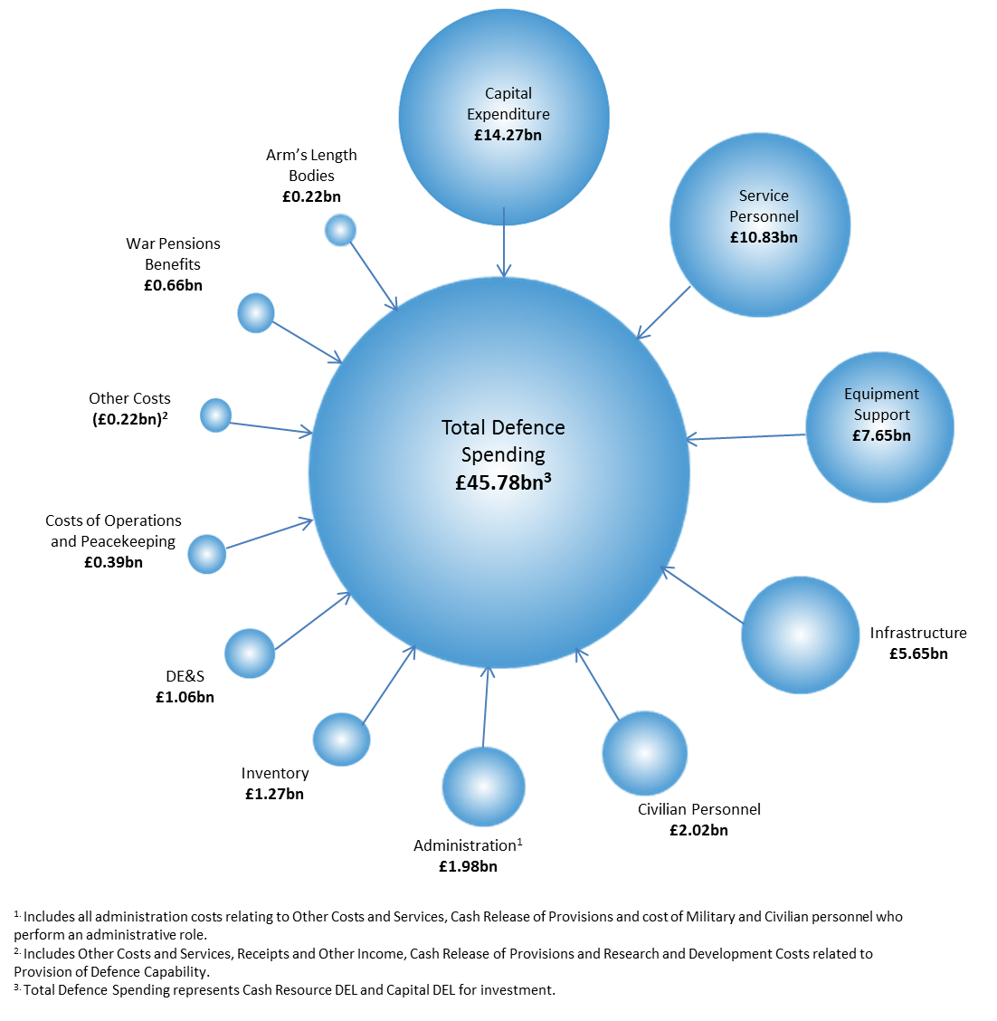

Measures of performance against each priority
The MOD’s objectives and commitments for this parliament were set out in its Single Departmental Plan, which has been agreed with HM Treasury and the Cabinet Office. This plan was last updated on 11 July 2019 and a copy can be found at:
https://www.gov.uk/government/publications/ministry-of-defence-single-departmental-plan/ministry-of-defence-single-departmental-plan-2019
The Single Departmental Plan will be replaced by the Outcomes Delivery Plan and will align with the MOD’s priority outcomes detailed in 1.1.

Commentary on steps being taken to address performance issues
Spending designed specifically to address performance issues includes:
- As part of the £1.0Bn additional funding announced in the Budget 2020, the Transformation Programme is prioritised and the Department commitment to fundamental workforce reform.

Major projects

The 2020 Annual Report on the Government Major Projects Portfolio (GMPP) from the Infrastructure and Projects Authority (IPA) can be found here:
https://www.gov.uk/government/publications/infrastructure-and-projects-authority-annual-report-2020
All MOD Capability Programmes are funded internally by the Department, via HM Treasury.

Other information

Summary of Resources sought in the Estimate
Part I of the Estimate sets out the new resource requirements for the year ending 31 March 2022. The resources requested are set out in Table 7 below.
Table 7: Summary of Expenditure and AME Request at 2021-22 Main Estimates
Resource Expenditure | £M
Resource DEL: Provision of Defence Capability | 41,576.8
Resource DEL: Operations and Peacekeeping & CSSF | 366.5
Resource DEL | 41,943.3
Resource AME Provision of Defence Capability | 1,519.0
Total Net Request for Resource at 2021-22 ME | 43,462.3
Capital Expenditure | £M
Capital DEL: Provision of Defence Capability | 14,314.7
Capital DEL: Operations and Peacekeeping & CSSF | 18.0
Total Net Request for Capital at 2021-22 ME | 14,332.7

Budgetary Transfers to and from Other Government Departments
Table 8: Transfers to MOD from Other Government Departments
Exporting Department | Defence Output | £M | Purpose
Security & Intelligence Agencies (SIA) | Provision of Defence Capability - RDEL | 35.900 | GCHQ Mil Support Costs (SIA)
Foreign Commonwealth & Development Office | Provision of Defence Capability - RDEL | 10.797 | One HMG Charge
Security & Intelligence Agencies (SIA) | Provision of Defence Capability - RDEL | 0.130 | NCSP6 (SIA)
Home Office | Provision of Defence Capability - RDEL | 1.200 | HO Project
Cabinet Office | Provision of Defence Capability - RDEL | 0.060 | COBSEO Grant
Total |  | 48.087

Table 9: Transfers from MOD to Other Government Departments
Importing Department | Defence Output | £M | Purpose
Security & Intelligence Agencies (SIA) | Provision of Defence Capability - RDEL | 28.520 | JCKP (JFC)
Security & Intelligence Agencies (SIA) | Provision of Defence Capability - CDEL | 21.480 | JCKP (JFC)
Security & Intelligence Agencies (SIA) | Provision of Defence Capability - CDEL | 120.000 | HQS
Security & Intelligence Agencies (SIA) | Provision of Defence Capability - RDEL | 87.000 | HQS
Security & Intelligence Agencies (SIA) | Provision of Defence Capability - RDEL | 305.000 | NCSP (SIA)
Security & Intelligence Agencies (SIA) | Provision of Defence Capability - RDEL | 9.570 | IATP / INITIATE
Department of Health & Social Care | Provision of Defence Capability - RDEL | 12.000 | War Pensions (DHSC)
Cabinet Office | Provision of Defence Capability - RDEL | 35.000 | NSS/JIO/COBR
Cabinet Office | Provision of Defence Capability - CDEL | 0.790 | Public Sector Geospatial Agreement
Cabinet Office | Provision of Defence Capability - RDEL | 0.081 | Civil Service Live
Cabinet Office | Provision of Defence Capability - RDEL | 0.340 | Special Advisers
Foreign Commonwealth & Development Office | Provision of Defence Capability - RDEL | 20.000 | IAF
Cabinet Office | Provision of Defence Capability - RDEL | 0.652 | Secure Mobile
Cabinet Office | Provision of Defence Capability - CDEL | 0.500 | Secure Mobile
Total |  | 640.933

Arm’s Length Bodies (ALBs)
Under Clear Line of Sight (CloS), Arm’s Length Bodies (ALBs) are part of Departmental DEL. Table 10 summarises the funding requested by MOD ALBs and is based on information received from the sponsoring Top-Level Budget (TLB).
Table 10: Breakdown of the Non-Departmental Public Bodies (NDPBs) Request for Resources at 2021-22 Main Estimate
Organisation | Resource DEL  £M | Capital DEL  £M
Armed Forces Covenant Fund Trustee Ltd | 10.2
Commonwealth War Graves Commission | 52.9
International Military Services Limited | 0.0
National Army Museum | 7.8 | 0.2
National Museum of the Royal Navy | 10.1 | 0.1
Royal Air Force Museum | 10.1
Royal Hospital, Chelsea | 14.6
Single Source Regulations Office | 6.3
Territorial, Auxiliary and Volunteer Reserve Associations established under s 110 of the Reserve Act | 104.3 | 2.4
Total | 216.3 | 2.7

Operations
The MOD’s total request for the initial net additional costs of military operations is set out in Table 11 below.
Table 11: Main Estimate initial total sought for MOD compared with last year Estimate
Operations and Peacekeeping |  | 2021-22 ME | 2020-21 SE | Change from Main Estimate  last year
Subheads | Commodity Block | £M | £M | £M | %
Q-W | Operations – RDEL | 282.0 | 449.0 | (167.0) | -37.2%
X | Operations - Capital DEL | 18.0 | 29.9 | (11.9) | -39.8%
AC | Conflict, Stability and Security Fund | 84.5 | 88.7 | (4.1) | -4.6%
 |  | 384.5 | 567.5 | (183.0) | -47.6%

A total of £385M in resources for Operations, Peacekeeping and the MOD’s share of the Conflict, Stability and Security Fund (CSSF) is requested. In line with previous years, and as agreed with HM Treasury, the MOD presents the initial cost of operations at Main Estimates and requests the full amount at Supplementary Estimates. A breakdown of the initial costs of operations is at Table 11. The details of key operations are:

Afghanistan:
Initial funding is requested to cover the initial costs of the UK’s contribution to the NATO Resolute Support Mission in Afghanistan and our support to the Afghan National Army Officer Academy.

Wider Gulf:
Initial funding is requested to cover the initial net additional costs of UK forces deployed to the wider Gulf to sustain UK influence in the region, reassure our regional allies and support access and over flight for operations in Afghanistan, Iraq and Syria.

Counter Daesh:
Initial funding is requested to meet the initial net additional costs of counter Daesh activity. This includes airstrikes and airborne intelligence gathering operations in Iraq and Syria, helping train local Security Forces and a contribution to coalition operations in Iraq.

Deployed Military Activity Pool (DMAP):
The DMAP is a joint HM Treasury and MOD initiative to make available resources to fund the initial and short-term costs of any unforeseen military activities, as authorised by the National Security Council. Initial funding is requested from the HM Treasury Special Reserve, which is matched by the same amount from the MOD’s Defence Capability resources.

Conflict Stability and Security Fund (CSSF)
The CSSF replaced the Conflict Pool as the Government’s mechanism for funding conflict prevention, stabilisation, security and peacekeeping activities, under the strategic direction of the NSC. An initial allocation of £85M is requested for the MOD’s contribution to this activity.

2021-22 Supplementary Estimates
It is anticipated that other adjustments will be required at the Supplementary Estimate (published early February 2022), including:
- Refinement and re-allocation of costs between commodity blocks resulting from the conclusion of the financial planning round; and
- Additional resources to cover the remaining net additional costs of military operations.

Accounting Officer Approval
This memorandum has been prepared according to the requirements and guidance set out by the House of Commons Scrutiny Unit, available on the Scrutiny Unit website.
The information in this Estimates Memorandum has been approved by myself as the Accounting Officer at the Ministry of Defence.

David Williams
Permanent Secretary and Accounting Officer
Ministry of Defence
Annex A

Annex A.1

Definition of Terms:

Non Ring-Fenced DEL Resource Expenditure:
This includes current expenditure which covers, for example, pay, purchase of goods and services, net of receipts, within the resource budget. It excludes items such as depreciation and movement in provisions.

Ring-Fenced DEL Resource Expenditure:

This control covers items such as depreciation and impairments.

Administration Cost Regime:
The current Administration Cost Regime, within DEL, cover departments’ current expenditure on civilian staff, and other services used in the administration of central government as agreed in our Spending Review Settlement.

Total Resource DEL:

This is the sum of non ring-fenced expenditure and ring-fenced expenditure.

Annually Managed Expenditure (AME):
Annually Managed Expenditure (AME) includes Programmes that are demand-led, such as War Pensions, and exceptionally, volatile items that cannot be controlled by the Department. AME also includes Programmes that are so large that the Department could not be expected to absorb the effects of volatility within them, such as cash release of provisions.

Total Net Resource:

This is the sum of Total Resource DEL and AME.

Capital Departmental Expenditure Limit (CDEL):
This is for new investment (SUME and Fiscal), including capital additions, disposals, and the capital repayment of loans.

Provision of Defence Capability:
Provision of Defence Capability provides for expenditure primarily to meet the Ministry of Defence’s operational support and logistics services costs and the costs of providing the equipment capability required by Defence policy.

Operations:
This provides primarily for the additional costs of operations. These are the net additional costs incurred: the costs that the Department would have incurred regardless of the operation taking place, such as wages and salaries, are recorded against provision of Defence Capability.

War Pensions Payments:
War Pensions and Allowances, etc. provides primarily for the payments of pensions and allowances for disablement or death arising out of war or service in the Armed Forces after 2 September 1939 and associated non-cash items.

Spending Review:

Spending Review 2015 (Cm 9162)

Total DEL:
This is the sum of Resource DEL and Capital DEL less the costs of depreciation. This is used as depreciation and is included as part of Resource DEL and, since Capital DEL includes capital spending, the inclusion of depreciation would lead to double counting.

Single Use Military Equipment (SUME):
National Accounts differentiates between single and dual use military equipment. Spending on single use military equipment is classified as current (resource) expenditure. Single use military assets are those that could not be used by civilian organisations to produce goods and services (i.e. weapons and equipment that supports and delivers such weapons). This distinction will disappear in the next Spending Review.

Voted and Non-Voted Expenditure:

The introduction to the Supply Estimate now covers both Voted and Non-Voted items.

Annex A.2

List of Abbreviations used in the Estimate
ABC Annual Budget Cycle
ACR Administration Cost Regime
ALB Arms Length Body
AME Annually Managed Expenditure
ANSF Afghan National Security Force
BTE Bespoke Trading Entity
CDEL Capital Departmental Expenditure Limit
CLoS Clear Line of Sight
CRFCA Council for Reserve Forces and Cadets Association
CSR Comprehensive Spending Review
CWGC Commonwealth War Graves Commission
DCLG Department for Communities and Local Government
DOH Department of Health
DEL Departmental Expenditure Limits
DFID Department for International Development
DMAP Deployed Military Activity Pool
ERNIC Employer’s National Insurance Contribution
GCHQ Government Communication Headquarters
HMT Her Majesty’s Treasury
LIBOR London Inter Bank Offered Rate
ME Supplementary Estimate
MOD Ministry of Defence
MOG Machinery of Government
NATO North Atlantic Treaty Organisation
NDPB Non Departmental Public Body
OSCAR Online System for Central Accounting and Reporting
ONS Office of National Statistics
RDEL Resource Departmental Expenditure Limit
RHC Royal Hospital Chelsea
SCAPE Superannuation Contribution Adjusted for Past Experience
SE Supplementary Estimates
SIA Single Intelligence Agency
SR Spending Review
SUME Single Use Military Equipment
TLB Top Level Budget
UK United Kingdom
UOR Urgent Operational Requirement

Annex A.3

Current RDEL Commodity Structure

Commodity Block | Major Cost Categories
Service Personnel Costs | Military and other ranks pay and other allowances; SCAPE; Employer’s National Insurance Contributions (ERNIC)
Civilian Personnel Costs | Civilian pay and other allowances; pension contributions; Employer’s National Insurance Contributions (ERNIC)
Infrastructure Costs | Property management; service charges; IT & communications costs; utilities costs.
Inventory Consumption | Munitions; stores; fuel (marine & aviation); clothing; other materials consumed e.g. stationary, sundries, general stores etc.
Equipment Support Costs | Equipment support costs, including leases & hire charges for plant, machinery and transport.
Other Costs & Services | Travel & subsistence; professional services & fees; training.
Research and Development | Research and Development expenditure is incurred Supplementary for the future benefit of the Department. Such expenditure is primarily incurred on the development of new single use military equipment (SUME) and on the improvement of the effectiveness and capability of existing single use military equipment.
Receipts and Other Income | Receipts from various sources; costs recoveries; dividends; interest.
Cash Release of Provisions | Nuclear and non-nuclear provisions e.g. staff redundancies, legal costs, environmental, etc.
Arm’s Length Bodies | CRFCA; Royal Hospital Chelsea; National Army Museum; RAF Museum; National Museum of the Royal Navy; Commonwealth War Graves Commission. Single Source Regulation Office
Ring-Fenced Non-Cash: Depreciation/ Impairments | Depreciation and impairments on Non-current Assets (Property, SUME, dual purpose).

https://www.gov.uk/government/publications/spending-review-2020-documents/spending-review-2020#departmental-settlements Spending Review 2020 - GOV.UK

