Rt Hon Stephen Barclay MP
Chief Secretary to the Treasury
HM Treasury
[By Email]

13 April 2021
Dear Chief Secretary

I write regarding the progress made by UK Government to deliver a freeport in Wales.

Freeports formed an important part of the UK Government’s 2021 Budget and it is a subject which the Welsh Affairs Committee has paid close attention to over the past year including in our report on Freeports and Wales which was published last year.

It is therefore a matter of concern that while the UK Government has completed its competition process for English freeport sites, with the eight successful bids announced in last month’s budget, there is still no sign of a competition process for a freeport in Wales.

When the First Minister of Wales appeared before our Committee last month, he told us that the Welsh Government was still in discussions with the UK Government (specifically with yourself), but that three issues required resolution before they could progress matters:

First is conditionality. We will not be keen to sign up to a freeport proposition that leads, for example, to a reduction in environmental standards. The UK Government have agreed conditionality with the Scottish Government in that way. We would look for joint decision making, given that devolved and non-devolved responsibilities are at stake in freeports. Again, the UK Government have agreed joint decision making with the Scottish Government. We look for the same level of funding for a freeport in Wales as is being made available to all freeports in England. About £25 million is available to a freeport in England, and we would expect to see the same level of funding for a freeport in Wales.

In light of the importance of this topic, and the steps which have been taken in progressing the policy in England, I would appreciate answers to the following questions by Friday 30 April:
- What is the current state of negotiations between HM Treasury and the Welsh Government regarding a Welsh freeport?
- Is the UK Government willing to replicate for a Welsh freeport the understandings reached with the Scottish Government on conditionality and joint decision making?
- Can you confirm whether the UK Government intends to only provide £8m of seed-funding for a Welsh freeport? If so, why is this less than the average funding that will be made available to English freeports?
- English freeports will benefit from the availability of full business rates and stamp duty relief until 2026, what is the Treasury’s assessment of the total cost of these exemptions for English freeports?
- Has the UK Government offered to underwrite, either in whole or in part, the cost of similar exemptions for those freeports in the devolved nations, or is it expected that the devolved administrations would fund the cost of exemptions from their own budgets?
- Does the UK Government intend to proceed with a freeport in Wales should an agreement not be reached with the Welsh Government?

Thank you for your assistance in this matter. I look forward to hearing from you.

Yours sincerely,

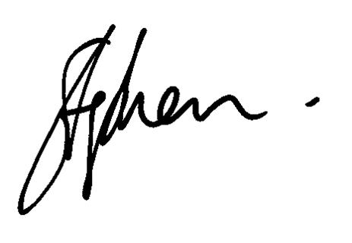
Rt Hon Stephen Crabb MP

