Mike Nesbitt MLA  Minister of Health  Department of Health  Castle Buildings  Stormont  Belfast  BT4 3SQ  Copied to: Aidan Dawson, Chief Executive, Public Health Agency | 5 June 2026
Dear Mike Nesbitt MLA,

Childhood vaccination rates in Northern Ireland

I write to you on behalf of the Childhood Vaccinations Committee regarding the Committee’s inquiry into childhood vaccination rates in England. The Childhood Vaccinations Committee was appointed by the House of Lords on 27 January 2026 to examine childhood vaccination coverage in England, including vaccinations in the routine immunisation schedule for infants, children, and young people up to the age of eighteen. The Committee has invited written evidence and is currently hearing oral evidence to inform its report, which will be agreed by 30 November 2026.

The UK Government is responsible for delivering the childhood vaccination programme in England only, which consequently is the focus of the current inquiry. However, the Committee would welcome evidence on what the UK Government could learn from the Scottish Government, Welsh Government, and Northern Ireland Executive to improve childhood vaccination coverage and reduce disparities.

As such, we would welcome any input to the Committee’s inquiry that the Northern Ireland Executive should wish to provide relating to its policy towards, and implementation of, the childhood vaccination programme. In particular, we would be grateful for your responses to the following questions.

- What are the key trends and disparities in childhood vaccination coverage in Northern Ireland? What are the drivers of those trends and disparities?

- What is the Northern Ireland Executive’s strategy to increase uptake of childhood vaccination?
  - What is the Northern Ireland Executive’s strategy for ensuring equitable access to childhood vaccinations and reducing disparities, including by deprivation, ethnicity, and primary language spoken?
- Who is responsible and accountable for sustaining and improving childhood vaccination coverage in Northern Ireland at the local, regional, and country levels?
- How are routine pre-school and school-aged vaccination programmes in Northern Ireland commissioned, funded, and delivered? What are the strengths and weaknesses of this model?
  - To what extent have alternate delivery models been piloted, evaluated, and scaled up?
- How is childhood vaccination integrated with the wider preventative health offer for infants and children in Northern Ireland, including health visiting and school nursing services?
  - What evidence is there on the influence of the higher number of mandatory health visits in Northern Ireland compared to England on child health and vaccination uptake?
- How are supplementary and outreach vaccination childhood services in Northern Ireland commissioned, funded, and delivered, including in partnership with communities with lower vaccination uptake?
- How does the NHS in Northern Ireland work with the wider public, community and voluntary sectors (including schools) to help improve childhood vaccination coverage and reduce disparities?
- How do call and recall, and consent processes support childhood vaccination in Northern Ireland? What is the Northern Ireland Executive and Public Health Agency doing to improve call and recall, and consent processes?
- How do data systems in Northern Ireland support childhood vaccination programmes, including data quality, data flows across systems, and monitoring of coverage and disparities? What is the Northern Ireland Executive and Public Health Agency doing to improve childhood vaccination data systems?
- How are the vaccination workforce and the wider healthcare workforce in Northern Ireland trained and supported to answer patients’ questions about vaccination and build trust? What is the Northern Ireland Executive and Public Health Agency doing to improve training and support?
- How do the Northern Ireland Executive and Public Health Agency work with the UK and other devolved governments and public health agencies to improve childhood vaccination rates and reduce disparities? How could collaboration be strengthened?
We would welcome any response you can provide to these questions; should you wish to do so, we would be grateful for a response by 6 July 2026 so that we can reflect your response in the Committee’s report. Any response you provide will be published on the Committee’s website and cited in its report.

Yours sincerely,

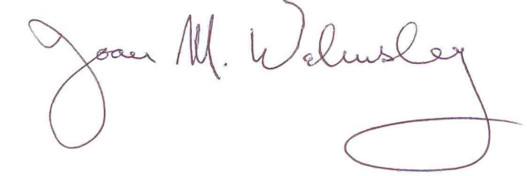

Baroness Walmsley
Chair of the Childhood Vaccinations Committee

Members of the Committee have declared interests in relation to healthcare. They are published on the Committee’s webpage. A list of all Members' interests is available in the Register of Interests.

