Department for Education

Main Estimates 2023-24: Estimates memorandum.

1 Overview

1.1 Objectives
The Department for Education (DfE) is responsible for children’s services and education, including early years, schools, further and higher education, apprenticeships and wider skills in England.
DfE enables children and students to thrive, by protecting the vulnerable and ensuring the delivery of excellent standards of education, training and care. This helps realise everyone's potential –powering our economy, strengthening society, and increasing fairness.
All departments produced a draft Outcome Delivery Plan (ODP) for 2022-23. However, with the announcement of Civil Service 2025 in May 2022, Cabinet Office and HM Treasury Ministers agreed to pause the publication of ODPs to ensure that the ODPs could reflect any workforce changes.
On 17 November 2022, the Chancellor of the Exchequer delivered the Autumn Statement and this needs to be reflected in plans. The government has agreed that departments will not be required to publish ODPs for 2022-23 but to concentrate on the production of ODPs for 2023-24.
For 2023-24 DFE has the following priority outcomes:
Skills - Level up productivity and employment by improving the skills pipeline and supporting people to work;
Schools - Level up education standards in every part of the country, and support children and young people to recover from the Covid-19 pandemic; and
Families - Support families and protect young people through high quality local services, early education and childcare.
The Outcome Delivery Plan will be published later in 2023.

1.2 Spending controls
DfE’s spending is broken down into several different spending totals, for which Parliament’s approval is sought. Parliament votes the following spending totals:
- Resource Departmental Expenditure Limit (“Resource DEL”) - day to day running costs. This includes Programme DEL, which goes to the sectors DfE works with and also covers a portion of the impairment charge for Student Loans, and Administration DEL, which relates to the running of the Department and its agencies;
- Capital Departmental Expenditure Limit (“Capital DEL”) - investment in infrastructure;
- Resource Annually Managed Expenditure (“Resource AME”) - in DfE’s case, this is mainly repayments of interest by students on their loans, and changes in the estimated value of the student loan book; and
- Capital Annually Managed Expenditure (“Capital AME”) - in DfE’s case, this covers payments of loans to students and interest added to students’ balances, less capital repayments from past students.
- The aggregate of the above categories is known as Total Managed Expenditure (“TME”).
In addition, Parliament votes a net cash requirement, designed to cover the elements of the above budgets which require DfE to pay out cash during the year.

Spending totals: DfE Main Estimate 2023-24

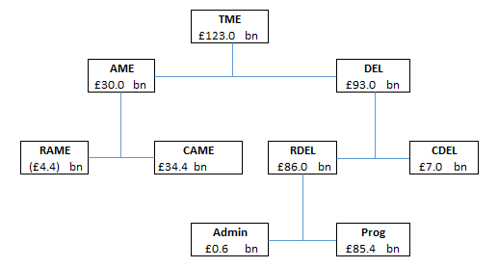

1.3 Main areas of spending

The graphic below shows the main components of DfE’s proposed budget, included in the latest Estimate, and the proportions spent on its main activities. Further details of budget by programme can be found in Annex A. Further descriptions of the activities within each estimate line are included in section 3.1.

Table 1: RDEL Main Estimate 2023-24
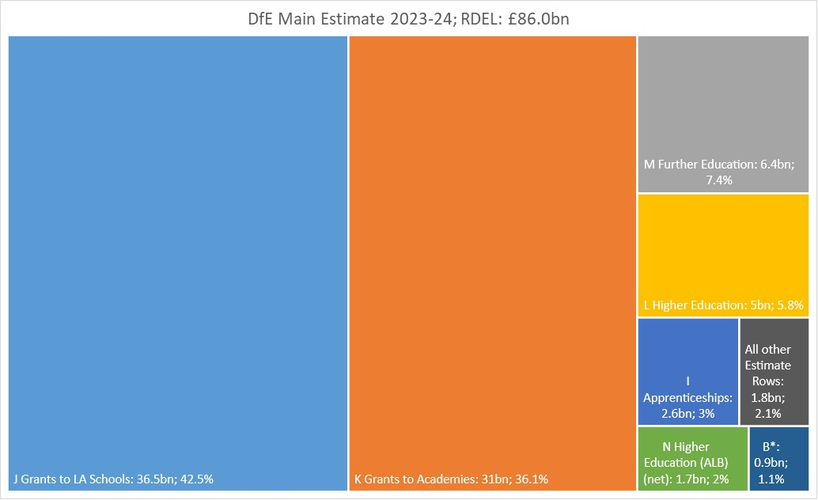
* Other School Funding (Department)

Descriptions of the activities within each estimate line are included in section 3.1.

Table 2: Capital DEL Main Estimate 2023-24
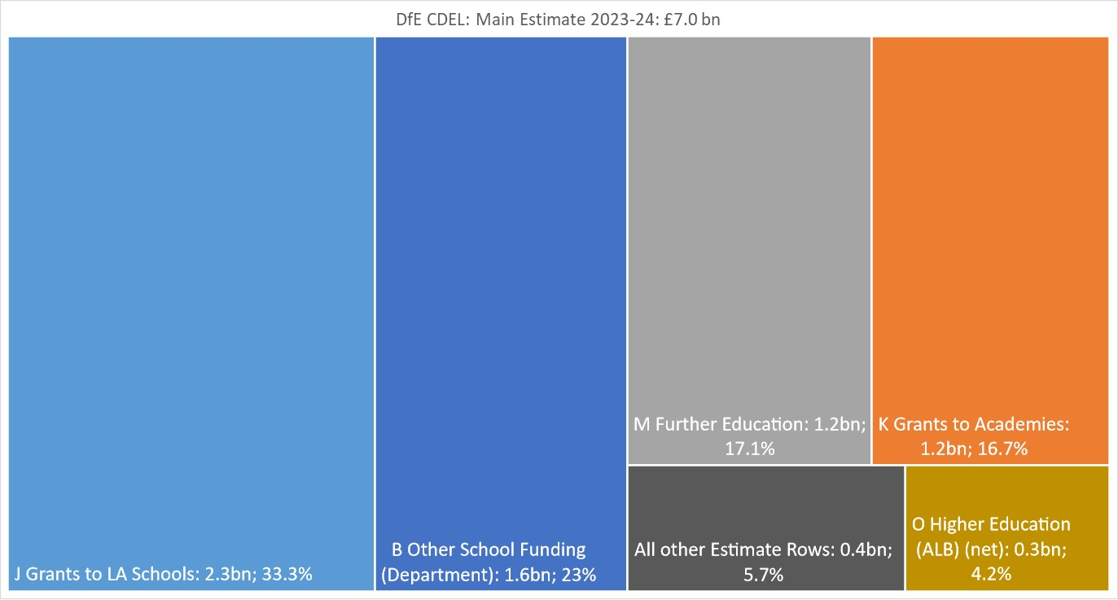
Descriptions of the activities within each estimate line are included in section 3.1.

1.4 Comparison of spending totals sought
The table and graphic below show how the totals sought for the Department compare with last year. These figures are net of income:

Spending total | Amounts sought this year  (Main Estimate 2023-24) | Difference compared to final budget last year (Supplementary Estimate 2022-23) |  | Difference compared to original budget last year (Main Estimate 2022-23)
 | £bn | £bn | % | £bn | %
Resource DEL | 86.0 | 10.2 | 13.5 | 14.1 | 19.6
Capital DEL | 7.0 | 0.8 | 12.3 | 0.7 | 10.6
Resource AME | (4.4) | 6.0 | 57.4 | 5.2 | 53.8
Capital AME | 34.4 | 7.2 | 26.3 | 5.7 | 19.8

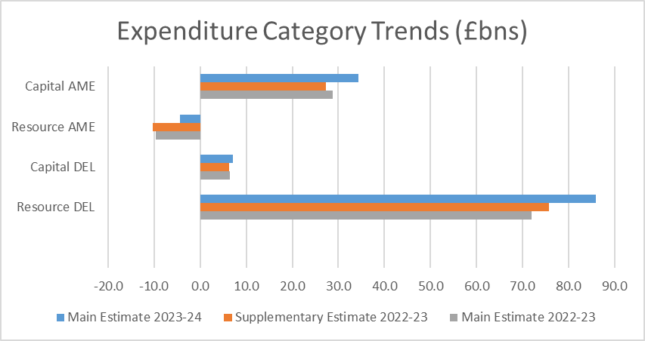

1.5 Key drivers of spending changes since last year
Changes since the 2022-23 Supplementary Estimate
The £10.2 billion increase in Resource DEL since the 2022-23 Supplementary Estimate is primarily driven by:
- a net increase in Resource DEL funding set out at the 2021 Spending Review (SR21) including an uplift to the core schools budget;
- an increase in the Resource DEL funding for core schools and childcare announced in the Autumn Statement 2022 and Spring Budget 2023; and
- an increase in the initial budget for costs associated with the student loan book (an increase of £5.5 billion compared to the Supplementary Estimate 2022-23) including the annual revaluation and impairment charge. This is a highly variable area sensitive to wider economic variables. The budget for 2023-24 has been set in line with the department’s current forecasts and will be reviewed at Supplementary Estimate to ensure appropriate budget cover for the remainder of the year.
The budget for Capital DEL is £0.8 billion higher than the 2022-23 Supplementary Estimate in line with the settlement agreed at SR21.

The main driver of the £6.0 billion increase in Resource AME and £7.2 billion increase in Capital AME since the 2022-23 Supplementary Estimate is expenditure relating to the student loan book. The budget required to cover the annual revaluation of the student loan book is highly variable and the final position for 2023-24 is expected to be covered within the Supplementary Estimate, in line with usual practice.

Changes since the 2022-23 Main Estimate
The year-on-year £14.1 billion increase in Resource DEL since the 2022-23 Main Estimate is primarily driven by:
- The net increase in Resource DEL funding set out at SR21, Autumn Statement 2022 and Spring budget 2023, including an uplift to the core schools budget; and
- inclusion at the Main Estimate 2023-24 of an increased initial budget for costs associated with the student loan book (an increase of £9.5 billion compared to the Main Estimate 2022-23) including the annual revaluation and impairment charge. This budget will be reviewed at Supplementary Estimate 2023-24 to ensure appropriate budget cover for the remainder of the year.
The budget for Capital DEL is £0.7 billion higher than the 2022-23 Main Estimate in line with the settlement agreed at SR21.
Further details are set out in Section 2.

1.6 New policies and programmes; ambit changes
The DfE has updated its ambit in line with the Supplementary Estimate 2022-23. These updates are to clarify wording and to reflect the reclassification of FE colleges to central government by the Office for National Statistics.
The Estimate structure is based on the programme activities of Groups within the Department, with each Executive Agency having its own budget line. During 2022-23, DfE management accounting has been updated to reflect alterations in the responsibilities of individual Groups as set out in section 2.2 below. This is now reflected in the format of the Estimate with the comparative figures for 2022-23 restated into the new estimate sections.

1.7 Spending trends
The charts below show overall spending trends for the last six years, based on outturn data for years to 2021-22 and Estimates for 2022-23 and 2023-24.

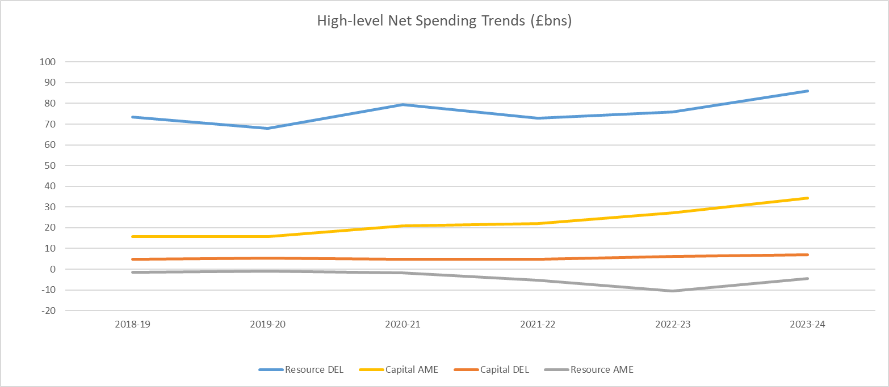

- The 2018-19 to 2021-22 figures have been taken from the DfE’s published core tables as included in DfE’s Annual Report and Accounts.
- Figures for 2023-24 are based on the DfE’s Main Estimate, figures for 2022-23 are based on the DfE’s Supplementary Estimate, whilst figures prior to and including 2021-22 are based on outturn.
- Resource DEL for 2020-21 shows an increase, driven by an increase in impairments on the loan book due to changes in earnings forecasts.

1.8 Administration costs
Administration costs are set to decrease by 1.6% in 2023-24 compared to last year’s final budget.

Spending total  Amounts sought this year  (Main Estimate 2023-24) |  | Difference compared to final budget last year (Supplementary Estimates 2022-23) |  | Difference compared to original budget last year (Main Estimates 2022-23)
 | £m | £m | % | £m | %
Administration costs | 561.2 | (8.9) | (1.6) | 7.8 | 1.4
Changes since the 2022-23 Supplementary Estimate
There has been a slight decrease of 1.6% since the 2022-23 Supplementary Estimate. This is primarily driven by specific one-off increases that were included in the 2022-23 Supplementary Estimate, and a lower amount of Shared Outcomes Funding for 2023-24, set against an increase in the administration budget for childcare policy and delivery in 2023-24.
Changes since the 2022-23 Main Estimate
DfE is committed to delivering efficiently. The increase in the year-on-year administration budget since the 2022-23 Main Estimate is due to the increases agreed as part of the Spring Budget for childcare and changes in classification of budgets, partially offset with a reduction in the budget for Shared Outcomes Fund.

1.9 Funding: Spending Review and Budgets
The level of DEL funding for DfE in 2022-23 is based on the three-year Spending Review set out in 2021 (SR21) to cover the financial years 2022-23, 2023-24 and 2024-25.

1.10 Other funding announcements
Since the Main Estimate 2022-23, the Chancellor announced in the Autumn Statement 2022 that the core schools’ budget will increase by £2 billion in each of 2023-24 and 2024-25, over and above totals announced at the 2021 Spending Review. In addition, £210 million announced as part of the spring budget for childcare has been included in this Estimate.
In addition to the voted Parliamentary control totals detailed in this Memorandum, DfE’s resource budget includes the following additional amounts relating to the academy sector:
Resource DEL: £1,906 million, covering academy sector depreciation. This is the same amount as at the Main Estimate 2022-23 and will be reviewed at the 2023-24 Supplementary Estimate. Also, under the Academies Risk Sharing agreement, the budgetary impact of any excess of academy sector expenditure over grants received in 2023-24 would normally be shared between DfE and HM Treasury.
Capital DEL: Under the Academies Risk Sharing agreement, the budgetary impact of any significant excess of academy sector expenditure over grants received in 2023-24 would normally be shared between DfE and HM Treasury.
Resource AME: £4,058 million, primarily covering academy sector pension costs movement and land and buildings impairments. This will be reviewed at the 2023-24 Supplementary Estimate.
The total adjustment to Parliamentary control totals at the 2023-24 Main Estimate is an addition of £5,964 million (net). This represents the difference between DfE’s Parliamentary control totals and resource budget.

2 Spending detail

2.1 Explanations of changes in spending

Resource DEL
The table below shows how the DfE’s spending plans for Resource DEL compare with last year.
In 2022-23 DfE implemented an internal restructure. This created new groups: Families, Schools, Skills, Strategy, Operations and Infrastructure, and Regions. Alongside this, the Education and Skills Funding Agency (ESFA) was also restructured. The Estimate lines used have been reviewed during 2022-23 and we have amended the structure of the Estimate to reflect these changes in 2023-24. The prior year comparatives have been restated into the new structure.
Resource DEL |  | Main Estimate 2023-24 | Supplementary Estimate 2022-23 | Change from Supplementary Estimate 2022-23 (decrease in brackets) |  | Note number
Sub-heading | Description | £m | £m | £m | %
A | Activities to support all Functions | 598.4 | 564.2 | 34.2 | 6.1
B | Other School Funding (Department) | 929.8 | 1,111.0 | (181.2) | (16.3) | 1
C | Other School Funding (ALB) (Net) | 7.6 | 7.2 | 0.4 | 5.2
D | Families and Children’s Services (Department) | 981.1 | 566.2 | 414.9 | 73.3 | 2
E | Families and Children’s Services (ALB) (Net) | 16.0 | 18.9 | (2.9) | (15.3)
F | Standards and Testing Agency | 48.8 | 45.8 | 3.1 | 6.7
G | Teaching Regulation Agency | 14.4 | 11.3 | 3.1 | 27.7
H | Education and Skills Funding Agency (ESFA) | 92.5 | 92.2 | 0.3 | 0.3
I | Apprenticeships | 2,590.8 | 2,562.3 | 28.5 | 1.1
J | Grants to LA Schools | 36,537.2 | 33,753.9 | 2,783.4 | 8.2
K | Grants to Academies | 31,008.6 | 29,725.5 | 1,283.0 | 4.3
L | Higher Education | 5,028.2 | (532.7) | 5,560.9 | 1,043.9 | 3
M | Further Education | 6,403.5 | 6,177.9 | 225.5 | 3.7
N | Higher Education (ALB) (net) | 1,705.5 | 1,664.4 | 41.1 | 2.5
O | Further Education (ALB) (net) | 30.8 | 29.2 | 1.6 | 5.5
 | Total Resource DEL | 85,993.3 | 75,797.4 | 10,195.9 | 13.5

The details of spend included in each Estimate line are explained in Section 3.
Differences of more than 10% which are more than £10 million are explained below. The numbers relate to the relevant row in the table above.

Other School Funding
The budget for this sub-head has decreased by £181.2 million from £1,111.0 million in the 2022-23 Supplementary Estimate to £929.8 million. This largely relates to a reduction in the budgets for Homes for Ukraine and Afghan resettlement, offset with increases across several budgets including Initial Teacher Training and priority areas.

Families and Children’s Services
The budget for this sub-head has increased by £414.9 million from £566.2 million in the 2022-23 Supplementary Estimate to £981.1 million. This includes the increase in childcare budget announced at the Spring Budget 2023 and other increases in budgets including Family Hubs, Start for Life, Supported Accommodation, Staying Put and Supporting families with disabled children.

Higher Education
The budget for this sub-head has increased by £5,560.9 million from minus £532.7 million in the 2022-23 Supplementary Estimate to a budget of £5,028.2 million. This is mostly due to the budget initially allocated for the RAB charge and changes in the valuation of the student loan book, where a significant gain is expected for 2023-24 due to a series of policy changes made. The final budget will be confirmed at the Supplementary Estimate, in line with usual practice and the annual revaluation of the student loan book.

Capital DEL
The table below shows how spending plans for Capital DEL compare with last year:
Capital DEL |  | Main Estimate 2023-24 | Supplementary Estimate 2022-23 | Change from Supplementary Estimate 2022-23 (decrease in brackets) |  | Note number
Sub-headings | Description | £m | £m | £m | %
A | Activities to Support all Functions | 261.0 | 128.0 | 133.0 | 103.9 | 4
B | Other School Funding (Department) | 1,616.1 | 1,495.5 | 120.6 | 8.1
C | Other School Funding (ALB) (Net) | (9.2) | (11.9) | 2.7 | 23.0
D | Families and Children’s Services (Department) | 102.4 | 63.5 | 38.9 | 61.3 | 5
E | Families and Children’s Services (ALB) (Net) | 2.2 | 2.8 | (0.6) | (20.9)
F | Standards and Testing Agency | 4.8 | 4.1 | 0.6 | 15.0
H | Education and Skills Funding Agency (ESFA) | 17.6 | 7.1 | 10.5 | 148.2 | 6
I | Apprenticeships | 5.0 | 5.0 | 0.0 | 0.0
J | Grants to LA Schools | 2,343.5 | 2,549.8 | (206.2) | (8.1)
K | Grants to Academies | 1,175.1 | 1,318.6 | (143.5) | (10.9) | 7
L | Higher Education | 16.1 | 21.2 | (5.1) | (24.1)
M | Further Education | 1,206.1 | 541.1 | 665.0 | 122.9 | 8
N | Higher Education (ALB) (net) | 295.3 | 142.1 | 153.2 | 107.8 | 9
O | Further Education (ALB) (net) | 1.9 | 1.9 | 0.0 | 0.2
 | Total Capital DEL | 7,037.9 | 6,268.7 | 769.2 | 12.3

Differences of more than 10% which are more than £10 million are explained below.

Activities to Support all Functions
The budget for this sub-head has increased by £133.0 million from £128.0 million in the 2022-23 Supplementary Estimate to £261.0 million. The main drivers of this are increases in our budgets for broadband and fibre in schools, sustainability and decarbonisation.

Families and Children’s Services
The budget for this sub-head has increased by £38.9 million from £63.5 million in the 2022-23 Supplementary Estimate to £102.4 million. The main drivers of this are increases to the secure children’s homes, open residential children’s homes and family hubs budgets, due to the delivery profiles of the programmes.

Education and Skills Funding Agency
The budget for this sub-head has increased by £10.5 million from £7.1 million in the 2022-23 Supplementary Estimate to £17.6 million. The main drivers of this are increases in data budgets and Schools Resource Management.

Grants to Academies
The budget for this sub-head has reduced by £143.5 million from £1,318.6 million in the 2022-23 Supplementary Estimate to £1,175.1 million. The main driver of this one-off allocation in 2022-23 is energy efficiency, partially offset by increases in budgets for school condition.

Further Education
The budget for this sub-head has increased by £665.0 million from £541.1 million in the 2022-23 Supplementary Estimate to £1,206.1 million. The main drivers of this are increases in the budget relating to FE reclassification and the FE capital transformation programme.

Higher Education (ALB)
The budget for this sub-head has increased by £153.2 million from £142.1 million in the 2022-23 Supplementary Estimate to £295.3million. The main drivers of this are increases in the Office For Students and Student Loan Company budgets.

Resource AME
The table below shows how spending plans for Resource AME compare with last year.

Resource AME |  | Main Estimate 2023-24 | Supplementary Estimate 2022-23 | Change from Supplementary Estimate 2022-23 (decrease in brackets) |  | Note number
Sub-headings | Description | £m | £m | £m | %
P | Activities to Support all Functions (Department) | (7.0) | 10.8 | (17.8) | (165.0) | 10
Q | Executive Agencies AME | 0.3 | 0.4 | (0.1) | (16.7)
R | Higher Education AME | (4,402.6) | (10,350.6) | 5,948.0 | 57.5 | 11
S | Further Education AME | (0.5) | (75.2) | 74.8 | 99.4 | 12
T | Higher Education (ALB) (net) AME | (26.7) | 0.6 | (27.3) | (4,344.8) | 13
U | Further Education (ALB) (net) AME | 4.9 | 22.6 | (17.7) | (78.3) | 14
 | Total Resource AME | (4,431.6) | (10,391.4) | 5,959.8 | (57.4)

Differences of more than 10% which are more than £10 million are explained below.

Activities to Support All Functions
The budget for this sub-head is forecast to change by £17.8 million from £10.8 million in the 2022-23 Supplementary Estimate to negative £7.0 million. This reflects changes in the budget requirements for provisions.

Higher Education
The budget for this sub-head is forecast to change by £5,948.0 million from a net income budget of £10,350.6 million in the 2022-23 Supplementary Estimate to a net income budget of £4,402.6 million. This forecast is expected to reduce in 2023-24 due to reduced RPI forecasts. The final budget for Student Loan Resource AME will be completed at the Supplementary Estimate, in line with usual practice and the annual revaluation of the student loan book.

Further Education
The budget for this sub-head is forecast to change by £74.8 million from an income budget of £0.4 million in the 2022-23 Supplementary Estimate to an income budget of £0.5 million. This reflects the current forecast for Advanced Learner Loans and will be reviewed at the Supplementary Estimate.

Higher Education (ALB)
The budget for this sub-head is forecast to change by £27.3 million from net expenditure of £0.6 million in the 2022-23 Supplementary Estimate to an income budget of £26.7 million This reflects changes in the budget requirements for provisions.

Further Education (ALB)
The budget for this sub-head is forecast to change by £17.7 million from £22.6 million in the 2022-23 Supplementary Estimate to a budget of £4.9 million. This reflects the current forecast for Advanced Learner Loans and will be reviewed at the Supplementary Estimate.

Capital AME
The table below shows how spending plans for Capital AME compare with last year.

Capital AME |  | Main Estimate 2023-24 | Supplementary Estimate 2022-23 | Change from Supplementary Estimate 2022-23 (decrease in brackets) |  | Note number
 | Description | £m | £m | £m | %
R | Higher Education | 34,297.5 | 27,068.1 | 7,229.4 | 26.7 | 15
S | Further Education | 128.7 | 182.5 | (53.8) | (29.5) | 16
U | Further Education (ALB) (net) | 2.5 | 2.6 | (0.0) | (2.0)
 | Total Capital AME | 34,428.7 | 27,253.2 | 7,175.5 | 26.3

Differences of more than 10% which are more than £10 million are explained below.

Higher Education
The budget for this sub-head has increased by £7,229.4 million from £27,068.1 million in the 2022-23 Supplementary Estimate to £34,297.5 million. This is due to increased interest rates.
The final budget for Student Loan Capital AME will be completed at Supplementary Estimate, in line with usual practice and the annual revaluation of the student loan book.

Further Education
The budget for this sub-head has increased by £53.8 million from £182.5 million in the 2022-23 Supplementary Estimate to £128.7 million. This is in line with the forecast take up for Advanced Learner Loans and will be reviewed at the Supplementary Estimate.

2.2 Restructuring

The Estimate structure is based on the programme activities of the Groups within the Department, with each Executive Agency having its own budget line.

Future DfE – internal restructuring
Under the Future DfE programme the department has made changes to its structure from 1 April 2022 onwards.
Work on the re-organisation has taken place with staff, partners and alongside the Arm’s Length Body review of the Education and Skills Funding Agency, an Executive Agency of the department, led by Sir David Bell KCB DL.
In line with the DfE’s response to the review recommendations, the new Education and Skills Funding Agency (ESFA) will focus on high-quality funding delivery. The ESFA will continue to focus on making sure that public funds are properly spent and that value for money for the taxpayer is achieved, while helping to inform policy and delivery activity and ensuring the financial health and sustainability of providers.
Other changes included the creation of a new Regions Group, aligned to the 9 regions used across the rest of government, from July 2022.
- North East
- North West
- Yorkshire and the Humber
- West Midlands
- East Midlands
- East of England
- South East
- South West
- London

This supports integrated delivery for schools and local authorities, including children’s social care and Special Educational Needs and Disabilities.

A new strategic centre is now in place to create better oversight, drawing together DfE’s work and setting strategy, working alongside Operations and Infrastructure, which retains its focus on running the DfE and capital funding.

There are also dedicated groups focussed on the following areas:
- Families, which includes children’s social care, safeguarding, special educational needs and disabilities, and early years, focussed on ensuring that no matter where they live, children receive the same high quality of care and support;
- Schools, dedicated to ensuring that every child gets a great education and the right support; and
- Skills, in line with the Education and Skills Funding Agency review recommendations, this Group will consolidate all post-16 work in one place to enable a high quality, outcomes-focused post-16 system that gives learners the skills and knowledge they need to succeed in their working lives and meet the needs of the economy.
There are no changes to the Department’s other Executive Agencies: the Standards and Testing Agency and the Teaching Regulation Agency.
The impact of these changes has been reflected in the 2023-24 Main Estimate with changes to the names of estimate lines and a new line for Apprenticeships.
FE reclassification
In November 2022 the Office for National Statistics (ONS) announced it has reclassified FE colleges, sixth form colleges and designated institutions in England to the central government sector. Work continues with HM Treasury on the impact of this upon the Estimate, and DFE have obtained a derogation for main estimate 23-24.

2.3 Ring-fenced budgets
Within the totals, the following elements are ring fenced, this means that any savings in these budgets may not be used to fund pressures on other budgets:

Ring-fenced budgets for depreciation, amortisation, and impairment.

Ring-fenced budgets  Amounts sought this year  Resource DEL (Main Estimate 2023-24) |  | Difference compared to final budget last year (Supplementary Estimate 2022-23) |  | Difference compared to original budget last year (Main Estimate 2022-23)
 | £m | £m | % | £m | %
Other Depreciation* | 109.3 | 0.8 | 0.8 | (1.9) | (1.7)
Adult Education | 80.4 | 9.5 | 13.4 | (23.1) | (22.3)
Higher Education | 4,144.6 | 5,485.7 | (409.1) | 9,317.1 | (180.1)

Protected and Policy Ring-fenced budgets.

Description | Amounts sought this Main Estimate 2023-24 | Difference compared to Supplementary Estimate 2022-23 |  | Difference compared to Outturn 2022-23
 |  | £m | % | £m | %
Protected
Schools Protected | 57,344.2 | 3,538.5 | 0.1 | 3,513.5 | 0.1
Apprenticeships | 2,585.0 | 31.0 | 0.0 | 141.8 | 0.1
Total DEL Protected | 59,929.2 | 3,569.5 | 0.1 | 3,851.0 | 0.1
Policy RF - Resource DEL
16-19 Tutoring | 111.0 | 4.0 | 0.0 | 39.6 | 0.6
Counter Terrorism | 2.1 | 0.5 | 0.3 | 1.2 | 1.2
Early Career Framework | 15.0 | (18.8) | (0.6) | (17.2) | (0.5)
Early Years Training | 68.8 | 30.5 | 0.8 | 40.7 | 1.5
Legacy IT/Cyber Security (DDat Modernisation) | 7.7 | 1.0 | 0.1 | 2.6 | 0.5
Multiply | 134.3 | 7.5 | 0.1 | 71.6 | 1.1
National Professional Qualifications | 62.3 | 14.2 | 0.3 | 24.5 | 0.6
National Tutoring Programme | 248.3 | (4.5) | 0.0 | 7.3 | 0.0
Recovery Premium | 502.0 | (32.0) | (0.1) | (22.2) | 0.0
Shared Outcomes Fund | 15.0 | (6.7) | (0.3) | (3.7) | (0.2)
Total Resource DEL | 1,166.5 | (4.3) | (0.6) | 144.4 | 4.8
Policy RF - Capital DEL
Legacy IT/Cyber Security | 7.5 | 1.4 | 0.2 | 3.5 | 0.9
R & D | 13.0 | 0.0 | 0.0 | 3.7 | 0.4
Total Capital DEL | 20.5 | 1.4 | 7.4 | 7.2 | 54.3
Total DEL Policy Ringfenced | 1,187.0 | (2.9) | (0.2) | 151.5 | 14.6.1

2.4 Changes to contingent liabilities

The following changes have occurred since the publication of the 2022-23 Supplementary Estimate.
Letter of comfort
A letter of comfort issued in 2022-23 relating to opening school facilities. This was provided to allow active partnerships to undertake preparatory works, prior to a contract being signed, with a maximum liability of £546k and has now expired.
Junior Individual Savings Account (JISA)
The value of this Contingent Liability has changed since the 2022-23 Supplementary Estimate from £1,585k to £ 1,557k.
The Department for Education has contracted a charity to manage the Junior Individual Savings Account (JISA) scheme on its behalf. Using an initial £200 payment from the Department, the contractor opens and manages JISAs on behalf of looked after children while they remain in care. The government made a commitment in 2011 to provide £200 to set up a JISA for each child in care across the UK. Local Authorities (LAs) have identified around 14,000 young people who left care before a JISA could be opened for them, of which around 8,000 have already claimed and received their £200 payments in lieu, leaving around 6,000 potential retrospective claims.
Coal Authority Permit
Four additional schools have been added to this existing contingent liability.
The permit is required to undertake a ground investigation (GI) survey as part of the delivery of a free school project. The total value is unquantifiable.
Section 278 (s278) agreement
An additional school has been added to this contingent liability.
Uncapped indemnity related to Section 278 (s278) agreements entered into as part of school builds. A s278 is a section of the Highways Act 1980 that allows developers to enter into a legal agreement with a council (in its capacity as the Highway Authority) to make permanent alterations or improvements to a public highway, as part of the planning approval for free school projects. The total value is unquantifiable.

Section 278 (s278) agreement
This is a new contingent liability. This relates to a previously unquantified indemnity, relating to 16 agreements for schools/colleges, in respect of Section 278 (s278) agreements entered as part of school builds. The maximum liability has been assessed as £134 million, with each agreement ranging between £137k and £11m.

Student Loans Company (SLC) Pension Transfer 2
This is a new contingent liability in respect of a warranty provided to the SLC Pension Scheme Trustee to cover any potential shortfall between scheme assets and liabilities when transferring the remaining members of the SLC Pension Scheme into the Civil Service Pension Scheme. The maximum liability has been assessed as £33 million.

3. Priorities and performance

3.1 How spending relates to objectives

Departmental objectives and performance measures
The Department published an Outcome Delivery Plan in July 2021, which replaced the Single Departmental Plan and includes performance measures against Departmental objectives. The table below shows the link between DfE's budget lines, set out in full in section 2 above, and the current departmental objectives. An updated Outcome Delivery Plan will be published later in 2023.

Outcome  Estimates subheads | 1: Skills - Level up productivity and employment by improving the skills pipeline and supporting people to work | 2: Schools - Level up education standards in every part of the country, and support children and young people to recover from the Covid-19 pandemic | 3: Families - Support families and protect young people through high quality local services, early education and childcare
A, O, P | X | X | X
B, D, E |  | X | X
C, F, G. J, K |  | X
H | X | X
I, L, M, N, Q, R, S, T, U | X

Key
Estimate Line | DEL / AME | Title | Explanation
A | DEL | Activities to Support All Functions | This is the budget set to support delivery of all functions and cannot be allocated to a specific estimate line. This includes corporate services and the running of the Department.
B | DEL | Other School Funding (Dept) | This is the budget set for funding provided by the DfE directly to the education system, rather than being distributed via grants to local authorities or Academy Trusts. For example, some expenditure on National Tutoring Programme, Teacher training and Regions is included in this estimate line.
C | DEL | Other School Funding ALBs | This is the budget set for LocatED Property Ltd and Aggregator Vehicle PLC.
D | DEL | Families and Children’s Services (Dept) | This is the budget set for expenditure by the department directly on Social Care and work to tackle disadvantage. For example, expenditure on Social Work reform is included in this estimate line.
E | DEL | Families and Children’s Services ALBs | This is the budget set for Social Work England.
F | DEL | Standards & Testing Agency | This is the budget line for the Standards and Testing Agency.
G | DEL | Teaching Regulation Agency | This is the budget line for the Teaching Regulation Agency.
H | DEL | Education & Skills Funding Agency | This is the budget line for the Education and Skills Funding Agency.
I | DEL | Apprenticeships | This is the budget set for delivering apprenticeships.
J | DEL | Grants to LA Schools | This is the budget set for grants paid to local authority schools for every day running costs and capital expenditure.
K | DEL | Grants to Academies | This is the budget set for grants paid to Academies and Academy Trusts for every day running costs and capital expenditure.
L | DEL | Higher Education (Dept) | This is the budget set for expenditure on Higher Education, including spend on student loans.
M | DEL | Further Education (Dept) | This is the budget set for expenditure on 16-19 Further Education and Adult Education.
N | DEL | Higher Education ALBs | This is the budget set for the Student Loans Company and the Office for Students.
O | DEL | Further Education ALBs | This is the budget set for the Institute for Apprenticeships & Technical Education.
P | AME | Activities to Support All Functions | This is the budget set for provisions expenses.
Q | AME | Executive Agencies | This is the budget set for provisions expenses for ESFA.
R, S | AME | R. Higher Education (Dept)  S. Further Education (Dept) | These budgets relate to the AME costs of Student Loans.
T | AME | Higher Education ALBs | This is the AME budget set for the Student Loans Company.
U | AME | Further Education ALBs | This line includes the budget set for the Construction Industry Training Board and the Engineering Construction Industry Training Board.

3.2 Measures of performance against each priority
The Outcome Delivery Plan for 2023-24 is currently being produced and updated. The Department has the following provisional metrics agreed for each outcome:
Priority outcome | Headline performance metrics
Skills - Level up productivity and employment by improving the skills pipeline and supporting people to work | Further Education Skills index
 | Value added per further education learner
 | Percentage of recent Higher Education (HE) graduates entering work in high skilled employment
Schools - Level up education standards in every part of the country, and support children and young people to recover from the Covid-19 pandemic | Percentage meeting expected standard in reading, writing and maths by end of primary (overall, disadvantaged pupils, by Education Investment Areas, Special Educational Needs pupils, Children in Need)
 | Average grade in GCSE English Language and maths by age 16 (across English state schools)
 | Disadvantage gap index Key Stage 2
 | Disadvantage gap index Key Stage 4
Families - Support families and protect young people through high quality local services, early education and childcare | Percentage of 5-year-olds achieving expected level on communication and language, literacy and maths early learning goals
 | Outcomes gap between children eligible for free school meals and peers, and pupils with special educational needs or disabilities and peers in Early Years Foundation Stage Profile assessment at age 5
 | Percentage of local authorities rated as inadequate for children’s social care services

3.3 Major projects

Major Projects Authority Reports
The Department has several major projects which are financed from Resource and Capital DEL. Details of the project aims, timescales and scope are given below.

Infrastructure and Projects Authority (IPA) Reports
The IPA reports on the delivery of major projects annually. The latest report can be found here:
Infrastructure and Projects Authority annual report 2022 - GOV.UK (www.gov.uk)
The qualifying criteria for the Government’s Major Project Portfolio (GMPP) is projects over the Treasury Delegated Authority Limit, projects that are significantly repercussive and/or transformational, projects that are Prime Ministerial priorities.

Student Loans Company (SLC) Evolve (Skills Group, SLC is an ALB)
Scope: This portfolio of change is an enterprise-wide transformation which enables SLC's corporate strategy. The strategy has 5 key objectives:
- An Outstanding Customer Experience;
- An Enabler of Opportunity;
- Leaner, Better, Doing more for less;
- A Great place to work; and
- Trusted delivery partner.

The Evolve programme is delivered across six interconnected and dynamic workstreams:
- Data - Build quality, integrity, and accuracy in SLC’s data to deliver better customer experience, better user experience and enhanced collections.
- Customer Engagement Management (CEM) - Enhance SLC’s online offering for customers by delivering a customer engagement platform, which sequentially delivers self-service for customers, and reduces calls, peak processing and the reliance on manual work. The new platform will also introduce case management, putting all customer data in one place so that SLC can track the full customer journey.
- People – Working through people at SLC to build transparency and consistency in pay, progression and targeted learning.
- Policy Commissioning and Product Simplification – With DfE and the devolved administrations of Wales, Northern Ireland and Scotland, improve the commissioning process such that we can better manage the policy 'ask' and build better products. A review of the range of products which SLC provides is being undertaken, with a view to simplifying and rationalising where possible.
- Working Practices Transformation – Improving the way in which SLC delivers change including the introduction of consistent and lean processes, systems and metrics, enhancing the software delivery process and changing the way we contract with partners to deliver more capacity to the organisation.
- Apps and Portals – To commence the simplification and standardisation of the architecture of SLC’s applications to support the broader aims of the programme e.g., CEM, Data, Working Practices. This includes new integration services to move data around SLC systems and new document management systems.
Timing: SLC Evolve became one of DfE’s GMPP projects in the third quarter of the 2019-20 financial year, the expected end date is the fourth quarter of the 2023-24 reporting period.

T-Levels (Skills Group)

Scope: This programme aims to increase the economic value of skills being supplied by the post 16 system, increasing take-up of high-quality qualifications to improve skills, productivity and social mobility. The programme will enable the sustainable delivery of new high-quality T-Levels for 16–19-year-olds.
Timing: This programme is expected to exit GMPP in the second quarter of 2025-26.

Teacher Development Reform Programme (formerly Early Career Framework (ECF) / National Professional Qualification (NPQ)) (Schools Group)
Scope: The Teacher Development Reform (TDR) Programme is part of the wider reforms to Teacher Continual Professional Development (CPD) as well as part of the DfE Teacher Recruitment and Retention Strategy. The TDR Programme includes the Early Career Framework (ECF), National Professional Qualifications (NPQ) and National Institute of Teaching (IoT) projects. These exciting innovations are part of the investment in our teachers and leaders which includes: a new two year induction for Early Career Teachers (ECT), with mentors trained and provided to support those new teachers; new Specialist NPQs; and reforms to our existing Leadership NPQs. Alongside this, the Institute of Teaching will become England’s flagship teacher training and development provider, showcasing exemplary delivery of the ECF and NPQs, delivering evidence-based approaches to teacher training, as well as leadership courses and continued professional development, building on existing high-quality provision. The driving force behind these reforms is to ensure an excellent teaching profession, and ultimately improve pupil outcomes. We will deliver this through high quality, evidence-based CPD for teachers and leaders.

Timing: The Teacher Development Reform Programme joined the GMPP in Q2 2020-21 and is scheduled to run until 2025-26.

FE Capital Transformation (FECT) (Skills Group)
Scope: The FE Capital Transformation programme will deliver the government's manifesto commitment to upgrade the further education college estate, supporting the FE sector to deliver on its reform agenda and the levelling up of learner and labour market needs across the country, with greater emphasis on technical education and vocational training.

Sixteen capital projects addressing some of the worst condition sites nationally are being delivered centrally by DfE, in partnership with colleges. Most of these projects are now in procurement or under construction, with the remaining ones due to follow in 2023.

The department announced grant awards to 62 colleges, and 78 projects that were successful in the bidding process and will receive funding of up to £405 million. The department also announced a further 2 condition improvement projects where colleges are involved with ESFA specialist restructuring. Most of these projects are now in procurement or under construction with grant funding expected to be drawn by 2024-25.

An announcement is expected in Spring 2023 on proposals for the remainder of the programme funding.

Timing: FECT became a GMPP project in the third quarter of 2020-21 and is scheduled to run until 2025-26.

Skills Bootcamps and Free Courses for Jobs (formerly National Skills Fund (NSF)) (Skills Group)
Scope: Skills Bootcamps and Free Courses for Jobs will help people retrain and upskill into better, more productive jobs through developing higher and intermediate skills, and, aligned with Further Education (FE) reform, ensure that the skills system better works for adults.
- Skills Bootcamps have the potential to transform the skills landscape for adults and employers. They offer free, flexible courses of up to 16 weeks, giving people the opportunity to build up sector-specific skills with an offer of a job interview with an employer on completion.
- The Free Courses for Jobs offer launched on 1 April 2021. This policy enables any adult aged 19 and over, who does not have an advanced technical certificate, diploma, or equivalent level 3 qualification, to access a range of fully funded level 3 qualifications. These qualifications have been identified for their strong wage outcomes and ability to meet key skills priorities.
- In April 2022 eligibility for the offer was expanded to also include any adult who earns below the annual National Living Wage (£18,525 in FY22-23) or is unemployed, regardless of their prior qualification level. Mayoral Combined Authorities and the Greater London Authority can determine the low wage threshold in their areas.
- Prior to the introduction of Free Courses for Jobs, adults aged 24+ had to self-fund or take out a loan to access these qualifications. Adults aged 19-23 also have access to their first full Level 3 qualifications for free via the Adult Education Budget, but the Free Courses for jobs offer gives them access to additional work-focused Level-3 qualifications.
Timing: Skills Bootcamps and Free Courses for Jobs became one of DfE’s GMPP projects in the third quarter of 2020-21 and is expected to exit GMPP in 2023-24

Schools Commercial (Operations and Infrastructure Group)
Scope: The Schools Buying Programme is designed to support schools in achieving value for money and directly contributes to delivery of both the efficiency and sustainability portfolios. The strategy is designed to support schools to achieve value for money on their non-staff spend, be more sustainable and change the behaviours of buyers in schools to ultimately achieve better value for money and enable more spend to be focused on improving educational outcomes.
Timing: Schools Commercial became one of DfE’s GMPP projects in the third quarter of 2020-21 and is expected to exit GMPP in 2024-25.

Institutes of Technology (IoT Wave 2) (Skills Group)

Scope: The Institutes of Technology programme is designed to establish high-quality institutes of technology (IoTs), which are collaborations between further education (FE) providers, universities and employers. They will specialise in delivering higher technical education (at Levels 4 and 5) with a focus on STEM (science, technology, engineering and mathematics) subjects.
Timing: IoT Wave 2 became one of DfE’s GMPP projects in the third quarter of 2020-21 and is expected to exit GMPP in 2025-26.

School Rebuilding Programme (SRP) (Operations and Infrastructure Group)
Scope: The School Rebuilding Programme was announced in June 2020 to carry out major rebuilding and refurbishment projects at primary, secondary and sixth form college buildings across England, with buildings prioritised based on their condition. The ten-year programme launched with a commitment to 500 rebuilding projects over the next decade, replacing poor condition and ageing school buildings with modern, energy efficient designs.
Timing: SRP became one of DfE’s GMPP projects in the third quarter of 2020-21 and is expected to exit GMPP in 2032-33.

National Tutoring Programme (NTP) (Schools Group)
Scope:
The NTP is a multi-year programme, with a key objective of sustaining a high-quality tutoring market and embedding a culture of schools using tutoring support for their pupils.
In Academic Years 22/23 and 23/24, the Department is providing funding directly to schools to subsidise the cost of tuition, principally for disadvantaged pupils. Schools will receive £358m in AY22/23 and £149m in AY23/24, which they can use to:
- Deliver tuition through a Tuition Partner – high-quality subsidised tuition available to all schools.
- Employ an Academic Mentor – in-school tutors to provide intensive support in schools with acute levels of disadvantage.
- Deliver tuition using existing staff – flexibility for schools to choose their own subsidised tutors.

Timing: NTP became one of DfE’s GMPP projects in the fourth quarter of 2020-21 and is expected to exit GMPP in 2024-25.

Initial Teacher Training Market Review (ITT Market Review) (Schools Group)
Scope: ITT provision in England that leads to Qualified Teacher Status
- The implementation of the recommendations from the Initial Teacher Training (ITT) Market Review is designed to complement a suite of reforms already underway to improve teaching quality, including the introductions of the ITT Core Content Framework (CCF), Early Career Framework (ECF), reformed National Professional Qualifications (NPQs) and Teaching School Hubs (TSHs).
- The recommendations from the ITT Market Review aim to increase the quality and consistency of ITT in a more effective and efficient market from September 2024. It will do so by ensuring ITT providers adopt a series of new 'Quality Requirements' and recommendations to be assessed through a market-wide re-accreditation process.
- The DfE ran two accreditation rounds (Stage 1) between February and September 2022. Applicants were assessed on their capacity to deliver against the DfE’s new ITT Criteria, which incorporates the Quality Requirements, covering the key areas of curriculum, mentoring, and partnerships.
- A total of 179 providers have been successful following the accreditation process. We are encouraging accredited providers to build partnerships with unsuccessful applicants to help retain local expertise and maximise the offer of high-quality ITT provision in all regions.
- We are also working with the accredited providers through our supportive follow-up phase (stage 2), during which the DfE will work with them to ensure that they are ready for delivery from September 2024.

Timing: The ITT Market Review became one of DfE’s GMPP projects in the fourth quarter of 2021-22. and is expected to exit GMPP in 2024-25.

Lifelong Loan Entitlement (LLE) (Skills Group)
Scope: In April 2022 the Skills and Post-16 Education Act was signed into law, building on the reforms set out in the Government’s Skills for Jobs White Paper published in January 2021. This Act underpins the Lifetime Skills Guarantee, as part of our blueprint for a post-16 education system that seeks to ensure that everyone, no matter where they live or their background, can gain the skills they need to progress in work at any stage of their lives. The LLE will support study throughout a learner’s life, with the opportunity to train, retrain and upskill as needed in response to changing skills needs and employment patterns.

From its introduction in 2025, the LLE will give individuals access to a loan entitlement equivalent to four years of post-18 education (£37,000 in today’s fees) to use over their lifetime. It will be available for both modules and full years of study regardless of whether they are provided in colleges or universities. The Government wants to drive a transformative impact on post-18 study, bringing FE and HE closer together. The LLE also aims to create a more streamlined funding system and make it easier for students to navigate the options available.

On 6th May 2022 we concluded our consultation on the Lifelong Loan Entitlement, as part of our planned pathway to delivery from 2025. This consultation and other ongoing sector engagement is a critical part of delivering a transformation of student finance. We are carefully considering the contributions and will publish our response in due course.

Timing: LLE joined GMPP in the second quarter of 2022-23 and is expected to exit GMPP in 2024-25.

Higher Technical Qualifications (HTE) (Skills Group)

Scope: The Higher Technical Education reforms are underpinned by the 2016 Sainsbury Review into Technical Education with the aim to grow the provision and raise the uptake of high-quality Levels 4/5 courses, with Higher Technical Qualifications (HTQs) as flagship technical courses offering attractive, employer-focussed alternatives to traditional 3-year degrees.
Timing: HTE joined GMPP in the third quarter of 2022-23.

4. Other information

4.1 Additional specific information required by the Select Committee.

Breakdown of Schools budgets and expected spending per pupil
The table below shows data published in January 2023 on revenue funding to state-funded schools for pupils aged 5-16 in England by financial year. The figures for 2018-19 to 2022-23 are based on the latest funding allocations that have been issued to schools and local authorities. The figures for 2023-24 are based on a combination of published funding allocations, the budget settlements agreed at the 2021 Spending Review and 2022 Autumn Statement, and some estimates of small grant and high needs spending.
Revenue funding to state-funded schools for pupils aged 5-16, in cash and real terms, by financial year (1)(2)
Description | 2018-19 | 2019-20 | 2020-21 | 2021-22 | 2022-23 | 2023-24 (3)
School funding, cash | £42,500m | £44,400m | £47,600m | £49,600m | £53,500m | £57,300m
annual growth in funding | 3.9% | 4.6% | 7.3% | 4.1% | 8.0% | 7.0%
School funding, 2022-23 terms | £48,200m | £49,100m | £49,600m | £52,000m | £53,500m | £55,500m
annual growth in funding | 2.1% | 1.9% | 1.0% | 4.8% | 3.0% | 3.6%
cumulative growth since 2010-11 | 6.7% | 8.7% | 9.8% | 15.1% | 18.5% | 22.8%
cumulative growth since 2015-16 | 1.5% | 3.5% | 4.5% | 9.5% | 12.8% | 16.9%
Per pupil funding, cash | £5,730 | £5,920 | £6,280 | £6,510 | £6,980 | £7,460
annual growth in funding | 2.5% | 3.2% | 6.2% | 3.6% | 7.1% | 6.9%
Per pupil funding, 2022-23 terms | £6,510 | £6,550 | £6,540 | £6,830 | £6,980 | £7,220
annual growth in funding | 0.7% | 0.6% | -0.1% | 4.4% | 2.2% | 3.5%
cumulative growth since 2010-11 | -2.6% | -2.0% | -2.1% | 2.2% | 4.4% | 8.1%
cumulative growth since 2015-16 | -3.1% | -2.5% | -2.6% | 1.6% | 3.8% | 7.5%
Pupil number, FTE (4) | 7,404,000 | 7,502,000 | 7,581,000 | 7,613,000 | 7,673,000 | 7,680,000
GDP deflator index (5) | 88.1 | 90.4 | 96.1 | 95.4 | 100.0 | 103.2

https://explore-education-statistics.service.gov.uk/find-statistics/school-funding-statistics
1. Funding covers the following grants: dedicated schools grant (excluding early years and post-16 high-needs funding); grants outside the DSG to the City of London, Isles of Scilly and City Technology Colleges; pre-16 high-needs funding in non-maintained special schools, special and alternative provision free schools; pupil premium (all pupil ages); schools supplementary grant (reception to year 11); mainstream schools additional grant; supplementary free school meals grant; teachers' pay grant (reception to year 11); teachers' pension employer contribution grant (TPECG) (reception to year 11).
2. State-funded providers, including mainstream primary and secondary schools, special schools, alternative provision, pupil referral units and non-maintained special schools.
3. Funding in 2023-24 is based on a combination of published funding allocations, and the budget settlement agreed at the 2021 Spending Review, and some estimates of small-grant and high needs spending.
4. Pupil number counts are taken from the January preceding each financial year.
5. Published in January 2023 by HM Treasury.

To calculate inflation-adjusted school funding figures in the table we use the GDP deflator, for which the most recent figures were published in January 2023 by HM Treasury.
The GDP deflator is the broadest measure of inflation in the domestic economy. It is commonly used to indicate price changes in public sector expenditure and is the most suitable for this national-level time series. Price inflation experienced by individual schools may be different.
The series displays atypical year-on-year movement in the data for years 2020-21 and 2021-22, which has arisen as a result of the impact of the COVID-19 pandemic. The deflator series indicates like-for-like price increases of about 5.5% over the two year period overall, equivalent to increases of 2.7% in each year.
5. Accounting Officer Approval

This memorandum has been prepared according to the requirements and guidance set out by the House of Commons Scrutiny Unit, available on the Scrutiny Unit website.

The information in this Estimates Memorandum has been approved by me as Departmental Accounting Officer.

Susan Acland-Hood
Accounting Officer
Permanent Secretary
Department for Education

Date: 17 May 2023

Analysis of Schools Capital Budgets

Schools capital funding represents a significant majority of the department’s capital investment. It is broadly spent on three categories:
- enabling local authorities to discharge their duty to ensure there are enough school places;
- maintaining the school estate, including rebuilds and refurbishments through the Priority Schools Building Programme and School Rebuilding Programme; and
- facilitating education reform.
The budgets listed represent our best estimate of how money will be spent this year. While formulaic and bid-based lines are unlikely to change significantly, estimates relating to construction programmes are more likely to experience in-year changes, going up or down depending on, for example, the price of land and construction costs, and the quality and mix of applications to receive funding.
Programme | Open to new applications? | Type of school/ body eligible | Funding allocation approach | 2022-23 budget (£m) | 2023-24 budget (£m)
Ensuring there are enough school places
Basic Need Funding  This funding is provided to local authorities to support the provision of new school places. It includes funding for additional mainstream primary and secondary school places for 5-16 year olds, needed to meet demographic demand. Local authorities can work with any and all taxpayer-funded schools to deliver the new places, including voluntary-aided schools, open academies, and new free schools. | N/A | Local authorities | Formulaic | 528 | 746
High Needs  This funding is provided to local authorities to support the provision of new school places and improvements to existing provision for children and young people with special educational needs and disabilities (SEND) or who require alternative provision (AP). | N/A | Local authorities | Various | 1,262 | 365
Maintaining the School Estate
Condition funding is apportioned, based broadly on pupil numbers and building condition, to local authorities, multi-academy trusts, schools and sixth-form colleges through the main funding routes below. These are Devolved Formula Capital, School Condition Allocations and the Condition Improvement Fund.
School Condition Allocations (SCA) (formerly Maintenance Allocations)  This funding is to support the maintenance needs of schools and institutions. For LA maintained schools, funding is passed to local authorities for them to allocate according to the needs of their schools and for the Sure Start children’s centres in their area.  Funding is allocated directly to multi-academy trusts with 5 or more schools and at least 3,000 pupils. (Funded in this way from 2015-16).  From 2020-21, larger Voluntary-Aided school bodies meeting the size criteria (5 or more schools and 3,000 pupils) also receive direct school condition allocations.  Non-maintained special schools and specialist post-16 institutions receive funding directly. | N/A | SCA - local authorities, large academy trusts, large voluntary aided school bodies, Sure Start centres, non-maintained special schools, specialist post-16 institutions | Formulaic | 1,097 | 1,116
Devolved Formula Capital (DFC)  This funding is given to schools to spend on maintenance. Local authorities are required to pass on the DFC allocation to each of their maintained schools. Voluntary-aided schools and academies receive their allocation directly from the ESFA. | N/A | DFC – all schools | Formulaic | 215 | 217
Condition Improvement Fund (CIF)  This bid-based funding is awarded to projects that address condition and/or buildings compliance issues at schools in responsible bodies that do not meet eligibility criteria for School Condition Allocations. A small proportion of the fund is used for projects to expand existing facilities to accommodate more pupils or address a lack of specialist facilities. The overall allocations include the remaining proportion of the Healthy Pupils Capital Fund. | Annually | CIF – Academies and voluntary aided schools not part of bodies eligible for SCA, sixth form colleges and City Technical Colleges | Bid-based | 462 | 499
School Rebuilding  Priority School Building Programme 1  This programme is rebuilding or refurbishing the schools in the poorest condition around the country. PSBP will also provide additional school places, by expanding schools when they are rebuilt.  Priority School Building Programme 2  The second phase of the programme, targeting individual school buildings rather than whole school projects.  School Rebuilding Programme  This is a ten-year rebuilding programme, replacing many poor condition and ageing school buildings with modern, energy efficient designs. | No | All | PSBP - Bid based  SRP – There are currently 400 projects in the programme, announced in four waves across 2021 and 22. Schools were prioritised on the basis of need and the 300 schools prioritised in 2022 were identified from nominations received from schools’ responsible bodies. | 440 | 694
Smaller Programmes and Additional Capital Spend  New demands or unpredictable events can cause additional pressures on maintenance spending. The department will allocate this funding as appropriate during the year. | N/A | Various / all | Various | 512 | 273
Facilitating education reform through Free Schools provision and selective schools expansion
Free Schools, University Technical Colleges (UTCs) and Studio Schools  This capital budget covers the costs of purchasing and refurbishing sites to make them fit for purpose for a new school. Similar funding for maths schools, UTCs and Studio Schools also comes from this budget. This also includes funding for the Selective Schools Expansion Fund (SSEF), which supports the expansion of selective schools where there is a need for additional places and plans are in place to increase access for disadvantaged pupils. | Yes | New schools proposers for FS, UTCs and studio schools and selective schools | Bid based | 876 | 875
Total |  |  |  | 5,392 | 4,784

Annex A - Resource DEL Expenditure Categorisation
To help the reader of the Main Estimate Memorandum understand how the Department spends resources, the table below has been designed to set out the total RDEL Main Estimate 2023-24 budget of £85,993 million in a way that shows spending against outcomes.

Resource DEL expenditure category | Outcome | Main Estimate 23-24  £000 | Supplementary Estimate 22-23  £000 | Variance  £000 | Variance  %
16-19 Education | Skills | 6,809,867 | 6,437,065 | 372,802 | 5.8%
Apprenticeships - Protected | Skills | 2,585,009 | 2,554,008 | 31,001 | 1.2%
Apprenticeships - Other | Skills | 36,632 | 37,558 | -926 | -2.5%
Careers and Skills | Skills | 120,766 | 116,246 | 4,520 | 3.9%
Children and Social Care | Families | 594,140 | 458,149 | 135,991 | 29.7%
Corporate Services | Cross Cutting | 578,081 | 572,059 | 6,022 | 1.1%
Curriculum and Qualifications | Schools | 232,448 | 222,466 | 9,982 | 4.5%
Early Years Education | Families / Schools | 4,183,898 | 3,833,204 | 350,694 | 9.1%
Further Education (FE) | Schools / Skills | 1,907,913 | 1,855,242 | 52,671 | 2.8%
Higher Education (HE) | Skills | 2,147,021 | 1,849,521 | 297,500 | 16.1%
International Education | Skills | 9,678 | 21,328 | -11,650 | -54.6%
Pupil Health and Wellbeing | Schools | 292,466 | 300,630 | -8,164 | -2.7%
School Funding and Analysis | Families / Schools / Skills | 60,488,957 | 56,920,790 | 3,568,167 | 6.3%
School Quality and Safeguarding | Schools | -4,155 | 5,843 | -9,998 | -171.1%
School System and Infrastructure | Schools | 855,051 | 854,316 | 735 | 0.1%
Standards and Testing | Schools | 48,849 | 45,795 | 3,054 | 6.7%
Student Loans | Skills | 4,577,442 | -739,165 | 5,316,607 | -719.3%
T-Levels | Skills | 73,492 | 60,390 | 13,102 | 21.7%
Teaching Workforce | Schools | 455,732 | 391,976 | 63,756 | 16.3%
Total |  | 85,993,287 | 75,797,421

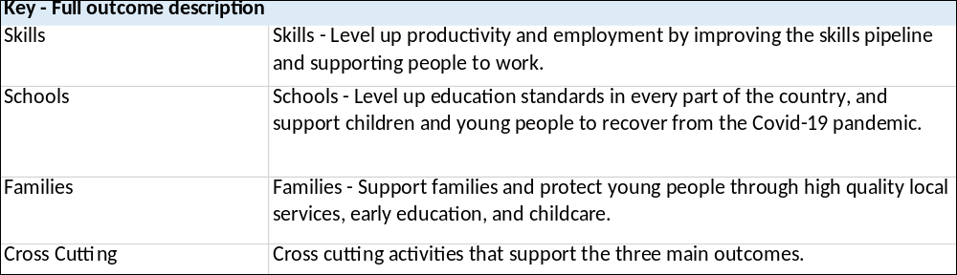

Annex B: Control total changes during Spending Review period

Annex B: Control total changes during Spending Review period | RDEL | RDEL | RDEL | CDEL | RAME | CAME | Voted-Non-Budget
Spending Review (SR21) 2023-24 CONTROL TOTALS - DfE Parliamentary Voted Control Totals 2023-24 | Admin | Programme | TOTAL (1) | Capital (2) | Resource (3) | Capital (4) | i.e. Grant in Aid
 | £000 | £000 | £000 | £000 | £000 | £000 | £000
Control Totals at start of Spending Review | 546,252 | 82,979,178 | 83,525,430 | 7,035,000 | (4,410,901) | 34,426,188
SR 21 Control Total – Non-ring-fenced | 500,182 | 78,715,938 | 79,216,120 | 7,035,000 | (4,410,901) | 34,426,188
SR 21 Control Total - Ring-fenced (depreciation) | 46,070 | 4,263,240 | 4,309,310 | 0 | 0 | 0 | 0
Changes since SR to Main Estimate
IFRS 16 conversion Ring-fenced | 17,017 |  | 17,017
IFRS 16 conversion Non-Ring-fenced | (12,914) | (430) | (13,344) | 3,400
Adjustment from summer exercise for depreciation. | 2,955 | 5,036 | 7,991
 | 7,058 | 4,606 | 11,664 | 3,400 | 0 | 0 | 0
Control Totals at Main Estimate | 553,310 | 82,983,784 | 83,537,094 | 7,038,400 | (4,410,901) | 34,426,188
Main Estimate – Non ring-fenced | 487,268 | 78,715,508 | 79,202,776 | 7,038,400 | (4,410,901) | 34,426,188
Main Estimate - Ring-fenced (depreciation) | 66,042 | 4,268,276 | 4,334,318 | 0 | 0 | 0
Changes agreed with HMT for Main Estimate 2023-24
Region’s reclassification admin to programme | (7,359) | 7,359 | 0
DA income reclassification | 8,455 | (8,455) | 0
Cost classification switch (Independent Education & Boarding Schools) and (Subject Knowledge Enhancement (SKE) integration) | (720) | 720 | 0
ST Pauls Place rent - switch programme to admin | 1,227 | (1,227) | 0
Childcare switches programme to admin | 5,786 | (5,786) | 0
sub totals of HMT agreed changes | 7,389 | (7,389) | 0
Reserves - Shared Outcome Funding (SOF)
SOF 2 - Family hubs | 1,120 | 8,860 | 9,980
SOF 2 - Family hubs march letter | 91 | 102 | 193
SOF 2 - Alternative provision specialist taskforce | 330 | 2,300 | 2,630
SOF 2 - Alternative provision specialist taskforce - Jan letter | 249 | 1,353 | 1,602
Data improvement | 596 | 0 | 596 | 20
Subtotal - Reserves - Shared Outcome Funding (SOF) | 2,386 | 12,615 | 15,001 | 20
Subtotal - Other agreed HMT changes/Funding | 9,775 | 5,226 | 15,001 | 20 | 0 | 0 | 0
Other Funding Changes - Autumn Budget Announcements
Reduction for HSC levy compensation core DfE | (2,389) | (2,762) | (5,151)
Reduction for HSC levy compensation core schools | 0 | (322,209) | (322,209)
Additional funding for core schools uplift 23-24 | 0 | 2,322,209 | 2,322,209
Subtotal - Other Funding Changes - Autumn Budget Announcements | (2,389) | 1,997,238 | 1,994,849
Spring budget - new funding
Spring Budget 2023: SWAPs |  | 5,700 | 5,700
Spring Budget 2023: Staying Close |  | 8,100 | 8,100
Childcare - uplift to hourly rate of existing offer |  | 203,798 | 203,798
Wrap around pathfinder programme in all LAs | 860 | 3,140 | 4,000
Childminder grants |  | 2,700 | 2,700
Subtotal: spring budget | 860 | 223,438 | 224,298
BCT Out
BCT OUT to CO - Special Advisors and Public Appointments Digital Service | (342) | 0 | (342)
BCT OUT to CO - Public Appointments Digital Service - Licencing Costs | (10) | 0 | (10)
BCT OUT to CO - Civil Service Live | (16) | 0 | (16)
BCT OUT to DLUHC - Family Voice project | 0 | (30) | (30)
BCT OUT to Local Gov (DLUHC) Financial Transparency of Local Authority Maintained Schools | 0 | (772) | (772)
BCT OUT to MOD - Apprenticeships - National shipbuilding office | 0 | (100) | (100)
BCT Out to OFSTED inspection of outstanding providers | 0 | (5,000) | (5,000)
BCT Out to OFSTED - Early years fees shortfall | 0 | (4,500) | (4,500)
BCT Out to OFSTED - Inspect all schools by July 2025 | 0 | (3,700) | (3,700)
BCT Out to OFSTED - Move G2 school inspections. | 0 | (700) | (700)
BCT Out to OFSTED - Move to a 3-year cycle for Colleges /SFC / SDI | 0 | (300) | (300)
BCT Out to OFSTED - Move from short to full inspections for Colleges / SFC / SDIs. | 0 | (900) | (900)
BCT Out to OFSTED - Introduce enhanced inspections of Colleges / Sixth Form College / Special Designated Institutes to cover local skills needs. | 0 | (1,350) | (1,350)
BCT Out to OFSTED - supported accommodation - Children in Care | 0 | 0 | 0 | (700)
BCT Out to OFSTED - Inspect 33% of good providers (excluding colleges) as a full inspection. | 0 | (200) | (200)
BCT Out to OFSTED - Inspect all FES providers (excluding colleges) | 0 | (700) | (700)
BCT Out to OFQUAL - Qualification review | 0 | (2,000) | (2,000)
BCT Out to DHSC - Fruit and Veg Scheme | 0 | (7,709) | (7,709)
BCT OUT to DWP - SOF Funding - Family Hubs | (38) | 0 | (38)
Subtotal Mains BCT Out | (406) | (27,961) | (28,367) | (700)
BCT IN
BCT IN from DLUHC - Supporting Families evaluation work 2023-24 |  |  | 0 | 190
BCT IN from DLUHC - Transfer for Digital - To provide adult numeracy (Multiply) funding |  | 40,000 | 40,000
BCT IN from DLUHC - Adult numeracy (Multiply) funding to DfE |  | 94,338 | 94,338
BCT IN from DLUHC - Food education programme |  | 1,600 | 1,600
BCT IN from DLUHC - Oak Academy, stretch material as per white paper. |  | 333 | 333
BCT In from DCMS - AI Conversion Courses |  | 8,517 | 8,517
BCT IN from DHSC - Family Hubs & Start for Life programme |  | 58,384 | 58,384
BCT IN from DHSC - Medical Expansion places (OFS) |  | 46,700 | 46,700
Subtotal Mains BCT IN | 0 | 249,872 | 249,872 | 190
MOG from DHSC for historic child migration agreed in 2022-23 for 2023-24 | 0 | 540 | 540
Subtotal Mains BCT In and Out and MOG | (406) | 222,451 | 222,045 | (510) | 0 | 0 | 0
Other changes
Other AME - Provision increases |  |  |  |  | 29,796
Other AME - Provision utilisation / decrease |  |  |  |  | (55,413)
Other AME changes agreed with HMT |  |  |  |  | 4,900 | 2,500
Net cash requirement for Mains
GIA funding for ALBs |  |  |  |  |  |  | 2,040,264
Subtotal other changes | 0 | 0 | 0 | 0 | (20,717) | 2,500 | 2,040,264
Changes for Main Estimate 2023-24 | 14,898 | 2,452,959 | 2,467,857 | 2,910 | (20,717) | 2,500 | 2,040,264
Final Control Totals at Main Estimate 2023-24 | 561,150 | 85,432,137 | 85,993,287 | 7,037,910 | (4,431,618) | 34,428,688 | 2,040,264
Of which
non-ringfenced | 495,108 | 81,163,861 | 81,658,969 | 7,037,910 | (4,431,618) | 34,428,688 | 2,040,264
ringfenced | 66,042 | 4,268,276 | 4,334,318 | 0 | 0 | 0 | 0

The total value of Basic Need allocations fluctuate year-by-year as they are determined by the changing need for school places.
In March 2023, the department announced to LAs an additional allocation of £430m of High Needs funding, reprofiled from the 23-24 allocation into 22-23.
This includes the £447 million of additional capital funding allocated in 2022-23 for eligible schools and sixth form colleges to spend on capital improvements to buildings and facilities, prioritising works to improve energy efficiency.
Higher spend in 2022-23 when compared to 2023-24 is in part a result of reprofiling a significant amount of High Needs funding from the 23-24 allocation into 22-23 (see footnote 2) and the additional capital funding allocated to improve energy efficiency (see footnote 3).

