14 February 2023
Dr Ben Calvert, Vice-Chancellor of the University of South Wales
University of South Wales
86-88 Adam Street
Cardiff
CF24 2FN

Dear Ben Calvert,

EU Structural Funds

The Welsh Affairs Committee has closely scrutinised the replacement of EU Structural Funds by the UK Shared Prosperity Fund, for example holding an evidence session on 7 September 2022. Universities in Wales, as with universities in other parts of the United Kingdom, have expressed concerns about the impact of this change. It has been suggested by Universities Wales that funding is reaching a “cliff edge” and that bridging funding is needed. Although parts of responsibility for higher education is devolved to the Senedd, this aspect, alongside other areas of research funding, remains a reserved matter.

To help the Committee in assessing the scale of the issue, I am writing to the Vice-Chancellor of all eight of the Welsh universities to ask for the following information.

- How much funding do you currently receive from EU Structural Funds and which of the different funds (regional development, social fund etc) do you draw money from?
- Which projects does this money support?
- How much funding from those EU Structural Funds do you anticipate receiving in 2023-24 and 2024-25?
- If these projects do not receive additional funding, for instance from the UK Shared Prosperity Fund, would the project cease to be viable?
- Have you or do you intend to apply for funds from the UK Shared Prosperity Fund? If you have not applied, could you please explain why not?
- Do you anticipate receiving funds from the UK Shared Prosperity Fund?
- Does there need to be wider reforms to the UK Shared Prosperity Fund, including how money from it is allocated?
- Universities UK has called for “bridging funding”. What are they bridging to?
- What representation have you made to other organisations – UK Government, Welsh Government, UKRI, private sector etc for alternative sources of replacement funding?

This information will greatly assist the Committee in deciding on the next steps to take.

Yours sincerely,

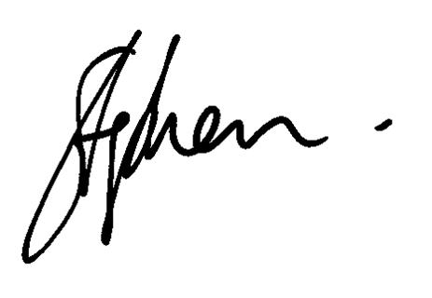
Rt Hon Stephen Crabb MP
Chair of the Welsh Affairs Committee

